431 Class 10
Thomas E. Love, Ph.D.
2026-09-24

Today’s Agenda
- Checking the fit of a linear model to assumptions
  - linearity
  - constant variance (homoscedasticity)
  - Normality of residuals
    - assessing influence and leverage
  - posterior predictive checks
- The impact of a transformation
- Model performance measures besides $R^{2}$ and $σ$

Today’s Setup
knitr::opts_chunk$set(comment = NA)
source("c10/data/Love-431.R") # for the lovedist() function
library(janitor)
library(naniar) ## dealing with missing data
library(car) ## for the Box-Cox plot
library(patchwork)
library(rstanarm)
library(easystats)
library(tidyverse)
theme_set(theme_light()) ## new theme for ggplots!

Data Ingest and Cleaning
EUROFAMCARE data introduced in Class 09.
- Our data describe 902 primary caregivers providing at least four hours of personal care or support per week to an elder aged 65 years or older.
eurocare <- read_csv("c10/data/eurocare.csv", show_col_types = FALSE) |>
janitor::clean_names() |>
mutate(subject = as.character(subject)) |>
select(subject, e_age, barthel, neg_impact, pos_impact)
dim(eurocare)
[1] 902 5

eurocare variables
Variable | Description
subject | Identifying code
e_age | Age of elder (years)
barthel | Barthel index for elder’s Activities of Daily Living (0 to 100 = complete independence)
neg_impact | COPE Index Negative Impact subscale
pos_impact | COPE Index Positive Impact subscale

Missingness Reports
miss_case_table(eurocare) # missingness by subject
# A tibble: 3 × 3
n_miss_in_case n_cases pct_cases
<int> <int> <dbl>
1 0 847 93.9
2 1 49 5.43
3 2 6 0.665
miss_var_summary(eurocare) # missingness by variable
# A tibble: 5 × 3
variable n_miss pct_miss
<chr> <int> <num>
1 pos_impact 21 2.33
2 barthel 19 2.11
3 e_age 11 1.22
4 neg_impact 10 1.11
5 subject 0 0

Filter to complete cases
- Drop missing values across all variables in eurocare.
ecare <- eurocare |> drop_na()
ecare
# A tibble: 847 × 5
subject e_age barthel neg_impact pos_impact
<chr> <dbl> <dbl> <dbl> <dbl>
1 S-0001 83 75 12 12
2 S-0002 88 75 20 11
3 S-0003 82 35 11 13
4 S-0004 67 0 10 15
5 S-0005 84 25 12 15
6 S-0006 85 60 19 9
7 S-0007 74 5 15 13
8 S-0008 87 35 11 14
9 S-0009 79 15 15 13
10 S-0010 83 0 10 13
# ℹ 837 more rows

Automated codebook
data_codebook(ecare |> select(-subject))
select(ecare, -subject) (847 rows and 4 variables, 4 shown)
ID | Name | Type | Missings | Values | N
---+------------+---------+----------+-----------+----
1 | e_age | numeric | 0 (0.0%) | [65, 103] | 847
---+------------+---------+----------+-----------+----
2 | barthel | numeric | 0 (0.0%) | [0, 100] | 847
---+------------+---------+----------+-----------+----
3 | neg_impact | numeric | 0 (0.0%) | [7, 28] | 847
---+------------+---------+----------+-----------+----
4 | pos_impact | numeric | 0 (0.0%) | [5, 16] | 847
------------------------------------------------------

Model we fit last time
fit3 <- lm(neg_impact ~ pos_impact, data = ecare)
model_parameters(fit3, ci = 0.97, pretty_names = FALSE)
Parameter | Coefficient | SE | 97% CI | t(845) | p
-------------------------------------------------------------------
(Intercept) | 20.70 | 0.69 | [19.20, 22.19] | 30.07 | < .001
pos_impact | -0.71 | 0.05 | [-0.83, -0.59] | -13.15 | < .001
Uncertainty intervals (equal-tailed) and p-values (two-tailed) computed
using a Wald t-distribution approximation.
model_performance(fit3)
# Indices of model performance
AIC | AICc | BIC | R2 | R2 (adj.) | RMSE | Sigma
------------------------------------------------------------
4534.6 | 4534.6 | 4548.8 | 0.170 | 0.169 | 3.506 | 3.510

Checking OLS Model Fit
Main assumptions of any simple linear regression are:
- linearity: we assume that the outcome is linearly related to our predictor
- constant variance (homoscedasticity): we assume that the variation of our outcome is about the same regardless of the value of our predictor
- normal distribution: we assume that the errors around the regression model at any specified values of the x-variables follow an approximately Normal distribution.

Fitting the diagnostic plots
To check these assumptions, consider the following plots.
fit3_diagnostic_plots <-
plot(check_model(fit3, panel = FALSE, detrend = FALSE))
For confidence bands, please install `qqplotr`.
- I don’t worry about confidence bands in these plots.

Checking Linearity
fit3_diagnostic_plots[[2]]
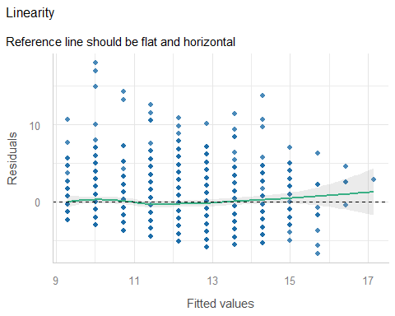

Checking Equal Variances
fit3_diagnostic_plots[[3]]
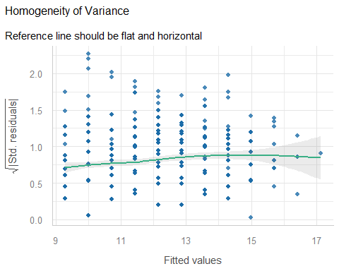

Checking for Influential Points
fit3_diagnostic_plots[[4]]
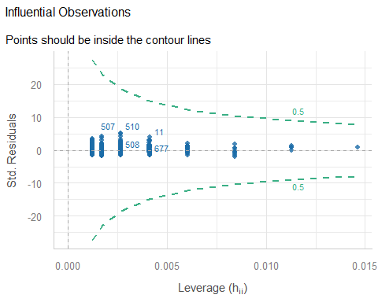

Checking Normality
fit3_diagnostic_plots[[5]]
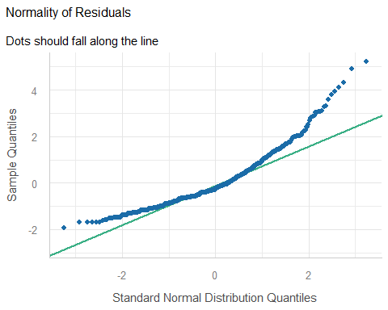

Alternative: Normal Q-Q
plot(fit3, which = 2)
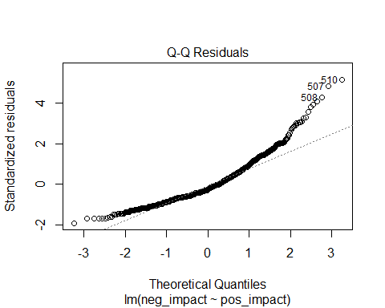

Posterior Predictive Checks
fit3_diagnostic_plots[[1]]
Ignoring unknown labels:
• size : ""
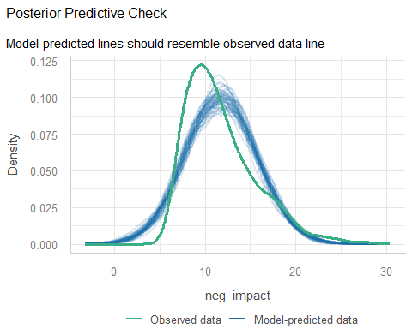

Box-Cox suggestion?
boxCox(fit3)
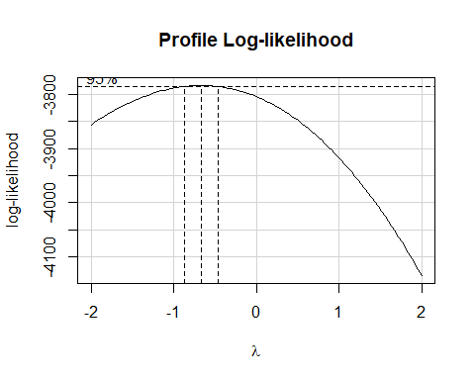

Transformation to Scatterplot
ggplot(ecare, aes(x = pos_impact, y = (1/sqrt(neg_impact)))) +
geom_point() +
geom_smooth(method = "lm", se = TRUE, col = "red", formula = y ~ x)
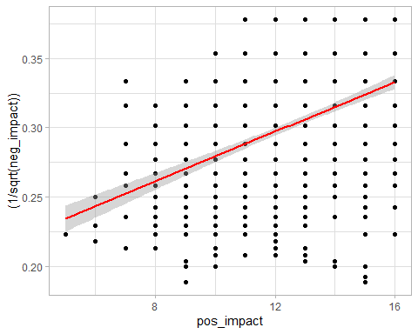

What would a transformed model look like?
ecare <- ecare |> mutate(neg_tr = 1/sqrt(neg_impact))
fit4 <- lm(neg_tr ~ pos_impact, data = ecare)
fit4_diagnostic_plots <-
plot(check_model(fit4, panel = FALSE, detrend = FALSE))
For confidence bands, please install `qqplotr`.

Posterior Predictive Check?
fit4_diagnostic_plots[[1]]
Ignoring unknown labels:
• size : ""
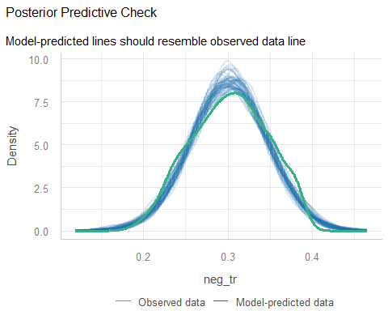

Normality of Residuals?
fit4_diagnostic_plots[[5]]
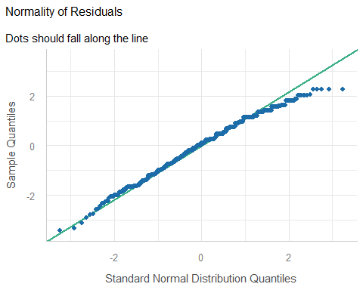

Interpreting the transformed model
model_parameters(fit4, ci = 0.97)
Parameter | Coefficient | SE | 97% CI | t(845) | p
---------------------------------------------------------------------
(Intercept) | 0.19 | 7.82e-03 | [0.17, 0.21] | 24.30 | < .001
pos impact | 8.93e-03 | 6.15e-04 | [0.01, 0.01] | 14.52 | < .001
Uncertainty intervals (equal-tailed) and p-values (two-tailed) computed
using a Wald t-distribution approximation.
model_performance(fit4)
# Indices of model performance
AIC | AICc | BIC | R2 | R2 (adj.) | RMSE | Sigma
---------------------------------------------------------------
-3050.5 | -3050.5 | -3036.3 | 0.200 | 0.199 | 0.040 | 0.040

Standing Break

A new question
How well can we predict an elder’s barthel index (0 = complete dependence for activities daily living to 100 = complete independence) on the basis of their age (stored in e_age)?
ecare |> reframe(lovedist(barthel))
# A tibble: 1 × 10
n miss mean sd med mad min q25 q75 max
<int> <int> <dbl> <dbl> <dbl> <dbl> <dbl> <dbl> <dbl> <dbl>
1 847 0 65.4 29.1 75 29.7 0 45 90 100
ecare |> reframe(lovedist(e_age))
# A tibble: 1 × 10
n miss mean sd med mad min q25 q75 max
<int> <int> <dbl> <dbl> <dbl> <dbl> <dbl> <dbl> <dbl> <dbl>
1 847 0 79.0 8.12 79 8.90 65 73 85 103

Histograms?
p1 <- ggplot(ecare, aes(x = barthel)) +
geom_histogram(binwidth = 1, fill = "blue", col = "white") +
labs(title = "Barthel Index")
p2 <- ggplot(ecare, aes(x = e_age)) +
geom_histogram(binwidth = 1, fill = "forestgreen", col = "white") +
labs(title = "Age of elder")
p1 + p2
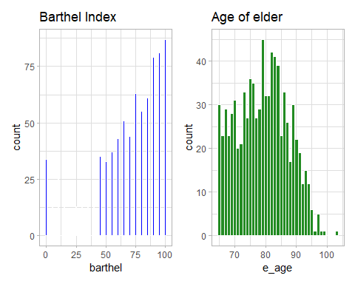

Scatterplot of 847 elders
We’ll look at barthel index (on the y axis) vs. e_age (on x). We’ll plot each point with alpha = 0.3 so that if we have multiple overlapping points, the plot will look darker there.
ggplot(ecare, aes(x = e_age, y = barthel)) +
geom_point(alpha = 0.3) +
geom_smooth(method = "loess",
formula = y ~ x, se = FALSE, col = "blue") +
geom_smooth(method = "lm",
formula = y ~ x, se = TRUE, col = "red") +
labs(title = "EUROFAMCARE data for 847 subjects",
x = "Age (years)", y = "Barthel Index for ADL",
caption = "Linear model in red, loess smooth in blue")
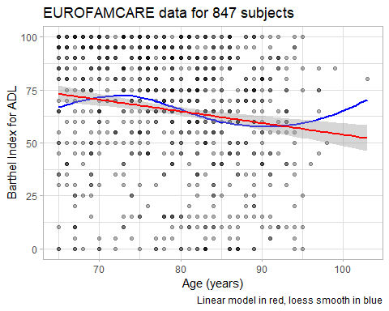

Jittered Scatterplot?
Let’s add a little random noise to each point on each scale to deal with the problem of overlapping points. We use geom_jitter() here rather than geom_point().
ggplot(ecare, aes(x = e_age, y = barthel)) +
geom_jitter() +
geom_smooth(method = "loess",
formula = y ~ x, se = FALSE, col = "blue") +
geom_smooth(method = "lm",
formula = y ~ x, se = TRUE, col = "red") +
labs(title = "Jittered EUROFAMCARE data for 847 subjects",
x = "Age (years)", y = "Barthel Index for ADL",
caption = "Linear model in red, loess smooth in blue")
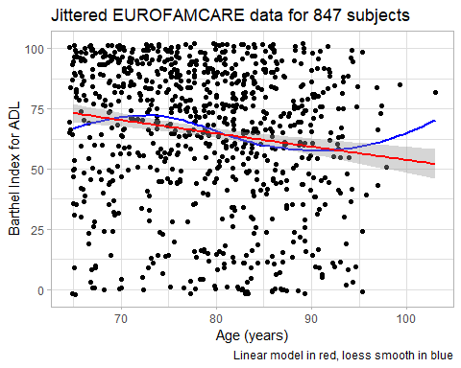

Pearson Correlation Coefficient
- Pearson $r$ ranges from -1 (perfect inverse relationship: as x goes up, y goes down) to +1 (perfect direct relationship: as x goes up, y goes up.)
- Pearson $r$ measures only a linear association.
ecare |> select(barthel, e_age) |> correlation()
# Correlation Matrix (pearson-method)
Parameter1 | Parameter2 | r | 95% CI | t(845) | p
---------------------------------------------------------------------
barthel | e_age | -0.15 | [-0.22, -0.09] | -4.53 | < .001***
p-value adjustment method: Holm (1979)
Observations: 847

OLS: Predict barthel with e_age
fit5 <- lm(barthel ~ e_age, data = ecare)
model_parameters(fit5, ci = 0.89)
Parameter | Coefficient | SE | 89% CI | t(845) | p
--------------------------------------------------------------------
(Intercept) | 109.00 | 9.69 | [93.50, 124.51] | 11.25 | < .001
e age | -0.55 | 0.12 | [-0.75, -0.36] | -4.53 | < .001
Uncertainty intervals (equal-tailed) and p-values (two-tailed) computed
using a Wald t-distribution approximation.
- Note that our variable e_age has been “prettified” here to e age which might be confusing…
model_parameters(fit5, ci = 0.89, pretty_names = FALSE)
Parameter | Coefficient | SE | 89% CI | t(845) | p
--------------------------------------------------------------------
(Intercept) | 109.00 | 9.69 | [93.50, 124.51] | 11.25 | < .001
e_age | -0.55 | 0.12 | [-0.75, -0.36] | -4.53 | < .001
Uncertainty intervals (equal-tailed) and p-values (two-tailed) computed
using a Wald t-distribution approximation.
What does this output tell us?

Interpreting the Intercept
model_parameters(fit5, ci = 0.89, pretty_names = FALSE)
Parameter | Coefficient | SE | 89% CI | t(845) | p
--------------------------------------------------------------------
(Intercept) | 109.00 | 9.69 | [93.50, 124.51] | 11.25 | < .001
e_age | -0.55 | 0.12 | [-0.75, -0.36] | -4.53 | < .001
Uncertainty intervals (equal-tailed) and p-values (two-tailed) computed
using a Wald t-distribution approximation.
- Our fit5 model estimates the barthel value of to be 109.01 if e_age = 0, but we have no values of e_age anywhere near 0 in our data, nor is such a value plausible clinically for either e_age (our values range from 65 to 103) or barthel (which must be between 0 and 100), so the intercept doesn’t tell us much here.

Point Estimate of the Slope
model_parameters(fit5, ci = 0.89, pretty_names = FALSE)
Parameter | Coefficient | SE | 89% CI | t(845) | p
--------------------------------------------------------------------
(Intercept) | 109.00 | 9.69 | [93.50, 124.51] | 11.25 | < .001
e_age | -0.55 | 0.12 | [-0.75, -0.36] | -4.53 | < .001
Uncertainty intervals (equal-tailed) and p-values (two-tailed) computed
using a Wald t-distribution approximation.
- Suppose Harry is one year older than Sally. Our fit5 model predicts the barthel index for Harry to be 0.55 points less than that of Sally, on average.
- Of course, this assumes Harry and Sally are similar to the subjects in e_care and that our linear model fit5 is correct.

Confidence Interval for Slope
model_parameters(fit5, ci = 0.89, pretty_names = FALSE)
Parameter | Coefficient | SE | 89% CI | t(845) | p
--------------------------------------------------------------------
(Intercept) | 109.00 | 9.69 | [93.50, 124.51] | 11.25 | < .001
e_age | -0.55 | 0.12 | [-0.75, -0.36] | -4.53 | < .001
Uncertainty intervals (equal-tailed) and p-values (two-tailed) computed
using a Wald t-distribution approximation.
- When we generalize beyond study participants to the population they were selected at random from, then our data are compatible (at the 89% confidence level) with population slopes between -0.75 and -0.36, depending on the assumptions of our linear model fit5 being correct.

Performance of our OLS model?
model_performance(fit5)
# Indices of model performance
AIC | AICc | BIC | R2 | R2 (adj.) | RMSE | Sigma
--------------------------------------------------------------
8099.2 | 8099.3 | 8113.5 | 0.024 | 0.023 | 28.751 | 28.785
- Key summaries for an OLS model with one predictor, like fit5, are $R^{2}$ and Sigma (which is similar to RMSE.)
- $R^{2}$ tells us model fit5 accounts for 2.4% of the variation in barthel that we observe in our ecare data.

Using the estimated Sigma ($σ$)
model_performance(fit5)
# Indices of model performance
AIC | AICc | BIC | R2 | R2 (adj.) | RMSE | Sigma
--------------------------------------------------------------
8099.2 | 8099.3 | 8113.5 | 0.024 | 0.023 | 28.751 | 28.785
- Our model fit5 assumes that our errors (residuals) come from a Normal distribution with mean 0 and standard deviation Sigma ($σ$) = 28.8.
- Thus, about 68% of our predictions should be within $±$ 28.8 points of the correct barthel index, and 95% of our predictions should be within $±2×28.8$, or 57.6 points on the barthel score. Is this good news?

Performance Measures (1/5)
- AIC: Akaike’s Information Criterion
- AICc: Second-order (or small sample) AIC with a correction for small sample sizes
- BIC: Bayesian Information Criterion
AIC, AICc and BIC are used when comparing one or more models for the same outcome. When comparing models fit using maximum likelihood (like OLS linear models), the smaller the AIC or BIC, the better the fit.

Performance Measures (2/5)
R2: r-squared value = 0.024
- The R-squared ($R^{2}$) measure for an OLS fit describes how much of the variation in our outcome can be explained using our model (and its predictors.) $R^{2}$ falls between 0 and 1, and the closer it is to 1, the better the model fits our data.
- In a simple (one-predictor) OLS model like this, the value is also the square of the Pearson correlation coefficient, $r$.
- We called this $R^{2}$ “eta-squared” ($η^{2}$) in ANOVA.

Performance Measures (3/5)
R2 (adj.): adjusted r-squared value = 0.023
- Adjusted R-squared is an index (so it’s not a proportion of anything) for comparing different models (different predictor sets) for the same outcome.
- The idea is to reduce the temptation to overfit the data, by penalizing the $R^{2}$ value a little for each predictor.
- Adjusted $R^{2}$ is usually between 0 and 1, but can be negative.
- The adjusted $R^{2}$ measure can never be larger than $R^{2}$.

Performance Measures (4/5)
RMSE = 28.742
- The RMSE is the square root of the variance of the residuals and summarizes the difference between the observed data and the model’s predicted values.
- It can be interpreted as the standard deviation of the unexplained variance, and has the same units as the outcome.
- When comparing models using the same data for the same outcome (but, for instance, with different predictor sets), lower RMSE values indicate better model fit.

Performance Measures (5/5)
Sigma = 28.776
- Linear models assume that their residuals are drawn from a Normal distribution with mean 0 and standard deviation equal to sigma ($σ$).
- This indicates that the predicted outcome will be within $±1σ$ units of the observed outcome for approximately 68% of the data points, for example.

Checking OLS Model Fit
Main assumptions of any simple linear regression are:
- linearity: we assume that the outcome is linearly related to our predictor
- constant variance (homoscedasticity): we assume that the variation of our outcome is about the same regardless of the value of our predictor
- normal distribution: we assume that the errors around the regression model at any specified values of the x-variables follow an approximately Normal distribution.

Fitting the diagnostic plots
To check these assumptions, consider the following plots.
fit5_diagnostic_plots <-
plot(check_model(fit5, panel = FALSE, detrend = FALSE))
For confidence bands, please install `qqplotr`.
- I don’t worry about confidence bands in these plots.

Checking Linearity
fit5_diagnostic_plots[[2]]
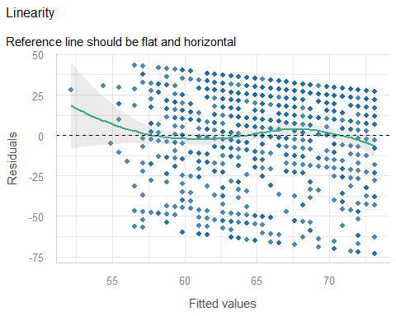

Checking Equal Variances
fit5_diagnostic_plots[[3]]
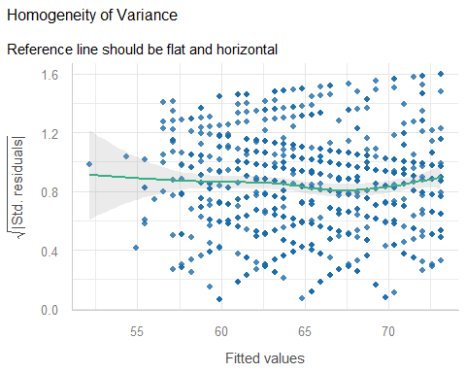

Checking for Influential Points
fit5_diagnostic_plots[[4]]
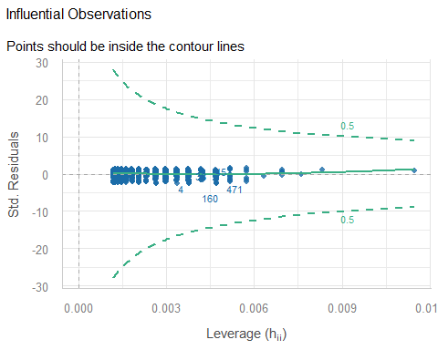

Which points are listed in the plot?
None are anywhere near the contours, as it turns out.
ecare |> slice(c(4, 38, 160, 470)) |> select(subject, barthel, e_age)
# A tibble: 4 × 3
subject barthel e_age
<chr> <dbl> <dbl>
1 S-0004 0 67
2 S-0043 0 67
3 S-0194 0 65
4 S-0517 50 87

Checking Normality
fit5_diagnostic_plots[[5]]
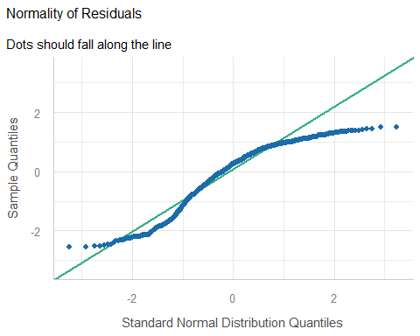

Alternative: Normal Q-Q
plot(fit5, which = 2)
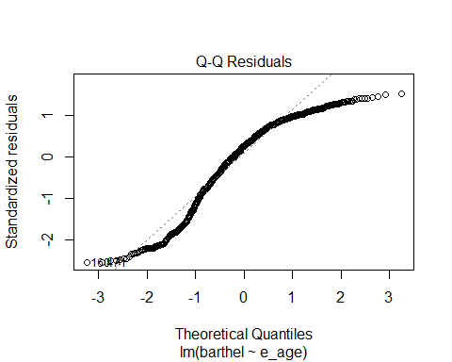

Which points are low outliers?
ecare |> slice(c(4, 47, 160)) |> select(subject, barthel, e_age)
# A tibble: 3 × 3
subject barthel e_age
<chr> <dbl> <dbl>
1 S-0004 0 67
2 S-0055 20 81
3 S-0194 0 65

Posterior Predictive Checks
fit5_diagnostic_plots[[1]]
Ignoring unknown labels:
• size : ""
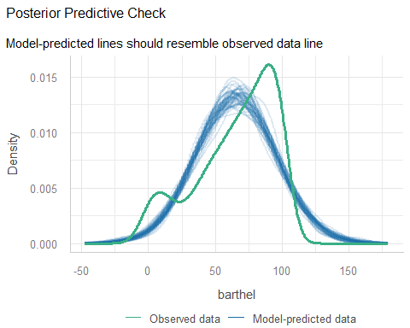

Box-Cox suggestion?
To use Box-Cox, all values of our outcome barthel would have to be strictly positive.
ecare |> reframe(lovedist(barthel))
# A tibble: 1 × 10
n miss mean sd med mad min q25 q75 max
<int> <int> <dbl> <dbl> <dbl> <dbl> <dbl> <dbl> <dbl> <dbl>
1 847 0 65.4 29.1 75 29.7 0 45 90 100
fit5_adj <- lm((barthel+1) ~ e_age, data = ecare)
boxCox(fit5_adj)
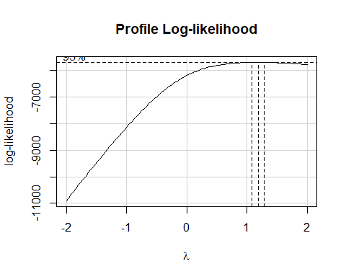

Next Time
What’s wrong with statistical significance?

Session Information
xfun::session_info()
R version 4.6.1 (2026-06-24 ucrt)
Platform: x86_64-w64-mingw32/x64
Running under: Windows 11 x64 (build 26200)
Locale:
LC_COLLATE=English_United States.utf8
LC_CTYPE=English_United States.utf8
LC_MONETARY=English_United States.utf8
LC_NUMERIC=C
LC_TIME=English_United States.utf8
Package version:
abind_1.4-8 ape_5.8.1 askpass_1.2.1
backports_1.5.1 base64enc_0.1-6 bayesplot_1.16.0
bayestestR_0.19.0 BH_1.90.0.1 bit_4.6.0
bit64_4.8.6 blob_1.3.0 boot_1.3-32
broom_1.0.13 bslib_0.12.0 cachem_1.1.0
callr_3.8.0 car_3.1-5 carData_3.0-6
cellranger_1.1.0 checkmate_2.3.4 cli_3.6.6
clipr_0.8.1 coda_0.19-4.1 codetools_0.2-20
colorspace_2.1.3 colourpicker_1.3.0 commonmark_2.0.0
compiler_4.6.1 conflicted_1.2.0 correlation_0.8.8
cowplot_1.2.0 cpp11_0.5.5 crayon_1.5.3
crosstalk_1.2.2 curl_8.0.0 data.table_1.18.6.1
datasets_4.6.1 datawizard_1.4.0 DBI_1.3.0
dbplyr_2.6.0 Deriv_4.3.5 desc_1.4.3
DHARMa_0.5.0 digest_0.6.39 distributional_0.9.0
doBy_4.7.2 doParallel_1.0.17 dplyr_1.2.1
DT_0.34.0 dtplyr_1.3.3 dygraphs_1.1.1.6
easystats_0.7.6 effectsize_1.0.3 emmeans_2.0.4
estimability_2.0.0 evaluate_1.0.5 farver_2.1.2
fastmap_1.2.0 fontawesome_0.5.3 forcats_1.0.1
foreach_1.5.2 forecast_9.0.2 Formula_1.2-6
fracdiff_1.5.4 fs_2.1.0 gap_1.15.2
gap.datasets_0.0.6 gargle_1.6.1 generics_0.1.4
ggdist_3.3.3 ggplot2_4.0.3 ggrepel_0.9.8
ggridges_0.5.7 glue_1.8.1 googledrive_2.1.2
googlesheets4_1.1.2 graphics_4.6.1 grDevices_4.6.1
grid_4.6.1 gridExtra_2.3.1 gtable_0.3.6
gtools_3.9.5 haven_2.5.5 highr_0.12
hms_1.1.4 htmltools_0.5.9 htmlwidgets_1.6.4
httpuv_1.6.17 httr_1.4.9 ids_1.0.1
igraph_2.3.3 inline_0.3.21 insight_1.5.4
isoband_0.3.0 iterators_1.0.14 janitor_2.2.1
jquerylib_0.1.4 jsonlite_2.0.0 knitr_1.52
labeling_0.4.3 later_1.4.8 lattice_0.23-1
lazyeval_0.2.3 lifecycle_1.0.5 litedown_0.11
lme4_2.0-6 lmtest_0.9.40 loo_2.10.1
lubridate_1.9.5 magrittr_2.0.5 markdown_2.0
MASS_7.3-66 Matrix_1.7-6 MatrixModels_0.5.4
matrixStats_1.5.0 memoise_2.0.1 methods_4.6.1
mgcv_1.9-4 mime_0.13 miniUI_0.1.2
minqa_1.2.8 modelbased_0.17.0 modelr_0.1.11
multcomp_1.4-32 mvtnorm_1.4-2 naniar_1.1.0
nlme_3.1-171 nloptr_2.2.1 nnet_7.3.21
norm_1.0.11.1 numDeriv_2016.8.1.1 openssl_2.4.2
otel_0.2.0 parallel_4.6.1 parameters_0.29.3
patchwork_1.3.2 pbkrtest_0.5.5 performance_0.18.2
pillar_1.11.1 pkgbuild_1.4.8 pkgconfig_2.0.3
plotly_4.12.1 plyr_1.8.9 posterior_1.7.0
prettyunits_1.2.0 processx_3.9.0 progress_1.2.3
promises_1.5.0 ps_1.9.3 purrr_1.2.2
qgam_2.0.0 quadprog_1.5.8 quantreg_6.1
QuickJSR_1.11.0 R6_2.6.1 ragg_1.5.2
rappdirs_0.3.4 rbibutils_2.4.1 RColorBrewer_1.1-3
Rcpp_1.1.2 RcppArmadillo_15.6.0.1 RcppEigen_0.3.4.0.2
RcppParallel_6.2.1 Rdpack_2.6.6 readr_2.2.0
readxl_1.5.0 reformulas_0.4.4 rematch_2.0.0
rematch2_2.1.2 report_0.6.4 reprex_2.1.1
reshape2_1.4.5 rlang_1.3.0 rmarkdown_2.32
rstan_2.32.7 rstanarm_2.32.2 rstantools_2.7.1
rstudioapi_0.19.0 rvest_1.0.5 S7_0.2.2
sandwich_3.1-3 sass_0.4.10 scales_1.4.0
see_0.14.2 selectr_0.6.0 shiny_1.14.0
shinyjs_2.1.1 shinystan_2.7.0 shinythemes_1.2.0
snakecase_0.11.1 sourcetools_0.1.7.2 SparseM_1.84.2
splines_4.6.1 StanHeaders_2.39.1 stats_4.6.1
stats4_4.6.1 stringi_1.8.9 stringr_1.6.0
survival_3.8-11 sys_3.4.3 systemfonts_1.3.2
tensorA_0.36.2.1 textshaping_1.0.5 TH.data_1.1-5
threejs_0.3.4 tibble_3.3.1 tidyr_1.3.2
tidyselect_1.2.1 tidyverse_2.0.0 timechange_0.4.0
timeDate_4052.112 tinytex_0.60 tools_4.6.1
tzdb_0.5.0 UpSetR_1.4.1 urca_1.3.4
utf8_1.2.6 utils_4.6.1 uuid_1.2.2
V8_8.2.0 vctrs_0.7.3 viridis_0.6.5
viridisLite_0.4.3 visdat_0.6.0 vroom_1.7.1
withr_3.0.3 xfun_0.60 xml2_1.6.0
xtable_1.8-8 xts_0.14.3 yaml_2.3.12
zoo_1.9-0

