431 Class 07
Thomas E. Love, Ph.D.
2026-09-15

Today’s Agenda
- What does “Normalish” data look like?
- Comparing Two Samples
  - Paired vs. Independent Samples
  - Checking Assumptions
  - How should we interpret an uncertainty interval?
- Transforming an Outcome (see Chapter 7)
  - The importance of power transformations
  - Tukey’s ladder and the Box-Cox plot

Load packages and set theme
knitr::opts_chunk$set(comment = NA)
source("c07/data/Love-431.R") # for the lovedist() function
library(janitor)
library(patchwork)
library(readxl)
library(knitr)
library(kableExtra)
library(MKinfer)
library(rstanarm)
library(car)
library(easystats)
library(tidyverse)
theme_set(theme_bw())

A Simulated Data Set
dat07
# A tibble: 125 × 6
var1 var2 var3 var4 var5 var6
<dbl> <dbl> <dbl> <dbl> <dbl> <dbl>
1 114. 132. 92.0 114. 113. 97.1
2 117. 102. 119. 99.6 113. 124.
3 109. 78.1 89.4 115. 83.7 122.
4 99.6 99.3 92.3 89.4 107. 105.
5 95.8 121. 93.3 111. 104. 115.
6 79.4 99.8 102. 92.2 115. 113.
7 87.7 90.4 80.7 89.6 95.3 113.
8 86.1 144. 99.9 86.9 58.0 110.
9 116. 56.4 78.3 117. 115. 93.7
10 95.5 94.3 103. 86.3 99.6 92.1
# ℹ 115 more rows
Simulation details for dat07 tibble are in the Quarto code.

Numerical Summaries
res1 <- dat07 |> reframe(lovedist(var1)) |> mutate(variable = "var1")
res2 <- dat07 |> reframe(lovedist(var2)) |> mutate(variable = "var2")
res3 <- dat07 |> reframe(lovedist(var3)) |> mutate(variable = "var3")
res4 <- dat07 |> reframe(lovedist(var4)) |> mutate(variable = "var4")
res5 <- dat07 |> reframe(lovedist(var5)) |> mutate(variable = "var5")
res6 <- dat07 |> reframe(lovedist(var6)) |> mutate(variable = "var6")
rbind(res1, res2, res3, res4, res5, res6) |> relocate(variable) |>
kable(digits = c(0, 0, 0, 2, 2, 2, 2, 1, 1, 1, 1))
variable | n | miss | mean | sd | med | mad | min | q25 | q75 | max
var1 | 125 | 0 | 102.37 | 16.12 | 100.61 | 17.40 | 54.4 | 89.7 | 115.2 | 149.3
var2 | 125 | 0 | 101.20 | 14.24 | 100.09 | 8.56 | 56.4 | 95.8 | 107.4 | 143.5
var3 | 125 | 0 | 101.78 | 19.63 | 96.35 | 14.87 | 75.7 | 89.3 | 112.0 | 178.8
var4 | 125 | 0 | 102.19 | 11.04 | 101.68 | 13.26 | 83.7 | 93.7 | 111.5 | 122.9
var5 | 125 | 0 | 101.25 | 13.29 | 103.93 | 12.57 | 56.9 | 95.5 | 112.2 | 117.0
var6 | 125 | 0 | 102.79 | 16.13 | 102.16 | 16.25 | 60.2 | 93.7 | 114.2 | 143.9

Histograms of dat07 variables
H1 <- ggplot(dat07, aes(x = var1)) + labs(title = "Histogram of var1") +
geom_histogram(binwidth = 6, col = "black", fill = "skyblue")
H2 <- ggplot(dat07, aes(x = var2)) + labs(title = "Histogram of var2") +
geom_histogram(binwidth = 6, col = "black", fill = "plum")
H3 <- ggplot(dat07, aes(x = var3)) + labs(title = "Histogram of var3") +
geom_histogram(binwidth = 6, col = "black", fill = "coral")
H4 <- ggplot(dat07, aes(x = var4)) + labs(title = "Histogram of var4") +
geom_histogram(binwidth = 3, col = "black", fill = "aquamarine")
H5 <- ggplot(dat07, aes(x = var5)) + labs(title = "Histogram of var5") +
geom_histogram(binwidth = 4, col = "black", fill = "slateblue")
H6 <- ggplot(dat07, aes(x = var6)) + labs(title = "Histogram of var6") +
geom_histogram(binwidth = 6, col = "black", fill = "burlywood")
(H1 + H2 + H3) / (H4 + H5 + H6)
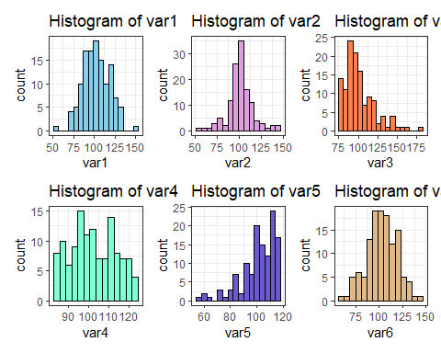

Three-Plot Summary for var01
plot1A <- ggplot(dat07, aes(sample = var1)) +
geom_qq(shape = 21, fill = "skyblue") + geom_qq_line(col = "red") +
labs(title = "Normal Q-Q plot of var1", y = "var1", x = "Standard Normal")
plot1B <- ggplot(dat07, aes(x = var1)) +
geom_histogram(binwidth = 6, col = "black", fill = "skyblue") +
stat_function(fun = function(x)
dnorm(x, mean = mean(dat07$var1, na.rm = TRUE),
sd = sd(dat07$var1,na.rm = TRUE)) *
length(dat07$var1) * 6,
geom = "area", alpha = 0.5, fill = "linen", col = "black") +
labs(title = "Histogram of var1", y = "")
plot1C <- ggplot(dat07, aes(x = var1, y = "")) +
geom_violin(fill = "skyblue") + geom_boxplot(width = 0.3) +
stat_summary(fun = "mean", geom = "point", col = "red") +
labs(title = "Boxplot of var1", y = "", x = "var1")
plot1A + (plot1B / plot1C + plot_layout(heights = c(2,1)))
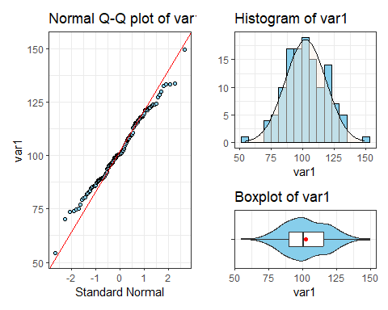

Three-Plot Summary for var02
plot2A <- ggplot(dat07, aes(sample = var2)) +
geom_qq(shape = 21, fill = "plum") + geom_qq_line(col = "red") +
labs(title = "Normal Q-Q plot of var2", y = "var2", x = "Standard Normal")
plot2B <- ggplot(dat07, aes(x = var2)) +
geom_histogram(binwidth = 6, col = "black", fill = "plum") +
stat_function(fun = function(x)
dnorm(x, mean = mean(dat07$var2, na.rm = TRUE),
sd = sd(dat07$var2,na.rm = TRUE)) *
length(dat07$var2) * 6,
geom = "area", alpha = 0.5, fill = "linen", col = "black") +
labs(title = "Histogram of var2", y = "")
plot2C <- ggplot(dat07, aes(x = var2, y = "")) +
geom_violin(fill = "plum") + geom_boxplot(width = 0.3) +
stat_summary(fun = "mean", geom = "point", col = "red") +
labs(title = "Boxplot of var2", y = "", x = "var2")
plot2A + (plot2B / plot2C + plot_layout(heights = c(2,1)))
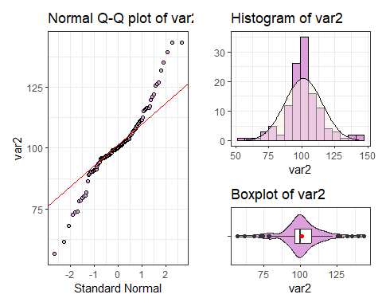

Three-Plot Summary for var03
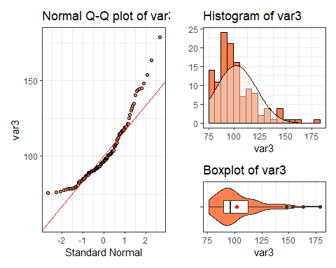

Three-Plot Summary for var04
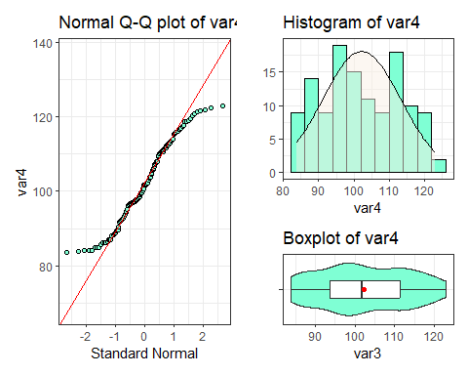

Three-Plot Summary for var05
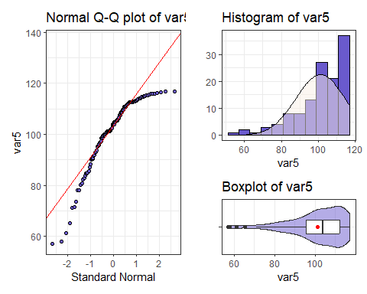

Three-Plot Summary for var06
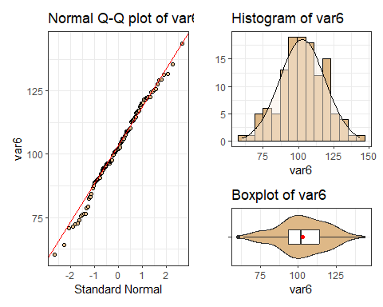

New Data: Ohio’s 88 Counties
Adult obesity rates (% of adult county residents reporting body-mass index of 30 $kg/m^{2}$ or higher) from County Health Rankings Reports in 2014 and 2024.
- CHR 2024 reports 2021 data from the Behavioral Risk Factor Surveillance System.
- CHR 2014 reports 2010 data from the National Center for Chronic Disease Prevention and Health Promotion, Division of Diabetes Translation.

Obesity in Ohio Counties
ohio88 <- read_csv("c07/data/ohio88.csv", show_col_types = FALSE) |>
janitor::clean_names() |>
mutate(obesity_diff = obesity_2024 - obesity_2014) |>
select(county, obesity_2024, obesity_2014, obesity_diff)
ohio88 |> filter(county %in%
c("Cuyahoga", "Geauga", "Lake", "Lorain",
"Medina", "Portage", "Summit"))
# A tibble: 7 × 4
county obesity_2024 obesity_2014 obesity_diff
<chr> <dbl> <dbl> <dbl>
1 Cuyahoga 35 27 8
2 Geauga 35 28 7
3 Lake 37 28 9
4 Lorain 37 31 6
5 Medina 38 29 9
6 Portage 35 30 5
7 Summit 43 29 14

Our Question
What can we say about the mean of the difference between the county-level obesity rates reported in 2024 and those reported in 2014?
- What is the outcome of interest?
- What two groups are we comparing?
- Do we have paired or independent samples here?

Numerical Summaries
res1 <- ohio88 |> reframe(lovedist(obesity_2024)) |> mutate(var = "2024")
res2 <- ohio88 |> reframe(lovedist(obesity_2014)) |> mutate(var = "2014")
res3 <- ohio88 |> reframe(lovedist(obesity_diff)) |> mutate(var = "diffs")
rbind(res1, res2, res3) |> relocate(var) |>
kable(digits = c(0, 0, 0, 2, 2, 2, 2, 1, 1, 1, 1))
var | n | miss | mean | sd | med | mad | min | q25 | q75 | max
2024 | 88 | 0 | 40.69 | 3.12 | 41 | 2.97 | 34 | 38.8 | 43.0 | 47
2014 | 88 | 0 | 31.30 | 2.45 | 31 | 1.48 | 26 | 30.0 | 33.0 | 37
diffs | 88 | 0 | 9.40 | 2.94 | 9 | 2.97 | 2 | 8.0 | 11.2 | 15

Plotting Paired Differences
p1 <- ggplot(ohio88, aes(sample = obesity_diff)) +
geom_qq() +
geom_qq_line(col = "red") +
labs(y = "2024 - 2014 difference",
x = "Standard Normal Distribution",
title = "Changes in Adult Obesity, 2024-2014")
bw <- 1 # specify width of bins in histogram
p2 <- ggplot(ohio88, aes(obesity_diff)) +
geom_histogram(binwidth = bw, fill = "black", col = "yellow" ) +
stat_function(fun = function(x) {
dnorm(x, mean = mean(ohio88$obesity_diff, na.rm = TRUE),
sd = sd(ohio88$obesity_diff, na.rm = TRUE) ) *
length(ohio88$obesity_diff) * bw},
geom = "area", alpha = 0.5, fill = "lightblue", col = "blue") +
labs(x = "2024 - 2014 difference", y = "",
title = "Histogram of 88 Ohio Counties")
p3 <- ggplot(ohio88, aes(x = obesity_diff, y = "")) +
geom_violin(fill = "cornsilk") +
geom_boxplot(width = 0.2) +
stat_summary(fun = mean, geom = "point", shape = 16, col = "red") +
labs(y = "", x = "2024 - 2014 difference",
title = "Boxplot with Violin: 88 Ohio Counties")
p1 + (p2 / p3 + plot_layout(heights = c(2, 1))) +
plot_annotation(title = "2024 - 2014 Difference in CHR Adult Obesity Rates")
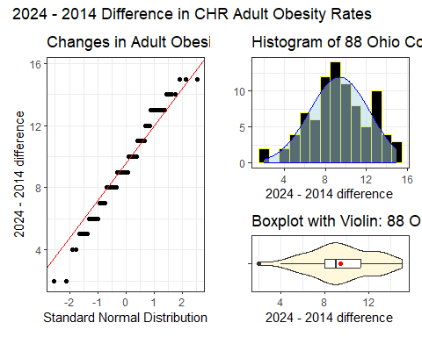

Our paired differences
ohio88 |> tabyl(obesity_diff) |> adorn_pct_formatting()
obesity_diff n percent
2 2 2.3%
4 2 2.3%
5 4 4.5%
6 7 8.0%
7 6 6.8%
8 12 13.6%
9 14 15.9%
10 11 12.5%
11 8 9.1%
12 5 5.7%
13 10 11.4%
14 4 4.5%
15 3 3.4%

Our 88 Paired Differences
ohio88 |> reframe(lovedist(obesity_diff))
# A tibble: 1 × 10
n miss mean sd med mad min q25 q75 max
<int> <int> <dbl> <dbl> <dbl> <dbl> <dbl> <dbl> <dbl> <dbl>
1 88 0 9.40 2.94 9 2.97 2 8 11.2 15
What can we say about the distribution of paired differences in our sample?
- Do we see meaningful skew?
- Do we see meaningfully heavy or light tails?
- Which comparison approach should we use?

OLS/t-based approach
m2a <- lm(obesity_diff ~ 1, data = ohio88)
model_parameters(m2a, conf.level = 0.95)
Parameter | Coefficient | SE | 95% CI | t(87) | p
-----------------------------------------------------------------
(Intercept) | 9.40 | 0.31 | [8.77, 10.02] | 29.96 | < .001
Uncertainty intervals (equal-tailed) and p-values (two-tailed) computed
using a Wald t-distribution approximation.
m2b <- t.test(ohio88$obesity_diff, conf.level = 0.95)
model_parameters(m2b)
One Sample t-test
Parameter | Mean | mu | Difference | 95% CI | t(87) | p
----------------------------------------------------------------------
obesity_diff | 9.40 | 0 | 9.40 | [8.77, 10.02] | 29.96 | < .001
Alternative hypothesis: true mean is not equal to 0

Bayesian Linear Model
set.seed(43101)
m3 <- stan_glm(obesity_diff ~ 1, data = ohio88, refresh = 0)
model_parameters(m3, conf.level = 0.95)
Parameter | Median | 95% CI | pd | Rhat | ESS (tail) | Prior
----------------------------------------------------------------------------------------
(Intercept) | 9.39 | [8.77, 10.03] | 100% | 1.000 | 2405 | Normal (9.40 +- 7.36)
Uncertainty intervals (equal-tailed) computed using a MCMC distribution
approximation.

Bootstrap approach
set.seed(432071)
boot.t.test(ohio88$obesity_diff, R = 2000, conf.level = 0.95)
Bootstrap One Sample t-test
data: ohio88$obesity_diff
number of bootstrap samples: 2000
bootstrap p-value < 5e-04
bootstrap mean of x (SE) = 9.401795 (0.3100755)
95 percent bootstrap percentile confidence interval:
8.783807 9.988636
Results without bootstrap:
t = 29.964, df = 87, p-value < 2.2e-16
alternative hypothesis: true mean is not equal to 0
95 percent confidence interval:
8.774351 10.021104
sample estimates:
mean of x
9.397727

Our estimates
Approach | Estimate | 95% confidence interval
OLS / t | 9.40 | (8.77, 10.02)
Bayes | 9.39 | (8.77, 10.03)
Bootstrap | 9.40 | (8.78, 9.99)
- Which of these should we choose?
  - Or does it not matter much?
- Once we’ve made a choice, how can we describe the result properly?

Choosing OLS for Paired t
Paired t result: Estimate = 9.40, 95% CI (8.77, 10.02)
- Our best point estimate for the true difference (2024-2014 reports on adult obesity) is 9.40 percentage points, based on our sample of 88 Ohio counties.
- The confidence interval reflects imprecision in the population estimate, based on assuming that the counties in our sample are selected at random from the population of interest, and that the assumptions of our paired t procedure hold.

Interpreting the Confidence Interval
Paired t result: Estimate = 9.40, 95% CI (8.77, 10.02)
When we generalize beyond these counties to the population they were selected at random from, then our data are compatible (at the 95% confidence level) with population mean differences in adult obesity rates between 8.77 and 10.02 percentage points, depending on the assumptions of our linear model (paired t test) being correct.

Paired Samples Strategy (1)
Suppose we want to estimate an uncertainty interval for the mean of a set of paired differences.
- Calculate the paired differences, then plot them.
- If the sample data are well described as “Normal”, then use the OLS / paired t procedure to obtain a confidence interval, or a Bayesian model to obtain a credible interval.

Paired Samples Strategy (2)
- If the sample data are best described as “symmetric but with outliers”, then use the bootstrap to obtain a confidence interval, although an OLS or Bayesian result may be quite similar.
- If the sample data are best described as “substantially skewed”, then consider whether you actually want to summarize with the mean, and consider whether a transformation might be helpful.

Standing Break

New Data: dm464 from Classes 5-6
dm464 <- read_xlsx("c07/data/dm464.xlsx") |>
janitor::clean_names() |>
select(id_code, ldl = ldl_start, statin = statin_start) |>
mutate(across(where(is.character), as_factor)) |>
mutate(id_code = as.character(id_code)) |>
mutate(stat_f = fct_recode(factor(statin), "Statin" = "1", "No" = "0"))
head(dm464)
# A tibble: 6 × 4
id_code ldl statin stat_f
<chr> <dbl> <dbl> <fct>
1 DM-1007 203 1 Statin
2 DM-1017 88 1 Statin
3 DM-1039 139 1 Statin
4 DM-1049 188 1 Statin
5 DM-1064 112 0 No
6 DM-1070 81 1 Statin

What is our goal?
Goal: 90% uncertainty interval for difference in average LDL between Statin and No Statin groups.
dm464 |> group_by(stat_f) |> reframe(lovedist(ldl)) |>
kable(digits = c(0, 0, 0, 2, 2, 2, 2, 0, 0, 0, 0))
stat_f | n | miss | mean | sd | med | mad | min | q25 | q75 | max
No | 97 | 0 | 96.26 | 31.63 | 91 | 28.17 | 40 | 75 | 112 | 225
Statin | 367 | 0 | 103.43 | 39.51 | 93 | 34.10 | 40 | 77 | 126 | 231
- What are we comparing? What is our outcome? How many group means?
- Are these paired or independent samples?

Estimate 1: Pooled t procedure
Pooled t procedure using lm (ordinary least squares)
fit1 <- lm(ldl ~ stat_f, data = dm464)
model_parameters(fit1, ci = 0.90) |>
kable(digits = 2)
Parameter | Coefficient | SE | CI | CI_low | CI_high | t | df_error | p
(Intercept) | 96.26 | 3.86 | 0.9 | 89.90 | 102.62 | 24.94 | 462 | 0.0
stat_fStatin | 7.17 | 4.34 | 0.9 | 0.02 | 14.32 | 1.65 | 462 | 0.1

Assumptions for Pooled t procedure
- Random sample from statin and no statin populations
- Each sample comes from a Normal population
- Equal population variances in the two statin groups

Interpreting the Pooled t result (1/2)
Pooled t result: Estimate = 7.17, 90% CI (0.02, 14.32)
- Our best point estimate for the true difference (Statin - No Statin) is 7.17 mg/dl in LDL cholesterol at baseline, based on our sample of 367 Statin and 97 No statin subjects with diabetes.
- The confidence interval reflects imprecision in the population estimate, based on assuming that the people in our sample are selected at random from the population of interest, and that the assumptions of our pooled t procedure hold.

Interpreting the Pooled t result (2/2)
When we generalize beyond these 464 subjects with diabetes to the population they were selected at random from, then our data are compatible (at the 90% confidence level) with population mean differences in LDL between 0.02 and 14.32 mg/dl, depending on the assumptions of our linear model (pooled t test) being correct.

Estimate 2: Bayesian linear model
If we use the default (weakly informative) prior, then the Bayesian model has essentially the same assumptions as the pooled t procedure:
set.seed(4312)
fit2 <- stan_glm(ldl ~ stat_f, data = dm464, refresh = 0)
model_parameters(fit2, ci = 0.90) |>
kable(digits = 2)
Parameter | Median | CI | CI_low | CI_high | pd | Rhat | ESS_tail | Prior_Distribution | Prior_Location | Prior_Scale
(Intercept) | 96.21 | 0.9 | 89.91 | 102.71 | 1.00 | 1 | 2515 | normal | 101.93 | 95.20
stat_fStatin | 7.16 | 0.9 | 0.17 | 14.65 | 0.95 | 1 | 2599 | normal | 0.00 | 233.87

Estimate 3: Welch’s t procedure
Welch’s t procedure drops requirement of equal population variances
fit3 <- t.test(ldl ~ stat_f, data = dm464)
model_parameters(fit3, ci = 0.90)
Welch Two Sample t-test
Parameter | Group | stat_f = No | stat_f = Statin | Difference
---------------------------------------------------------------
ldl | stat_f | 96.26 | 103.43 | -7.17
Parameter | 90% CI | t(183.36) | p
----------------------------------------------
ldl | [-14.70, 0.36] | -1.88 | 0.062
Alternative hypothesis: true difference in means between group No and group Statin is not equal to 0

Estimate 4: Bootstrap with pooling
Bootstrap (percentile) procedure (with pooling) maintains assumption of equal population variances but does not require Normally distributed populations
set.seed(43104)
boot.t.test(ldl ~ stat_f, var.equal = TRUE, R = 2000,
data = dm464, conf.level = 0.90)
Bootstrap Two Sample t-test
data: ldl by stat_f
number of bootstrap samples: 2000
bootstrap p-value = 0.093
bootstrap difference of means (SE) = -7.251915 (4.34287)
90 percent bootstrap percentile confidence interval:
-14.2840024 -0.1761131
Results without bootstrap:
t = -1.6523, df = 462, p-value = 0.09915
alternative hypothesis: true difference in means is not equal to 0
90 percent confidence interval:
-14.32216921 -0.01795271
sample estimates:
mean in group No mean in group Statin
96.25773 103.42779

Estimate 5: Bootstrap: unpooled
Bootstrap (percentile) procedure (without pooling) drops assumptions of equal population variances and of Normally distributed populations
set.seed(43105)
boot.t.test(ldl ~ stat_f, var.equal = FALSE, R = 2000,
data = dm464, conf.level = 0.90)
Bootstrap Welch Two Sample t-test
data: ldl by stat_f
number of bootstrap samples: 2000
bootstrap p-value = 0.056
bootstrap difference of means (SE) = -7.0623 (3.784715)
90 percent bootstrap percentile confidence interval:
-12.9985828 -0.8738097
Results without bootstrap:
t = -1.8786, df = 183.36, p-value = 0.06188
alternative hypothesis: true difference in means is not equal to 0
90 percent confidence interval:
-13.4797701 -0.8603518
sample estimates:
mean in group No mean in group Statin
96.25773 103.42779

Results So Far
- All methods assume random samples
- Est. = point estimate of Statin - No Statin group mean difference
Method | Est. | 90% Interval | Assumptions
Pooled t | 7.17 | (0.02, 14.32) | Normality, equal variances
Bayesian | 7.16 | (0.17, 14.65) | Same as pooled t, basically
Welch t | 7.17 | (-0.36, 14.70) | Normality only
Boot (pooled) | 7.25 | (0.18, 14.28) | Equal variances only
Boot (Welch) | 7.06 | (0.87, 12.99) | Neither
- So what do we need to look for in our data?

LDL by Statin prescription status
Comparison Boxplot with Violins
ggplot(dm464, aes(x = ldl, y = stat_f)) +
geom_violin() +
geom_boxplot(aes(fill = stat_f), width = 0.3) +
stat_summary(fun = mean, geom = "point",
shape = 18, size = 4, col = "black") +
guides(fill = "none") +
labs(y = "Statin prescription", x = "LDL Cholesterol (mg/dl)",
title = "LDL by Statin prescription")
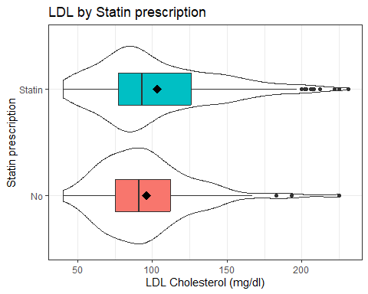

LDL by Statin prescription status
How about a pair of Normal Q-Q plots?
p1 <- dm464 |>
filter(stat_f == "Statin") |>
ggplot(aes(sample = ldl)) +
geom_qq() + geom_qq_line(col = "red") +
labs(title = "Statin group", y = "LDL Cholesterol (mg/dl)",
x = "Standard Normal")
p2 <- dm464 |>
filter(stat_f == "No") |>
ggplot(aes(sample = ldl)) +
geom_qq() + geom_qq_line(col = "red") +
labs(title = "No Statin group", y = "LDL Cholesterol (mg/dl)",
x = "Standard Normal")
p1 + p2 +
plot_annotation(title = "Normal Q-Q plots of LDL by Statin group")
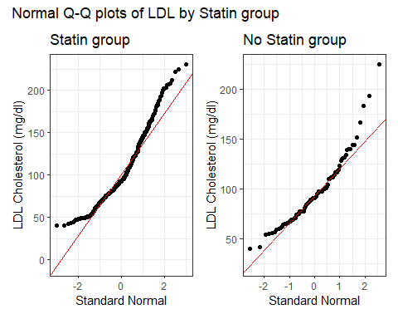

LDL by Statin prescription status
A look at some numerical summaries…
dm464 |> group_by(stat_f) |> reframe(lovedist(ldl)) |>
kable(digits = 2)
stat_f | n | miss | mean | sd | med | mad | min | q25 | q75 | max
No | 97 | 0 | 96.26 | 31.63 | 91 | 28.17 | 40 | 75 | 112 | 225
Statin | 367 | 0 | 103.43 | 39.51 | 93 | 34.10 | 40 | 77 | 126 | 231
- skew₁ for “Statin” = (103.43 - 93)/39.51 = 0.26
- skew₁ for “No” = (96.26 - 91)/31.63 = 0.17
Our rough cutoff for substantial right skew ~ 0.20.

What can we do about the skew?
- Could we build a confidence interval for medians instead of means?
  - Yes, with the bootstrap, for example see Section 6.9.2 of my text.
- Could we transform the data in a non-linear way to better match assumptions?
  - Yes, with the help of Tukey’s ladder of power transformations.

Tukey’s Ladder
Power ($λ$) | -2 | -1 | -0.5 | 0 | 0.5 | 1 | 2 | 3
Transform | $\frac{1}{y^{2}}$​ | $\frac{1}{y}$​ | $\frac{1}{\sqrt{y}}$​ | $logy$​ | $\sqrt{y}$​ | y | $y^{2}$​ | $y^{3}$​
- Start at no transformation ($λ$ = 1)
  - Try moving in one direction, searching for a better result (more “Normal” distribution)
  - Keep going until you start turning in the wrong direction.

Tukey’s Ladder
Power ($λ$) | -2 | -1 | -0.5 | 0 | 0.5 | 1 | 2 | 3
Transform | $\frac{1}{y^{2}}$​ | $\frac{1}{y}$​ | $\frac{1}{\sqrt{y}}$​ | $logy$​ | $\sqrt{y}$​ | $y$​ | $y^{2}$​ | $y^{3}$​
- These power transformations help us address skew, mainly.
- They’re not much help if the data are symmetric, but have heavy/light tails.
- Some transformations require all values to be positive. If they aren’t, we can add a small amount to each observation until they are.

LDL (untransformed) by statin
ggplot(dm464, aes(x = ldl, y = stat_f)) +
geom_violin() +
geom_boxplot(aes(fill = stat_f), width = 0.3) +
stat_summary(fun = mean, geom = "point",
shape = 18, size = 4, col = "black") +
guides(fill = "none") +
labs(y = "Statin prescription", x = "LDL Cholesterol (mg/dl)",
title = "LDL by Statin prescription",
subtitle = "Each group is a bit skewed to the right")
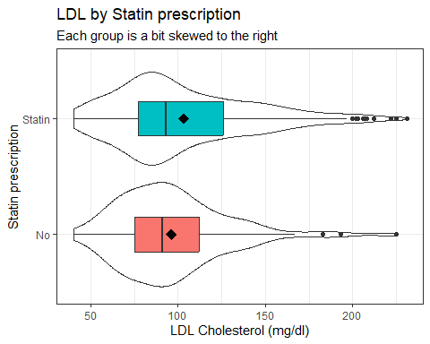
- Let’s try $λ=2$, squaring the LDL values.

LDL squared, by statin
ggplot(dm464, aes(x = ldl^2, y = stat_f)) +
geom_violin() +
geom_boxplot(aes(fill = stat_f), width = 0.3) +
stat_summary(fun = mean, geom = "point",
shape = 18, size = 4, col = "black") +
guides(fill = "none") +
labs(y = "Statin prescription", x = "LDL^2",
title = "LDL^2 by Statin prescription")
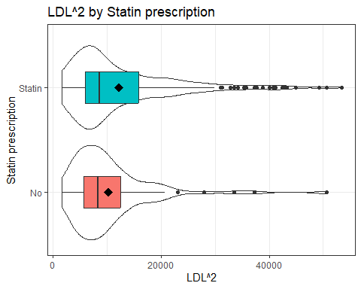
- Is this an improvement?

Square root of LDL?
ggplot(dm464, aes(x = sqrt(ldl), y = stat_f)) +
geom_violin() +
geom_boxplot(aes(fill = stat_f), width = 0.3) +
stat_summary(fun = mean, geom = "point",
shape = 18, size = 4, col = "black") +
guides(fill = "none") +
labs(y = "Statin prescription", x = "sqrt(LDL)",
title = "Square Root of LDL by Statin prescription")
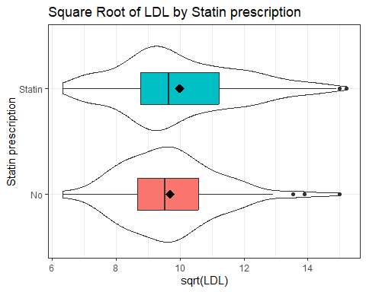

Logarithm of LDL?
ggplot(dm464, aes(x = log(ldl), y = stat_f)) +
geom_violin() +
geom_boxplot(aes(fill = stat_f), width = 0.3) +
stat_summary(fun = mean, geom = "point",
shape = 18, size = 4, col = "black") +
guides(fill = "none") +
labs(y = "Statin prescription", x = "log(LDL)",
title = "Logarithm of LDL by Statin prescription")
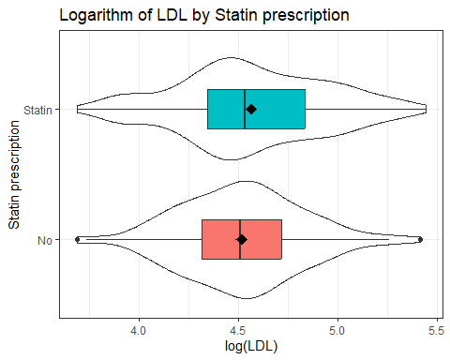

Inverse of LDL?
ggplot(dm464, aes(x = (1/ldl), y = stat_f)) +
geom_violin() +
geom_boxplot(aes(fill = stat_f), width = 0.3) +
stat_summary(fun = mean, geom = "point",
shape = 18, size = 4, col = "black") +
guides(fill = "none") +
labs(y = "Statin prescription", x = "1/LDL",
title = "Inverse of LDL by Statin prescription")
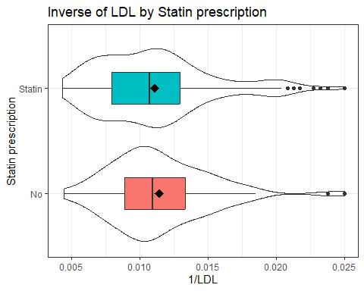

Which Transformation to Choose?
Box-Cox approach: can we get a suggested “power” to use when transforming our outcome?
- Specify the model then apply boxCox from car package.
- Here, all values of our outcome (LDL) are strictly positive.
  - If not, we’d have to add a constant so that they were.

Tukey’s Ladder
Power ($λ$) | -2 | -1 | -0.5 | 0 | 0.5 | 1 | 2 | 3
Transform | $\frac{1}{y^{2}}$​ | $\frac{1}{y}$​ | $\frac{1}{\sqrt{y}}$​ | $logy$​ | $\sqrt{y}$​ | $y$​ | $y^{2}$​ | $y^{3}$​

Box-Cox Suggestion?
fit6 <- lm(ldl ~ stat_f, data = dm464)
boxCox(fit6)
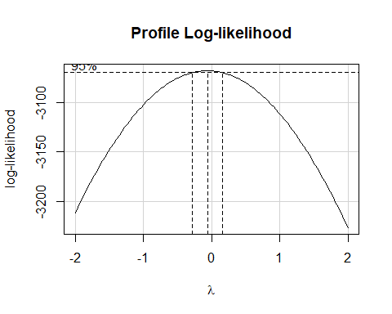

Logarithm of LDL?
p1 <- dm464 |>
filter(stat_f == "Statin") |>
ggplot(aes(sample = log(ldl))) +
geom_qq() + geom_qq_line(col = "red") +
labs(title = "Statin group", y = "log(LDL Cholesterol)",
x = "Standard Normal")
p2 <- dm464 |>
filter(stat_f == "No") |>
ggplot(aes(sample = log(ldl))) +
geom_qq() + geom_qq_line(col = "red") +
labs(title = "No Statin group", y = "log(LDL Cholesterol)",
x = "Standard Normal")
p1 + p2 +
plot_annotation(title = "Normal Q-Q plots of log(LDL) by Statin group")
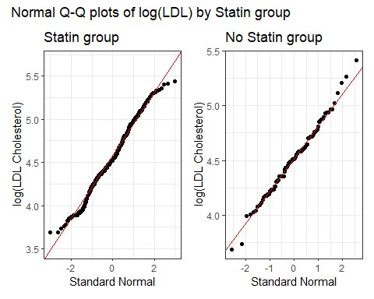

Using the log transformation
fit7 <- lm(log(ldl) ~ stat_f, data = dm464)
model_parameters(fit7, ci = 0.90)
Parameter | Coefficient | SE | 90% CI | t(462) | p
----------------------------------------------------------------------
(Intercept) | 4.52 | 0.04 | [ 4.46, 4.58] | 122.75 | < .001
stat f [Statin] | 0.05 | 0.04 | [-0.02, 0.12] | 1.23 | 0.220
Uncertainty intervals (equal-tailed) and p-values (two-tailed) computed
using a Wald t-distribution approximation.
The model has a log-transformed response variable. Consider using
`exponentiate = TRUE` to interpret coefficients as ratios.
- How do we interpret these results?
  - Should we exponentiate?

Using the log transformation
fit7 <- lm(log(ldl) ~ stat_f, data = dm464)
model_parameters(fit7, ci = 0.90)
Parameter | Coefficient | SE | 90% CI | t(462) | p
----------------------------------------------------------------------
(Intercept) | 4.52 | 0.04 | [ 4.46, 4.58] | 122.75 | < .001
stat f [Statin] | 0.05 | 0.04 | [-0.02, 0.12] | 1.23 | 0.220
Uncertainty intervals (equal-tailed) and p-values (two-tailed) computed
using a Wald t-distribution approximation.
- Subjects with statin prescriptions have, on average, 0.05 higher log(LDL) than subjects without a statin prescription.
- The 90% confidence interval for the Statin - No Statin difference in log (LDL) is (-0.02, 0.12).

Exponentiating the Coefficients
fit7 <- lm(log(ldl) ~ stat_f, data = dm464)
model_parameters(fit7, ci = 0.90, exponentiate = TRUE)
Parameter | Coefficient | SE | 90% CI | t(462) | p
-----------------------------------------------------------------------
(Intercept) | 91.67 | 3.37 | [86.27, 97.40] | 122.75 | < .001
stat f [Statin] | 1.05 | 0.04 | [ 0.98, 1.13] | 1.23 | 0.220
Uncertainty intervals (equal-tailed) and p-values (two-tailed) computed
using a Wald t-distribution approximation.
- After exponentiating, the point estimate for the comparison is 1.05, with 90% CI (0.98, 1.13).
- Subjects with statin prescriptions have, on average, 5% higher LDL than do subjects without such a prescription.
  - How should we interpret the confidence interval?

Interpreting the Result Properly
- In our sample, subjects with a statin prescription have 5% higher LDL, on average, than do subjects without.
- When we generalize beyond these 464 subjects with diabetes to the population they were selected at random from, then our data are compatible (at the 90% confidence level) with population LDL values for statin users that are between 98% and 113% as large as non-statin users, depending on the assumptions of our linear model being correct after our log transformation of the outcome.

Independent Samples Strategy (1)
Suppose we want to estimate an uncertainty interval for the difference in means across two groups. To begin, plot the data from each sample.
- If the sample data in each group are well described as “Normal”, then use the OLS / pooled t procedure to obtain a confidence interval, or a Bayesian model to obtain a credible interval.
  - If the sample sizes are not the same, and the sample variances aren’t close to each other, consider using a Welch t procedure.

Independent Samples Strategy (2)
- If either sample’s data are “symmetric but with outliers”, then consider using the bootstrap to obtain a confidence interval, although an OLS or Bayesian result may also be reasonable.
- If either sample’s data are best described as “substantially skewed”, then consider whether you actually want to summarize with the difference in means, and consider whether a transformation might be helpful.

Session Information
xfun::session_info()
R version 4.6.1 (2026-06-24 ucrt)
Platform: x86_64-w64-mingw32/x64
Running under: Windows 11 x64 (build 26200)
Locale:
LC_COLLATE=English_United States.utf8
LC_CTYPE=English_United States.utf8
LC_MONETARY=English_United States.utf8
LC_NUMERIC=C
LC_TIME=English_United States.utf8
Package version:
abind_1.4-8 arrangements_1.1.10 askpass_1.2.1
backports_1.5.1 base64enc_0.1-6 bayesplot_1.16.0
bayestestR_0.19.0 BH_1.90.0.1 bit_4.6.0
bit64_4.8.6 blob_1.3.0 boot_1.3-32
broom_1.0.13 bslib_0.12.0 cachem_1.1.0
callr_3.8.0 car_3.1-5 carData_3.0-6
cellranger_1.1.0 checkmate_2.3.4 cli_3.6.6
clipr_0.8.1 coda_0.19-4.1 codetools_0.2-20
colorspace_2.1.3 colourpicker_1.3.0 commonmark_2.0.0
compiler_4.6.1 conflicted_1.2.0 correlation_0.8.8
cowplot_1.2.0 cpp11_0.5.5 crayon_1.5.3
crosstalk_1.2.2 curl_8.0.0 data.table_1.18.6.1
datasets_4.6.1 datawizard_1.4.0 DBI_1.3.0
dbplyr_2.6.0 Deriv_4.3.5 desc_1.4.3
digest_0.6.39 distributional_0.9.0 doBy_4.7.2
dplyr_1.2.1 DT_0.34.0 dtplyr_1.3.3
dygraphs_1.1.1.6 easystats_0.7.6 effectsize_1.0.3
emmeans_2.0.4 estimability_2.0.0 evaluate_1.0.5
exactRankTests_0.8-37 farver_2.1.2 fastmap_1.2.0
fontawesome_0.5.3 forcats_1.0.1 foreach_1.5.2
forecast_9.0.2 Formula_1.2-6 fracdiff_1.5.4
fs_2.1.0 gargle_1.6.1 generics_0.1.4
ggdist_3.3.3 ggplot2_4.0.3 ggridges_0.5.7
glmnet_5.0 glue_1.8.1 gmp_0.7-5.1
googledrive_2.1.2 googlesheets4_1.1.2 graphics_4.6.1
grDevices_4.6.1 grid_4.6.1 gridExtra_2.3.1
gtable_0.3.6 gtools_3.9.5 haven_2.5.5
highr_0.12 hms_1.1.4 htmltools_0.5.9
htmlwidgets_1.6.4 httpuv_1.6.17 httr_1.4.9
ids_1.0.1 igraph_2.3.3 inline_0.3.21
insight_1.5.4 isoband_0.3.0 iterators_1.0.14
janitor_2.2.1 jomo_2.7-6 jquerylib_0.1.4
jsonlite_2.0.0 kableExtra_1.4.1 knitr_1.52
labeling_0.4.3 later_1.4.8 lattice_0.23-1
lazyeval_0.2.3 lifecycle_1.0.5 litedown_0.11
lme4_2.0-6 lmtest_0.9.40 loo_2.10.1
lubridate_1.9.5 magrittr_2.0.5 markdown_2.0
MASS_7.3-66 Matrix_1.7-6 MatrixModels_0.5.4
matrixStats_1.5.0 memoise_2.0.1 methods_4.6.1
mgcv_1.9.4 mice_3.19.0 miceadds_3.20-10
mime_0.13 miniUI_0.1.2 minqa_1.2.8
mitml_0.4-5 mitools_2.7 MKdescr_0.9
MKinfer_1.3 modelbased_0.17.0 modelr_0.1.11
multcomp_1.4-32 mvtnorm_1.4-2 nlme_3.1-171
nloptr_2.2.1 nnet_7.3-21 numDeriv_2016.8.1.1
openssl_2.4.2 ordinal_2026.7.26 otel_0.2.0
pan_2.0 parallel_4.6.1 parameters_0.29.3
patchwork_1.3.2 pbkrtest_0.5.5 performance_0.18.2
pillar_1.11.1 pkgbuild_1.4.8 pkgconfig_2.0.3
plyr_1.8.9 posterior_1.7.0 prettyunits_1.2.0
processx_3.9.0 progress_1.2.3 promises_1.5.0
ps_1.9.3 purrr_1.2.2 quadprog_1.5.8
quantreg_6.1 QuickJSR_1.11.0 R6_2.6.1
ragg_1.5.2 rappdirs_0.3.4 rbibutils_2.4.1
RColorBrewer_1.1-3 Rcpp_1.1.2 RcppArmadillo_15.6.0.1
RcppEigen_0.3.4.0.2 RcppParallel_6.2.1 Rdpack_2.6.6
readr_2.2.0 readxl_1.5.0 reformulas_0.4.4
rematch_2.0.0 rematch2_2.1.2 report_0.6.4
reprex_2.1.1 reshape2_1.4.5 rlang_1.3.0
rmarkdown_2.32 rpart_4.1.27 rstan_2.32.7
rstanarm_2.32.2 rstantools_2.7.1 rstudioapi_0.19.0
rvest_1.0.5 S7_0.2.2 sandwich_3.1-3
sass_0.4.10 scales_1.4.0 see_0.14.2
selectr_0.6.0 shape_1.4.6.1 shiny_1.14.0
shinyjs_2.1.1 shinystan_2.7.0 shinythemes_1.2.0
snakecase_0.11.1 sourcetools_0.1.7.2 SparseM_1.84.2
splines_4.6.1 StanHeaders_2.39.1 stats_4.6.1
stats4_4.6.1 stringi_1.8.9 stringr_1.6.0
survival_3.8-11 svglite_2.2.2 sys_3.4.3
systemfonts_1.3.2 tensorA_0.36.2.1 textshaping_1.0.5
TH.data_1.1-5 threejs_0.3.4 tibble_3.3.1
tidyr_1.3.2 tidyselect_1.2.1 tidyverse_2.0.0
timechange_0.4.0 timeDate_4052.112 tinytex_0.60
tools_4.6.1 tzdb_0.5.0 ucminf_1.2.3
urca_1.3.4 utf8_1.2.6 utils_4.6.1
uuid_1.2.2 V8_8.2.0 vctrs_0.7.3
viridisLite_0.4.3 vroom_1.7.1 withr_3.0.3
xfun_0.60 xml2_1.6.0 xtable_1.8-8
xts_0.14.3 yaml_2.3.12 zoo_1.9-0

