431 Class 11
Thomas E. Love, Ph.D.
2026-09-29

Today’s Agenda
- Statistical Significance: What I Taught for Many Years
- Statistical Significance: What is the problem?
  - Do Confidence Intervals Solve the Problem?
  - Borrowing from Bayesian Ideas
- Replicable Research and the Crisis in Science

What’s Wrong with Statistical Significance?

Comparing 2 Means (Unmatched)
In the old days, I used to teach…
$$H_{0}:μ_{1}=μ_{2}\text{ vs. }H_{A}:μ_{1}≠μ_{2}$$
- Decide on a significance level $α$, usually 0.05
- Select the most appropriate test; calculate $p$-value.
- If the $p$-value is below $α$, declare statistical significance.
- Otherwise, retain the null hypothesis that the means (may be) equal.

Comparing 2 Means (Matched)
Let $δ$ be the (true) mean of the paired differences.
$$H_{0}:δ=0\text{ vs. }H_{A}:δ≠0$$
- Decide on a significance level $α$, usually 0.05.
- Select the most appropriate test; calculate $p$-value.
- If the $p$-value is below $α$, declare statistical significance.
- Otherwise, retain the null hypothesis that the mean of the differences (may be) zero.

Confidence Intervals and p-values
In the old days, I used to teach…
If the 95% confidence interval doesn’t include the null hypothesized value, then the $p$ value is below 0.05, and again…
- If the $p$-value is below 0.05, declare statistical significance at the 95% confidence level.
- Otherwise, retain the null hypothesis that the mean of the differences (may be) zero.

Conventions for Reporting p Values
I also spent meaningful time on making your work look like everyone else…
- Use an italicized, lower-case p to specify the p value. Don’t use p for anything else.
- For p values above 0.10, round to two decimal places, at most.
- For p values near $α$, include only enough decimal places to clarify the reject/retain decision.
- For very small p values, always report either p < 0.0001 or even just p < 0.001, rather than specifying the result in scientific notation, or, worse, as $p=0$ which is glaringly inappropriate.
- Report p values above 0.99 as p > 0.99, rather than p = 1.

What I Taught for Many Years
- Null hypothesis significance testing is here to stay.
  - Learn how to present your p value so it looks like what everyone else does
  - Think about “statistically detectable” rather than “statistically significant”
  - Don’t accept a null hypothesis, just retain it.
- Use point and interval estimates
  - Try to get your statements about confidence intervals right (right = just like I said it in those days, which is different than what I focus on now)
- Use Bayesian approaches/simulation/hierarchical models when they seem appropriate or for “non-standard” designs
  - But look elsewhere for people to teach/do that stuff
- Power is basically a hurdle to overcome in a grant application

From George Cobb - on why p values deserve to be re-evaluated
The idea of a p-value as one possible summary of evidence
morphed into a
- rule for authors: reject the null hypothesis if p < .05.

From George Cobb - on why p values deserve to be re-evaluated
The idea of a p-value as one possible summary of evidence
morphed into a
- rule for authors: reject the null hypothesis if p < .05,
which morphed into a
- rule for editors: reject the submitted article if p > .05.

From George Cobb - on why p values deserve to be re-evaluated
The idea of a p-value as one possible summary of evidence
morphed into a
- rule for authors: reject the null hypothesis if p < .05,
which morphed into a
- rule for editors: reject the submitted article if p > .05,
which morphed into a
- rule for journals: reject all articles that report p-values

From George Cobb - on why p values deserve to be re-evaluated
The idea of a p-value as one possible summary of evidence
morphed into a
- rule for authors: reject the null hypothesis if p < .05, which morphed into a
- rule for editors: reject the submitted article if p > .05, which morphed into a
- rule for journals: reject all articles that report p-values.
Bottom line: Reject rules. Ideas matter.

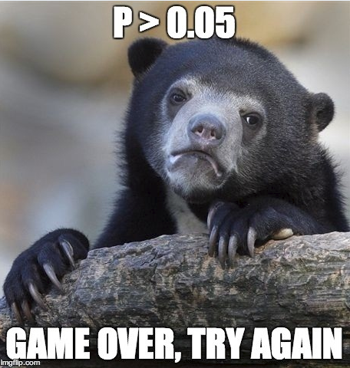

Gerd Gigerenzer “The Null Ritual”
Gigerenzer describes how a rigid hybrid model merged elements of Ronald Fisher and Jerzy Neyman’s distinct statistical approaches into a standardized procedure.
Researchers mechanically follow three steps without applying judgment:
- State a null hypothesis ($H_{0}$) of zero effect.
- Adopt a sacred 5% significance level (p < 0.05) to reject the null hypothesis.
- Always perform this exact procedure and treat significance as proof of the experimental hypothesis.

Widespread Delusions
Instead of treating statistics as a tool for evaluating evidence, Gigerenzer argues that the strange idea of statistical significance has turned into an unthinking administrative hurdle that contributes to the replication crisis.
Gigerenzer’s research shows that many academics and students harbor fundamental misconceptions about what a p-value actually means. He highlights three major psychological fallacies (see next slide.)

Widespread Delusions
- The Replication Delusion: The false belief that 1 - p represents the exact probability of a successful replication, which mistakenly makes future replication studies look unnecessary.
- The Illusion of Certainty: The mistaken belief that a significant p-value completely disproves the null hypothesis.
- Bayesian Wishful Thinking: The incorrect assumption that the p-value tells you the probability that the hypothesis is true or false.

Gigerenzer (2004) Mindless Statistics
Participants were presented with a scenario involving a common statistical procedure—a simple t-test comparing two independent groups. They were given the following results:
t = 2.7, df = 18, p = 0.01
They were then asked to evaluate six statements regarding the p-value and mark each as “true” or “false”, and the test instructions explicitly stated that “several or none of the statements may be correct.”

Three of Gigerenzer’s Statements
Remember: t = 2.7, df = 18, p = 0.01
- “You have found the probability of getting a significant result if you repeat the experiment.” True or False?
- “You have found the probability of the null hypothesis being true” or “You have proved the alternative hypothesis.” True or False?
- “You know, if you decide to reject the null hypothesis, the probability that you are making the wrong decision.” True or False?

The Replication Delusion
Statement: “You have found the probability of getting a significant result if you repeat the experiment.”
- Participants believed a p = 0.01 meant there was a 99% chance a repeat study would be significant.
- Reality: The p-value is calculated under the strict assumption that the null hypothesis is true. It cannot calculate the probability of a future successful replication, which depends on the actual statistical power and true effect size of the experiment.
Roughly half of the statistics instructors fell for this claim.

Bayesian Wishful Thinking
Statement: “You have found the probability of the null hypothesis being true” or “You have proved the alternative hypothesis.”
- Reality: A p-value represents Pr(Data | Null Hypothesis). It does not represent the inverse conditional probability: Pr(Null Hypothesis | Data).
This was the most common error among researchers. Over 70% of non-statistics professors and standard students believed the p value gave them the direct probability that the hypothesis itself was true or false.

The Illusion of Certainty
Statement: “You know, if you decide to reject the null hypothesis, the probability that you are making the wrong decision.”
- Reality: The p-value only tells you how unusual your current data is if the null hypothesis is true. It cannot predict the specific error rate of your real-world decision-making process, which requires knowing prior probabilities.
Over 60% of students and nearly 40% of all faculty members got this wrong.

Gigerenzer’s Conclusion
Gigerenzer argued that this data highlights a major systemic problem.
- Because the math behind a p-value is technically simple, the high failure rates are not caused by a lack of intelligence. Instead, he suggests it is caused by an anxious, social ritual.
- Researchers feel immense pressure to publish significant results (p < 0.05), leading them to treat the p-value as an unthinking magic stamp of truth rather than a tool for logical statistical reasoning.

Is this better in medicine?
Steven Goodman A Dirty Dozen: Twelve P-value Misconceptions
- The P value’s inferential meaning is widely and often wildly misconstrued, a fact that has been pointed out innumerable times since at least the 1940s.
- This commentary reviews a dozen of these common misinterpretations and explains why each is wrong.
- It also reviews the possible consequences of these improper understandings or representations of its meaning.

Goodman key highlights (1)
Equating a small p-value with a major medical breakthrough. Clinicians routinely review clinical trial data and assume that a highly significant result (p < 0.001) means a drug has a powerful therapeutic effect.
- A massive multi-center trial with tens of thousands of patients can yield p < 0.001 for a blood pressure medication that only lowers BP by clinically meaningless fraction of a millimeter of mercury.
- Conversely, a genuinely life-saving drug tested on a small pool of patients with a rare disease might return a “non-significant” p = 0.08 due to low statistical power.

Goodman highlights (2)
Diagnostic test fallacy (Bayesian wishful thinking): A vast majority of surveyed physicians believe that if a clinical trial shows a drug reduces mortality with a p = 0.05, there is only a 5% chance the drug is ineffective (the null hypothesis).
- This is the prosecutor’s fallacy applied to medicine. The p-value is the probability of seeing the data given the drug doesn’t work. It is not the probability that the drug doesn’t work given the data.

Goodman highlights (3)
Medical researchers frequently commit a logical error that directly harms patients: treating a failure to reject the null hypothesis as proof of safety.
- In trials comparing a new drug to an old drug, if p > 0.05, researchers frequently write in their conclusions that “there was no difference in adverse events between the two groups.”
- As Altman and Bland famously put it: “Absence of evidence is not evidence of absence.”
- A high p-value simply means the study was not large enough or precise enough to detect a difference.

Institutional Consequences
Because of these widespread misunderstandings, the medical community heavily incentivizes “p-hacking”: covertly manipulating data, dropping outliers, or running dozens of unadjusted subgroup analyses until something drops below 0.05.
- See Ioannidis’s 2005 paper “Why Most Published Research Findings Are False” demonstrating that these very statistical delusions run rampant through medical journals.

American Statistical Association to the rescue!?!

The American Statistical Association
2016
- Ronald L. Wasserstein & Nicole A. Lazar (2016) The ASA’s Statement on p-Values: Context, Process, and Purpose, The American Statistician, 70:2, 129-133,
2019
- Ronald L. Wasserstein, Allen L. Schirm & Nicole A. Lazar (2019) Moving to a World Beyond “p < 0.05”, The American Statistician, 73:sup1, 1-19.

Statistical Inference in the 21st Century
… a world learning to venture beyond “p < 0.05”
This is a world where researchers are free to treat “p = 0.051” and “p = 0.049” as not being categorically different, where authors no longer find themselves constrained to selectively publish their results based on a single magic number.

Statistical Inference in the 21st Century
In this world, where studies with “p < 0.05” and studies with “p > 0.05” are not automatically in conflict, researchers will see their results more easily replicated – and, even when not, they will better understand why.
The 2016 ASA Statement on P-Values and Statistical Significance started moving us toward this world. As of the date of publication of this special issue, the statement has been viewed over 294,000 times and cited over 1700 times-an average of about 11 citations per week since its release. Now we must go further.

The American Statistical Association Statement on P values and Statistical Significance
The ASA Statement (2016) was mostly about what not to do.
The 2019 effort represents an attempt to explain what to do.

ASA 2019 Statement
Some of you exploring this special issue of The American Statistician might be wondering if it’s a scolding from pedantic statisticians lecturing you about what not to do with p-values, without offering any real ideas of what to do about the very hard problem of separating signal from noise in data and making decisions under uncertainty. Fear not. In this issue, thanks to 43 innovative and thought-provoking papers from forward-looking statisticians, help is on the way.

“Don’t” is not enough.
If you’re just arriving to the debate, here’s a sampling of what not to do.
- Don’t base your conclusions solely on whether an association or effect was found to be “statistically significant” (i.e., the p value passed some arbitrary threshold such as p < 0.05).
- Don’t believe that an association or effect exists just because it was statistically significant.

“Don’t” is not enough.
- Don’t believe that an association or effect is absent just because it was not statistically significant.
- Don’t believe that your p-value gives the probability that chance alone produced the observed association or effect or the probability that your test hypothesis is true.
- Don’t conclude anything about scientific or practical importance based on statistical significance (or lack thereof).

Problems with p Values
- P values are inherently unstable
- The p value, or statistical significance, does not measure the size of an effect or the importance of a result
- Scientific conclusions should not be based only on whether a p value passes a specific threshold
- Proper inference requires full reporting and transparency
- By itself, a p value does not provide a good measure of evidence regarding a model or hypothesis
http://jamanetwork.com/journals/jamaotolaryngology/fullarticle/2546529

One More Don’t…
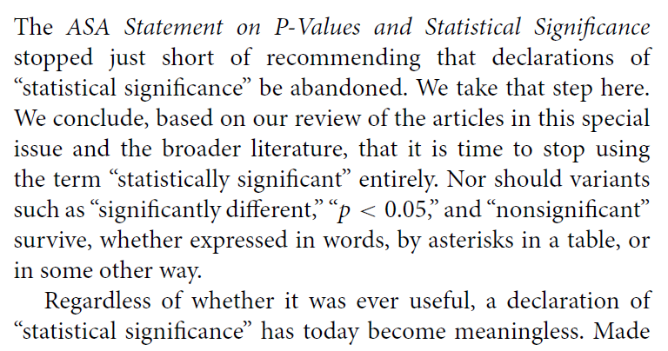
A label of statistical significance adds nothing to what is already conveyed by the value of p; in fact, this dichotomization of p-values makes matters worse.

Gelman on p values, 1
The common practice of dividing data comparisons into categories based on significance levels is terrible, but it happens all the time…. so it’s worth examining the prevalence of this error. Consider, for example, this division:
- “really significant” for p < .01,
- “significant” for p < .05,
- “marginally significant” for p < .1, and
- “not at all significant” otherwise.

Gelman on p values, 2
Now consider some typical p-values in these ranges: say, p = .005, p = .03, p = .08, and p = .2.
Translate these two-sided p-values back into z-scores…
Description | really sig. | sig. | marginally sig. | not at all sig.
p value | 0.005 | 0.03 | 0.08 | 0.20
Z score | 2.8 | 2.2 | 1.8 | 1.3

Gelman on p values, 3
The seemingly yawning gap in p-values comparing the not at all significant p-value of .2 to the really significant p-value of .005, is only a z score of 1.5.
If you had two independent experiments with z-scores of 2.8 and 1.3 and with equal standard errors and you wanted to compare them, you’d get a difference of 1.5 with a standard error of 1.4, which is completely consistent with noise.

Gelman on p values, 4
From a statistical point of view, the trouble with using the p-value as a data summary is that the p-value can only be interpreted in the context of the null hypothesis of zero effect, and (much of the time), nobody’s interested in the null hypothesis.
Indeed, once you see comparisons between large, marginal, and small effects, the null hypothesis is irrelevant, as you want to be comparing effect sizes.

Gelman on p values, 5
From a psychological point of view, the trouble with using the p-value as a data summary is that this is a kind of deterministic thinking, an attempt to convert real uncertainty into firm statements that are just not possible (or, as we would say now, just not replicable).
The key point: The difference between statistically significant and NOT statistically significant is not, generally, statistically significant.
http://andrewgelman.com/2016/10/15/marginally-significant-effects-as-evidence-for-hypotheses-changing-attitudes-over-four-decades/

So what is the problem?
If I have to boil it down to one thing, it’s not that p values or confidence intervals are inherently bad data summaries, although their interpretation is by no means straightforward.
It’s that the whole notion of statistical significance is the problem.
- Working your data to provide a single “yes/no” answer instead of embracing its variation and understanding what the data suggest thoroughly is the problem.

Standing Break

Nuzzo: Nature Statistical Errors
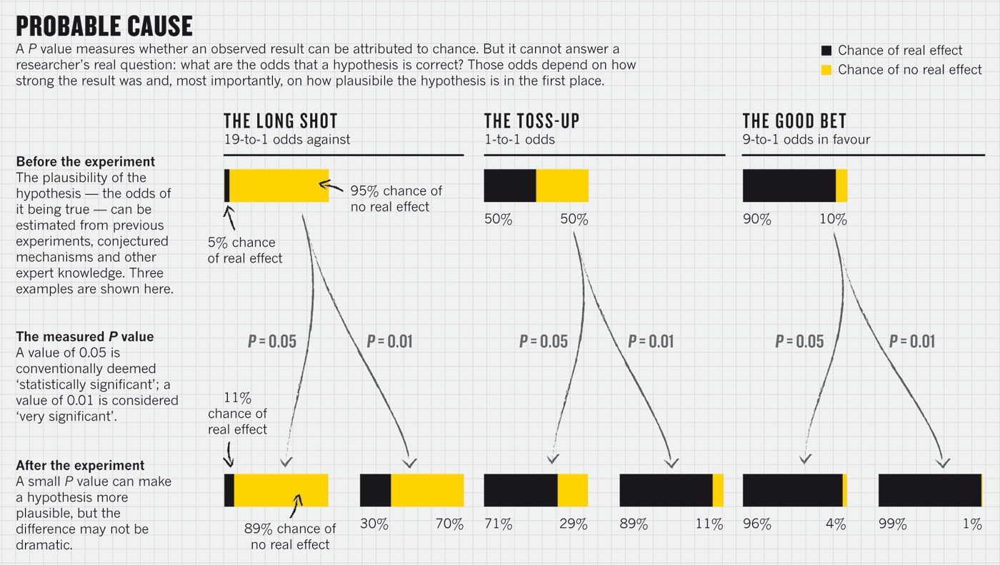

Are P values all that bad?
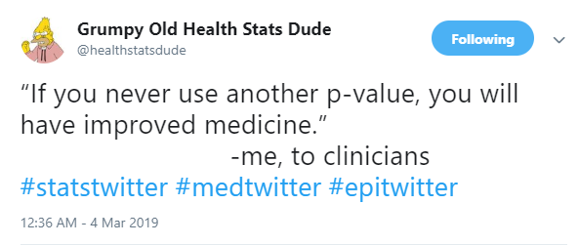

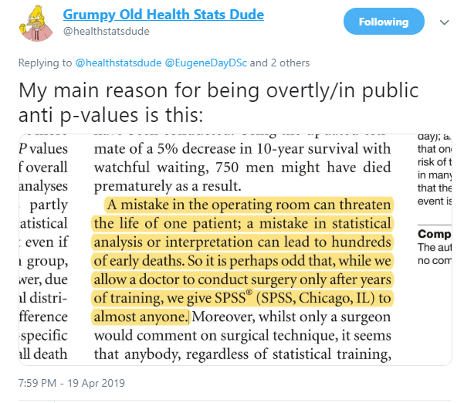

ASA Statement on p Values
ASA Statement: “Informally, a p-value is the probability under a specified statistical model that a statistical summary of the data (e.g., the sample mean difference between two compared groups) would be equal to or more extreme than its observed value.”
… Try to distill the p-value down to an intuitive concept and it loses all its nuances and complexity, said science journalist Regina Nuzzo, a statistics professor at Gallaudet University. “Then people get it wrong, and this is why statisticians are upset and scientists are confused.” You can get it right, or you can make it intuitive, but it’s all but impossible to do both.
(This quote comes from the much-lamented fivethirtyeight.com website.)

A Few Comments on Significance
- A significant effect is not necessarily the same thing as an interesting effect. For example, results calculated from large samples are nearly always “significant” even when the effects are quite small in magnitude. Before doing a test, always ask if the effect is large enough to be of any practical interest. If not, why do the test?
- A non-significant effect is not necessarily the same thing as no difference. A large effect of real practical interest may still produce a non-significant result simply because the sample is too small.
- There are assumptions behind all statistical inferences. Checking assumptions is crucial to validating the inference made by any test or confidence interval.
- “Scientific conclusions and business or policy decisions should not be based only on whether a p-value passes a specific threshold.”
ASA 2016 statement on p values

p = 0.05?
“For decades, the conventional p-value threshold has been 0.05,” says Dr. Paul Wakim, chief of the biostatistics and clinical epidemiology service at the National Institutes of Health Clinical Center, “but it is extremely important to understand that this 0.05, there’s nothing rigorous about it. It wasn’t derived from statisticians who got together, calculated the best threshold, and then found that it is 0.05. No, it’s Ronald Fisher, who basically said, ‘Let’s use 0.05,’ and he admitted that it was arbitrary.”
- NOVA “Rethinking Science’s Magic Number” by Tiffany Dill 2018-02-28. See especially the video labeled “Science’s most important (and controversial) number has its origins in a British experiment involving milk and tea.”

More from Dr. Wakim…
“People say, ‘Ugh, it’s above 0.05, I wasted my time.’ No, you didn’t waste your time.” says Dr. Wakim. “If the research question is important, the result is important. Whatever it is.”
- NOVA Season 45 Episode 6 2018-02-28.

p values don’t trend…
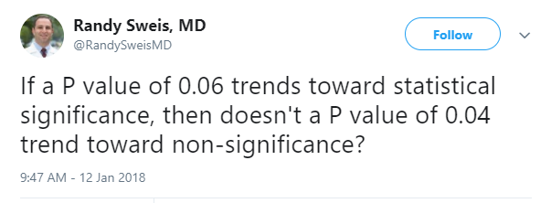

All the p values
The p-value is the most widely-known statistic. P-values are reported in a large majority of scientific publications that measure and report data. R.A. Fisher is widely credited with inventing the p-value. If he was cited every time a p-value was reported his paper would have, at the very least, 3 million citations - making it the most highly cited paper of all time.
- Visit Jeff Leek’s Github for tidypvals package
  - 2.5 million p values in 25 scientific fields
What do you suppose the distribution of those p values is going to look like?

2.5 million p values in 25 scientific fields: Jeff Leek
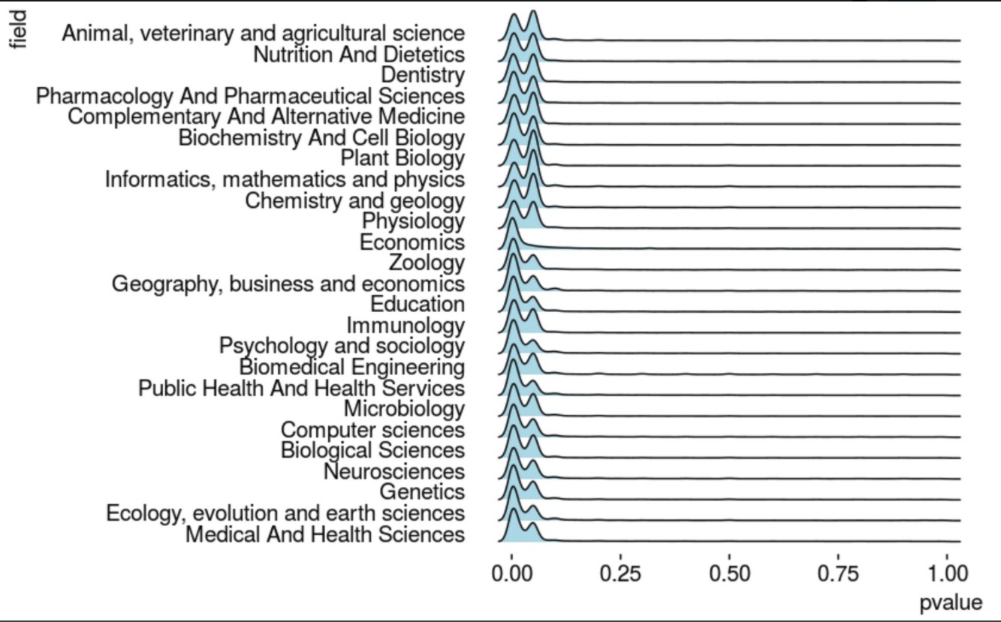

from Michael Lopez
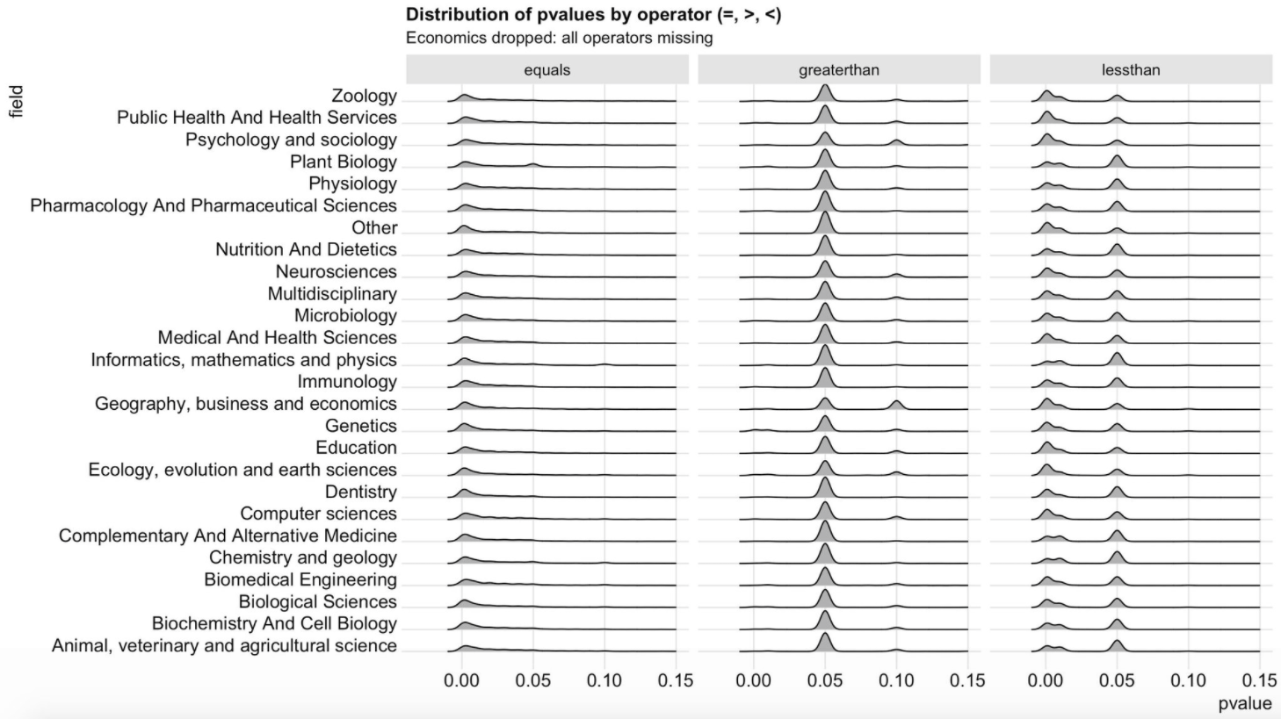

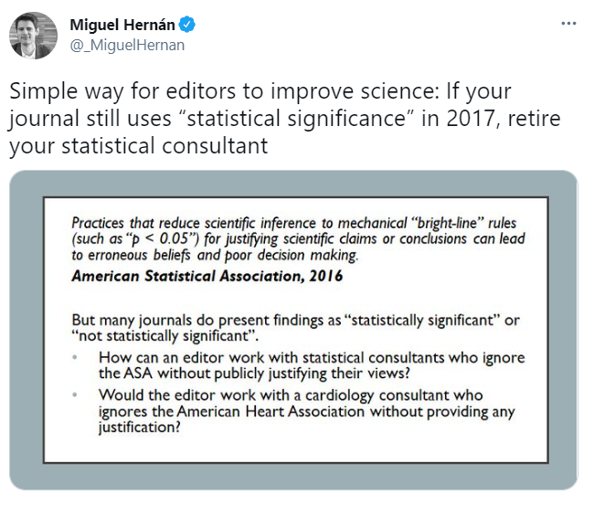

Unfortunately…
There are a lot of candidates for the most outrageous misuse of “statistical significance” out there.

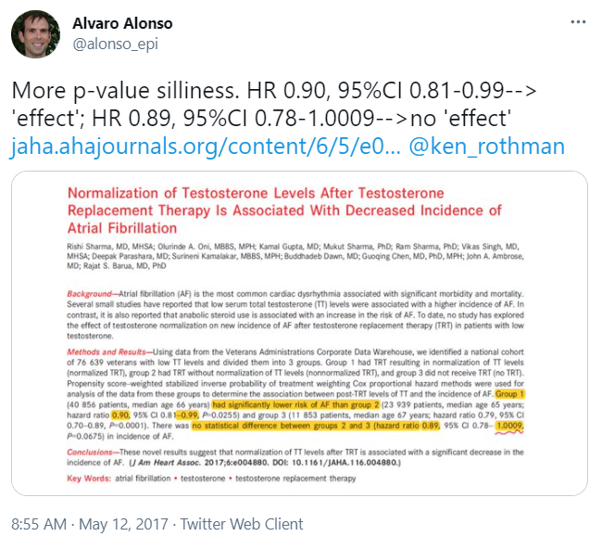

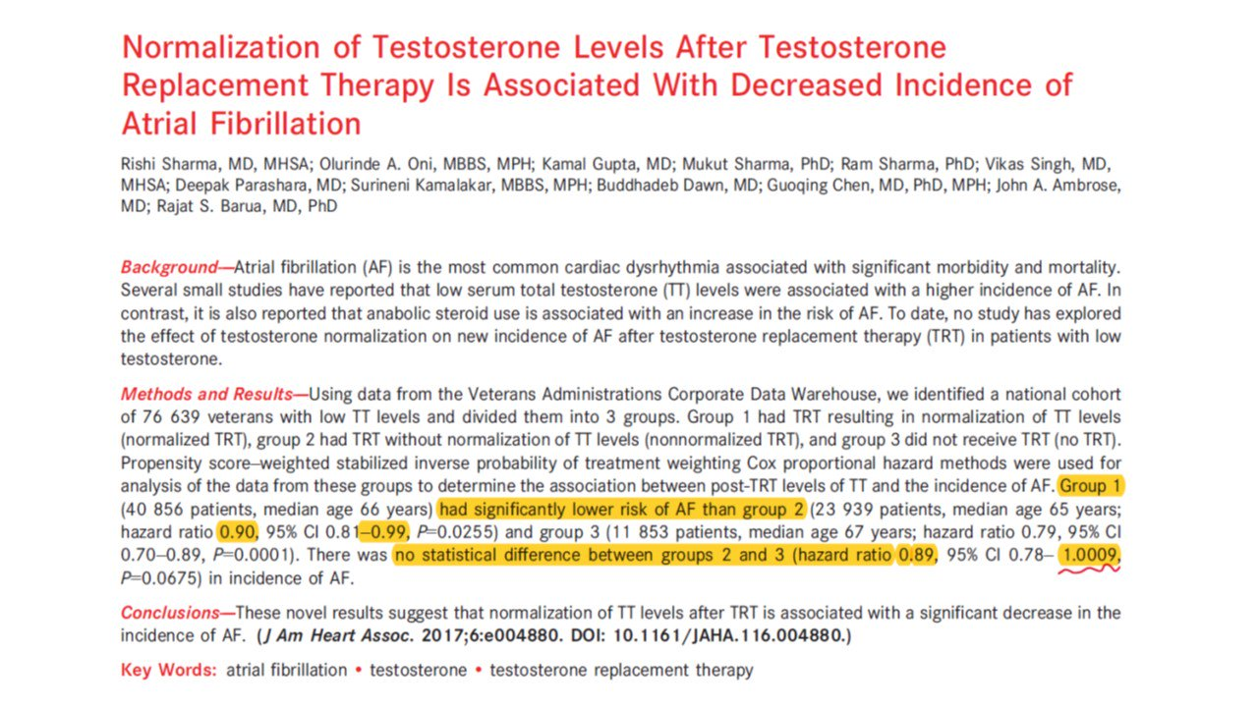

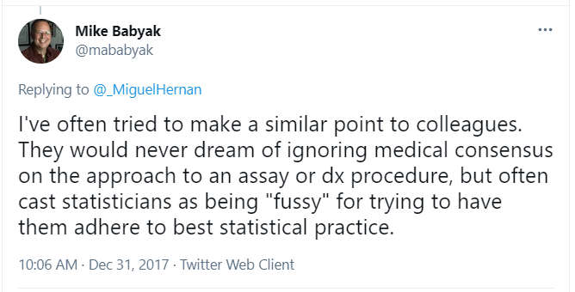

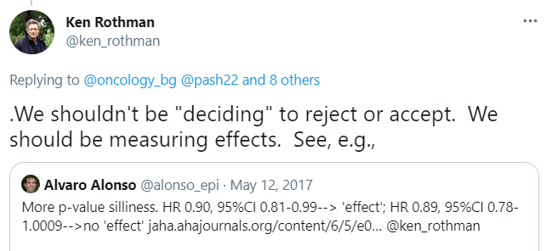

George Cobb’s Questions
In February 2014, George Cobb, Professor Emeritus of Mathematics and Statistics at Mount Holyoke College, posed these questions to an ASA discussion forum:
Q: Why do so many colleges and grad schools teach p = 0.05?
A: Because that’s still what the scientific community and journal editors use.
Q: Why do so many people still use p = 0.05?
A: Because that’s what they were taught in college or grad school.

“Researcher Degrees of Freedom”, 1
[I]t is unacceptably easy to publish statistically significant evidence consistent with any hypothesis.
The culprit is a construct we refer to as researcher degrees of freedom. In the course of collecting and analyzing data, researchers have many decisions to make: Should more data be collected? Should some observations be excluded? Which conditions should be combined and which ones compared? Which control variables should be considered? Should specific measures be combined or transformed or both?
Simmons et al.

“Researcher Degrees of Freedom”, 2
… It is rare, and sometimes impractical, for researchers to make all these decisions beforehand. Rather, it is common (and accepted practice) for researchers to explore various analytic alternatives, to search for a combination that yields statistical significance, and to then report only what worked. The problem, of course, is that the likelihood of at least one (of many) analyses producing a falsely positive finding at the 5% level is necessarily greater than 5%.
For more, see
- Gelman’s blog 2012-11-01 “Researcher Degrees of Freedom”,
- Simmons and others, defining the term.

And this is really hard to deal with…
The garden of forking paths: Why multiple comparisons can be a problem, even when there is no “fishing expedition” or p-hacking and the research hypothesis was posited ahead of time
Researcher degrees of freedom can lead to a multiple comparisons problem, even in settings where researchers perform only a single analysis on their data. The problem is there can be a large number of potential comparisons when the details of data analysis are highly contingent on data, without the researcher having to perform any conscious procedure of fishing or examining multiple p-values. We discuss in the context of several examples of published papers where data-analysis decisions were theoretically-motivated based on previous literature, but where the details of data selection and analysis were not pre-specified and, as a result, were contingent on data.
- Gelman and Loken

Abandon Statistical Significance
Gelman blog 2017-09-26 on “Abandon Statistical Significance”
“Measurement error and variation are concerns even if your estimate is more than 2 standard errors from zero. Indeed, if variation or measurement error are high, then you learn almost nothing from an estimate even if it happens to be ‘statistically significant.’”
Read the whole paper here

Nature P values are just the tip of the iceberg!
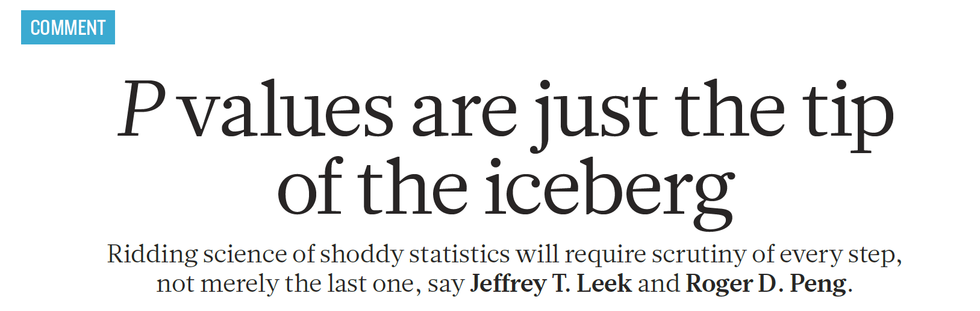

OK, so what SHOULD we do?
The American Statistician Volume 73, 2019, Supplement 1
Articles on:
- Getting to a Post “p < 0.05” Era
- Interpreting and Using p
- Supplementing or Replacing p
- Adopting more holistic approaches
- Reforming Institutions: Changing Publication Policies and Statistical Education
- Note that there is an enormous list of “things to do” in Section 7 of the main editorial, too.

Statistical Inference in the 21st Century
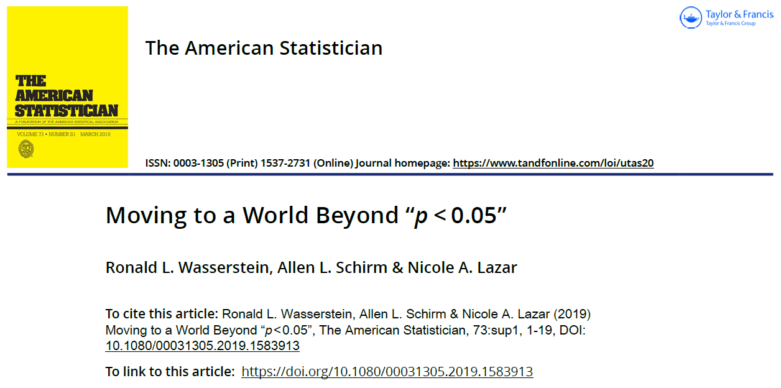

ATOM: Accept uncertainty. Be Thoughtful, Open and Modest.
- Statistical methods do not rid data of their uncertainty.
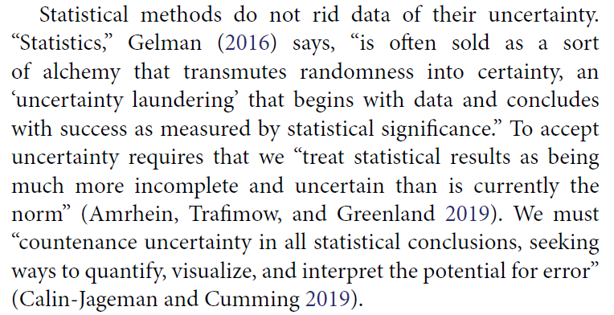

ATOM: Accept uncertainty. Be Thoughtful, Open and Modest.
We can make acceptance of uncertainty more natural to our thinking by accompanying every point estimate in our research with a measure of its uncertainty such as a standard error or interval estimate. Reporting and interpreting point and interval estimates should be routine.
How will accepting uncertainty change anything? To begin, it will prompt us to seek better measures, more sensitive designs, and larger samples, all of which increase the rigor of research.
It also helps us be modest … [and] leads us to be thoughtful.

ATOM: Accept uncertainty. Be Thoughtful, Open and Modest.
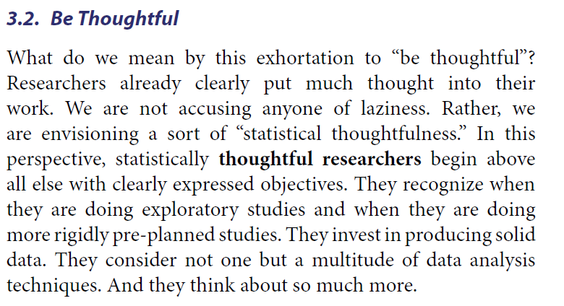

ATOM: Accept uncertainty. Be Thoughtful, Open and Modest.
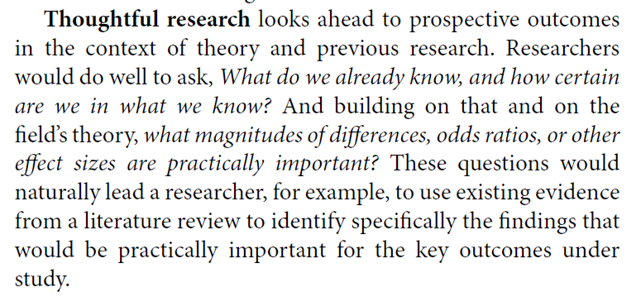

ATOM: Accept uncertainty. Be Thoughtful, Open and Modest.
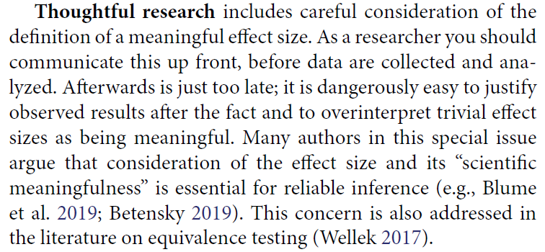

ATOM: Accept uncertainty. Be Thoughtful, Open and Modest.
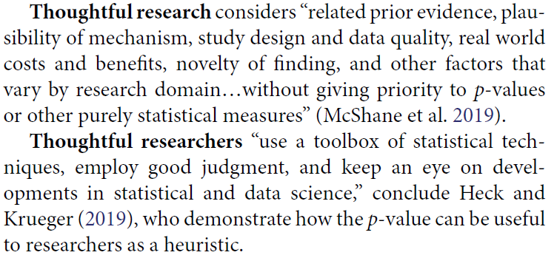

ATOM: Accept uncertainty. Be Thoughtful, Open and Modest.
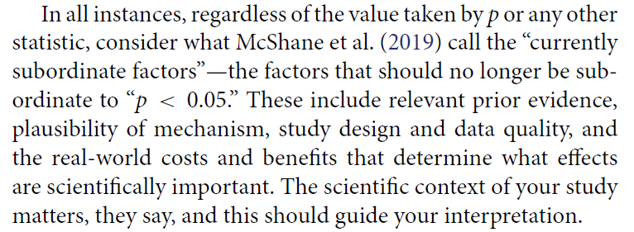

ATOM: Accept uncertainty. Be Thoughtful, Open and Modest.
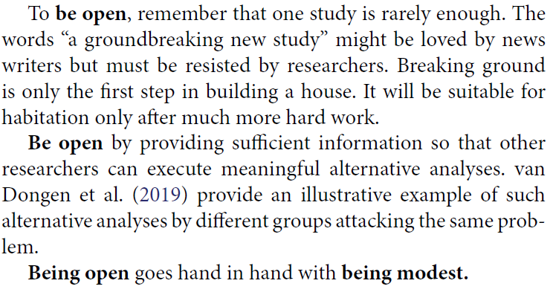

ATOM: Accept uncertainty. Be Thoughtful, Open and Modest.
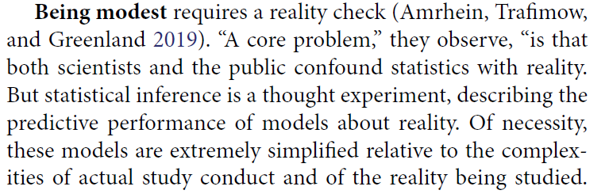

ATOM: Accept uncertainty. Be Thoughtful, Open and Modest.
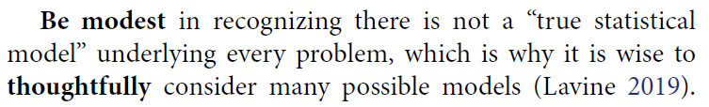

ATOM: Accept uncertainty. Be Thoughtful, Open and Modest.
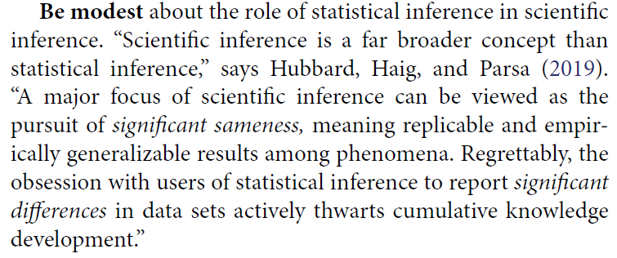

ATOM: Accept uncertainty. Be Thoughtful, Open and Modest.
The nexus of openness and modesty is to report everything while at the same time not concluding anything from a single study with unwarranted certainty. Because of the strong desire to inform and be informed, there is a relentless demand to state results with certainty. Again, accept uncertainty and embrace variation in associations and effects, because they are always there, like it or not. Understand that expressions of uncertainty are themselves uncertain. Accept that one study is rarely definitive, so encourage, sponsor, conduct, and publish replication studies.
Be modest by encouraging others to reproduce your work. Of course, for it to be reproduced readily, you will necessarily have been thoughtful in conducting the research and open in presenting it.

What I Think I Think Now
- Null hypothesis significance testing is much harder (and less useful) than I thought.
  - The null hypothesis is almost never a real thing.
  - Rather than rejiggering the cutoff, I have largely abandoned categorizing p values
  - Replication is far more useful than I thought it was.

What I Think I Think Now
- Some hills aren’t worth dying on.
  - Think about uncertainty intervals more than confidence or credible intervals
  - Focus on estimation of effects, rather than “is this effect a big deal or not a big deal?”
- Which method to use is far less important than finding better data
  - The biggest mistake I make regularly is throwing away useful data, and I’m not the only one with this problem.

What I Think I Think Now
- The best thing I do most days is communicate more clearly.
  - When stuck in a design, I think about how to get better data.
  - When stuck in an analysis, I try to turn a table into a graph.
- I have A LOT to learn.

