431 Class 04
Thomas E. Love, Ph.D.
2026-09-03

Today’s Agenda
Today, we’ll work with some data from the 15-item survey from Class 2.
- Ingesting data from a .csv file
- Data management and clean-up
- Dealing with missing data via “complete cases”
- Addressing a few exploratory comparisons
- Visualization, Modeling and Inference
One goal is to make sure you’re ready for Lab 1, due 2026-09-09.

How did ingesting the data go?
The 2026 results (pdf of survey is here):
- I received 41 paper surveys.
- Two surveys had identical responses, so I dropped one.
In all, 14 of the 41 (34.1%) responses gave me no trouble in 2026. In 2014-2025, 36% of forms gave me no trouble.
Issues seen in 2026: interpreting handwriting, imprecise circles, cross-outs, not following directions on pulse rate, problems interpreting the handedness scale, difficult to identify units of measurement, listing multiple colors

What have I done to set up today?
From 431-data, I have:
- 431-first-r-template.qmd: our Quarto starting point
- Love-431.R script (for the lovedist() function)
- class02_survey_2014_to_2026.csv: main data file
Then I created an R Project directory for this work, which has the Quarto template in the main directory, and the .R and .csv files in a “c04/data” subdirectory.

Next steps
- Open RStudio
- Start a new R Project in the Project Directory I created on the previous slide.
- Open the Quarto template, then saved it as class04_survey_complete.qmd after adjusting the title and author.
- Next step is to adjust the R setup and get rolling.

Load packages and set theme
knitr::opts_chunk$set(comment = NA)
source("c04/data/Love-431.R")
library(janitor)
library(naniar) ## this will help us identify missing values
library(patchwork) ## stitch together two different ggplots
library(easystats)
library(tidyverse)
theme_set(theme_bw())

Ingest 2014-2026 data
s15 <- read_csv("c04/data/class02_survey_2014_to_2026.csv",
show_col_types = FALSE) |>
janitor::clean_names()
s15
# A tibble: 696 × 25
student glasses english statsofar love_htcm smoke h_left h_right handedness
<dbl> <chr> <chr> <dbl> <dbl> <dbl> <dbl> <dbl> <dbl>
1 202601 y y 5 183 1 0 18 1
2 202602 n y 5 180 1 4 11 0.47
3 202603 y n 6 178 1 3 17 0.7
4 202604 y y 5 175 1 2 15 0.76
5 202605 n y 6 180 1 2 15 0.76
6 202606 y y 6 178 1 2 14 0.75
7 202607 n y 6 175 1 12 12 0
8 202608 y y 1 180 1 10 0 -1
9 202609 y y 2 180 1 1 10 0.82
10 202610 y y 5 185 3 18 10 -0.29
# ℹ 686 more rows
# ℹ 16 more variables: statfuture <dbl>, haircut <dbl>, lecture <dbl>,
# alone <dbl>, height_in <dbl>, hand_span <dbl>, favcolor <chr>,
# lastsleep <dbl>, pulse <dbl>, year <dbl>, lovetrueht <dbl>,
# lovetrueage <dbl>, sex <chr>, ageguess <dbl>, trouble <dbl>,
# colors_13 <chr>

Variables in the data
names(s15)
[1] "student" "glasses" "english" "statsofar" "love_htcm"
[6] "smoke" "h_left" "h_right" "handedness" "statfuture"
[11] "haircut" "lecture" "alone" "height_in" "hand_span"
[16] "favcolor" "lastsleep" "pulse" "year" "lovetrueht"
[21] "lovetrueage" "sex" "ageguess" "trouble" "colors_13"
Let’s select just the variables we’ll use today.
s15 <- s15 |> select(student, glasses, english, love_htcm,
smoke, haircut, height_in, hand_span,
favcolor, lastsleep, pulse, year,
colors_13)
dim(s15)
[1] 696 13
- Same number of rows, but now only 13 columns.

What is in these variables? (1/2)
Variable | Description
student | identifying code (202601, 202602, etc.)
glasses | y if student wears corrective eyewear, otherwise n
english | y if english is best language, otherwise n
love_htcm | guess of my height (in centimeters)
smoke | 1 = never smoked, 2 = quit, 3 = current smoker
haircut | price (in $) of last haircut

What is in these variables? (2/2)
Variable | Description
height_in | your height (in inches)
hand_span | your hand span (in centimeters)
favcolor | your favorite color (>40 colors mentioned)
lastsleep | hours of sleep last night
pulse | current pulse rate (beats per minute)
year | year of survey (2014 - 2026)
colors_13 | my attempt to collapse the colors a bit

Variable types, as ingested
- <chr> = character variable: as opposed to a factor
- <dbl> = double-precision numeric variable
glimpse(s15)
Rows: 696
Columns: 13
$ student <dbl> 202601, 202602, 202603, 202604, 202605, 202606, 202607, 2026…
$ glasses <chr> "y", "n", "y", "y", "n", "y", "n", "y", "y", "y", "y", "y", …
$ english <chr> "y", "y", "n", "y", "y", "y", "y", "y", "y", "y", "y", "y", …
$ love_htcm <dbl> 183, 180, 178, 175, 180, 178, 175, 180, 180, 185, 191, 170, …
$ smoke <dbl> 1, 1, 1, 1, 1, 1, 1, 1, 1, 3, 1, 1, 1, 1, 1, 1, 1, 1, 1, 1, …
$ haircut <dbl> 45, 11, 45, 75, 12, 0, 0, 80, 65, 0, 25, 28, 14, 30, 50, 55,…
$ height_in <dbl> 65.0, 66.5, 58.0, 65.0, 65.0, 63.0, 70.0, 63.0, 69.0, 66.0, …
$ hand_span <dbl> 19.5, 22.5, 19.3, 22.0, 21.1, 21.0, 22.0, 17.0, 23.0, 20.0, …
$ favcolor <chr> "navy blue", "blue", "white", "green", "blue", "blue", "blue…
$ lastsleep <dbl> 8.00, 8.50, 8.00, 8.00, 8.50, 7.00, 6.00, 7.00, 5.00, 7.00, …
$ pulse <dbl> 64, 104, 85, 97, 90, 98, 72, 80, 92, 72, 72, 72, 60, 68, 80,…
$ year <dbl> 2026, 2026, 2026, 2026, 2026, 2026, 2026, 2026, 2026, 2026, …
$ colors_13 <chr> "blue", "blue", "white", "green", "blue", "blue", "blue", "g…

The subject ID should be of the character type
Some of the variables need to be of a different type:
- student is just a code to identify each subject. We’d like that to be of character type, rather than double, so we don’t accidentally use it in a model.
s15 <- s15 |> mutate(student = as.character(student))

Making some variables into factors
- glasses, english, favcolor, and colors13 should all be factors, rather than character variables.
  - R made these characters because the values included non-numbers (specifically, letters.)
  - A factor is easy to use in an analysis or summary, while a character variable isn’t.
s15 <- s15 |> mutate(glasses = factor(glasses),
english = factor(english),
favcolor = factor(favcolor),
colors_13 = factor(colors_13))

smoke is also categorical
We’d also like to turn smoke into a factor, and use the actual names for the levels rather than the 1-2-3 codes.
s15 <- s15 |> mutate(smoke = fct_recode(factor(smoke),
"Never" = "1",
"Quit" = "2",
"Current" = "3"))
s15 |> tabyl(smoke) |> adorn_pct_formatting()
smoke n percent valid_percent
Never 642 92.2% 92.5%
Quit 38 5.5% 5.5%
Current 14 2.0% 2.0%
<NA> 2 0.3% -

Missing values?
- The read_csv() function recognizes (by default) NA or blank cells as missing. How many cells are missing?
dim(s15)
[1] 696 13
696 * 13
[1] 9048
n_miss(s15)
[1] 869
pct_miss(s15)
[1] 9.604332
We have 869 missing cells in our rectangular tibble, so 9.6% of the data are missing.

Missingness by variable?
- I started asking for guesses of my height in 2021.
- I started asking about glasses in 2019.
miss_var_summary(s15)
# A tibble: 13 × 3
variable n_miss pct_miss
<chr> <int> <num>
1 love_htcm 385 55.3
2 glasses 256 36.8
3 pulse 79 11.4
4 hand_span 77 11.1
5 colors_13 19 2.73
6 favcolor 15 2.16
7 haircut 12 1.72
8 height_in 9 1.29
9 lastsleep 8 1.15
10 english 7 1.01
11 smoke 2 0.287
12 student 0 0
13 year 0 0

Missingness by row (case / subject)?
miss_case_table(s15)
# A tibble: 10 × 3
n_miss_in_case n_cases pct_cases
<int> <int> <dbl>
1 0 293 42.1
2 1 68 9.77
3 2 246 35.3
4 3 75 10.8
5 4 5 0.718
6 5 1 0.144
7 6 1 0.144
8 7 5 0.718
9 8 1 0.144
10 10 1 0.144
- About 42% of the cases are complete.

Quick Summary of All Variables
summary(s15)
student glasses english love_htcm smoke
Length :696 n :160 n :147 Min. :152.0 Never :642
N.unique :696 y :280 y :542 1st Qu.:178.0 Quit : 38
N.blank : 0 NAs:256 NAs: 7 Median :183.0 Current: 14
Min.nchar: 6 Mean :182.2 NAs : 2
Max.nchar: 6 3rd Qu.:187.5
Max. :196.0
NAs :385
haircut height_in hand_span favcolor lastsleep
Min. : 0.00 Min. :57.0 Min. : 8.00 blue :251 Min. : 2.000
1st Qu.: 12.00 1st Qu.:64.0 1st Qu.:19.00 green :117 1st Qu.: 6.000
Median : 25.00 Median :67.0 Median :20.50 purple : 68 Median : 7.000
Mean : 32.97 Mean :67.1 Mean :20.32 red : 62 Mean : 6.914
3rd Qu.: 40.00 3rd Qu.:70.0 3rd Qu.:22.00 yellow : 23 3rd Qu.: 8.000
Max. :300.00 Max. :77.5 Max. :27.00 (Other):160 Max. :12.000
NAs :12 NAs :9 NAs :77 NAs : 15 NAs :8
pulse year colors_13
Min. : 20.00 Min. :2014 blue :272
1st Qu.: 66.00 1st Qu.:2017 green :125
Median : 72.00 Median :2020 purple : 74
Mean : 74.34 Mean :2020 red : 67
3rd Qu.: 81.00 3rd Qu.:2023 pink : 25
Max. :124.00 Max. :2026 (Other):114
NAs :79 NAs : 19

Describing Quantities
describe_distribution(s15)
Variable | Mean | SD | IQR | Range | Skewness | Kurtosis
-------------------------------------------------------------------------------
love_htcm | 182.23 | 6.27 | 10.00 | [152.00, 196.00] | -1.05 | 3.35
haircut | 32.97 | 37.16 | 28.00 | [0.00, 300.00] | 3.13 | 14.22
height_in | 67.10 | 3.82 | 6.00 | [57.00, 77.50] | 0.21 | -0.53
hand_span | 20.32 | 2.52 | 3.00 | [8.00, 27.00] | -1.33 | 4.62
lastsleep | 6.91 | 1.34 | 2.00 | [2.00, 12.00] | -0.35 | 0.72
pulse | 74.34 | 12.77 | 15.50 | [20.00, 124.00] | 0.18 | 0.80
year | 2019.99 | 3.57 | 6.00 | [2014.00, 2026.00] | -1.85e-03 | -1.14
Variable | n | n_Missing
---------------------------
love_htcm | 311 | 385
haircut | 684 | 12
height_in | 687 | 9
hand_span | 619 | 77
lastsleep | 688 | 8
pulse | 617 | 79
year | 696 | 0

Exploratory Question 1
What is the relationship between hand span and height for 431 students since 2014? Can we draw a scatterplot?
ggplot(data = s15, aes(x = height_in, y = hand_span)) +
geom_point()
Warning: Removed 78 rows containing missing values or values outside the scale range
(`geom_point()`).
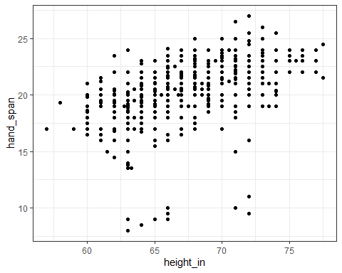

Filtering to complete cases
Let’s require complete data on these variables…
s15_q1 <- s15 |> filter(complete.cases(hand_span, height_in))
s15_q1 |> reframe(lovedist(hand_span))
# A tibble: 1 × 10
n miss mean sd med mad min q25 q75 max
<int> <int> <dbl> <dbl> <dbl> <dbl> <dbl> <dbl> <dbl> <dbl>
1 618 0 20.3 2.52 20.5 2.22 8 19 22 27
s15_q1 |> reframe(lovedist(height_in))
# A tibble: 1 × 10
n miss mean sd med mad min q25 q75 max
<int> <int> <dbl> <dbl> <dbl> <dbl> <dbl> <dbl> <dbl> <dbl>
1 618 0 67.2 3.79 67 4.45 57 64 70 77.5

Scatterplot of Hand Span by Height
ggplot(data = s15_q1, aes(x = height_in, y = hand_span)) +
geom_point()


Lots of ties - can we show that?
ggplot(data = s15_q1, aes(x = height_in, y = hand_span)) +
geom_jitter()
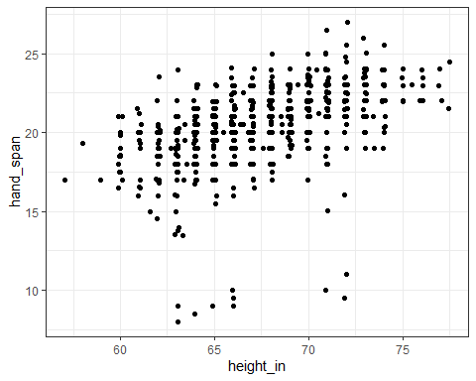

Add a loess smooth, improve labels
ggplot(data = s15_q1, aes(x = height_in, y = hand_span)) +
geom_smooth(method = "loess", col = "blue", formula = y ~ x, se = TRUE) +
geom_point() +
labs(x = "Height (in)", y = "Hand Span (cm)",
title = "Association of student hand span and height",
subtitle = "n = 618 students in 431 between 2014 and 2026")
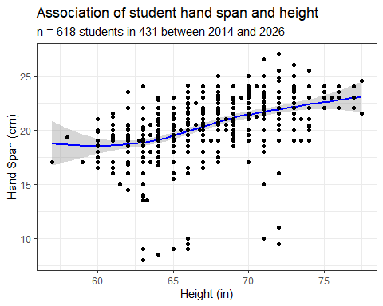

Add a linear model, as well
ggplot(data = s15_q1, aes(x = height_in, y = hand_span)) +
geom_smooth(method = "loess", col = "blue",
formula = y ~ x, se = FALSE) +
geom_smooth(method = "lm", col = "red",
formula = y ~ x, se = TRUE) +
geom_point() +
labs(x = "Height (in)",
y = "Hand Span (cm)",
title = "Association of student hand span and height",
subtitle = "n = 618 students in 431 between 2014 and 2026")
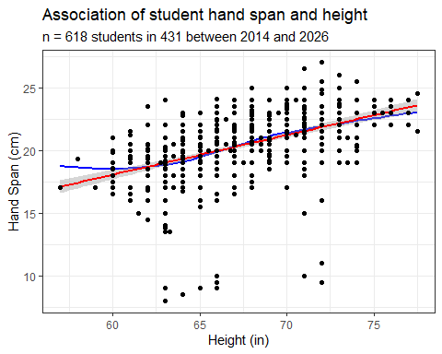

What is the straight line fit?
fit1 <- lm(hand_span ~ height_in, data = s15_q1)
model_parameters(fit1, pretty_names = FALSE, ci = 0.95)
Parameter | Coefficient | SE | 95% CI | t(616) | p
------------------------------------------------------------------
(Intercept) | -0.87 | 1.58 | [-3.98, 2.24] | -0.55 | 0.584
height_in | 0.32 | 0.02 | [ 0.27, 0.36] | 13.39 | < .001
Uncertainty intervals (equal-tailed) and p-values (two-tailed) computed
using a Wald t-distribution approximation.
So what is the straight line equation from lm?
- hand_span = -0.87 + 0.32 height_in
- How do we interpret the slope (0.32) of height_in?
- How do we interpret the intercept (-0.87)?
Note the 95% confidence intervals around these OLS estimates.

Exploratory Question 2
What is the relationship between haircut price and height among the 40 students responding in 2026?
- What do we expect to see in this scatterplot? Why?
Let’s just look at 2026 data this time.
s15_2026 <- s15 |> filter(year == 2026)
- What do the results below tell us?
dim(s15_2026)
[1] 40 13
s15_2026 |> select(haircut, height_in) |> n_miss()
[1] 0

Haircut Price vs. Height in 2026
ggplot(s15_2026, aes(x = height_in, y = haircut)) +
geom_jitter() +
geom_smooth(method = "loess", formula = y ~ x,
se = FALSE, col = "blue") +
geom_smooth(method = "lm", formula = y ~ x,
se = TRUE, col = "red") +
labs(title = "Association of haircut price and height",
subtitle = "n = 40 students in 431 for Fall 2026 (values jittered)",
x = "Height (in)",
y = "Price of last haircut ($)")
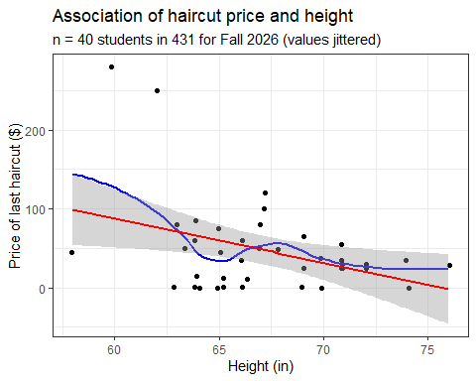

What is the OLS model here?
fit2 <- lm(haircut ~ height_in, data = s15_2026)
model_parameters(fit2, pretty_names = TRUE, ci = 0.90)
Parameter | Coefficient | SE | 90% CI | t(38) | p
---------------------------------------------------------------------
(Intercept) | 423.93 | 151.20 | [169.01, 678.84] | 2.80 | 0.008
height in | -5.60 | 2.25 | [ -9.39, -1.81] | -2.49 | 0.017
Uncertainty intervals (equal-tailed) and p-values (two-tailed) computed
using a Wald t-distribution approximation.
- How do we interpret the slope of height_in?
- How do we interpret the intercept?
- What does pretty_names = TRUE, ci = 0.90 do?
Are we likely to see a similar result in previous years?

Compare 2026 to 2014-2025
plot1 <- ggplot(s15_2026, aes(x = height_in, y = haircut)) +
geom_point() +
geom_smooth(method = "loess", formula = y ~ x, se = FALSE, col = "blue") +
geom_smooth(method = "lm", formula = y ~ x, se = TRUE, col = "red") +
ylim(0, 300) + ## make limits of y axis 0 and 300
labs(title = "2026: Association of haircut price and height",
subtitle = "n = 40 students in 431 for Fall 2026",
x = "Height (in)", y = "Price of last haircut ($)")
s15_q2 <- s15 |> filter(complete.cases(height_in, haircut)) |>
filter(year < 2026) ## this contains 642 rows, it turns out
plot2 <- ggplot(s15_q2, aes(x = height_in, y = haircut)) +
geom_point() +
geom_smooth(method = "loess", formula = y ~ x, se = FALSE, col = "blue") +
geom_smooth(method = "lm", formula = y ~ x, se = TRUE, col = "red") +
ylim(0, 300) + ## make limits of y axis 0 and 300 here, too
labs(title = "2014-2025: Association of haircut price and height",
subtitle = "n = 642 students in 431 for 2014-2025",
x = "Height (in)", y = "Price of last haircut ($)")
plot1 + plot2 + ## "stitch" the plots together
plot_layout(axes = "collect") ## thanks to patchwork package
Warning: Removed 2 rows containing missing values or values outside the scale range
(`geom_smooth()`).
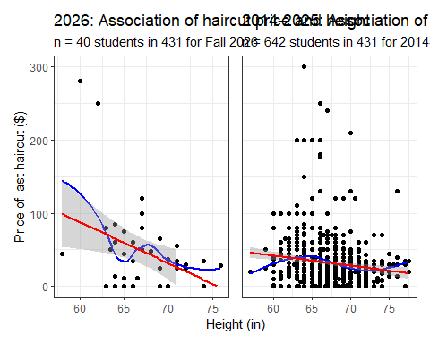

Seems like the place for a break.

Exploratory Question 3
Students specified their height (height_in) and guessed mine (love_htcm), since 2021.
- Did taller students guess that I was taller?
- Let’s convert the heights so each is in inches.
s15_q3 <- s15 |>
select(student, height_in, love_htcm) |>
filter(complete.cases(height_in, love_htcm)) |>
mutate(love_htin = round_half_up(love_htcm * 0.3937, 1)) |>
mutate(delta = love_htin - height_in)
So what’s in this new tibble?

Contents of s15_q3 tibble
s15_q3
# A tibble: 306 × 5
student height_in love_htcm love_htin delta
<chr> <dbl> <dbl> <dbl> <dbl>
1 202601 65 183 72 7
2 202602 66.5 180 70.9 4.40
3 202603 58 178 70.1 12.1
4 202604 65 175 68.9 3.90
5 202605 65 180 70.9 5.90
6 202606 63 178 70.1 7.10
7 202607 70 175 68.9 -1.10
8 202608 63 180 70.9 7.90
9 202609 69 180 70.9 1.90
10 202610 66 185 72.8 6.8
# ℹ 296 more rows
- What does delta mean?

Numerical Summaries
- Student Guesses of My Height (in inches)
s15_q3 |> reframe(lovedist(love_htin))
# A tibble: 1 × 10
n miss mean sd med mad min q25 q75 max
<int> <int> <dbl> <dbl> <dbl> <dbl> <dbl> <dbl> <dbl> <dbl>
1 306 0 71.8 2.47 72 2.82 59.8 70.1 74 77.2
- Student Heights (in inches)
s15_q3 |> reframe(lovedist(height_in))
# A tibble: 1 × 10
n miss mean sd med mad min q25 q75 max
<int> <int> <dbl> <dbl> <dbl> <dbl> <dbl> <dbl> <dbl> <dbl>
1 306 0 67.1 3.93 67 4.45 58 64 70 77.5
Suppose we want to compare these means.

Visualizing the Distributions
plot3 <- ggplot(s15_q3, aes(x = love_htin)) +
geom_histogram(binwidth = 1, fill = "tomato", col = "white") +
labs(title = "Histogram: Guess of Dr. Love's height (inches)",
x = "Guess of Dr. Love's height (in)", y = "# of students")
plot4 <- ggplot(s15_q3, aes(x = love_htin)) +
geom_histogram(binwidth = 1, fill = "royalblue", col = "white") +
labs(title = "Histogram: Student height (inches)",
x = "Student's height (in)", y = "# of students")
plot3 / plot4 + ## thanks, patchwork!
plot_annotation(title = "306 students in Dr. Love's 431 Class, 2021-2026")
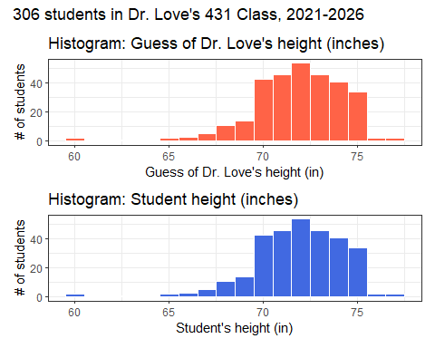

Numerical Summaries
Each subject gives us their guess of my height, and their height.
- $Δ$ = How much taller did I seem? (in inches)
s15_q3 |> reframe(lovedist(delta))
# A tibble: 1 × 10
n miss mean sd med mad min q25 q75 max
<int> <int> <dbl> <dbl> <dbl> <dbl> <dbl> <dbl> <dbl> <dbl>
1 306 0 4.68 4.45 5 4.45 -9.1 2 8 16.2
These are the “paired” differences. What do they look like?

Histogram of $Δ$
ggplot(s15_q3, aes(x = delta)) +
geom_histogram(binwidth = 1, fill = "aquamarine", col = "black") +
labs(title = "How much taller did Dr. Love seem?",
subtitle = "306 students in his 2021-2026 431 classes",
x = "Guess of Dr. Love's height - Student's height (inches)",
y = "# of students")
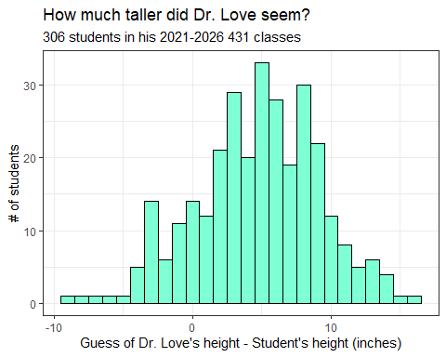

Estimating the mean $Δ$
Use a linear model to estimate the true mean difference between guesses of my height and actual student heights, using a 90% confidence interval.
fit3 <- lm(delta ~ 1, data = s15_q3)
model_parameters(fit3, ci = 0.90)
Parameter | Coefficient | SE | 90% CI | t(305) | p
-----------------------------------------------------------------
(Intercept) | 4.68 | 0.25 | [4.26, 5.10] | 18.39 | < .001
Uncertainty intervals (equal-tailed) and p-values (two-tailed) computed
using a Wald t-distribution approximation.
- What would a 95% confidence interval look like?
model_parameters(fit3, ci = 0.95)
Parameter | Coefficient | SE | 95% CI | t(305) | p
-----------------------------------------------------------------
(Intercept) | 4.68 | 0.25 | [4.18, 5.19] | 18.39 | < .001
Uncertainty intervals (equal-tailed) and p-values (two-tailed) computed
using a Wald t-distribution approximation.

Did taller people guess I’m taller?
ggplot(s15_q3, aes(x = height_in, y = love_htin)) +
geom_jitter() +
geom_smooth(method = "loess", formula = y ~ x, col = "blue")
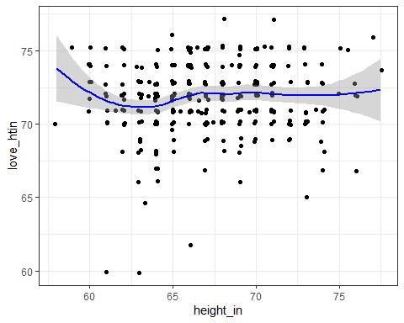

Exploratory Question 4
Did students for whom English is their primary language have larger (or smaller) hand spans?
s15_q4 <- s15 |> filter(complete.cases(english, hand_span)) |>
select(student, english, hand_span, year)
dim(s15_q4)
[1] 613 4
summary(s15_q4)
student english hand_span year
Length :613 n:131 Min. : 8.50 Min. :2014
N.unique :613 y:482 1st Qu.:19.00 1st Qu.:2017
N.blank : 0 Median :20.50 Median :2019
Min.nchar: 6 Mean :20.35 Mean :2020
Max.nchar: 6 3rd Qu.:22.00 3rd Qu.:2023
Max. :27.00 Max. :2026

Visualizing the groups
ggplot(s15_q4, aes(x = hand_span, y = english)) +
geom_violin(aes(fill = english)) +
geom_boxplot(width = 0.4) +
stat_summary(fun = "mean", geom = "point",
size = 3, col = "royalblue") +
labs(title = "Comparing hand span by preferred language",
subtitle = "613 of Dr. Love's 431 students asked 'Is English your most comfortable language?'",
caption = "Sample means indicated by blue dots",
x = "Hand Span (in cm)",
y = "Prefers English?")
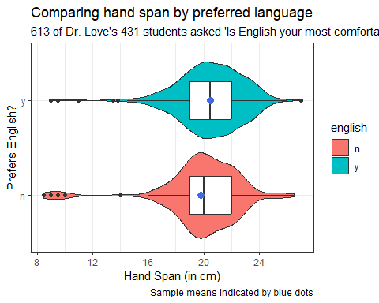

Summarizing our Samples
- Compare the English “Yes” vs. “No” group on hand span.
s15_q4 |> group_by(english) |>
reframe(lovedist(hand_span))
# A tibble: 2 × 11
english n miss mean sd med mad min q25 q75 max
<fct> <int> <int> <dbl> <dbl> <dbl> <dbl> <dbl> <dbl> <dbl> <dbl>
1 n 131 0 19.8 2.99 20 1.48 8.5 19 22 26.5
2 y 482 0 20.5 2.30 20.5 2.22 9 19 22 27
- What seems to be happening here?
- Does the difference in sample means look important?

Build a model
Let’s use a linear model to estimate the difference in hand span between those whose primary language is English and those whose primary language is not English…
fit4 <- lm(hand_span ~ english, data = s15)
model_parameters(fit4, ci = 0.90)
Parameter | Coefficient | SE | 90% CI | t(611) | p
-------------------------------------------------------------------
(Intercept) | 19.82 | 0.22 | [19.47, 20.18] | 92.03 | < .001
english [y] | 0.66 | 0.24 | [ 0.26, 1.06] | 2.73 | 0.007
Uncertainty intervals (equal-tailed) and p-values (two-tailed) computed
using a Wald t-distribution approximation.
- How would you describe the point estimate here?
- What is the 90% confidence interval?

Some Categories: Your Favorite Colors
s15 |> tabyl(favcolor) |> arrange(desc(n))
favcolor n percent valid_percent
blue 251 0.360632184 0.368575624
green 117 0.168103448 0.171806167
purple 68 0.097701149 0.099853157
red 62 0.089080460 0.091042584
yellow 23 0.033045977 0.033773862
pink 22 0.031609195 0.032305433
black 20 0.028735632 0.029368576
orange 18 0.025862069 0.026431718
white 16 0.022988506 0.023494860
<NA> 15 0.021551724 NA
gray 11 0.015804598 0.016152717
brown 6 0.008620690 0.008810573
light blue 5 0.007183908 0.007342144
navy 5 0.007183908 0.007342144
sky blue 4 0.005747126 0.005873715
teal 4 0.005747126 0.005873715
turquoise 4 0.005747126 0.005873715
lavender 3 0.004310345 0.004405286
maroon 3 0.004310345 0.004405286
sage green 3 0.004310345 0.004405286
aqua 2 0.002873563 0.002936858
aquamarine 2 0.002873563 0.002936858
baby pink 2 0.002873563 0.002936858
burgundy 2 0.002873563 0.002936858
dark blue 2 0.002873563 0.002936858
dark green 2 0.002873563 0.002936858
none 2 0.002873563 0.002936858
royal blue 2 0.002873563 0.002936858
silver 2 0.002873563 0.002936858
all of them 1 0.001436782 0.001468429
baby blue 1 0.001436782 0.001468429
beige 1 0.001436782 0.001468429
blue-green 1 0.001436782 0.001468429
burnt orange 1 0.001436782 0.001468429
chartreuse 1 0.001436782 0.001468429
depends 1 0.001436782 0.001468429
forest green 1 0.001436782 0.001468429
hunter green 1 0.001436782 0.001468429
light purple 1 0.001436782 0.001468429
light yellow 1 0.001436782 0.001468429
navy blue 1 0.001436782 0.001468429
pink-orange 1 0.001436782 0.001468429
royal purple 1 0.001436782 0.001468429
salmon 1 0.001436782 0.001468429
sapphire 1 0.001436782 0.001468429
seafoam green 1 0.001436782 0.001468429
violet 1 0.001436782 0.001468429

I collapsed these to 13 colors
s15 |> tabyl(colors_13) |> arrange(desc(n)) |>
adorn_totals() |> adorn_pct_formatting()
colors_13 n percent valid_percent
blue 272 39.1% 40.2%
green 125 18.0% 18.5%
purple 74 10.6% 10.9%
red 67 9.6% 9.9%
pink 25 3.6% 3.7%
yellow 25 3.6% 3.7%
black 20 2.9% 3.0%
orange 20 2.9% 3.0%
<NA> 19 2.7% -
white 16 2.3% 2.4%
blue-green 13 1.9% 1.9%
gray 11 1.6% 1.6%
brown 7 1.0% 1.0%
silver 2 0.3% 0.3%
Total 696 100.0% 100.0%

Glasses vs. English
This is a 2x2 table.
s15 |> tabyl(glasses, english)
glasses n y NA_
n 40 119 1
y 60 218 2
<NA> 47 205 4
s15 |>
filter(complete.cases(glasses, english)) |>
tabyl(glasses, english) |>
adorn_totals(where = c("row", "col"))
glasses n y Total
n 40 119 159
y 60 218 278
Total 100 337 437

Smoking Status by English
Here’s a 3x2 table.
s15 |> filter(complete.cases(smoke, english)) |>
tabyl(smoke, english) |>
adorn_totals(where = c("row", "col")) |> knitr::kable()
smoke | n | y | Total
Never | 136 | 500 | 636
Quit | 5 | 33 | 38
Current | 6 | 8 | 14
Total | 147 | 541 | 688

Finishing Up
- I’ve shown you everything you need to complete Lab 1, due Wednesday 2026-09-09 at noon.
- class04_survey_complete.qmd: Quarto file with the analyses in these slides, pulling directly from our 431-data page. You can render to HTML if you like.
- As always, you have the Quarto file for these slides, too.
Next week we’ll work with new data and get into chapters 5-7 of my book.

Session Information
xfun::session_info()
R version 4.6.1 (2026-06-24 ucrt)
Platform: x86_64-w64-mingw32/x64
Running under: Windows 11 x64 (build 26200)
Locale:
LC_COLLATE=English_United States.utf8
LC_CTYPE=English_United States.utf8
LC_MONETARY=English_United States.utf8
LC_NUMERIC=C
LC_TIME=English_United States.utf8
Package version:
askpass_1.2.1 backports_1.5.1 base64enc_0.1.6
bayestestR_0.18.1 bit_4.6.0 bit64_4.8.4
blob_1.3.0 broom_1.0.13 bslib_0.12.0
cachem_1.1.0 callr_3.8.0 cellranger_1.1.0
cli_3.6.6 clipr_0.8.1 coda_0.19-4.1
codetools_0.2-20 compiler_4.6.1 conflicted_1.2.0
correlation_0.8.8 cpp11_0.5.5 crayon_1.5.3
curl_8.0.0 data.table_1.18.6.1 datasets_4.6.1
datawizard_1.3.1 DBI_1.3.0 dbplyr_2.6.0
digest_0.6.39 dplyr_1.2.1 dtplyr_1.3.3
easystats_0.7.6 effectsize_1.0.3 emmeans_2.0.4
estimability_2.0.0 evaluate_1.0.5 farver_2.1.2
fastmap_1.2.0 fontawesome_0.5.3 forcats_1.0.1
fs_2.1.0 gargle_1.6.1 generics_0.1.4
ggplot2_4.0.3 glue_1.8.1 googledrive_2.1.2
googlesheets4_1.1.2 graphics_4.6.1 grDevices_4.6.1
grid_4.6.1 gridExtra_2.3.1 gtable_0.3.6
haven_2.5.5 highr_0.12 hms_1.1.4
htmltools_0.5.9 httr_1.4.8 ids_1.0.1
insight_1.5.3 isoband_0.3.0 janitor_2.2.1
jquerylib_0.1.4 jsonlite_2.0.0 knitr_1.51
labeling_0.4.3 lattice_0.23-1 lifecycle_1.0.5
lubridate_1.9.5 magrittr_2.0.5 MASS_7.3-66
Matrix_1.7-6 memoise_2.0.1 methods_4.6.1
mgcv_1.9-4 mime_0.13 modelbased_0.17.0
modelr_0.1.11 multcomp_1.4-32 mvtnorm_1.4-2
naniar_1.1.0 nlme_3.1-170 norm_1.0.11.1
numDeriv_2016.8.1.1 openssl_2.4.2 otel_0.2.0
parallel_4.6.1 parameters_0.29.2 patchwork_1.3.2
performance_0.18.0 pillar_1.11.1 pkgconfig_2.0.3
plyr_1.8.9 prettyunits_1.2.0 processx_3.9.0
progress_1.2.3 ps_1.9.3 purrr_1.2.2
R6_2.6.1 ragg_1.5.2 rappdirs_0.3.4
RColorBrewer_1.1-3 Rcpp_1.1.2 readr_2.2.0
readxl_1.5.0 rematch_2.0.0 rematch2_2.1.2
report_0.6.4 reprex_2.1.1 rlang_1.3.0
rmarkdown_2.31 rstudioapi_0.19.0 rvest_1.0.5
S7_0.2.2 sandwich_3.1-3 sass_0.4.10
scales_1.4.0 see_0.14.1 selectr_0.6.0
snakecase_0.11.1 splines_4.6.1 stats_4.6.1
stringi_1.8.9 stringr_1.6.0 survival_3.8-11
sys_3.4.3 systemfonts_1.3.2 textshaping_1.0.5
TH.data_1.1-5 tibble_3.3.1 tidyr_1.3.2
tidyselect_1.2.1 tidyverse_2.0.0 timechange_0.4.0
tinytex_0.60 tools_4.6.1 tzdb_0.5.0
UpSetR_1.4.1 utf8_1.2.6 utils_4.6.1
uuid_1.2.2 vctrs_0.7.3 viridis_0.6.5
viridisLite_0.4.3 visdat_0.6.0 vroom_1.7.1
withr_3.0.3 xfun_0.60 xml2_1.6.0
xtable_1.8-8 yaml_2.3.12 zoo_1.9-0

This file is also available to you on our 431-data page.

