431 Class 20
Thomas E. Love, Ph.D.
2026-11-05

Class 19 Agenda (last week)
- Exploration and Initial Data Summaries
- Dealing with Missing Data (today via Single Imputation)
- Partitioning into Training and Testing Samples
- How might we transform our outcome?
- Building Three Candidate Prediction Models
  - Assessing coefficients (model parameters)
  - Obtaining summaries of fit quality (performance)
- Comparing some in-sample performance indices.

Agenda for These Slides
- Turning values like 77 and 99 into NA and vice versa
- Refitting the models from last time
- model_parameters(): include_info, bootstrap CIs
- Checking assumptions via check_model()
- Prediction Errors: (MAPE, RMSPE, etc.)
  - Validated $R^{2}$ in test sample
- Incorporating multiple imputation
- Considering Bayesian alternative fits

431 strategy: “most useful” model?
- Split the data into a development (model training) sample of about 70-80% of the observations, and a holdout (model test) sample, containing the remaining observations.
- Develop candidate models using the development sample.
- Assess the quality of fit for candidate models within the development sample.

431 strategy: “most useful” model?
- Check adherence to regression assumptions in the development sample.
- When you have candidates, assess them based on the accuracy of the predictions they make for the data held out (and thus not used in building the models.)
- Select a “final” model for use based on the evidence in steps 3, 4 and especially 5.

R Packages
knitr::opts_chunk$set(comment = NA)
library(here)
here() starts at D:/Teaching/431/2026-431/431-slides-2026
source(here("c20/data/Love-431.R"))
library(janitor)
Attaching package: 'janitor'
The following objects are masked from 'package:stats':
chisq.test, fisher.test
library(naniar)
library(patchwork)
library(rstanarm) # fit Bayesian models
Loading required package: Rcpp
This is rstanarm version 2.32.2
- See https://mc-stan.org/rstanarm/articles/priors for changes to default priors!
- Default priors may change, so it's safest to specify priors, even if equivalent to the defaults.
- For execution on a local, multicore CPU with excess RAM we recommend calling
options(mc.cores = parallel::detectCores())
library(mice) # imputation
Attaching package: 'mice'
The following object is masked from 'package:stats':
filter
The following objects are masked from 'package:base':
cbind, rbind
library(car) # Box-Cox
Loading required package: carData
Registered S3 method overwritten by 'car':
method from
na.action.merMod lme4
Attaching package: 'car'
The following object is masked from 'package:rstanarm':
logit
library(GGally) # scatterplot matrix
Loading required package: ggplot2
library(gt) # pretty tables
library(broom) # augmenting data with model results
library(easystats)
# Attaching packages: easystats 0.7.6 (red = needs update)
✔ bayestestR 0.20.0 ✔ correlation 0.8.8
✖ datawizard 1.4.1 ✔ effectsize 1.0.3
✔ insight 1.7.0 ✔ modelbased 0.18.0
✔ performance 0.19.0 ✔ parameters 0.30.0
✔ report 0.6.4 ✔ see 0.15.0
Restart the R-Session and update packages with `easystats::easystats_update()`.
library(tidyverse)
── Attaching core tidyverse packages ──────────────────────── tidyverse 2.0.0 ──
✔ dplyr 1.2.1 ✔ readr 2.2.0
✔ forcats 1.0.1 ✔ stringr 1.6.0
✔ lubridate 1.9.5 ✔ tibble 3.3.1
✔ purrr 1.2.2 ✔ tidyr 1.3.2
── Conflicts ────────────────────────────────────────── tidyverse_conflicts() ──
✖ dplyr::filter() masks mice::filter(), stats::filter()
✖ dplyr::lag() masks stats::lag()
✖ dplyr::recode() masks car::recode()
✖ dplyr::recode_values() masks datawizard::recode_values()
✖ purrr::some() masks car::some()
ℹ Use the conflicted package (<http://conflicted.r-lib.org/>) to force all conflicts to become errors
theme_set(theme_lucid())

Creating / Replacing Missing Values

Turning values like 99 into NA
Suppose 77 = “Refused” and 99 = “No Response” or some other term that we want to think of as “missing”.
var1 <- c(20, 22, 35, 19, 77, 99)
var2 <- c(1, 3, 4, 77, 6, 99)
var3 <- c("Yes", "No", 77, 99, "No", "Yes")
dat <- tibble(var1, var2, var3) |> mutate(var3 = factor(var3))
miss_var_summary(dat)
# A tibble: 3 × 3
variable n_miss pct_miss
<chr> <int> <num>
1 var1 0 0
2 var2 0 0
3 var3 0 0
How do we convince R the 77s and 99s are missing values?

Use replace_with_na() from naniar
dat1 <- dat |>
replace_with_na(
replace = list(var1 = c(77, 99), var2 = c(77, 99),
var3 = c(77, 99)))
miss_var_summary(dat1)
# A tibble: 3 × 3
variable n_miss pct_miss
<chr> <int> <num>
1 var1 2 33.3
2 var2 2 33.3
3 var3 2 33.3
More on replace_with_na() at this link.

From 77 and 99 to NA across all variables
dat2 <- dat |>
replace_with_na_all(
condition = ~.x %in% c(77, 99))
miss_var_summary(dat2)
# A tibble: 3 × 3
variable n_miss pct_miss
<chr> <int> <num>
1 var1 2 33.3
2 var2 2 33.3
3 var3 2 33.3
Other ways to extend replace_with_na() are described in this vignette.

What if we have the opposite issue?
The replace_na() function from the tidyr package (details here) replaces an NA value with a specified value.
In that sense, it is the compliment to the replace_with_na() function.

Demo: Replacing NA with a value
df <- tibble(x = c(1, 2, NA), y = c("a", NA, "b"))
df
# A tibble: 3 × 2
x y
<dbl> <chr>
1 1 a
2 2 <NA>
3 NA b
df1 <- df |> replace_na(list(x = 0, y = "unknown"))
df1
# A tibble: 3 × 2
x y
<dbl> <chr>
1 1 a
2 2 unknown
3 0 b
More on replace_na() at this link.

Back to regression modeling

dm500 data again
dm500 <- readRDS(here("c20/data/dm500.Rds"))
gt_preview(dm500, top_n = 6, bottom_n = 2)
 | a1c | a1c_old | age | income | subject
1 | 6.3 | 11.4 | 62 | Higher_than_50K | S-001
2 | 11.0 | 16.3 | 54 | Between_30-50K | S-002
3 | 8.7 | 10.7 | 47 | NA | S-003
4 | 6.5 | 5.8 | 53 | Below_30K | S-004
5 | 6.7 | 6.3 | 64 | Between_30-50K | S-005
6 | 5.8 | 6.5 | 48 | Below_30K | S-006
7..498
499 | 16.7 | 14.6 | 54 | Below_30K | S-499
500 | 6.3 | 7.6 | 69 | Below_30K | S-500

Same dm500.Rds Data
Outcome: a1c and we’ll use three models …
- Model 1: Use a1c_old alone to predict a1c
- Model 2: Use a1c_old and age together to predict a1c
- Model 3: Use a1c_old, age, and income together to predict a1c
Today, we’ll use 90% confidence, rather than 95%.

Today’s Single Imputation
We assume all missing values are Missing at Random (MAR) and create 10 imputations but for today, we’ll switch things up and use a different seed and select the 4th instead of the 7th imputation.
dm500_tenimps <- mice(dm500, m = 10,
seed = 20251111, printFlag = FALSE)
Warning: Number of logged events: 1
dm500_i <- complete(dm500_tenimps, 4) |> tibble()
n_miss(dm500); n_miss(dm500_i)
[1] 24
[1] 0

Train and Test Samples (new seed)
- Select a random sample (without replacement) of 70% of dm500_i (60-80% is common) for model training.
- Hold out the other 30% for model testing, using anti_join() to pull subjects not in dm500_i_train.
set.seed(2025431)
dm500_i_train <- dm500_i |>
slice_sample(prop = 0.7, replace = FALSE)
dm500_i_test <-
anti_join(dm500_i, dm500_i_train, by = "subject")
c(nrow(dm500_i_train), nrow(dm500_i_test), nrow(dm500_i))
[1] 350 150 500

Distribution of a1c (outcome)
p1 <- ggplot(dm500_i_train, aes(x = a1c)) +
geom_histogram(binwidth = 0.5,
fill = "slateblue", col = "white")
p2 <- ggplot(dm500_i_train, aes(sample = a1c)) +
geom_qq(col = "slateblue") + geom_qq_line(col = "violetred") +
labs(y = "Observed a1c", x = "Normal (0,1) quantiles") +
theme(aspect.ratio = 1)
p3 <- ggplot(dm500_i_train, aes(x = "", y = a1c)) +
geom_violin(fill = "slateblue", alpha = 0.1) +
geom_boxplot(fill = "slateblue", width = 0.3, notch = TRUE,
outlier.color = "slateblue", outlier.size = 3) +
labs(x = "") + coord_flip()
p1 + p2 - p3 +
plot_layout(ncol = 1, height = c(3, 2)) +
plot_annotation(title = "Hemoglobin A1c values (%)",
subtitle = str_glue("Model Development Sample: ", nrow(dm500_i_train),
" adults with diabetes"))
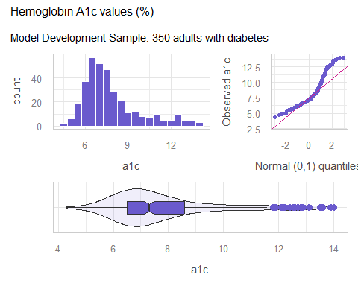

Box-Cox still suggests inverse?
mod_0 <- lm(a1c ~ a1c_old + age + income,
data = dm500_i_train)
boxCox(mod_0) ## from car package
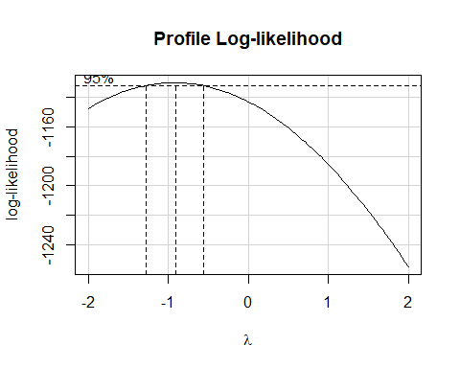

Scatterplot Matrix
- Rescale inverse transformation with 100/A1c for transa1c.
temp <- dm500_i_train |>
mutate(transa1c = 100/a1c) |>
select(a1c_old, age, income, transa1c)
ggpairs(temp,
title = "Scatterplots: Model Development Sample",
lower = list(combo = wrap("facethist", bins = 10)))
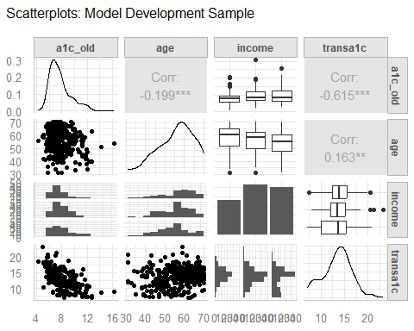

Fit the three models
- We continue to use the model training sample, and work with the (100/a1c) transformation.
dm500_i_train <- dm500_i_train |> mutate(transa1c = 100/a1c)
fit1 <- lm(transa1c ~ a1c_old, data = dm500_i_train)
fit2 <- lm(transa1c ~ a1c_old + age, data = dm500_i_train)
fit3 <- lm(transa1c ~ a1c_old + age + income,
data = dm500_i_train)
c(n_obs(fit1), n_obs(fit2), n_obs(fit3))
[1] 350 350 350

Estimated coefficients (fit1)
- 90% confidence intervals, rather than 95% today.
- Notice what include_info = TRUE does.
model_parameters(fit1, ci = 0.90, pretty_names = FALSE,
include_info = TRUE)
Parameter | Coefficient | SE | 90% CI | t(348) | p
-------------------------------------------------------------------
(Intercept) | 21.54 | 0.57 | [20.60, 22.48] | 37.94 | < .001
a1c_old | -1.05 | 0.07 | [-1.17, -0.93] | -14.56 | < .001
Model: transa1c ~ a1c_old (350 Observations)
Sigma: 2.342 (df = 348)
RMSE : 2.335
R2: 0.379; adjusted R2: 0.377
Uncertainty intervals (equal-tailed) and p-values (two-tailed) computed
using a Wald t-distribution approximation.

Making this prettier?
model_parameters(fit1, ci = 0.90, pretty_names = FALSE,
include_info = TRUE) |>
print_md()
Parameter | Coefficient | SE | 90% CI | t(348) | p
(Intercept) | 21.54 | 0.57 | (20.60, 22.48) | 37.94 | < .001
a1c_old | -1.05 | 0.07 | (-1.17, -0.93) | -14.56 | < .001
Model: transa1c ~ a1c_old (350 Observations) Sigma: 2.342 (df = 348) RMSE : 2.335 R2: 0.379; adjusted R2: 0.377

Can we use bootstrap CIs?
set.seed(431)
model_parameters(fit1, ci = 0.90, pretty_names = FALSE,
bootstrap = TRUE, iterations = 1000)
Parameter | Coefficient | 90% CI | p
---------------------------------------------------
(Intercept) | 21.59 | [20.58, 22.70] | < .001
a1c_old | -1.05 | [-1.20, -0.93] | < .001
Uncertainty intervals (equal-tailed) are naıve bootstrap intervals.
Compare to our t-based intervals:
model_parameters(fit1, ci = 0.90)
Parameter | Coefficient | SE | 90% CI | t(348) | p
-------------------------------------------------------------------
(Intercept) | 21.54 | 0.57 | [20.60, 22.48] | 37.94 | < .001
a1c old | -1.05 | 0.07 | [-1.17, -0.93] | -14.56 | < .001
Uncertainty intervals (equal-tailed) and p-values (two-tailed) computed
using a Wald t-distribution approximation.
- What does pretty_names = FALSE do?

fit2 parameters
model_parameters(fit2, ci = 0.90, pretty_names = FALSE,
include_info = TRUE)
Parameter | Coefficient | SE | 90% CI | t(347) | p
-------------------------------------------------------------------
(Intercept) | 20.64 | 1.07 | [18.88, 22.40] | 19.30 | < .001
a1c_old | -1.04 | 0.07 | [-1.16, -0.91] | -14.07 | < .001
age | 0.01 | 0.01 | [-0.01, 0.04] | 0.99 | 0.321
Model: transa1c ~ a1c_old + age (350 Observations)
Sigma: 2.342 (df = 347)
RMSE : 2.332
R2: 0.380; adjusted R2: 0.377
Uncertainty intervals (equal-tailed) and p-values (two-tailed) computed
using a Wald t-distribution approximation.

fit3 parameters
model_parameters(fit3, ci = 0.90, pretty_names = FALSE,
include_info = TRUE)
Parameter | Coefficient | SE | 90% CI | t(345) | p
----------------------------------------------------------------------------
(Intercept) | 20.70 | 1.09 | [18.90, 22.51] | 18.92 | < .001
a1c_old | -1.03 | 0.07 | [-1.16, -0.91] | -13.91 | < .001
age | 0.01 | 0.01 | [-0.01, 0.04] | 0.88 | 0.381
incomeBetween_30-50K | 0.19 | 0.32 | [-0.34, 0.72] | 0.59 | 0.553
incomeBelow_30K | -0.18 | 0.33 | [-0.73, 0.36] | -0.56 | 0.578
Model: transa1c ~ a1c_old + age + income (350 Observations)
Sigma: 2.343 (df = 345)
RMSE : 2.326
R2: 0.383; adjusted R2: 0.376
Uncertainty intervals (equal-tailed) and p-values (two-tailed) computed
using a Wald t-distribution approximation.

fit1 performance
model_performance(fit1)
# Indices of model performance
AIC | AICc | BIC | R2 | R2 (adj.) | RMSE | Sigma
------------------------------------------------------------
1592.9 | 1593.0 | 1604.5 | 0.379 | 0.377 | 2.335 | 2.342
model_performance(fit1, metrics = "common") |>
print_md(digits = 3)
Indices of model performance
AIC | BIC | R2 | R2 (adj.) | RMSE
1592.9 | 1604.5 | 0.379 | 0.377 | 2.335

Compare Fit Quality
- Same results as last week?
compare_performance(fit1, fit2, fit3, rank = TRUE)
# Comparison of Model Performance Indices
Name | Model | R2 | R2 (adj.) | RMSE | Sigma | AIC weights | AICc weights
-----------------------------------------------------------------------------
fit1 | lm | 0.379 | 0.377 | 2.335 | 2.342 | 0.558 | 0.567
fit2 | lm | 0.380 | 0.377 | 2.332 | 2.342 | 0.337 | 0.335
fit3 | lm | 0.383 | 0.376 | 2.326 | 2.343 | 0.105 | 0.097
Name | BIC weights | Performance-Score
--------------------------------------
fit1 | 0.919 | 71.43%
fit2 | 0.081 | 54.14%
fit3 | 5.28e-04 | 28.57%

Performance Comparison
plot(compare_performance(fit1, fit2, fit3))
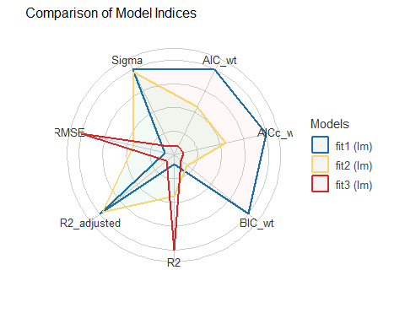

Assumption Checking (done in the Training Sample)

Assessing the models with check_model()
Three key assumptions we need to think about:
- Linearity
- Constant Variance (Homoscedasticity)
- Normality
How do we assess 1, 2, and 3? Residual plots.

In the slides, these are too short!
Plot not shown in Word version.
check_model(fit1, detrend = FALSE)

Fixing the “too short” problem?
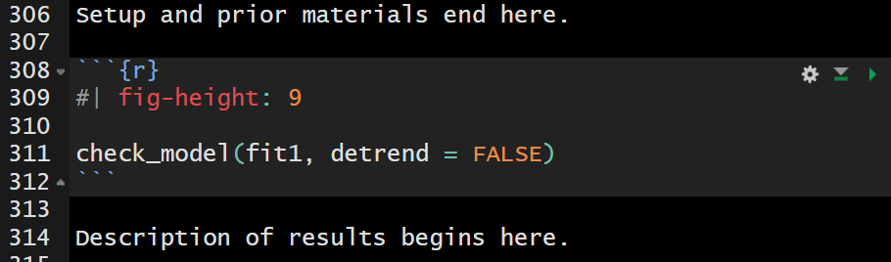
- Note where the blank lines are and where they are not.
- Check the result in your HTML!

fit1: Linearity & Homoscedasticity
check_model(fit1, check = c("linearity", "homogeneity"))
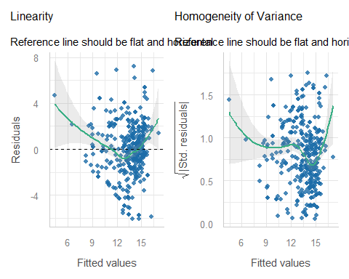

fit2: Linearity & Homoscedasticity
check_model(fit2, check = c("linearity", "homogeneity"))
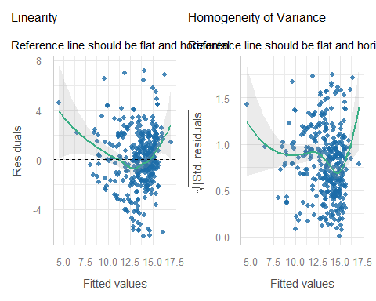

fit3: Linearity & Homoscedasticity
check_model(fit3, check = c("linearity", "homogeneity"))
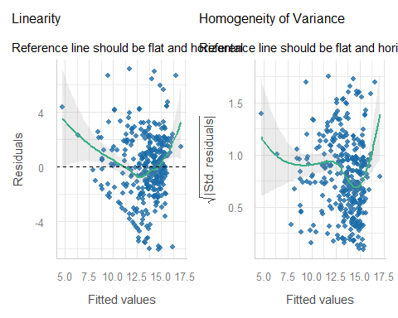

Influential Observations in fit1?
check_model(fit1, check = "outliers")
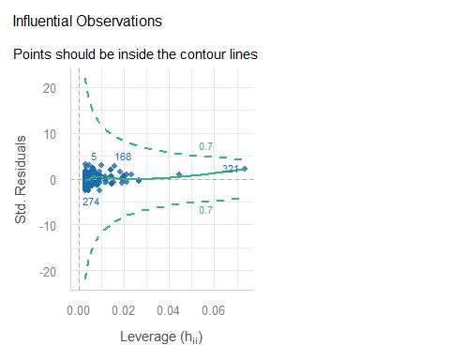

Looking at row 321?
dm500_i_train |> slice(321) |>
gt() |> tab_options(table.font.size = 20)
a1c | a1c_old | age | income | subject | transa1c
11 | 16.3 | 54 | Between_30-50K | S-002 | 9.090909

augment adds fits, residuals, etc.
from the broom package…
aug1 <- augment(fit1, data = dm500_i_train)
aug1 includes all variables in dm500_i_train and also:
- transa1c = 100/a1c, transformed outcome fit1 predicts
- .fitted = fitted (predicted) values of 100/a1c
- .resid = residual (observed - fitted outcome) values; larger residuals (positive or negative) mean poorer fit
- .std.resid = standardized residuals (residuals scaled to SD = 1, remember residual mean is already 0)

What does augment give us?
aug1 also includes:
- .hat statistic = measures leverage (larger values of .hat indicate unusual combinations of predictor values)
- .cooksd = Cook’s distance (or Cook’s d), a measure of the subject’s influence on the model (larger Cook’s d values indicate that removing the point will materially change the model’s coefficients)
- plus .sigma = estimated $σ$ if this point is dropped from the model

augment results
aug1 |> gt_preview(top_n = 7, bottom_n = 3)
 | a1c | a1c_old | age | income | subject | transa1c | .fitted | .resid | .hat | .sigma | .cooksd | .std.resid
1 | 12.7 | 9.2 | 54 | Below_30K | S-252 | 7.874016 | 11.871279 | -3.9972633 | 0.005071731 | 2.335335 | 7.463620e-03 | -1.7112267
2 | 8.0 | 8.0 | 62 | Below_30K | S-069 | 12.500000 | 13.132389 | -0.6323890 | 0.002958770 | 2.344977 | 1.085188e-04 | -0.2704384
3 | 6.5 | 5.6 | 55 | Below_30K | S-275 | 15.384615 | 15.654609 | -0.2699935 | 0.006937258 | 2.345178 | 4.675117e-05 | -0.1156926
4 | 7.1 | 10.3 | 56 | Higher_than_50K | S-187 | 14.084507 | 10.715262 | 3.3692455 | 0.009411061 | 2.338172 | 9.925863e-03 | 1.4455283
5 | 4.3 | 4.9 | 59 | Between_30-50K | S-386 | 23.255814 | 16.390256 | 6.8655576 | 0.010158248 | 2.315781 | 4.455437e-02 | 2.9466842
6 | 7.1 | 8.0 | 39 | Between_30-50K | S-440 | 14.084507 | 13.132389 | 0.9521181 | 0.002958770 | 2.344665 | 2.459902e-04 | 0.4071692
7 | 8.3 | 7.0 | 61 | Higher_than_50K | S-269 | 12.048193 | 14.183314 | -2.1351212 | 0.003287055 | 2.342412 | 1.375191e-03 | -0.9132258
8..347
348 | 11.5 | 11.8 | 43 | Below_30K | S-064 | 8.695652 | 9.138874 | -0.4432219 | 0.019031709 | 2.345100 | 3.542107e-04 | -0.1910884
349 | 5.4 | 4.2 | 56 | Higher_than_50K | S-078 | 18.518519 | 17.125904 | 1.3926147 | 0.014309832 | 2.344014 | 2.604156e-03 | 0.5989650
350 | 10.9 | 8.4 | 54 | Below_30K | S-038 | 9.174312 | 12.712019 | -3.5377071 | 0.003359223 | 2.337495 | 3.858839e-03 | -1.5131891

Summarizing our New Measures
for model fit1…
aug1 |> select(transa1c, .fitted:.std.resid) |>
summary()
transa1c .fitted .resid .hat
Min. : 7.143 Min. : 4.41 Min. :-6.08809 Min. :0.002858
1st Qu.:11.662 1st Qu.:12.71 1st Qu.:-1.37938 1st Qu.:0.003121
Median :13.699 Median :13.92 Median : 0.01877 Median :0.004007
Mean :13.476 Mean :13.48 Mean : 0.00000 Mean :0.005714
3rd Qu.:15.385 3rd Qu.:14.71 3rd Qu.: 1.51743 3rd Qu.:0.005842
Max. :23.256 Max. :17.13 Max. : 7.19837 Max. :0.073532
.sigma .cooksd .std.resid
Min. :2.313 Min. :1.800e-08 Min. :-2.6051184
1st Qu.:2.342 1st Qu.:1.539e-04 1st Qu.:-0.5902304
Median :2.344 Median :8.454e-04 Median : 0.0080404
Mean :2.342 Mean :3.251e-03 Mean : 0.0005387
3rd Qu.:2.345 3rd Qu.:2.870e-03 3rd Qu.: 0.6491588
Max. :2.345 Max. :1.712e-01 Max. : 3.0786781

augment results: row 321
for model fit1…
aug1 |> slice(321) |> gt() |> fmt_number(decimals = 2)
a1c | a1c_old | age | income | subject | transa1c | .fitted | .resid | .hat | .sigma | .cooksd | .std.resid
11.00 | 16.30 | 54.00 | Between_30-50K | S-002 | 9.09 | 4.41 | 4.68 | 0.07 | 2.33 | 0.17 | 2.08
- We’ll want augment results for fit2 and fit3 soon.
aug2 <- augment(fit2, data = dm500_i_train)
aug3 <- augment(fit3, data = dm500_i_train)

Testing the largest outlier?
car::outlierTest(fit1)
No Studentized residuals with Bonferroni p < 0.05
Largest |rstudent|:
rstudent unadjusted p-value Bonferroni p
111 3.116992 0.0019796 0.69286
A studentized residual is just another way to standardize the residuals that has some useful properties here.
- No indication that having a maximum absolute value of 3.12 in a sample of 350 studentized residuals is a major concern about the Normality assumption, given the Bonferroni p-value = 0.693.

Influential Observations in fit2?
check_model(fit2, check = "outliers")
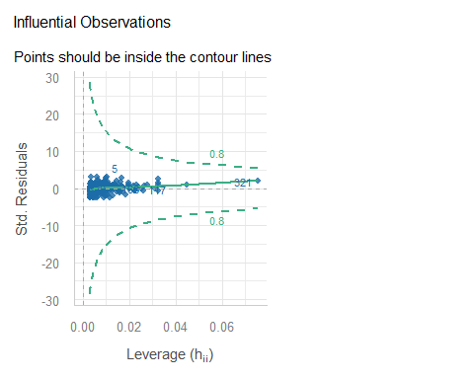

Influential Observations in fit2?
check_model(fit3, check = "outliers")
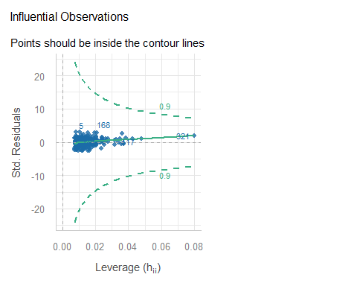

Testing the largest outlier?
- Model fit2
outlierTest(fit2)
No Studentized residuals with Bonferroni p < 0.05
Largest |rstudent|:
rstudent unadjusted p-value Bonferroni p
111 3.101016 0.002087 0.73044
- Model fit3
outlierTest(fit3)
No Studentized residuals with Bonferroni p < 0.05
Largest |rstudent|:
rstudent unadjusted p-value Bonferroni p
56 3.108793 0.0020352 0.71232

Normality Check of fit1 Residuals?
check_model(fit1, check = c("qq", "normality"),
detrend = FALSE)
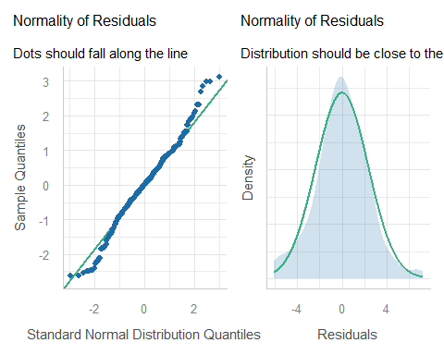

fit1: poorly fit points
which.max(aug1$.std.resid); which.min(aug1$.std.resid)
[1] 111
[1] 124
slice(aug1, c(111, 124)) |> gt() |>
fmt_number(columns = c(transa1c:.std.resid), decimals = 3)
a1c | a1c_old | age | income | subject | transa1c | .fitted | .resid | .hat | .sigma | .cooksd | .std.resid
4.7 | 7.1 | 59 | Between_30-50K | S-164 | 21.277 | 14.078 | 7.198 | 0.003 | 2.313 | 0.015 | 3.079
11.6 | 6.5 | 56 | Higher_than_50K | S-488 | 8.621 | 14.709 | -6.088 | 0.004 | 2.322 | 0.014 | -2.605
aug1 |> arrange(desc(abs(.std.resid))) |>
head(3) |> gt() |>
fmt_number(columns = c(transa1c:.std.resid), n_sigfig = 3)
a1c | a1c_old | age | income | subject | transa1c | .fitted | .resid | .hat | .sigma | .cooksd | .std.resid
4.7 | 7.1 | 59 | Between_30-50K | S-164 | 21.3 | 14.1 | 7.20 | 0.00317 | 2.31 | 0.0151 | 3.08
5.3 | 9.1 | 48 | Below_30K | S-071 | 18.9 | 12.0 | 6.89 | 0.00479 | 2.32 | 0.0209 | 2.95
4.3 | 4.9 | 59 | Between_30-50K | S-386 | 23.3 | 16.4 | 6.87 | 0.0102 | 2.32 | 0.0446 | 2.95

Normality Check of fit2 Residuals?
check_model(fit2, check = c("qq", "normality"),
detrend = FALSE)
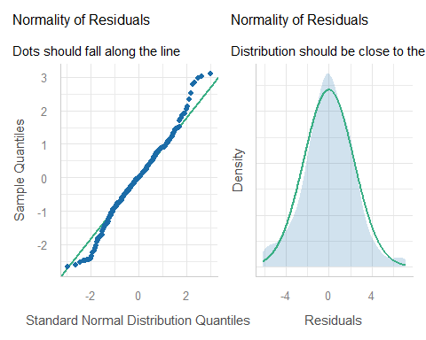

fit2: 8 poorly fit points
aug2 |> arrange(desc(abs(.std.resid))) |>
head(8) |>
gt() |>
fmt_number(columns = c(transa1c:.std.resid), decimals = 3)
a1c | a1c_old | age | income | subject | transa1c | .fitted | .resid | .hat | .sigma | .cooksd | .std.resid
4.7 | 7.1 | 59 | Between_30-50K | S-164 | 21.277 | 14.115 | 7.161 | 0.003 | 2.313 | 0.011 | 3.063
5.3 | 9.1 | 48 | Below_30K | S-071 | 18.868 | 11.887 | 6.981 | 0.006 | 2.315 | 0.019 | 2.990
4.3 | 4.9 | 59 | Between_30-50K | S-386 | 23.256 | 16.395 | 6.861 | 0.010 | 2.316 | 0.030 | 2.945
6.2 | 11.4 | 56 | Below_30K | S-341 | 16.129 | 9.616 | 6.513 | 0.017 | 2.319 | 0.044 | 2.804
4.9 | 7.0 | 43 | Higher_than_50K | S-052 | 20.408 | 13.993 | 6.416 | 0.010 | 2.320 | 0.026 | 2.753
12.8 | 7.3 | 65 | Below_30K | S-214 | 7.812 | 13.993 | -6.180 | 0.006 | 2.321 | 0.014 | -2.647
11.6 | 6.5 | 56 | Higher_than_50K | S-488 | 8.621 | 14.695 | -6.074 | 0.004 | 2.322 | 0.009 | -2.599
9.7 | 5.1 | 58 | Higher_than_50K | S-368 | 10.309 | 16.174 | -5.864 | 0.009 | 2.324 | 0.019 | -2.516

Normality Check of fit3 Residuals?
check_model(fit3, check = c("qq", "normality"),
detrend = FALSE)
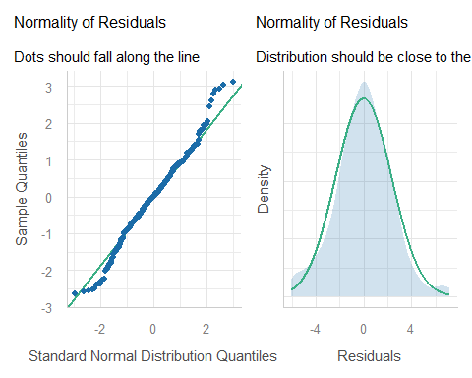

fit3: 8 poorly fit points
aug3 |> arrange(desc(abs(.std.resid))) |>
head(8) |>
gt() |>
fmt_number(columns = c(transa1c:.std.resid), decimals = 3)
a1c | a1c_old | age | income | subject | transa1c | .fitted | .resid | .hat | .sigma | .cooksd | .std.resid
5.3 | 9.1 | 48 | Below_30K | S-071 | 18.868 | 11.711 | 7.157 | 0.010 | 2.314 | 0.020 | 3.070
4.7 | 7.1 | 59 | Between_30-50K | S-164 | 21.277 | 14.292 | 6.984 | 0.008 | 2.316 | 0.015 | 2.993
6.2 | 11.4 | 56 | Below_30K | S-341 | 16.129 | 9.432 | 6.697 | 0.021 | 2.318 | 0.035 | 2.888
4.3 | 4.9 | 59 | Between_30-50K | S-386 | 23.256 | 16.568 | 6.688 | 0.015 | 2.318 | 0.026 | 2.876
4.9 | 7.0 | 43 | Higher_than_50K | S-052 | 20.408 | 14.004 | 6.405 | 0.019 | 2.320 | 0.030 | 2.760
11.6 | 6.5 | 56 | Higher_than_50K | S-488 | 8.621 | 14.685 | -6.064 | 0.012 | 2.323 | 0.016 | -2.603
4.8 | 5.8 | 31 | Below_30K | S-464 | 20.833 | 14.910 | 5.923 | 0.036 | 2.324 | 0.050 | 2.575
12.8 | 7.3 | 65 | Below_30K | S-214 | 7.812 | 13.787 | -5.974 | 0.012 | 2.324 | 0.017 | -2.566

Collinearity

Checking for Collinearity
Collinearity refers to correlations between predictors.
- Strong correlations between predictors can inflate the variance of our estimates, and also make it hard to distinguish effects attributable to correlated predictors.
- When we have multiple predictors (as in fit2 and fit3) it is worth quantifying the extent to which our variances are inflated by collinearity.
- We can estimate the effect of collinearity directly through the vif() function in the car package, or …

fit2: Collinearity Check
check_collinearity(fit2)
# Check for Multicollinearity
Low Correlation
Term VIF VIF 95% CI adj. VIF Tolerance Tolerance 95% CI
a1c_old 1.04 [1.01, 1.09] 1.02 0.96 [0.91, 0.99]
age 1.04 [1.01, 1.09] 1.02 0.96 [0.91, 0.99]
- (generalized) variance inflation factors above 5 are worthy of our special attention

Model fit2 Check for Collinearity
check_model(fit2, check = "vif")
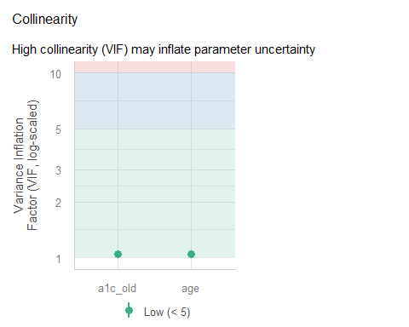

fit3: Collinearity Check
check_collinearity(fit3)
# Check for Multicollinearity
Low Correlation
Term VIF VIF 95% CI adj. VIF Tolerance Tolerance 95% CI
a1c_old 1.06 [1.01, 1.12] 1.03 0.94 [0.90, 0.99]
age 1.06 [1.01, 1.12] 1.03 0.94 [0.90, 0.99]
income 1.05 [1.01, 1.10] 1.01 0.96 [0.91, 0.99]
- If there’s no problem with collinearity in fit3, can there be a problem with collinearity in fit2, which contains a subset of the same predictors?

Model fit3 Check for Collinearity
check_model(fit3, check = "vif")
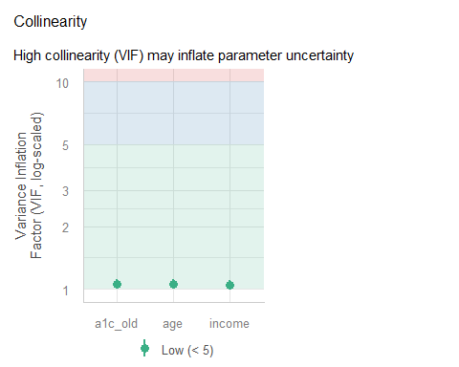

Posterior Predictive Checks

Posterior Predictive Check: fit1
check_model(fit1, check = "pp_check")
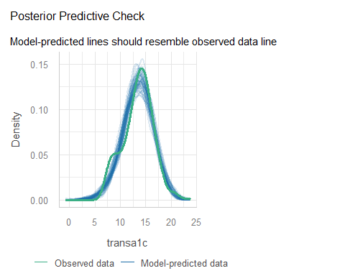

fit1: Observed vs. Predicted
ggplot(aug1, aes(x = .fitted, y = transa1c)) +
geom_point() +
geom_abline(slope = 1, intercept = 0,
lwd = 2, lty = "dashed", col = "magenta")
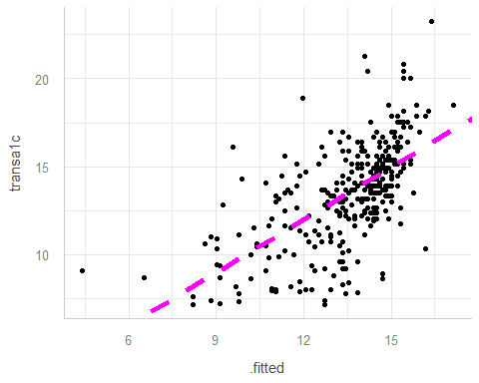

fit1: Observed and Predicted
aug1 |> reframe(lovedist(transa1c))
# A tibble: 1 × 10
n miss mean sd med mad min q25 q75 max
<int> <int> <dbl> <dbl> <dbl> <dbl> <dbl> <dbl> <dbl> <dbl>
1 350 0 13.5 2.97 13.7 2.50 7.14 11.7 15.4 23.3
aug1 |> reframe(lovedist(.fitted))
# A tibble: 1 × 10
n miss mean sd med mad min q25 q75 max
<int> <int> <dbl> <dbl> <dbl> <dbl> <dbl> <dbl> <dbl> <dbl>
1 350 0 13.5 1.83 13.9 1.48 4.41 12.7 14.7 17.1
cor(aug1$transa1c, aug1$.fitted); cor(aug1$transa1c, aug1$.fitted)^2
[1] 0.6153499
[1] 0.3786555
r2(fit1)
# R2 for Linear Regression
R2: 0.379
adj. R2: 0.377

fit1: Predictions and Observed
p1 <- ggplot(aug1, aes(x = .fitted, y = "")) +
geom_violin() +
geom_boxplot(fill = "royalblue", alpha = 0.5, width = 0.3) +
xlim(0, 25) +
stat_summary(fun = "mean", col = "red") +
labs(title = "Predicted 100/A1c values (model fit1)", y = "")
p2 <- ggplot(aug1, aes(x = transa1c, y = "")) +
geom_violin() +
geom_boxplot(fill = "mistyrose", alpha = 0.5, width = 0.3) +
xlim(0, 25) +
stat_summary(fun = "mean", col = "red") +
labs(title = "Observed 100/A1c values", y = "")
p1 / p2
Warning: Removed 1 row containing missing values or values outside the scale range
(`geom_segment()`).
Removed 1 row containing missing values or values outside the scale range
(`geom_segment()`).
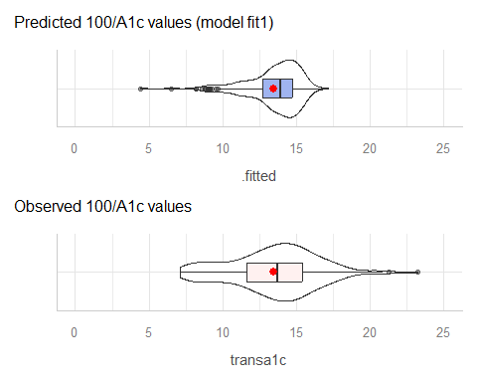

Posterior Predictive Check: fit2
check_model(fit2, check = "pp_check")
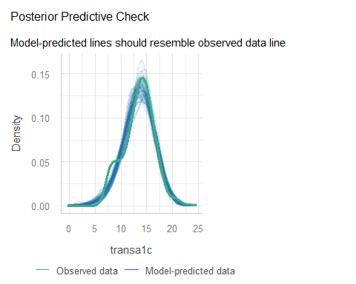

fit2: Predictions and Observed
p1 <- ggplot(aug2, aes(x = .fitted, y = "")) +
geom_violin() +
geom_boxplot(fill = "royalblue", alpha = 0.5, width = 0.3) +
xlim(0, 25) +
stat_summary(fun = "mean", col = "red") +
labs(title = "Predicted 100/A1c values (model fit2)", y = "")
p2 <- ggplot(aug2, aes(x = transa1c, y = "")) +
geom_violin() +
geom_boxplot(fill = "mistyrose", alpha = 0.5, width = 0.3) +
xlim(0, 25) +
stat_summary(fun = "mean", col = "red") +
labs(title = "Observed 100/A1c values", y = "")
p1 / p2
Warning: Removed 1 row containing missing values or values outside the scale range
(`geom_segment()`).
Removed 1 row containing missing values or values outside the scale range
(`geom_segment()`).
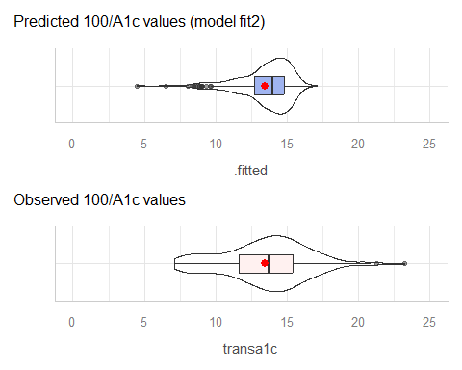

fit2: Observed and Predicted
aug2 |> reframe(lovedist(transa1c))
# A tibble: 1 × 10
n miss mean sd med mad min q25 q75 max
<int> <int> <dbl> <dbl> <dbl> <dbl> <dbl> <dbl> <dbl> <dbl>
1 350 0 13.5 2.97 13.7 2.50 7.14 11.7 15.4 23.3
aug2 |> reframe(lovedist(.fitted))
# A tibble: 1 × 10
n miss mean sd med mad min q25 q75 max
<int> <int> <dbl> <dbl> <dbl> <dbl> <dbl> <dbl> <dbl> <dbl>
1 350 0 13.5 1.83 14.0 1.46 4.51 12.7 14.8 17.1
cor(aug2$transa1c, aug2$.fitted); cor(aug2$transa1c, aug2$.fitted)^2
[1] 0.6167804
[1] 0.380418
r2(fit2)
# R2 for Linear Regression
R2: 0.380
adj. R2: 0.377

Posterior Predictive Check: fit3
check_model(fit3, check = "pp_check")
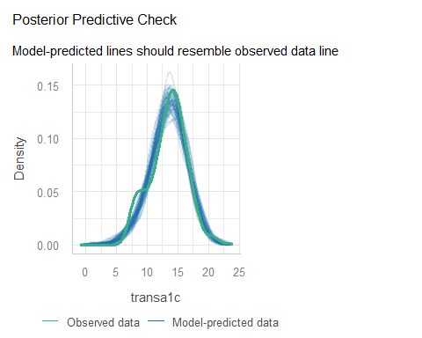

fit3: Predictions and Observed
p1 <- ggplot(aug3, aes(x = .fitted, y = "")) +
geom_violin() +
geom_boxplot(fill = "royalblue", alpha = 0.5, width = 0.3) +
xlim(0, 25) +
stat_summary(fun = "mean", col = "red") +
labs(title = "Predicted 100/A1c values (model fit3)", y = "")
p2 <- ggplot(aug1, aes(x = transa1c, y = "")) +
geom_violin() +
geom_boxplot(fill = "mistyrose", alpha = 0.5, width = 0.3) +
xlim(0, 25) +
stat_summary(fun = "mean", col = "red") +
labs(title = "Observed 100/A1c values", y = "")
p1 / p2
Warning: Removed 1 row containing missing values or values outside the scale range
(`geom_segment()`).
Removed 1 row containing missing values or values outside the scale range
(`geom_segment()`).
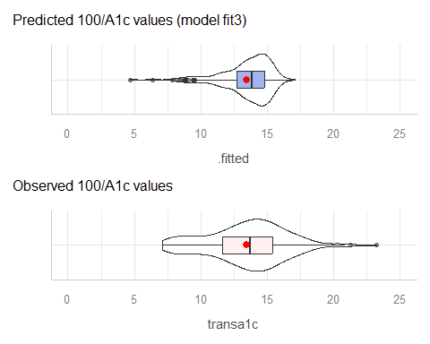

fit3: Observed and Predicted
aug3 |> reframe(lovedist(transa1c))
# A tibble: 1 × 10
n miss mean sd med mad min q25 q75 max
<int> <int> <dbl> <dbl> <dbl> <dbl> <dbl> <dbl> <dbl> <dbl>
1 350 0 13.5 2.97 13.7 2.50 7.14 11.7 15.4 23.3
aug3 |> reframe(lovedist(.fitted))
# A tibble: 1 × 10
n miss mean sd med mad min q25 q75 max
<int> <int> <dbl> <dbl> <dbl> <dbl> <dbl> <dbl> <dbl> <dbl>
1 350 0 13.5 1.84 13.9 1.47 4.71 12.7 14.8 17.1
cor(aug3$transa1c, aug3$.fitted); cor(aug3$transa1c, aug3$.fitted)^2
[1] 0.6191479
[1] 0.3833441
r2(fit3)
# R2 for Linear Regression
R2: 0.383
adj. R2: 0.376

Extending to the Test Sample

Making Predictions: Test Sample
- Create transformed outcome in test sample.
- For OLS fits, apply augment() to new data = test sample.
dm500_i_test <- dm500_i_test |> mutate(transa1c = 100/a1c)
aug1_test <- augment(fit1, newdata = dm500_i_test) |>
mutate(mod = "fit1")
aug2_test <- augment(fit2, newdata = dm500_i_test) |>
mutate(mod = "fit2")
aug3_test <- augment(fit3, newdata = dm500_i_test) |>
mutate(mod = "fit3")
Results on next slide…

augment for each model
aug1_test |> head(2) |> gt()
a1c | a1c_old | age | income | subject | transa1c | .fitted | .resid | mod
6.3 | 11.4 | 62 | Higher_than_50K | S-001 | 15.87302 | 9.559244 | 6.31377179 | fit1
6.5 | 5.8 | 53 | Below_30K | S-004 | 15.38462 | 15.444424 | -0.05980853 | fit1
aug2_test |> head(2) |> gt()
a1c | a1c_old | age | income | subject | transa1c | .fitted | .resid | mod
6.3 | 11.4 | 62 | Higher_than_50K | S-001 | 15.87302 | 9.701117 | 6.171898626 | fit2
6.5 | 5.8 | 53 | Below_30K | S-004 | 15.38462 | 15.377594 | 0.007020891 | fit2
aug3_test |> head(2) |> gt()
a1c | a1c_old | age | income | subject | transa1c | .fitted | .resid | mod
6.3 | 11.4 | 62 | Higher_than_50K | S-001 | 15.87302 | 9.691255 | 6.1817606 | fit3
6.5 | 5.8 | 53 | Below_30K | S-004 | 15.38462 | 15.187314 | 0.1973018 | fit3

Combine Augmented Results
temp12 <- bind_rows(aug1_test, aug2_test)
test_res <- bind_rows(temp12, aug3_test) |>
relocate(subject, mod, a1c, everything()) |>
arrange(subject, mod)
test_res |> head() |> gt() |> tab_options(table.font.size = 20)
subject | mod | a1c | a1c_old | age | income | transa1c | .fitted | .resid
S-001 | fit1 | 6.3 | 11.4 | 62 | Higher_than_50K | 15.87302 | 9.559244 | 6.313771788
S-001 | fit2 | 6.3 | 11.4 | 62 | Higher_than_50K | 15.87302 | 9.701117 | 6.171898626
S-001 | fit3 | 6.3 | 11.4 | 62 | Higher_than_50K | 15.87302 | 9.691255 | 6.181760567
S-004 | fit1 | 6.5 | 5.8 | 53 | Below_30K | 15.38462 | 15.444424 | -0.059808527
S-004 | fit2 | 6.5 | 5.8 | 53 | Below_30K | 15.38462 | 15.377594 | 0.007020891
S-004 | fit3 | 6.5 | 5.8 | 53 | Below_30K | 15.38462 | 15.187314 | 0.197301765

Calculating Prediction Errors
For each of our (OLS) models, we have:
- a1c, the outcome we actually care about
- transa1c = 100/a1c, the transformed outcome
- .fitted, a predicted transa1c from the model
What we want is
- a1c_pred, the predicted a1c using this model, and
- a1c_error, the error made in predicting a1c

Back-Transformation
Each .fitted value is a prediction of 100/a1c.
$$
\frac{100}{a1c} = \mbox{.fitted}, \mbox{ so } \frac{1}{a1c} = \frac{\mbox{.fitted}}{100}, \mbox{ and so}\\
a1c = \frac{100}{\mbox{.fitted}}
$$
To get a1c_pred we need to back-transform our .fitted values, with 100/.fitted, it seems.

Adding predicted A1c and error
- We add a1c_pred, the predicted a1c using this model, and
- a1c_error = error for this model in predicting a1c
test_res <- test_res |>
mutate(a1c_pred = 100/.fitted,
a1c_error = a1c - a1c_pred)
test_res |> head(4) |> gt()
subject | mod | a1c | a1c_old | age | income | transa1c | .fitted | .resid | a1c_pred | a1c_error
S-001 | fit1 | 6.3 | 11.4 | 62 | Higher_than_50K | 15.87302 | 9.559244 | 6.31377179 | 10.461078 | -4.16107821
S-001 | fit2 | 6.3 | 11.4 | 62 | Higher_than_50K | 15.87302 | 9.701117 | 6.17189863 | 10.308091 | -4.00809106
S-001 | fit3 | 6.3 | 11.4 | 62 | Higher_than_50K | 15.87302 | 9.691255 | 6.18176057 | 10.318581 | -4.01858070
S-004 | fit1 | 6.5 | 5.8 | 53 | Below_30K | 15.38462 | 15.444424 | -0.05980853 | 6.474829 | 0.02517125

Summarize Errors for Each Fit
We’ll look at four summary measures in 431…
- MAPE = mean absolute prediction error
- Max_APE = maximum absolute prediction error
- RMSPE = square root of mean squared prediction error
- Validated $R^{2}$ = squared correlation of predictions and outcome in the new data
Measures 1-3 are all in the same units as a1c, our outcome.

Building our Four Summaries
The test_res tibble contains, for each model,
- a1c, the actual outcome value
- a1c_pred, the predicted outcome value
- a1c_error = a1c - a1c_pred = prediction error
test_summary <- test_res |>
group_by(mod) |>
summarize(MAPE = mean(abs(a1c_error)),
Max_APE = max(abs(a1c_error)),
RMSE = sqrt(mean(a1c_error^2)),
R2_val = cor(a1c, a1c_pred)^2)

Table for Test-Sample Prediction
test_summary |>
gt() |>
fmt_number(decimals = 4) |>
tab_options(table.font.size = 24)
mod | MAPE | Max_APE | RMSE | R2_val
fit1 | 1.1033 | 5.7532 | 1.6080 | 0.4608
fit2 | 1.0958 | 5.5978 | 1.5911 | 0.4699
fit3 | 1.0959 | 5.8548 | 1.5965 | 0.4685
- Which model is best, by these metrics?
- fit2 has smallest MAPE, Max_APE, RMSPE, and largest validated $R^{2}$

Putting this all together
- fit1 includes a1c_old, fit2 adds age, fit3 adds income
- Similar model assumption issues (hard-to-ignore problem with linearity, maybe non-constant variance)
- training sample: fit3 performed best on $R^{2}$ and RMSE, fit1 was best on adjusted $R^{2}$, AIC, BIC and $σ$.
- test sample: fit2 performed best on MAPE, Max(APE), RMSPE and validated $R^{2}$.
- Only modest differences between models on most metrics.

I decided to choose Model fit2

Complete Case Analysis
- Project B Study 2: Report the model building process, displaying conclusions from training sample (transformation decisions, fitted parameters with CIs and interpretations, comparison of performance metrics, checks of model assumptions) and from test sample (comparison of predictive error)
- Of course, here we did some imputation, so we’d need to do this all over again with complete cases to get these results.

Simple Imputation
- Project B Study 2: Report the model building process, displaying conclusions from training sample (transformation decisions, fitted parameters with CIs and interpretations, comparison of performance metrics, checks of model assumptions) and from test sample (comparison of predictive error)
- Sometimes, we do some of the steps above without reporting them to the public, of course. But that’s not the goal here.

Model fit2 using Single Imputation
Estimated using a single imputation in training sample.
model_parameters(fit2, ci = 0.90,
pretty_names = FALSE,
include_info = TRUE)
Parameter | Coefficient | SE | 90% CI | t(347) | p
-------------------------------------------------------------------
(Intercept) | 20.64 | 1.07 | [18.88, 22.40] | 19.30 | < .001
a1c_old | -1.04 | 0.07 | [-1.16, -0.91] | -14.07 | < .001
age | 0.01 | 0.01 | [-0.01, 0.04] | 0.99 | 0.321
Model: transa1c ~ a1c_old + age (350 Observations)
Sigma: 2.342 (df = 347)
RMSE : 2.332
R2: 0.380; adjusted R2: 0.377
Uncertainty intervals (equal-tailed) and p-values (two-tailed) computed
using a Wald t-distribution approximation.

Incorporating Multiple Imputations
- Same as Project B Study 2: Report the model building process, displaying conclusions from training sample (transformation decisions, fitted parameters with CIs and interpretations, comparison of performance metrics, checks of model assumptions) and from test sample (comparison of predictive error)
- New Then add information on fitted parameters across the whole data set (not split into training and testing) after multiple (in this case, 10) imputations.

Using Ten Imputations
dm500_tenimps contained mice results across 10 imputations, then we used the 4th in our work. Let’s build a new set of results across the model we’ve settled on, with a fresh set of 10 imputations.
- The original data (with missing values) are in dm500 - we need only to add our transformed outcome, 100/a1c.
dm500 <- dm500 |> mutate(transa1c = 100/a1c)
imp2_fit <- dm500 |>
mice(m = 10, seed = 431, print = FALSE) |>
with(lm(transa1c ~ a1c_old + age)) |>
pool()
Warning: Number of logged events: 1

Estimates across 10 imputations
model_parameters(imp2_fit, ci = 0.90,
pretty_names = FALSE)
Warning: Number of logged events: 1
Warning: Number of logged events: 1
Warning: Number of logged events: 1
Warning: Number of logged events: 1
# Fixed Effects
Parameter | Coefficient | SE | 90% CI | t | df | p
----------------------------------------------------------------------------
(Intercept) | 19.93 | 0.85 | [18.53, 21.33] | 23.49 | 485.52 | < .001
a1c_old | -1.00 | 0.06 | [-1.10, -0.90] | -16.77 | 465.43 | < .001
age | 0.02 | 0.01 | [ 0.00, 0.04] | 1.79 | 482.67 | 0.075
Uncertainty intervals (equal-tailed) and p-values (two-tailed) computed
using a Wald t-distribution approximation.
pool.r.squared(imp2_fit)
est lo 95 hi 95 fmi
R^2 0.3842468 0.3143945 0.4525868 0.06619506
pool.r.squared(imp2_fit, adjusted = TRUE)
est lo 95 hi 95 fmi
adj R^2 0.3817684 0.3118849 0.4502088 0.06660368

Bayesian model fits instead?

Refit with Bayesian models?
What must we change to use Bayesian (stan_glm) fits?
- Must create transformed outcome in data prior to fitting with rstanarm().
- Results are a bit different for model_parameters()
- Results are a bit different for model_performance()
- No real change for check_model()
- No augment() function for rstanarm() fits.

Refit with Bayesian models?
- Single imputation, default weakly informative priors
set.seed(20251111)
fit1B <- stan_glm(transa1c ~ a1c_old,
data = dm500_i_train, refresh = 0)
fit2B <- stan_glm(transa1c ~ a1c_old + age,
data = dm500_i_train, refresh = 0)
fit3B <- stan_glm(transa1c ~ a1c_old + age + income,
data = dm500_i_train, refresh = 0)
- By default, stan_glm() performs 4000 simulations from the joint distribution of parameters.

Estimating fit1B Coefficients?
model_parameters(fit1B, ci = 0.90, pretty_names = FALSE, include_info = TRUE)
Parameter | Median | 90% CI | pd | Rhat | ESS (tail) | Prior
------------------------------------------------------------------------------------------
(Intercept) | 21.54 | [20.60, 22.46] | 100% | 1.000 | 2696 | Normal (13.48 +- 7.42)
a1c_old | -1.05 | [-1.17, -0.93] | 100% | 1.000 | 2669 | Normal (0.00 +- 4.27)
Model: transa1c ~ a1c_old (350 Observations)
RMSE : 2.335
: 0.378
Uncertainty intervals (equal-tailed) computed using a MCMC distribution
approximation.
- : 0.378 indicates “Bayesian” $R^{2}$ value
- pd = probability of direction, an index of effect existence, representing the certainty with which an effect goes in a particular direction.
- We want Rhat < 1.05 and ESS > 100.

fit2B Coefficients?
model_parameters(fit2B, ci = 0.90, pretty_names = FALSE) |>
gt()
Parameter | Median | CI | CI_low | CI_high | pd | Rhat | ESS_tail | Prior_Distribution | Prior_Location | Prior_Scale
(Intercept) | 20.62084500 | 0.9 | 18.884286939 | 22.43192391 | 1.00000 | 1.000513 | 2558 | normal | 13.47619 | 7.4166884
a1c_old | -1.03788107 | 0.9 | -1.156468570 | -0.91340801 | 1.00000 | 1.001463 | 2519 | normal | 0.00000 | 4.2696233
age | 0.01459798 | 0.9 | -0.009797824 | 0.03770488 | 0.84625 | 1.000090 | 2863 | normal | 0.00000 | 0.8252597
- Rhat and ESS are diagnostic metrics.
  - If Rhat < 1.05, model convergence is probably OK.
  - If ESS > 100, then estimates are usually reliable.

fit3B Coefficients?
model_parameters(fit3B, ci = 0.90,
pretty_names = FALSE) |>
gt()
Parameter | Median | CI | CI_low | CI_high | pd | Rhat | ESS_tail | Prior_Distribution | Prior_Location | Prior_Scale
(Intercept) | 20.7072038 | 0.9 | 18.87443659 | 22.4977987 | 1.00000 | 1.0007519 | 2833 | normal | 13.47619 | 7.4166884
a1c_old | -1.0334197 | 0.9 | -1.15591666 | -0.9076764 | 1.00000 | 1.0003656 | 2356 | normal | 0.00000 | 4.2696233
age | 0.0123540 | 0.9 | -0.01088992 | 0.0368757 | 0.81275 | 1.0007125 | 3190 | normal | 0.00000 | 0.8252597
incomeBetween_30-50K | 0.1921164 | 0.9 | -0.34195993 | 0.7207961 | 0.73575 | 0.9992967 | 2821 | normal | 0.00000 | 15.2362290
incomeBelow_30K | -0.1734018 | 0.9 | -0.73343326 | 0.3738690 | 0.70850 | 0.9999700 | 2594 | normal | 0.00000 | 15.4564766

Model Performance with fit1B?
model_performance(fit1B)
# Indices of model performance
ELPD | ELPD_SE | LOOIC | LOOIC_SE | WAIC | R2 | R2 (adj.) | RMSE | Sigma
-----------------------------------------------------------------------------------
-796.711 | 15.056 | 1593.4 | 30.112 | 1593.4 | 0.378 | 0.373 | 2.335 | 2.347
- R2 = “unadjusted” Bayesian $R^{2}$ (see r2_bayes for details)
- R2_adjusted = leave-one-out cross-validation (LOO) adjusted $R^{2}$, which is conceptually closer to our OLS adjusted $R^{2}$ than some other options.
- RMSE = root mean squared error, so lower values mean better fit.

Bayesian Model Performance
model_performance(fit2B)
# Indices of model performance
ELPD | ELPD_SE | LOOIC | LOOIC_SE | WAIC | R2 | R2 (adj.) | RMSE | Sigma
-----------------------------------------------------------------------------------
-797.335 | 15.158 | 1594.7 | 30.316 | 1594.7 | 0.380 | 0.372 | 2.332 | 2.348
- Sigma = residual standard deviation (95% of in-sample predictions should be within $±2σ$)
- WAIC = Widely Applicable Information Criterion. Lower WAIC values mean better fit.

Bayesian Model Performance
model_performance(fit3B)
# Indices of model performance
ELPD | ELPD_SE | LOOIC | LOOIC_SE | WAIC | R2 | R2 (adj.) | RMSE | Sigma
-----------------------------------------------------------------------------------
-798.461 | 15.113 | 1596.9 | 30.226 | 1596.9 | 0.382 | 0.368 | 2.326 | 2.349
- ELPD = expected log predictive density. Larger ELPD means better fit.
- LOOIC = leave-one-out cross-validation (LOO) information criterion. Lower LOOIC means better fit.
- LOOIC_SE = standard error of LOOIC
Performance of Bayesian Models describes more options.

Performance in Training Sample?
compare_performance(fit1B, fit2B, fit3B, rank = TRUE) |>
gt() |> fmt_number(decimals = 3) |>
tab_options(table.font.size = 20)
Name | Model | R2 | R2_adjusted | RMSE | Sigma | WAIC_wt | LOOIC_wt | Performance_Score
fit1B | stanreg | 0.378 | 0.373 | 2.335 | 2.347 | 0.583 | 1.000 | 0.667
fit2B | stanreg | 0.380 | 0.372 | 2.332 | 2.348 | 0.314 | 0.000 | 0.409
fit3B | stanreg | 0.382 | 0.368 | 2.326 | 2.349 | 0.102 | 0.000 | 0.333

Bayes Performance Indicators?
plot(compare_performance(fit1B, fit2B, fit3B,
metrics = c("WAIC", "R2", "RMSE")))
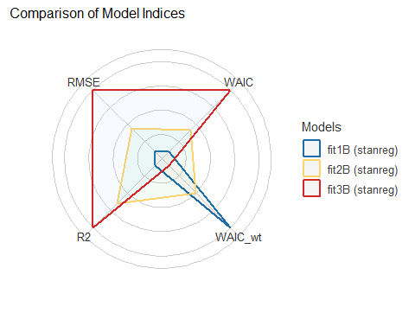

Why not all the indicators?
plot(compare_performance(fit1B, fit2B, fit3B))
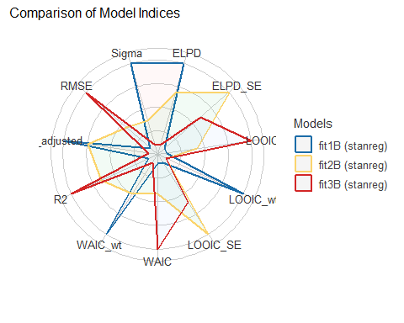

Checking Bayesian fit1B, fit2B and fit3B
Plots not shown in Word version. See HTML slides.

No augment from Bayes fits
The augment() function from broom doesn’t work with Bayesian fits using rstanarm().
We still want to get our predicted (fitted) values and residuals for each observation in our training sample.
aug_1B <- dm500_i_train |>
mutate(.fitted = predict(fit1B),
.resid = transa1c - predict(fit1B))
aug_2B <- dm500_i_train |>
mutate(.fitted = predict(fit2B),
.resid = transa1c - predict(fit2B))
aug_3B <- dm500_i_train |>
mutate(.fitted = predict(fit3B),
.resid = transa1c - predict(fit3B))

fit2 model (OLS vs Bayes)
aug2 |> select(1:8) |> head(3)
# A tibble: 3 × 8
a1c a1c_old age income subject transa1c .fitted .resid
<dbl> <dbl> <dbl> <fct> <chr> <dbl> <dbl> <dbl>
1 12.7 9.2 54 Below_30K S-252 7.87 11.9 -3.99
2 8 8 62 Below_30K S-069 12.5 13.2 -0.725
3 6.5 5.6 55 Below_30K S-275 15.4 15.6 -0.229
aug_2B |> head(3)
# A tibble: 3 × 8
a1c a1c_old age income subject transa1c .fitted .resid
<dbl> <dbl> <dbl> <fct> <chr> <dbl> <dbl> <dbl>
1 12.7 9.2 54 Below_30K S-252 7.87 11.9 -3.99
2 8 8 62 Below_30K S-069 12.5 13.2 -0.723
3 6.5 5.6 55 Below_30K S-275 15.4 15.6 -0.227

Bayes fit to test sample?
Everything is the same as OLS, except we’d have to work around the use of augment in our test data, but predict() can handle what we need, as below.
test_1B <- dm500_i_test |>
mutate(a1c_pred = predict(fit1B, newdata = dm500_i_test),
a1c_error = transa1c - a1c_pred,
mod = "fit1B")
test_1B |> head(4) |> gt()
a1c | a1c_old | age | income | subject | transa1c | a1c_pred | a1c_error | mod
6.3 | 11.4 | 62 | Higher_than_50K | S-001 | 15.873016 | 9.561669 | 6.31134667 | fit1B
6.5 | 5.8 | 53 | Below_30K | S-004 | 15.384615 | 15.442260 | -0.05764483 | fit1B
5.8 | 6.5 | 48 | Below_30K | S-006 | 17.241379 | 14.707186 | 2.53419297 | fit1B
16.7 | 14.6 | 54 | Below_30K | S-011 | 5.988024 | 6.201331 | -0.21330754 | fit1B

Bayes fit to test sample?
test_2B <- dm500_i_test |>
mutate(a1c_pred = predict(fit2B, newdata = dm500_i_test),
a1c_error = transa1c - a1c_pred,
mod = "fit2B")
test_3B <- dm500_i_test |>
mutate(a1c_pred = predict(fit3B, newdata = dm500_i_test),
a1c_error = transa1c - a1c_pred,
mod = "fit3B")

Combine test sample results
- For our Bayesian models…
temp12B <- bind_rows(test_1B, test_2B)
test_resB <- bind_rows(temp12B, test_3B) |>
relocate(subject, mod, a1c, everything()) |>
arrange(subject, mod)
testB_summary <- test_resB |>
group_by(mod) |>
summarize(MAPE = mean(abs(a1c_error)),
Max_APE = max(abs(a1c_error)),
RMSE = sqrt(mean(a1c_error^2)),
R2_val = cor(a1c, a1c_pred)^2)

Test-Sample Predictions
- From our Bayes models
testB_summary |> gt() |> fmt_number(decimals = 4) |>
tab_options(table.font.size = 24)
mod | MAPE | Max_APE | RMSE | R2_val
fit1B | 1.6510 | 8.1551 | 2.1900 | 0.4464
fit2B | 1.6407 | 8.0454 | 2.1743 | 0.4525
fit3B | 1.6504 | 8.2237 | 2.1877 | 0.4539
- What’s the winner among these?

What’s next?
- Do most of this again, including some additional bells and whistles, and some new data.
- Multiple imputation with Bayesian linear models is a topic for 432 (or later.)

Session Information
xfun::session_info()
R version 4.6.1 (2026-06-24 ucrt)
Platform: x86_64-w64-mingw32/x64
Running under: Windows 11 x64 (build 26200)
Locale:
LC_COLLATE=English_United States.utf8
LC_CTYPE=English_United States.utf8
LC_MONETARY=English_United States.utf8
LC_NUMERIC=C
LC_TIME=English_United States.utf8
Package version:
abind_1.4-8 ape_5.8.1 askpass_1.2.1
backports_1.5.1 base64enc_0.1-6 bayesplot_1.16.0
bayestestR_0.20.0 BH_1.90.0.1 bigD_0.3.1
bit_4.6.0 bit64_4.8.6 bitops_1.1.0
blob_1.3.0 boot_1.3-32 broom_1.0.13
bslib_0.12.0 cachem_1.1.0 callr_3.8.0
car_3.1-5 carData_3.0-6 cellranger_1.1.0
checkmate_2.3.4 cli_3.6.6 clipr_0.8.1
coda_0.19-4.1 codetools_0.2-20 colorspace_2.1.4
colourpicker_1.3.0 commonmark_2.0.0 compiler_4.6.1
conflicted_1.2.0 correlation_0.8.8 cowplot_1.2.0
cpp11_0.5.5 crayon_1.5.3 crosstalk_1.2.2
curl_8.1.0 data.table_1.18.6.1 datasets_4.6.1
datawizard_1.4.1 DBI_1.3.0 dbplyr_2.6.0
Deriv_4.3.6 desc_1.4.3 DHARMa_0.5.0
digest_0.6.39 distributional_0.9.0 doBy_4.7.2
doParallel_1.0.17 dplyr_1.2.1 DT_0.34.0
dtplyr_1.3.3 dygraphs_1.1.1.6 easystats_0.7.6
effectsize_1.0.3 emmeans_2.0.4 estimability_2.0.0
evaluate_1.0.5 farver_2.1.2 fastmap_1.2.0
fontawesome_0.5.3 forcats_1.0.1 foreach_1.5.2
forecast_9.0.2 Formula_1.2-6 fracdiff_1.5.4
fs_2.1.0 gap_1.15.3 gap.datasets_0.0.6
gargle_1.7.0 generics_0.1.4 GGally_2.4.0
ggdist_3.3.3 ggplot2_4.0.3 ggrepel_0.9.8
ggridges_0.5.7 ggstats_0.14.0 glmnet_5.2
glue_1.8.1 googledrive_2.2.0 googlesheets4_1.1.3
graphics_4.6.1 grDevices_4.6.1 grid_4.6.1
gridExtra_2.3.1 gt_1.4.0 gtable_0.3.6
gtools_3.9.5 haven_2.5.5 here_1.0.2
highr_0.12 hms_1.1.4 htmltools_0.5.9
htmlwidgets_1.6.4 httpuv_1.6.17 httr_1.4.9
ids_1.0.1 igraph_2.3.4 inline_0.3.21
insight_1.7.0 isoband_0.3.0 iterators_1.0.14
janitor_2.2.1 jomo_2.7-6 jquerylib_0.1.4
jsonlite_2.0.0 juicyjuice_0.1.0 knitr_1.52
labeling_0.4.3 later_1.4.8 lattice_0.23-1
lazyeval_0.2.3 lifecycle_1.0.5 litedown_0.11
lme4_2.1-0 lmtest_0.9.40 loo_2.10.1
lubridate_1.9.5 magrittr_2.0.5 markdown_2.1
MASS_7.3-66 Matrix_1.7-6 MatrixModels_0.5.4
matrixStats_1.5.0 memoise_2.0.1 methods_4.6.1
mgcv_1.9-4 mice_3.19.0 mime_0.13
miniUI_0.1.2 minqa_1.2.8 mitml_0.4-5
modelbased_0.18.0 modelr_0.1.11 multcomp_1.4-32
mvtnorm_1.4-2 naniar_1.1.0 nlme_3.1-171
nloptr_2.2.1 nnet_7.3-21 norm_1.0.11.1
numDeriv_2016.8.1.1 openssl_2.4.2 ordinal_2026.7.26
otel_0.2.0 pan_2.0 parallel_4.6.1
parameters_0.30.0 patchwork_1.3.2 pbkrtest_0.5.5
performance_0.19.0 pillar_1.11.1 pkgbuild_1.4.8
pkgconfig_2.0.3 plotly_4.12.1 plyr_1.8.9
posterior_1.7.0 prettyunits_1.2.0 processx_3.9.0
progress_1.2.3 promises_1.5.0 ps_1.9.3
purrr_1.2.2 qgam_2.0.0 quadprog_1.5.8
quantreg_6.1 QuickJSR_1.11.0 R6_2.6.1
ragg_1.5.2 rappdirs_0.3.4 rbibutils_2.4.1
RColorBrewer_1.1-3 Rcpp_1.1.2 RcppArmadillo_15.6.2.1
RcppEigen_0.3.4.0.2 RcppParallel_6.2.1 Rdpack_2.6.6
reactable_0.4.5 reactR_0.6.1 readr_2.2.0
readxl_1.6.0 reformulas_0.4.4 rematch_2.0.0
rematch2_2.1.2 report_0.6.4 reprex_2.1.1
reshape2_1.4.5 rlang_1.3.0 rmarkdown_2.32
rpart_4.1.27 rprojroot_2.1.1 rstan_2.32.7
rstanarm_2.32.2 rstantools_2.7.1 rstudioapi_0.19.0
rvest_1.0.5 S7_0.2.2 sandwich_3.1-3
sass_0.4.10 scales_1.4.0 see_0.15.0
selectr_0.8.0 shape_1.4.6.1 shiny_1.14.0
shinyjs_2.1.1 shinystan_2.7.0 shinythemes_1.2.0
snakecase_0.11.1 sourcetools_0.1.7.2 SparseM_1.84.2
splines_4.6.1 StanHeaders_2.39.1 stats_4.6.1
stats4_4.6.1 stringi_1.8.9 stringr_1.6.0
survival_3.8-12 sys_3.4.3 systemfonts_1.3.2
tensorA_0.36.2.1 textshaping_1.0.5 TH.data_1.1-5
threejs_0.3.4 tibble_3.3.1 tidyr_1.3.2
tidyselect_1.2.1 tidyverse_2.0.0 timechange_0.4.0
timeDate_4052.112 tinytex_0.61 tools_4.6.1
tzdb_0.5.0 ucminf_1.2.3 UpSetR_1.4.1
urca_1.3.4 utf8_1.2.6 utils_4.6.1
uuid_1.2.2 V8_8.2.1 vctrs_0.7.3
viridis_0.6.5 viridisLite_0.4.3 visdat_0.6.1
vroom_1.7.1 withr_3.0.3 xfun_0.62
xml2_1.6.0 xtable_1.8-8 xts_0.14.3
yaml_2.3.12 zoo_1.9-1

compare_performance() weights AIC / BIC so higher values mean better fit.

