431 Class 08
Thomas E. Love, Ph.D.
2026-09-17

Today’s Agenda
- Data from Class 07: Ohio’s 88 Counties
- One-Factor Analysis of Variance (ANOVA)
  - Using Regression to Develop an ANOVA model
  - Pairwise comparisons of means
    - Getting actual simultaneous confidence intervals
    - Bonferroni and Tukey HSD procedures
  - Checking ANOVA Model Assumptions
- Favorite Movies: Discussion 1

Load packages and set theme
knitr::opts_chunk$set(comment = NA)
source("c08/data/Love-431.R") # for the lovedist() function
library(janitor)
library(patchwork)
library(readxl)
library(DescTools) ## NEW - for Bonferroni and Tukey HSD CIs
library(easystats)
library(tidyverse)
theme_set(theme_lucid())

Creating the ohio_8 tibble
ohio_8 <- read_xlsx("c08/data/ohio_2019.xlsx") |>
janitor::clean_names() |>
select(county, h_out24, h_fac19rk, low_bwt = lbw_24) |>
mutate(hfactor = case_when(
h_fac19rk <= 22 ~ "Best",
h_fac19rk > 22 & h_fac19rk <= 44 ~ "High",
h_fac19rk > 44 & h_fac19rk <= 66 ~ "Low",
h_fac19rk > 66 ~ "Worst")) |>
mutate(hfactor = fct_relevel(factor(hfactor),
"Worst", "Low", "High", "Best"))
ohio_8 |> filter(county %in% c("Cuyahoga", "Geauga", "Portage"))
# A tibble: 3 × 5
county h_out24 h_fac19rk low_bwt hfactor
<chr> <dbl> <dbl> <dbl> <fct>
1 Cuyahoga -0.33 66 11 Low
2 Geauga 1.01 3 6 Best
3 Portage 0.46 28 8 High

Key Variables from ohio_8
- h_out24 = CHR 2024 Health Outcomes Score
- hfactor = 4-level factor (Worst, Low, High, Best) grouped by CHR 2019 Health Factors Score
- county name and FIPS code used as identifiers
- low_bwt low birth weight rate reported in CHR 2024

Today’s Question
How large is the mean difference in 2024 Health Outcomes scores across the four groups of Ohio counties defined by their 2019 Health Factors rankings?
ggplot(ohio_8, aes(x = hfactor, y = h_out24)) +
geom_violin(aes(fill = hfactor)) +
geom_boxplot(width = 0.2, fill = "white") +
stat_summary(fun = mean, geom = "point",
size = 2, col = "red") +
scale_fill_viridis_d(option = "plasma", alpha = 0.4) +
guides(fill = "none") +
labs(x = "CHR 2019 Health Factors Group",
y = "CHR 2024 Health Outcomes Score",
title = "Comparing Four Independent Samples")
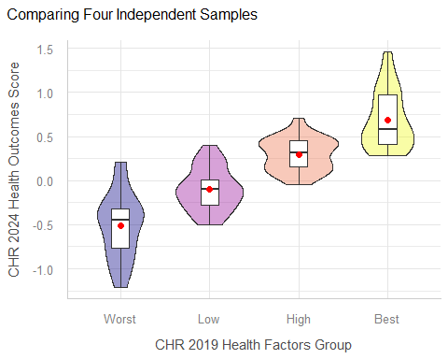

Numerical Summary
ohio_8 |> group_by(hfactor) |> reframe(lovedist(h_out24))
# A tibble: 4 × 11
hfactor n miss mean sd med mad min q25 q75 max
<fct> <int> <int> <dbl> <dbl> <dbl> <dbl> <dbl> <dbl> <dbl> <dbl>
1 Worst 22 0 -0.513 0.376 -0.445 0.393 -1.21 -0.768 -0.32 0.21
2 Low 22 0 -0.1 0.242 -0.095 0.259 -0.5 -0.28 0.0125 0.4
3 High 22 0 0.296 0.189 0.32 0.215 -0.04 0.16 0.458 0.71
4 Best 22 0 0.683 0.334 0.585 0.289 0.28 0.412 0.975 1.46
- Do we have a balanced design?
- Any extreme skew or massive outlier issues in plot?
- Shall we try an Analysis of Variance (ANOVA) model?

ANOVA: Indicator Variable Regression

Indicator Variable Regression
fit1 <- lm(h_out24 ~ hfactor, data = ohio_8) ## fitting the model
round_half_up(coef(fit1),4) ## rounded off regression coefficients
(Intercept) hfactorLow hfactorHigh hfactorBest
-0.5132 0.4132 0.8095 1.1959
 What does our fit1 model predict for each hfactor group?
Predicted h_out24 = -0.5132 + 0.4132 (Low) + 0.8095 (High) + 1.1959 (Best)
- so our prediction for Worst (to three decimal places) is -0.513
- for Low is -0.5132 + 0.4132 = -0.100
- for High is -0.5132 + 0.8095 = 0.296
- for Best is -0.5132 + 1.1959 = 0.683
Note that these are also the observed group means of h_out24.

The ANOVA table
fit1 <- lm(h_out24 ~ hfactor, data = ohio_8)
anova(fit1) # ANOVA table
Analysis of Variance Table
Response: h_out24
Df Sum Sq Mean Sq F value Pr(>F)
hfactor 3 17.464 5.8214 67.115 < 2.2e-16 ***
Residuals 84 7.286 0.0867
---
Signif. codes: 0 '***' 0.001 '**' 0.01 '*' 0.05 '.' 0.1 ' ' 1
What is in the ANOVA table? (details next slide)
- Df = Degrees of Freedom, SS = Sum of Squares, MS = SS/Df for each row
- F value = MS(hfactor)/MS(Residuals) and Pr(>F) = p-value

What’s in the ANOVA table? (df)
The ANOVA table reports on one factor (hfactor group) with 4 levels, and the residual variation in our outcome, h_out24.
Response: h_out24 | Df | Sum Sq | Mean Sq | F value | Pr(>F)
hfactor | 3 | 17.464 | 5.8214 | 67.115 | < 2.2e-16
Residuals | 84 | 7.286 | 0.0867
Degrees of Freedom (df) is an index of sample size…
- df for our factor is one less than the number of categories. We have four hfactor groups, so 3 degrees of freedom.
- Adding df(hfactor) + df(Residuals) = 3 + 84 = 87 = df(Total), one less than the number of observations (counties) in Ohio.
- n observations and g groups yield $n−g$ residual df in a one-factor ANOVA table.

What’s in the ANOVA table? (SS)
Response: h_out24 | Df | Sum Sq | Mean Sq | F value | Pr(>F)
hfactor | 3 | 17.464 | 5.8214 | 67.115 | < 2.2e-16
Residuals | 84 | 7.286 | 0.0867
Sum of Squares (Sum Sq, or SS) is an index of variation…
- SS(hfactor) measures the amount of variation accounted for by the hfactor groups in our fit1 model.
- The total variation in h_out24 to be explained by the model is SS(hfactor) + SS(Residuals) = SS(Total) in a one-factor ANOVA table.
- We describe the proportion of variation explained by a one-factor ANOVA model with $η^{2}$ (“eta-squared”: same as $R^{2}$ in regression)
$$η^{2}=\frac{SS(\text{hfactor})}{SS(\text{Total})}=\frac{17.464}{17.464+7.286}=\frac{17.464}{24.75}≈0.71$$

Proportion of Variation Explained
eta_squared(fit1)
For one-way between subjects designs, partial eta squared is equivalent
to eta squared. Returning eta squared.
# Effect Size for ANOVA
Parameter | Eta2 | 95% CI
-------------------------------
hfactor | 0.71 | [0.62, 1.00]
- One-sided CIs: upper bound fixed at [1.00].
- “eta-squared” ($η^{2}$) is the proportion of variation in our outcome (h_out24) accounted for by fit1.
- In our ohio_8 sample, 71% of the variation in h_out24 is accounted for by differences in hfactor group means.

What’s in the ANOVA table? (MS)
Response: h_out24 | Df | Sum Sq | Mean Sq | F value | Pr(>F)
hfactor | 3 | 17.464 | 5.8214 | 67.115 | < 2.2e-16
Residuals | 84 | 7.286 | 0.0867
Mean Square (Mean Sq, or MS) = Sum of Squares / df
$$MS(\text{hfactor})=\frac{SS(\text{hfactor})}{df(\text{hfactor})}=\frac{17.464}{3}≈5.8214$$
- MS(Residuals) estimates the model’s residual variance (symbolized $σ^{2}$), the square of the residual standard deviation, $σ$.
$$MS(\text{Residuals})=\hat{σ^{2}}=\frac{SS(\text{Residuals})}{df(\text{Residuals})}=\frac{7.286}{84}≈0.0867$$

ANOVA table (F test and p value)
Response: h_out24 | Df | Sum Sq | Mean Sq | F value | Pr(>F)
hfactor | 3 | 17.464 | 5.8214 | 67.115 | < 2.2e-16
Residuals | 84 | 7.286 | 0.0867
The ratio of MS values is the ANOVA F value.
$$\text{ANOVA F-value}=\frac{MS(\text{hfactor})}{MS(\text{Residuals})}=\frac{5.8214}{0.0867}≈67.115$$
- The ANOVA table’s p value (shown as Pr(>F)) is derived from the F value, as compared to a specified F distribution, indexed by the two Df values.
pf(q = 67.115, df1 = 3, df2 = 84, lower.tail = FALSE)
[1] 3.079519e-22

The ANOVA F test has p < 0.01
- In a sense, this small p value gives us some confidence (even at the 99% confidence level) that:
  - the true (population) means of h_out24 (our response, or outcome) at the various levels of hfactor (our factor, or group) are different from each other.
- Is that surprising or exciting here?
- What more would we like to know?

99% CIs for the group means
means_1 <- estimate_means(fit1, ci = 0.99)
We selected `by=c("hfactor")`.
means_1
Estimated Marginal Means
hfactor | Mean | SE | 99% CI | t(84)
-----------------------------------------------
Worst | -0.51 | 0.06 | [-0.68, -0.35] | -8.17
Low | -0.10 | 0.06 | [-0.27, 0.07] | -1.59
High | 0.30 | 0.06 | [ 0.13, 0.46] | 4.72
Best | 0.68 | 0.06 | [ 0.52, 0.85] | 10.87
Variable predicted: h_out24
Predictors modulated: hfactor

Quick Plot of Means (and CIs)
plot(visualisation_recipe(means_1)) +
labs(title = "Estimated group means and 99% CIs from fit1")
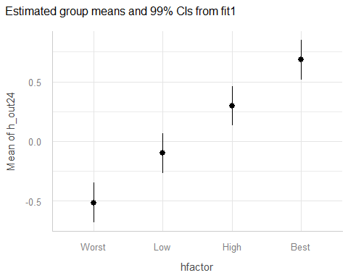

Fancier Plot of Means (and CIs)
ggplot(ohio_8, aes(x = hfactor, y = h_out24, fill = hfactor)) +
geom_violin() +
geom_boxplot(width = 0.2, fill = "white") +
geom_line(data = means_1, aes(y = Mean, group = 1),
col = "red") +
geom_pointrange(data = means_1,
aes(y = Mean, ymin = CI_low, ymax = CI_high),
size = 0.75, linewidth = 1.5, color = "red") +
scale_fill_viridis_d(option = "plasma", alpha = 0.4) +
guides(fill = "none") +
labs(x = "CHR 2019 Health Factors Group",
y = "CHR 2024 Health Outcomes Score",
title = "Model `fit1` Estimates with 99% CIs")
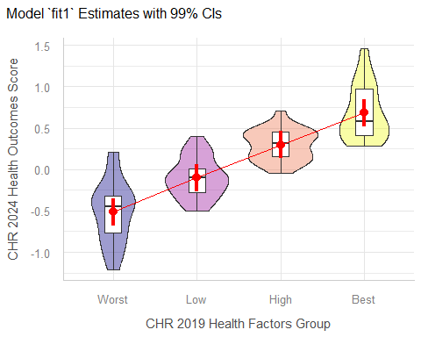

Multiple Pairwise Comparisons

Multiple Pairwise Comparisons
ANOVA suggests that the means aren’t likely to all be the same, but we really want to make pairwise comparisons. For example, is Best meaningfully different from High?
There are two (main) methods we’ll study to estimate the difference between specific pairs of means with uncertainty intervals, while dealing with the problem of multiple comparisons.
- Bonferroni pairwise comparisons
- Tukey’s HSD (Honestly Significant Differences) approach

Just run all of the pooled t tests?
estimate_contrasts(fit1, ci = 0.99, p_adjust = "none")
We selected `contrast=c("hfactor")`.
Marginal Contrasts Analysis
Level1 | Level2 | Difference | SE | 99% CI | t(84) | p
-------------------------------------------------------------------
Low | Worst | 0.41 | 0.09 | [0.18, 0.65] | 4.65 | < .001
High | Worst | 0.81 | 0.09 | [0.58, 1.04] | 9.12 | < .001
Best | Worst | 1.20 | 0.09 | [0.96, 1.43] | 13.47 | < .001
High | Low | 0.40 | 0.09 | [0.16, 0.63] | 4.46 | < .001
Best | Low | 0.78 | 0.09 | [0.55, 1.02] | 8.81 | < .001
Best | High | 0.39 | 0.09 | [0.15, 0.62] | 4.35 | < .001
Variable predicted: h_out24
Predictors contrasted: hfactor
p-values are uncorrected.

The problem of Multiple Comparisons
- The more comparisons you do simultaneously, the more likely you are to make an error.
In the worst case scenario, suppose you do two tests - first A vs. B and then A vs. C, each at the 99% confidence level.
- What is the combined error rate across those two t tests?

Multiple Comparisons
Run the first test. Make a Type I error 1% of the time.
A vs B Type I error | Probability
Yes | 0.01
No | 0.99
Now, run the second test. Assume (perhaps wrongly) that comparing A to C is independent of your A-B test result. What is the error rate now?

Multiple Comparisons
Assuming there is a 1% chance of making an error in either test, independently …
– | Error in A vs. C | No Error | Total
Type I error in A vs. B | 0.0001 | 0.0099 | 0.01
No Type I error in A-B | 0.0099 | 0.9801 | 0.99
Total | 0.01 | 0.99 | 1.00
So you will make an error in the A-B or A-C comparison 1.99% of the time, rather than the nominal $α=0.01$ error rate.

But we’re building SIX tests
- Best vs. High
- Best vs. Low
- Best vs. Worst
- High vs. Low
- High vs. Worst
- Low vs. Worst
and if they were independent, and each done at a 5% error rate, we could still wind up with an error rate of
$.05+(.95)(.05)+(.95)(.95)(.05)+(.95)^{3}(.05)+(.95)^{4}(.05)+(.95)^{5}(.05)$ = .265
Or worse, if they’re not independent.

The Bonferroni Method
If we do 6 tests, we could reduce the necessary $α$ to 0.01 / 6 = 0.00167 and that maintains an error rate no higher than $α=0.01$ across the 6 tests. We can obtain the relevant confidence intervals and p values…

Bonferroni CIs and p values
## requires library(DescTools)
PostHocTest(aov(fit1), method = "bonferroni", conf.level = 0.99)
Posthoc multiple comparisons of means : Bonferroni
99% family-wise confidence level
$hfactor
diff lwr.ci upr.ci pval
Low-Worst 0.4131818 0.12468081 0.7016828 7.2e-05 ***
High-Worst 0.8095455 0.52104444 1.0980465 2.1e-13 ***
Best-Worst 1.1959091 0.90740808 1.4844101 < 2e-16 ***
High-Low 0.3963636 0.10786263 0.6848646 0.00015 ***
Best-Low 0.7827273 0.49422626 1.0712283 8.4e-13 ***
Best-High 0.3863636 0.09786263 0.6748646 0.00023 ***
---
Signif. codes: 0 '***' 0.001 '**' 0.01 '*' 0.05 '.' 0.1 ' ' 1

Plotting the Bonferroni intervals
par(mar=c(3,7,3,3), las = 1)
plot(PostHocTest(aov(fit1), method = "bonferroni", conf.level = 0.99))
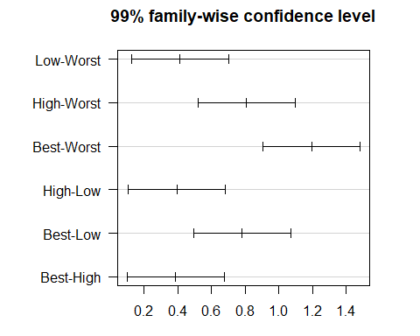

What about Tukey HSD intervals?
Tukey’s HSD approach is a better choice than Bonferroni for pre-planned comparisons with a balanced (or nearly balanced) design. Which should we use here?
PostHocTest(aov(fit1), method = "hsd", conf.level = 0.99, ordered = TRUE)
Posthoc multiple comparisons of means : Tukey HSD
99% family-wise confidence level
factor levels have been ordered
$hfactor
diff lwr.ci upr.ci pval
Low-Worst 0.4131818 0.1282141 0.6981495 7.0e-05 ***
High-Worst 0.8095455 0.5245777 1.0945132 1.6e-10 ***
Best-Worst 1.1959091 0.9109414 1.4808768 1.6e-10 ***
High-Low 0.3963636 0.1113959 0.6813314 0.00014 ***
Best-Low 0.7827273 0.4977595 1.0676950 1.6e-10 ***
Best-High 0.3863636 0.1013959 0.6713314 0.00022 ***
---
Signif. codes: 0 '***' 0.001 '**' 0.01 '*' 0.05 '.' 0.1 ' ' 1

Plot means with Tukey HSD CIs
par(mar=c(3,10,3,3), las = 1)
plot(PostHocTest(aov(fit1), method = "hsd", conf.level = 0.99))
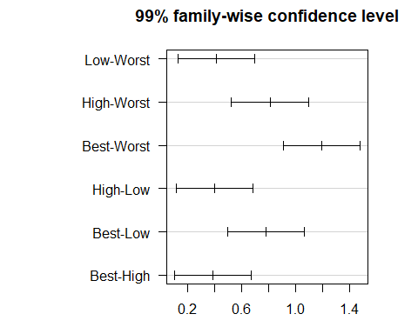

Standing Break

Comparing Low Birth Weight Rates
How large is the mean difference in low birth weight rates across the four groups of Ohio counties defined by their 2019 Health Factors rankings?
ggplot(ohio_8, aes(x = hfactor, y = low_bwt)) +
geom_violin(aes(fill = hfactor)) +
geom_boxplot(width = 0.2, fill = "white") +
stat_summary(fun = mean, geom = "point",
size = 2, col = "red") +
scale_fill_viridis_d(option = "plasma", alpha = 0.4) +
guides(fill = "none") +
labs(x = "CHR 2019 Health Factors Group",
y = "Low Birth Weight Rates (2016-22)",
title = "Comparing Four Independent Samples")
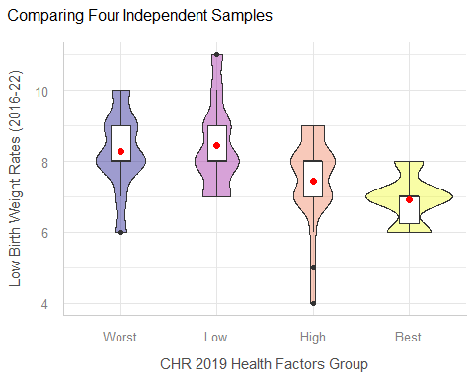

Numerical Summary
ohio_8 |> group_by(hfactor) |> reframe(lovedist(low_bwt))
# A tibble: 4 × 11
hfactor n miss mean sd med mad min q25 q75 max
<fct> <int> <int> <dbl> <dbl> <dbl> <dbl> <dbl> <dbl> <dbl> <dbl>
1 Worst 22 0 8.27 1.12 8 1.48 6 8 9 10
2 Low 22 0 8.45 1.22 8 1.48 7 8 9 11
3 High 22 0 7.45 1.26 8 1.48 4 7 8 9
4 Best 22 0 6.91 0.684 7 0 6 6.25 7 8

ANOVA table: low birth weight
fit2 <- lm(low_bwt ~ hfactor, data = ohio_8)
anova(fit2) # ANOVA table
Analysis of Variance Table
Response: low_bwt
Df Sum Sq Mean Sq F value Pr(>F)
hfactor 3 34.364 11.4545 9.518 1.765e-05 ***
Residuals 84 101.091 1.2035
---
Signif. codes: 0 '***' 0.001 '**' 0.01 '*' 0.05 '.' 0.1 ' ' 1

Comparing Low Birth Weight Rates: Tukey HSD 95% CIs
par(mar=c(3,10,3,3), las = 1)
plot(PostHocTest(aov(fit2), method = "hsd", conf.level = 0.95))
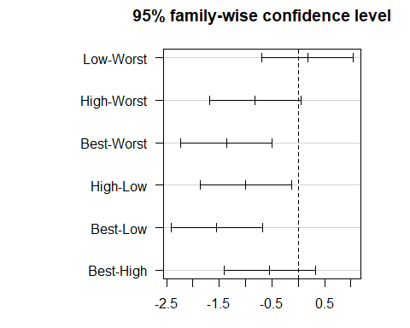

Low Birth Weight Tukey HSD 95% CIs
PostHocTest(aov(fit2), method = "hsd", conf.level = 0.95)
Posthoc multiple comparisons of means : Tukey HSD
95% family-wise confidence level
$hfactor
diff lwr.ci upr.ci pval
Low-Worst 0.1818182 -0.6851887 1.04882503 0.9464
High-Worst -0.8181818 -1.6851887 0.04882503 0.0715 .
Best-Worst -1.3636364 -2.2306432 -0.49662952 0.0005 ***
High-Low -1.0000000 -1.8670068 -0.13299315 0.0171 *
Best-Low -1.5454545 -2.4124614 -0.67844770 6.5e-05 ***
Best-High -0.5454545 -1.4124614 0.32155230 0.3572
---
Signif. codes: 0 '***' 0.001 '**' 0.01 '*' 0.05 '.' 0.1 ' ' 1

ANOVA Assumptions
The assumptions behind analysis of variance are those of a linear model. Of specific interest are:
- The samples obtained from each group are independent.
- Ideally, the samples from each group are a random sample from the population described by that group.
- In the population, the variance of the outcome in each group is equal. (This is less of an issue if our study involves a balanced design.)
- In the population, we have Normal distributions of the outcome in each group.
Happily, the ANOVA F test is fairly robust to violations of the Normality assumption.

Normality for first example
Normal Q-Q plot of fit1 regression residuals
plot(fit1, which = 2, col = "blue")
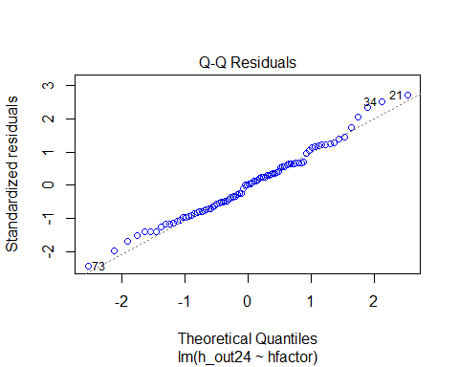

Normality for Low Birth Weight Model
Normal Q-Q plot of fit2 regression residuals
plot(fit2, which = 2, col = "blue")
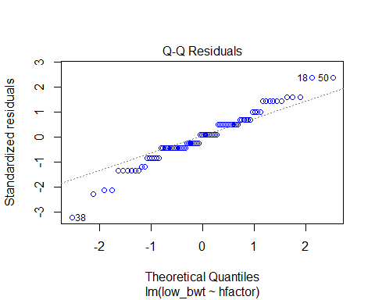

Other Checks to come…
plot(check_model(fit1), detrend = FALSE)
For confidence bands, please install `qqplotr`.
Ignoring unknown labels:
• size : ""
Warning in simpleLoess(y, x, w, span, degree = degree, parametric = parametric,
: pseudoinverse used at -0.51916
Warning in simpleLoess(y, x, w, span, degree = degree, parametric = parametric,
: neighborhood radius 0.81553
Warning in simpleLoess(y, x, w, span, degree = degree, parametric = parametric,
: reciprocal condition number 1.173e-15
Warning in simpleLoess(y, x, w, span, degree = degree, parametric = parametric,
: There are other near singularities as well. 0.62206
Warning in simpleLoess(y, x, w, span, degree = degree, parametric = parametric,
: pseudoinverse used at -0.51916
Warning in simpleLoess(y, x, w, span, degree = degree, parametric = parametric,
: neighborhood radius 0.81553
Warning in simpleLoess(y, x, w, span, degree = degree, parametric = parametric,
: reciprocal condition number 1.173e-15
Warning in simpleLoess(y, x, w, span, degree = degree, parametric = parametric,
: There are other near singularities as well. 0.62206

Favorite Movies Discussion 1

Session Information
xfun::session_info()
R version 4.6.1 (2026-06-24 ucrt)
Platform: x86_64-w64-mingw32/x64
Running under: Windows 11 x64 (build 26200)
Locale:
LC_COLLATE=English_United States.utf8
LC_CTYPE=English_United States.utf8
LC_MONETARY=English_United States.utf8
LC_NUMERIC=C
LC_TIME=English_United States.utf8
Package version:
ape_5.8.1 askpass_1.2.1 backports_1.5.1
base_4.6.1 base64enc_0.1.6 bayestestR_0.19.0
bit_4.6.0 bit64_4.8.6 blob_1.3.0
boot_1.3-32 broom_1.0.13 bslib_0.12.0
cachem_1.1.0 callr_3.8.0 cellranger_1.1.0
checkmate_2.3.4 class_7.3-24 cli_3.6.6
clipr_0.8.1 coda_0.19-4.1 codetools_0.2-20
commonmark_2.0.0 compiler_4.6.1 conflicted_1.2.0
correlation_0.8.8 cpp11_0.5.5 crayon_1.5.3
crosstalk_1.2.2 curl_8.0.0 data.table_1.18.6.1
datasets_4.6.1 datawizard_1.4.0 DBI_1.3.0
dbplyr_2.6.0 DescTools_0.99.60 DHARMa_0.5.0
digest_0.6.39 doParallel_1.0.17 dplyr_1.2.1
dtplyr_1.3.3 e1071_1.7-17 easystats_0.7.6
effectsize_1.0.3 emmeans_2.0.4 estimability_2.0.0
evaluate_1.0.5 Exact_3.3 expm_1.0-1
farver_2.1.2 fastmap_1.2.0 fontawesome_0.5.3
forcats_1.0.1 foreach_1.5.2 Formula_1.2-6
fs_2.1.0 gap_1.15.2 gap.datasets_0.0.6
gargle_1.6.1 generics_0.1.4 ggplot2_4.0.3
ggrepel_0.9.8 gld_2.6.8 glue_1.8.1
googledrive_2.1.2 googlesheets4_1.1.2 graphics_4.6.1
grDevices_4.6.1 grid_4.6.1 gtable_0.3.6
haven_2.5.5 highr_0.12 hms_1.1.4
htmltools_0.5.9 htmlwidgets_1.6.4 httpuv_1.6.17
httr_1.4.9 ids_1.0.1 insight_1.5.4
isoband_0.3.0 iterators_1.0.14 janitor_2.2.1
jquerylib_0.1.4 jsonlite_2.0.0 knitr_1.52
labeling_0.4.3 later_1.4.8 lattice_0.23-1
lazyeval_0.2.3 lifecycle_1.0.5 lme4_2.0-6
lmom_3.3 lmtest_0.9.40 lubridate_1.9.5
magrittr_2.0.5 marginaleffects_1.0.0 MASS_7.3-66
Matrix_1.7-6 memoise_2.0.1 methods_4.6.1
mgcv_1.9-4 mime_0.13 minqa_1.2.8
modelbased_0.17.0 modelr_0.1.11 multcomp_1.4-32
mvtnorm_1.4-2 nlme_3.1-171 nloptr_2.2.1
numDeriv_2016.8.1.1 openssl_2.4.2 otel_0.2.0
parallel_4.6.1 parameters_0.29.3 patchwork_1.3.2
performance_0.18.2 pillar_1.11.1 pkgconfig_2.0.3
plotly_4.12.1 plyr_1.8.9 prettyunits_1.2.0
processx_3.9.0 progress_1.2.3 promises_1.5.0
proxy_0.4-29 ps_1.9.3 purrr_1.2.2
qgam_2.0.0 R6_2.6.1 ragg_1.5.2
rappdirs_0.3.4 rbibutils_2.4.1 RColorBrewer_1.1-3
Rcpp_1.1.2 RcppEigen_0.3.4.0.2 Rdpack_2.6.6
readr_2.2.0 readxl_1.5.0 reformulas_0.4.4
rematch_2.0.0 rematch2_2.1.2 report_0.6.4
reprex_2.1.1 rlang_1.3.0 rmarkdown_2.32
rootSolve_1.8.2.4 rstudioapi_0.19.0 rvest_1.0.5
S7_0.2.2 sandwich_3.1-3 sass_0.4.10
scales_1.4.0 see_0.14.2 selectr_0.7.0
shiny_1.14.0 snakecase_0.11.1 sourcetools_0.1.7.2
splines_4.6.1 stats_4.6.1 stringi_1.8.9
stringr_1.6.0 survival_3.8-12 sys_3.4.3
systemfonts_1.3.2 textshaping_1.0.5 TH.data_1.1-5
tibble_3.3.1 tidyr_1.3.2 tidyselect_1.2.1
tidyverse_2.0.0 timechange_0.4.0 tinytex_0.61
tools_4.6.1 tzdb_0.5.0 utf8_1.2.6
utils_4.6.1 uuid_1.2.2 vctrs_0.7.3
viridisLite_0.4.3 vroom_1.7.1 withr_3.0.3
xfun_0.60 xml2_1.6.0 xtable_1.8-8
yaml_2.3.12 zoo_1.9-0

The CHR Health Outcomes score includes measures of length of life and quality of life. More positive results here are better (opposite of CHR’s scale.)
The CHR Health Factors score includes measures of health behaviors, clinical care, social and economic factors, and the physical environment.

