431 Class 03
Thomas E. Love, Ph.D.
2026-09-01

Today’s Agenda
- Using RStudio, R and Quarto
  - R Projects, Quarto template, Rendering HTML
- Using a “built in” R data frame (iris, then ToothGrowth)
  - Data management and cleaning
  - Visual and numerical summaries, fitting models
- Some Thoughts on Project A

Getting started in a reliable way

Gathering the files we’ll need
From our 431-data page, you should find:
- 431-first-r-template.qmd (Quarto starting point)
- Love-431.R (my R script containing lovedist())
- class02_survey_2014_to_2026.csv (we’ll use in class 4)
- class02_survey_2026.csv (also for class 4)
- class03_toothgrowth_complete.qmd (today’s goal)

Today’s Plan
We’re using Quarto to gather together into a single document:
- the R code we build,
- text commenting on and reacting to that R code, and
- the output of the analyses we build.
Everything in these slides is in the Quarto file for today.

Create a directory on my computer
I’ll create 431-class03 on my D drive.
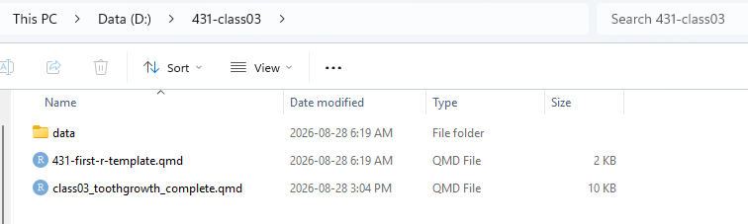

What’s in the data subdirectory?
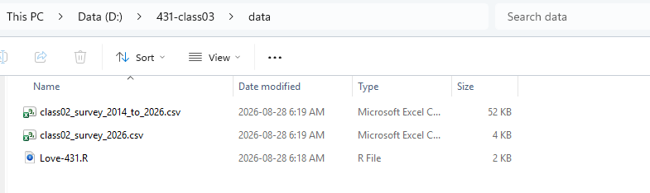

Where did I get these files?
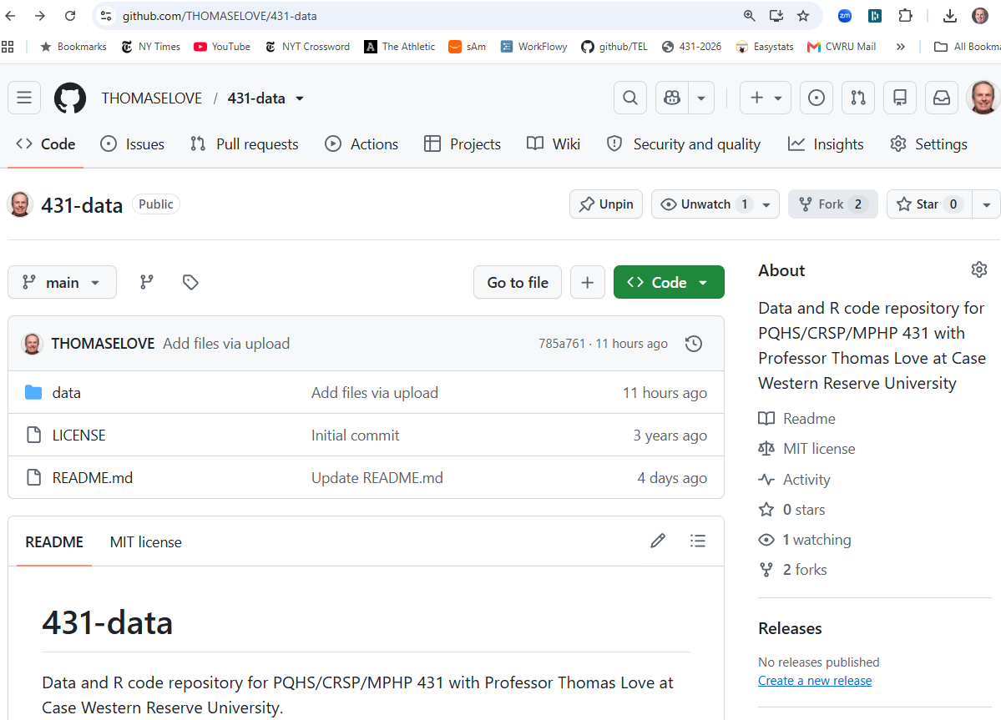

431-data page: data subdirectory
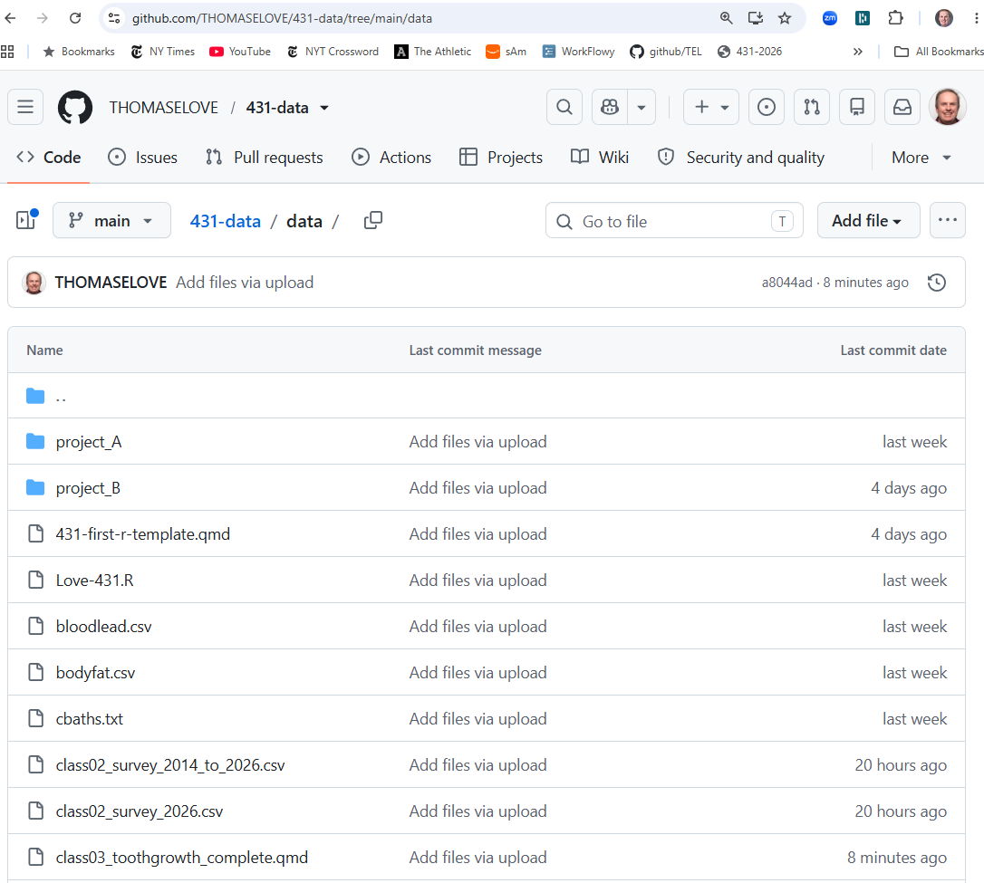

Open RStudio
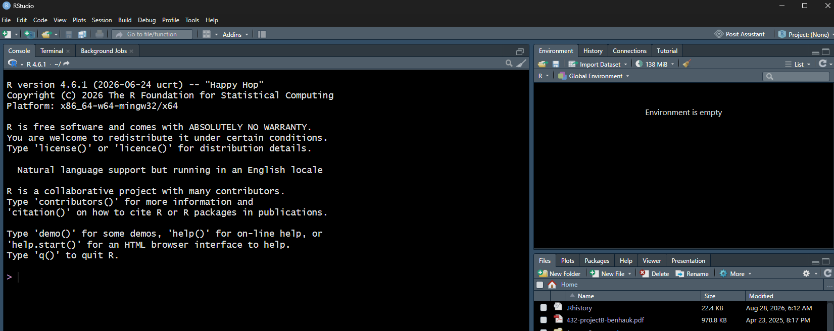

My RStudio setup
Visit Tools … Global Options
- under Appearance, I use
  - RStudio theme: Modern
  - Editor font: Lucida Console
  - Editor theme: Tomorrow Night Bright

Start by creating a new R Project
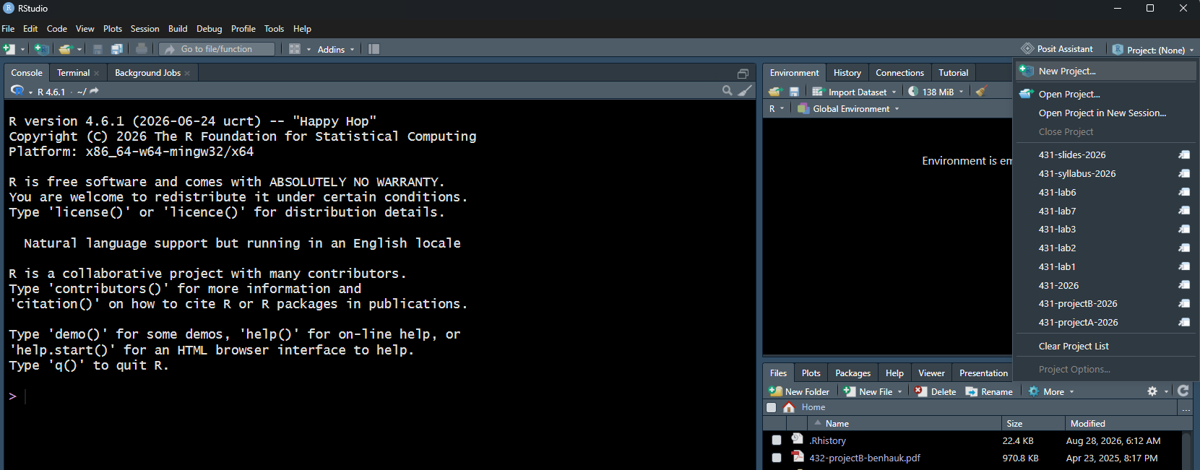

New Project Wizard
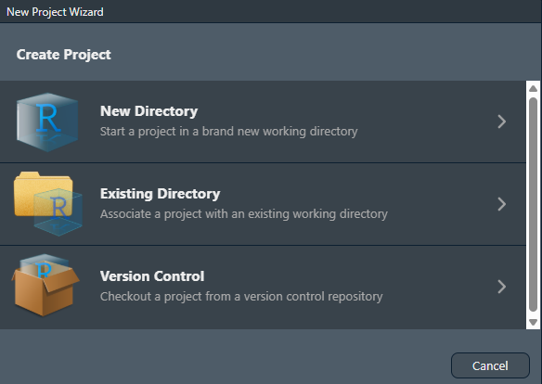
Here, I’ll select Existing Directory.

Create Project
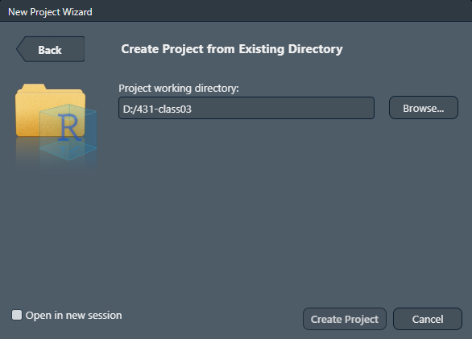

I’m now using a 431-class03 project
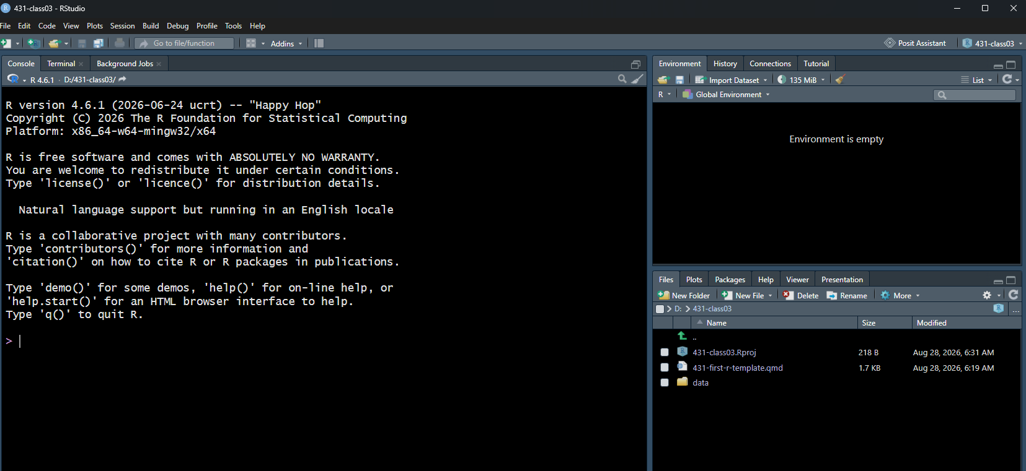
- Now, click to open 431-first-r-template.qmd

431-first-r-template.qmd
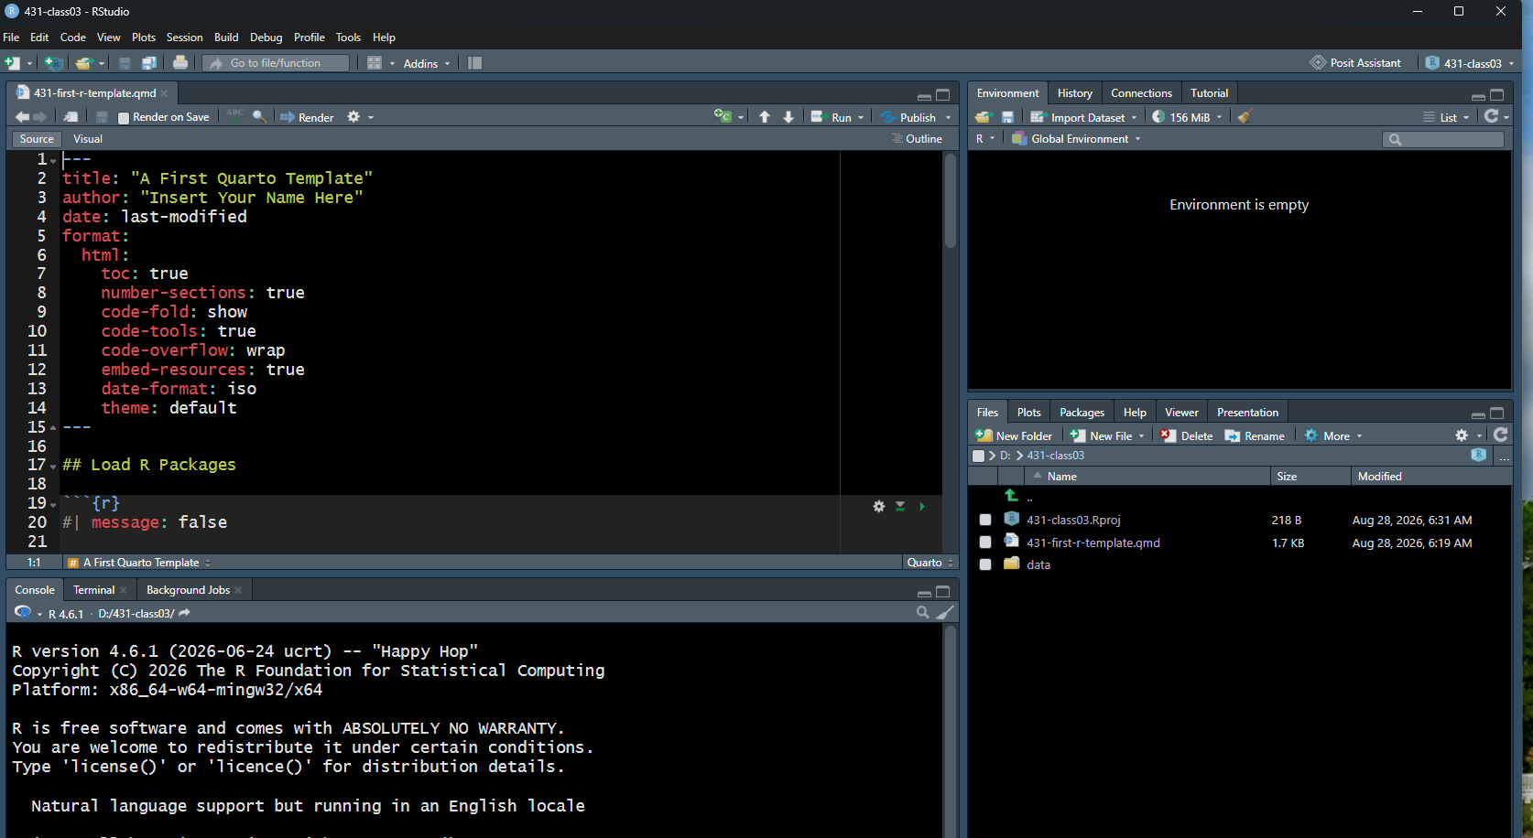
Save this file as class03_iris.qmd

Personalize title and author
Now using class03_iris.qmd
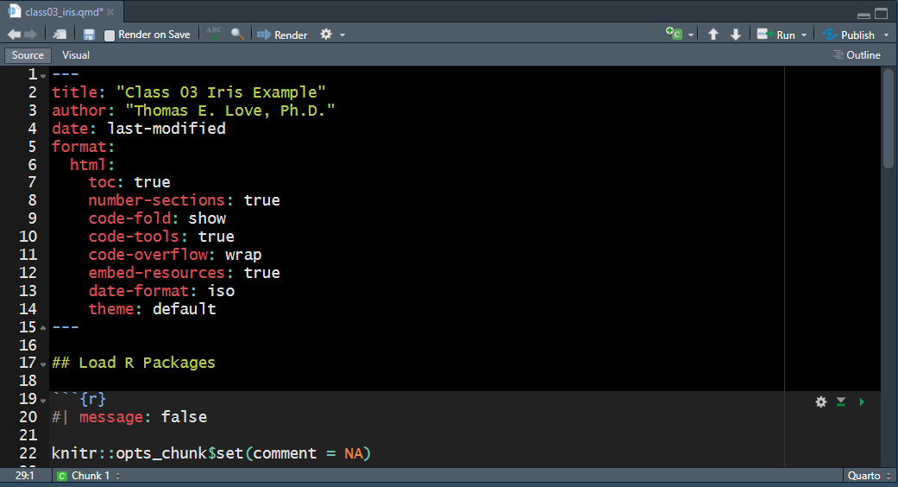

Now hit Render to create HTML
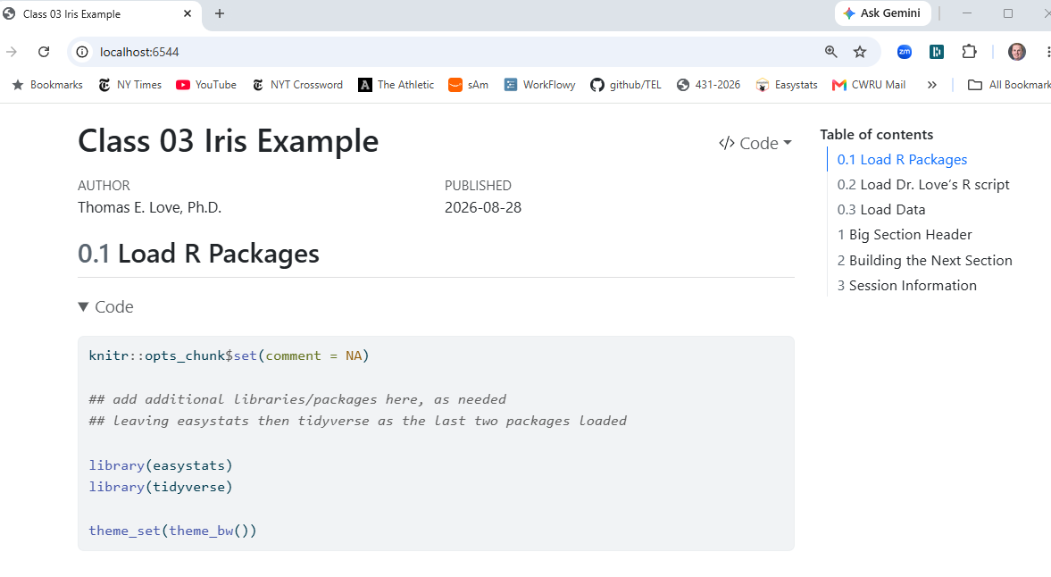

Click to Section 1
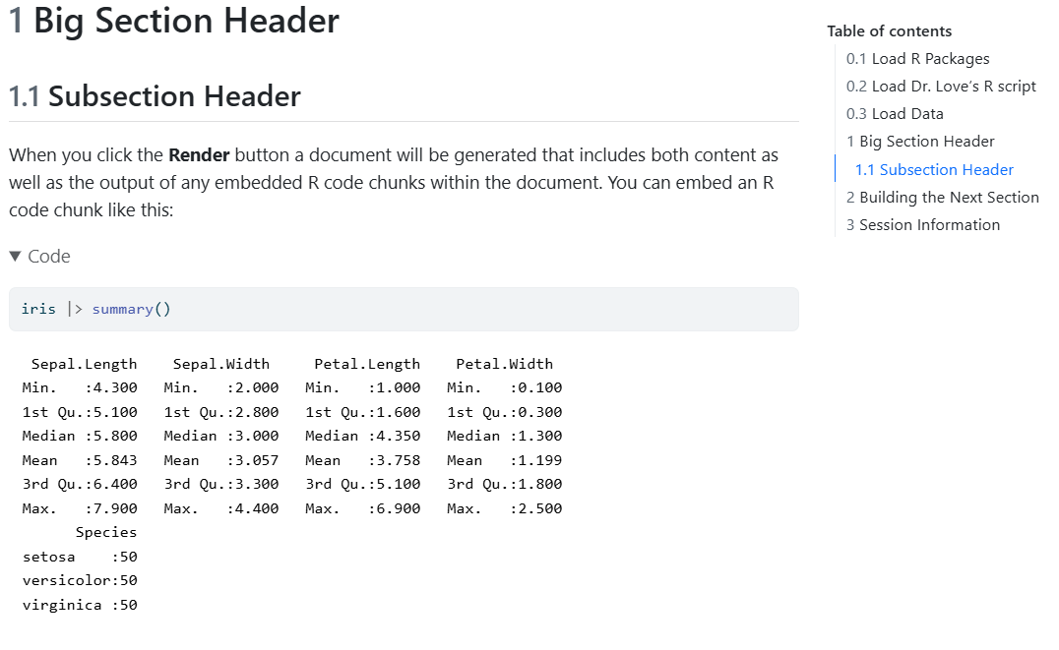

Click to Section 2
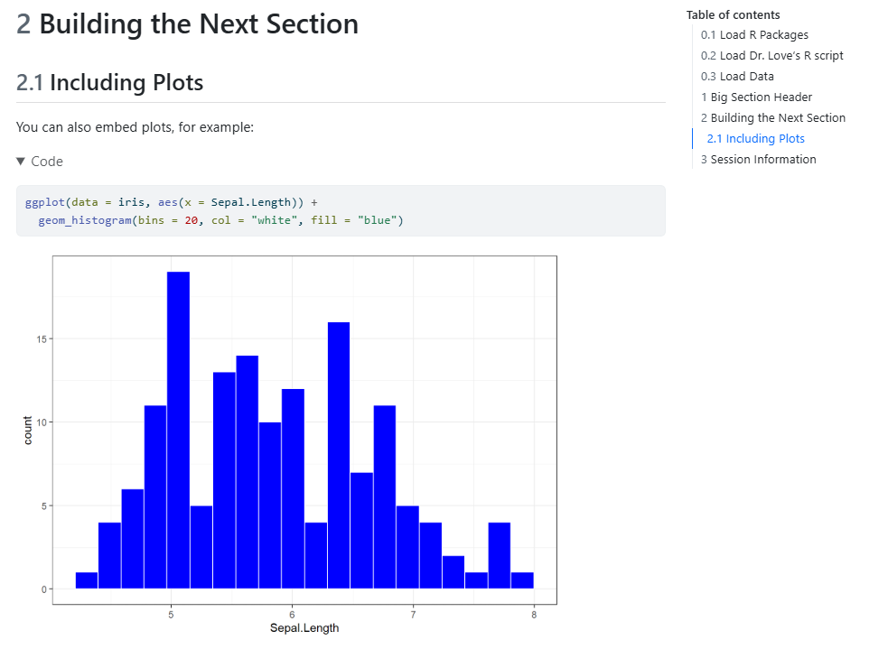

OK, we’ll start again
- Close the class03_iris.qmd example (saving your changes.)
- Now open the class03_toothgrowth_complete.qmd file.
  - Feel free to change the title and author, if you like.

Should look like this…
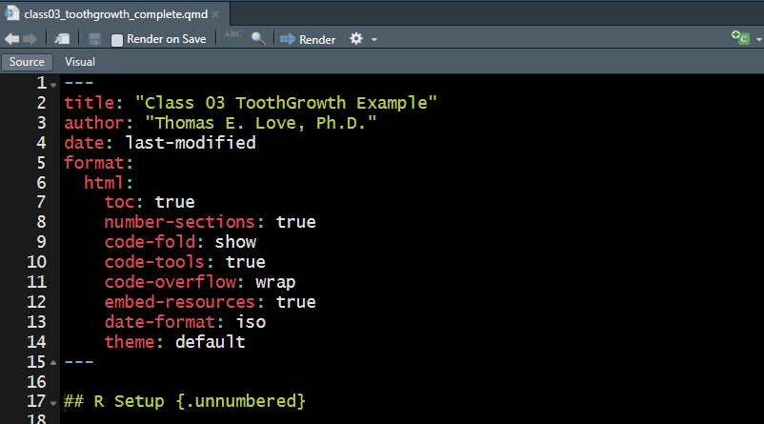

Scroll down to see R Setup
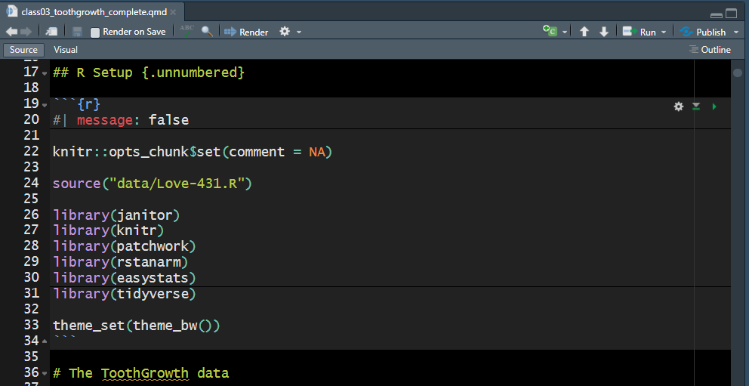
#| message: false silences messages for this code chunk

Today’s R Setup in the slides
knitr::opts_chunk$set(comment = NA)
source("c03/data/Love-431.R")
library(janitor)
library(knitr)
library(patchwork)
library(rstanarm)
library(easystats)
library(tidyverse)
theme_set(theme_bw())

Today’s R Setup (details)
- knitr::opts_chunk$set(comment = NA) sets an option that I prefer for how R’s output is presented to us
- We’ve used the source() function to include some code I’ve written into an R script called Love-431.R. This includes a function called lovedist().

Loading R Packages
Loading packages in R is like opening up apps on your phone. We need to tell R that, in addition to the base functions available in the software, we also have other functions we want to use.
- The janitor package has tools for examining, cleaning and tabulating data
- knitr includes the kable() function for pretty tables

More on Today’s R Setup
- patchwork helps us combine plots
- rstanarm lets us fit Bayesian models
- The easystats meta-package contains several other packages that will help us (especially) with building models and presenting our results.
- It’s helpful to load the tidyverse meta-package last.

The tidyverse meta-package
- We will use the series of packages called the tidyverse in every Quarto file we create.
  - The tidyverse was developed (in part) by Hadley Wickham, Chief Scientist at Posit (makers of RStudio).
  - dplyr for data wrangling, cleaning and transformation
  - ggplot2 is our main visualization package
  - other tidyverse packages help import data, work with factors and other common activities.
theme_set(theme_bw()) sets a theme I like for today’s plots.

The ToothGrowth data
These data describe the length (len) of odontoblasts (cells responsible for tooth growth) in 60 guinea pigs.
- Each received one of three dose levels of vitamin C (0.5, 1 or 2 mg/day)
- delivered (supplied) by either:
  - supp = VC for ascorbic acid or
  - supp = OJ for orange juice
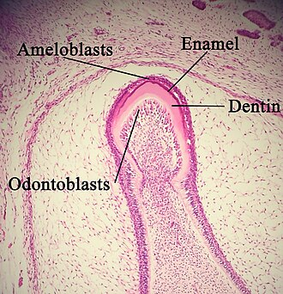
Photo: Wikipedia
I think the lengths are measured in micrometers (µm), also known as microns.

In class, you have two options…
- Look at these slides, which include the code and some screenshots.
- Render the class03_toothgrowth_complete.qmd and look at the HTML instead.
It’s your choice.

Show me the data…
ToothGrowth
len supp dose
1 4.2 VC 0.5
2 11.5 VC 0.5
3 7.3 VC 0.5
4 5.8 VC 0.5
5 6.4 VC 0.5
6 10.0 VC 0.5
7 11.2 VC 0.5
8 11.2 VC 0.5
9 5.2 VC 0.5
10 7.0 VC 0.5
11 16.5 VC 1.0
12 16.5 VC 1.0
13 15.2 VC 1.0
14 17.3 VC 1.0
15 22.5 VC 1.0
16 17.3 VC 1.0
17 13.6 VC 1.0
18 14.5 VC 1.0
19 18.8 VC 1.0
20 15.5 VC 1.0
21 23.6 VC 2.0
22 18.5 VC 2.0
23 33.9 VC 2.0
24 25.5 VC 2.0
25 26.4 VC 2.0
26 32.5 VC 2.0
27 26.7 VC 2.0
28 21.5 VC 2.0
29 23.3 VC 2.0
30 29.5 VC 2.0
31 15.2 OJ 0.5
32 21.5 OJ 0.5
33 17.6 OJ 0.5
34 9.7 OJ 0.5
35 14.5 OJ 0.5
36 10.0 OJ 0.5
37 8.2 OJ 0.5
38 9.4 OJ 0.5
39 16.5 OJ 0.5
40 9.7 OJ 0.5
41 19.7 OJ 1.0
42 23.3 OJ 1.0
43 23.6 OJ 1.0
44 26.4 OJ 1.0
45 20.0 OJ 1.0
46 25.2 OJ 1.0
47 25.8 OJ 1.0
48 21.2 OJ 1.0
49 14.5 OJ 1.0
50 27.3 OJ 1.0
51 25.5 OJ 2.0
52 26.4 OJ 2.0
53 22.4 OJ 2.0
54 24.5 OJ 2.0
55 24.8 OJ 2.0
56 30.9 OJ 2.0
57 26.4 OJ 2.0
58 27.3 OJ 2.0
59 29.4 OJ 2.0
60 23.0 OJ 2.0

We prefer tibbles to data frames
TG_new <- ToothGrowth |> as_tibble()
TG_new
# A tibble: 60 × 3
len supp dose
<dbl> <fct> <dbl>
1 4.2 VC 0.5
2 11.5 VC 0.5
3 7.3 VC 0.5
4 5.8 VC 0.5
5 6.4 VC 0.5
6 10 VC 0.5
7 11.2 VC 0.5
8 11.2 VC 0.5
9 5.2 VC 0.5
10 7 VC 0.5
# ℹ 50 more rows
- Since TG_new is a tibble, printing it shows the first 10 rows and its dimensions and variable types…

Using a tibble
After creating a tibble called TG_new with the ToothGrowth data, printing that tibble shows (only) the first 10 rows as well as the tibble’s dimensions (number of rows and columns) and specifies the type of each variable.
- <dbl> means a double-precision decimal numeric value.
  - Sometimes numeric values can be integer type: <int>.
- Also, we see that the supp information is stored as a categorical factor (type = <fct>) in R.

Exploring the Data
Here is a general numeric summary of our tibble.
summary(TG_new)
len supp dose
Min. : 4.20 OJ:30 Min. :0.500
1st Qu.:13.07 VC:30 1st Qu.:0.500
Median :19.25 Median :1.000
Mean :18.81 Mean :1.167
3rd Qu.:25.27 3rd Qu.:2.000
Max. :33.90 Max. :2.000

Table of supp and dose counts
TG_new |> tabyl(supp, dose)
supp 0.5 1 2
OJ 10 10 10
VC 10 10 10

Using kable() to neaten the table
Using kable() helps make the HTML a little prettier.
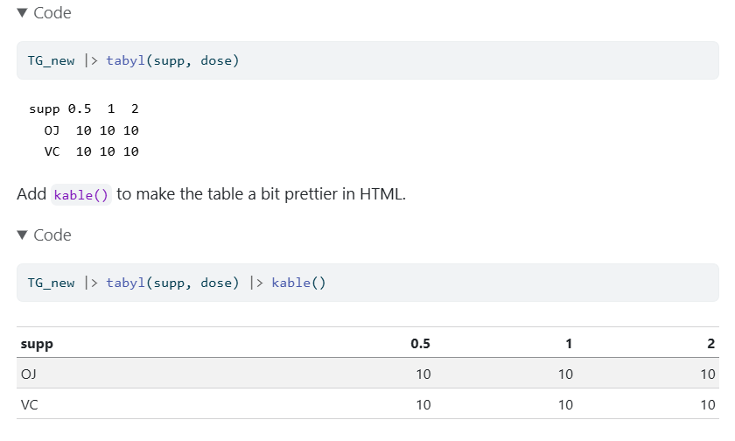

Show the odontoblast lengths
Can we sort the lengths (len) from low to high?
sort(TG_new$len)
[1] 4.2 5.2 5.8 6.4 7.0 7.3 8.2 9.4 9.7 9.7 10.0 10.0 11.2 11.2 11.5
[16] 13.6 14.5 14.5 14.5 15.2 15.2 15.5 16.5 16.5 16.5 17.3 17.3 17.6 18.5 18.8
[31] 19.7 20.0 21.2 21.5 21.5 22.4 22.5 23.0 23.3 23.3 23.6 23.6 24.5 24.8 25.2
[46] 25.5 25.5 25.8 26.4 26.4 26.4 26.4 26.7 27.3 27.3 29.4 29.5 30.9 32.5 33.9

Counting is wonderful
How many of the lengths are more than 20 microns?
TG_new |> count(len > 20)
# A tibble: 2 × 2
`len > 20` n
<lgl> <int>
1 FALSE 32
2 TRUE 28

Filtering the data by row
Which subjects received doses of 1.0 mg/day via OJ?
TG_new |> filter(dose == 1, supp == "OJ")
# A tibble: 10 × 3
len supp dose
<dbl> <fct> <dbl>
1 19.7 OJ 1
2 23.3 OJ 1
3 23.6 OJ 1
4 26.4 OJ 1
5 20 OJ 1
6 25.2 OJ 1
7 25.8 OJ 1
8 21.2 OJ 1
9 14.5 OJ 1
10 27.3 OJ 1

Some of my favorite summaries
TG_new |> reframe(lovedist(len))
# A tibble: 1 × 10
n miss mean sd med mad min q25 q75 max
<int> <int> <dbl> <dbl> <dbl> <dbl> <dbl> <dbl> <dbl> <dbl>
1 60 0 18.8 7.65 19.2 9.04 4.2 13.1 25.3 33.9
- n = 60 observations,
- miss = 0, so no missing data
- mean = “average” (sum of values / number of values)
- med = median (middle value when data are sorted)

Some of my favorite summaries (2)
TG_new |> reframe(lovedist(len))
# A tibble: 1 × 10
n miss mean sd med mad min q25 q75 max
<int> <int> <dbl> <dbl> <dbl> <dbl> <dbl> <dbl> <dbl> <dbl>
1 60 0 18.8 7.65 19.2 9.04 4.2 13.1 25.3 33.9
Measures of spread or variation:
- sd = standard deviation (formula in our book)
- mad = median absolute deviation (formula in our book)
- min, max = minimum and maximum value
- q25, q75 = 25th and 75th quantiles (percentiles)

We’ll discuss Project A briefly after this break.

Project A webpage

Phases of the project
- Read the instructions thoroughly. Work with partner?
- Use the provided template and data to get started.
- Finish data management to do Lab 4 (2026-09-30)
- Finish four analyses before Quiz 1 (2026-10-09)
- Project A due 2026-10-21 (day after Fall Break)
  - R data set, Report: both Quarto and HTML files
  - Video (max: 3 minutes), Self-Evaluation form

Returning to the ToothGrowth data
Numerical summaries of the len variable:
TG_new |> select(len) |> describe_distribution()
Variable | Mean | SD | IQR | Range | Skewness | Kurtosis | n | n_Missing
--------------------------------------------------------------------------------------
len | 18.81 | 7.65 | 13.40 | [4.20, 33.90] | -0.15 | -0.95 | 60 | 0
- IQR = q75 - q25, the interquartile range
TG_new |> reframe(lovedist(len))
# A tibble: 1 × 10
n miss mean sd med mad min q25 q75 max
<int> <int> <dbl> <dbl> <dbl> <dbl> <dbl> <dbl> <dbl> <dbl>
1 60 0 18.8 7.65 19.2 9.04 4.2 13.1 25.3 33.9

Histogram of odontoblast lengths
- HTML result shown on next slide.
ggplot(data = TG_new, aes(x = len)) +
geom_histogram()
`stat_bin()` using `bins = 30`. Pick better value `binwidth`.
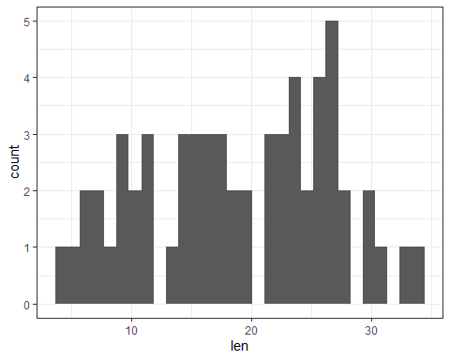

HTML of Histogram, version 1
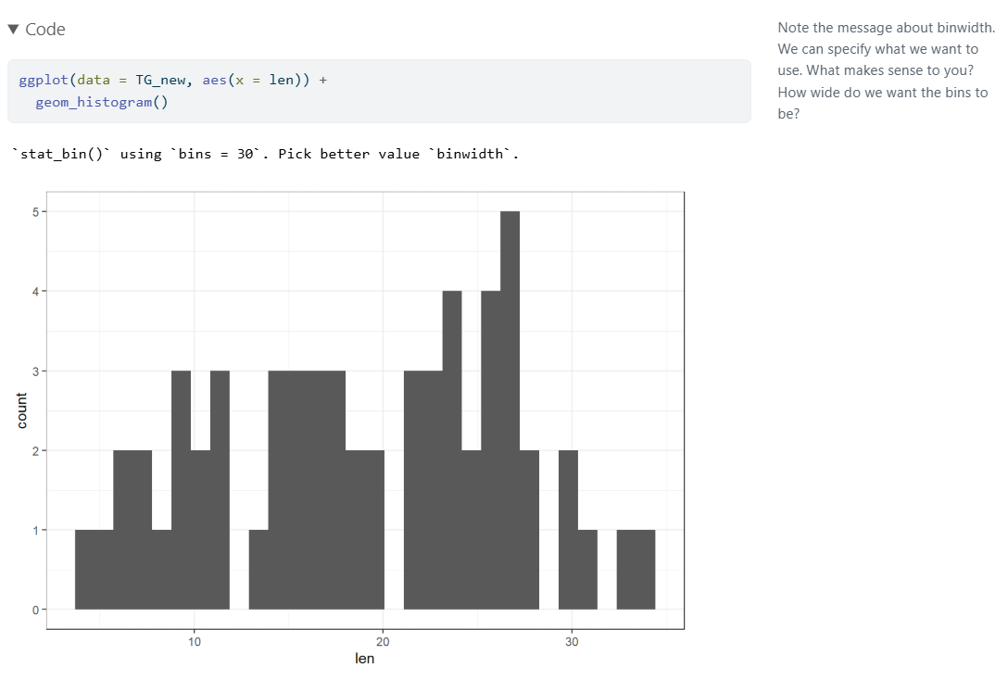

Version 2: set bin width and colors
ggplot(data = TG_new, aes(x = len)) +
geom_histogram(binwidth = 1, fill = "navy", col = "yellow")
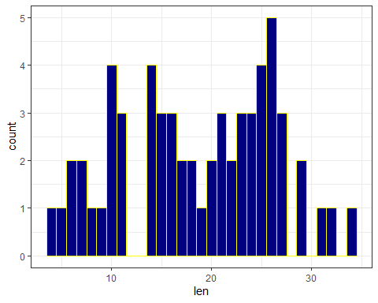

HTML of Histogram, version 2
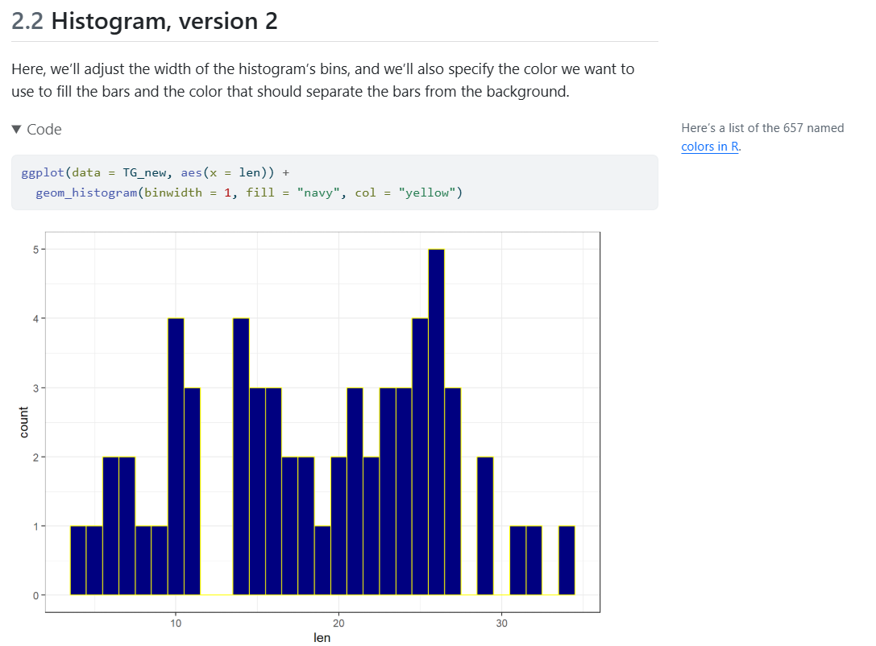

Version 3: try 10 bins, set labels
ggplot(data = TG_new, aes(x = len)) +
geom_histogram(bins = 10, fill = "navy", col = "yellow") +
labs(title = "Odontoblast lengths for 60 guinea pigs",
x = "Odontoblast length", y = "Number of animals")
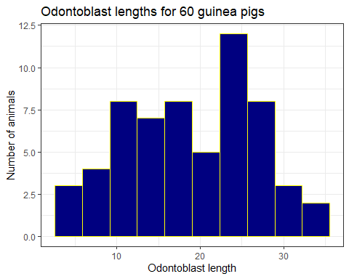

Estimating the mean len
- We’ll fit a linear regression model using ordinary least squares (OLS) with lm().
fit1 <- lm(len ~ 1, data = TG_new)
model_parameters(fit1, ci = 0.95)
Parameter | Coefficient | SE | 95% CI | t(59) | p
------------------------------------------------------------------
(Intercept) | 18.81 | 0.99 | [16.84, 20.79] | 19.05 | < .001
Uncertainty intervals (equal-tailed) and p-values (two-tailed) computed
using a Wald t-distribution approximation.
- Our linear model for the mean odontoblast length provides a point estimate (sample mean) of 18.81 with a 95% confidence interval ranging from 16.84 to 20.79.

How is dose related to length?
The guinea pigs were randomly allocated to receive one of three doses:
- 0.5 mg/day
- 1.0 mg/day
- 2.0 mg/day
with 20 animals at each dose.
- How can we picture the relationship between dose and odontoblast length (len)?

Plotting len by dose?
ggplot(TG_new, aes(x = dose, y = len)) +
geom_point()
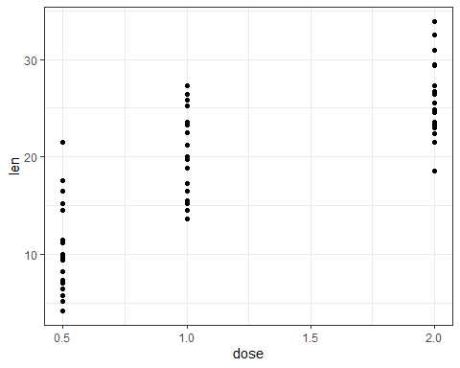

Treat dose as a categorical factor
ggplot(TG_new, aes(x = factor(dose), y = len)) +
geom_violin(fill = "tan") +
geom_point()
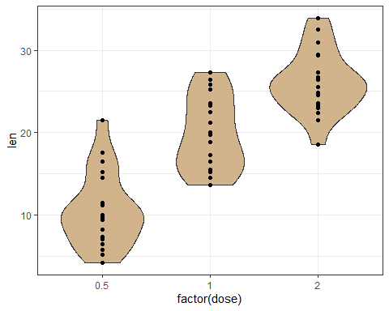

Add boxplots, sample means
ggplot(TG_new, aes(x = factor(dose), y = len)) +
geom_violin(fill = "tan") +
geom_boxplot(aes(width = 0.2)) +
stat_summary(fun = mean, geom = "point", size = 3, col = "red")
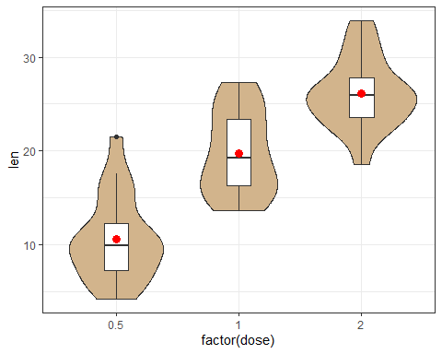

Numerical summary (len by dose)
TG_new <- TG_new |> mutate(dose_f = as_factor(dose))
TG_new |> reframe(lovedist(len), .by = dose_f)
# A tibble: 3 × 11
dose_f n miss mean sd med mad min q25 q75 max
<fct> <int> <int> <dbl> <dbl> <dbl> <dbl> <dbl> <dbl> <dbl> <dbl>
1 0.5 20 0 10.6 4.50 9.85 4.00 4.2 7.22 12.2 21.5
2 1 20 0 19.7 4.42 19.2 5.78 13.6 16.2 23.4 27.3
3 2 20 0 26.1 3.77 26.0 3.71 18.5 23.5 27.8 33.9
- When assessing the center of these distributions, should we use a mean or a median or does it not really matter?
- How might we assess the spread/range/variation?
- How about the shape of the data?

Length and supply method
- What should this look like, based on the code?
  - Plot shown on next slide…
ggplot(TG_new, aes(x = supp, y = len)) +
geom_violin() +
geom_boxplot(aes(fill = supp, width = 0.2)) +
stat_summary(fun = mean, geom = "point", size = 3, col = "black") +
scale_fill_metro(palette = "light", reverse = TRUE) +
labs(title = "Comparing odontoblast length by supply method",
subtitle = "60 guinea pigs: The ToothGrowth data",
x = "Method of Supply (Orange Juice (OJ) or Ascorbic Acid (VC))",
y = "Odontoblast length")
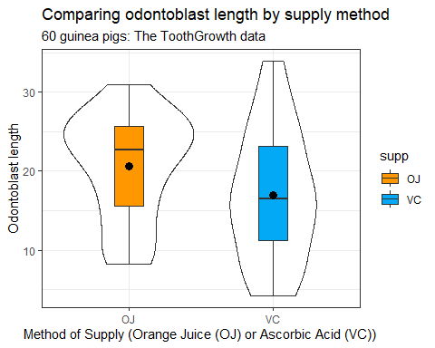

Lengths within each supply method
TG_new |> group_by(supp) |>
reframe(lovedist(len))
# A tibble: 2 × 11
supp n miss mean sd med mad min q25 q75 max
<fct> <int> <int> <dbl> <dbl> <dbl> <dbl> <dbl> <dbl> <dbl> <dbl>
1 OJ 30 0 20.7 6.61 22.7 5.49 8.2 15.5 25.7 30.9
2 VC 30 0 17.0 8.27 16.5 9.27 4.2 11.2 23.1 33.9

Estimate Difference in Means with Confidence Interval?
We’ll fit a linear regression model using ordinary least squares (OLS) to build one possible confidence interval.
fit2 <- lm(len ~ (supp == "OJ"), data = TG_new)
model_parameters(fit2, ci = 0.95)
Parameter | Coefficient | SE | 95% CI | t(58) | p
-----------------------------------------------------------------------
(Intercept) | 16.96 | 1.37 | [14.23, 19.70] | 12.42 | < .001
supp == "OJ"TRUE | 3.70 | 1.93 | [-0.17, 7.57] | 1.92 | 0.060
Uncertainty intervals (equal-tailed) and p-values (two-tailed) computed
using a Wald t-distribution approximation.
Our model for the difference in mean length suggests that the OJ animals had odontoblasts that were 3.7 μm longer, with 95% confidence interval -0.17 to 7.57 μm.

What if we don’t specify supp == "OJ"?
Notice the change when we fit the model without specifying the direction of effect that interests us.
fit2_revised <- lm(len ~ supp, data = TG_new)
model_parameters(fit2_revised, ci = 0.95)
Parameter | Coefficient | SE | 95% CI | t(58) | p
------------------------------------------------------------------
(Intercept) | 20.66 | 1.37 | [17.93, 23.40] | 15.13 | < .001
supp [VC] | -3.70 | 1.93 | [-7.57, 0.17] | -1.92 | 0.060
Uncertainty intervals (equal-tailed) and p-values (two-tailed) computed
using a Wald t-distribution approximation.
- Previous slide: OJ were 3.7 μm longer (95% CI: -0.17, 7.57).

Consider both dose and supp
The guinea pigs were randomly allocated so that we have 10 animals at each combination of one of the three doses and one of the two supps.
- How does the relationship we observed between dose and odontoblast length (len) change when we take into account the supp method?

Summarizing len by dose and supp
TG_new |> group_by(dose_f, supp) |>
reframe(lovedist(len))
# A tibble: 6 × 12
dose_f supp n miss mean sd med mad min q25 q75 max
<fct> <fct> <int> <int> <dbl> <dbl> <dbl> <dbl> <dbl> <dbl> <dbl> <dbl>
1 0.5 OJ 10 0 13.2 4.46 12.2 4.30 8.2 9.7 16.2 21.5
2 0.5 VC 10 0 7.98 2.75 7.15 3.56 4.2 5.95 10.9 11.5
3 1 OJ 10 0 22.7 3.91 23.5 3.93 14.5 20.3 25.6 27.3
4 1 VC 10 0 16.8 2.52 16.5 1.70 13.6 15.3 17.3 22.5
5 2 OJ 10 0 26.1 2.66 26.0 2.08 22.4 24.6 27.1 30.9
6 2 VC 10 0 26.1 4.80 26.0 4.60 18.5 23.4 28.8 33.9
Boxplots of len in each dose, now separated (faceted) by supp…

Impact of dose and supp?
Result of adding the facet_wrap() line: next slide…
ggplot(TG_new, aes(x = dose_f, y = len)) +
geom_violin(fill = "tan") +
geom_boxplot(aes(width = 0.2)) +
stat_summary(fun = mean, geom = "point", size = 3, col = "red") +
facet_wrap(~ supp, labeller = "label_both")
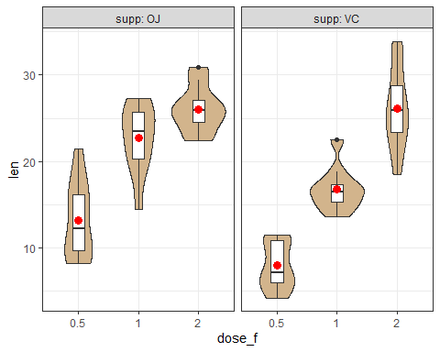

Length by supply, facets by dose?
ggplot(TG_new, aes(x = supp, y = len)) +
geom_violin() +
geom_boxplot(aes(fill = supp, width = 0.2)) +
stat_summary(fun = mean, geom = "point", size = 3, col = "white") +
facet_wrap(~ dose_f, labeller = "label_both") +
scale_fill_metro(palette = "light", reverse = TRUE) +
labs(title = "Comparing Length by Supply Method, by dose",
subtitle = "Vitamin C experiment in Tooth Growth of 60 guinea pigs",
x = "Supply Method", y = "Odontoblast length",
caption = "Sample means shown as white dots.")
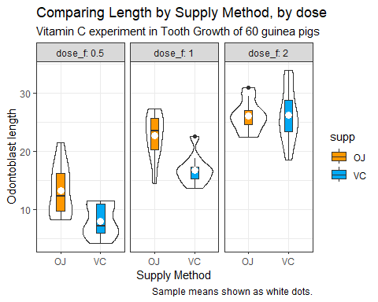

Recap: What Have We Done?
- Created an R Project to house our work
- Altered a Quarto template to do what we want
- Rendered the Quarto file to create HTML
- R packages and other R setup
- Tibble with as_tibble(), <- (assignment), |> (pipe)
- Numerical and tabular summaries
- Visualizations (histograms and boxplots)
- Estimating confidence intervals for one mean, or comparing two means, using a linear model

Next Time
- Data from the 15-item survey in Class 2
  - Ingesting data from the internet via .csv
  - Data Management and 6 key verbs in tidyverse
  - Visualization, Modeling, Inference tools
  - Exploring the data
  - Asking and answering some questions
- Making sure you’re ready for Lab 1 (due 2026-09-09)
Please don’t forget to do the Minute Paper after Class 3.

Session Information
xfun::session_info()
R version 4.6.1 (2026-06-24 ucrt)
Platform: x86_64-w64-mingw32/x64
Running under: Windows 11 x64 (build 26200)
Locale:
LC_COLLATE=English_United States.utf8
LC_CTYPE=English_United States.utf8
LC_MONETARY=English_United States.utf8
LC_NUMERIC=C
LC_TIME=English_United States.utf8
Package version:
abind_1.4-8 askpass_1.2.1 backports_1.5.1
base64enc_0.1-6 bayesplot_1.16.0 bayestestR_0.18.1
BH_1.90.0.1 bit_4.6.0 bit64_4.8.4
blob_1.3.0 boot_1.3-32 broom_1.0.13
bslib_0.12.0 cachem_1.1.0 callr_3.8.0
cellranger_1.1.0 checkmate_2.3.4 cli_3.6.6
clipr_0.8.1 coda_0.19-4.1 codetools_0.2-20
colourpicker_1.3.0 commonmark_2.0.0 compiler_4.6.1
conflicted_1.2.0 correlation_0.8.8 cpp11_0.5.5
crayon_1.5.3 crosstalk_1.2.2 curl_7.1.0
data.table_1.18.4 datasets_4.6.1 datawizard_1.3.1
DBI_1.3.0 dbplyr_2.6.0 desc_1.4.3
digest_0.6.39 distributional_0.8.1 dplyr_1.2.1
DT_0.34.0 dtplyr_1.3.3 dygraphs_1.1.1.6
easystats_0.7.6 effectsize_1.0.3 emmeans_2.0.4
estimability_2.0.0 evaluate_1.0.5 farver_2.1.2
fastmap_1.2.0 fontawesome_0.5.3 forcats_1.0.1
fs_2.1.0 gargle_1.6.1 generics_0.1.4
ggdist_3.3.3 ggplot2_4.0.3 ggridges_0.5.7
glue_1.8.1 googledrive_2.1.2 googlesheets4_1.1.2
graphics_4.6.1 grDevices_4.6.1 grid_4.6.1
gridExtra_2.3.1 gtable_0.3.6 gtools_3.9.5
haven_2.5.5 highr_0.12 hms_1.1.4
htmltools_0.5.9 htmlwidgets_1.6.4 httpuv_1.6.17
httr_1.4.8 ids_1.0.1 igraph_2.3.3
inline_0.3.21 insight_1.5.3 isoband_0.3.0
janitor_2.2.1 jquerylib_0.1.4 jsonlite_2.0.0
knitr_1.51 labeling_0.4.3 later_1.4.8
lattice_0.23-1 lazyeval_0.2.3 lifecycle_1.0.5
litedown_0.11 lme4_2.0-6 loo_2.10.1
lubridate_1.9.5 magrittr_2.0.5 markdown_2.0
MASS_7.3-66 Matrix_1.7-6 matrixStats_1.5.0
memoise_2.0.1 methods_4.6.1 mime_0.13
miniUI_0.1.2 minqa_1.2.8 modelbased_0.16.0
modelr_0.1.11 multcomp_1.4-32 mvtnorm_1.4-2
nlme_3.1-170 nloptr_2.2.1 numDeriv_2016.8.1.1
openssl_2.4.2 otel_0.2.0 parallel_4.6.1
parameters_0.29.2 patchwork_1.3.2 performance_0.17.1
pillar_1.11.1 pkgbuild_1.4.8 pkgconfig_2.0.3
plyr_1.8.9 posterior_1.7.0 prettyunits_1.2.0
processx_3.9.0 progress_1.2.3 promises_1.5.0
ps_1.9.3 purrr_1.2.2 quadprog_1.5.8
QuickJSR_1.11.0 R6_2.6.1 ragg_1.5.2
rappdirs_0.3.4 rbibutils_2.4.1 RColorBrewer_1.1-3
Rcpp_1.1.2 RcppEigen_0.3.4.0.2 RcppParallel_6.2.0
Rdpack_2.6.6 readr_2.2.0 readxl_1.5.0
reformulas_0.4.4 rematch_2.0.0 rematch2_2.1.2
report_0.6.4 reprex_2.1.1 reshape2_1.4.5
rlang_1.3.0 rmarkdown_2.31 rstan_2.32.7
rstanarm_2.32.2 rstantools_2.7.0 rstudioapi_0.19.0
rvest_1.0.5 S7_0.2.2 sandwich_3.1-3
sass_0.4.10 scales_1.4.0 see_0.14.1
selectr_0.6.0 shiny_1.14.0 shinyjs_2.1.1
shinystan_2.7.0 shinythemes_1.2.0 snakecase_0.11.1
sourcetools_0.1.7.2 splines_4.6.1 StanHeaders_2.32.10
stats_4.6.1 stats4_4.6.1 stringi_1.8.9
stringr_1.6.0 survival_3.8-11 sys_3.4.3
systemfonts_1.3.2 tensorA_0.36.2.1 textshaping_1.0.5
TH.data_1.1-5 threejs_0.3.4 tibble_3.3.1
tidyr_1.3.2 tidyselect_1.2.1 tidyverse_2.0.0
timechange_0.4.0 tinytex_0.60 tools_4.6.1
tzdb_0.5.0 utf8_1.2.6 utils_4.6.1
uuid_1.2.2 V8_8.2.0 vctrs_0.7.3
viridisLite_0.4.3 vroom_1.7.1 withr_3.0.3
xfun_0.60 xml2_1.6.0 xtable_1.8-8
xts_0.14.2 yaml_2.3.12 zoo_1.9-0

