431 Class 06
Thomas E. Love, Ph.D.
2026-09-10
 An IMPORTANT Note to Word users
The kable_styling() stuff used in the HTML slides doesn’t work in Word. Hence, those bits of code are not included in this Word version.

Today’s Agenda
- Assumptions of our uncertainty intervals for means
  - for one sample / paired differences
  - for two independent samples
- Transforming an Outcome (see Chapter 7)
  - The importance of power transformations
  - Tukey’s ladder and the Box-Cox plot
  - Back-transforming predictions, not coefficients
The last few slides describe a worked example for self-study.

Load packages and set theme
knitr::opts_chunk$set(comment = NA)
source("c06/data/Love-431.R") # for the lovedist() function
library(janitor)
library(patchwork)
library(readxl)
library(knitr)
library(kableExtra)
library(MKinfer)
library(rstanarm)
library(car) ## new today
library(infer) ## new today
library(easystats)
library(tidyverse)
theme_set(theme_bw())

Our data: from dm464 again
class06 <- read_xlsx("c06/data/dm464.xlsx") |>
janitor::clean_names() |>
select(id_code, age = age_start, sex, home = home_start,
a1c_base = a1c_start, a1c_end, ldl = ldl_start,
statin = statin_start) |>
mutate(across(where(is.character), as_factor)) |>
mutate(id_code = as.character(id_code)) |>
mutate(stat_f = as_factor(statin),
stat_f = fct_recode(stat_f, "Statin" = "1", "No" = "0"))
- Read in the Excel data, then clean names and select (and rename some) variables.
- Change all character variables to factors, except id_code.
- Create a “Statin”/“No” factor for the 1/0 data in statin.

The class06 data
class06
# A tibble: 464 × 9
id_code age sex home a1c_base a1c_end ldl statin stat_f
<chr> <dbl> <fct> <fct> <dbl> <dbl> <dbl> <dbl> <fct>
1 DM-1007 63 Female City 9.5 9 203 1 Statin
2 DM-1017 56 Male Suburbs 6.2 6.5 88 1 Statin
3 DM-1039 53 Female City 6.6 7 139 1 Statin
4 DM-1049 52 Female City 7 6.7 188 1 Statin
5 DM-1064 55 Female City 5.3 5.6 112 0 No
6 DM-1070 61 Female City 6.9 7 81 1 Statin
7 DM-1076 68 Female City 11.1 9.8 167 0 No
8 DM-1095 56 Female City 8.3 8.8 89 1 Statin
9 DM-1110 67 Male City 10.5 13.1 135 1 Statin
10 DM-1143 64 Female City 5.7 5.4 68 0 No
# ℹ 454 more rows
write_rds(class06, "c06/data/class06.Rds")

Uncertainty Interval Assumptions in One Sample / Paired Samples

One Sample (maybe Paired Differences)
- All approaches assume our sample is a random sample (or at least a representative one) from the population of interest.
- Ordinary Least Squares model / Paired T test also assumes that the population of interest follows a Normal distribution, so that our sample data should look as though it were drawn from a Normal distribution.

One Sample (maybe Paired Differences)
- Our Bayesian approach assumes a (weakly informative) prior distribution on the coefficient in our model.
- The bootstrap approach does not assume a Normal distribution for the population.
Main check in data: Normal distribution?

Does a Normal model fit well?
Don’t rely on hypothesis tests of whether data follow a Normal distribution. Instead, do we have…
- A histogram that is symmetric and bell-shaped.
- A boxplot where the box is symmetric around the median, as are the whiskers, without severe outliers.
- A normal Q-Q plot that essentially falls on a straight line.
- If in doubt, maybe compare mean and sd to median and MAD, and perhaps consider Empirical Rule.

Difference in A1c (end - baseline)
class06 <- class06 |> mutate(a1c_diff = a1c_end - a1c_base)
plot1 <- ggplot(class06, aes(sample = a1c_diff)) +
geom_qq() + geom_qq_line(col = "red") +
labs(y = "A1c difference (%)", x = "Standard Normal Distribution",
title = "Normal Q-Q plot")
bw = 1 # specify width of bins in histogram
plot2 <- ggplot(class06, aes(x = a1c_diff)) +
geom_histogram(binwidth = bw, fill = "black", col = "yellow") +
stat_function(fun = function(x)
dnorm(x, mean = mean(class06$a1c_diff, na.rm = TRUE),
sd = sd(class06$a1c_diff, na.rm = TRUE)) *
length(class06$a1c_diff) * bw,
geom = "area", alpha = 0.5,
fill = "lightblue", col = "blue") +
labs(x = "A1c difference (%)", y = "Count",
title = "Histogram & Normal Curve")
plot3 <- ggplot(class06, aes(x = a1c_diff, y = "")) +
geom_violin(fill = "cornsilk") +
geom_boxplot(width = 0.2) +
stat_summary(fun = mean, geom = "point", shape = 16, col = "red") +
labs(y = "", x = "A1c difference (%)", title = "Boxplot with Violin")
plot1 +
(plot2 / plot3 + plot_layout(heights = c(2,1))) +
plot_annotation("Are differences in Hemoglobin A1c Normally distributed?")
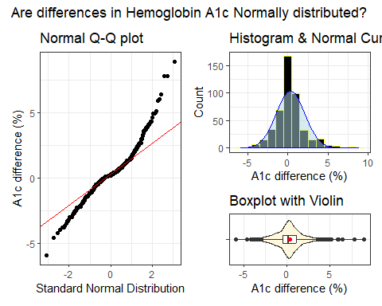

OLS/t test vs. Bayes
fit1 <- lm(a1c_diff ~ 1, data = class06)
model_parameters(fit1, ci = 0.9)
Parameter | Coefficient | SE | 90% CI | t(463) | p
-----------------------------------------------------------------
(Intercept) | 0.33 | 0.08 | [0.20, 0.47] | 4.00 | < .001
Uncertainty intervals (equal-tailed) and p-values (two-tailed) computed
using a Wald t-distribution approximation.
set.seed(43101)
fit2 <- stan_glm(a1c_diff ~ 1, data = class06, refresh = 0)
model_parameters(fit2, ci = 0.9)
Parameter | Median | 90% CI | pd | Rhat | ESS (tail) | Prior
---------------------------------------------------------------------------------------
(Intercept) | 0.33 | [0.20, 0.47] | 100% | 1.000 | 2157 | Normal (0.33 +- 4.46)
Uncertainty intervals (equal-tailed) computed using a MCMC distribution
approximation.
- OLS: estimate: 0.33, 90% confidence interval (0.20, 0.47)
- Bayes: estimate: 0.33, 90% credible interval (0.20, 0.47)

Bootstrapped t test
set.seed(43102)
boot.t.test(class06$a1c_diff, conf.level = 0.90, R = 2000)
Bootstrap One Sample t-test
data: class06$a1c_diff
number of bootstrap samples: 2000
bootstrap p-value < 5e-04
bootstrap mean of x (SE) = 0.3318219 (0.08270615)
90 percent bootstrap percentile confidence interval:
0.1974030 0.4762931
Results without bootstrap:
t = 4.0016, df = 463, p-value = 7.323e-05
alternative hypothesis: true mean is not equal to 0
90 percent confidence interval:
0.1950719 0.4682901
sample estimates:
mean of x
0.331681

What to do about outliers? (1/3)
The paired differences here appear to be symmetric, but with outliers.
- This should push us towards a method which doesn’t require the assumption of Normality.
  - Specifically, the bootstrap would likely be a better choice than a t test, although it didn’t make a meaningful difference.
  - 90% uncertainty interval with OLS/t test was (0.20, 0.47) and the bootstrap 90% uncertainty interval was (0.20, 0.48).

What to do about outliers? (2/3)
class06 |> reframe(lovedist(a1c_diff)) |>
kable(digits = 2)
n | miss | mean | sd | med | mad | min | q25 | q75 | max
464 | 0 | 0.33 | 1.79 | 0.2 | 1.19 | -5.9 | -0.5 | 1.1 | 8.9
- skew₁ = (mean - median)/sd = (0.33 - 0.2)/1.79 = 0.073
Could we transform these data in a non-linear way to better match assumptions?
- Not really, no. Most of the transformations we use regularly are designed to address skew in the data, rather than tail behavior.

What to do about outliers? (3/3)
Should we build our interval around the median instead of the mean?
- sample median = 0.2, sample mean = 0.33
ggplot(class06, aes(x = a1c_diff, y = "")) +
geom_violin(fill = "cornsilk") +
geom_boxplot(width = 0.2) +
stat_summary(fun = mean, geom = "point", shape = 16, col = "red") +
labs(y = "", x = "A1c difference (%)", title = "Boxplot with Violin")
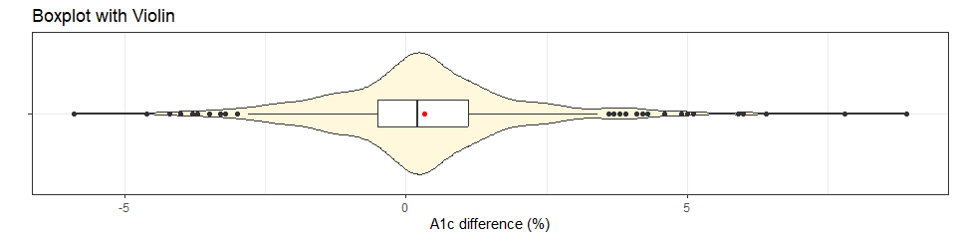
- Maybe, but does that actually address the issue here?

Bootstrap 90% interval for Median
This is from the infer package…
set.seed(43103)
x_med <- class06 |> observe(response = a1c_diff, stat = "median")
res1 <- class06 |>
specify(response = a1c_diff) |>
generate(reps = 2000, type = "bootstrap") |>
calculate(stat = "median") |>
get_confidence_interval(level = 0.90, type = "percentile")
res1 <- res1 |> mutate(pt_est = x_med$stat) |>
relocate(pt_est)
res1
# A tibble: 1 × 3
pt_est lower_ci upper_ci
<dbl> <dbl> <dbl>
1 0.200 0.200 0.300

A Strategy for Paired Samples
Suppose we want to estimate an uncertainty interval for the mean of a set of paired differences.
- Calculate the paired differences, then plot them.
- If the sample data are well described as “Normal”, then use the OLS / paired t procedure to obtain a confidence interval, or a Bayesian model to obtain a credible interval.
- If the sample data are best described as “symmetric but with outliers”, then use the bootstrap to obtain a confidence interval, although an OLS or Bayesian result (with a weakly informative prior) may be quite similar.
- If the sample data are best described as “substantially skewed”, then consider whether you actually want to summarize with the mean, and consider whether a transformation of the outcome might be helpful.

Uncertainty Interval Assumptions in Independent Samples

Two Independent Samples (1/2)
- All methods assume each of the two samples is a random sample (or at least representative) of its population.
- Ordinary Least Squares model / Pooled T test assumes:
  - each of the two populations of interest follows a Normal distribution, and
  - either the variance of those two populations is equal, so it makes sense to pool the standard deviations, or the sample sizes are equal (a balanced design)

Two Independent Samples (2/2)
- The Welch t test makes the Normality assumption, but not the assumption of equal population variances.
- Our Bayesian approach assumes a (weakly informative) prior distribution on each of the coefficients (intercept and slope) of our model.
- The bootstrap approach does not assume a Normal distribution for the population, but can take advantage of an assumption of equal variances if it exists.

LDL means by statin group (1/5)
OLS / pooled t
fit3 <- lm(ldl ~ stat_f, data = class06)
model_parameters(fit3, ci = 0.90)
Parameter | Coefficient | SE | 90% CI | t(462) | p
------------------------------------------------------------------------
(Intercept) | 96.26 | 3.86 | [89.90, 102.62] | 24.94 | < .001
stat f [Statin] | 7.17 | 4.34 | [ 0.02, 14.32] | 1.65 | 0.099
Uncertainty intervals (equal-tailed) and p-values (two-tailed) computed
using a Wald t-distribution approximation.

LDL means by statin group (2/5)
Welch t (no pooling)
fit4 <- t.test(ldl ~ stat_f, data = class06,
var.equal = FALSE, conf.level = 0.90)
model_parameters(fit4, ci = 0.90)
Welch Two Sample t-test
Parameter | Group | stat_f = No | stat_f = Statin | Difference
---------------------------------------------------------------
ldl | stat_f | 96.26 | 103.43 | -7.17
Parameter | 90% CI | t(183.36) | p
-----------------------------------------------
ldl | [-13.48, -0.86] | -1.88 | 0.062
Alternative hypothesis: true difference in means between group No and group Statin is not equal to 0

LDL means by statin group (3/5)
Bayesian linear model
set.seed(43105)
fit5 <- stan_glm(ldl ~ stat_f, data = class06, refresh = 0)
model_parameters(fit5, ci = 0.90)
Parameter | Median | 90% CI | pd | Rhat | ESS (tail) | Prior
------------------------------------------------------------------------------------------------
(Intercept) | 96.17 | [89.91, 102.31] | 100% | 1.000 | 3060 | Normal (101.93 +- 95.20)
stat_fStatin | 7.26 | [ 0.11, 14.48] | 95.17% | 1.000 | 2590 | Normal (0.00 +- 233.87)
Uncertainty intervals (equal-tailed) computed using a MCMC distribution
approximation.

LDL means by statin group (4/5)
Bootstrap, without pooling sd estimates
set.seed(43106)
boot.t.test(ldl ~ stat_f, var.equal = FALSE, R = 2000,
data = class06, conf.level = 0.90)
Bootstrap Welch Two Sample t-test
data: ldl by stat_f
number of bootstrap samples: 2000
bootstrap p-value = 0.07
bootstrap difference of means (SE) = -7.156579 (3.782602)
90 percent bootstrap percentile confidence interval:
-13.02256 -1.16262
Results without bootstrap:
t = -1.8786, df = 183.36, p-value = 0.06188
alternative hypothesis: true difference in means is not equal to 0
90 percent confidence interval:
-13.4797701 -0.8603518
sample estimates:
mean in group No mean in group Statin
96.25773 103.42779

LDL means by statin group (5/5)
Bootstrap, with pooling of sd estimates
set.seed(43107)
boot.t.test(ldl ~ stat_f, var.equal = TRUE, R = 2000,
data = class06, conf.level = 0.90)
Bootstrap Two Sample t-test
data: ldl by stat_f
number of bootstrap samples: 2000
bootstrap p-value = 0.11
bootstrap difference of means (SE) = -7.356209 (4.338503)
90 percent bootstrap percentile confidence interval:
-14.54414309 0.01876738
Results without bootstrap:
t = -1.6523, df = 462, p-value = 0.09915
alternative hypothesis: true difference in means is not equal to 0
90 percent confidence interval:
-14.32216921 -0.01795271
sample estimates:
mean in group No mean in group Statin
96.25773 103.42779

Findings So Far…
Estimating the mean difference in LDL levels at baseline for the “Statin” group minus the “No Statin” group…
Approach | Estimate & 90% Interval
OLS model / Pooled t | 7.17 (0.02, 14.32)
Welch t without pooling sd | 7.17 (0.86, 13.48)
Bayesian fit: stan_glm() | 7.26 (0.11, 14.48)
Bootstrap with unpooled sd | 7.16 (1.16, 13.02)
Bootstrap with pooled sd | 7.36 (-0.02, 14.54)

Standing Break

LDL by Statin prescription status
To assess how well our data fit the assumptions of the various estimates we have, start with a comparison boxplot.
ggplot(class06, aes(x = ldl, y = stat_f)) +
geom_violin() +
geom_boxplot(aes(fill = stat_f), width = 0.3) +
stat_summary(fun = mean, geom = "point",
shape = 18, size = 4, col = "black") +
guides(fill = "none") +
labs(y = "Statin prescription", x = "LDL Cholesterol (mg/dl)",
title = "LDL by Statin prescription",
subtitle = "Each group is a bit skewed to the right")
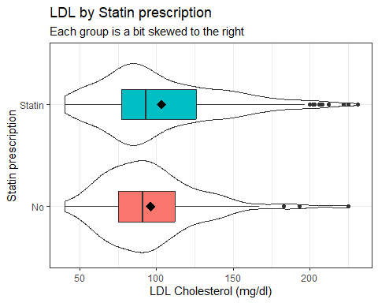

LDL by Statin prescription status
How about a pair of Normal Q-Q plots?
p1 <- class06 |>
filter(stat_f == "Statin") |>
ggplot(aes(sample = ldl)) +
geom_qq() + geom_qq_line(col = "red") +
labs(title = "Statin group", y = "LDL Cholesterol (mg/dl)",
x = "Standard Normal")
p2 <- class06 |>
filter(stat_f == "No") |>
ggplot(aes(sample = ldl)) +
geom_qq() + geom_qq_line(col = "red") +
labs(title = "No Statin group", y = "LDL Cholesterol (mg/dl)",
x = "Standard Normal")
p1 + p2 +
plot_annotation(title = "Normal Q-Q plots of LDL by Statin group")
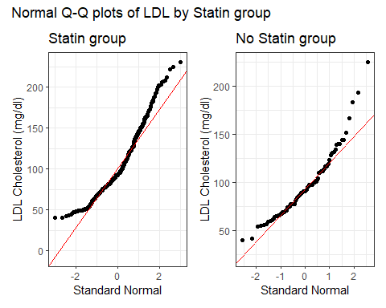

LDL by Statin prescription status
A look at some numerical summaries…
class06 |> group_by(stat_f) |> reframe(lovedist(ldl)) |>
kable(digits = 2)
stat_f | n | miss | mean | sd | med | mad | min | q25 | q75 | max
No | 97 | 0 | 96.26 | 31.63 | 91 | 28.17 | 40 | 75 | 112 | 225
Statin | 367 | 0 | 103.43 | 39.51 | 93 | 34.10 | 40 | 77 | 126 | 231
- skew₁ for “Statin” = (103.43 - 93)/39.51 = 0.26
- skew₁ for “No” = (96.26 - 91)/31.63 = 0.17
Our rough cutoff for substantial right skew ~ 0.20.

What can we do about the skew?
- Could we build a confidence interval for medians instead of means?
  - Yes, with the bootstrap, for example see Section 6.9.2 of my text.
- Could we transform the data in a non-linear way to better match assumptions?
  - Yes, with the help of Tukey’s ladder of power transformations.

Tukey’s Ladder
Power ($λ$) | -2 | -1 | -0.5 | 0 | 0.5 | 1 | 2 | 3
Transformation | $\frac{1}{y^{2}}$ | $\frac{1}{y}$ | $\frac{1}{\sqrt{y}}$ | log $y$ | $\sqrt{y}$ | $y$ | $y^{2}$ | $y^{3}$
- Works to address skew, mainly, rather than symmetry with problems in the tails
- Some of these transformations require all values to be positive. If they aren’t, we can add a small amount to each observation until they are.
- Start at no transformation ($λ=1$)
- Try moving in one direction or the other, searching for a result which better matches what we might expect from a Normal distribution
  - If a step (like taking the square root) helps, move in that same direction.
  - If it doesn’t help, try moving in the other direction.

A1c values (end of study)
ggplot(class06, aes(x = a1c_end)) +
geom_histogram(binwidth = 0.4, fill = "slateblue", col = "white") +
stat_function(fun = function(x)
dnorm(x, mean = mean(class06$a1c_end, na.rm = TRUE),
sd = sd(class06$a1c_end, na.rm = TRUE)) *
length(class06$a1c_end) * 0.4,
geom = "area", alpha = 0.5,
fill = "lightblue", col = "blue") +
labs(title = "A1c (untransformed)", x = "Hemoglobin A1c, %", y = "Count")
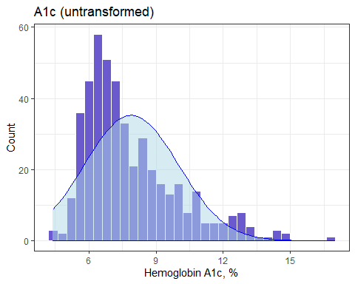

Six Power Transformations
p1 <- ggplot(class06, aes(x = a1c_end^3)) +
geom_histogram(bins = 25, fill = "firebrick", col = "white") +
labs(title = "A1c^3 (cubed)", x = "A1c^3", y = "Count")
p2 <- ggplot(class06, aes(x = a1c_end^2)) +
geom_histogram(bins = 25, fill = "magenta", col = "white") +
labs(title = "A1c^2 (squared)", x = "A1c^2", y = "Count")
p3 <- ggplot(class06, aes(x = a1c_end)) +
geom_histogram(bins = 25, fill = "slateblue", col = "white") +
labs(title = "A1c (untransformed)", x = "Hemoglobin A1c, %", y = "Count")
p4 <- ggplot(class06, aes(x = sqrt(a1c_end))) +
geom_histogram(bins = 25, fill = "skyblue", col = "white") +
labs(title = "sqrt(A1c) (square root)", x = "sqrt(A1c)", y = "Count")
p5 <- ggplot(class06, aes(x = log(a1c_end))) +
geom_histogram(bins = 25, fill = "navy", col = "white") +
labs(title = "log A1c (logarithm)", x = "log A1c", y = "Count")
p6 <- ggplot(class06, aes(x = 1/a1c_end)) +
geom_histogram(bins = 25, fill = "thistle", col = "white") +
labs(title = "1/A1c (inverse)", x = "1/A1c", y = "Count")
(p1 + p2 + p3) / (p4 + p5 + p6)
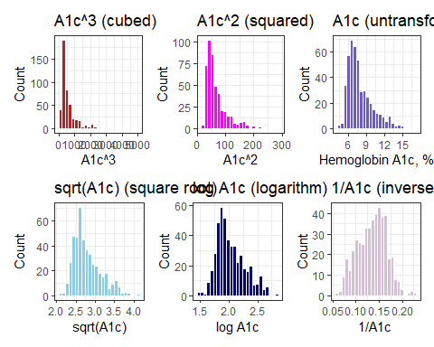

Which Transformation to Choose?
Box-Cox approach: can we get a suggested “power” to use when transforming our outcome?
- Specify the model then apply boxCox from car package.
- Here, all values of our outcome (A1c) are strictly positive.
  - If not, we’d have to add a constant so that they were.
fit1 <- lm(a1c_end ~ 1, data = class06)
boxCox(fit1)
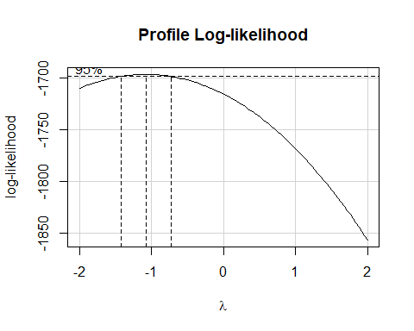

Back to LDL by Statin prescription
ggplot(class06, aes(x = ldl, y = stat_f)) +
geom_violin() +
geom_boxplot(aes(fill = stat_f), width = 0.3) +
stat_summary(fun = mean, geom = "point",
shape = 18, size = 4, col = "black") +
guides(fill = "none") +
labs(y = "Statin prescription", x = "LDL Cholesterol (mg/dl)",
title = "LDL by Statin prescription",
subtitle = "Each group is a bit skewed to the right")


What transformation should we try?
fit2 <- lm(ldl ~ statin, data = class06)
boxCox(fit2)
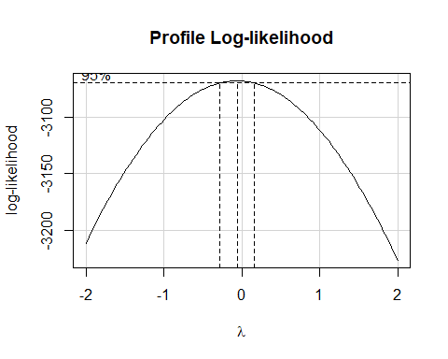

log(LDL) by Statin?
ggplot(class06, aes(x = log(ldl), y = stat_f)) +
geom_violin() +
geom_boxplot(aes(fill = stat_f), width = 0.3) +
stat_summary(fun = mean, geom = "point",
shape = 18, size = 4, col = "black") +
labs(y = "Statin prescription", x = "log(LDL)",
title = "log(LDL) by Statin prescription") +
guides(fill = "none")
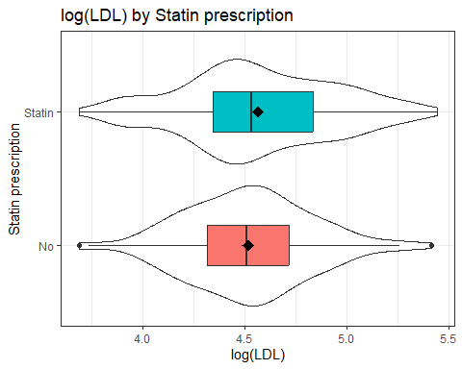

Estimate log(LDL) mean by Statin
fit3 <- lm(log(ldl) ~ stat_f, data = class06)
model_parameters(fit3, ci = 0.90) ## 90% uncertainty interval
Parameter | Coefficient | SE | 90% CI | t(462) | p
----------------------------------------------------------------------
(Intercept) | 4.52 | 0.04 | [ 4.46, 4.58] | 122.75 | < .001
stat f [Statin] | 0.05 | 0.04 | [-0.02, 0.12] | 1.23 | 0.220
Uncertainty intervals (equal-tailed) and p-values (two-tailed) computed
using a Wald t-distribution approximation.
The model has a log-transformed response variable. Consider using
`exponentiate = TRUE` to interpret coefficients as ratios.
- The difference between Statin and No Statin on the logarithmic scale (in mean of log(LDL)) is thus 0.05, with 90% CI (-0.02, 0.12).

Expectations from our model
- The model coefficients exist in the transformed world, but we can make predictions back on our original scale.
estimate_expectation(fit3, data = "grid", ci = 0.90)
Model-based Predictions
stat_f | Predicted | SE | 90% CI
----------------------------------------
No | 4.52 | 0.04 | [4.46, 4.58]
Statin | 4.57 | 0.02 | [4.54, 4.60]
Variable predicted: ldl
Predictors modulated: stat_f
Predictions are on the log-scale (consider `transform=TRUE`).
- and we exponentiate to get back to our original scale…

Expectations from our model
- We use transform = TRUE to exponentiate back out of the logarithms to our original scale of LDL cholesterol levels.
estimate_expectation(fit3, data = "grid", ci = 0.90, transform = TRUE)
Model-based Predictions
stat_f | Predicted | 90% CI
-----------------------------------
No | 91.67 | [86.27, 97.40]
Statin | 96.45 | [93.49, 99.50]
Variable predicted: ldl
Predictors modulated: stat_f

Exponentiation of Expectations
- Back out of logged predictions by exponentiating…
Group | Predicted LDL | 90% uncertainty interval
No Statin | exp(4.52) = 91.8 | (exp(4.46), exp(4.58)) = (86.5, 97.5)
Statin | exp(4.57) = 96.5 | (exp(4.54), exp(4.60)) = (93.7, 99.5)
- These intervals describe uncertainty about the average predicted LDL across all subjects in each statin group.

Fitting Individual Predictions
- Use estimate_prediction() to make predictions for an individual subject in each group.
estimate_prediction(fit3, data = "grid", ci = 0.90)
Model-based Predictions
stat_f | Predicted | SE | 90% CI
----------------------------------------
No | 4.52 | 0.36 | [3.92, 5.12]
Statin | 4.57 | 0.36 | [3.97, 5.17]
Variable predicted: ldl
Predictors modulated: stat_f
Predictions are on the log-scale (consider `transform=TRUE`).
- and exponentiate to get back to our original scale…

Fitting Individual Predictions
- Back out of log transformation with transform = TRUE.
estimate_prediction(fit3, data = "grid", ci = 0.90, transform = TRUE)
Model-based Predictions
stat_f | Predicted | 90% CI
------------------------------------
No | 91.67 | [50.28, 167.12]
Statin | 96.45 | [53.02, 175.44]
Variable predicted: ldl
Predictors modulated: stat_f

Fitting Individual Predictions
- Exponentiating the predictions gives…
Group | Predicted LDL | 90% uncertainty interval
No Statin | exp(4.52) = 91.8 | (exp(3.92), exp(5.12)) = (50.4, 167.3)
Statin | exp(4.57) = 96.5 | (exp(3.97), exp(5.17)) = (53, 175.9)
- These intervals describe uncertainty about an individual predicted LDL for a single subject in each group.

Using the log transformation
- The log transformation in R (log in R is the natural log - the base 10 log is log10()) generates coefficients which describe a multiplicative effect.
If we fit a model to predict $y$ using $x$ of the form:
$$logy=β_{0}+β_{1}x$$
where $logy$ is the natural log, then if we exponentiate the slope coefficient, we get the multiplicative factor for a one-unit increase in the predictor.

The Math
$$
\log(y) = \beta_0 + \beta_1 x \\
\exp(\log(y)) = \exp(\beta_0 + \beta_1 x) \\
y = \exp(\beta_0 + \beta_1 x) \\
y = \exp(\beta_0) \times \exp(\beta_1 x)
$$
This implies that our predictor ($x$) has a multiplicative relationship with our outcome ($y$) instead of the usual additive relationship. Hence, we can express the effect of a one-unit change in $x$ on $y$ as a percentage change.

Example 1
Suppose we build a regression model with equation $logy=6+0.23x$.
Note that $exp(0.23)=1.26$.
- If Harry’s value of $x$ is 1 point larger than Sally’s, the predicted $y$ value for Harry will be increased by 26% relative to Sally’s. (Increased by 26% = multiplied by 1.26.)

Back to log(LDL) by Statin
fit3 <- lm(log(ldl) ~ stat_f, data = class06)
model_parameters(fit3, ci = 0.90) ## 90% uncertainty interval
Parameter | Coefficient | SE | 90% CI | t(462) | p
----------------------------------------------------------------------
(Intercept) | 4.52 | 0.04 | [ 4.46, 4.58] | 122.75 | < .001
stat f [Statin] | 0.05 | 0.04 | [-0.02, 0.12] | 1.23 | 0.220
Uncertainty intervals (equal-tailed) and p-values (two-tailed) computed
using a Wald t-distribution approximation.
- Now, we’ll exponentiate these coefficients…

Exponentiating the Coefficients
fit3 <- lm(log(ldl) ~ stat_f, data = class06)
model_parameters(fit3, ci = 0.90, exponentiate = TRUE)
Parameter | Coefficient | SE | 90% CI | t(462) | p
-----------------------------------------------------------------------
(Intercept) | 91.67 | 3.37 | [86.27, 97.40] | 122.75 | < .001
stat f [Statin] | 1.05 | 0.04 | [ 0.98, 1.13] | 1.23 | 0.220
Uncertainty intervals (equal-tailed) and p-values (two-tailed) computed
using a Wald t-distribution approximation.
Subjects with a statin prescription have 5% higher LDL, on average, than do subjects without.
- The ratio has point estimate 1.05 and 90% interval estimate (0.98, 1.13).

Independent Samples Strategy
Suppose we want to estimate an uncertainty interval for the difference in means across two groups. To begin, plot the data from each sample.
- If the sample data in each group are well described as “Normal”, then use the OLS / pooled t procedure to obtain a confidence interval, or a Bayesian model to obtain a credible interval.
  - If the sample sizes are not the same, and the sample variances aren’t close to each other, consider using a Welch t procedure.
- If either sample’s data are “symmetric but with outliers”, then consider using the bootstrap to obtain a confidence interval, although an OLS or Bayesian result may also be reasonable.
- If either sample’s data are best described as “substantially skewed”, then consider whether you actually want to summarize with the difference in means, and consider whether a transformation might be helpful.

Another worked example (for self-study)

Boxplot: Difference in A1c by Sex
ggplot(class06, aes(x = a1c_diff, y = sex)) +
geom_violin() + geom_boxplot(aes(fill = sex), width = 0.3) +
labs(x = "Change in A1c", y = "Sex",
title = "Difference in A1c (end - base) by Sex") +
guides(fill = "none")
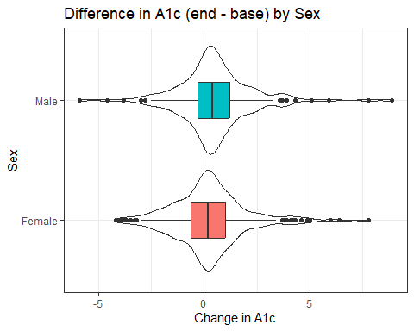

Numerical Summary (A1c by Sex)
class06 |> group_by(sex) |>
reframe(lovedist(a1c_diff)) |>
kable(digits = 3)
sex | n | miss | mean | sd | med | mad | min | q25 | q75 | max
Female | 288 | 0 | 0.227 | 1.747 | 0.2 | 1.186 | -4.2 | -0.625 | 1.0 | 7.8
Male | 176 | 0 | 0.503 | 1.838 | 0.4 | 1.186 | -5.9 | -0.300 | 1.2 | 8.9
- Difference in sample means is 0.503 - 0.227 = 0.276
- Do we have a balanced design?
- Are we comfortable pooling standard deviations?
- Are we comfortable assuming Normality for each sex?

Might a transformation help here?
Some of the A1c changes are negative (minimum = -5.9)
class06 <- class06 |> mutate(a1c_diff_p6 = a1c_diff + 6)
fit4 <- lm(a1c_diff_p6 ~ sex, data = class06)
boxCox(fit4)
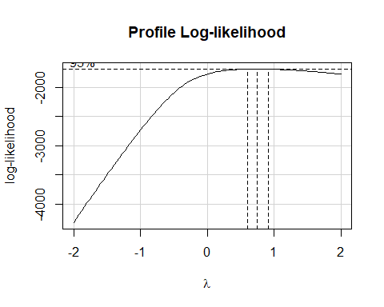

Does using a square root help?
p1 <- ggplot(class06, aes(x = a1c_diff_p6, y = sex)) +
geom_violin() + geom_boxplot(aes(fill = sex), width = 0.3) +
labs(x = "Change in A1c + 6", y = "Sex",
title = "A1c difference (+ 6) by Sex") +
guides(fill = "none")
p2 <- ggplot(class06, aes(x = sqrt(a1c_diff_p6), y = sex)) +
geom_violin() + geom_boxplot(aes(fill = sex), width = 0.3) +
labs(x = "Square Root of (Change in A1c + 6)", y = "Sex",
title = "Square Root of (A1c difference + 6) by Sex") +
guides(fill = "none")
p1 / p2
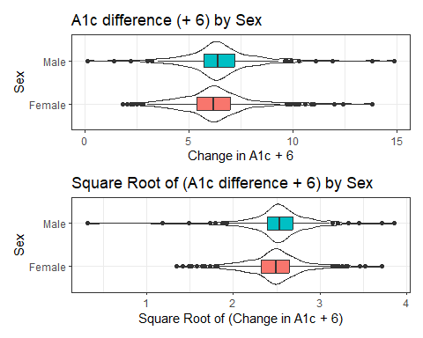

Addressing outliers?

OLS model
fit5 <- lm(a1c_diff ~ sex, data = class06)
model_parameters(fit5, ci = 0.90)
Parameter | Coefficient | SE | 90% CI | t(462) | p
-----------------------------------------------------------------
(Intercept) | 0.23 | 0.11 | [ 0.05, 0.40] | 2.16 | 0.031
sex [Male] | 0.28 | 0.17 | [ 0.00, 0.56] | 1.62 | 0.105
Uncertainty intervals (equal-tailed) and p-values (two-tailed) computed
using a Wald t-distribution approximation.
- Male subjects had A1c changes that were 0.28 larger than females, on average, with 90% uncertainty interval (0, 0.56) according to our OLS model (pooled t test.)

Addressing outliers?

Bayesian model
set.seed(20240912)
fit6 <- stan_glm(a1c_diff ~ sex, data = class06, refresh = 0)
model_parameters(fit6, ci = 0.90)
Parameter | Median | 90% CI | pd | Rhat | ESS (tail) | Prior
------------------------------------------------------------------------------------------
(Intercept) | 0.22 | [ 0.05, 0.39] | 98.42% | 1.000 | 2257 | Normal (0.33 +- 4.46)
sexMale | 0.28 | [ 0.00, 0.57] | 94.80% | 1.000 | 2783 | Normal (0.00 +- 9.19)
Uncertainty intervals (equal-tailed) computed using a MCMC distribution
approximation.
- Male subjects had A1c changes that were 0.28 larger than females, on average, with 90% uncertainty interval (0, 0.57) according to our Bayesian model.

Addressing outliers?

Bootstrap with boot.t.test
set.seed(20240912)
boot.t.test(a1c_diff ~ sex, data = class06, conf.level = 0.90)
Bootstrap Welch Two Sample t-test
data: a1c_diff by sex
number of bootstrap samples: 9999
bootstrap p-value = 0.1096
bootstrap difference of means (SE) = -0.2787276 (0.1715815)
90 percent bootstrap percentile confidence interval:
-0.566107955 0.002070707
Results without bootstrap:
t = -1.6028, df = 355.56, p-value = 0.1099
alternative hypothesis: true difference in means is not equal to 0
90 percent confidence interval:
-0.561349458 0.008003498
sample estimates:
mean in group Female mean in group Male
0.2267361 0.5034091

Repeating: Paired Samples Strategy
Suppose we want to estimate an uncertainty interval for the mean of a set of paired differences.
- Calculate the paired differences, then plot them.
- If the sample data are well described as “Normal”, then use the OLS / paired t procedure to obtain a confidence interval, or a Bayesian model to obtain a credible interval.
- If the sample data are best described as “symmetric but with outliers”, then use the bootstrap to obtain a confidence interval, although an OLS or Bayesian result may be quite similar.
- If the sample data are best described as “substantially skewed”, then consider whether you actually want to summarize with the mean, and consider whether a transformation might be helpful.

Independent Samples Strategy
Suppose we want to estimate an uncertainty interval for the difference in means across two groups. To begin, plot the data from each sample.
- If the sample data in each group are well described as “Normal”, then use the OLS / pooled t procedure to obtain a confidence interval, or a Bayesian model to obtain a credible interval.
  - If the sample sizes are not the same, and the sample variances aren’t close to each other, consider using a Welch t procedure.
- If either sample’s data are “symmetric but with outliers”, then consider using the bootstrap to obtain a confidence interval, although an OLS or Bayesian result may also be reasonable.
- If either sample’s data are best described as “substantially skewed”, then consider whether you actually want to summarize with the difference in means, and consider whether a transformation might be helpful.

Session Information
xfun::session_info()
R version 4.6.1 (2026-06-24 ucrt)
Platform: x86_64-w64-mingw32/x64
Running under: Windows 11 x64 (build 26200)
Locale:
LC_COLLATE=English_United States.utf8
LC_CTYPE=English_United States.utf8
LC_MONETARY=English_United States.utf8
LC_NUMERIC=C
LC_TIME=English_United States.utf8
Package version:
abind_1.4-8 arrangements_1.1.10 askpass_1.2.1
backports_1.5.1 base64enc_0.1-6 bayesplot_1.16.0
bayestestR_0.18.1 BH_1.90.0.1 bit_4.6.0
bit64_4.8.4 blob_1.3.0 boot_1.3-32
broom_1.0.13 bslib_0.12.0 cachem_1.1.0
callr_3.8.0 car_3.1-5 carData_3.0-6
cellranger_1.1.0 checkmate_2.3.4 cli_3.6.6
clipr_0.8.1 coda_0.19-4.1 codetools_0.2-20
colorspace_2.1.3 colourpicker_1.3.0 commonmark_2.0.0
compiler_4.6.1 conflicted_1.2.0 correlation_0.8.8
cowplot_1.2.0 cpp11_0.5.5 crayon_1.5.3
crosstalk_1.2.2 curl_8.0.0 data.table_1.18.6.1
datasets_4.6.1 datawizard_1.3.1 DBI_1.3.0
dbplyr_2.6.0 Deriv_4.3.0 desc_1.4.3
digest_0.6.39 distributional_0.8.1 doBy_4.7.2
dplyr_1.2.1 DT_0.34.0 dtplyr_1.3.3
dygraphs_1.1.1.6 easystats_0.7.6 effectsize_1.0.3
emmeans_2.0.4 estimability_2.0.0 evaluate_1.0.5
exactRankTests_0.8-37 farver_2.1.2 fastmap_1.2.0
fontawesome_0.5.3 forcats_1.0.1 foreach_1.5.2
forecast_9.0.2 Formula_1.2-6 fracdiff_1.5.4
fs_2.1.0 gargle_1.6.1 generics_0.1.4
ggdist_3.3.3 ggplot2_4.0.3 ggridges_0.5.7
glmnet_5.0 glue_1.8.1 gmp_0.7-5.1
googledrive_2.1.2 googlesheets4_1.1.2 graphics_4.6.1
grDevices_4.6.1 grid_4.6.1 gridExtra_2.3.1
gtable_0.3.6 gtools_3.9.5 haven_2.5.5
highr_0.12 hms_1.1.4 htmltools_0.5.9
htmlwidgets_1.6.4 httpuv_1.6.17 httr_1.4.8
ids_1.0.1 igraph_2.3.3 infer_1.1.0
inline_0.3.21 insight_1.5.3 isoband_0.3.0
iterators_1.0.14 janitor_2.2.1 jomo_2.7-6
jquerylib_0.1.4 jsonlite_2.0.0 kableExtra_1.4.1
knitr_1.51 labeling_0.4.3 later_1.4.8
lattice_0.23-1 lazyeval_0.2.3 lifecycle_1.0.5
litedown_0.11 lme4_2.0-6 lmtest_0.9.40
loo_2.10.1 lubridate_1.9.5 magrittr_2.0.5
markdown_2.0 MASS_7.3-66 Matrix_1.7-6
MatrixModels_0.5.4 matrixStats_1.5.0 memoise_2.0.1
methods_4.6.1 mgcv_1.9.4 mice_3.19.0
miceadds_3.20-10 mime_0.13 miniUI_0.1.2
minqa_1.2.8 mitml_0.4-5 mitools_2.4
MKdescr_0.9 MKinfer_1.3 modelbased_0.17.0
modelr_0.1.11 multcomp_1.4-32 mvtnorm_1.4-2
nlme_3.1-170 nloptr_2.2.1 nnet_7.3-21
numDeriv_2016.8.1.1 openssl_2.4.2 ordinal_2026.7.26
otel_0.2.0 pan_2.0 parallel_4.6.1
parameters_0.29.2 patchwork_1.3.2 pbkrtest_0.5.5
performance_0.18.0 pillar_1.11.1 pkgbuild_1.4.8
pkgconfig_2.0.3 plyr_1.8.9 posterior_1.7.0
prettyunits_1.2.0 processx_3.9.0 progress_1.2.3
promises_1.5.0 ps_1.9.3 purrr_1.2.2
quadprog_1.5.8 quantreg_6.1 QuickJSR_1.11.0
R6_2.6.1 ragg_1.5.2 rappdirs_0.3.4
rbibutils_2.4.1 RColorBrewer_1.1-3 Rcpp_1.1.2
RcppArmadillo_15.4.2.1 RcppEigen_0.3.4.0.2 RcppParallel_6.2.0
Rdpack_2.6.6 readr_2.2.0 readxl_1.5.0
reformulas_0.4.4 rematch_2.0.0 rematch2_2.1.2
report_0.6.4 reprex_2.1.1 reshape2_1.4.5
rlang_1.3.0 rmarkdown_2.31 rpart_4.1.27
rstan_2.32.7 rstanarm_2.32.2 rstantools_2.7.1
rstudioapi_0.19.0 rvest_1.0.5 S7_0.2.2
sandwich_3.1-3 sass_0.4.10 scales_1.4.0
see_0.14.1 selectr_0.6.0 shape_1.4.6.1
shiny_1.14.0 shinyjs_2.1.1 shinystan_2.7.0
shinythemes_1.2.0 snakecase_0.11.1 sourcetools_0.1.7.2
SparseM_1.84.2 splines_4.6.1 StanHeaders_2.32.10
stats_4.6.1 stats4_4.6.1 stringi_1.8.9
stringr_1.6.0 survival_3.8-11 svglite_2.2.2
sys_3.4.3 systemfonts_1.3.2 tensorA_0.36.2.1
textshaping_1.0.5 TH.data_1.1-5 threejs_0.3.4
tibble_3.3.1 tidyr_1.3.2 tidyselect_1.2.1
tidyverse_2.0.0 timechange_0.4.0 timeDate_4052.112
tinytex_0.60 tools_4.6.1 tzdb_0.5.0
ucminf_1.2.3 urca_1.3.4 utf8_1.2.6
utils_4.6.1 uuid_1.2.2 V8_8.2.0
vctrs_0.7.3 viridisLite_0.4.3 vroom_1.7.1
withr_3.0.3 xfun_0.60 xml2_1.6.0
xtable_1.8-8 xts_0.14.2 yaml_2.3.12
zoo_1.9-0

