431 Class 16
Thomas E. Love, Ph.D.
2026-10-15

Today’s Agenda
- Ingesting / Managing some Favorite Movies Data
- Comparing two groups on a transformed outcome
- Comparing two groups adjusting for a covariate
- Fitting OLS models with two predictors
- Model Parameters, Model Performance comparisons
- Using estimate_relation() for…
  - predictions and uncertainty intervals (PIs & CIs)
  - back-transformation of predictions
- Checking Model Diagnostics

Today’s Packages
love431_url <-
"https://raw.githubusercontent.com/THOMASELOVE/431-data/refs/heads/main/data/Love-431.R"
- OK. Let’s build our R setup…
knitr::opts_chunk$set(comment = NA)
source(love431_url)
library(janitor)
library(naniar)
library(googlesheets4) ## ingest favorite movies from Google Sheets
library(car)
library(easystats)
library(tidyverse)
theme_set(theme_lucid()) ## from easystats

Cleveland Guardians Team Colors?
guards_red <- "#E50022"
guards_navy <- "#00358D"
Source: https://teamcolorcodes.com/.
cream <- "#FFFCD8"

Data Ingest and Management

Importing Data on Favorite Movies
gs4_deauth() # indicates to Google Drive that you're reading a public file
url_movies <- "https://docs.google.com/spreadsheets/d/1LJdlS1JUYQqJidrnkJ5OmFZr009g25oiZkvtZXhXXlc"
## this is movies_2026-10-13 from our shared drive
mov_raw <- read_sheet(url_movies, na = c("", "NA"))
✔ Reading from "movies_2026-10-13".
✔ Range 'movies_2026-10-13'.
dim(mov_raw)
[1] 282 97

Data Cleanup for Today
movies <- mov_raw |>
select(mov_id, bw_rating, imdb_stars, gend_1, gend_2, gend_3,
rt_audience, movie) |>
mutate(across(where(is.character), as_factor),
movie = as.character(movie),
mov_id = as.character(mov_id))
movies |> head()
# A tibble: 6 × 8
mov_id bw_rating imdb_stars gend_1 gend_2 gend_3 rt_audience movie
<chr> <dbl> <dbl> <fct> <fct> <fct> <dbl> <chr>
1 M-001 1 8.4 M M F 93 3 Idiots
2 M-002 3 8 M F F 92 8 1/2
3 M-003 3 7.4 M F M 69 10 Things I Hate…
4 M-004 3 7.3 F F F 74 20th Century Wom…
5 M-005 NA 7.6 M F M 89 300
6 M-006 0 8.3 M M M 89 2001: A Space Od…

Missingness?
miss_var_summary(movies) |> filter(n_miss > 0)
# A tibble: 2 × 3
variable n_miss pct_miss
<chr> <int> <num>
1 bw_rating 17 6.03
2 rt_audience 3 1.06
miss_case_table(movies)
# A tibble: 3 × 3
n_miss_in_case n_cases pct_cases
<int> <int> <dbl>
1 0 265 94.0
2 1 14 4.96
3 2 3 1.06

Which movies have missing data?
movies |> filter(!complete.cases(bw_rating, rt_audience)) |>
select(mov_id, bw_rating, rt_audience, movie)
# A tibble: 17 × 4
mov_id bw_rating rt_audience movie
<chr> <dbl> <dbl> <chr>
1 M-005 NA 89 300
2 M-013 NA NA Ananda Bhairavi
3 M-018 NA NA B for Busy (Al qing shen hua)
4 M-044 NA NA Chinese Doctors (Zhong guo yi sheng)
5 M-080 NA 84 The Garden of Words (Kotonoha no niwa)
6 M-085 NA 85 Gifted Hands: The Ben Carson Story
7 M-086 NA 28 The Gingerdead Man
8 M-103 NA 80 Harlem Nights
9 M-117 NA 65 House Party 2
10 M-134 NA 90 Jab We Met (When We Met)
11 M-151 NA 91 The Legend of 1900 (La leggenda del pianista su…
12 M-155 NA 96 Like Stars on Earth (Taare Zameen Par)
13 M-165 NA 56 Loving Adults (Kærlighed for voksne)
14 M-181 NA 89 Miracle in Cell No. 7 (7-beon-bang-ui seon-mul)
15 M-199 NA 77 Om Shanti Om (Peace Be With You)
16 M-254 NA 90 Still Walking (Aruitemo aruitemo)
17 M-273 NA 88 Waterloo Bridge

How to deal with missing data?
- Solution today: complete case analysis
- Solution coming soon: (single or multiple) imputation
movies_cc <- movies |> drop_na()
dim(movies_cc)
[1] 265 8

Bechdel-Wallace Rating
Bechdel-Wallace scores range from 0 to 3, and are a count of how many of these standards are met by the movie:
- It has to have at least two named women in it.
- Who talk to each other
- About something besides a man.
A passing score is 3, anything less doesn’t pass the test.
- We’ll create bw_test to show Pass or Fail.

Star Genders
gend_1, gend_2 and gend_3 represent the genders (M or F) played in the movie by each of the first three listed stars on IMDB.
- We’ll create a variable called females to count the number of female stars (0-3).

Code to create new variables
movies_cc <- movies_cc |>
mutate(bw_test = factor(bw_rating == 3),
bw_test = fct_recode(bw_test, "Pass" = "TRUE", "Fail" = "FALSE")) |>
mutate(females = as.numeric(gend_1 == "F") +
as.numeric(gend_2 == "F") + as.numeric(gend_3 == "F"))

Checking our cleaning
movies_cc |> select(mov_id, bw_test, bw_rating, females, gend_1, gend_2, gend_3) |>
head()
# A tibble: 6 × 7
mov_id bw_test bw_rating females gend_1 gend_2 gend_3
<chr> <fct> <dbl> <dbl> <fct> <fct> <fct>
1 M-001 Fail 1 1 M M F
2 M-002 Pass 3 2 M F F
3 M-003 Pass 3 1 M F M
4 M-004 Pass 3 3 F F F
5 M-006 Fail 0 0 M M M
6 M-007 Pass 3 2 F M F

Tabulating the New Variables
movies_cc |> tabyl(bw_test, females) |>
adorn_totals(where = c("row", "col")) |>
adorn_title()
females
bw_test 0 1 2 3 Total
Fail 41 68 5 0 114
Pass 17 76 44 14 151
Total 58 144 49 14 265
Let’s put Pass before Fail in the bw_test variable when we fit models:
movies_cc <- movies_cc |> mutate(bw_test = fct_relevel(bw_test, "Pass"))

Today’s Outcome: imdb_stars
- 1 star = worst possible, 10 stars = best possible
ggplot(movies_cc, aes(x = imdb_stars)) +
geom_histogram(binwidth = 0.25, fill = guards_red, col = cream)
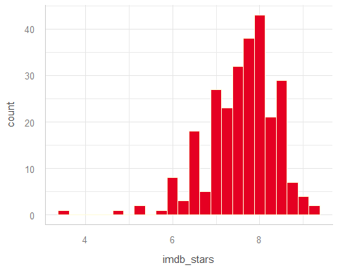

A Covariate: rt_audience
- This is the Popcornmeter, audience scores on 0-100 scale
ggplot(movies_cc, aes(x = rt_audience)) +
geom_histogram(binwidth = 2, fill = guards_red, col = cream)
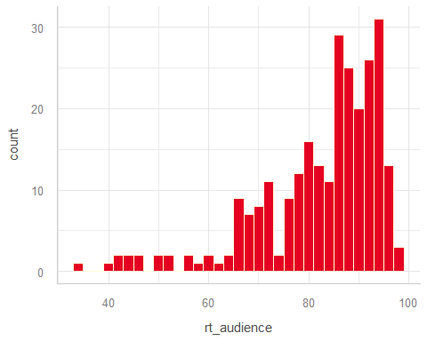

Audience Reaction Measures
- imdb_stars (1 = worst possible, 10 = best possible)
movies_cc |> reframe(lovedist(imdb_stars))
# A tibble: 1 × 10
n miss mean sd med mad min q25 q75 max
<int> <int> <dbl> <dbl> <dbl> <dbl> <dbl> <dbl> <dbl> <dbl>
1 265 0 7.59 0.781 7.7 0.741 3.6 7.2 8.1 9.3
- rt_audience (0 to 100 scale: the “Popcornmeter”)
movies_cc |> reframe(lovedist(rt_audience))
# A tibble: 1 × 10
n miss mean sd med mad min q25 q75 max
<int> <int> <dbl> <dbl> <dbl> <dbl> <dbl> <dbl> <dbl> <dbl>
1 265 0 82.8 12.3 86 10.4 34 78 92 99

Today’s Analyses
movies1 <- movies_cc |> select(mov_id, bw_test, imdb_stars,
females, rt_audience, movie)
dim(movies1)
[1] 265 6
- Do movies which pass the bw_test have more (or fewer) imdb_stars than movies which do not pass it?
- Would adjusting for the number of female characters among the first three stars (females) change our thinking about the association in analysis 1?
- Would adjusting for the Rotten Tomatoes Popcornmeter (rt_audience) change our thinking about analysis 1?

Analysis 1

IMDB Stars by bw_test (pass/fail)
ggplot(movies1, aes(x = imdb_stars, y = bw_test)) +
geom_violin(col = guards_red) +
geom_boxplot(width = 0.3, col = guards_red, fill = cream, outlier.size = 3) +
stat_summary(geom = "point", fun = mean, shape = 16, size = 3, col = guards_navy)
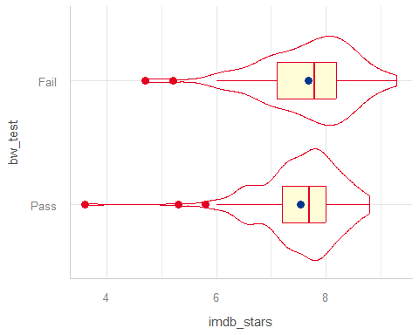

Analysis 1: Numerical Summary
- Do movies which pass the bw_test have more (or fewer) imdb_stars than movies which do not pass it?
movies1 |>
reframe(lovedist(imdb_stars), .by = bw_test)
# A tibble: 2 × 11
bw_test n miss mean sd med mad min q25 q75 max
<fct> <int> <int> <dbl> <dbl> <dbl> <dbl> <dbl> <dbl> <dbl> <dbl>
1 Fail 114 0 7.68 0.832 7.8 0.741 4.7 7.1 8.2 9.3
2 Pass 151 0 7.53 0.737 7.7 0.593 3.6 7.2 8 8.8
- What should we do to compare these means?
  - t test / OLS model, Bayes t test / model, Bootstrap, Wilcoxon rank sum test?

Box-Cox?
fit0 <- lm(imdb_stars ~ bw_test, data = movies1)
boxCox(fit0, lambda = seq(-2, 5, 1/10))
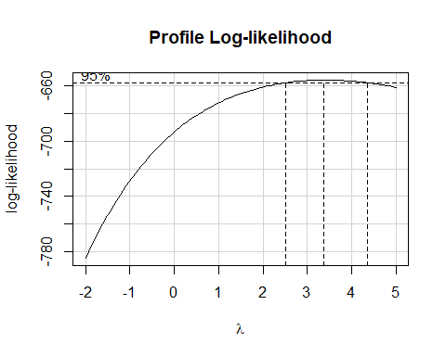

Squaring the outcome?
ggplot(movies1, aes(x = imdb_stars^2, y = bw_test)) +
geom_violin(col = guards_red) +
geom_boxplot(width = 0.3, col = guards_red, fill = cream, outlier.size = 3) +
stat_summary(geom = "point", fun = mean, shape = 16, size = 3, col = guards_navy)
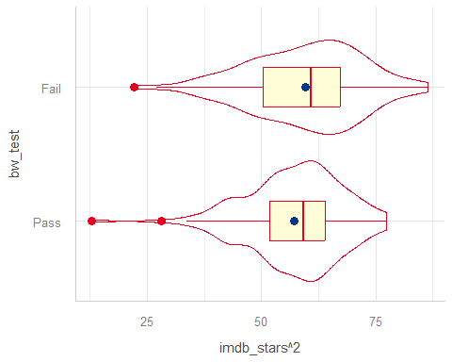

Cubing the outcome?
ggplot(movies1, aes(x = imdb_stars^3, y = bw_test)) +
geom_violin(col = guards_red) +
geom_boxplot(width = 0.3, col = guards_red, fill = cream, outlier.size = 3) +
stat_summary(geom = "point", fun = mean, shape = 16, size = 3, col = guards_navy)
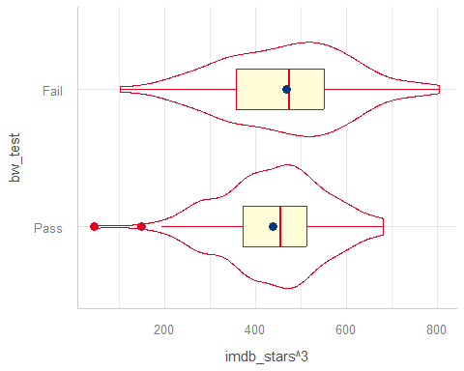

Tesseracting? (outcome^4)
ggplot(movies1, aes(x = imdb_stars^4, y = bw_test)) +
geom_violin(col = guards_red) +
geom_boxplot(width = 0.3, col = guards_red, fill = cream, outlier.size = 3) +
stat_summary(geom = "point", fun = mean, shape = 16, size = 3, col = guards_navy)
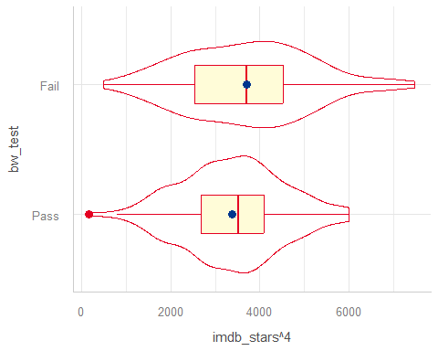

Which shall we choose?
- If our main goal is to create an interpretable model, then we have a different answer than if our main goal is to transform until the data appear as close to a Normal distribution as possible.
- Most of the time, I stick with simpler transformations, that I can back out of easily, like squares, logs, square roots and inverses.
So here, I’ll go with imdb_stars squared…
movies1 <- movies1 |>
mutate(stars_sq = imdb_stars^2)

OLS Linear Model (t test)
fit1 <- lm(stars_sq ~ bw_test, data = movies1)
model_parameters(fit1, ci = 0.9)
Parameter | Coefficient | SE | 90% CI | t(263) | p
----------------------------------------------------------------------
(Intercept) | 57.25 | 0.92 | [55.73, 58.76] | 62.43 | < .001
bw test [Fail] | 2.38 | 1.40 | [ 0.07, 4.69] | 1.70 | 0.090
Uncertainty intervals (equal-tailed) and p-values (two-tailed) computed
using a Wald t-distribution approximation.
- What does the intercept in fit1 mean?
- What does the slope of bw_test mean in fit1?

OLS Linear Model (t test)
fit1 <- lm(stars_sq ~ bw_test, data = movies1)
model_parameters(fit1, ci = 0.9)
Parameter | Coefficient | SE | 90% CI | t(263) | p
----------------------------------------------------------------------
(Intercept) | 57.25 | 0.92 | [55.73, 58.76] | 62.43 | < .001
bw test [Fail] | 2.38 | 1.40 | [ 0.07, 4.69] | 1.70 | 0.090
Uncertainty intervals (equal-tailed) and p-values (two-tailed) computed
using a Wald t-distribution approximation.
Interpretation?
- Movies which failed the Bechdel-Wallace test had a higher average (squared number of IMDB stars) by 2.38 than did movies which passed the B-W test.

OLS Linear Model (t test)
fit1 <- lm(stars_sq ~ bw_test, data = movies1)
model_parameters(fit1, ci = 0.9, pretty_names = FALSE)
Parameter | Coefficient | SE | 90% CI | t(263) | p
-------------------------------------------------------------------
(Intercept) | 57.25 | 0.92 | [55.73, 58.76] | 62.43 | < .001
bw_testFail | 2.38 | 1.40 | [ 0.07, 4.69] | 1.70 | 0.090
Uncertainty intervals (equal-tailed) and p-values (two-tailed) computed
using a Wald t-distribution approximation.
Interpretation?
- The data are consistent at the 90% confidence level with (0.07, 4.69) more (squared IMDB stars) on average when bw_test is Fail, assuming a random sample of movies, and that our model fit1 is correct.

Estimating the Effect with fit1
estimate_contrasts(fit1, contrast = "bw_test", ci = 0.90)
Marginal Contrasts Analysis
Level1 | Level2 | Difference | SE | 90% CI | t(263) | p
-------------------------------------------------------------------
Fail | Pass | 2.38 | 1.40 | [0.07, 4.69] | 1.70 | 0.090
Variable predicted: stars_sq
Predictors contrasted: bw_test
p-values are uncorrected.
- Same results as previous slide.
- More useful if we have more than 2 levels of our predictor, naturally.

Is fit1 correct?
set.seed(43101)
plot(check_model(fit1, check = c("pp_check", "qq")))
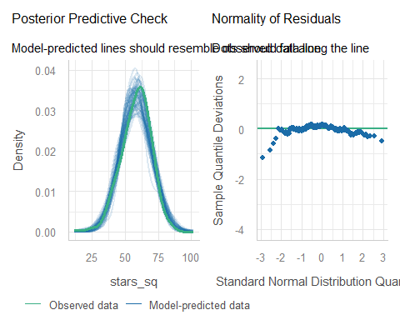

Let’s keep in the trend…
set.seed(43102)
plot(check_model(fit1, check = c("pp_check", "qq"), detrend = FALSE))
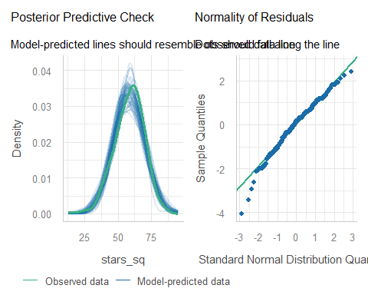

Which plots are useful?
If we have at least one quantitative predictor, then we consider all five diagnostic plots carefully.
- The 5 Plots include: linearity, homogeneity, influential points, as well as posterior predictive check and Normal Q-Q plot of residuals.
- If we have only a categorical predictor (or predictors), then we will focus on 2 plots: the posterior predictive check and the Normal Q-Q plot of residuals.

Useful here?
plot(check_model(fit1, check = c("linearity", "homogeneity")))
Warning in simpleLoess(y, x, w, span, degree = degree, parametric = parametric,
: pseudoinverse used at 57.235
Warning in simpleLoess(y, x, w, span, degree = degree, parametric = parametric,
: neighborhood radius 2.3912
Warning in simpleLoess(y, x, w, span, degree = degree, parametric = parametric,
: reciprocal condition number 1.3225e-15
Warning in simpleLoess(y, x, w, span, degree = degree, parametric = parametric,
: There are other near singularities as well. 5.7179
Warning in simpleLoess(y, x, w, span, degree = degree, parametric = parametric,
: pseudoinverse used at 57.235
Warning in simpleLoess(y, x, w, span, degree = degree, parametric = parametric,
: neighborhood radius 2.3912
Warning in simpleLoess(y, x, w, span, degree = degree, parametric = parametric,
: reciprocal condition number 1.3225e-15
Warning in simpleLoess(y, x, w, span, degree = degree, parametric = parametric,
: There are other near singularities as well. 5.7179
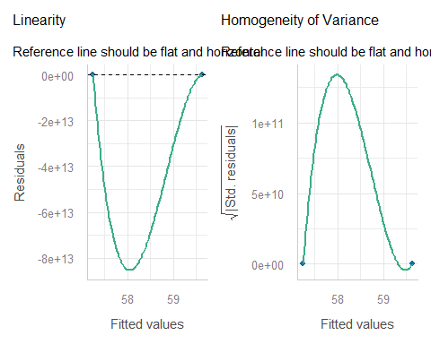

Useful here?
plot(check_model(fit1, check = "outliers"))
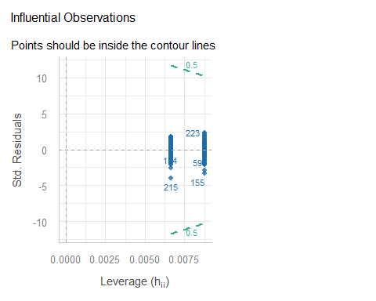

Performance of the model
model_performance(fit1)
# Indices of model performance
AIC | AICc | BIC | R2 | R2 (adj.) | RMSE | Sigma
--------------------------------------------------------------
2039.7 | 2039.8 | 2050.4 | 0.011 | 0.007 | 11.225 | 11.268
- Can we provide some context for the Sigma value?
movies1 |> reframe(lovedist(imdb_stars^2), .by = bw_test)
# A tibble: 2 × 11
bw_test n miss mean sd med mad min q25 q75 max
<fct> <int> <int> <dbl> <dbl> <dbl> <dbl> <dbl> <dbl> <dbl> <dbl>
1 Fail 114 0 59.6 12.3 60.8 11.9 22.1 50.4 67.2 86.5
2 Pass 151 0 57.2 10.4 59.3 8.90 13.0 51.8 64 77.4

Uncertainty Intervals
When making predictions, we can build confidence or prediction intervals using our linear regression model.
- We can do so using estimate_relation()…
  - confidence intervals: describe the mean across a population of subjects with this predictor value
  - prediction intervals: describe the best estimate for a single new subject with this predictor value.
- We can also transform the predictions and intervals back to our original outcome (imdb_stars).

Estimate Relation with fit1
estimate_relation(fit1, ci = 0.90)
Model-based Predictions
bw_test | Predicted | SE | 90% CI
-------------------------------------------
Pass | 57.25 | 0.92 | [55.73, 58.76]
Fail | 59.63 | 1.06 | [57.88, 61.37]
Variable predicted: stars_sq
Predictors modulated: bw_test
- From fit1: Predicted stars_sq when bw_test is “Pass” = 57.25, with 90% confidence interval (55.73, 58.76).
- Predicted stars_sq when bw_test is “Fail” = 59.63, with 90% CI (57.88. 61.37).

Transform and predict imdb_stars
- Refit fit1 to clarify the outcome transformation to R.
fit1a <- lm((imdb_stars)^2 ~ bw_test, data = movies1)
- Back-transform predictions, with 90% confidence intervals.
estimate_relation(fit1a, ci = 0.90, transform = TRUE) ## back-transform
Model-based Predictions
bw_test | Predicted | 90% CI
----------------------------------
Pass | 7.57 | [7.47, 7.67]
Fail | 7.72 | [7.61, 7.83]
Variable predicted: imdb_stars
Predictors modulated: bw_test

Prediction Plot with CIs
plot(estimate_relation(fit1a, ci = 0.90, transform = TRUE)) +
labs(title = "Predictions from `fit1a` with 90% Confidence Intervals")
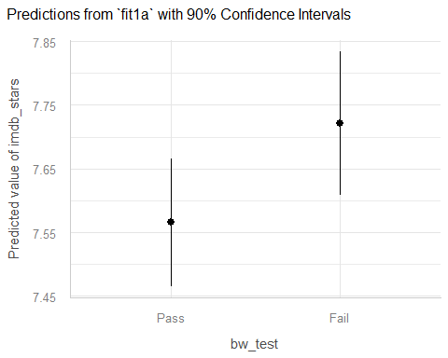

Prediction Intervals
estimate_relation(fit1a, ci = 0.90, transform = TRUE,
predict = "prediction")
Model-based Predictions
bw_test | Predicted | 90% CI
----------------------------------
Pass | 7.57 | [6.21, 8.71]
Fail | 7.72 | [6.40, 8.85]
Variable predicted: imdb_stars
Predictors modulated: bw_test
- What is the difference between these prediction intervals and the 90% confidence intervals we saw 2 slides ago?

Prediction Plot with PIs
plot(estimate_relation(fit1a, ci = 0.90,
predict = "prediction", transform = TRUE)) +
labs(title = "Predictions from `fit1a` with 90% Prediction Intervals")
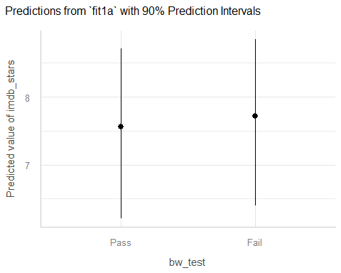

Uncertainty Intervals
We can build uncertainty intervals using our linear model for new predictor values, but if the outcome is transformed, we must back-transform manually.
- For confidence intervals for the mean across a population of subjects with (new) specified values of the predictors, use estimate_expectation().
- For prediction intervals for a single new subject with (new) specified values of the predictors, use estimate_prediction().

estimate_expectation(fit1, contrast = "bw_test", ci = 0.90,
data = tibble(bw_test = c("Pass", "Fail")))
Model-based Predictions
bw_test | Predicted | SE | 90% CI
-------------------------------------------
Pass | 57.25 | 0.92 | [55.73, 58.76]
Fail | 59.63 | 1.06 | [57.88, 61.37]
Variable predicted: stars_sq
fit1 predictions (and 90% confidence intervals) for average imdb_stars across many movies…
bw_test | Predicted imdb_stars | 90% CI for imdb_stars
Pass | $\sqrt{57.25}$ = 7.57 | (7.47, 7.67)
Fail | $\sqrt{59.63}$ = 7.72 | (7.61, 7.83)

estimate_prediction(fit1, ci = 0.90,
data = tibble(bw_test = c("Pass", "Fail")))
Model-based Predictions
bw_test | Predicted | SE | 90% CI
--------------------------------------------
Pass | 57.25 | 11.31 | [38.59, 75.91]
Fail | 59.63 | 11.32 | [40.95, 78.31]
Variable predicted: stars_sq
fit1 predictions (and 90% prediction intervals) for imdb_stars for a single new movie…
bw_test | Predicted imdb_stars | 90% CI for imdb_stars
Pass | $\sqrt{57.25}$ = 7.57 | (6.21, 8.71)
Fail | $\sqrt{59.63}$ = 7.72 | (6.4, 8.85)

Standing Break

Analysis 2

Adjusting for a Covariate
- Would adjusting for the number of female characters among the first three stars (females) change our thinking about the association in analysis 1?
Analysis 1 conclusion:
- Movies that failed had 2.38 more (90% CI: 0.07, 4.69) “imdb_stars squared” than did movies that passed the Bechdel-Wallace test, assuming our sample is randomly drawn from all movies of interest, and that our regression model for stars_sq is correct.

Fit model fit2
Let’s include both the key predictor (bw_test) and the covariate (females) in the model for stars_sq…
fit2 <- lm(stars_sq ~ bw_test + females, data = movies1)
model_parameters(fit2, ci = 0.90, pretty_names = FALSE)
Parameter | Coefficient | SE | 90% CI | t(262) | p
-------------------------------------------------------------------
(Intercept) | 60.96 | 1.60 | [58.31, 63.61] | 38.03 | < .001
bw_testFail | 0.53 | 1.53 | [-2.00, 3.05] | 0.35 | 0.730
females | -2.72 | 0.97 | [-4.32, -1.12] | -2.81 | 0.005
Uncertainty intervals (equal-tailed) and p-values (two-tailed) computed
using a Wald t-distribution approximation.
- What does this intercept (61.19) mean?

Interpreting fit2 intercept
model_parameters(fit2, ci = 0.90, pretty_names = FALSE)
Parameter | Coefficient | SE | 90% CI | t(262) | p
-------------------------------------------------------------------
(Intercept) | 60.96 | 1.60 | [58.31, 63.61] | 38.03 | < .001
bw_testFail | 0.53 | 1.53 | [-2.00, 3.05] | 0.35 | 0.730
females | -2.72 | 0.97 | [-4.32, -1.12] | -2.81 | 0.005
Uncertainty intervals (equal-tailed) and p-values (two-tailed) computed
using a Wald t-distribution approximation.
Intercept = 60.96 specifies the predicted stars_sq according to the fit2 model if both bw_testFail = 0 and females = 0.
- bw_testFail = 1 if bw_test = Fail, and
- bw_testFail = 0 if bw_test = Pass, so…

fit2 Intercept
model_parameters(fit2, ci = 0.90, pretty_names = FALSE)
Parameter | Coefficient | SE | 90% CI | t(262) | p
-------------------------------------------------------------------
(Intercept) | 60.96 | 1.60 | [58.31, 63.61] | 38.03 | < .001
bw_testFail | 0.53 | 1.53 | [-2.00, 3.05] | 0.35 | 0.730
females | -2.72 | 0.97 | [-4.32, -1.12] | -2.81 | 0.005
Uncertainty intervals (equal-tailed) and p-values (two-tailed) computed
using a Wald t-distribution approximation.
- Model fit2 predicts that for a movie with 0 females among the three main stars, and a passing bw_test result, the stars_sq will be 60.96 (so the predicted imdb_stars = $\sqrt{60.96}$ = 7.81 stars.)

Interpret bw_test slope
model_parameters(fit2, ci = 0.90, pretty_names = FALSE)
Parameter | Coefficient | SE | 90% CI | t(262) | p
-------------------------------------------------------------------
(Intercept) | 60.96 | 1.60 | [58.31, 63.61] | 38.03 | < .001
bw_testFail | 0.53 | 1.53 | [-2.00, 3.05] | 0.35 | 0.730
females | -2.72 | 0.97 | [-4.32, -1.12] | -2.81 | 0.005
Uncertainty intervals (equal-tailed) and p-values (two-tailed) computed
using a Wald t-distribution approximation.
- What does the slope of bw_test mean here?

Interpret slope of bw_test
model_parameters(fit2, ci = 0.90, pretty_names = FALSE)
Parameter | Coefficient | SE | 90% CI | t(262) | p
-------------------------------------------------------------------
(Intercept) | 60.96 | 1.60 | [58.31, 63.61] | 38.03 | < .001
bw_testFail | 0.53 | 1.53 | [-2.00, 3.05] | 0.35 | 0.730
females | -2.72 | 0.97 | [-4.32, -1.12] | -2.81 | 0.005
Uncertainty intervals (equal-tailed) and p-values (two-tailed) computed
using a Wald t-distribution approximation.
Suppose we have two movies, each with the same number of females in its first three stars, but one movie passed and the other failed the B-W test.
The model fit2 predicts that the movie which failed will have 0.53 more “imdb_stars squared” than the movie which passed, with 90% CI (-2.00, 3.05).

Interpret females slope
model_parameters(fit2, ci = 0.90, pretty_names = FALSE)
Parameter | Coefficient | SE | 90% CI | t(262) | p
-------------------------------------------------------------------
(Intercept) | 60.96 | 1.60 | [58.31, 63.61] | 38.03 | < .001
bw_testFail | 0.53 | 1.53 | [-2.00, 3.05] | 0.35 | 0.730
females | -2.72 | 0.97 | [-4.32, -1.12] | -2.81 | 0.005
Uncertainty intervals (equal-tailed) and p-values (two-tailed) computed
using a Wald t-distribution approximation.
- What does the slope of females mean?

Interpret slope of females
model_parameters(fit2, ci = 0.90, pretty_names = FALSE)
Parameter | Coefficient | SE | 90% CI | t(262) | p
-------------------------------------------------------------------
(Intercept) | 60.96 | 1.60 | [58.31, 63.61] | 38.03 | < .001
bw_testFail | 0.53 | 1.53 | [-2.00, 3.05] | 0.35 | 0.730
females | -2.72 | 0.97 | [-4.32, -1.12] | -2.81 | 0.005
Uncertainty intervals (equal-tailed) and p-values (two-tailed) computed
using a Wald t-distribution approximation.
Suppose we have two movies, each with the same B-W test result, but movie A has one more female in its first three stars than movie B.
- The model fit2 predicts that movie A will have 2.72 fewer “imdb_stars squared” than movie B, with 90% CI (1.12, 4.32) fewer “imdb_stars squared”.

fit1 and fit2 parameters
What do we learn from this comparison?
model_parameters(fit1, ci = 0.90, pretty_names = FALSE)
Parameter | Coefficient | SE | 90% CI | t(263) | p
-------------------------------------------------------------------
(Intercept) | 57.25 | 0.92 | [55.73, 58.76] | 62.43 | < .001
bw_testFail | 2.38 | 1.40 | [ 0.07, 4.69] | 1.70 | 0.090
Uncertainty intervals (equal-tailed) and p-values (two-tailed) computed
using a Wald t-distribution approximation.
model_parameters(fit2, ci = 0.90, pretty_names = FALSE)
Parameter | Coefficient | SE | 90% CI | t(262) | p
-------------------------------------------------------------------
(Intercept) | 60.96 | 1.60 | [58.31, 63.61] | 38.03 | < .001
bw_testFail | 0.53 | 1.53 | [-2.00, 3.05] | 0.35 | 0.730
females | -2.72 | 0.97 | [-4.32, -1.12] | -2.81 | 0.005
Uncertainty intervals (equal-tailed) and p-values (two-tailed) computed
using a Wald t-distribution approximation.
- Do the differences in slope for bw_testFail make sense?

Model Performance?
model_performance(fit1)
# Indices of model performance
AIC | AICc | BIC | R2 | R2 (adj.) | RMSE | Sigma
--------------------------------------------------------------
2039.7 | 2039.8 | 2050.4 | 0.011 | 0.007 | 11.225 | 11.268
model_performance(fit2)
# Indices of model performance
AIC | AICc | BIC | R2 | R2 (adj.) | RMSE | Sigma
--------------------------------------------------------------
2033.8 | 2034.0 | 2048.1 | 0.040 | 0.032 | 11.060 | 11.123
- fit2 has better (smaller) AIC, AICc, BIC, RMSE and Sigma
- fit2 also has better (larger) R-squared and adjusted R-squared

Performance Comparison Plot
plot(compare_performance(fit1, fit2))
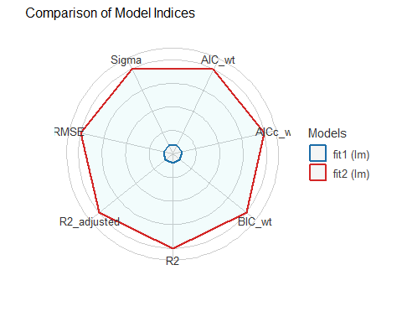

Diagnostics for fit2?
set.seed(43103)
plot(check_model(fit2, check = c("pp_check", "qq"), detrend = FALSE))
For confidence bands, please install `qqplotr`.
Ignoring unknown labels:
• size : ""
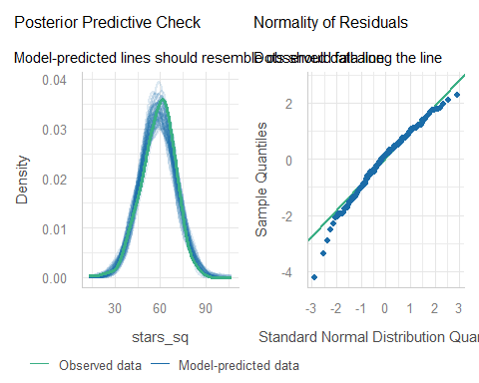

Predictions with fit2?
fit2a <- lm((imdb_stars^2) ~ bw_test + females, data = movies1)
estimate_relation(fit2, ci = 0.9)
Model-based Predictions
bw_test | females | Predicted | SE | 90% CI
-----------------------------------------------------
Pass | 0 | 60.96 | 1.60 | [58.31, 63.61]
Fail | 0 | 61.49 | 1.24 | [59.45, 63.53]
Pass | 1 | 58.24 | 0.97 | [56.63, 59.84]
Fail | 1 | 58.77 | 1.09 | [56.97, 60.56]
Pass | 2 | 55.52 | 1.10 | [53.71, 57.32]
Fail | 2 | 56.04 | 1.65 | [53.33, 58.76]
Pass | 3 | 52.79 | 1.83 | [49.78, 55.81]
Variable predicted: stars_sq
Predictors modulated: bw_test, females

No prediction at Fail, 3 females?
Recall the original data…
movies1 |> tabyl(bw_test, females)
bw_test 0 1 2 3
Pass 17 76 44 14
Fail 41 68 5 0
- With no observations in the (Fail, 3) cell to work with, R won’t make a prediction.

Back-transform predictions?
fit2a <- lm((imdb_stars^2) ~ bw_test + females, data = movies1)
estimate_relation(fit2a, ci = 0.9, transform = TRUE)
Model-based Predictions
bw_test | females | Predicted | 90% CI
--------------------------------------------
Pass | 0 | 7.81 | [7.64, 7.98]
Fail | 0 | 7.84 | [7.71, 7.97]
Pass | 1 | 7.63 | [7.53, 7.74]
Fail | 1 | 7.67 | [7.55, 7.78]
Pass | 2 | 7.45 | [7.33, 7.57]
Fail | 2 | 7.49 | [7.30, 7.67]
Pass | 3 | 7.27 | [7.06, 7.47]
Variable predicted: imdb_stars
Predictors modulated: bw_test, females

fit2 predictions with CIs
plot(estimate_relation(fit2a, ci = 0.9, transform = TRUE)) +
labs(title = "Predicted imdb_stars with 90% CIs")
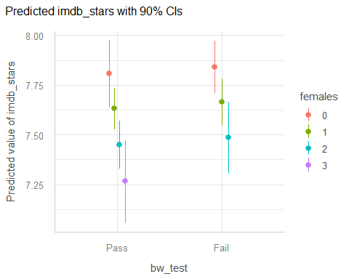

fit2 predictions with PIs
plot(estimate_relation(fit2a, ci = 0.9, transform = TRUE,
predict = "prediction")) +
labs(title = "Predicted imdb_stars with 90% PIs")
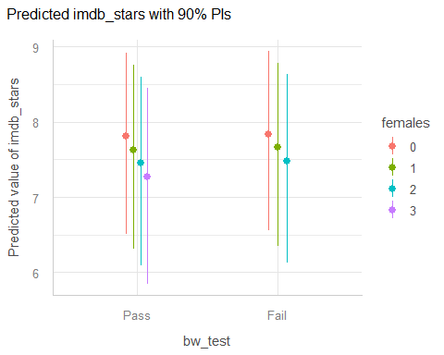

Other fit2 Diagnostics?
plot(check_model(fit2, check = c("linearity", "homogeneity")))
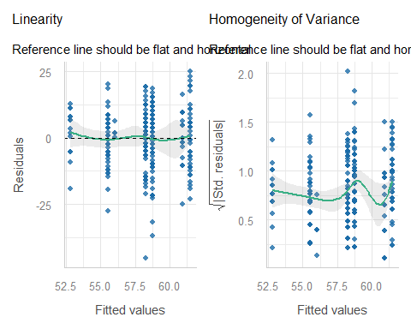

Other fit2 Diagnostics?
plot(check_model(fit2, check = c("outliers")))
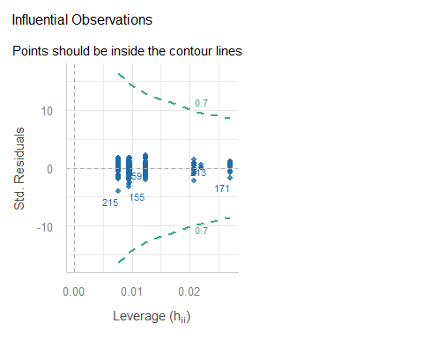

Analysis 3

Adjusting for a Covariate
- Would adjusting for the Rotten Tomatoes Popcornmeter (rt_audience) change our thinking about analysis 1?
Analysis 1 conclusion:
- Movies that failed had 2.38 more (90% CI: 0.07, 4.69) “imdb_stars squared” than did movies that passed the Bechdel-Wallace test, assuming our sample is randomly drawn from all movies of interest, and that our regression model for stars_sq is correct.

Fit a model (1st try)
Let’s include both the key predictor (bw_test) and the covariate (rt_audience) in the model for stars_sq…
fit3x <- lm(stars_sq ~ bw_test + rt_audience,
data = movies1)
model_parameters(fit3x, ci = 0.90, pretty_names = FALSE)
Parameter | Coefficient | SE | 90% CI | t(262) | p
------------------------------------------------------------------
(Intercept) | 0.47 | 3.11 | [-4.66, 5.60] | 0.15 | 0.880
bw_testFail | 1.47 | 0.92 | [-0.05, 2.99] | 1.60 | 0.112
rt_audience | 0.69 | 0.04 | [ 0.63, 0.75] | 18.61 | < .001
Uncertainty intervals (equal-tailed) and p-values (two-tailed) computed
using a Wald t-distribution approximation.
- What does this intercept (0.47) mean?
- rt_audience had minimum 34 and maximum 99, in our data, on the 0-100 scale.

Centering the Covariate
In the movies1 data, the variable rt_audience has mean 82.82.
- We’ll center our covariate (rt_audience) by subtracting its mean.
- This will help our intercept term in the model to mean something, since centered(rt_audience) = 0 means the mean value of rt_audience.

Centering rt_audience
movies1 <- movies1 |>
mutate(rt_aud_c = center(rt_audience),
rt_aud_c2 = rt_audience - mean(rt_audience))
movies1 |>
select(mov_id, rt_audience, rt_aud_c, rt_aud_c2, movie) |>
head(4)
# A tibble: 4 × 5
mov_id rt_audience rt_aud_c rt_aud_c2 movie
<chr> <dbl> <dw_trnsf> <dbl> <chr>
1 M-001 93 10.181132 10.2 3 Idiots
2 M-002 92 9.181132 9.18 8 1/2
3 M-003 69 -13.818868 -13.8 10 Things I Hate About You
4 M-004 74 -8.818868 -8.82 20th Century Women

Interpreting fit3 intercept
fit3 <- lm(stars_sq ~ bw_test + rt_aud_c, data = movies1)
model_parameters(fit3, ci = 0.90, pretty_names = FALSE)
Parameter | Coefficient | SE | 90% CI | t(262) | p
-------------------------------------------------------------------
(Intercept) | 57.64 | 0.60 | [56.64, 58.63] | 95.53 | < .001
bw_testFail | 1.47 | 0.92 | [-0.05, 2.99] | 1.60 | 0.112
rt_aud_c | 0.69 | 0.04 | [ 0.63, 0.75] | 18.61 | < .001
Uncertainty intervals (equal-tailed) and p-values (two-tailed) computed
using a Wald t-distribution approximation.
Intercept = 57.64 specifies the predicted stars_sq according to the fit3 model if both bw_test = “Pass” and rt_audience is at its mean.

Interpret bw_test slope
model_parameters(fit3, ci = 0.90, pretty_names = FALSE)
Parameter | Coefficient | SE | 90% CI | t(262) | p
-------------------------------------------------------------------
(Intercept) | 57.64 | 0.60 | [56.64, 58.63] | 95.53 | < .001
bw_testFail | 1.47 | 0.92 | [-0.05, 2.99] | 1.60 | 0.112
rt_aud_c | 0.69 | 0.04 | [ 0.63, 0.75] | 18.61 | < .001
Uncertainty intervals (equal-tailed) and p-values (two-tailed) computed
using a Wald t-distribution approximation.
Suppose we have two movies, each with the same Rotten Tomatoes audience rating, but one movie passed and the other failed the B-W test.
The model fit3 predicts that the movie which failed will have 1.47 more “imdb_stars squared” than the movie which passed, with 90% CI (-0.05, 2.99).

Interpret rt_aud_c slope
model_parameters(fit3, ci = 0.90, pretty_names = FALSE)
Parameter | Coefficient | SE | 90% CI | t(262) | p
-------------------------------------------------------------------
(Intercept) | 57.64 | 0.60 | [56.64, 58.63] | 95.53 | < .001
bw_testFail | 1.47 | 0.92 | [-0.05, 2.99] | 1.60 | 0.112
rt_aud_c | 0.69 | 0.04 | [ 0.63, 0.75] | 18.61 | < .001
Uncertainty intervals (equal-tailed) and p-values (two-tailed) computed
using a Wald t-distribution approximation.
Suppose we have two movies, each with the same B-W test result, but movie A has a Rotten Tomatoes Audience Score 1 point higher than movie B.
- The model fit3 predicts that movie A will have 0.69 more “imdb_stars squared” than movie B, with 90% CI (0.63, 0.75).

fit1 and fit3 parameters
model_parameters(fit1, ci = 0.90, pretty_names = FALSE)
Parameter | Coefficient | SE | 90% CI | t(263) | p
-------------------------------------------------------------------
(Intercept) | 57.25 | 0.92 | [55.73, 58.76] | 62.43 | < .001
bw_testFail | 2.38 | 1.40 | [ 0.07, 4.69] | 1.70 | 0.090
Uncertainty intervals (equal-tailed) and p-values (two-tailed) computed
using a Wald t-distribution approximation.
model_parameters(fit3, ci = 0.90, pretty_names = FALSE)
Parameter | Coefficient | SE | 90% CI | t(262) | p
-------------------------------------------------------------------
(Intercept) | 57.64 | 0.60 | [56.64, 58.63] | 95.53 | < .001
bw_testFail | 1.47 | 0.92 | [-0.05, 2.99] | 1.60 | 0.112
rt_aud_c | 0.69 | 0.04 | [ 0.63, 0.75] | 18.61 | < .001
Uncertainty intervals (equal-tailed) and p-values (two-tailed) computed
using a Wald t-distribution approximation.

Model Performance?
model_performance(fit1)
# Indices of model performance
AIC | AICc | BIC | R2 | R2 (adj.) | RMSE | Sigma
--------------------------------------------------------------
2039.7 | 2039.8 | 2050.4 | 0.011 | 0.007 | 11.225 | 11.268
model_performance(fit3)
# Indices of model performance
AIC | AICc | BIC | R2 | R2 (adj.) | RMSE | Sigma
------------------------------------------------------------
1818.5 | 1818.6 | 1832.8 | 0.574 | 0.571 | 7.367 | 7.409
- fit3 has better (smaller) AIC, AICc, BIC, RMSE and Sigma
- fit3 also has better (larger) R-squared and adjusted R-squared

Performance Comparison Plot
plot(compare_performance(fit1, fit3))
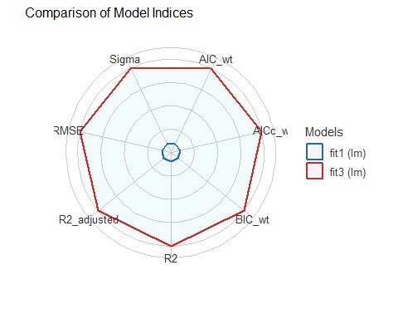

fit3 vs. fit2?
plot(compare_performance(fit2, fit3))
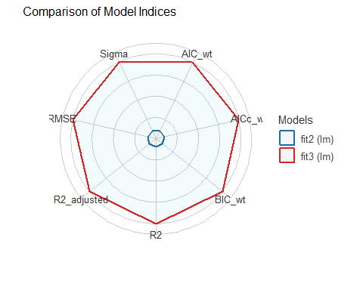

Predictions with fit3?
fit3a <- lm((imdb_stars^2) ~ bw_test + center(rt_audience),
data = movies1)
estimate_relation(fit3a, ci = 0.9)
Model-based Predictions
bw_test | rt_audience | Predicted | SE | 90% CI
---------------------------------------------------------
Fail | 34.00 | 25.41 | 1.97 | [22.16, 28.65]
Pass | 41.22 | 28.93 | 1.64 | [26.22, 31.63]
Fail | 41.22 | 30.39 | 1.72 | [27.56, 33.23]
Pass | 48.44 | 33.91 | 1.39 | [31.61, 36.21]
Fail | 48.44 | 35.38 | 1.48 | [32.94, 37.82]
Pass | 55.67 | 38.90 | 1.16 | [36.99, 40.80]
Fail | 55.67 | 40.37 | 1.25 | [38.31, 42.42]
Pass | 62.89 | 43.88 | 0.94 | [42.33, 45.43]
Fail | 62.89 | 45.35 | 1.03 | [43.64, 47.06]
Pass | 70.11 | 48.87 | 0.75 | [47.62, 50.11]
Fail | 70.11 | 50.34 | 0.85 | [48.92, 51.75]
Pass | 77.33 | 53.85 | 0.63 | [52.81, 54.89]
Fail | 77.33 | 55.32 | 0.73 | [54.11, 56.53]
Pass | 84.56 | 58.84 | 0.61 | [57.83, 59.84]
Fail | 84.56 | 60.31 | 0.69 | [59.16, 61.45]
Pass | 91.78 | 63.82 | 0.70 | [62.67, 64.98]
Fail | 91.78 | 65.29 | 0.76 | [64.04, 66.54]
Pass | 99.00 | 68.81 | 0.87 | [67.38, 70.24]
Variable predicted: imdb_stars
Predictors modulated: bw_test, rt_audience
Predictions are on the power-scale (consider `transform=TRUE`).

Back-transform predictions?
fit3b <- lm((imdb_stars^2) ~ center(rt_audience) + bw_test,
data = movies1)
estimate_relation(fit3b, ci = 0.9, transform = TRUE)
Model-based Predictions
rt_audience | bw_test | Predicted | 90% CI
------------------------------------------------
41.22 | Pass | 5.38 | [5.12, 5.62]
48.44 | Pass | 5.82 | [5.62, 6.02]
55.67 | Pass | 6.24 | [6.08, 6.39]
62.89 | Pass | 6.62 | [6.51, 6.74]
70.11 | Pass | 6.99 | [6.90, 7.08]
77.33 | Pass | 7.34 | [7.27, 7.41]
84.56 | Pass | 7.67 | [7.60, 7.74]
91.78 | Pass | 7.99 | [7.92, 8.06]
99.00 | Pass | 8.30 | [8.21, 8.38]
34.00 | Fail | 5.04 | [4.71, 5.35]
41.22 | Fail | 5.51 | [5.25, 5.76]
48.44 | Fail | 5.95 | [5.74, 6.15]
55.67 | Fail | 6.35 | [6.19, 6.51]
62.89 | Fail | 6.73 | [6.61, 6.86]
70.11 | Fail | 7.09 | [6.99, 7.19]
77.33 | Fail | 7.44 | [7.36, 7.52]
84.56 | Fail | 7.77 | [7.69, 7.84]
91.78 | Fail | 8.08 | [8.00, 8.16]
Variable predicted: imdb_stars
Predictors modulated: rt_audience, bw_test

fit3 predictions with CIs
plot(estimate_relation(fit3b, ci = 0.9, transform = TRUE)) +
scale_fill_viridis_d() +
labs(title = "fit3b Predicted imdb_stars with 90% CIs")
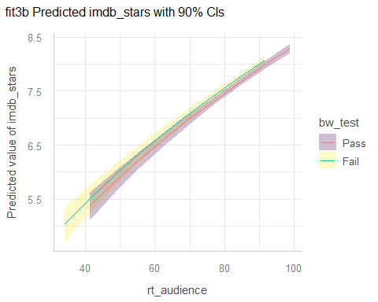

fit3b predictions with PIs
plot(estimate_relation(fit3b, ci = 0.9, transform = TRUE,
predict = "prediction")) +
scale_fill_oi() +
labs(title = "fit3b Predicted imdb_stars with 90% PIs")
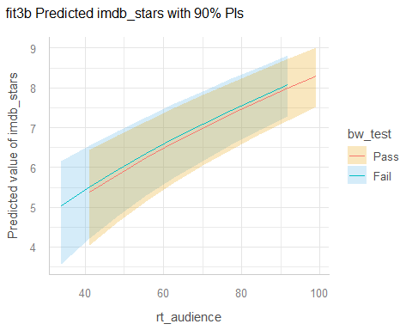

Diagnostics for fit3?
set.seed(43104)
plot(check_model(fit3, check = c("pp_check", "qq"), detrend = FALSE))
For confidence bands, please install `qqplotr`.
Ignoring unknown labels:
• size : ""
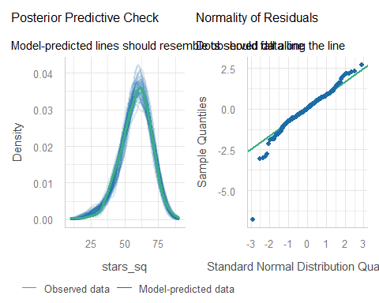

Other fit3 Diagnostics?
plot(check_model(fit3, check = c("linearity", "homogeneity")))
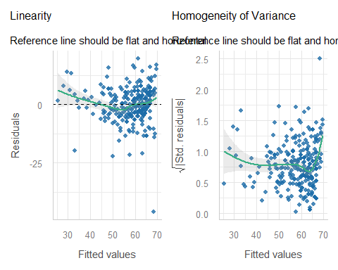

What movie is the big outlier?
movies1 <- movies1 |>
mutate(pred3 = fit3$fitted.values, res3 = fit3$resid)
temp <- movies1 |>
select(mov_id, rt_aud = rt_audience, bw_test, stars_sq,
pred3, res3, movie) |> arrange(res3)
temp |> head(3) ## three most negative residuals
# A tibble: 3 × 7
mov_id rt_aud bw_test stars_sq pred3 res3 movie
<chr> <dbl> <fct> <dbl> <dbl> <dbl> <chr>
1 M-168 96 Fail 22.1 68.2 -46.1 Madea Goes To Jail
2 M-112 72 Pass 28.1 50.2 -22.1 High School Musical 2
3 M-092 83 Pass 36 57.8 -21.8 Godzilla, King of the Monsters
temp |> tail(3) ## three most positive residuals
# A tibble: 3 × 7
mov_id rt_aud bw_test stars_sq pred3 res3 movie
<chr> <dbl> <fct> <dbl> <dbl> <dbl> <chr>
1 M-175 85 Pass 75.7 59.1 16.5 The Matrix
2 M-238 98 Fail 86.5 69.6 16.9 The Shawshank Redemption
3 M-164 86 Fail 81 61.3 19.7 Lord of the Rings: The Return of t…

Could we make other decisions?

What if we cubed imdb_stars?
movies1 <- movies1 |>
mutate(stars_cubed = imdb_stars^3)
fit4a <- lm(stars_cubed ~ bw_test + rt_aud_c,
data = movies1)
set.seed(43105)
plot(check_model(fit4a,
check = c("pp_check", "qq"),
detrend = FALSE),
colors = c(guards_navy, guards_red))
For confidence bands, please install `qqplotr`.
Ignoring unknown labels:
• size : ""
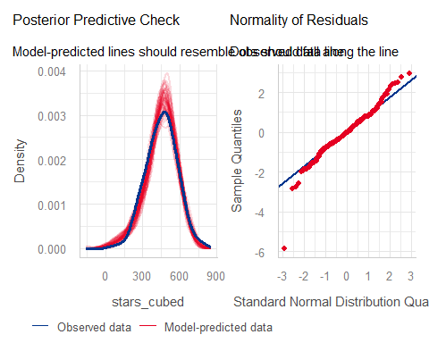

imdb_stars to the 4th power?
movies1 <- movies1 |>
mutate(stars_4 = imdb_stars^4)
fit5 <- lm(stars_4 ~ bw_test + rt_aud_c,
data = movies1)
set.seed(43106)
plot(check_model(fit5,
check = c("pp_check", "qq"),
detrend = FALSE),
colors = c(guards_navy, guards_red))
For confidence bands, please install `qqplotr`.
Ignoring unknown labels:
• size : ""
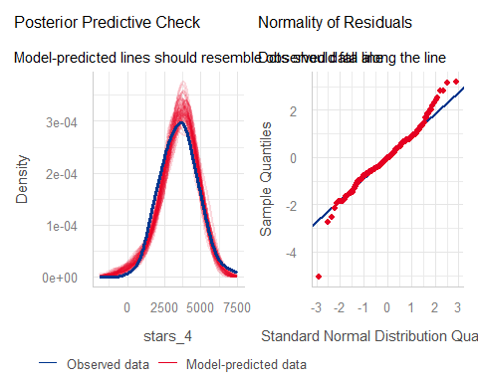

That’s all, folks!
Is there more we could do? Sure. There always is.
xfun::session_info()
R version 4.6.1 (2026-06-24 ucrt)
Platform: x86_64-w64-mingw32/x64
Running under: Windows 11 x64 (build 26200)
Locale:
LC_COLLATE=English_United States.utf8
LC_CTYPE=English_United States.utf8
LC_MONETARY=English_United States.utf8
LC_NUMERIC=C
LC_TIME=English_United States.utf8
Package version:
abind_1.4-8 ape_5.8.1 askpass_1.2.1
backports_1.5.1 base64enc_0.1.6 bayestestR_0.19.0
bit_4.6.0 bit64_4.8.6 blob_1.3.0
boot_1.3-32 broom_1.0.13 bslib_0.12.0
cachem_1.1.0 callr_3.8.0 car_3.1-5
carData_3.0-6 cellranger_1.1.0 checkmate_2.3.4
cli_3.6.6 clipr_0.8.1 coda_0.19-4.1
codetools_0.2-20 colorspace_2.1.3 commonmark_2.0.0
compiler_4.6.1 conflicted_1.2.0 correlation_0.8.8
cowplot_1.2.0 cpp11_0.5.5 crayon_1.5.3
crosstalk_1.2.2 curl_8.0.0 data.table_1.18.6.1
datasets_4.6.1 datawizard_1.4.0 DBI_1.3.0
dbplyr_2.6.0 Deriv_4.3.5 DHARMa_0.5.0
digest_0.6.39 doBy_4.7.2 doParallel_1.0.17
dplyr_1.2.1 dtplyr_1.3.3 easystats_0.7.6
effectsize_1.0.3 emmeans_2.0.4 estimability_2.0.0
evaluate_1.0.5 farver_2.1.2 fastmap_1.2.0
fontawesome_0.5.3 forcats_1.0.1 foreach_1.5.2
forecast_9.0.2 Formula_1.2-6 fracdiff_1.5.4
fs_2.1.0 gap_1.15.2 gap.datasets_0.0.6
gargle_1.6.1 generics_0.1.4 ggplot2_4.0.3
ggrepel_0.9.8 glue_1.8.1 googledrive_2.1.2
googlesheets4_1.1.2 graphics_4.6.1 grDevices_4.6.1
grid_4.6.1 gridExtra_2.3.1 gtable_0.3.6
haven_2.5.5 highr_0.12 hms_1.1.4
htmltools_0.5.9 htmlwidgets_1.6.4 httpuv_1.6.17
httr_1.4.9 ids_1.0.1 insight_1.5.4
isoband_0.3.0 iterators_1.0.14 janitor_2.2.1
jquerylib_0.1.4 jsonlite_2.0.0 knitr_1.52
labeling_0.4.3 later_1.4.8 lattice_0.23-1
lazyeval_0.2.3 lifecycle_1.0.5 lme4_2.0-6
lmtest_0.9.40 lubridate_1.9.5 magrittr_2.0.5
marginaleffects_1.0.0 MASS_7.3-66 Matrix_1.7-6
MatrixModels_0.5.4 memoise_2.0.1 methods_4.6.1
mgcv_1.9-4 mime_0.13 minqa_1.2.8
modelbased_0.17.0 modelr_0.1.11 multcomp_1.4-32
mvtnorm_1.4-2 naniar_1.1.0 nlme_3.1-171
nloptr_2.2.1 nnet_7.3.21 norm_1.0.11.1
numDeriv_2016.8.1.1 openssl_2.4.2 otel_0.2.0
parallel_4.6.1 parameters_0.29.3 patchwork_1.3.2
pbkrtest_0.5.5 performance_0.18.2 pillar_1.11.1
pkgconfig_2.0.3 plotly_4.12.1 plyr_1.8.9
prettyunits_1.2.0 processx_3.9.0 progress_1.2.3
promises_1.5.0 ps_1.9.3 purrr_1.2.2
qgam_2.0.0 quantreg_6.1 R6_2.6.1
ragg_1.5.2 rappdirs_0.3.4 rbibutils_2.4.1
RColorBrewer_1.1-3 Rcpp_1.1.2 RcppArmadillo_15.6.0.1
RcppEigen_0.3.4.0.2 Rdpack_2.6.6 readr_2.2.0
readxl_1.5.0.1 reformulas_0.4.4 rematch_2.0.0
rematch2_2.1.2 report_0.6.4 reprex_2.1.1
rlang_1.3.0 rmarkdown_2.32 rstudioapi_0.19.0
rvest_1.0.5 S7_0.2.2 sandwich_3.1-3
sass_0.4.10 scales_1.4.0 see_0.14.2
selectr_0.8.0 shiny_1.14.0 snakecase_0.11.1
sourcetools_0.1.7.2 SparseM_1.84.2 splines_4.6.1
stats_4.6.1 stringi_1.8.9 stringr_1.6.0
survival_3.8-12 sys_3.4.3 systemfonts_1.3.2
textshaping_1.0.5 TH.data_1.1-5 tibble_3.3.1
tidyr_1.3.2 tidyselect_1.2.1 tidyverse_2.0.0
timechange_0.4.0 timeDate_4052.112 tinytex_0.61
tools_4.6.1 tzdb_0.5.0 UpSetR_1.4.1
urca_1.3.4 utf8_1.2.6 utils_4.6.1
uuid_1.2.2 vctrs_0.7.3 viridis_0.6.5
viridisLite_0.4.3 visdat_0.6.1 vroom_1.7.1
withr_3.0.3 xfun_0.61 xml2_1.6.0
xtable_1.8-8 yaml_2.3.12 zoo_1.9-1

Here is a video explaining the Bechdel-Wallace test.

