431 Class 22
Thomas E. Love, Ph.D.
2026-11-12

Today’s Packages
- Today’s (arbitrary) confidence level = 93%.
library(naniar)
library(janitor)
library(mice)
library(car)
library(patchwork)
library(broom)
library(GGally)
library(gt); library(gtExtras)
library(glue)
library(nhanesA) ## ingest NHANES data
library(olsrr) ## for best subsets
library(easystats)
library(tidyverse)
theme_set(theme_light())

Today’s Agenda
- An example from NHANES 2013-2014
- Dealing with Missing Data, Partitioning, etc.
- Most of the things we’ve done previously, plus…
- Automated Variable Selection in Multiple Regression
  - Stepwise regression (AIC-based backwards elimination)
  - Best subsets (based on Mallows’ $C_{p}$)
- Some rudimentary cross-validation approaches

Outcome and Potential Predictors
Data Source: NHANES 2013-2014
Today, we will try to predict waist circumference (in cm) using some combination of these 12 candidate predictors:
- body weight (in kg): expected to be primary driver
- demographics: age, sex, race/ethnicity, marital status, educational attainment, and insurance status
- systolic and diastolic blood pressure (1st reading), total cholesterol, self-rated oral health, sedentary minutes/day

NHANES 2013-14 data we’ll use
- We’ll use the Demographics file: DEMO_H
- from the Examination data: Blood Pressure BPX_H, and Body Measures BMX_H
- from the Laboratory data: Cholesterol - Total TCHOL_H
- and from the Questionnaire data: Health Insurance HIQ, Oral Health OHQ, and Physical Activity PAQ

Data Ingest from NHANES 2013-14
- In the next 2 slides, I’ll show the work I did to create a raw data set containing data on subjects from this administration of NHANES, using the nhanesA package, but I won’t execute that code.
Instead, I placed an R data set of the raw data (nh_H_raw.Rds) on our 431-data page, which we’ll use shortly.
- Source: NHANES 2013-2014 Data

R code ingesting NHANES data
demoH <- nhanes('DEMO_H', translated = FALSE) |>
tibble() |> mutate(SEQN = as.character(SEQN))
bpxH <- nhanes('BPX_H', translated = FALSE) |>
tibble() |> mutate(SEQN = as.character(SEQN))
bmxH <- nhanes('BMX_H', translated = FALSE) |>
tibble() |> mutate(SEQN = as.character(SEQN))
tcholH <- nhanes('TCHOL_H', translated = FALSE) |>
tibble() |> mutate(SEQN = as.character(SEQN))
hiqH <- nhanes('HIQ_H', translated = FALSE) |>
tibble() |> mutate(SEQN = as.character(SEQN))
ohqH <- nhanes('OHQ_H', translated = FALSE) |>
tibble() |> mutate(SEQN = as.character(SEQN))
paqH <- nhanes('PAQ_H', translated = FALSE) |>
tibble() |> mutate(SEQN = as.character(SEQN))

R code aggregating NHANES data
t12 <- left_join(demoH, bpxH, by = "SEQN")
t123 <- left_join(t12, bmxH, by = "SEQN")
t1234 <- left_join(t123, tcholH, by = "SEQN")
t12345 <- left_join(t1234, hiqH, by = "SEQN")
t123456 <- left_join(t12345, ohqH, by = "SEQN")
nh_H_raw <- left_join(t123456, paqH, by = "SEQN")
write_rds(nh_H_raw, "c22/data/nh_H_raw.Rds")

Using the .Rds file: pruning rows
Let’s ingest the raw data from the Rds file.
nh_H_raw <- read_rds("c22/data/nh_H_raw.Rds")
dim(nh_H_raw)
[1] 10175 260
Then we want to focus on adults ages 21-79 (Age is in the RIDAGEYR variable) who were both interviewed and MEC examined (RIDSTATR = 2)
nh_H <- nh_H_raw |>
filter(RIDSTATR == 2,
RIDAGEYR >= 21 & RIDAGEYR <= 79)
dim(nh_H)
[1] 5150 260

Pruning the Variables
… and replacing Refused, and Don’t Know codes with NA.
nh_H <- nh_H |>
select(SEQN, RIAGENDR, RIDAGEYR, RIDRETH3, DMDEDUC2, DMDMARTL,
BPXSY1, BPXDI1, BMXWT, BMXWAIST, LBXTC,
HIQ011, HIQ031A, HIQ031B, HIQ031D,
OHQ845, PAD680, WTINT2YR, WTMEC2YR) |>
replace_with_na(replace =
list(DMDEDUC2 = c(7, 9), DMDMARTL = c(77, 99), HIQ011 = c(7, 9),
HIQ031A = c(77, 99), OHQ845 = c(7, 9), PAD680 = c(7777, 9999)))

Factor Cleaning (1/2)
nh_H <- nh_H |>
mutate(sex = fct_recode(factor(RIAGENDR), "M" = "1", "F" = "2")) |>
mutate(race_eth = fct_recode(factor(RIDRETH3),
"Hispanic" = "1", "Hispanic" = "2", "NH_White" = "3",
"NH_Black" = "4", "NH_Asian" = "6", "Other" = "7")) |>
mutate(educ = fct_recode(factor(DMDEDUC2),
"NonHSGrad" = "1", "NonHSGrad" = "2", "HSGrad" = "3",
"SomeCollege" = "4", "CollegeGrad" = "5")) |>
mutate(marital = fct_recode(factor(DMDMARTL),
"Together" = "1", "Formerly" = "2", "Formerly" = "3",
"Formerly" = "4", "Never" = "5", "Together" = "6"))

Factor Cleaning (2/2)
nh_H <- nh_H |>
mutate(insur = factor(case_when(
HIQ011 == 2 ~ "Uninsured",
HIQ011 == 1 & HIQ031D == 17 ~ "Medicaid",
HIQ011 == 1 & HIQ031B == 15 ~ "Medicare",
HIQ011 == 1 & HIQ031A == 14 ~ "Commercial"))) |>
mutate(insur = fct_relevel(insur, "Medicare")) |>
mutate(oral_h = fct_recode(factor(OHQ845),
"E" = "1", "VG" = "2", "G" = "3", "F" = "4", "P" = "5"))

Variable Renaming
nh_H <- nh_H |>
rename(age = RIDAGEYR, sbp1 = BPXSY1, dbp1 = BPXDI1,
wt_kg = BMXWT, waist = BMXWAIST, tot_chol = LBXTC,
sedentary = PAD680)

Changing implausible values to NA
- We’re going to treat as missing values of systolic and diastolic blood pressure and total cholesterol that we think are implausible.
- Suppose we believe sbp1 and tot_chol should be at least 70, while dbp1 should be at least 40.
nh_H <- nh_H |>
replace_with_na_at(.vars = c("sbp1", "tot_chol"), condition = ~ .x < 70) |>
replace_with_na_at(.vars = "dbp1", condition = ~ .x < 40)

The nh_H data after that work
nh_H <- nh_H |>
select(SEQN, waist, wt_kg, age, sex, race_eth, marital, educ, insur,
sbp1, dbp1, waist, tot_chol, oral_h, sedentary, WTINT2YR, WTMEC2YR)
gt_preview(nh_H)
 | SEQN | waist | wt_kg | age | sex | race_eth | marital | educ | insur | sbp1 | dbp1 | tot_chol | oral_h | sedentary | WTINT2YR | WTMEC2YR
1 | 73557 | 100.0 | 78.3 | 69 | M | NH_Black | Formerly | HSGrad | Medicaid | 122 | 72 | 167 | E | 600 | 13281.24 | 13481.04
2 | 73558 | 107.6 | 89.5 | 54 | M | NH_White | Together | HSGrad | Uninsured | 156 | 62 | 170 | F | 540 | 23682.06 | 24471.77
3 | 73559 | 109.2 | 88.9 | 72 | M | NH_White | Together | SomeCollege | Medicare | 140 | 90 | 126 | G | 300 | 57214.80 | 57193.29
4 | 73561 | NA | 52.0 | 73 | F | NH_White | Together | CollegeGrad | Medicare | 136 | 86 | 201 | VG | 480 | 63709.67 | 65541.87
5 | 73562 | 123.1 | 105.0 | 56 | M | Hispanic | Formerly | SomeCollege | NA | 160 | 84 | 226 | F | 360 | 24978.14 | 25344.99
6..5149
5150 | 83729 | 102.7 | 89.6 | 42 | F | NH_Black | Formerly | CollegeGrad | Commercial | 136 | 82 | 152 | VG | 720 | 24122.25 | 26902.34

Variable Descriptions (1/3)
Variable | Description | NA
SEQN | Subject identifier code | 0
waist | Waist circumference (cm) | 242
wt_kg | Body weight (kg) | 46
age | age in years (21-79) | 0
sex | M or F | 0
race_eth | race/ethnicity (5 categories) | 0

Variable Descriptions (2/3)
Variable | Description | NA
marital | marital status (3 categories) | 2
educ | educational attainment (4 categories) | 4
insur | primary insurance (4 categories) | 343
sbp1 | 1st Systolic BP reading (mm Hg) | 436
dbp1 | 1st Diastolic BP reading (mm Hg) | 477
tot_chol | Total Cholesterol (mg/dl) | 222

Variable Descriptions (3/3)
Variable | Description | NA
oral_h | self-reported oral health (5 levels) | 2
sedentary | typical day: sedentary activity (minutes) | 22
WTINT2YR | sampling weight for interview items | 0
WTMEC2YR | sampling weight for examination items | 0

data_codebook() results
data_codebook(nh_H |> select(-SEQN, -WTINT2YR, -WTMEC2YR))
select(nh_H, -SEQN, -WTINT2YR, -WTMEC2YR) (5150 rows and 13 variables, 13 shown)
ID | Name | Type | Missings | Values | N
---+-----------+-------------+------------+---------------+-------------
1 | waist | numeric | 242 (4.7%) | [55.5, 177.9] | 4908
---+-----------+-------------+------------+---------------+-------------
2 | wt_kg | numeric | 46 (0.9%) | [32.3, 222.6] | 5104
---+-----------+-------------+------------+---------------+-------------
3 | age | numeric | 0 (0.0%) | [21, 79] | 5150
---+-----------+-------------+------------+---------------+-------------
4 | sex | categorical | 0 (0.0%) | M | 2461 (47.8%)
| | | | F | 2689 (52.2%)
---+-----------+-------------+------------+---------------+-------------
5 | race_eth | categorical | 0 (0.0%) | Hispanic | 1193 (23.2%)
| | | | NH_White | 2101 (40.8%)
| | | | NH_Black | 1083 (21.0%)
| | | | NH_Asian | 613 (11.9%)
| | | | Other | 160 ( 3.1%)
---+-----------+-------------+------------+---------------+-------------
6 | marital | categorical | 2 (0.0%) | Together | 3136 (60.9%)
| | | | Formerly | 1048 (20.4%)
| | | | Never | 964 (18.7%)
---+-----------+-------------+------------+---------------+-------------
7 | educ | categorical | 4 (0.1%) | NonHSGrad | 1104 (21.5%)
| | | | HSGrad | 1141 (22.2%)
| | | | SomeCollege | 1593 (31.0%)
| | | | CollegeGrad | 1308 (25.4%)
---+-----------+-------------+------------+---------------+-------------
8 | insur | categorical | 343 (6.7%) | Medicare | 767 (16.0%)
| | | | Commercial | 2299 (47.8%)
| | | | Medicaid | 599 (12.5%)
| | | | Uninsured | 1142 (23.8%)
---+-----------+-------------+------------+---------------+-------------
9 | sbp1 | numeric | 436 (8.5%) | [72, 222] | 4714
---+-----------+-------------+------------+---------------+-------------
10 | dbp1 | numeric | 477 (9.3%) | [40, 122] | 4673
---+-----------+-------------+------------+---------------+-------------
11 | tot_chol | numeric | 222 (4.3%) | [82, 813] | 4928
---+-----------+-------------+------------+---------------+-------------
12 | oral_h | categorical | 2 (0.0%) | E | 520 (10.1%)
| | | | VG | 1110 (21.6%)
| | | | G | 1795 (34.9%)
| | | | F | 1176 (22.8%)
| | | | P | 547 (10.6%)
---+-----------+-------------+------------+---------------+-------------
13 | sedentary | numeric | 22 (0.4%) | [0, 1200] | 5128
------------------------------------------------------------------------

Missing Data by Variable
miss_var_summary(nh_H) |> filter(n_miss > 0)
# A tibble: 10 × 3
variable n_miss pct_miss
<chr> <int> <num>
1 dbp1 477 9.26
2 sbp1 436 8.47
3 insur 343 6.66
4 waist 242 4.70
5 tot_chol 222 4.31
6 wt_kg 46 0.893
7 sedentary 22 0.427
8 educ 4 0.0777
9 marital 2 0.0388
10 oral_h 2 0.0388

Missing Data
dim(nh_H)
[1] 5150 16
miss_case_table(nh_H)
# A tibble: 6 × 3
n_miss_in_case n_cases pct_cases
<int> <int> <dbl>
1 0 4020 78.1
2 1 603 11.7
3 2 414 8.04
4 3 90 1.75
5 4 20 0.388
6 5 3 0.0583
pct_miss_case(nh_H)
[1] 21.94175

Missingness Mechanism
Can we assume the data are MCAR, per Little’s test?
mcar_test(nh_H)
# A tibble: 1 × 4
statistic df p.value missing.patterns
<dbl> <dbl> <dbl> <int>
1 752. 490 2.45e-13 37
- Looks like we’ll need to assume MAR and do some imputation.

Outcome and Potential Predictors
Again, our goal is to try to predict waist circumference (in cm) using some combination of these 12 candidate predictors:
- body weight (in kg): expected to be primary driver
- demographics: age, sex, race/ethnicity, marital status, educational attainment, and insurance status
- systolic and diastolic blood pressure, total cholesterol, self-rated oral health, sedentary minutes/day
We’ll generate several possible models.

Single imputation
set.seed(20251118)
nh_i1 <- mice(nh_H, m = 1, printFlag = FALSE)
Warning: Number of logged events: 1
nh_si <- complete(nh_i1) ## si for single imputation
n_miss(nh_si)
[1] 0
We’ll use this single imputation for decision-making…

Looking at the logged events
- The main reasons we get logged events are:
  - We have a “constant” term (or a variable of type character, which is removed from the imputation model, or
  - One variable is completely collinear with another.
nh_i1$loggedEvents
it im dep meth out
1 0 0 constant SEQN

Partition the Data
c(nrow(nh_si), n_distinct(nh_si$SEQN)) # check that SEQNs are all distinct
[1] 5150 5150
set.seed(2025431)
nh_train <- nh_si |> slice_sample(n = 4000, replace = FALSE)
nh_test <- anti_join(nh_si, nh_train, by = "SEQN")
c(nrow(nh_train), nrow(nh_test))
[1] 4000 1150

Waist Circumference (our outcome)
bw = 2.5 # specify width of bins in histogram
p1 <- ggplot(nh_train, aes(x = waist)) +
geom_histogram(binwidth = bw, fill = "black", col = "white") +
stat_function(fun = function(x)
dnorm(x, mean = mean(nh_train$waist, na.rm = TRUE),
sd = sd(nh_train$waist, na.rm = TRUE)) *
length(nh_train$waist) * bw,
geom = "area", alpha = 0.5, fill = "lightblue", col = "blue") +
labs(x = "Waist Circumference (cm)", y = "",
title = "Histogram & Normal Curve")
p2 <- ggplot(nh_train, aes(sample = waist)) +
geom_qq() + geom_qq_line(col = "red") +
labs(y = "Waist Circumference (cm)",
x = "Standard Normal Distribution",
title = "Normal Q-Q plot")
p3 <- ggplot(nh_train, aes(x = waist, y = "")) +
geom_violin(fill = "cornsilk") +
geom_boxplot(width = 0.2) +
stat_summary(fun = mean, geom = "point",
shape = 16, col = "red") +
labs(y = "", x = "Waist Circumference (cm)",
title = "Boxplot with Violin")
p1 + (p2 / p3 + plot_layout(heights = c(2, 1))) +
plot_annotation(
title = "Waist Circumference seems a little right skewed",
subtitle = glue("NHANES 2013-14 Training Data Set (n = ", nrow(nh_train), ")"))
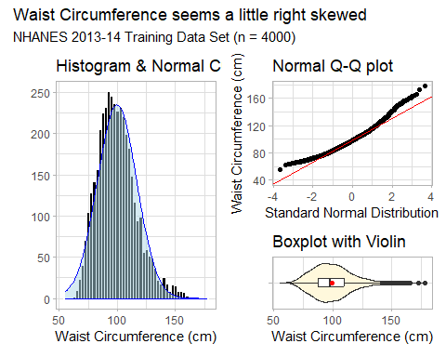

Transform our Outcome?
t_check <- lm(waist ~ wt_kg + age + sex + race_eth + marital + educ +
insur + sbp1 + dbp1 + tot_chol + oral_h + sedentary,
data = nh_train)
boxCox(t_check)
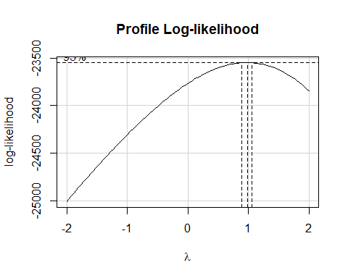

Collinearity?
check_collinearity(t_check)
# Check for Multicollinearity
Low Correlation
Term VIF VIF 95% CI adj. VIF Tolerance Tolerance 95% CI
wt_kg 1.21 [1.18, 1.24] 1.10 0.82 [0.81, 0.85]
age 2.08 [1.99, 2.15] 1.44 0.48 [0.47, 0.50]
sex 1.12 [1.10, 1.14] 1.06 0.89 [0.88, 0.91]
race_eth 1.47 [1.42, 1.51] 1.05 0.68 [0.66, 0.71]
marital 1.38 [1.33, 1.41] 1.08 0.73 [0.71, 0.75]
educ 1.52 [1.46, 1.56] 1.07 0.66 [0.64, 0.68]
insur 2.16 [2.07, 2.23] 1.14 0.46 [0.45, 0.48]
sbp1 1.67 [1.61, 1.72] 1.29 0.60 [0.58, 0.62]
dbp1 1.40 [1.35, 1.43] 1.18 0.72 [0.70, 0.74]
tot_chol 1.08 [1.06, 1.09] 1.04 0.93 [0.92, 0.95]
oral_h 1.21 [1.18, 1.24] 1.02 0.82 [0.81, 0.85]
sedentary 1.07 [1.05, 1.09] 1.04 0.93 [0.92, 0.95]

Standing Break, followed by Automated Predictor Selection (not usually a great idea, but …)

Stepwise Regression Process
Start with a model including all candidate predictors.
- R looks at each variable in turn to see what would happen to AIC if we dropped it from the model.
- It then drops the variable that most reduces the AIC, creating the first step down.
- Then it repeats the process with the new stepped down model and drops the variable that most reduces the AIC now.
- When we can no longer drop a variable and reduce AIC, stop.

Stepwise Regression
Start with a 12-predictor model, predicting waist circumference.
fit_all12 <- lm(waist ~ wt_kg + age + sex + race_eth +
marital + educ + insur + sbp1 + dbp1 +
tot_chol + oral_h + sedentary,
data = nh_train)
Here’s one way to run a backwards stepwise elimination search of our regression model, using AIC as the measure to tell us when to stop removing variables.
step_res <- step(fit_all12, direction = "backward")
Start: AIC=13967.78
waist ~ wt_kg + age + sex + race_eth + marital + educ + insur +
sbp1 + dbp1 + tot_chol + oral_h + sedentary
Df Sum of Sq RSS AIC
- dbp1 1 15 129847 13966
<none> 129832 13968
- sbp1 1 89 129921 13968
- marital 2 158 129990 13969
- sedentary 1 126 129957 13970
- tot_chol 1 225 130057 13973
- oral_h 4 1225 131057 13997
- insur 3 1393 131225 14004
- educ 3 2150 131982 14028
- race_eth 4 9092 138924 14230
- age 1 14525 144356 14390
- sex 1 21116 150948 14569
- wt_kg 1 863032 992863 22103
Step: AIC=13966.24
waist ~ wt_kg + age + sex + race_eth + marital + educ + insur +
sbp1 + tot_chol + oral_h + sedentary
Df Sum of Sq RSS AIC
<none> 129847 13966
- sbp1 1 75 129921 13966
- marital 2 162 130008 13967
- sedentary 1 130 129976 13968
- tot_chol 1 215 130061 13971
- oral_h 4 1219 131066 13996
- insur 3 1442 131289 14004
- educ 3 2157 132004 14026
- race_eth 4 9078 138924 14228
- age 1 14606 144453 14391
- sex 1 21277 151123 14571
- wt_kg 1 873019 1002865 22141
Results on the next slide.

So What Happened?
- The big model (12 predictors) had an AIC of 13887
- Dropping dbp1 reduced the AIC a little
- Then dropping sbp1 reduced the AIC to 13886
- but at that point, no additional variable removals reduce AIC. The best we can do is to drop sedentary but that increases AIC back to 13887.

Stepwise Regression Result
So we drop two of the 12 predictors (sbp1 and dbp1) and keep the remaining ten (wt_kg, age, sex, race_eth, marital, educ, insur, tot_chol, oral_h and sedentary).
fit_step10 <- lm(waist ~ wt_kg + age + sex + race_eth + marital +
educ + insur + tot_chol + oral_h + sedentary,
data = nh_train)
It turns out that stepwise regression is pretty bad, even by the standards of automated variable selection procedures. Are there better options?
- Can we generate other competitive candidate predictor sets?

A Best Subsets Approach
Again, we start with our big model fit_all12, with all 12 predictors, but now we use a function from the olsrr package to complete some automated variable selection.
nh_best_res <-
ols_step_best_subset(fit_all12, max_order = 8, metric = "cp")
This code identifies the best subsets of variables according to Mallows’ $C_{p}$ statistic, while restricting the search to models with 1-8 variables (of our original 12) included. Results on the next slide…

Results from “Best Subsets” Search
nh_best_res
Best Subsets Regression
----------------------------------------------------------------
Model Index Predictors
----------------------------------------------------------------
1 wt_kg
2 wt_kg age
3 wt_kg age sex
4 wt_kg age sex race_eth
5 wt_kg age sex race_eth educ
6 wt_kg age sex race_eth educ insur
7 wt_kg age sex race_eth educ insur oral_h
8 wt_kg age sex race_eth educ insur tot_chol oral_h
----------------------------------------------------------------
Subsets Regression Summary
----------------------------------------------------------------------------------------------------------------------------------------------
Adj. Pred
Model R-Square R-Square R-Square C(p) AIC SBIC SBC MSEP FPE HSP APC
----------------------------------------------------------------------------------------------------------------------------------------------
1 0.8187 0.8186 0.8184 2405.3742 27182.2307 15828.9404 27201.1128 209133.9765 52.3096 0.0131 0.1815
2 0.8518 0.8517 0.8515 1238.0942 26377.4264 15024.3943 26402.6026 170976.1786 42.7761 0.0107 0.1484
3 0.8709 0.8708 0.8706 566.2258 25827.9137 14475.3958 25859.3840 148992.5579 37.2854 0.0093 0.1294
4 0.8797 0.8795 0.8792 262.0797 25552.1644 14194.0699 25608.8108 138824.3359 34.7756 0.0087 0.1206
5 0.8842 0.8839 0.8835 110.1998 25406.5988 14044.8308 25482.1274 133695.9755 33.5161 0.0084 0.1162
6 0.8857 0.8854 0.8849 61.2521 25358.4720 13992.8482 25452.8828 131932.0669 33.0988 0.0083 0.1147
7 0.8868 0.8864 0.8857 30.9602 25328.3144 13956.8263 25447.9013 130712.2409 32.8256 0.0082 0.1136
8 0.8870 0.8865 0.8859 26.3540 25323.6944 13952.2387 25449.5754 130528.7962 32.7878 0.0082 0.1135
----------------------------------------------------------------------------------------------------------------------------------------------
AIC: Akaike Information Criteria
SBIC: Sawa's Bayesian Information Criteria
SBC: Schwarz Bayesian Criteria
MSEP: Estimated error of prediction, assuming multivariate normality
FPE: Final Prediction Error
HSP: Hocking's Sp
APC: Amemiya Prediction Criteria

We’ll compare four options
I’ve somewhat arbitrarily selected these four options.
fit_12 <- lm(waist ~ wt_kg + age + sex + race_eth + marital +
educ + insur + sbp1 + dbp1 + tot_chol +
oral_h + sedentary,
data = nh_train)
fit_10 <- lm(waist ~ wt_kg + age + sex + race_eth + marital +
educ + insur + tot_chol + oral_h + sedentary,
data = nh_train)
fit_04 <- lm(waist ~ wt_kg + age + sex + race_eth, data = nh_train)
fit_01 <- lm(waist ~ wt_kg, data = nh_train)

Two Model Checks (fit_12)
set.seed(43101); check_model(fit_12, detrend = FALSE, check = c("pp_check", "linearity"))
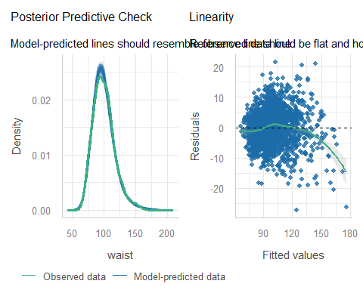

Two Model Checks (fit_10)
set.seed(43102); check_model(fit_10, detrend = FALSE, check = c("pp_check", "linearity"))
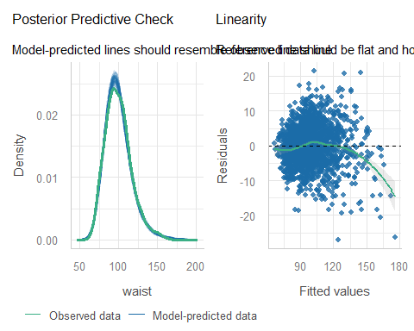

Two Model Checks (fit_04)
set.seed(43103); check_model(fit_04, detrend = FALSE, check = c("pp_check", "linearity"))
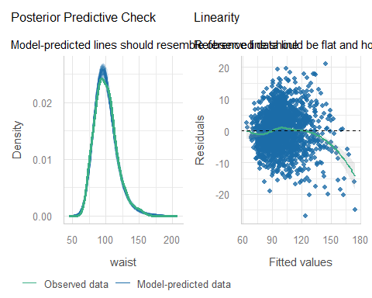

Two Model Checks (fit_01)
set.seed(43104); check_model(fit_01, detrend = FALSE, check = c("pp_check", "linearity"))
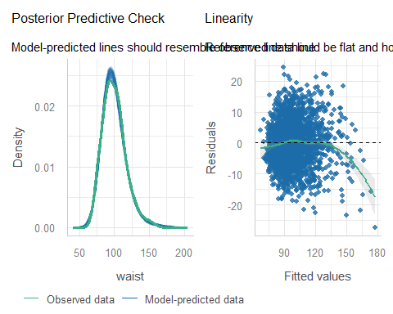

Other Checks for Model fit_04
set.seed(43105); check_model(fit_04, detrend = FALSE, check = c("homogeneity", "outliers"))
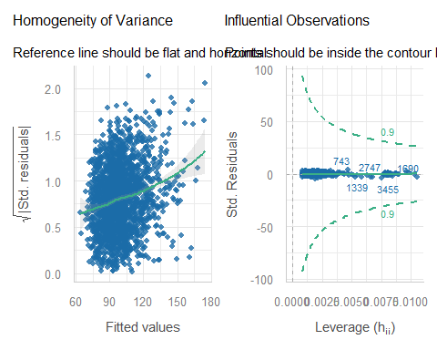

Still more Checks for Model fit_04
set.seed(43106); check_model(fit_04, detrend = FALSE, check = c("vif", "qq"))
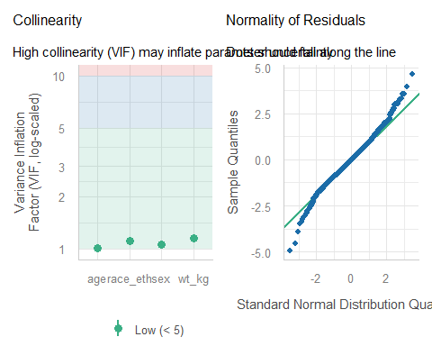

Training Sample Performance
plot(compare_performance(fit_12, fit_10, fit_04, fit_01))
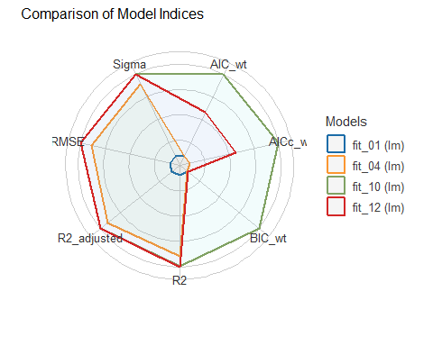

Training Sample Performance
compare_performance(fit_12, fit_10, fit_04, fit_01, rank = TRUE) |>
gt() |> fmt_number(decimals = 3) |> gt_theme_espn()
Name | Model | R2 | R2_adjusted | RMSE | Sigma | AIC_wt | AICc_wt | BIC_wt | Performance_Score
fit_10 | lm | 0.887 | 0.887 | 5.699 | 5.715 | 0.650 | 0.656 | 0.999 | 1.000
fit_12 | lm | 0.887 | 0.887 | 5.697 | 5.714 | 0.350 | 0.344 | 0.001 | 0.724
fit_04 | lm | 0.880 | 0.880 | 5.888 | 5.893 | 0.000 | 0.000 | 0.000 | 0.506
fit_01 | lm | 0.819 | 0.819 | 7.229 | 7.231 | 0.000 | 0.000 | 0.000 | 0.000

Cross-Validation Performance
In the training sample, we’ll try some cross-validation.
set.seed(20254312)
performance_accuracy(fit_12, method = "cv", k = 5)
# Accuracy of Model Predictions
Accuracy (95% CI): 94.09% [93.46%, 94.95%]
Method: Correlation between observed and predicted
performance_cv(fit_12)
# Cross-validation performance (30% holdout method)
MSE | RMSE | R2
-----------------
34 | 5.8 | 0.87
This is something we’ll do in 432, too. We can do the same thing for the other three models (R code on next slide.)

R code for other models
set.seed(20254313)
performance_accuracy(fit_10, method = "cv", k = 5)
performance_cv(fit_10)
set.seed(20254314)
performance_accuracy(fit_04, method = "cv", k = 5)
performance_cv(fit_04)
set.seed(20254315)
performance_accuracy(fit_01, method = "cv", k = 5)
performance_cv(fit_01)

Cross-Validation Results
- across the four models we’re considering…
Model | Accuracy | $MSE_{30}$​ | $RMSE_{30}$​ | $R_{30}^{2}$​
fit_12 | 0.9409 | 34 | 5.8 | 0.87
fit_10 | 0.9412 | 34 | 5.8 | 0.88
fit_04 | 0.9378 | 35 | 5.9 | 0.87
fit_01 | 0.9047 | 51 | 7.1 | 0.82
- Accuracy = correlation of waist$​_{observed}$, waist$​_{predicted}$.
- Other summaries use 30% holdout approach.

Predicting into Test Sample
aug01_test <- augment(fit_01, newdata = nh_test) |> mutate(mod = "fit_01")
aug04_test <- augment(fit_04, newdata = nh_test) |> mutate(mod = "fit_04")
aug10_test <- augment(fit_10, newdata = nh_test) |> mutate(mod = "fit_10")
aug12_test <- augment(fit_12, newdata = nh_test) |> mutate(mod = "fit_12")
temp14 <- bind_rows(aug01_test, aug04_test)
temp140 <- bind_rows(temp14, aug10_test)
test_res <- bind_rows(temp140, aug12_test) |>
relocate(SEQN, mod, waist, everything()) |> arrange(SEQN, mod)

Four Summary Measures
test_summary <- test_res |>
group_by(mod) |>
summarize(MAPE = mean(abs(.resid)),
Max_APE = max(abs(.resid)),
RMSE = sqrt(mean(.resid^2)),
R2_val = cor(waist, .fitted)^2)
test_summary |> gt() |> fmt_number(decimals = 4) |>
gt_theme_espn()
mod | MAPE | Max_APE | RMSE | R2_val
fit_01 | 5.8163 | 45.2882 | 7.4688 | 0.8057
fit_04 | 4.5745 | 44.8749 | 6.1507 | 0.8685
fit_10 | 4.4722 | 43.7459 | 6.0702 | 0.8719
fit_12 | 4.4696 | 43.8222 | 6.0654 | 0.8721

Multiple Imputation

We’d like to do 25 imputations
25 imputations on model fit_04 takes a little while (60 seconds on my machine.)
pct_miss_case(nh_H)
[1] 21.94175
imp25_ests <- nh_H |>
mice(m = 25, seed = 4312345, print = FALSE) |>
with(lm(waist ~ wt_kg + age + sex + race_eth)) |>
pool()
Warning: Number of logged events: 1

Pooled Results for model fit_04
glance(imp25_ests)
nimp nobs r.squared adj.r.squared
1 25 5150 0.8787014 0.8785362
tidy(imp25_ests, conf.int = TRUE, conf.level = 0.93) |>
select(term, estimate, std.error, conf.low, conf.high, p.value) |>
gt() |> fmt_number(decimals = 3, columns = c(-p.value))
term | estimate | std.error | conf.low | conf.high | p.value
(Intercept) | 30.297 | 0.488 | 29.412 | 31.183 | 0.000000e+00
wt_kg | 0.725 | 0.004 | 0.717 | 0.733 | 0.000000e+00
age | 0.201 | 0.005 | 0.191 | 0.210 | 1.529386e-263
sexF | 4.847 | 0.175 | 4.530 | 5.164 | 7.328862e-150
race_ethNH_White | -2.551 | 0.221 | -2.951 | -2.151 | 2.711498e-30
race_ethNH_Black | -4.779 | 0.255 | -5.242 | -4.316 | 1.025151e-74
race_ethNH_Asian | -1.701 | 0.307 | -2.257 | -1.145 | 3.095868e-08
race_ethOther | -3.193 | 0.521 | -4.138 | -2.249 | 1.046632e-09

Training Sample Results for fit_04
glance(fit_04) |> select(nobs, r.squared, adj.r.squared)
# A tibble: 1 × 3
nobs r.squared adj.r.squared
<int> <dbl> <dbl>
1 4000 0.880 0.880
tidy(fit_04, conf.int = TRUE, conf.level = 0.93) |>
select(term, estimate, std.error, conf.low, conf.high, p.value) |>
gt() |> fmt_number(decimals = 3) |> gt_theme_guardian()
term | estimate | std.error | conf.low | conf.high | p.value
(Intercept) | 29.656 | 0.534 | 28.688 | 30.624 | 0.000
wt_kg | 0.735 | 0.005 | 0.727 | 0.743 | 0.000
age | 0.198 | 0.006 | 0.187 | 0.209 | 0.000
sexF | 4.879 | 0.192 | 4.532 | 5.227 | 0.000
race_ethNH_White | -2.555 | 0.243 | -2.995 | -2.115 | 0.000
race_ethNH_Black | -4.781 | 0.284 | -5.296 | -4.266 | 0.000
race_ethNH_Asian | -1.593 | 0.338 | -2.205 | -0.981 | 0.000
race_ethOther | -3.298 | 0.547 | -4.289 | -2.307 | 0.000

Single Imputation Results for fit_04
Our model fit_04 uses wt_kg, age, sex and race_eth to predict waist. Our identifying code is in SEQN.
fit4_si <- lm(waist ~ wt_kg + age + sex + race_eth, data = nh_si)
n_obs(fit4_si)
[1] 5150

Single Imputation Results for fit_04
glance(fit4_si) |> select(nobs, r.squared, adj.r.squared)
# A tibble: 1 × 3
nobs r.squared adj.r.squared
<int> <dbl> <dbl>
1 5150 0.877 0.877
tidy(fit4_si, conf.int = TRUE, conf.level = 0.93) |>
select(term, estimate, std.error, conf.low, conf.high, p.value) |>
gt() |> fmt_number(decimals = 3) |> gt_theme_guardian()
term | estimate | std.error | conf.low | conf.high | p.value
(Intercept) | 30.525 | 0.469 | 29.675 | 31.375 | 0.000
wt_kg | 0.724 | 0.004 | 0.717 | 0.731 | 0.000
age | 0.200 | 0.005 | 0.190 | 0.209 | 0.000
sexF | 4.798 | 0.171 | 4.489 | 5.107 | 0.000
race_ethNH_White | -2.603 | 0.216 | -2.995 | -2.211 | 0.000
race_ethNH_Black | -4.821 | 0.252 | -5.277 | -4.365 | 0.000
race_ethNH_Asian | -1.773 | 0.301 | -2.319 | -1.228 | 0.000
race_ethOther | -3.452 | 0.503 | -4.363 | -2.541 | 0.000

Building “Complete Case” Data
Our model fit_04 uses wt_kg, age, sex and race_eth to predict waist. Our identifying code is in SEQN.
nh_cc <- nh_H |> select(SEQN, waist, wt_kg, age, sex, race_eth) |>
drop_na()
fit4_cc <- lm(waist ~ wt_kg + age + sex + race_eth, data = nh_cc)
n_obs(fit4_cc)
[1] 4902

“Complete Case” Results for fit_04
glance(fit4_cc) |> select(nobs, r.squared, adj.r.squared)
# A tibble: 1 × 3
nobs r.squared adj.r.squared
<int> <dbl> <dbl>
1 4902 0.878 0.878
tidy(fit4_cc, conf.int = TRUE, conf.level = 0.93) |>
select(term, estimate, std.error, conf.low, conf.high, p.value) |>
gt() |> fmt_number(decimals = 3) |> gt_theme_guardian()
term | estimate | std.error | conf.low | conf.high | p.value
(Intercept) | 29.513 | 0.478 | 28.647 | 30.379 | 0.000
wt_kg | 0.734 | 0.004 | 0.727 | 0.742 | 0.000
age | 0.200 | 0.005 | 0.190 | 0.210 | 0.000
sexF | 4.942 | 0.172 | 4.631 | 5.254 | 0.000
race_ethNH_White | -2.598 | 0.217 | -2.991 | -2.205 | 0.000
race_ethNH_Black | -4.813 | 0.253 | -5.272 | -4.355 | 0.000
race_ethNH_Asian | -1.554 | 0.302 | -2.102 | -1.007 | 0.000
race_ethOther | -2.815 | 0.505 | -3.730 | -1.901 | 0.000

Our 4-predictor model
- Use wt_kg, age, sex and race_eth to predict waist.
Method | Sample | $R^{2}$​ | wt_kg (93% CI)
Complete Cases | 4,902 | 0.878 | 0.734 (0.727, 0.742)
Training Sample | 4,000 | 0.880 | 0.735 (0.727, 0.743)
Single Imp. (all) | 5,150 | 0.877 | 0.724 (0.717, 0.731)
Multiple Imp. (25) | 5,150 | 0.879 | 0.725 (0.717, 0.733)

Session Information
xfun::session_info()
R version 4.6.1 (2026-06-24 ucrt)
Platform: x86_64-w64-mingw32/x64
Running under: Windows 11 x64 (build 26200)
Locale:
LC_COLLATE=English_United States.utf8
LC_CTYPE=English_United States.utf8
LC_MONETARY=English_United States.utf8
LC_NUMERIC=C
LC_TIME=English_United States.utf8
Package version:
abind_1.4-8 ape_5.8.1 AsioHeaders_1.30.2.1
askpass_1.2.1 backports_1.5.1 base64enc_0.1.6
bayestestR_0.20.0 bigD_0.3.1 bit_4.6.0
bit64_4.8.6 bitops_1.1.0 blob_1.3.0
boot_1.3-32 broom_1.0.13 bslib_0.12.0
cachem_1.1.0 callr_3.8.0 car_3.1-5
carData_3.0-6 cellranger_1.1.0 chromote_0.5.1
cli_3.6.6 clipr_0.8.1 coda_0.19-4.1
codetools_0.2-20 colorspace_2.1.4 commonmark_2.0.0
compiler_4.6.1 conflicted_1.2.0 correlation_0.8.8
cowplot_1.2.0 cpp11_0.5.5 crayon_1.5.3
crosstalk_1.2.2 curl_8.1.0 data.table_1.18.6.1
datasets_4.6.1 datawizard_1.4.1 DBI_1.3.0
dbplyr_2.6.0 Deriv_4.3.6 DHARMa_0.5.0
digest_0.6.39 doBy_4.7.2 doParallel_1.0.17
dplyr_1.2.1 dtplyr_1.3.3 easystats_0.7.6
effectsize_1.0.3 emmeans_2.0.4 estimability_2.0.0
evaluate_1.0.5 farver_2.1.2 fastmap_1.2.0
fontawesome_0.5.3 forcats_1.0.1 foreach_1.5.2
forecast_9.0.2 foreign_0.8-92 Formula_1.2-6
fracdiff_1.5.4 fs_2.1.0 gap_1.15.3
gap.datasets_0.0.6 gargle_1.7.0 generics_0.1.4
GGally_2.4.0 ggplot2_4.0.3 ggrepel_0.9.8
ggstats_0.14.0 glmnet_5.2 glue_1.8.1
goftest_1.2-3 googledrive_2.2.0 googlesheets4_1.1.3
graphics_4.6.1 grDevices_4.6.1 grid_4.6.1
gridExtra_2.3.1 gt_1.4.0 gtable_0.3.6
gtExtras_0.6.2 haven_2.5.5 highr_0.12
hms_1.1.4 htmltools_0.5.9 htmlwidgets_1.6.4
httpuv_1.6.17 httr_1.4.9 ids_1.0.1
insight_1.7.0 isoband_0.3.0 iterators_1.0.14
janitor_2.2.1 jomo_2.7-6 jquerylib_0.1.4
jsonlite_2.0.0 juicyjuice_0.1.0 knitr_1.52
labeling_0.4.3 later_1.4.8 lattice_0.23-1
lazyeval_0.2.3 lifecycle_1.0.5 litedown_0.11
lme4_2.1-0 lmtest_0.9.40 lubridate_1.9.5
magrittr_2.0.5 markdown_2.1 MASS_7.3-66
Matrix_1.7-6 MatrixModels_0.5.4 memoise_2.0.1
methods_4.6.1 mgcv_1.9-4 mice_3.19.0
mime_0.13 minqa_1.2.8 mitml_0.4-5
modelbased_0.18.0 modelr_0.1.11 multcomp_1.4-32
mvtnorm_1.4-2 naniar_1.1.0 nhanesA_1.4.1
nlme_3.1-171 nloptr_2.2.1 nnet_7.3-21
norm_1.0-11.1 nortest_1.0-4 numDeriv_2016.8.1.1
olsrr_0.7.0 openssl_2.4.2 ordinal_2026.7.26
otel_0.2.0 paletteer_1.7.0 pan_2.0
parallel_4.6.1 parameters_0.30.0 patchwork_1.3.2
pbkrtest_0.5.5 performance_0.19.0 pillar_1.11.1
pkgconfig_2.0.3 plotly_4.12.1 plyr_1.8.9
prettyunits_1.2.0 prismatic_1.1.2 processx_3.9.0
progress_1.2.3 promises_1.5.0 ps_1.9.3
purrr_1.2.2 qgam_2.0.0 quantreg_6.1
R6_2.6.1 ragg_1.5.2 rappdirs_0.3.4
rbibutils_2.4.1 RColorBrewer_1.1-3 Rcpp_1.1.2
RcppArmadillo_15.6.2.1 RcppEigen_0.3.4.0.2 Rdpack_2.6.6
reactable_0.4.5 reactR_0.6.1 readr_2.2.0
readxl_1.6.0 reformulas_0.4.4 rematch_2.0.0
rematch2_2.1.2 report_0.6.4 reprex_2.1.1
rlang_1.3.0 rmarkdown_2.32 rpart_4.1.27
rstudioapi_0.19.0 rvest_1.0.5 S7_0.2.2
sandwich_3.1-3 sass_0.4.10 scales_1.4.0
see_0.15.0 selectr_0.8.0 shape_1.4.6.1
shiny_1.14.0 snakecase_0.11.1 sourcetools_0.1.7.2
SparseM_1.84.2 splines_4.6.1 stats_4.6.1
stats4_4.6.1 stringi_1.8.9 stringr_1.6.0
survival_3.8-12 sys_3.4.3 systemfonts_1.3.2
textshaping_1.0.5 TH.data_1.1-5 tibble_3.3.1
tidyr_1.3.2 tidyselect_1.2.1 tidyverse_2.0.0
timechange_0.4.0 timeDate_4052.112 tinytex_0.61
tools_4.6.1 tzdb_0.5.0 ucminf_1.2.3
UpSetR_1.4.1 urca_1.3.4 utf8_1.2.6
utils_4.6.1 uuid_1.2.2 V8_8.2.1
vctrs_0.7.3 viridis_0.6.5 viridisLite_0.4.3
visdat_0.6.1 vroom_1.7.1 websocket_1.4.4
withr_3.0.3 xfun_0.62 xml2_1.6.0
xplorerr_0.2.0 xtable_1.8-8 yaml_2.3.12
zip_3.0.2 zoo_1.9-1

In part, this is so you can see how to do it.
Caution: this process takes a while.
fit12 is the “kitchen sink”, fit10 is “stepwise”, fit04 has a nice adjusted $R^{2}$, and fit01 is the most crucial predictor.

