431 Class 18
Thomas E. Love, Ph.D.
2026-10-27

Today’s Agenda
Two-Factor (Two-Way) Analysis of Variance
- The importance of interaction
- Interpreting ANOVA output
- What are the key model checks for ANOVA?
- Comparing Model Performance Indices
- What if we add a covariate?

Today’s Packages
knitr::opts_chunk$set(comment = NA)
library(googlesheets4)
library(gt)
library(janitor)
library(mice)
library(naniar)
library(easystats)
library(tidyverse)
theme_set(theme_bw())

Favorite Movies Data
gs4_deauth() # indicates to Google Drive that you're reading a public file
url_movies <- "https://docs.google.com/spreadsheets/d/1LJdlS1JUYQqJidrnkJ5OmFZr009g25oiZkvtZXhXXlc"
## this is movies_2026-10-13 from our shared drive
mov_raw <- read_sheet(url_movies, na = c("", "NA"))
✔ Reading from "movies_2026-10-13".
✔ Range 'movies_2026-10-13'.
dim(mov_raw)
[1] 282 97

Describing Today’s Variables
- Favorite movies from students in 2020-2026
Variable | Description
mov_id | M-xxx code to identify movie
metascore | outcome: critic rating (0 to 100) pulled from Metacritic
drama | Is drama one of the IMDB genres for this movie? (1 = yes, 0 = no)
comedy | Is comedy one of the IMDB genres for this movie? (1 = yes, 0 = no)
bacon_s1 | Bacon number (from Oracle of Bacon) for movie’s first listed star
rt_audience | Audience rating (0 to 100) from Rotten Tomatoes
movie | Movie Name to identify movie
- Bacon number = # of movies it takes to connect the star to Kevin Bacon.
  - Bacon = 1: star has been in a movie with Kevin Bacon.
  - None of our 282 movies feature Kevin Bacon, as it turns out.

Today’s analytic data
mov_18 <- mov_raw |>
select(mov_id, metascore, drama, comedy, bacon_s1, rt_audience, movie) |>
mutate(drama = factor(drama), comedy = factor(comedy),
bacon_s1 = factor(bacon_s1), movie = as.character(movie))
mov_18 |> gt_preview(top_n = 5, bottom_n = 1, incl_rownums = TRUE) |>
tab_options(table.font.size = 24)
 | mov_id | metascore | drama | comedy | bacon_s1 | rt_audience | movie
1 | M-001 | 67 | 1 | 1 | 3 | 93 | 3 Idiots
2 | M-002 | 93 | 1 | 0 | 2 | 92 | 8 1/2
3 | M-003 | 70 | 1 | 1 | 2 | 69 | 10 Things I Hate About You
4 | M-004 | 83 | 1 | 1 | 2 | 74 | 20th Century Women
5 | M-005 | 52 | 1 | 0 | 2 | 89 | 300
6..281
282 | M-282 | 61 | 0 | 1 | 2 | 80 | Zoolander

Dealing with missing values
miss_var_summary(mov_18) |> filter(n_miss > 0) |>
gt() |> tab_options(table.font.size = 20)
variable | n_miss | pct_miss
metascore | 18 | 6.38
rt_audience | 3 | 1.06
bacon_s1 | 2 | 0.709
miss_case_table(mov_18) |>
gt() |> tab_options(table.font.size = 20)
n_miss_in_case | n_cases | pct_cases
0 | 264 | 93.6170213
1 | 15 | 5.3191489
2 | 1 | 0.3546099
3 | 2 | 0.7092199

Can we assume MCAR?
Can we use data to assess whether assuming MCAR is reasonable?
mov_18 |> mcar_test()
# A tibble: 1 × 4
statistic df p.value missing.patterns
<dbl> <dbl> <dbl> <int>
1 41.3 15 0.000284 4
With a high chi-square statistic and tiny p value from the Little (1988) test, we conclude that there is essentially no evidence that the data are missing completely at random.
- So we should be highly motivated to impute.

Today’s Imputation Strategy
Today, we’ll assume MAR and impute all missing values, including metascore, which will be our outcome.
- Another approach we’ll often use would be to impute everything except for the outcome.
How many imputations should we consider running?
mov_18 |> pct_miss_case()
[1] 6.382979

Building 10 imputations
set.seed(20261027)
mov_18_mice10 <- mice(mov_18, m = 10, printFlag = FALSE)
Warning: Number of logged events: 2

Two Primary Analytic Data Sets
## complete cases
mov_cc <- mov_18 |> drop_na()
dim(mov_cc)
[1] 264 7
n_miss(mov_cc)
[1] 0

Selecting a single imputation
## arbitrarily chose to look at the third imputation of 10
mov_i3 <- complete(mov_18_mice10, 3) |> tibble()
dim(mov_i3)
[1] 282 7
n_miss(mov_i3)
[1] 0

Example 1
Suppose we want to simultaneously understand the impacts of two factors on metascore, specifically:
- drama (1 or 0)
- comedy (1 or 0), and
and it is possible that the impact of comedy on metascore may depend on whether the movie is also a drama (i.e. comedy and drama may interact.)
- For a start, we’ll analyze the data with complete cases.

Looking at our two factors
mov_cc |> count(drama, comedy) |>
gt() |> tab_options(table.font.size = 24) |>
opt_stylize(style = 6, color = "blue", add_row_striping = TRUE)
drama | comedy | n
0 | 0 | 57
0 | 1 | 56
1 | 0 | 104
1 | 1 | 47

An interaction plot is a plot of means.
Calculate and store the group means.
ex1_means <- mov_cc |>
group_by(comedy, drama) |>
summarize(n = n(), mean_metascore = mean(metascore))
`summarise()` has regrouped the output.
ℹ Summaries were computed grouped by comedy and drama.
ℹ Output is grouped by comedy.
ℹ Use `summarise(.groups = "drop_last")` to silence this message.
ℹ Use `summarise(.by = c(comedy, drama))` for per-operation grouping
(`?dplyr::dplyr_by`) instead.
ex1_means
# A tibble: 4 × 4
# Groups: comedy [2]
comedy drama n mean_metascore
<fct> <fct> <int> <dbl>
1 0 0 57 70.5
2 0 1 104 74.8
3 1 0 56 65.8
4 1 1 47 68.2

How strong is the interaction?
Now, we’ll plot these means, and look for a substantial interaction (non-parallel lines.)
ggplot(ex1_means, aes(x = drama, y = mean_metascore)) +
geom_line(aes(group = comedy, color = comedy)) +
geom_point(aes(color = comedy)) +
scale_color_material() +
labs(title = "Example 1 Interaction Plot",
subtitle = "Do we see substantially non-parallel lines?",
y = "Metascore (0-100)",
x = "Drama (1 = yes, 0 = no)",
color = "Comedy",
caption = "Complete Cases (n = 264 movies)")
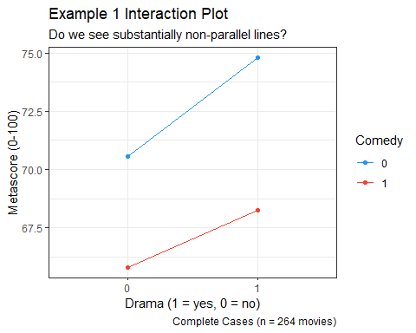

Two-Way ANOVA without interaction
This model predicts our outcome (metascore) using the two factors as main effects only (with no interaction.)
mainfx <- lm(metascore ~ drama + comedy, data = mov_cc)
mainfx
Call:
lm(formula = metascore ~ drama + comedy, data = mov_cc)
Coefficients:
(Intercept) drama1 comedy1
71.024 3.501 -5.709
$$metascore=71.024+3.501(drama=1)−5.709(comedy=1)$$

Interpret the drama estimate: 3.50?
model_parameters(mainfx, ci = 0.90, pretty_names = FALSE)
Parameter | Coefficient | SE | 90% CI | t(261) | p
-------------------------------------------------------------------
(Intercept) | 71.02 | 1.77 | [68.10, 73.95] | 40.09 | < .001
drama1 | 3.50 | 1.97 | [ 0.24, 6.76] | 1.77 | 0.077
comedy1 | -5.71 | 2.00 | [-9.02, -2.40] | -2.85 | 0.005
Uncertainty intervals (equal-tailed) and p-values (two-tailed) computed
using a Wald t-distribution approximation.
If we have two movies with the same comedy status, but only one has a drama = 1, then on average the dramatic movie will have a metascore that is 3.50 points higher than the movie which is not a drama, according to our mainfx model.

Interpret the estimate: -5.71?
model_parameters(mainfx, ci = 0.90, pretty_names = FALSE)
Parameter | Coefficient | SE | 90% CI | t(261) | p
-------------------------------------------------------------------
(Intercept) | 71.02 | 1.77 | [68.10, 73.95] | 40.09 | < .001
drama1 | 3.50 | 1.97 | [ 0.24, 6.76] | 1.77 | 0.077
comedy1 | -5.71 | 2.00 | [-9.02, -2.40] | -2.85 | 0.005
Uncertainty intervals (equal-tailed) and p-values (two-tailed) computed
using a Wald t-distribution approximation.
Our mainfx model estimates that if we have two movies with the same drama status, but one is a comedy and the other is not, then on average the comedy will have a metascore that is 5.71 points lower than the movie which is not a comedy.

Interpret the intercept term?
model_parameters(mainfx, ci = 0.90, pretty_names = FALSE)
Parameter | Coefficient | SE | 90% CI | t(261) | p
-------------------------------------------------------------------
(Intercept) | 71.02 | 1.77 | [68.10, 73.95] | 40.09 | < .001
drama1 | 3.50 | 1.97 | [ 0.24, 6.76] | 1.77 | 0.077
comedy1 | -5.71 | 2.00 | [-9.02, -2.40] | -2.85 | 0.005
Uncertainty intervals (equal-tailed) and p-values (two-tailed) computed
using a Wald t-distribution approximation.
71.02 is the intercept. It’s the mainfx model’s estimate of the mean of metascore across all movies where both drama is 0 and comedy is 0.

ANOVA table for mainfx
anova(mainfx)
Analysis of Variance Table
Response: metascore
Df Sum Sq Mean Sq F value Pr(>F)
drama 1 1340 1340.21 5.5099 0.01966 *
comedy 1 1976 1975.76 8.1228 0.00472 **
Residuals 261 63484 243.24
---
Signif. codes: 0 '***' 0.001 '**' 0.01 '*' 0.05 '.' 0.1 ' ' 1

% of Total SS explained by the two factors?
- Total SS = 1340 + 1976 + 63484 = 66800
- So % explained = (1340 + 1976) / 66800 = 0.0496, or 4.96%

Model mainfx and its assumptions
- mainfx is a “main effects only” model. It assumes there is zero interaction between drama and comedy in predicting metascore.
- Like any ANOVA model, mainfx makes the usual linear model assumptions (linearity, constant variance, Normality)
  - Focus: posterior predictive check, and Normal Q-Q plot of residuals.

Checking model mainfx
set.seed(20264311)
check_model(mainfx, check = c("pp_check", "qq"), detrend = FALSE)
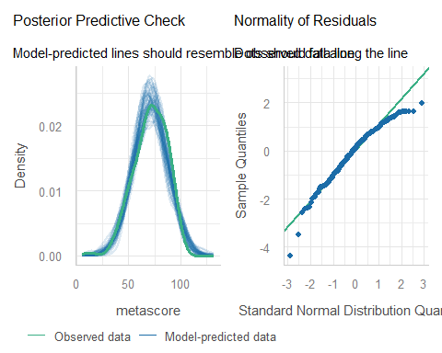

Interaction Plot, again
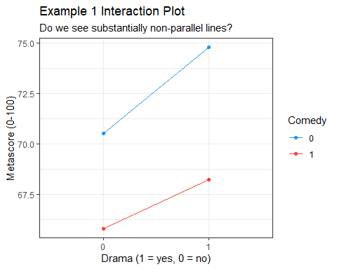

Two-Way ANOVA with Interaction
Fit the linear model, including an interaction (*) between our factors.
withint <- lm(metascore ~ drama * comedy, data = mov_cc)
withint
Call:
lm(formula = metascore ~ drama * comedy, data = mov_cc)
Coefficients:
(Intercept) drama1 comedy1 drama1:comedy1
70.544 4.245 -4.740 -1.814

withint model equation?
$$
metascore = 70.544 + 4.245 (drama = 1) - 4.740 (comedy = 1) \\
- 1.814 (drama = 1) \times (comedy = 1)
$$
drama | comedy | Estimated metascore
0 | 0 | 70.544
0 | 1 | 70.544 - 4.740 = 65.804
1 | 0 | 70.544 + 4.245 = 74.789
1 | 1 | 70.544 + 4.245 - 4.740 - 1.814 = 68.235

Effect of comedy = 1?
Est. metascore | comedy = 0 | comedy = 1
drama = 0 | 70.544 | 65.804
drama = 1 | 74.789 | 68.235
- If drama = 0, difference between comedy = 0 and comedy = 1 estimates is 4.740 (70.544 - 65.804)
- If drama = 1, difference between comedy = 0 and comedy = 1 estimates is 6.554 (74.789 - 68.235)
- So the model’s estimated effect of comedy depends on drama.

Effect of drama = 1?
Est. metascore | comedy = 0 | comedy = 1
drama = 0 | 70.544 | 65.804
drama = 1 | 74.789 | 68.235
- If comedy = 0, difference between drama = 1 and drama = 0 estimates is 4.245 (74.789 - 70.544)
- If comedy = 1, difference between drama = 1 and drama = 0 estimates is 2.431 (68.235 - 65.804)
- So the model’s estimated effect of drama depends on comedy.

ANOVA table for withint model
anova(withint)
Analysis of Variance Table
Response: metascore
Df Sum Sq Mean Sq F value Pr(>F)
drama 1 1340 1340.21 5.4931 0.019845 *
comedy 1 1976 1975.76 8.0980 0.004784 **
drama:comedy 1 50 49.64 0.2035 0.652305
Residuals 260 63435 243.98
---
Signif. codes: 0 '***' 0.001 '**' 0.01 '*' 0.05 '.' 0.1 ' ' 1
- Total SS = 1340 + 1976 + 50 + 63435 = 66801
- % explained = (1340 + 1976 + 50) / 66801 = 0.0504, or 5.04%
- Is this a big improvement over the mainfx model?

Checking model withint
set.seed(20264312)
check_model(withint, check = c("pp_check", "qq"), detrend = FALSE)
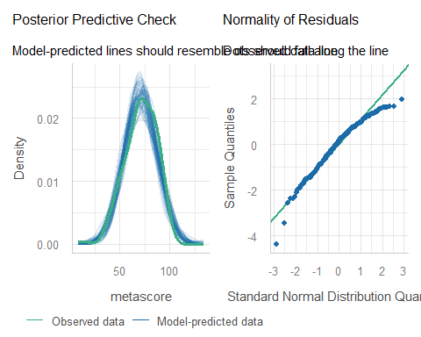

Compare performance of our two models?
compare_performance(mainfx, withint, rank = TRUE)
# Comparison of Model Performance Indices
Name | Model | R2 | R2 (adj.) | RMSE | Sigma | AIC weights
-------------------------------------------------------------------
mainfx | lm | 0.050 | 0.042 | 15.507 | 15.596 | 0.710
withint | lm | 0.050 | 0.039 | 15.501 | 15.620 | 0.290
Name | AICc weights | BIC weights | Performance-Score
--------------------------------------------------------
mainfx | 0.718 | 0.936 | 71.43%
withint | 0.282 | 0.064 | 28.57%

Plot to compare performance indicators
plot(compare_performance(mainfx, withint))
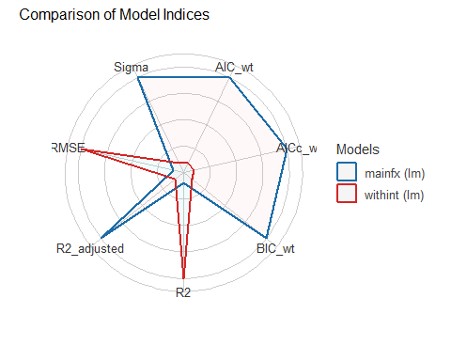

Do we have a substantial interaction?
- Interaction plot shows essentially parallel lines.
- % of variation explained by the interaction term is less than 0.1% of the variation in meta_score, overall.
- p value for the interaction term is pretty large ($p$ = 0.65)
- Is there a substantial improvement in the fit with the interaction?
  - Only in terms of raw $R^{2}$ and RMSE.

What if we used the single imputation instead?
In this example, nothing important changes as it turns out.
- We’ll largely skip through the slides from here to the standing break, but you can review them on your own to see that nothing substantial has changed as a result of including a few more movies.
- Doesn’t mean that nothing could have changed, but not much did, in this case.

Table of Means?
ex1_means_i <- mov_i3 |>
group_by(comedy, drama) |>
summarize(n = n(), mean_metascore = mean(metascore))
`summarise()` has regrouped the output.
ℹ Summaries were computed grouped by comedy and drama.
ℹ Output is grouped by comedy.
ℹ Use `summarise(.groups = "drop_last")` to silence this message.
ℹ Use `summarise(.by = c(comedy, drama))` for per-operation grouping
(`?dplyr::dplyr_by`) instead.
ex1_means_i
# A tibble: 4 × 4
# Groups: comedy [2]
comedy drama n mean_metascore
<fct> <fct> <int> <dbl>
1 0 0 57 70.5
2 0 1 112 75.3
3 1 0 58 65.2
4 1 1 55 66.7

How strong is the interaction?
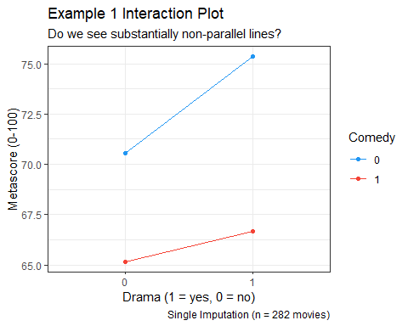

Two-Way ANOVA without interaction
mainfx_i <- lm(metascore ~ drama + comedy, data = mov_i3)
mainfx_i
Call:
lm(formula = metascore ~ drama + comedy, data = mov_i3)
Coefficients:
(Intercept) drama1 comedy1
71.473 3.394 -7.213
Remember, the model with complete cases was:
$$metascore=71.024+3.501(drama=1)−5.709(comedy=1)$$

ANOVA table for mainfx_i
anova(mainfx_i)
Analysis of Variance Table
Response: metascore
Df Sum Sq Mean Sq F value Pr(>F)
drama 1 1477 1476.5 6.0478 0.0145307 *
comedy 1 3415 3414.8 13.9873 0.0002234 ***
Residuals 279 68115 244.1
---
Signif. codes: 0 '***' 0.001 '**' 0.01 '*' 0.05 '.' 0.1 ' ' 1

% of Total SS explained by the two factors?
- Total SS = 1477 + 3415 + 68115 = 73007
- So % explained = (1477 + 3415) / 73007 = 0.0670, or 6.70%

Checking model mainfx_i
set.seed(20264313)
check_model(mainfx_i, check = c("pp_check", "qq"), detrend = FALSE)
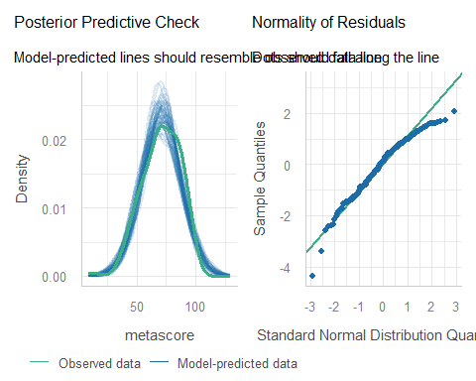

Two-Way ANOVA with Interaction
withint_i <- lm(metascore ~ drama * comedy, data = mov_i3)
withint_i
Call:
lm(formula = metascore ~ drama * comedy, data = mov_i3)
Coefficients:
(Intercept) drama1 comedy1 drama1:comedy1
70.544 4.795 -5.371 -3.277
With complete cases, the model was:
$$
metascore = 70.544 + 4.245 (drama = 1) - 4.740 (comedy = 1) \\
- 1.814 (drama = 1) \times (comedy = 1)
$$

ANOVA table for withint_i model
anova(withint_i)
Analysis of Variance Table
Response: metascore
Df Sum Sq Mean Sq F value Pr(>F)
drama 1 1477 1476.5 6.0415 0.0145836 *
comedy 1 3415 3414.8 13.9727 0.0002252 ***
drama:comedy 1 173 173.5 0.7099 0.4002075
Residuals 278 67941 244.4
---
Signif. codes: 0 '***' 0.001 '**' 0.01 '*' 0.05 '.' 0.1 ' ' 1
- Total SS = 1477 + 3415 + 173 + 67941 = 73006
- % explained = (1477 + 3415 + 173) / 73006 = 0.0693, or 6.93%
- Again, no big improvement over the mainfx model

Checking model withint_i
set.seed(20264314)
check_model(withint_i, check = c("pp_check", "qq"), detrend = FALSE)
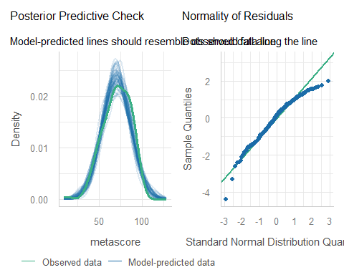

Plot to compare performance indicators
plot(compare_performance(mainfx_i, withint_i))
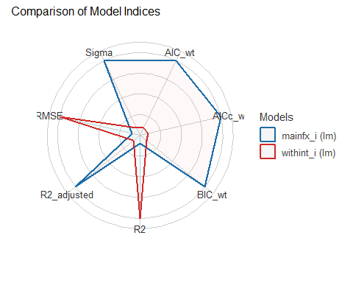

Do we have a substantial interaction?
No change in any of this.
- Interaction plot shows essentially parallel lines.
- % of variation explained by the interaction term is less than 0.3% of the variation in metascore, overall.
- p value for the interaction term is pretty large ($p$ = 0.40)
- Substantial improvement in the fit with the interaction?
  - Only in terms of raw $R^{2}$ and RMSE.

Standing Break

Example 2
For the rest of today’s work, we’ll use the singly imputed data.
Suppose that we now want to understand the impact on metascore, of:
- drama (1 or 0), and
- bacon_s1 (1, 2 or 3)
and it’s possible that the impact of drama on metascore may depend on the first-listed star’s Bacon number, and vice versa.

Build an interaction plot
Calculate and store group means.
ex2_means <- mov_i3 |>
group_by(drama, bacon_s1) |>
summarize(n = n(), mean_metascore = mean(metascore))
`summarise()` has regrouped the output.
ℹ Summaries were computed grouped by drama and bacon_s1.
ℹ Output is grouped by drama.
ℹ Use `summarise(.groups = "drop_last")` to silence this message.
ℹ Use `summarise(.by = c(drama, bacon_s1))` for per-operation grouping
(`?dplyr::dplyr_by`) instead.
ex2_means
# A tibble: 6 × 4
# Groups: drama [2]
drama bacon_s1 n mean_metascore
<fct> <fct> <int> <dbl>
1 0 1 26 61.4
2 0 2 86 69.3
3 0 3 3 81
4 1 1 39 72.4
5 1 2 113 72
6 1 3 15 76.4

How strong is the interaction?
Now, we’ll plot these means, and look for a substantial interaction (non-parallel lines.)
ggplot(ex2_means, aes(x = bacon_s1, y = mean_metascore)) +
geom_line(aes(group = drama, color = drama)) +
geom_point(aes(color = drama)) +
scale_color_material() +
labs(title = "Example 2 Interaction Plot",
subtitle = "Do we see substantially non-parallel lines?",
y = "Metascore (mean)",
x = "Bacon score for Star 1",
color = "Drama?",
caption = "Single Imputation: n = 282 movies")
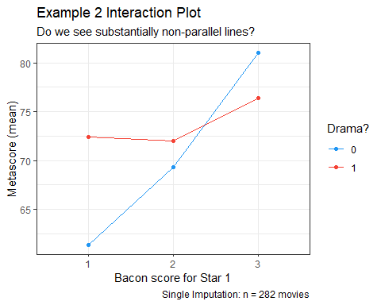

Example 2: Two-Way ANOVA models
mainfx2 <- lm(metascore ~ bacon_s1 + drama, data = mov_i3)
withint2 <- lm(metascore ~ bacon_s1 * drama, data = mov_i3)
compare_performance(mainfx2, withint2, rank = TRUE)
# Comparison of Model Performance Indices
Name | Model | R2 | R2 (adj.) | RMSE | Sigma | AIC weights
--------------------------------------------------------------------
withint2 | lm | 0.048 | 0.031 | 15.697 | 15.866 | 0.520
mainfx2 | lm | 0.034 | 0.024 | 15.813 | 15.926 | 0.480
Name | AICc weights | BIC weights | Performance-Score
---------------------------------------------------------
withint2 | 0.496 | 0.028 | 71.43%
mainfx2 | 0.504 | 0.972 | 28.57%

Plotting Performance Indices
plot(compare_performance(mainfx2, withint2))
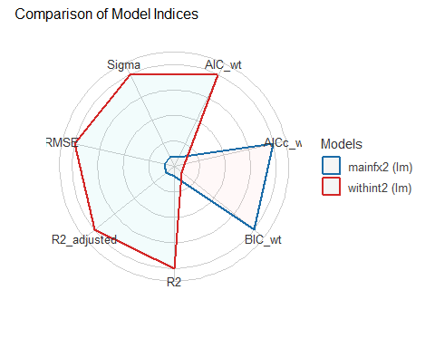

Interpret mainfx2 estimates?
model_parameters(mainfx2, ci = 0.90, pretty_names = FALSE)
Parameter | Coefficient | SE | 90% CI | t(278) | p
-------------------------------------------------------------------
(Intercept) | 65.39 | 2.29 | [61.60, 69.18] | 28.49 | < .001
bacon_s12 | 2.98 | 2.28 | [-0.77, 6.74] | 1.31 | 0.191
bacon_s13 | 8.15 | 4.27 | [ 1.11, 15.19] | 1.91 | 0.057
drama1 | 4.35 | 1.95 | [ 1.14, 7.56] | 2.23 | 0.026
Uncertainty intervals (equal-tailed) and p-values (two-tailed) computed
using a Wald t-distribution approximation.
$$
metascore = 65.39 + 2.98 (Bacon = 2) + 8.15 (Bacon = 3) \\
+ 4.35 (drama = 1)
$$

Making Predictions with mainfx2
estimate_relation(mainfx2, ci = 0.90)
Model-based Predictions
bacon_s1 | drama | Predicted | SE | 90% CI
----------------------------------------------------
1 | 0 | 65.39 | 2.29 | [61.60, 69.18]
2 | 0 | 68.37 | 1.58 | [65.77, 70.98]
3 | 0 | 73.54 | 4.09 | [66.79, 80.29]
1 | 1 | 69.74 | 2.12 | [66.24, 73.24]
2 | 1 | 72.72 | 1.41 | [70.40, 75.05]
3 | 1 | 77.89 | 3.77 | [71.67, 84.11]
Variable predicted: metascore
Predictors modulated: bacon_s1, drama

Specify withint2 equation?
model_parameters(withint2, ci = 0.90, pretty_names = FALSE)
Parameter | Coefficient | SE | 90% CI | t(276) | p
--------------------------------------------------------------------------
(Intercept) | 61.38 | 3.11 | [ 56.25, 66.52] | 19.73 | < .001
bacon_s12 | 7.94 | 3.55 | [ 2.08, 13.80] | 2.24 | 0.026
bacon_s13 | 19.62 | 9.67 | [ 3.65, 35.58] | 2.03 | 0.044
drama1 | 11.03 | 4.02 | [ 4.40, 17.66] | 2.74 | 0.006
bacon_s12:drama1 | -8.35 | 4.61 | [-15.97, -0.74] | -1.81 | 0.071
bacon_s13:drama1 | -15.63 | 10.81 | [-33.46, 2.21] | -1.45 | 0.149
Uncertainty intervals (equal-tailed) and p-values (two-tailed) computed
using a Wald t-distribution approximation.

Making Predictions with withint2
estimate_relation(withint2, ci = 0.90)
Model-based Predictions
bacon_s1 | drama | Predicted | SE | 90% CI
----------------------------------------------------
1 | 0 | 61.38 | 3.11 | [56.25, 66.52]
2 | 0 | 69.33 | 1.71 | [66.50, 72.15]
3 | 0 | 81.00 | 9.16 | [65.88, 96.12]
1 | 1 | 72.41 | 2.54 | [68.22, 76.60]
2 | 1 | 72.00 | 1.49 | [69.54, 74.46]
3 | 1 | 76.40 | 4.10 | [69.64, 83.16]
Variable predicted: metascore
Predictors modulated: bacon_s1, drama

ANOVA for mainfx2 model
anova(mainfx2)
Analysis of Variance Table
Response: metascore
Df Sum Sq Mean Sq F value Pr(>F)
bacon_s1 2 1227 613.72 2.4196 0.09083 .
drama 1 1266 1266.03 4.9914 0.02627 *
Residuals 278 70513 253.64
---
Signif. codes: 0 '***' 0.001 '**' 0.01 '*' 0.05 '.' 0.1 ' ' 1

% of Total SS explained by the two factors?
eta_squared(anova(mainfx2))
# Effect Size for ANOVA (Type I)
Parameter | Eta2 (partial) | 95% CI
-----------------------------------------
bacon_s1 | 0.02 | [0.00, 1.00]
drama | 0.02 | [0.00, 1.00]
- One-sided CIs: upper bound fixed at [1.00].

ANOVA table for interaction model
anova(withint2)
Analysis of Variance Table
Response: metascore
Df Sum Sq Mean Sq F value Pr(>F)
bacon_s1 2 1227 613.72 2.4379 0.08922 .
drama 1 1266 1266.03 5.0291 0.02572 *
bacon_s1:drama 2 1033 516.28 2.0509 0.13058
Residuals 276 69480 251.74
---
Signif. codes: 0 '***' 0.001 '**' 0.01 '*' 0.05 '.' 0.1 ' ' 1

% of Total SS explained by the factors?
eta_squared(anova(withint2))
# Effect Size for ANOVA (Type I)
Parameter | Eta2 (partial) | 95% CI
----------------------------------------------
bacon_s1 | 0.02 | [0.00, 1.00]
drama | 0.02 | [0.00, 1.00]
bacon_s1:drama | 0.01 | [0.00, 1.00]
- One-sided CIs: upper bound fixed at [1.00].

Checking model mainfx2
set.seed(20264315)
check_model(mainfx2, check = c("pp_check", "qq"), detrend = FALSE)
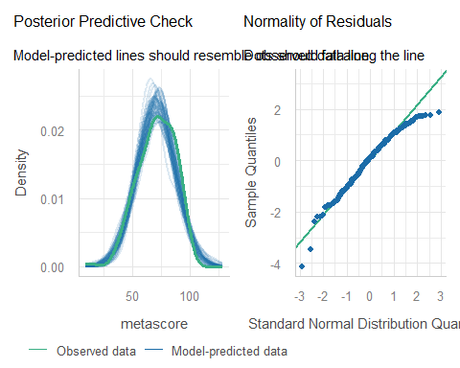

Checking model withint2
set.seed(20264316)
check_model(withint2, check = c("pp_check", "qq"), detrend = FALSE)
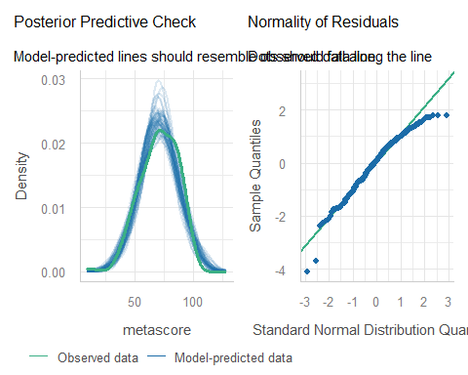

Substantial interaction here?
- Interaction plot shows substantially non-parallel lines.
- Interaction term explains about 1% of the variation in metascore, overall.
- p value for the interaction term: ($p$ = 0.13)
- Substantial improvement in the fit with interaction?
  - 5/7 in-sample performance indices prefer interaction
What do you think?

Treating Bacon number as quantitative?
We make a lot of little decisions. Are our conclusions robust?
mov_i3_extra <- mov_i3 |> mutate(bacon = as.numeric(bacon_s1))
anova(lm(metascore ~ drama * bacon, data = mov_i3_extra))
Analysis of Variance Table
Response: metascore
Df Sum Sq Mean Sq F value Pr(>F)
drama 1 1477 1476.51 5.8895 0.01587 *
bacon 1 965 965.33 3.8506 0.05073 .
drama:bacon 1 870 869.68 3.4690 0.06358 .
Residuals 278 69695 250.70
---
Signif. codes: 0 '***' 0.001 '**' 0.01 '*' 0.05 '.' 0.1 ' ' 1

Example 3
What if we add rt_audience as a covariate?
- We might consider centering rt_audience.
- Here is an analysis of covariance model.
fit3 <- lm(metascore ~ drama * bacon_s1 + center(rt_audience),
data = mov_i3)

Our ANCOVA model fit3
anova(fit3)
Analysis of Variance Table
Response: metascore
Df Sum Sq Mean Sq F value Pr(>F)
drama 1 1477 1476.5 7.6545 0.006047 **
bacon_s1 2 1017 508.5 2.6361 0.073452 .
center(rt_audience) 1 17162 17162.2 88.9728 < 2.2e-16 ***
drama:bacon_s1 2 305 152.4 0.7903 0.454754
Residuals 275 53046 192.9
---
Signif. codes: 0 '***' 0.001 '**' 0.01 '*' 0.05 '.' 0.1 ' ' 1

Variation explained by this model?
eta_squared(fit3)
# Effect Size for ANOVA (Type I)
Parameter | Eta2 (partial) | 95% CI
---------------------------------------------------
drama | 0.03 | [0.00, 1.00]
bacon_s1 | 0.02 | [0.00, 1.00]
center(rt_audience) | 0.24 | [0.18, 1.00]
drama:bacon_s1 | 5.71e-03 | [0.00, 1.00]
- One-sided CIs: upper bound fixed at [1.00].

Drop Interaction Term?
fit3_noint <- lm(metascore ~ drama + bacon_s1 + center(rt_audience),
data = mov_i3)
anova(fit3_noint)
Analysis of Variance Table
Response: metascore
Df Sum Sq Mean Sq F value Pr(>F)
drama 1 1477 1476.5 7.6661 0.006006 **
bacon_s1 2 1017 508.5 2.6401 0.073151 .
center(rt_audience) 1 17162 17162.2 89.1077 < 2.2e-16 ***
Residuals 277 53350 192.6
---
Signif. codes: 0 '***' 0.001 '**' 0.01 '*' 0.05 '.' 0.1 ' ' 1

Compare three models?
compare_performance(withint2, fit3, fit3_noint, rank = TRUE)
# Comparison of Model Performance Indices
Name | Model | R2 | R2 (adj.) | RMSE | Sigma | AIC weights
----------------------------------------------------------------------
fit3_noint | lm | 0.269 | 0.259 | 13.754 | 13.878 | 0.767
fit3 | lm | 0.273 | 0.258 | 13.715 | 13.889 | 0.233
withint2 | lm | 0.048 | 0.031 | 15.697 | 15.866 | 1.88e-17
Name | AICc weights | BIC weights | Performance-Score
-----------------------------------------------------------
fit3_noint | 0.786 | 0.992 | 99.45%
fit3 | 0.214 | 0.008 | 65.33%
withint2 | 1.83e-17 | 3.94e-18 | 0.00%

Compare performance plot?
plot(compare_performance(withint2, fit3, fit3_noint))
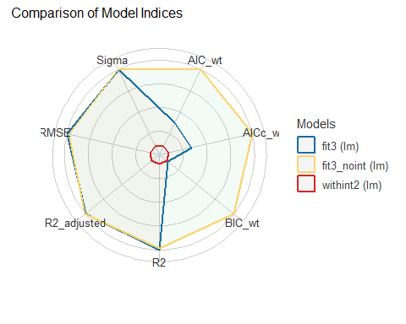

Check model fit3 (1/3)
check_model(fit3, check = c("pp_check", "qq"), detrend = FALSE)
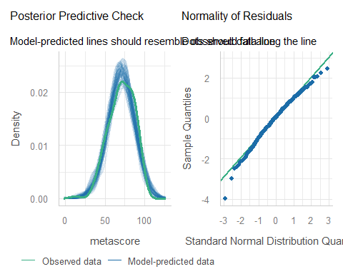

Check model fit3 (2/3)
check_model(fit3, check = c("linearity", "homogeneity"))
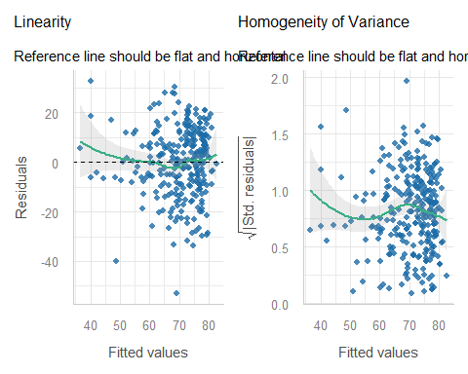

Check model fit3 (3/3)
check_model(fit3, check = c("outliers", "vif"))
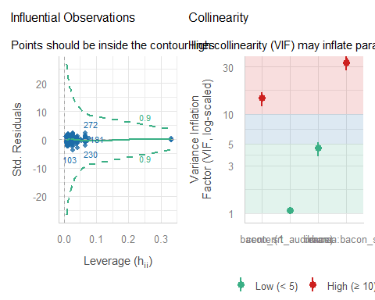

Next Time
- Our first attempt at a general strategy for regression model building and assessment.
- A data set containing 500 adults living with diabetes.

Session Information
xfun::session_info()
R version 4.6.1 (2026-06-24 ucrt)
Platform: x86_64-w64-mingw32/x64
Running under: Windows 11 x64 (build 26200)
Locale:
LC_COLLATE=English_United States.utf8
LC_CTYPE=English_United States.utf8
LC_MONETARY=English_United States.utf8
LC_NUMERIC=C
LC_TIME=English_United States.utf8
Package version:
ape_5.8.1 askpass_1.2.1 backports_1.5.1
base64enc_0.1.6 bayestestR_0.20.0 bigD_0.3.1
bit_4.6.0 bit64_4.8.6 bitops_1.1.0
blob_1.3.0 boot_1.3-32 broom_1.0.13
bslib_0.12.0 cachem_1.1.0 callr_3.8.0
cellranger_1.1.0 cli_3.6.6 clipr_0.8.1
coda_0.19-4.1 codetools_0.2-20 commonmark_2.0.0
compiler_4.6.1 conflicted_1.2.0 correlation_0.8.8
cpp11_0.5.5 crayon_1.5.3 crosstalk_1.2.2
curl_8.1.0 data.table_1.18.6.1 datasets_4.6.1
datawizard_1.4.1 DBI_1.3.0 dbplyr_2.6.0
DHARMa_0.5.0 digest_0.6.39 doParallel_1.0.17
dplyr_1.2.1 dtplyr_1.3.3 easystats_0.7.6
effectsize_1.0.3 emmeans_2.0.4 estimability_2.0.0
evaluate_1.0.5 farver_2.1.2 fastmap_1.2.0
fontawesome_0.5.3 forcats_1.0.1 foreach_1.5.2
fs_2.1.0 gap_1.15.2 gap.datasets_0.0.6
gargle_1.6.1 generics_0.1.4 ggplot2_4.0.3
ggrepel_0.9.8 glmnet_5.1 glue_1.8.1
googledrive_2.1.2 googlesheets4_1.1.2 graphics_4.6.1
grDevices_4.6.1 grid_4.6.1 gridExtra_2.3.1
gt_1.4.0 gtable_0.3.6 haven_2.5.5
highr_0.12 hms_1.1.4 htmltools_0.5.9
htmlwidgets_1.6.4 httpuv_1.6.17 httr_1.4.9
ids_1.0.1 insight_1.6.0 isoband_0.3.0
iterators_1.0.14 janitor_2.2.1 jomo_2.7-6
jquerylib_0.1.4 jsonlite_2.0.0 juicyjuice_0.1.0
knitr_1.52 labeling_0.4.3 later_1.4.8
lattice_0.23-1 lazyeval_0.2.3 lifecycle_1.0.5
litedown_0.11 lme4_2.0-6 lmtest_0.9.40
lubridate_1.9.5 magrittr_2.0.5 markdown_2.0
MASS_7.3-66 Matrix_1.7-6 memoise_2.0.1
methods_4.6.1 mgcv_1.9-4 mice_3.19.0
mime_0.13 minqa_1.2.8 mitml_0.4-5
modelbased_0.18.0 modelr_0.1.11 multcomp_1.4-32
mvtnorm_1.4-2 naniar_1.1.0 nlme_3.1-171
nloptr_2.2.1 nnet_7.3-21 norm_1.0-11.1
numDeriv_2016.8.1.1 openssl_2.4.2 ordinal_2026.7.26
otel_0.2.0 pan_2.0 parallel_4.6.1
parameters_0.30.0 patchwork_1.3.2 performance_0.19.0
pillar_1.11.1 pkgconfig_2.0.3 plotly_4.12.1
plyr_1.8.9 prettyunits_1.2.0 processx_3.9.0
progress_1.2.3 promises_1.5.0 ps_1.9.3
purrr_1.2.2 qgam_2.0.0 R6_2.6.1
ragg_1.5.2 rappdirs_0.3.4 rbibutils_2.4.1
RColorBrewer_1.1-3 Rcpp_1.1.2 RcppEigen_0.3.4.0.2
Rdpack_2.6.6 reactable_0.4.5 reactR_0.6.1
readr_2.2.0 readxl_1.6.0 reformulas_0.4.4
rematch_2.0.0 rematch2_2.1.2 report_0.6.4
reprex_2.1.1 rlang_1.3.0 rmarkdown_2.32
rpart_4.1.27 rstudioapi_0.19.0 rvest_1.0.5
S7_0.2.2 sandwich_3.1-3 sass_0.4.10
scales_1.4.0 see_0.15.0 selectr_0.8.0
shape_1.4.6.1 shiny_1.14.0 snakecase_0.11.1
sourcetools_0.1.7.2 splines_4.6.1 stats_4.6.1
stringi_1.8.9 stringr_1.6.0 survival_3.8-12
sys_3.4.3 systemfonts_1.3.2 textshaping_1.0.5
TH.data_1.1-5 tibble_3.3.1 tidyr_1.3.2
tidyselect_1.2.1 tidyverse_2.0.0 timechange_0.4.0
tinytex_0.61 tools_4.6.1 tzdb_0.5.0
ucminf_1.2.3 UpSetR_1.4.1 utf8_1.2.6
utils_4.6.1 uuid_1.2.2 V8_8.2.0
vctrs_0.7.3 viridis_0.6.5 viridisLite_0.4.3
visdat_0.6.1 vroom_1.7.1 withr_3.0.3
xfun_0.62 xml2_1.6.0 xtable_1.8-8
yaml_2.3.12 zoo_1.9-1

The assessment of linearity and non-constant variance used by check_model() are best used when we have at least one quantitative predictor in our model.

