431 Class 02
Thomas E. Love, Ph.D.
2026-08-27

Today’s Agenda
- Data Structures and Variables
  - Evaluating the in-class survey you just completed
- Evaluating some built-in data from R
  - An experiment in tooth growth and Vitamin C
- Looking at some of the data collected in Class 1
  - Group Guessing of Ages from 10 Photographs
  - Guessing Dr. Love’s Age (twice)
- Welcome to 431 Survey (see Class 2 README)

The R Packages I’ll Load Today
library(janitor)
library(knitr)
library(rstanarm)
library(easystats)
library(tidyverse)
source("c02/data/Love-431.R")
knitr::opts_chunk$set(comment = NA)
- If you actually run this in R, you will get some messages which we will suppress and ignore today.

Six Rules for Data Analysis
- Do not attempt to analyze the data until you understand what is being measured and why.
- Find out how the data were collected.
- Look at the structure of the data.
- Carefully examine the data in an exploratory way, before attempting a more sophisticated analysis.
- Use your common sense at all times.
- Report the results in a clear, self-explanatory way.
Chatfield, Chris (1996) Problem Solving: A Statistician’s Guide, 2nd ed.

Our Quick Survey
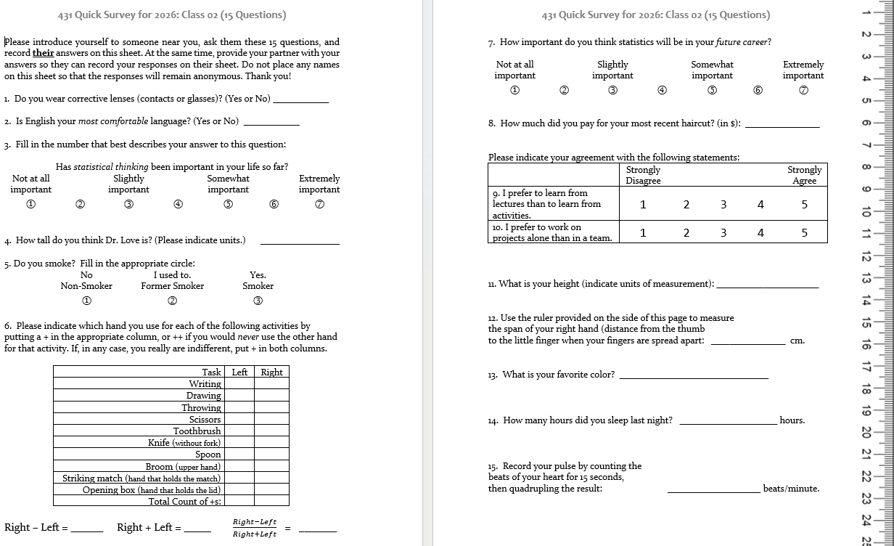

Types of Data
The key distinction we’ll make is between
- quantitative (numerical) and
- categorical (qualitative) information.
Information that is quantitative describes a quantity.
- All quantitative variables have units of measurement.
- Quantitative variables are recorded in numbers, and we use them as numbers (for instance, taking a mean of the variable makes some sense.)

Continuous vs. Discrete Quantities
Continuous variables (can take any value in a range) vs. Discrete variables (limited set of potential values)
- Is Height a continuous or a discrete variable?
- Height is certainly continuous as a concept, but how precise is our ruler?
- Piano vs. Violin

Quantitative Variable Subtypes
We can also distinguish interval (equal distance between values, but zero point is arbitrary) from ratio variables (meaningful zero point.)
- Is Weight an interval or ratio variable?
- How about IQ?

Qualitative (Categorical) Data
Qualitative variables consist of names of categories.
- Each possible value is a code for a category (could use numerical or non-numerical codes.)
  - Binary categorical variables (two categories, often labeled 1 or 0)
  - Multi-categorical variables (three or more categories)
- Can distinguish nominal (no underlying order) vs. ordinal (categories are ordered.)

Some Categorical Variables
- How is your overall health? (Excellent, Very Good, Good, Fair, Poor)
- Which candidate would you vote for if the election were held today?
- Did this patient receive this procedure?
- If you needed to analyze a small data set right away, which of the following software tools would you be comfortable using to accomplish that task?

Quantitative or categorical?
- Do you smoke? (1 = Non-, 2 = Former, 3 = Smoker)
- How much did you pay for your most recent haircut? (in $)
- What is your favorite color?
- How many hours did you sleep last night?
- Statistical thinking in your future career? (1 = Not at all to 7 = Extremely important)
- If quantitative…
  - are they discrete or continuous?
  - Do they have a meaningful zero point?
- If categorical…
  - How many categories?
  - Are the categories nominal or ordinal?

Importing and Tidying Data
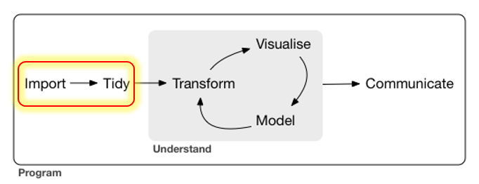

Ingesting the Quick Surveys
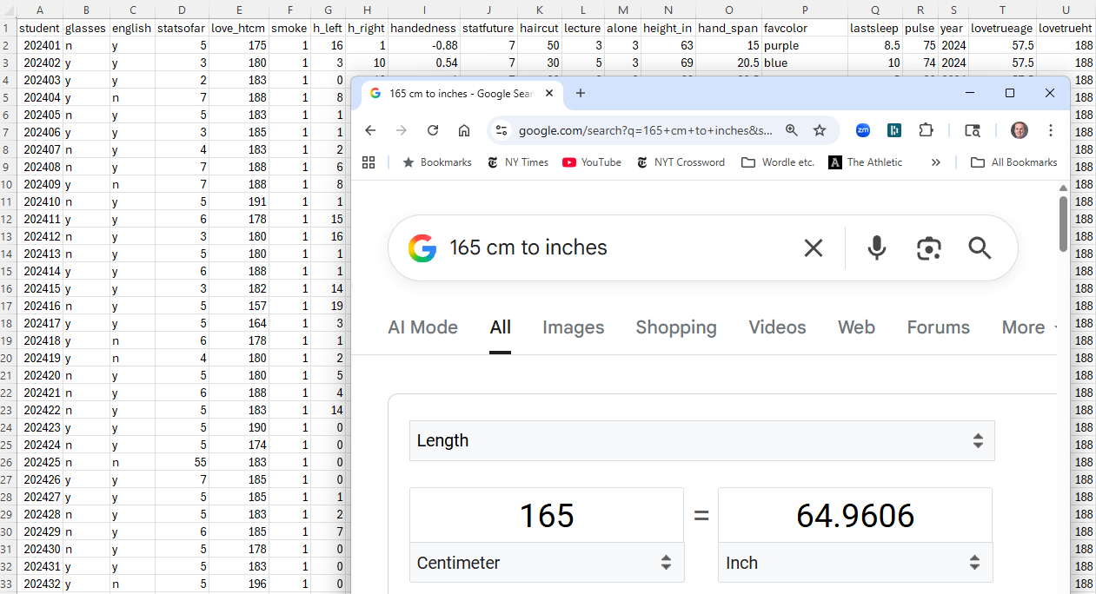

The Quick Survey
Since 2014, 656 students took (essentially) this survey.
Fall | 2025 | 2024 | 2023 | 2022 | 2021 | 2020
n | 53 | 56 | 53 | 54 | 58 | 67

Fall | 2019 | 2018 | 2017 | 2016 | 2015 | 2014 | Total
n | 61 | 51 | 48 | 64 | 49 | 42 | 656

Question
What percentage of those 656 surveys caused no problems in recording responses?

The 15 Survey Items
# | Topic | # | Topic
Q1 | glasses | Q9 | lectures_vs_activities
Q2 | english | Q10 | projects_alone
Q3 | stats_so_far | Q11 | height
Q4 | guess_TL_ht | Q12 | hand_span
Q5 | smoke | Q13 | color
Q6 | handedness | Q14 | sleep
Q7 | stats_future | Q15 | pulse_rate
Q8 | haircut | - | -
- At one time, I asked about sex rather than glasses.
- In prior years, people guessed my age, rather than height here.
- Sometimes, I’ve asked for a 30-second pulse check, then doubled.

Response to the Question I asked
What percentage of those 656 surveys caused no problems in recording responses?
- Let’s categorize your guesses…
  - Over 80% were OK (caused no problems)?
  - 61 to 80%?
  - 41 to 60%?
  - 0 to 40%?
- Actually …
  - 235/656 (36%) caused no problems.

Guess My Age
What should we do in these cases?

English best language?
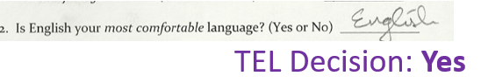
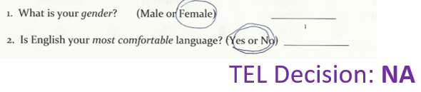
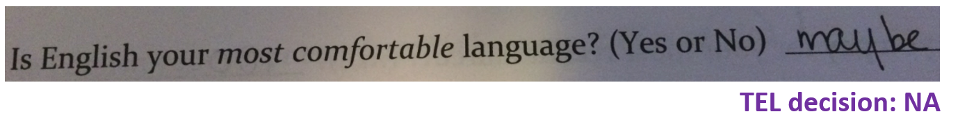

Height
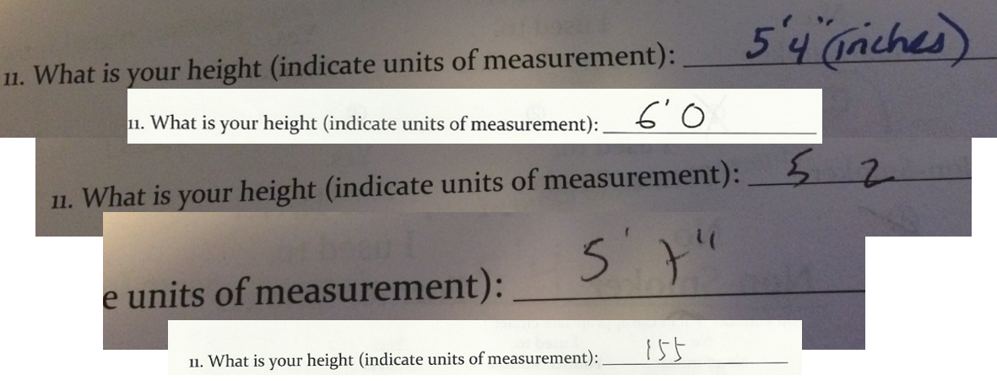

Handedness Scale (2016-21 version)
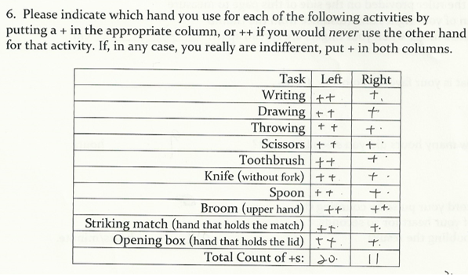

Favorite color
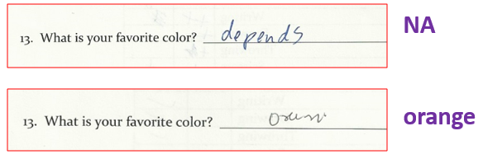
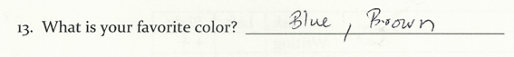
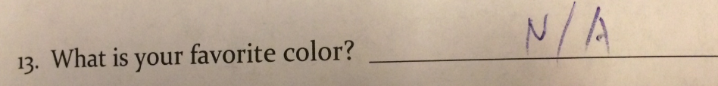

Following the Rules? (2019 version)
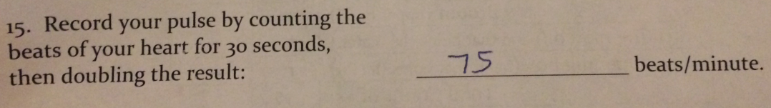

2019 pulse responses, sorted (n = 61, 1 NA)
33 46 48 56 60 60 3 | 3
62 63 65 65 66 66 4 | 68
68 68 68 69 70 70 5 | 6
70 70 70 70 70 70 6 | 002355668889
71 72 72 74 74 74 7 | 00000000122444445666888
74 74 75 76 76 76 8 | 000012445668
78 78 78 80 80 80 9 | 000046
80 81 82 84 84 85 10 | 44
86 86 88 90 90 90 11 | 0
90 94 96 104 104 110

Pulse Rates: 2014-2025
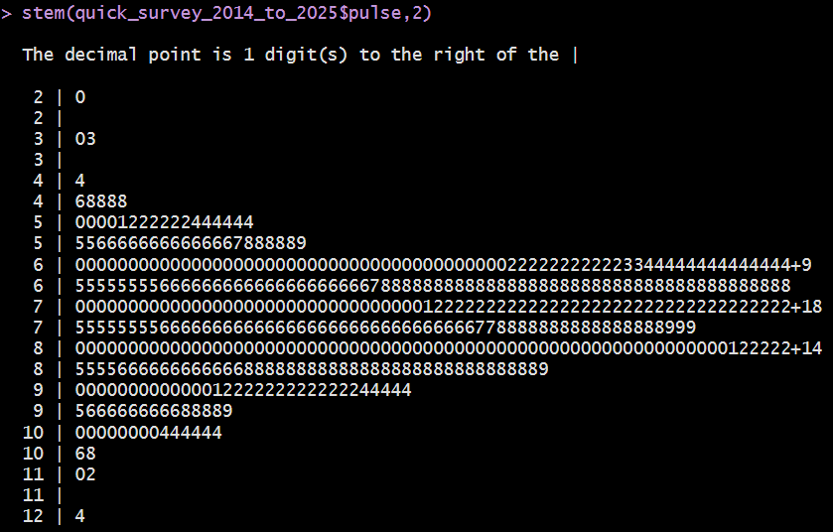
This stem-and-leaf display is thanks to John Tukey.

Garbage in, garbage out …
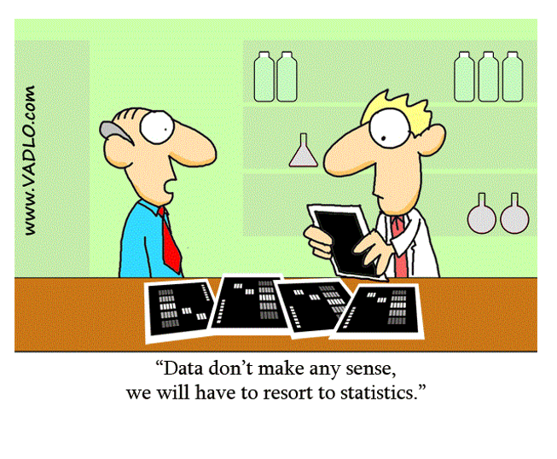
In Class 3, we’ll look at the data from today’s survey.

Group Age Guessing from Photos (9 groups in 2026, 10 Photos)

Photos 1-5
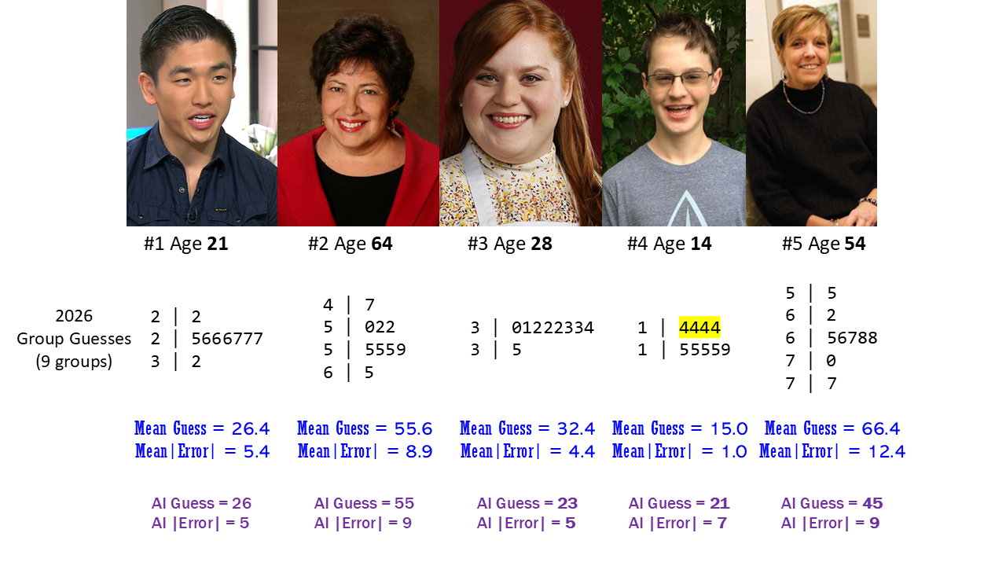

Photos 6-10
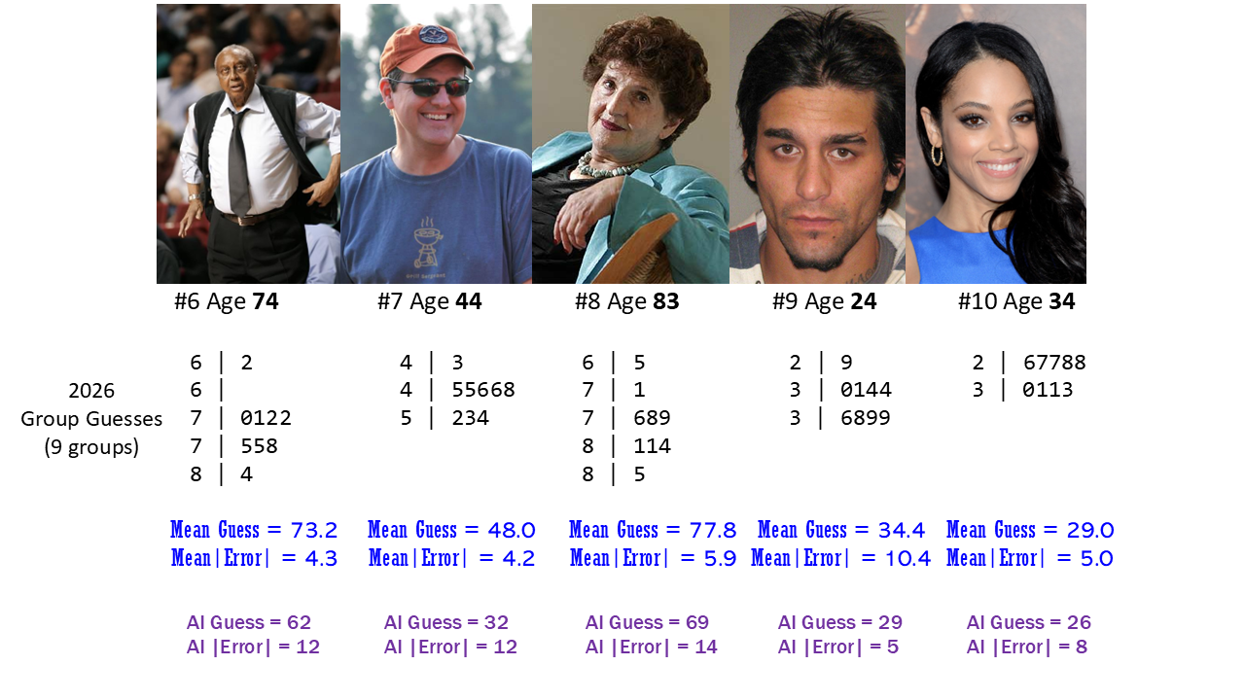

We had 9 groups in 2026
ANOVAs, Beavers, New Beginnings, Static Five, The Tom Tukeys, The Tropic of Answer, Tukey Time, We ♥ Cleveland, World Gators
Which group wins? How should we judge/measure this?
- Most correct guesses out of the 10 photos?
  - Only four groups had a correct guess, all on my son.
- Most guesses within 2 years? Maybe within 5 years?
- Most times beating the AI bot?
  - https://howolddoyoulook.com/ on 2025-08-21.

2026 Groups + AI: Ten Photos
2026 Group | Within 2 | Within 5 | Too Low | Correct | Too High | Beat AI
We ♥ Cleveland | 3 | 6 | 4 | 1 | 5 | 7
World Gators | 2 | 5 | 2 | 1 | 7 | 6
Beavers | 4 | 5 | 4 | 1 | 5 | 6
Static Five | 3 | 7 | 3 | 1 | 6 | 5
Tropic of Answer | 1 | 5 | 3 | 0 | 7 | 7
ANOVAs | 4 | 6 | 1 | 0 | 9 | 6
New Beginnings | 4 | 6 | 4 | 0 | 6 | 6
Tukey Time | 3 | 5 | 4 | 0 | 6 | 6
The Tom Tukeys | 3 | 4 | 4 | 0 | 6 | 5
AI (2025) | 0 | 3 | 7 | 0 | 3 | –

Consider the AI (2025) results
Subject | Photo | AI guess | True Age | Error
Chong | 1 | 26 | 21 | 5
Archuleta | 2 | 55 | 64 | -9
Mayfield | 3 | 23 | 28 | 5
…
Lawson | 10 | 26 | 34 | -8
Sum of AI errors = 5 + (-9) + (-5) + 7 + (-9) + (-12) + (-12) + (-14) + 5 + (-8) = -52
- Mean of AI errors across 10 photos is -5.2 years.
- Minimum AI error is -14 years, Maximum AI error is 7 years
- Median of the AI errors = -8.5 years.
- Standard Deviation of the AI errors = 7.9 years.

2026 Summaries Set 2
2026 Groups | Mean Error | SD (Err) | Median (Err) | (Min, Max) Err
We ♥ Cleveland | 1.4 | 7.4 | 0.5 | (-9, 15)
World Gators | 5.3 | 8.8 | 5 | (-7, 23)
Beavers | 1.6 | 7.9 | 1 | (-12, 14)
Static Five | 0.7 | 8.4 | 1.5 | (-18, 14)
Tropic of Answer | 2.7 | 7.6 | 4 | (-12, 15)
ANOVAs | 5.6 | 5.4 | 4.5 | (-1, 16)
New Beginnings | 0.3 | 7.7 | 1 | (-14, 14)
Tukey Time | 1.5 | 7 | 1 | (-9, 13)
The Tom Tukeys | -2.6 | 9 | 1 | (-17, 10)
AI (2025) | -5.2 | 7.9 | -8.5 | (-14, 7)

Summaries of Errors
- How helpful are the summaries on the previous slide?
- Should we be looking at |error| or maybe squared error?
AI errors were: 5, -9, -5, 7, -9, -12, -12, -14, 5, -8
- Sum of the AI errors is -52, and mean error is -5.2
- For AI, sum of the |errors| = 86, so mean absolute error (AE) = 8.6 years
- Sum of squared errors (SSE) is 834, so mean squared error is 83.4, whose square root (RMSE) = 9.13

Absolute and Squared Errors
Group | Mean AE | Range (AE) | Median AE | SSE | RMSE
We ♥ Cleveland | 5.6 | (0, 15) | 4 | 516 | 7.18
World Gators | 7.7 | (0, 23) | 6 | 979 | 9.89
Beavers | 6.0 | (0, 14) | 5 | 584 | 7.64
Static Five | 5.9 | (0, 18) | 5 | 645 | 8.03
Tropic of Answer | 6.5 | (1, 15) | 5.5 | 593 | 7.70
ANOVAs | 5.8 | (1, 16) | 4.5 | 574 | 7.58
New Beginnings | 5.7 | (1, 14) | 4.5 | 541 | 7.36
Tukey Time | 5.5 | (1, 13) | 5 | 463 | 6.80
The Tom Tukeys | 7.2 | (1, 17) | 7 | 796 | 8.92
AI (2025) | 8.6 | (5, 14) | 8.5 | 834 | 9.13

So now who wins?
Group | Mean AE | Range (AE) | Median AE | RMSE | Within 2 | Within 5 | Beat AI
We ♥ Cleveland | 5.6 | (0, 15) | 4 | 7.18 | 3 | 6 | 7
World Gators | 7.7 | (0, 23) | 6 | 9.89 | 2 | 5 | 6
Beavers | 6 | (0, 14) | 5 | 7.64 | 4 | 5 | 6
Static Five | 5.9 | (0, 18) | 5 | 8.03 | 3 | 7 | 5
Tropic of Answer | 6.5 | (1, 15) | 5.5 | 7.7 | 1 | 5 | 7
ANOVAs | 5.8 | (1, 16) | 4.5 | 7.58 | 3 | 6 | 6
New Beginnings | 5.7 | (1, 14) | 4.5 | 7.36 | 4 | 6 | 6
Tukey Time | 5.5 | (1, 13) | 5 | 6.80 | 3 | 5 | 6
The Tom Tukeys | 7.2 | (1, 17) | 7 | 8.92 | 3 | 4 | 5
AI (2025) | 8.6 | (5, 14) | 8.5 | 9.13 | 0 | 3 | –

Importing guesses from 2014-2026
photos <-
read_csv("c02/data/ten-photo-age-history-2026.csv",
show_col_types = F)
photos <- photos |>
mutate(label = fct_reorder(label, card))
head(photos)
# A tibble: 6 × 13
order card label age sex facing year mean_guess error abs_error sq_error
<dbl> <dbl> <fct> <dbl> <chr> <chr> <chr> <dbl> <dbl> <dbl> <dbl>
1 1 1 Chong 21 M R 2026 26.4 5.4 5.4 29.2
2 2 2 Arch… 64 F L 2026 56 -8 8 64
3 3 3 Mayf… 28 F L 2026 32.6 4.6 4.6 21.2
4 4 4 Love 14 M L 2026 14.5 0.5 0.5 0.25
5 5 5 McGi… 54 F R 2026 67 13 13 169
6 6 6 Chan… 74 M L 2026 73 -1 1 1
# ℹ 2 more variables: `detailed description` <chr>, jpeg <chr>

2014-2025 Errors vs. 2026
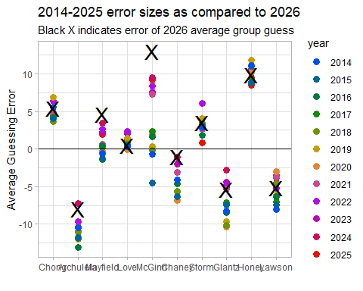

Standing Break When we return, we’ll explore a “built-in” R data set

R Console in RStudio
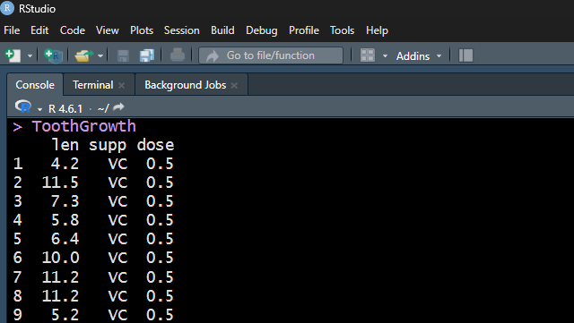

The ToothGrowth data
These data describe the length (len) of odontoblasts (cells responsible for tooth growth) in 60 guinea pigs.
- Each received one of three dose levels of vitamin C (0.5, 1 or 2 mg/day)
- delivered by either
  - supp = VC for asorbic acid, or
  - supp = OJ for orange juice
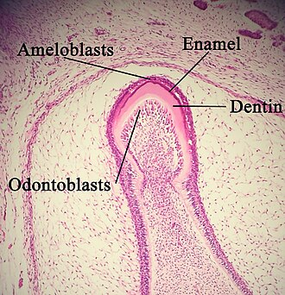
Photo: Wikipedia
I think the lengths are measured in micrometers (µm), also known as microns.

Show me the data…
ToothGrowth
len supp dose
1 4.2 VC 0.5
2 11.5 VC 0.5
3 7.3 VC 0.5
4 5.8 VC 0.5
5 6.4 VC 0.5
6 10.0 VC 0.5
7 11.2 VC 0.5
8 11.2 VC 0.5
9 5.2 VC 0.5
10 7.0 VC 0.5
11 16.5 VC 1.0
12 16.5 VC 1.0
13 15.2 VC 1.0
14 17.3 VC 1.0
15 22.5 VC 1.0
16 17.3 VC 1.0
17 13.6 VC 1.0
18 14.5 VC 1.0
19 18.8 VC 1.0
20 15.5 VC 1.0
21 23.6 VC 2.0
22 18.5 VC 2.0
23 33.9 VC 2.0
24 25.5 VC 2.0
25 26.4 VC 2.0
26 32.5 VC 2.0
27 26.7 VC 2.0
28 21.5 VC 2.0
29 23.3 VC 2.0
30 29.5 VC 2.0
31 15.2 OJ 0.5
32 21.5 OJ 0.5
33 17.6 OJ 0.5
34 9.7 OJ 0.5
35 14.5 OJ 0.5
36 10.0 OJ 0.5
37 8.2 OJ 0.5
38 9.4 OJ 0.5
39 16.5 OJ 0.5
40 9.7 OJ 0.5
41 19.7 OJ 1.0
42 23.3 OJ 1.0
43 23.6 OJ 1.0
44 26.4 OJ 1.0
45 20.0 OJ 1.0
46 25.2 OJ 1.0
47 25.8 OJ 1.0
48 21.2 OJ 1.0
49 14.5 OJ 1.0
50 27.3 OJ 1.0
51 25.5 OJ 2.0
52 26.4 OJ 2.0
53 22.4 OJ 2.0
54 24.5 OJ 2.0
55 24.8 OJ 2.0
56 30.9 OJ 2.0
57 26.4 OJ 2.0
58 27.3 OJ 2.0
59 29.4 OJ 2.0
60 23.0 OJ 2.0

We prefer tibbles to data frames
TG_new <- ToothGrowth |> as_tibble()
TG_new
# A tibble: 60 × 3
len supp dose
<dbl> <fct> <dbl>
1 4.2 VC 0.5
2 11.5 VC 0.5
3 7.3 VC 0.5
4 5.8 VC 0.5
5 6.4 VC 0.5
6 10 VC 0.5
7 11.2 VC 0.5
8 11.2 VC 0.5
9 5.2 VC 0.5
10 7 VC 0.5
# ℹ 50 more rows
- Since TG_new is a tibble, printing it shows the first 10 rows and its dimensions and variable types.

head() and tail() of the data
head(TG_new)
# A tibble: 6 × 3
len supp dose
<dbl> <fct> <dbl>
1 4.2 VC 0.5
2 11.5 VC 0.5
3 7.3 VC 0.5
4 5.8 VC 0.5
5 6.4 VC 0.5
6 10 VC 0.5
tail(TG_new)
# A tibble: 6 × 3
len supp dose
<dbl> <fct> <dbl>
1 24.8 OJ 2
2 30.9 OJ 2
3 26.4 OJ 2
4 27.3 OJ 2
5 29.4 OJ 2
6 23 OJ 2

Exploring the Data
summary(TG_new)
len supp dose
Min. : 4.20 OJ:30 Min. :0.500
1st Qu.:13.07 VC:30 1st Qu.:0.500
Median :19.25 Median :1.000
Mean :18.81 Mean :1.167
3rd Qu.:25.27 3rd Qu.:2.000
Max. :33.90 Max. :2.000
TG_new |> tabyl(supp, dose)
supp 0.5 1 2
OJ 10 10 10
VC 10 10 10
sort(TG_new$len)
[1] 4.2 5.2 5.8 6.4 7.0 7.3 8.2 9.4 9.7 9.7 10.0 10.0 11.2 11.2 11.5
[16] 13.6 14.5 14.5 14.5 15.2 15.2 15.5 16.5 16.5 16.5 17.3 17.3 17.6 18.5 18.8
[31] 19.7 20.0 21.2 21.5 21.5 22.4 22.5 23.0 23.3 23.3 23.6 23.6 24.5 24.8 25.2
[46] 25.5 25.5 25.8 26.4 26.4 26.4 26.4 26.7 27.3 27.3 29.4 29.5 30.9 32.5 33.9

Some of my favorite summaries
TG_new |> reframe(lovedist(len))
# A tibble: 1 × 10
n miss mean sd med mad min q25 q75 max
<int> <int> <dbl> <dbl> <dbl> <dbl> <dbl> <dbl> <dbl> <dbl>
1 60 0 18.8 7.65 19.2 9.04 4.2 13.1 25.3 33.9
- n = 60 observations,
- miss = 0, so no missing data
- mean = “average” (sum of values / number of values)
- med = median (middle value when data are sorted)

Some of my favorite summaries (2)
TG_new |> reframe(lovedist(len))
# A tibble: 1 × 10
n miss mean sd med mad min q25 q75 max
<int> <int> <dbl> <dbl> <dbl> <dbl> <dbl> <dbl> <dbl> <dbl>
1 60 0 18.8 7.65 19.2 9.04 4.2 13.1 25.3 33.9
Measures of Spread or variation:
- sd = standard deviation (formula in our book)
- mad = median absolute deviation (formula in our book)
- min, max = minimum and maximum value
- q25, q75 = 25th and 75th quantiles (percentiles)

Histogram of odontoblast lengths
ggplot(data = TG_new, aes(x = len)) +
geom_histogram()
`stat_bin()` using `bins = 30`. Pick better value `binwidth`.
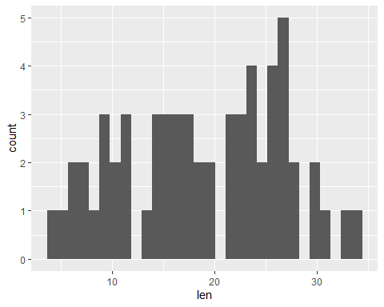

Version 2: set bin width and colors
ggplot(data = TG_new, aes(x = len)) +
geom_histogram(binwidth = 1, fill = "navy", col = "yellow")
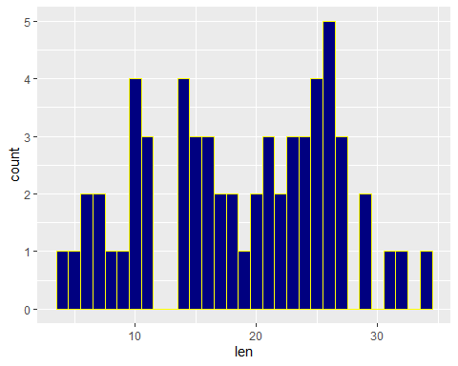

Version 3: try 10 bins, set labels
ggplot(data = TG_new, aes(x = len)) +
geom_histogram(bins = 10, fill = "navy", col = "yellow") +
labs(title = "Odontoblast lengths for 60 guinea pigs",
x = "Odontoblast length", y = "Number of animals")
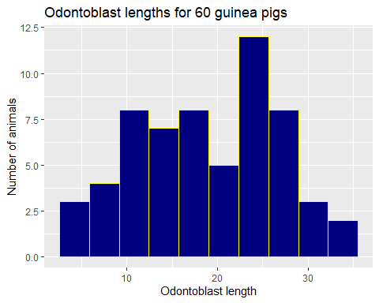

What to do about dose?
The guinea pigs were randomly allocated to receive one of three doses:
- 0.5 mg/day
- 1.0 mg/day
- 2.0 mg/day
with 20 animals at each dose.
- How can we picture the relationship between dose and odontoblast length (len)?

Plotting len by dose?
ggplot(TG_new, aes(x = dose, y = len)) +
geom_point()
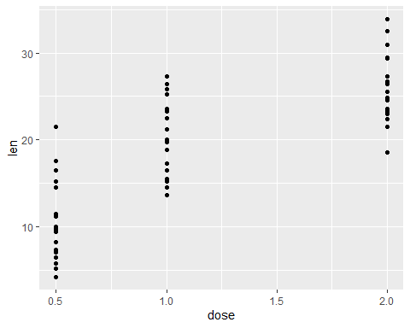

Treat dose as a categorical factor
ggplot(TG_new, aes(x = factor(dose), y = len)) +
geom_violin() +
geom_point()
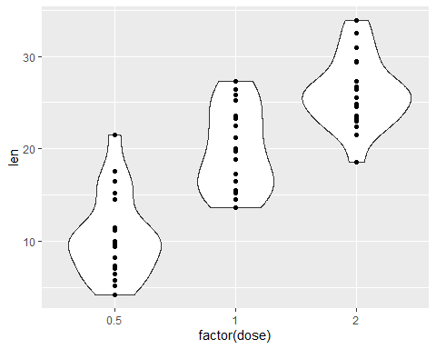

Add boxplots, sample means
ggplot(TG_new, aes(x = factor(dose), y = len)) +
geom_violin(fill = "skyblue") +
geom_boxplot(aes(width = 0.2)) +
stat_summary(fun = mean, geom = "point", size = 3, col = "red")
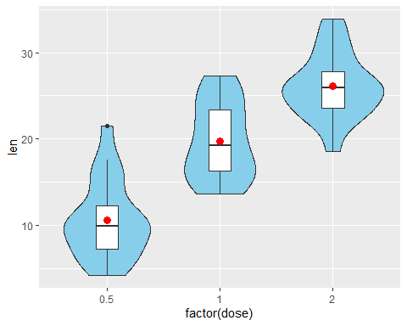

Numerical summary (len by dose)
TG_new <- TG_new |> mutate(dose_f = as_factor(dose))
TG_new |> reframe(lovedist(len), .by = dose_f)
# A tibble: 3 × 11
dose_f n miss mean sd med mad min q25 q75 max
<fct> <int> <int> <dbl> <dbl> <dbl> <dbl> <dbl> <dbl> <dbl> <dbl>
1 0.5 20 0 10.6 4.50 9.85 4.00 4.2 7.22 12.2 21.5
2 1 20 0 19.7 4.42 19.2 5.78 13.6 16.2 23.4 27.3
3 2 20 0 26.1 3.77 26.0 3.71 18.5 23.5 27.8 33.9
- When assessing the center of these distributions by dose, is it better to use a mean or a median?

What to do about supp?
The guinea pigs were also randomly allocated to receive either ascorbic acid (supp = VC) or orange juice (supp = OJ) so that we have 10 animals at each combination of one of the three doses and one of the two supps.
- How does the relationship we observed between dose and odontoblast length (len) change when we take into account the supp method?
One approach: show the same type of plot, but separated (faceted) by supp…

Impact of dose and supp?
Result of adding the facet_wrap() line shown on next slide…
ggplot(TG_new, aes(x = dose_f, y = len)) +
geom_violin(fill = "skyblue") +
geom_boxplot(aes(width = 0.2)) +
stat_summary(fun = mean, geom = "point", size = 3, col = "red") +
facet_wrap(~ supp, labeller = "label_both")
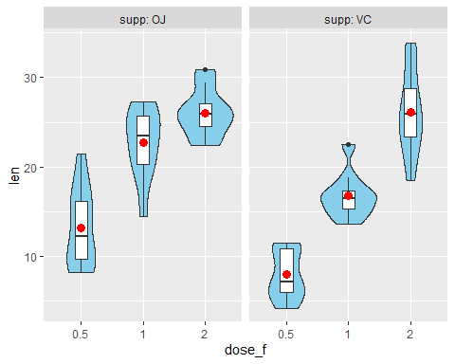

Summarizing len by dose and supp
TG_new |> group_by(dose_f, supp) |> reframe(lovedist(len))
# A tibble: 6 × 12
dose_f supp n miss mean sd med mad min q25 q75 max
<fct> <fct> <int> <int> <dbl> <dbl> <dbl> <dbl> <dbl> <dbl> <dbl> <dbl>
1 0.5 OJ 10 0 13.2 4.46 12.2 4.30 8.2 9.7 16.2 21.5
2 0.5 VC 10 0 7.98 2.75 7.15 3.56 4.2 5.95 10.9 11.5
3 1 OJ 10 0 22.7 3.91 23.5 3.93 14.5 20.3 25.6 27.3
4 1 VC 10 0 16.8 2.52 16.5 1.70 13.6 15.3 17.3 22.5
5 2 OJ 10 0 26.1 2.66 26.0 2.08 22.4 24.6 27.1 30.9
6 2 VC 10 0 26.1 4.80 26.0 4.60 18.5 23.4 28.8 33.9

Guesses from Class 1 of My Age (Twice)

From our 431-Data Page: A .csv file
love-age-guesses-2022-2026.csv is on our 431-data page.
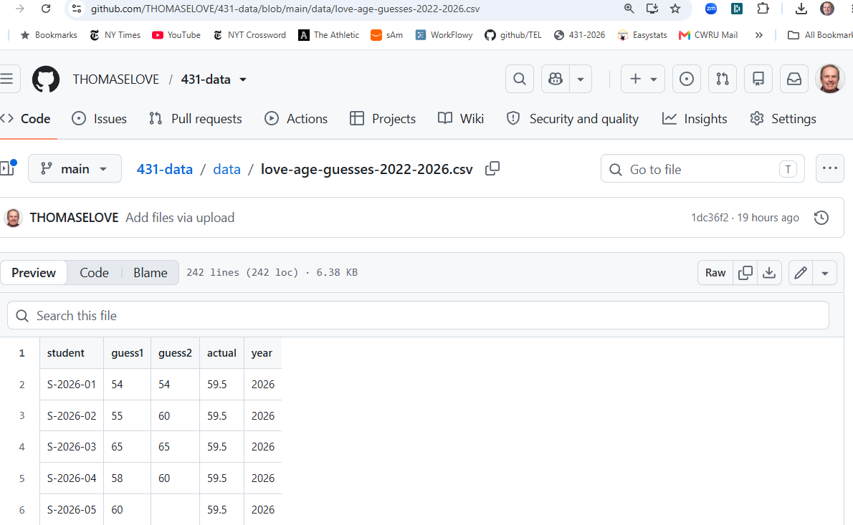

Creating the age_guess Tibble
Clicking on RAW in the 431-data presentation takes us to a (long) URL that contains the raw data in this sheet.
I’ll read in the sheet’s data to a new tibble (useful version of an R data frame) called age_guess using the read_csv() function.
url_age <-
"https://raw.githubusercontent.com/THOMASELOVE/431-data/refs/heads/main/data/love-age-guesses-2022-2026.csv"
age_guess <- read_csv(url_age, show_col_types = FALSE)

What have we created?
age_guess
# A tibble: 241 × 5
student guess1 guess2 actual year
<chr> <dbl> <dbl> <dbl> <dbl>
1 S-2026-01 54 54 59.5 2026
2 S-2026-02 55 60 59.5 2026
3 S-2026-03 65 65 59.5 2026
4 S-2026-04 58 60 59.5 2026
5 S-2026-05 60 NA 59.5 2026
6 S-2026-06 50 56 59.5 2026
7 S-2026-07 58 62 59.5 2026
8 S-2026-08 64 62 59.5 2026
9 S-2026-09 68 62 59.5 2026
10 S-2026-10 62 NA 59.5 2026
# ℹ 231 more rows
This is a tibble, so it prints first 10 rows, shows dimensions and variable types.

Numerical Summary
summary(age_guess)
student guess1 guess2 actual year
Length :241 Min. :40.00 Min. :40.00 Min. :55.50 Min. :2022
N.unique :241 1st Qu.:52.00 1st Qu.:55.00 1st Qu.:56.50 1st Qu.:2023
N.blank : 0 Median :56.00 Median :58.00 Median :57.50 Median :2024
Min.nchar: 9 Mean :56.05 Mean :57.58 Mean :57.46 Mean :2024
Max.nchar: 9 3rd Qu.:60.00 3rd Qu.:61.00 3rd Qu.:58.50 3rd Qu.:2025
Max. :72.00 Max. :70.00 Max. :59.50 Max. :2026
NAs :5
 Looking this over …
- Why is student summarized differently?
- What does NA's : 5 mean in guess2?
- Is this summary of year helpful?

Turning year into a factor
age_guess <- age_guess |> mutate(year = as.factor(year))
summary(age_guess)
student guess1 guess2 actual year
Length :241 Min. :40.00 Min. :40.00 Min. :55.50 2022:53
N.unique :241 1st Qu.:52.00 1st Qu.:55.00 1st Qu.:56.50 2023:39
N.blank : 0 Median :56.00 Median :58.00 Median :57.50 2024:56
Min.nchar: 9 Mean :56.05 Mean :57.58 Mean :57.46 2025:51
Max.nchar: 9 3rd Qu.:60.00 3rd Qu.:61.00 3rd Qu.:58.50 2026:42
Max. :72.00 Max. :70.00 Max. :59.50
NAs :5
 Looking this over …
- Was the average guess larger on guess 1 or 2?
- What was the range of first guesses? Second guesses?
- In what year do you think people guessed I was oldest?

In which year did I look oldest?
Create facets separating out each year’s guess1s…
ggplot(age_guess,
aes(x = guess1, fill = year)) +
geom_histogram(binwidth = 1, col = "white") +
scale_fill_metro_d(guide = "none") +
facet_grid(year ~ .) +
labs(
x = "First Guess of Dr. Love's Age",
y = "# of Students",
title = "Distribution of first guesses over the past five years",
subtitle = "Dr. Love's Actual Age = 55.5 in 2022, 59.5 in 2026")
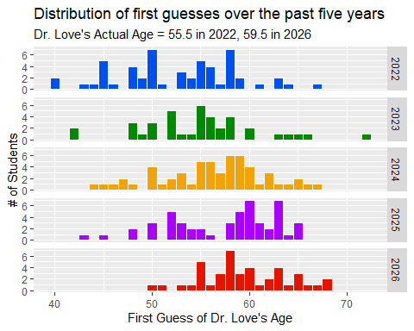

Same plot with binwidth doubled
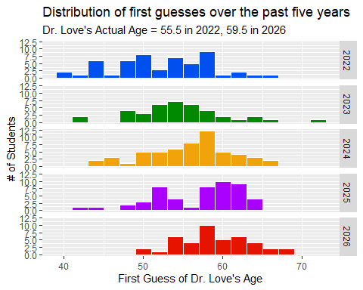

Comparison Boxplot (w/violins)
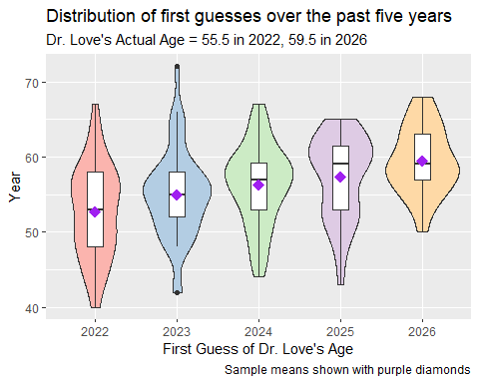

Histogram of Guess Changes
What will this look like?
age_guess <- age_guess |> mutate(change = guess2 - guess1)
ggplot(data = age_guess, aes(x = change)) +
geom_histogram(binwidth = 1, fill = "royalblue", col = "white") +
labs(x = "Change from first to second guess",
y = "Students in 431 for Fall 2022-2026",
title = "Most stayed close to their first guess.") +
theme_light()
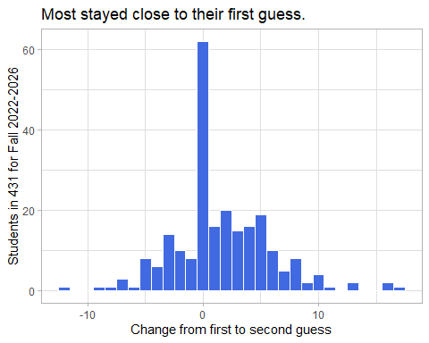

Guess 1 vs. Guess 2 Scatterplot
ggplot(data = age_guess, aes(x = guess1, y = guess2)) +
geom_point()
Warning: Removed 5 rows containing missing values or values outside the scale range
(`geom_point()`).
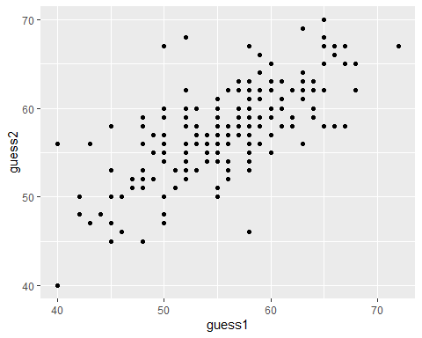

Filter to complete cases, and add loess smooth
temp <- age_guess |>
filter(complete.cases(guess1, guess2))
ggplot(data = temp, aes(x = guess1, y = guess2)) +
geom_point() +
geom_smooth(method = "loess", formula = y ~ x, col = "blue")
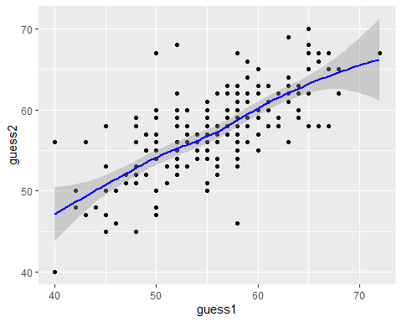

Remove range around smooth; add regression line
ggplot(data = temp, aes(x = guess1, y = guess2)) +
geom_point() +
geom_smooth(method = "loess", formula = y ~ x, se = FALSE, col = "blue") +
geom_smooth(method = "lm", formula = y ~ x, col = "red")
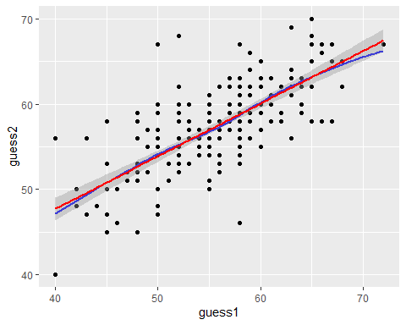

What is that regression line?
fit1 <- lm(guess2 ~ guess1, data = age_guess)
fit1
Call:
lm(formula = guess2 ~ guess1, data = age_guess)
Coefficients:
(Intercept) guess1
23.0136 0.6173
model_parameters(fit1)
Parameter | Coefficient | SE | 95% CI | t(234) | p
-------------------------------------------------------------------
(Intercept) | 23.01 | 2.20 | [18.67, 27.35] | 10.45 | < .001
guess1 | 0.62 | 0.04 | [ 0.54, 0.69] | 15.78 | < .001
Uncertainty intervals (equal-tailed) and p-values (two-tailed) computed
using a Wald t-distribution approximation.
By default, lm filters to complete cases.

Bayesian linear regression instead?
Here, we’ll use the default set of weakly informative priors for these coefficients, which will likely yield a model very similar to what lm produced.
set.seed(431)
fit2 <- stan_glm(guess2 ~ guess1, data = age_guess, refresh = 0)
model_parameters(fit2)
Parameter | Median | 95% CI | pd | Rhat | ESS (tail) | Prior
-------------------------------------------------------------------------------------------
(Intercept) | 23.02 | [18.80, 27.45] | 100% | 1.001 | 2668 | Normal (57.58 +- 12.87)
guess1 | 0.62 | [ 0.54, 0.69] | 100% | 1.001 | 2517 | Normal (0.00 +- 2.15)
Uncertainty intervals (equal-tailed) computed using a MCMC distribution
approximation.
Recall the lm model equation: guess2 = 23.01 + 0.62 guess1.

2026: 1st vs. 2nd Guesses
ggplot(data = temp |> filter(year == "2026"), aes(x = guess1, y = guess2)) +
geom_point() +
geom_smooth(method = "loess", formula = y ~ x, se = FALSE, col = "blue") +
geom_label(x = 51.5, y = 53.5, label = "loess smooth", col = "blue") +
geom_smooth(method = "lm", formula = y ~ x, se = FALSE, col = "red") +
geom_label(x = 52, y = 57.5, label = "lm fit", col = "red") +
geom_abline(intercept = 0, slope = 1, col = "black") +
geom_label(x = 53, y = 52, label = "y = x", col = "black") +
geom_vline(xintercept = 59.5, col = "slateblue", lty = "dashed") +
geom_label(x = 59.5, y = 54, label = "59.5", col = "slateblue") +
labs(x = "First Guess of Love's Age",
y = "Second Guess of Love's Age",
title = "Student Guesses of Dr. Love's Age in 2026",
subtitle = "Love's actual age = 59.5 in 2026")
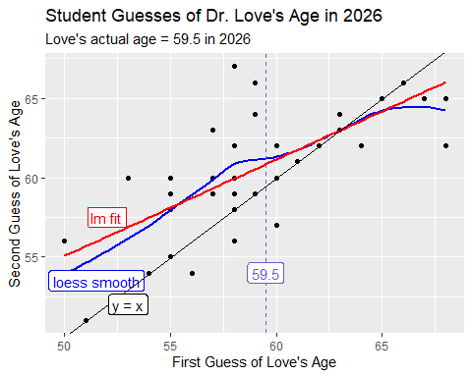
Here, I’ve added a black line to indicate y = x (guess is the same) and labeled the three superimposed “smooths.”

R Session Information
xfun::session_info()
R version 4.6.1 (2026-06-24 ucrt)
Platform: x86_64-w64-mingw32/x64
Running under: Windows 11 x64 (build 26200)
Locale:
LC_COLLATE=English_United States.utf8
LC_CTYPE=English_United States.utf8
LC_MONETARY=English_United States.utf8
LC_NUMERIC=C
LC_TIME=English_United States.utf8
Package version:
abind_1.4-8 askpass_1.2.1 backports_1.5.1
base64enc_0.1-6 bayesplot_1.15.0 bayestestR_0.18.1
BH_1.90.0.1 bit_4.6.0 bit64_4.8.2
blob_1.3.0 boot_1.3-32 broom_1.0.13
bslib_0.11.0 cachem_1.1.0 callr_3.8.0
cellranger_1.1.0 checkmate_2.3.4 cli_3.6.6
clipr_0.8.1 coda_0.19-4.1 codetools_0.2-20
colourpicker_1.3.0 commonmark_2.0.0 compiler_4.6.1
conflicted_1.2.0 correlation_0.8.8 cpp11_0.5.5
crayon_1.5.3 crosstalk_1.2.2 curl_7.1.0
data.table_1.18.4 datasets_4.6.1 datawizard_1.3.1
DBI_1.3.0 dbplyr_2.6.0 desc_1.4.3
digest_0.6.39 distributional_0.8.1 dplyr_1.2.1
DT_0.34.0 dtplyr_1.3.3 dygraphs_1.1.1.6
easystats_0.7.6 effectsize_1.0.3 emmeans_2.0.4
estimability_2.0.0 evaluate_1.0.5 farver_2.1.2
fastmap_1.2.0 fontawesome_0.5.3 forcats_1.0.1
fs_2.1.0 gargle_1.6.1 generics_0.1.4
ggplot2_4.0.3 ggridges_0.5.7 glue_1.8.1
googledrive_2.1.2 googlesheets4_1.1.2 graphics_4.6.1
grDevices_4.6.1 grid_4.6.1 gridExtra_2.3.1
gtable_0.3.6 gtools_3.9.5 haven_2.5.5
highr_0.12 hms_1.1.4 htmltools_0.5.9
htmlwidgets_1.6.4 httpuv_1.6.17 httr_1.4.8
ids_1.0.1 igraph_2.3.3 inline_0.3.21
insight_1.5.2 isoband_0.3.0 janitor_2.2.1
jquerylib_0.1.4 jsonlite_2.0.0 knitr_1.51
labeling_0.4.3 later_1.4.8 lattice_0.22-9
lazyeval_0.2.3 lifecycle_1.0.5 litedown_0.10
lme4_2.0-6 loo_2.10.1 lubridate_1.9.5
magrittr_2.0.5 markdown_2.0 MASS_7.3-66
Matrix_1.7-6 matrixStats_1.5.0 memoise_2.0.1
methods_4.6.1 mgcv_1.9-4 mime_0.13
miniUI_0.1.2 minqa_1.2.8 modelbased_0.16.0
modelr_0.1.11 multcomp_1.4-31 mvtnorm_1.4-2
nlme_3.1-170 nloptr_2.2.1 numDeriv_2016.8.1.1
openssl_2.4.2 otel_0.2.0 parallel_4.6.1
parameters_0.29.2 patchwork_1.3.2 performance_0.17.1
pillar_1.11.1 pkgbuild_1.4.8 pkgconfig_2.0.3
plyr_1.8.9 posterior_1.7.0 prettyunits_1.2.0
processx_3.9.0 progress_1.2.3 promises_1.5.0
ps_1.9.3 purrr_1.2.2 QuickJSR_1.10.0
R6_2.6.1 ragg_1.5.2 rappdirs_0.3.4
rbibutils_2.4.1 RColorBrewer_1.1-3 Rcpp_1.1.2
RcppEigen_0.3.4.0.2 RcppParallel_6.2.0 Rdpack_2.6.6
readr_2.2.0 readxl_1.5.0 reformulas_0.4.4
rematch_2.0.0 rematch2_2.1.2 report_0.6.4
reprex_2.1.1 reshape2_1.4.5 rlang_1.3.0
rmarkdown_2.31 rstan_2.32.7 rstanarm_2.32.2
rstantools_2.7.0 rstudioapi_0.19.0 rvest_1.0.5
S7_0.2.2 sandwich_3.1-2 sass_0.4.10
scales_1.4.0 see_0.14.1 selectr_0.6.0
shiny_1.14.0 shinyjs_2.1.1 shinystan_2.7.0
shinythemes_1.2.0 snakecase_0.11.1 sourcetools_0.1.7.2
splines_4.6.1 StanHeaders_2.32.10 stats_4.6.1
stats4_4.6.1 stringi_1.8.7 stringr_1.6.0
survival_3.8-9 sys_3.4.3 systemfonts_1.3.2
tensorA_0.36.2.1 textshaping_1.0.5 TH.data_1.1-5
threejs_0.3.4 tibble_3.3.1 tidyr_1.3.2
tidyselect_1.2.1 tidyverse_2.0.0 timechange_0.4.0
tinytex_0.60 tools_4.6.1 tzdb_0.5.0
utf8_1.2.6 utils_4.6.1 uuid_1.2.2
V8_8.2.0 vctrs_0.7.3 viridisLite_0.4.3
vroom_1.7.1 withr_3.0.3 xfun_0.60
xml2_1.6.0 xtable_1.8-8 xts_0.14.2
yaml_2.3.12 zoo_1.9-0

If you have no idea what I’m talking about, we’ll get there in a few weeks.

