432 Class 03

https://thomaselove.github.io/432-2024/

2024-01-23

## Today’s Agenda

Incorporating Survey Weights …

1. In estimating means and confidence intervals
2. In building linear regression models
3. Into a more detailed t-test approach using NHANES

Primary Source: <https://bookdown.org/rwnahhas/RMPH/survey-design.html>

## Today’s R Setup

knitr::opts_chunk$set(comment = NA)  
  
library(broom)  
library(janitor)

Attaching package: 'janitor'

The following objects are masked from 'package:stats':  
  
 chisq.test, fisher.test

library(gtsummary)  
library(gt)  
library(mosaic)

Registered S3 method overwritten by 'mosaic':  
 method from   
 fortify.SpatialPolygonsDataFrame ggplot2

The 'mosaic' package masks several functions from core packages in order to add   
additional features. The original behavior of these functions should not be affected by this.

Attaching package: 'mosaic'

The following objects are masked from 'package:dplyr':  
  
 count, do, tally

The following object is masked from 'package:Matrix':  
  
 mean

The following object is masked from 'package:ggplot2':  
  
 stat

The following objects are masked from 'package:stats':  
  
 binom.test, cor, cor.test, cov, fivenum, IQR, median, prop.test,  
 quantile, sd, t.test, var

The following objects are masked from 'package:base':  
  
 max, mean, min, prod, range, sample, sum

library(nhanesA) # data source  
library(survey) # survey-specific tools

Loading required package: grid

Loading required package: survival

Attaching package: 'survey'

The following object is masked from 'package:graphics':  
  
 dotchart

library(tidyverse)

── Attaching core tidyverse packages ──────────────────────── tidyverse 2.0.0 ──  
✔ forcats 1.0.0 ✔ stringr 1.5.1  
✔ lubridate 1.9.3 ✔ tibble 3.2.1  
✔ purrr 1.0.2 ✔ tidyr 1.3.0  
✔ readr 2.1.5

── Conflicts ────────────────────────────────────────── tidyverse_conflicts() ──  
✖ mosaic::count() masks dplyr::count()  
✖ purrr::cross() masks mosaic::cross()  
✖ mosaic::do() masks dplyr::do()  
✖ tidyr::expand() masks Matrix::expand()  
✖ dplyr::filter() masks stats::filter()  
✖ dplyr::lag() masks stats::lag()  
✖ tidyr::pack() masks Matrix::pack()  
✖ mosaic::stat() masks ggplot2::stat()  
✖ mosaic::tally() masks dplyr::tally()  
✖ tidyr::unpack() masks Matrix::unpack()  
ℹ Use the conflicted package (<http://conflicted.r-lib.org/>) to force all conflicts to become errors

theme_set(theme_bw())

# Incorporating survey weights (an introduction)

## What are survey weights?

In many surveys, each sampled subject is assigned a weight that is equivalent to the reciprocal of his/her probability of selection into the sample.

$$\text{Sample Subject’s Weight}=\frac{1}{Prob\left(selection\right)}$$

but more sophisticated sampling designs require more complex weighting schemes. Usually these are published as part of the survey data.

I’ll demonstrate part of the survey package today.

## An NHANES Example

Let’s use the NHANES 2013-14 data and pull in both the demographics (DEMO_H) and total cholesterol (TCHOL_H) databases.

demo_raw <- nhanes('DEMO_H', translated = FALSE)  
tchol_raw <- nhanes('TCHOL_H', translated = FALSE)

Detailed descriptions available at

* <https://wwwn.cdc.gov/Nchs/Nhanes/2013-2014/DEMO_H.htm>
* <https://wwwn.cdc.gov/Nchs/Nhanes/2013-2014/TCHOL_H.htm>

## Weighting in NHANES

Weights for each sampled person in NHANES account for the complex survey design. The weight describes the number of people in the population represented by the sampled person, and is created in three steps:

1. the base weight is computed, which accounts for the unequal probabilities of selection given that some demographic groups were over-sampled;
2. adjustments are made for non-response; and
3. post-stratification adjustments are made to match estimates of the U.S. civilian non-institutionalized population available from the Census Bureau.

Source: <https://wwwn.cdc.gov/nchs/nhanes/tutorials/Module3.aspx>

## Weights in our NHANES data

The DEMO file contains two kinds of sampling weights:

* the interview weight (WTINT2yr), and
* the MEC exam weight (WTMEC2yr)

NHANES also provides several weights for subsamples. In NHANES, we identify the variable of interest that was collected on the smallest number of respondents. The sample weight that applies to that variable is the appropriate one to use. In our first case, we will study total cholesterol and use the weights from the MEC exam.

## What Variables Do We Need?

* SEQN = subject identifying code
* RIAGENDR = sex (1 = M, 2 = F)
* RIDAGEYR = age (in years at screening, topcode at 80)
* DMQMILIZ = served active duty in US Armed Forces (yes/no)
* RIDSTATR = 2 if subject took both interview and MEC exam
* WTMEC2YR - Full sample 2 year MEC exam weight
* LBXTC = Total Cholesterol (mg/dl) - this is our outcome

The first 5 are in DEMO_H, and the first and last are in TCHOL_H.

## Merge the DEMO and TCHOL files

dim(demo_raw)

[1] 10175 47

dim(tchol_raw)

[1] 8291 3

joined_df <- inner_join(demo_raw, tchol_raw, by = c("SEQN"))  
  
dim(joined_df)

[1] 8291 49

## Create a small analytic tibble

nh1314 <- joined_df |> # has n = 8291  
 tibble() |>  
 filter(complete.cases(LBXTC)) |> # now n = 7624  
 filter(RIDSTATR == 2) |> # still 7624  
 filter(RIDAGEYR > 19 & RIDAGEYR < 40) |> # now n = 1802  
 filter(DMQMILIZ < 3) |> # drop 7 = refused, n = 1801  
 mutate(FEMALE = RIAGENDR - 1,  
 AGE = RIDAGEYR,  
 US_MIL = ifelse(DMQMILIZ == 1, 1, 0),  
 WT_EX = WTMEC2YR,  
 TOTCHOL = LBXTC) |>  
 select(SEQN, FEMALE, AGE, TOTCHOL, US_MIL, WT_EX)

## nh1314 analytic sample

nh1314 |> select(AGE, TOTCHOL, WT_EX) |> summary()

AGE TOTCHOL WT_EX   
 Min. :20.00 Min. : 69 Min. : 8430   
 1st Qu.:24.00 1st Qu.:156 1st Qu.: 24694   
 Median :30.00 Median :178 Median : 34642   
 Mean :29.47 Mean :181 Mean : 44529   
 3rd Qu.:34.00 3rd Qu.:203 3rd Qu.: 59561   
 Max. :39.00 Max. :417 Max. :125680

nh1314 |> tabyl(FEMALE, US_MIL) |>   
 adorn_totals(where = c("row", "col")) |> adorn_title()

US_MIL   
 FEMALE 0 1 Total  
 0 829 45 874  
 1 921 6 927  
 Total 1750 51 1801

## Formatting df_stats with gt()

df_stats(~ AGE + TOTCHOL, data = nh1314) |>  
 mutate(across(mean:sd, ~ round_half_up(.x, 2))) |>   
 gt() |> tab_options(table.font.size = 20) |>  
 tab_header(title = "Approach A",   
 subtitle = "Data from nh1314 sample, unadjusted")

Table 1: Approach A

Data from nh1314 sample, unadjusted

| response | min | Q1 | median | Q3 | max | mean | sd | n | missing |
| --- | --- | --- | --- | --- | --- | --- | --- | --- | --- |
| AGE | 20 | 24 | 30 | 34 | 39 | 29.47 | 5.80 | 1801 | 0 |
| TOTCHOL | 69 | 156 | 178 | 203 | 417 | 181.01 | 37.41 | 1801 | 0 |

## Formatting df_stats with gt()

df_stats(~ AGE + TOTCHOL, data = nh1314) |>  
 gt() |> fmt_number(columns = mean:sd, decimals = 2) |>  
 tab_options(table.font.size = 20) |>  
 tab_header(title = "Approach B",   
 subtitle = "Data from nh1314 sample, unadjusted")

Table 1: Approach B

Data from nh1314 sample, unadjusted

| response | min | Q1 | median | Q3 | max | mean | sd | n | missing |
| --- | --- | --- | --- | --- | --- | --- | --- | --- | --- |
| AGE | 20 | 24 | 30 | 34 | 39 | 29.47 | 5.80 | 1801 | 0 |
| TOTCHOL | 69 | 156 | 178 | 203 | 417 | 181.01 | 37.41 | 1801 | 0 |

## Our nh1314 analytic sample: Weights

Each weight represents the number of people exemplified by that subject.

favstats(~ WT_EX, data = nh1314) |>  
 rename(na = missing) |> gt() |>  
 tab_options(table.font.size = 20)

| min | Q1 | median | Q3 | max | mean | sd | n | na |
| --- | --- | --- | --- | --- | --- | --- | --- | --- |
| 8430.461 | 24694.05 | 34642.05 | 59560.74 | 125680.3 | 44528.66 | 26027.44 | 1801 | 0 |

## Using gtsummary() to describe nh1314 (unweighted)

table1 <- nh1314 |>  
 tbl_summary(include = -SEQN)  
  
table1

Table printed with `knitr::kable()`, not {gt}. Learn why at  
https://www.danieldsjoberg.com/gtsummary/articles/rmarkdown.html  
To suppress this message, include `message = FALSE` in the code chunk header.

| **Characteristic** | **N = 1,801** |
| --- | --- |
| FEMALE | 927 (51%) |
| AGE | 30.0 (24.0, 34.0) |
| TOTCHOL | 178 (156, 203) |
| US_MIL | 51 (2.8%) |
| WT_EX | 34,642 (24,694, 59,561) |

See <https://www.danieldsjoberg.com/gtsummary/> for more options.

## Create nh_design survey design

nh_design <-   
 svydesign(  
 id = ~ SEQN,  
 weights = ~ WT_EX,  
 data = nh1314)   
  
nh_design <- update( nh_design, one = 1)   
  
## this one = 1 business will help us count  
  
nh_design

Independent Sampling design (with replacement)  
update(nh_design, one = 1)

## Unweighted Counts

### Overall

sum(weights(nh_design, "sampling") != 0)

[1] 1801

### By Groups

svyby( ~ one, ~ FEMALE, nh_design, unwtd.count)

FEMALE counts se  
0 0 874 0  
1 1 927 0

svyby( ~ one, ~ FEMALE + US_MIL, nh_design, unwtd.count)

FEMALE US_MIL counts se  
0.0 0 0 829 0  
1.0 1 0 921 0  
0.1 0 1 45 0  
1.1 1 1 6 0

## Weighted Counts

svytotal( ~ one, nh_design )

total SE  
one 80196108 1104558

### By Groups

svyby( ~ one, ~ FEMALE, nh_design, svytotal)

FEMALE one se  
0 0 39694756 1255122  
1 1 40501352 1196260

svyby( ~ one, ~ FEMALE * US_MIL, nh_design, svytotal)

FEMALE US_MIL one se  
0.0 0 0 37185326.4 1225990.7  
1.0 1 0 40151728.1 1192408.4  
0.1 0 1 2509429.8 419477.5  
1.1 1 1 349624.1 157476.1

## Use survey design for weighted means

What is the mean of total cholesterol, overall and in groups?

svymean( ~ TOTCHOL, nh_design, na.rm = TRUE)

mean SE  
TOTCHOL 181.25 1.0172

svyby(~ TOTCHOL, ~ FEMALE, nh_design, svymean, na.rm = TRUE)

FEMALE TOTCHOL se  
0 0 182.6313 1.515072  
1 1 179.8881 1.359801

svyby(~ TOTCHOL, ~ FEMALE + US_MIL, nh_design, svymean, na.rm = TRUE)

FEMALE US_MIL TOTCHOL se  
0.0 0 0 182.3569 1.575994  
1.0 1 0 180.0248 1.368408  
0.1 0 1 186.6966 5.354835  
1.1 1 1 164.1984 6.535223

## Unweighted Summaries of TOTCHOL

favstats(~ TOTCHOL, data = nh1314) |>   
 mutate(se = sd / sqrt(n)) |>  
 gt() |> fmt_number(columns = c(mean, sd, se), decimals = 3) |>  
 tab_options(table.font.size = 20)

| min | Q1 | median | Q3 | max | mean | sd | n | missing | se |
| --- | --- | --- | --- | --- | --- | --- | --- | --- | --- |
| 69 | 156 | 178 | 203 | 417 | 181.012 | 37.408 | 1801 | 0 | 0.881 |

nh1314 |> group_by(FEMALE, US_MIL) |>  
 summarise(n = n(), mean = mean(TOTCHOL), se = sd(TOTCHOL)/sqrt(n))

`summarise()` has grouped output by 'FEMALE'. You can override using the  
`.groups` argument.

# A tibble: 4 × 5  
# Groups: FEMALE [2]  
 FEMALE US_MIL n mean se  
 <dbl> <dbl> <int> <dbl> <dbl>  
1 0 0 829 182. 1.33  
2 0 1 45 187. 5.47  
3 1 0 921 180. 1.21  
4 1 1 6 170. 7.87

## Survey-Weighted Measures of uncertainty

Mean of total cholesterol within groups with 90% CI?

grouped_result <- svyby(~ TOTCHOL, ~ FEMALE + US_MIL,   
 nh_design, svymean, na.rm = TRUE)  
coef(grouped_result)

0.0 1.0 0.1 1.1   
182.3569 180.0248 186.6966 164.1984

confint(grouped_result, level = 0.90)

5 % 95 %  
0.0 179.7646 184.9492  
1.0 177.7739 182.2756  
0.1 177.8887 195.5045  
1.1 153.4489 174.9478

* Get standard errors with se(grouped_result), too.

## Store estimated means in res

res <- tibble(  
 type = rep(c("Unweighted", "Survey-Weighted"),4),  
 female = c(rep("Female", 4), rep("Male", 4)),  
 us_mil = rep(c("Military", "Military", "Not Military", "Not Military"), 2),  
 MEAN = c(169.5, 164.1984, 179.71, 180.0248, 187.11, 186.6966, 182.22, 182.3569) )  
  
res |> gt()

| type | female | us_mil | MEAN |
| --- | --- | --- | --- |
| Unweighted | Female | Military | 169.5000 |
| Survey-Weighted | Female | Military | 164.1984 |
| Unweighted | Female | Not Military | 179.7100 |
| Survey-Weighted | Female | Not Military | 180.0248 |
| Unweighted | Male | Military | 187.1100 |
| Survey-Weighted | Male | Military | 186.6966 |
| Unweighted | Male | Not Military | 182.2200 |
| Survey-Weighted | Male | Not Military | 182.3569 |

## Estimated Means, plotted

ggplot(res, aes(x = female, y = MEAN, col = type)) +  
 geom_point(size = 4) +  
 facet_wrap(~ us_mil)

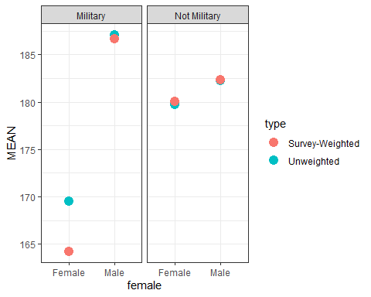

# Building Models and Survey Weights

## Modeling TOTCHOL in nh1314

First, we’ll ignore weighting, and fit a model with main effects of all three predictors (mod1), then a model (mod2) which incorporates an interaction of FEMALE and US_MIL.

mod1 <- lm(TOTCHOL ~ AGE + FEMALE + US_MIL, data = nh1314)  
  
mod2 <- lm(TOTCHOL ~ AGE + FEMALE * US_MIL, data = nh1314)

The interaction term means that the effect of FEMALE on TOTCHOL depends on the US_MIL status.

## mod1, unweighted

tidy(mod1, conf.int = TRUE, conf.level = 0.90) |>  
 select(-statistic) |> gt() |> tab_options(table.font.size = 20)

| term | estimate | std.error | p.value | conf.low | conf.high |
| --- | --- | --- | --- | --- | --- |
| (Intercept) | 136.345657 | 4.4915861 | 9.534649e-164 | 128.953845 | 143.7374695 |
| AGE | 1.571367 | 0.1474222 | 9.149426e-26 | 1.328754 | 1.8139805 |
| FEMALE | -3.312433 | 1.7274350 | 5.532719e-02 | -6.155276 | -0.4695898 |
| US_MIL | 2.003854 | 5.2026231 | 7.001628e-01 | -6.558113 | 10.5658215 |

glance(mod1) |> select(r2 = r.squared, adjr2 = adj.r.squared, AIC, BIC,  
 sigma, nobs, df) |> gt() |> tab_options(table.font.size = 20)

| r2 | adjr2 | AIC | BIC | sigma | nobs | df |
| --- | --- | --- | --- | --- | --- | --- |
| 0.06097646 | 0.0594088 | 18052.71 | 18080.19 | 36.27952 | 1801 | 3 |

## mod1 Residuals (plots 1, 2)

par(mfrow = c(1,2)); plot(mod1, which = c(1,2))

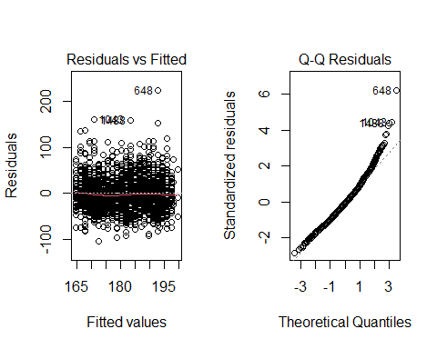

## mod1 Residuals (plots 3, 5)

par(mfrow = c(1,2)); plot(mod1, which = c(3,5))

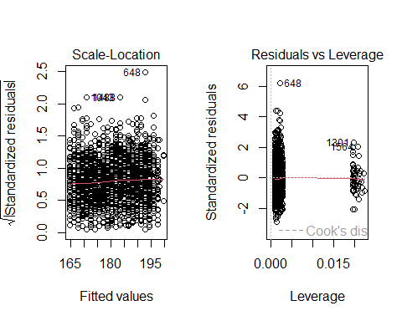

## mod2, unweighted

tidy(mod2, conf.int = TRUE, conf.level = 0.90) |>  
 select(-statistic) |> gt() |> tab_options(table.font.size = 20)

| term | estimate | std.error | p.value | conf.low | conf.high |
| --- | --- | --- | --- | --- | --- |
| (Intercept) | 136.299221 | 4.4922913 | 1.340759e-163 | 128.906246 | 143.6921962 |
| AGE | 1.570077 | 0.1474422 | 1.015235e-25 | 1.327431 | 1.8127229 |
| FEMALE | -3.151959 | 1.7380814 | 6.992615e-02 | -6.012324 | -0.2915943 |
| US_MIL | 3.639800 | 5.5547809 | 5.123873e-01 | -5.501717 | 12.7813170 |
| FEMALE:US_MIL | -13.342653 | 15.8650968 | 4.004561e-01 | -39.451882 | 12.7665766 |

glance(mod2) |>   
 select(r2 = r.squared, adjr2 = adj.r.squared, AIC, BIC, sigma,   
 nobs, df) |> gt() |> tab_options(table.font.size = 20)

| r2 | adjr2 | AIC | BIC | sigma | nobs | df |
| --- | --- | --- | --- | --- | --- | --- |
| 0.06134611 | 0.05925557 | 18054 | 18086.97 | 36.28248 | 1801 | 4 |

## mod2 Residuals (plots 1, 2)

par(mfrow = c(1,2)); plot(mod2, which = c(1,2))

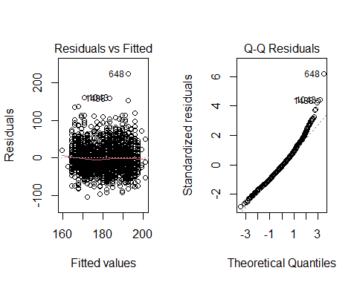

## mod2 Residuals (plots 3, 5)

par(mfrow = c(1,2)); plot(mod2, which = c(3,5))

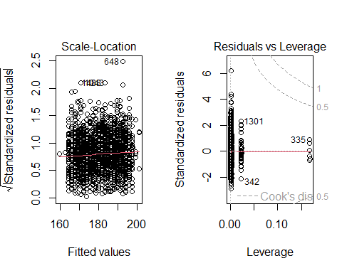

## Survey-weighted models via svyglm

Again, we’ll run two models, first without and second with an interaction term between FEMALE and US_MIL.

glm1_results <- svyglm(TOTCHOL ~ AGE + FEMALE + US_MIL,   
 nh_design, family = gaussian())

glm2_results <- svyglm(TOTCHOL ~ AGE + FEMALE * US_MIL,   
 nh_design, family = gaussian())

Gaussian family used to generate linear regressions here.

## Weighted Model 1

tidy(glm1_results, conf.int = TRUE, conf.level = 0.90) |>  
 select(-statistic) |> gt() |> tab_options(table.font.size = 20)

| term | estimate | std.error | p.value | conf.low | conf.high |
| --- | --- | --- | --- | --- | --- |
| (Intercept) | 137.1292664 | 5.0039123 | 1.906826e-138 | 128.894318 | 145.36421489 |
| AGE | 1.5646634 | 0.1696597 | 7.889576e-20 | 1.285454 | 1.84387266 |
| FEMALE | -3.2123089 | 2.0091506 | 1.100321e-01 | -6.518772 | 0.09415432 |
| US_MIL | 0.5935502 | 5.0392343 | 9.062506e-01 | -7.699528 | 8.88662816 |

glance(glm1_results) |> select(nobs, AIC, BIC, everything()) |>   
 gt() |> tab_options(table.font.size = 20)

| nobs | AIC | BIC | null.deviance | df.null | deviance | df.residual |
| --- | --- | --- | --- | --- | --- | --- |
| 1801 | 21.6033 | 2344965 | 2498023 | 1800 | 2344935 | 1797 |

## Weighted Model 2

tidy(glm2_results, conf.int = TRUE, conf.level = 0.90) |>  
 select(-statistic) |> gt() |> tab_options(table.font.size = 20)

| term | estimate | std.error | p.value | conf.low | conf.high |
| --- | --- | --- | --- | --- | --- |
| (Intercept) | 136.863878 | 5.0060799 | 6.872607e-138 | 128.625359 | 145.1023957 |
| AGE | 1.567633 | 0.1695865 | 6.517529e-20 | 1.288544 | 1.8467218 |
| FEMALE | -2.868135 | 2.0285450 | 1.575681e-01 | -6.206517 | 0.4702464 |
| US_MIL | 3.426681 | 5.4709976 | 5.311744e-01 | -5.576953 | 12.4303155 |
| FEMALE:US_MIL | -22.065349 | 8.5522325 | 9.956850e-03 | -36.139779 | -7.9909185 |

glance(glm2_results) |> select(nobs, AIC, BIC, everything()) |>  
 gt() |> tab_options(table.font.size = 20)

| nobs | AIC | BIC | null.deviance | df.null | deviance | df.residual |
| --- | --- | --- | --- | --- | --- | --- |
| 1801 | 22.19935 | 2341671 | 2498023 | 1800 | 2341633 | 1796 |

## Residuals for Model glm1_results

par(mfrow = c(1,2)); plot(glm1_results, which = c(1,2))

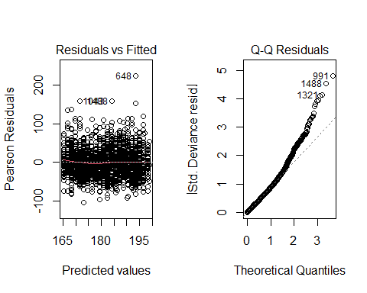

## Residuals for Model glm1_results

par(mfrow = c(1,2)); plot(glm1_results, which = c(3,5))

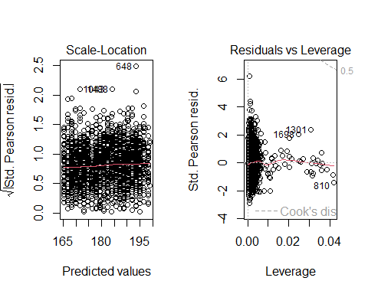

## Residuals for Model glm2_res

par(mfrow = c(1,2)); plot(glm2_results, which = c(1,2))

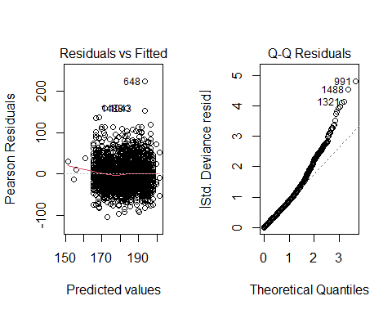

## Residuals for Model glm2_res

par(mfrow = c(1,2)); plot(glm2_results, which = c(3,5))

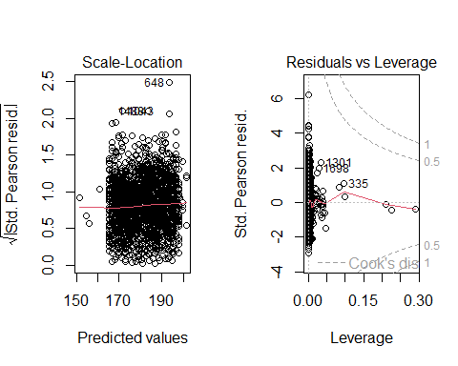

# A More Complete Weighted NHANES Analysis

## New Question, New Data

Key Source: <https://wwwn.cdc.gov/nchs/data/tutorials/DB303_Fig1_R.R>

Now, we are looking at the percentage of persons aged 20 and over with depression, by age and sex, in the US in 2013-2016. Pull in data using nhanesA…

DEMO_H <- nhanes('DEMO_H', translated = FALSE) |>   
 select(SEQN, RIAGENDR, RIDAGEYR, SDMVSTRA, SDMVPSU, WTMEC2YR)  
DEMO_I <- nhanes('DEMO_I', translated = FALSE) |>  
 select(SEQN, RIAGENDR, RIDAGEYR, SDMVSTRA, SDMVPSU, WTMEC2YR)  
DEMO <- bind_rows(DEMO_H, DEMO_I)   
DPQ_H <- nhanes('DPQ_H', translated = FALSE)   
DPQ_I <- nhanes('DPQ_I', translated = FALSE)   
DPQ <- bind_rows(DPQ_H, DPQ_I)

## Merge DEMO and DPQ files and create derived variables

dat2 <- left_join(DEMO, DPQ, by = "SEQN") |> tibble() |>  
 # Set 7=Refused and 9=Don't Know To NA   
 mutate(across(.cols = DPQ010:DPQ090,   
 ~ ifelse(. >=7, NA, .))) %>%  
 mutate(one = 1,  
 PHQ9_score = rowSums(select(. , DPQ010:DPQ090)),  
 Depression = ifelse(PHQ9_score >= 10, 100, 0),  
 Sex = factor(RIAGENDR, labels = c("M", "F")),  
 Age_group = cut(RIDAGEYR,   
 breaks = c(-Inf, 19, 39, 59, Inf),  
 labels = c("Under 20", "20-39", "40-59", "60+")),  
 WTMEC4YR = WTMEC2YR/2,  
 inAnalysis = (RIDAGEYR >= 20 & !is.na(PHQ9_score))) |>  
 select(-starts_with("DPQ"))

## Define Survey Design

Here’s the survey design for the overall data set:

NH_des_all <- svydesign(data = dat2, id = ~ SDMVPSU,   
 strata = ~ SDMVSTRA, weights = ~ WTMEC4YR, nest = TRUE)  
  
dim(NH_des_all)

[1] 20146 13

Here’s the survey design object for the subset of interest: adults aged 20 and over with a valid PHQ-9 depression score:

NH_des_dat2 <- NH_des_all |> subset(inAnalysis)  
  
dim(NH_des_dat2)

[1] 9942 13

## Define a function to call svymean and unweighted count

ourSummary <- function(varformula, byformula, design){  
 # Get mean, stderr, and unweighted sample size  
 c <- svyby(varformula, byformula, design, unwtd.count )   
 p <- svyby(varformula, byformula, design, svymean )   
 outSum <- left_join(select(c,-se), p)   
 outSum  
}

### Estimate overall prevalence of depression

ourSummary(~ Depression, ~ one, NH_des_dat2)

Joining with `by = join_by(one)`

one counts Depression se  
1 1 9942 8.056844 0.3599894

## Estimate prevalence of depression in various strata

## By sex  
ourSummary(~ Depression, ~ Sex, NH_des_dat2)

Joining with `by = join_by(Sex)`

Sex counts Depression se  
1 M 4821 5.549344 0.4293217  
2 F 5121 10.427654 0.5658239

## By age  
ourSummary(~ Depression, ~ Age_group, NH_des_dat2)

Joining with `by = join_by(Age_group)`

Age_group counts Depression se  
1 20-39 3328 7.744613 0.5236944  
2 40-59 3307 8.429826 0.6164284  
3 60+ 3307 7.971216 0.7797954

## Estimate prevalence of depression by Age and Sex

## By sex and age  
ourSummary(~ Depression, ~ Sex + Age_group, NH_des_dat2)

Joining with `by = join_by(Sex, Age_group)`

Sex Age_group counts Depression se  
1 M 20-39 1654 5.513778 0.6461045  
2 F 20-39 1674 10.050321 0.8036891  
3 M 40-59 1556 5.222060 0.7699895  
4 F 40-59 1751 11.477238 1.2011361  
5 M 60+ 1611 6.052782 0.8295114  
6 F 60+ 1696 9.579923 1.0534115

## Compare Prevalence between Male and Female

Across all age groups:

svyttest(Depression ~ Sex, NH_des_dat2)

Design-based t-test  
  
data: Depression ~ Sex  
t = 6.8246, df = 29, p-value = 1.706e-07  
alternative hypothesis: true difference in mean is not equal to 0  
95 percent confidence interval:  
 3.416354 6.340267  
sample estimates:  
difference in mean   
 4.87831

## Compare Prevalence between Male and Female

In people ages 40-59:

svyttest(Depression ~ Sex, subset(NH_des_dat2, Age_group == "40-59"))

Design-based t-test  
  
data: Depression ~ Sex  
t = 3.8688, df = 29, p-value = 0.0005706  
alternative hypothesis: true difference in mean is not equal to 0  
95 percent confidence interval:  
 2.948407 9.561949  
sample estimates:  
difference in mean   
 6.255178

## Differences by Age Group, among Adults

svyttest(Depression ~ Age_group, subset(NH_des_dat2,   
 Age_group=="20-39" | Age_group=="40-59"))

Design-based t-test  
  
data: Depression ~ Age_group  
t = 0.79398, df = 29, p-value = 0.4337  
alternative hypothesis: true difference in mean is not equal to 0  
95 percent confidence interval:  
 -1.079836 2.450262  
sample estimates:  
difference in mean   
 0.6852129

## Next Time?

* Linear Regression and ANOVA / ANCOVA models
* Incorporating Polynomials into our models

### Reminders

1. Please complete the **Minute Paper after Class 3** by noon tomorrow (Wednesday 2024-01-24)
2. Get started on **Lab 2**, due next Tuesday 2024-01-30 at Noon.
3. Continue reading **How To Be A Modern Scientist**