432 Class 14

Thomas E. Love, Ph.D.

2024-02-29

## Today’s Agenda

1. Discussion of Quiz 1
2. Introduction to Time-to-Event Data

* The Survival Function, S(t)
  + Kaplan-Meier Estimation of the Survival Function
  + Creating Survival Objects in R
  + Drawing a Survival Curve
  + Comparing Survival Curves with log-rank tests

## Today’s R Setup

knitr::opts_chunk$set(comment = NA)  
  
library(janitor)  
library(broom)  
library(gt)  
library(mosaic)  
library(rms)  
library(survival) ## new today  
library(survminer) ## new today  
library(tidyverse)  
  
theme_set(theme_bw())

# Introduction to Time-to-Event Data

## The **survex** Data Set

survex <- read_csv("c14/data/survex.csv",   
 show_col_types = FALSE) |>  
 type.convert(as.is = FALSE)  
  
head(survex)

# A tibble: 6 × 5  
 sub_id age grp study_yrs death  
 <int> <dbl> <fct> <dbl> <int>  
1 1 60.6 B 3.10 1  
2 2 42.1 B 1.57 0  
3 3 54.9 B 3.24 0  
4 4 55.8 B 12.5 0  
5 5 52.5 A 3.25 0  
6 6 46.1 B 2.84 0

## Working with Time to Event Data

In many medical studies, the main outcome variable is the time to the occurrence of a particular event.

* In a randomized controlled trial of cancer, for instance, surgery, radiation, and chemotherapy might be compared with respect to time from randomization and the start of therapy until death.

## Time-to-Event data

* In this case, the event of interest is the death of a patient, but in other situations it might be remission from a disease, relief from symptoms or the recurrence of a particular condition.
* Such observations are generally referred to by the generic term survival data even when the endpoint or event being considered is not death but something else.

## What’s in a Time-to-Event Study?

Survival analysis is concerned with prospective studies. We start with a cohort of patients and follow them forwards in time to determine some clinical outcome.

* Follow-up continues until either some event of interest occurs, the study ends, or further observation becomes impossible.

## Time-to-Event (Survival) Outcomes

The outcomes in a survival analysis consist of the patient’s **fate** and **length of follow-up** at the end of the study.

* For some patients, the outcome of interest may not occur during follow-up.
* For such patients, whose follow-up time is *censored*, we know only that this event did not occur while the patient was being followed. We do not know whether or not it will occur at some later time.

## Problems with Time to Event Data

The primary problems are *censoring* and *non-Normality*…

1. At the completion of the study, some patients may not have reached the endpoint of interest (death, relapse, etc.). Consequently, the exact survival times are not known.
   * All that is known is that the survival times are greater than the amount of time the individual has been in the study.
   * The survival times of these individuals are said to be **censored** (precisely, they are right-censored).

## Problems with Time to Event Data

The primary problems are *censoring* and *non-Normality*…

1. Survival data are not symmetrically distributed. They will often appear positively skewed, with a few people surviving a very long time compared with the majority; so assuming a normal distribution will not be reasonable.

Next, we’ll define some special functions to build models that address these concerns.

## The Survival Function, $S\left(t\right)$

The **survival function**, $S\left(t\right)$ (sometimes called the survivor function) is the probability that the survival time, $T$, is greater than or equal to a particular time, $t$.

* $S\left(t\right)$ = proportion of people surviving to time $t$ or beyond

## If there’s no censoring, the survival function is easy to estimate

When there is no censoring, this function is easily estimated.

$$\hat{S}\left(t\right)=\frac{\#\text{ of subjects with survival times }≥t}{n}$$

but this won’t work if there is censoring.

Even with censoring, the Kaplan-Meier approach essentially estimates the survival function by the number of patients alive at time $t$ divided by the total number of study subjects remaining at that time.

## Kaplan-Meier Estimator

The Kaplan-Meier estimator first orders the (unique) survival times from smallest to largest, then estimates the survival function at each unique survival time.

* The survival function at the second death time, $t_{\left(2\right)}$ is equal to the estimated probability of not dying at time $t_{\left(2\right)}$ conditional on the individual being still at risk at time $t_{\left(2\right)}$.

## Kaplan-Meier Estimator

1. Order the survival times from smallest to largest, where $t_{\left(j\right)}$ is the $j$ th largest unique survival time, so we have…

$$t_{\left(1\right)}≤t_{\left(2\right)}≤t_{\left(3\right)}≤...t_{\left(n\right)}$$

## Kaplan-Meier Estimator

1. The Kaplan-Meier estimate of the survival function is



where $r_{j}$ is the number of people at risk just before $t_{\left(j\right)}$, including those censored at time $t_{\left(j\right)}$, and $d_{j}$ is the number of people who experience the event at time $t_{\left(j\right)}$.

## Creating a Survival Object in R

The Surv function, part of the survival package in R, will create a **survival object** from two arguments:

1. time = follow-up time
2. event = a status indicator, where
   * event = 1 or TRUE means the event was observed (for instance, the patient died)
   * event = 0 or FALSE means the follow-up time was censored

## The survex data frame

The survex.csv file on our website is motivated by a similar file simulated by Frank Harrell and his team to introduce some of the key results from the cph function, which is part of the rms package in R.

The survex data includes 1,000 subjects…

## The survex data

* sub_id = patient ID (1-1000)
* age = patient’s age at study entry, years
* grp = patient’s group (A or B)
* study_yrs = patient’s years of observed time in study until death or censoring
* death = 1 if patient died, 0 if censored.

## A first example: with $n=100$

set.seed(4322020)   
ex100 <- sample_n(survex, 100, replace = F)  
ex100 |> select(sub_id, study_yrs, death) |> summary()

sub_id study_yrs death   
 Min. : 23.0 Min. : 0.175 Min. :0.00   
 1st Qu.:258.2 1st Qu.: 2.122 1st Qu.:0.00   
 Median :468.0 Median : 4.864 Median :0.00   
 Mean :479.1 Mean : 6.007 Mean :0.17   
 3rd Qu.:710.0 3rd Qu.: 9.759 3rd Qu.:0.00   
 Max. :938.0 Max. :14.817 Max. :1.00

For a moment, let’s focus on developing a survival object in this setting.

## Relationship between death and study_yrs?

* study_yrs here is follow-up time, in years
* death = 1 if subject had the event (death), 0 if not.

favstats(study_yrs ~ death, data = ex100) |>  
 gt() |> fmt_number(decimals = 2) |> tab_options(table.font.size = 24)

| death | min | Q1 | median | Q3 | max | mean | sd | n | missing |
| --- | --- | --- | --- | --- | --- | --- | --- | --- | --- |
| 0 | 0.17 | 2.48 | 5.27 | 10.23 | 14.82 | 6.37 | 4.46 | 83.00 | 0.00 |
| 1 | 0.64 | 1.85 | 2.64 | 4.82 | 13.75 | 4.21 | 3.78 | 17.00 | 0.00 |

## Building a Survival Object

surv_100 <- Surv(time = ex100$study_yrs, event = ex100$death)  
  
head(surv_100, 3)

[1] 3.047 9.454+ 4.023+

* Subject 1 survived 3.047 years and then died.
* Subject 2 survived 9.454 years before being censored.
* Subject 3 survived 4.023 years before being censored.

Remember that 17 of these 100 subjects died, the rest were censored at the latest time where they were seen for follow-up.

## On dealing with time-to-event data

You have these three subjects.

1. Alice died in the hospital after staying for 20 days.
2. Betty died at home on the 20th day after study enrollment, after staying in the hospital for the first ten days.
3. Carol left the hospital after 20 days, but was then lost to follow up.

## You plan a time-to-event analysis.

* How should you code “time” and “event” to produce a “time-to-event” object you can model if …
  + **death** is your primary outcome
  + **length of hospital stay** is your primary outcome?

## Building a Kaplan-Meier Estimate

Remember that surv_100 is the survival object we created.

km_100 <- survfit(surv_100 ~ 1)  
  
print(km_100, print.rmean = TRUE)

Call: survfit(formula = surv_100 ~ 1)  
  
 n events rmean* se(rmean) median 0.95LCL 0.95UCL  
[1,] 100 17 12.2 0.567 NA 13.7 NA  
 * restricted mean with upper limit = 14.8

* 17 events (deaths) occurred in 100 subjects.
* Restricted mean survival time is 12.16 years (upper limit 14.8?)
* Median survival time is NA (why?) but has a lower bound for 95% CI.

## Kaplan-Meier Estimate

summary(km_100)

Call: survfit(formula = surv_100 ~ 1)  
  
 time n.risk n.event survival std.err lower 95% CI upper 95% CI  
 0.641 95 1 0.989 0.0105 0.969 1.000  
 1.312 87 1 0.978 0.0153 0.949 1.000  
 1.690 82 1 0.966 0.0192 0.929 1.000  
 1.742 81 1 0.954 0.0224 0.911 0.999  
 1.846 80 1 0.942 0.0251 0.894 0.993  
 1.987 77 1 0.930 0.0276 0.878 0.986  
 2.190 74 1 0.918 0.0299 0.861 0.978  
 2.455 72 1 0.905 0.0321 0.844 0.970  
 2.641 71 1 0.892 0.0341 0.828 0.961  
 2.715 70 1 0.879 0.0359 0.812 0.953  
 3.047 65 1 0.866 0.0378 0.795 0.943  
 4.402 53 1 0.849 0.0405 0.774 0.933  
 4.815 51 1 0.833 0.0430 0.753 0.921  
 6.962 38 1 0.811 0.0471 0.724 0.909  
 7.302 36 1 0.788 0.0509 0.695 0.895  
 12.143 15 1 0.736 0.0695 0.611 0.885  
 13.746 6 1 0.613 0.1261 0.410 0.917

## Interpreting the K-M Estimate

* Up to 0.641 years, no one died, but five people were censored (so 95 were at risk at that time). (Estimated survival probability = 0.989)
* By the time of the next death at 1.312 years, only 87 people were still at risk. (Estimated Pr(survival) now 0.978)

Call: survfit(formula = surv_100 ~ 1)  
  
 time n.risk n.event survival std.err lower 95% CI upper 95% CI  
 0.641 95 1 0.989 0.0105 0.969 1.000  
 1.312 87 1 0.978 0.0153 0.949 1.000  
 1.690 82 1 0.966 0.0192 0.929 1.000  
etc.

## Kaplan-Meier Plot, via survminer

* The solid line indicates survival probability at each time point (in years.)
* The crosses indicate time points where censoring has occurred.
* The steps down indicate events (deaths.)
* The shading indicates (by default, 95%) pointwise confidence intervals.

ggsurvplot(km_100, data = ex100)

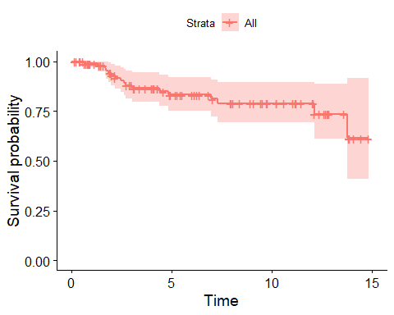

## Where We Are So Far

* Created a small (n = 100) simulated data frame, ex100.
* Observed 17 deaths, and 83 subjects censored before death.
* Survival object (containing time and fate) called surv_100
* Created Kaplan-Meier estimate of survival function, called km_100.
* Plotted the Kaplan-Meier estimate with ggsurvplot().

## Next steps

1. Add a number at risk table to our Kaplan-Meier curve.
2. Consider potential predictors (age and group) of our time-to-event outcome.

## Adding a Number at Risk Table

ggsurvplot(km_100, data = ex100,  
 conf.int = TRUE, # Add confidence interval  
 risk.table = TRUE, # Add risk table  
 xlab = "Time in years", # Adjust X axis label  
 break.time.by = 3 # X ticks every 3 years  
 )

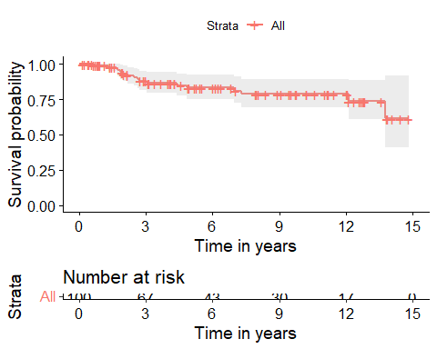

## Comparing Survival, by Group

Suppose we want to compare the survival functions for subjects classified by their group

* So, for instance, in our sample, 8 of 32 in group A and 9 of 68 in group B had the event (died).

ex100 |> tabyl(death, grp) |> adorn_totals()

death A B  
 0 24 59  
 1 8 9  
 Total 32 68

## Estimated Survival Function, by Group

km_100_grp <- survfit(surv_100 ~ ex100$grp)  
  
print(km_100_grp, print.rmean = TRUE)

Call: survfit(formula = surv_100 ~ ex100$grp)  
  
 n events rmean* se(rmean) median 0.95LCL 0.95UCL  
ex100$grp=A 32 8 10.2 1.325 NA 7.3 NA  
ex100$grp=B 68 9 13.0 0.561 NA 13.7 NA  
 * restricted mean with upper limit = 14.8

* 8 of 32 group A subjects died; estimated restricted mean survival time is 10.2 years.
* 9 of 68 in group B died, est. restricted mean survival = 13.0 years.

## Kaplan-Meier Survival Function Estimates, by Group

ggsurvplot(km_100_grp, data = ex100,  
 conf.int = TRUE,  
 xlab = "Time in years",  
 break.time.by = 3,  
 risk.table = TRUE,  
 risk.table.height = 0.25,   
 pval = TRUE)

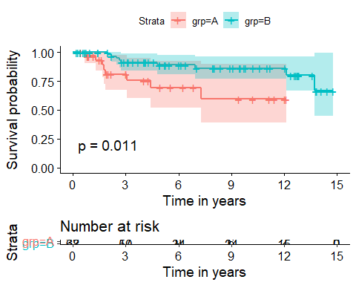

## Testing the difference between 2 survival curves

To obtain a significance test comparing these two survival curves, we turn to a log rank test, which tests the null hypothesis $H_{0}:S_{1}\left(t\right)=S_{2}\left(t\right)$ for all $t$ where the two exposures have survival functions $S_{1}\left(t\right)$ and $S_{2}\left(t\right)$.

survdiff(surv_100 ~ ex100$grp)

Call:  
survdiff(formula = surv_100 ~ ex100$grp)  
  
 N Observed Expected (O-E)^2/E (O-E)^2/V  
ex100$grp=A 32 8 3.75 4.81 6.39  
ex100$grp=B 68 9 13.25 1.36 6.39  
  
 Chisq= 6.4 on 1 degrees of freedom, p= 0.01

## Alternative log rank tests

An alternative is the *Peto and Peto modification of the Gehan-Wilcoxon test*, which results from adding rho=1 to the survdiff function (rho=0, the default, yields the log rank test.)

survdiff(surv_100 ~ ex100$grp, rho = 1)

Call:  
survdiff(formula = surv_100 ~ ex100$grp, rho = 1)  
  
 N Observed Expected (O-E)^2/E (O-E)^2/V  
ex100$grp=A 32 7.44 3.45 4.62 6.7  
ex100$grp=B 68 7.79 11.79 1.35 6.7  
  
 Chisq= 6.7 on 1 degrees of freedom, p= 0.01

## Alternative log rank tests

* As compared to the log rank test, this Peto-Peto modification (and others using rho > 0) give greater weight to the left hand (earlier) side of the survival curves.
* To obtain chi-square tests that give greater weight to the right hand (later) side of the survival curves than the log rank test, use rho < 0.

The log rank test generalizes to permit survival comparisons across more than two groups.

## A Highly Customized K-M Plot

ggsurvplot(km_100_grp,   
 data = ex100,   
 palette = c("red", "blue"),  
 risk.table = TRUE,   
 pval = TRUE,   
 conf.int = TRUE,   
 xlab = "Time in years",   
 break.time.by = 3,   
 ggtheme = theme_light(),  
 risk.table.y.text.col = T,  
 risk.table.height = 0.25,   
 risk.table.y.text = FALSE,  
 ncensor.plot = TRUE,  
 ncensor.plot.height = 0.25,  
 conf.int.style = "step",  
 surv.median.line = "hv")

Warning in .add_surv_median(p, fit, type = surv.median.line, fun = fun, :  
Median survival not reached.

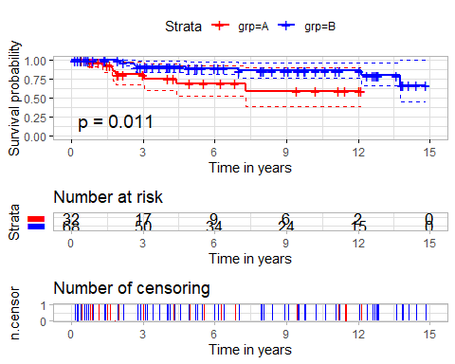

## Customizing the K-M Plot Further

See <https://rpkgs.datanovia.com/survminer/> or <https://github.com/kassambara/survminer/> for many more options.

Also, consider [this YouTube Video from Frank Harrell](https://www.youtube.com/watch?v=EoIB_Obddrk) entitled “[Survival Curves: Showing More by Showing Less](https://www.youtube.com/watch?v=EoIB_Obddrk)” which highlights the value of interactive approaches.

## Comparing Survival Functions, by group, n = 1000

surv_obj2 <- Surv(time = survex$study_yrs,   
 event = survex$death)  
  
km_grp2 <- survfit(surv_obj2 ~ survex$grp)  
  
survdiff(surv_obj2 ~ survex$grp)

Call:  
survdiff(formula = surv_obj2 ~ survex$grp)  
  
 N Observed Expected (O-E)^2/E (O-E)^2/V  
survex$grp=A 380 90 62.7 11.85 18.1  
survex$grp=B 620 93 120.3 6.18 18.1  
  
 Chisq= 18.1 on 1 degrees of freedom, p= 2e-05

## Kaplan-Meier Plot of Survival, by Group (n = 1000)

ggsurvplot(km_grp2, data = survex,  
 conf.int = TRUE,  
 pval = TRUE,  
 xlab = "Time in years",  
 break.time.by = 2,  
 risk.table = TRUE,  
 risk.table.height = 0.25)

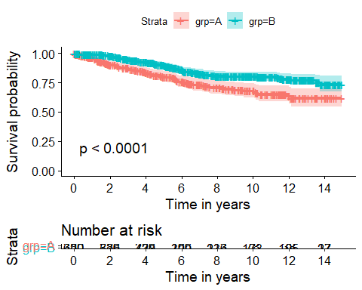

## Kaplan-Meier Plot of Survival Percentage, Instead?

Just add fun = "pct" to the plot.

ggsurvplot(km_grp2, data = survex, fun = "pct",  
 conf.int = TRUE,  
 pval = TRUE,  
 xlab = "Time in years",  
 break.time.by = 2,  
 risk.table = TRUE,  
 risk.table.height = 0.25)

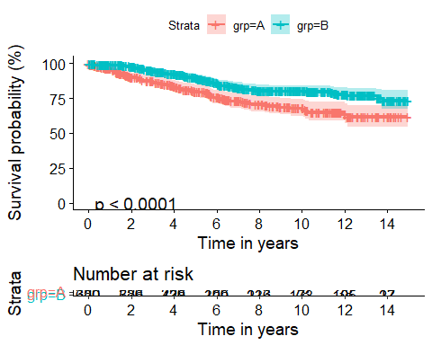

## Plot Cumulative Event Rate

Let’s look at our original km_100 model for 100 observations.

* Add fun = "event" to our ggsurvplot.

ggsurvplot(km_100, data = survex, fun = "event",  
 xlab = "Time in years",  
 break.time.by = 2,  
 risk.table = TRUE,  
 risk.table.height = 0.25)

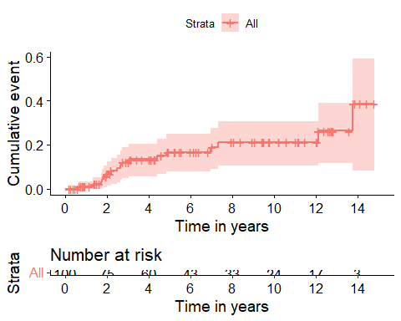

## Cumulative Event Rate for km_grp2 model

Let’s look at our model for 1000 observations, that includes grp:

ggsurvplot(km_grp2, data = survex, fun = "event",  
 xlab = "Time in years",  
 break.time.by = 2,  
 risk.table = TRUE,  
 risk.table.height = 0.25)

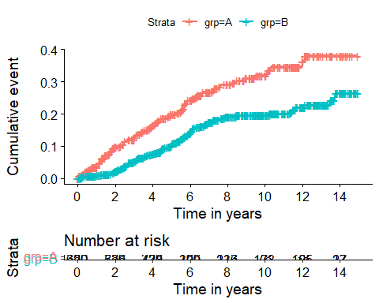

## More to come on Time-to-Event Data

after spring break…

Next week, we’ll start to tackle regression on count outcomes.