432 Class 22

Thomas E. Love, Ph.D.

2024-04-04

## Today’s Topic

**Cox models for time-to-event data**

* Returning to the breast cancer trial
* Using cph from rms to fit a Cox model

This material is discussed in Chapters 29-31 of our Course Notes

**Replicable Research and the Crisis in Science**

* Some reminders from the ASA’s 2019 Statement on Statistical Inference in the 21st Century

## Setup

knitr::opts_chunk$set(comment=NA)  
options(width = 80)  
  
library(janitor)

Attaching package: 'janitor'

The following objects are masked from 'package:stats':  
  
 chisq.test, fisher.test

library(broom)  
library(gt)  
library(rms)

Loading required package: Hmisc

Attaching package: 'Hmisc'

The following object is masked from 'package:gt':  
  
 html

The following objects are masked from 'package:base':  
  
 format.pval, units

library(survival)  
library(survminer)

Loading required package: ggplot2

Loading required package: ggpubr

Attaching package: 'survminer'

The following object is masked from 'package:survival':  
  
 myeloma

library(tidyverse)

── Attaching core tidyverse packages ──────────────────────── tidyverse 2.0.0 ──  
✔ dplyr 1.1.4 ✔ readr 2.1.5  
✔ forcats 1.0.0 ✔ stringr 1.5.1  
✔ lubridate 1.9.3 ✔ tibble 3.2.1  
✔ purrr 1.0.2 ✔ tidyr 1.3.0

── Conflicts ────────────────────────────────────────── tidyverse_conflicts() ──  
✖ dplyr::filter() masks stats::filter()  
✖ dplyr::lag() masks stats::lag()  
✖ dplyr::src() masks Hmisc::src()  
✖ dplyr::summarize() masks Hmisc::summarize()  
ℹ Use the conflicted package (<http://conflicted.r-lib.org/>) to force all conflicts to become errors

theme_set(theme_bw())

## Our breast cancer data

brca <- read_csv("c22/data/brca.csv", show_col_types = FALSE) |>   
 mutate(across(where(is_character), as_factor),  
 subject = as.character(subject))  
  
head(brca)

# A tibble: 6 × 5  
 subject treat trial_weeks last_alive age  
 <chr> <fct> <dbl> <dbl> <dbl>  
1 A01 S_CT 102 0 55  
2 A02 S_IT 192 0 62  
3 A03 S_Both 73 0 72  
4 A04 S_CT 58 1 48  
5 A05 S_CT 48 1 26  
6 A06 S_IT 182 1 52

## Recap of Class 21

Data from a trial of three treatments for breast cancer

* brca tibble with treat = S_CT, S_IT, S_Both and age at baseline
* Time to event data are gathered in trial_weeks and last_alive which we used to create a survival object S.
* Created Kaplan-Meier estimate, kmfit to compare the treat results
* Then built a Cox model for treatment, called mod_T.

## What Will We Do Now?

* incorporate the covariate (age) into the model
* use cph from the rms package to fit a Cox model that incorporates some non-linearity

## Create survival object

* trial_weeks: time in the study, in weeks, to death or censoring
* last_alive: 1 if alive at last follow-up (and thus censored), 0 if dead

So last_alive = 0 if the event (death) occurs.

brca$S <- with(brca, Surv(trial_weeks, last_alive == 0))  
  
head(brca$S)

[1] 102 192 73 58+ 48+ 182+

## Fit Cox Model mod_T: Treatment alone

mod_T <- coxph(S ~ treat, data = brca)  
mod_T

Call:  
coxph(formula = S ~ treat, data = brca)  
  
 coef exp(coef) se(coef) z p  
treatS_IT -0.5832 0.5581 0.6088 -0.958 0.338  
treatS_Both -0.8313 0.4355 0.6547 -1.270 0.204  
  
Likelihood ratio test=1.75 on 2 df, p=0.4164  
n= 31, number of events= 15

## Fit Cox Model mod_AT: Age + Treatment

mod_AT <- coxph(S ~ age + treat, data = brca)  
mod_AT

Call:  
coxph(formula = S ~ age + treat, data = brca)  
  
 coef exp(coef) se(coef) z p  
age 0.07807 1.08119 0.03672 2.126 0.0335  
treatS_IT -0.31161 0.73227 0.60936 -0.511 0.6091  
treatS_Both -0.59960 0.54903 0.65741 -0.912 0.3617  
  
Likelihood ratio test=6.99 on 3 df, p=0.07224  
n= 31, number of events= 15

## Coefficients of mod_AT

tidy(mod_AT, exponentiate = TRUE, conf.int = TRUE) |>  
 select(term, estimate, std.error, conf.low, conf.high) |>  
 gt() |> fmt_number(decimals = 3) |> tab_options(table.font.size = 20)

| term | estimate | std.error | conf.low | conf.high |
| --- | --- | --- | --- | --- |
| age | 1.081 | 0.037 | 1.006 | 1.162 |
| treatS_IT | 0.732 | 0.609 | 0.222 | 2.417 |
| treatS_Both | 0.549 | 0.657 | 0.151 | 1.992 |

* If Harry and Sally receive the same treat but Harry is one year older, the model estimates Harry will have 1.08 times the hazard of Sally (95% CI 1.01, 1.16).

## Coefficients of mod_AT

tidy(mod_AT, exponentiate = TRUE, conf.int = TRUE) |>  
 select(term, estimate, std.error, conf.low, conf.high) |>  
 gt() |> fmt_number(decimals = 3) |> tab_options(table.font.size = 20)

| term | estimate | std.error | conf.low | conf.high |
| --- | --- | --- | --- | --- |
| age | 1.081 | 0.037 | 1.006 | 1.162 |
| treatS_IT | 0.732 | 0.609 | 0.222 | 2.417 |
| treatS_Both | 0.549 | 0.657 | 0.151 | 1.992 |

* If Cyrus receives S_IT and Sally receives S_CT, and they are the same age, the model estimates Cyrus will have 0.73 times the hazard of Sally (95% CI 0.22, 2.41).
* If Barry receives S_Both and Sally receives S_CT, and they are the same age, the model estimates Barry will have 0.55 times the hazard of Sally (95% CI 0.15, 1.99).

## Comparing the Two Models

n = 31, nevent = 15 for each model.

bind_rows(glance(mod_T), glance(mod_AT)) |>  
 mutate(model = c("mod_T", "mod_AT")) |>  
 select(model, p.value.log, concordance, r.squared,   
 max_r2 = r.squared.max, AIC, BIC) |>   
 gt() |> fmt_number(decimals = 3) |> tab_options(table.font.size = 20)

| model | p.value.log | concordance | r.squared | max_r2 | AIC | BIC |
| --- | --- | --- | --- | --- | --- | --- |
| mod_T | 0.416 | 0.577 | 0.055 | 0.944 | 91.773 | 93.189 |
| mod_AT | 0.072 | 0.701 | 0.202 | 0.944 | 88.536 | 90.660 |

What do the glance results indicate?

## Likelihood Ratio ANOVA

Comparing the mod_AT model with age and treatment to the mod_T model with treatment alone…

anova(mod_AT, mod_T)

Analysis of Deviance Table  
 Cox model: response is S  
 Model 1: ~ age + treat  
 Model 2: ~ treat  
 loglik Chisq Df Pr(>|Chi|)   
1 -41.268   
2 -43.886 5.237 1 0.02211 *  
---  
Signif. codes: 0 '***' 0.001 '**' 0.01 '*' 0.05 '.' 0.1 ' ' 1

What does this suggest? Does this match with what AIC and BIC suggested?

## Graphical PH Check for mod_AT

ggcoxzph(cox.zph(mod_AT))

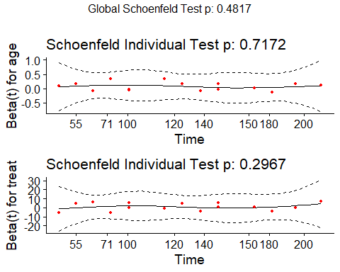

# Using cph from the rms package

## Using rms::cph to fit a fancier AxT

brca <- read_csv("c22/data/brca.csv", show_col_types = FALSE) |>   
 mutate(across(where(is_character), as_factor),  
 subject = as.character(subject)) # reload without S  
  
d <- datadist(brca)  
options(datadist="d")  
  
brca$S <- with(brca, Surv(trial_weeks, last_alive == 0))  
  
cph_AxT <- cph(S ~ rcs(age, 4) + treat + age %ia% treat,   
 data = brca,   
 x = TRUE, y = TRUE, surv = TRUE)

## cph_AxT results

cph_AxT

Cox Proportional Hazards Model  
  
cph(formula = S ~ rcs(age, 4) + treat + age %ia% treat, data = brca,   
 x = TRUE, y = TRUE, surv = TRUE)  
  
 Model Tests Discrimination   
 Indexes   
Obs 31 LR chi2 11.66 R2 0.332   
Events 15 d.f. 7 R2(7,31) 0.140   
Center 19.2233 Pr(> chi2) 0.1123 R2(7,15) 0.267   
 Score chi2 11.89 Dxy 0.488   
 Pr(> chi2) 0.1042   
  
 Coef S.E. Wald Z Pr(>|Z|)  
age 0.4016 0.2610 1.54 0.1239   
age' -1.2521 0.7528 -1.66 0.0963   
age'' 2.7316 1.5490 1.76 0.0778   
treat=S_IT 5.0537 6.1625 0.82 0.4122   
treat=S_Both 4.9327 6.6650 0.74 0.4592   
age * treat=S_IT -0.1011 0.1072 -0.94 0.3455   
age * treat=S_Both -0.1006 0.1157 -0.87 0.3846

## Effects Plot

plot(summary(cph_AxT))

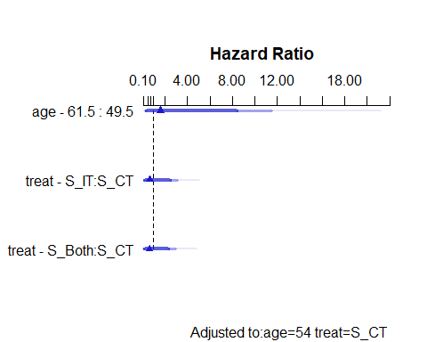

## Effects Summary

summary(cph_AxT)

Effects Response : S   
  
 Factor Low High Diff. Effect S.E. Lower 0.95 Upper 0.95  
 age 49.5 61.5 12 0.48200 0.99998 -1.47790 2.4419   
 Hazard Ratio 49.5 61.5 12 1.61930 NA 0.22811 11.4950   
 treat - S_IT:S_CT 1.0 2.0 NA -0.40504 0.78888 -1.95120 1.1411   
 Hazard Ratio 1.0 2.0 NA 0.66695 NA 0.14210 3.1303   
 treat - S_Both:S_CT 1.0 3.0 NA -0.49745 0.80805 -2.08120 1.0863   
 Hazard Ratio 1.0 3.0 NA 0.60808 NA 0.12478 2.9633   
  
Adjusted to: age=54 treat=S_CT

## Validation of model summaries

set.seed(4321234)  
validate(cph_AxT)

Warning in fitter(..., strata = strata, rownames = rownames, offset = offset, :  
Ran out of iterations and did not converge  
  
Warning in fitter(..., strata = strata, rownames = rownames, offset = offset, :  
Ran out of iterations and did not converge  
  
Warning in fitter(..., strata = strata, rownames = rownames, offset = offset, :  
Ran out of iterations and did not converge  
  
Warning in fitter(..., strata = strata, rownames = rownames, offset = offset, :  
Ran out of iterations and did not converge  
  
Warning in fitter(..., strata = strata, rownames = rownames, offset = offset, :  
Ran out of iterations and did not converge  
  
Warning in fitter(..., strata = strata, rownames = rownames, offset = offset, :  
Ran out of iterations and did not converge  
  
Warning in fitter(..., strata = strata, rownames = rownames, offset = offset, :  
Ran out of iterations and did not converge  
  
Warning in fitter(..., strata = strata, rownames = rownames, offset = offset, :  
Ran out of iterations and did not converge  
  
Warning in fitter(..., strata = strata, rownames = rownames, offset = offset, :  
Ran out of iterations and did not converge

Divergence or singularity in 12 samples

index.orig training test optimism index.corrected n  
Dxy 0.4883 0.6194 0.3722 0.2472 0.2411 28  
R2 0.3320 0.5047 0.1632 0.3415 -0.0096 28  
Slope 1.0000 1.0000 0.3040 0.6960 0.3040 28  
D 0.1191 0.2346 0.0482 0.1864 -0.0673 28  
U -0.0223 -0.0220 1.7430 -1.7650 1.7427 28  
Q 0.1414 0.2566 -1.6949 1.9514 -1.8100 28  
g 1.9803 9.9533 1.0352 8.9181 -6.9377 28

## ANOVA for cph_AxT model

anova(cph_AxT)

Wald Statistics Response: S   
  
 Factor Chi-Square d.f. P   
 age (Factor+Higher Order Factors) 7.71 5 0.1727  
 All Interactions 0.96 2 0.6175  
 Nonlinear 3.73 2 0.1548  
 treat (Factor+Higher Order Factors) 2.58 4 0.6297  
 All Interactions 0.96 2 0.6175  
 age * treat (Factor+Higher Order Factors) 0.96 2 0.6175  
 TOTAL NONLINEAR + INTERACTION 3.74 4 0.4423  
 TOTAL 8.55 7 0.2868

## survplot in rms for age comparison

survplot(cph_AxT, age = c(35, 45, 55, 65),  
 time.inc = 26, type = "kaplan-meier",  
 xlab = "Study Survival Time in weeks")

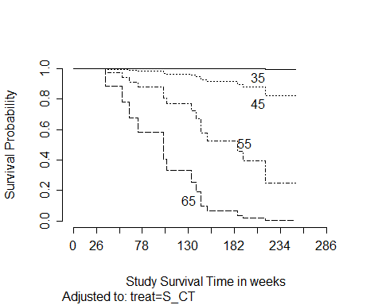

## survplot for treat comparison

survplot(cph_AxT, treat,   
 time.inc = 26, type = "kaplan-meier",  
 xlab = "Study Survival Time in weeks")

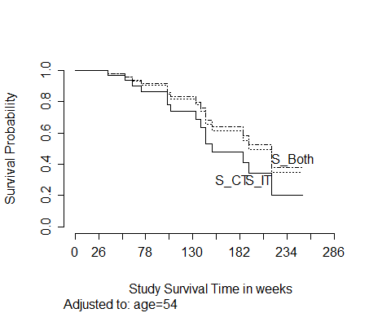

## Plotting age effect in cph_AxT

ggplot(Predict(cph_AxT, age))

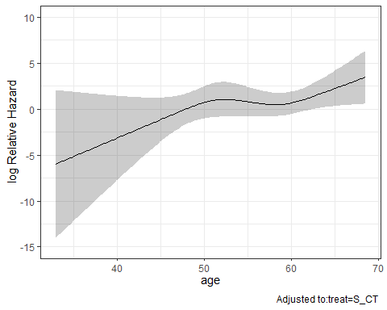

## Plotting treat effect in cph_AxT

ggplot(Predict(cph_AxT, treat))

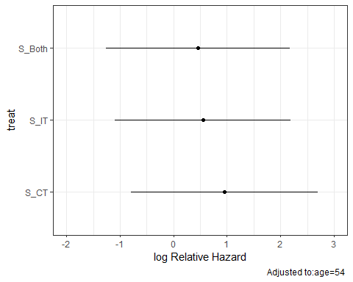

## cph_AxT nomogram

Suppose I want to show 4-year survival rates at the bottom of the nomogram. 4 years is 208 weeks, which is the unit of time the model works with, so we have…

sv <- Survival(cph_AxT)  
surv4 <- function(x) sv(208, lp = x)  
  
plot(nomogram(cph_AxT,  
 fun = surv4,  
 funlabel = c("4 year survival")))

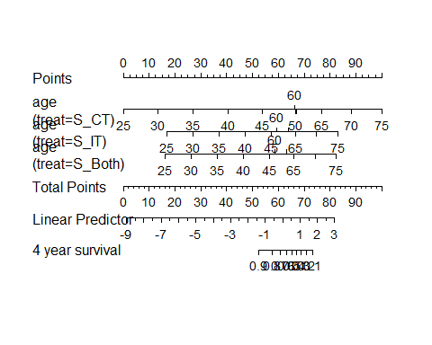

## Proportional Hazards Assumption?

cox.zph(cph_AxT, transform = "km", global = TRUE)

chisq df p  
rcs(age, 4) 1.98 3 0.576  
treat 4.38 2 0.112  
age %ia% treat 5.71 2 0.058  
GLOBAL 10.67 7 0.154

## Proportional Hazards Assumption?

ggcoxzph(cox.zph(cph_AxT))

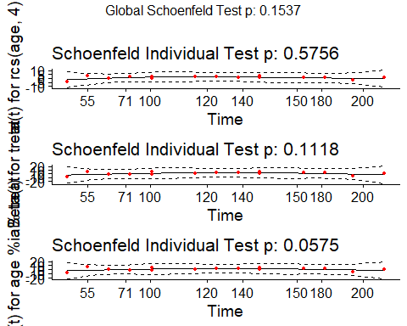

## More Cox Model Diagnostic Plots?

* survminer has a function called ggcoxdiagnostics() which plots different types of residuals as a function of time, linear predictor or observation id.
  + See next slide for the default graph (martingale residuals.)
  + Available diagnostics are specified with the type parameter, with options…

type = c("martingale", "deviance", "score", "schoenfeld",   
 "dfbeta", "dfbetas", "scaledsch", "partial")

## Diagnostics from survminer

ggcoxdiagnostics(cph_AxT)

Warning: `gather_()` was deprecated in tidyr 1.2.0.  
ℹ Please use `gather()` instead.  
ℹ The deprecated feature was likely used in the survminer package.  
 Please report the issue at <https://github.com/kassambara/survminer/issues>.

`geom_smooth()` using formula = 'y ~ x'

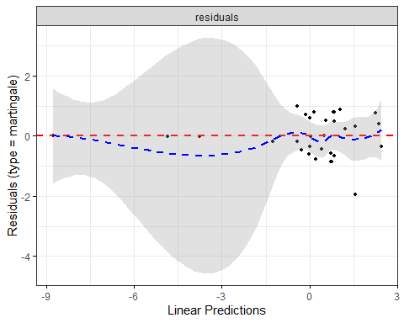

## More on Survival Analysis?

Our department teaches an entire course on this subject every Spring (PQHS 435).

# Some Reminders from the [ASA 2019 Statement on Statistical Inference](https://www.tandfonline.com/doi/full/10.1080/00031305.2019.1583913)

## Moving to a World Beyond “*p* < 0.05”

1. Getting to a Post “*p* < 0.05” Era
2. Interpreting and Using *p*
3. Supplementing or Replacing *p*
4. Adopting more holistic approaches
5. Reforming Institutions: Changing Publication Policies and Statistical Education

* Long list of “things to do” in Section 7 of the main editorial.

## Statistical Inference in the 21st Century

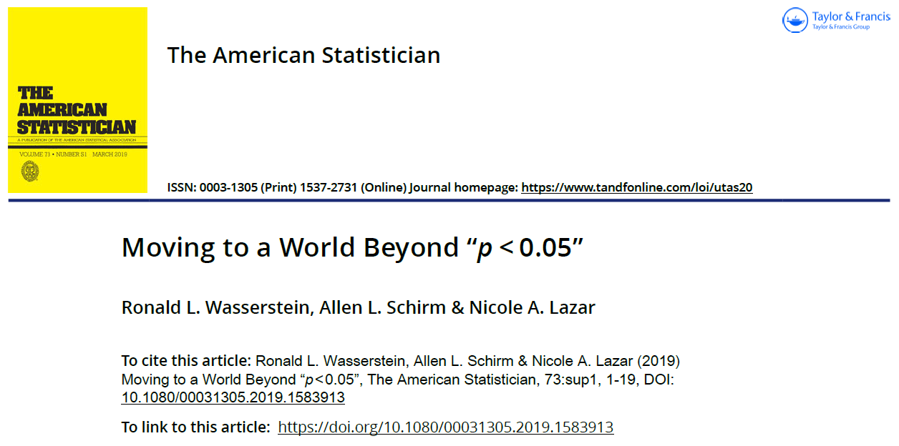

## ATOM: **A**ccept uncertainty. Be **T**houghtful, **O**pen and **M**odest.

* Statistical methods do not rid data of their uncertainty.

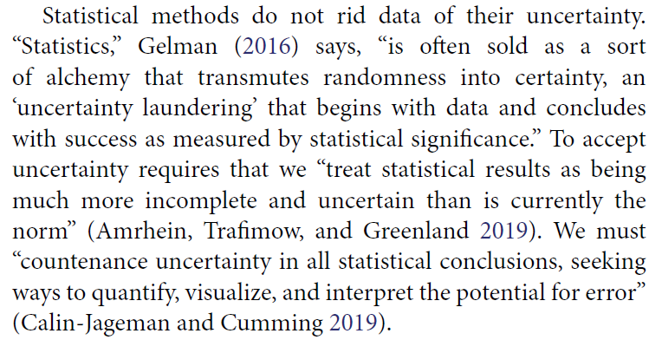

## ATOM: **A**ccept uncertainty. Be **T**houghtful, **O**pen and **M**odest.

We can make acceptance of uncertainty more natural to our thinking by accompanying every point estimate in our research with a measure of its uncertainty such as a standard error or interval estimate. Reporting and interpreting point and interval estimates should be routine.

## ATOM: **A**ccept uncertainty. Be **T**houghtful, **O**pen and **M**odest.

How will accepting uncertainty change anything? To begin, it will prompt us to seek better measures, more sensitive designs, and larger samples, all of which increase the rigor of research.

It also helps us be modest … [and] leads us to be thoughtful.

## ATOM: **A**ccept uncertainty. Be **T**houghtful, **O**pen and **M**odest.

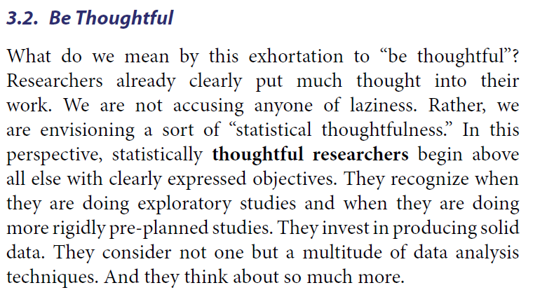

## ATOM: **A**ccept uncertainty. Be **T**houghtful, **O**pen and **M**odest.

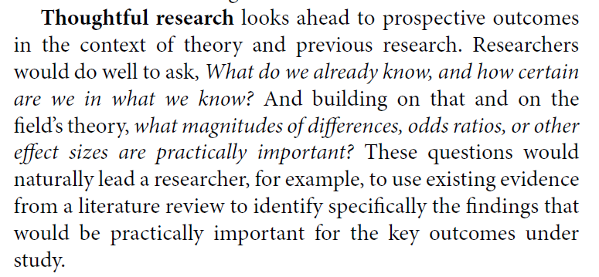

## ATOM: **A**ccept uncertainty. Be **T**houghtful, **O**pen and **M**odest.

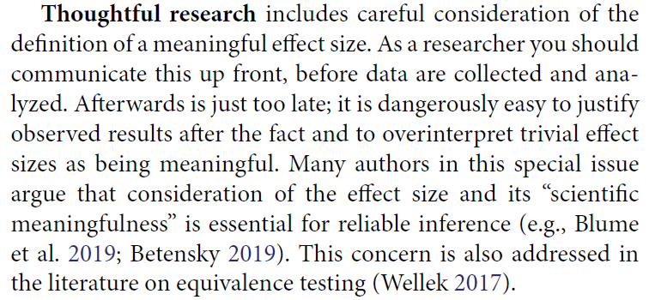

## ATOM: **A**ccept uncertainty. Be **T**houghtful, **O**pen and **M**odest.

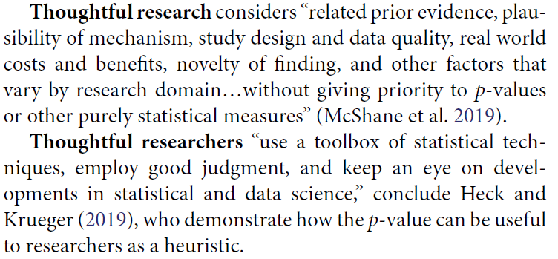

## ATOM: **A**ccept uncertainty. Be **T**houghtful, **O**pen and **M**odest.

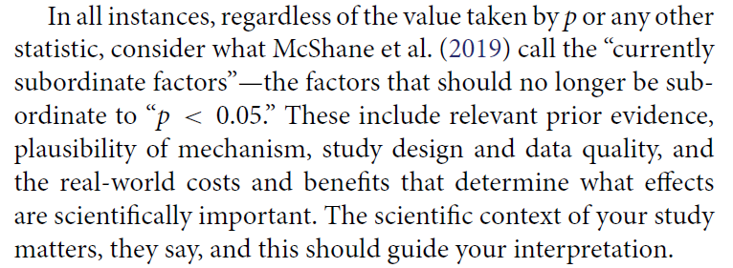

## ATOM: **A**ccept uncertainty. Be **T**houghtful, **O**pen and **M**odest.

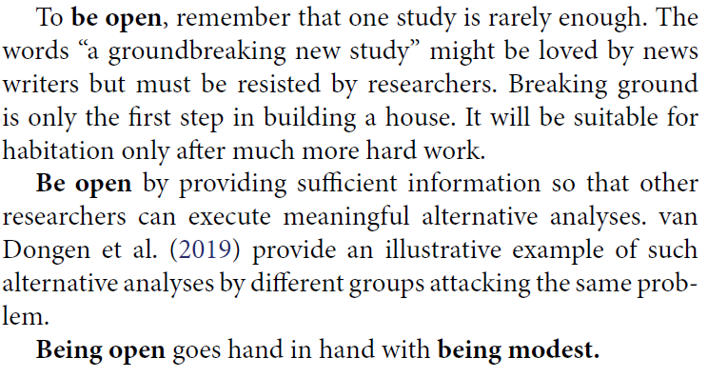

## ATOM: **A**ccept uncertainty. Be **T**houghtful, **O**pen and **M**odest.

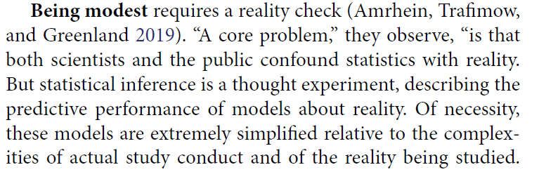

## ATOM: **A**ccept uncertainty. Be **T**houghtful, **O**pen and **M**odest.

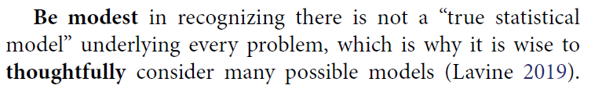

## ATOM: **A**ccept uncertainty. Be **T**houghtful, **O**pen and **M**odest.

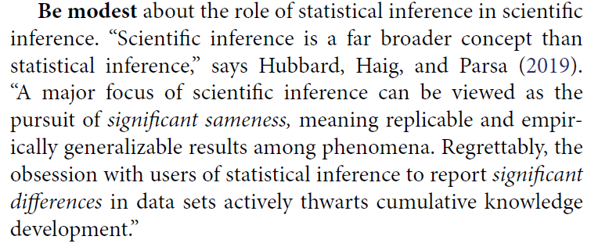

## ATOM: **A**ccept uncertainty. Be **T**houghtful, **O**pen and **M**odest.

The nexus of openness and modesty is to report everything while at the same time not concluding anything from a single study with unwarranted certainty. Because of the strong desire to inform and be informed, there is a relentless demand to state results with certainty. Again, accept uncertainty and embrace variation in associations and effects, because they are always there, like it or not.

## ATOM: **A**ccept uncertainty. Be **T**houghtful, **O**pen and **M**odest.

Understand that expressions of uncertainty are themselves uncertain. Accept that one study is rarely definitive, so encourage, sponsor, conduct, and publish replication studies.

Be modest by encouraging others to reproduce your work. Of course, for it to be reproduced readily, you will necessarily have been thoughtful in conducting the research and open in presenting it.

## On “Practical Benefit”

Switch from reliance on statistical or practical significance to the more stringent statistical criterion of practical benefit for:

* 1. assessing whether applied research findings indicate that an intervention is effective and should be adopted and scaled—particularly in complex organizations such as schools and hospitals and
  2. determining whether relationships are sufficiently strong and explanatory to be used as a basis for setting policy or practice recommendations.

## On “Practical Benefit”

Require that applied research reveal the actual unadjusted means/medians of results for all groups and subgroups, and that review panels take such data into account, as opposed to only reporting relative differences between adjusted means/medians.

## So let’s do it!

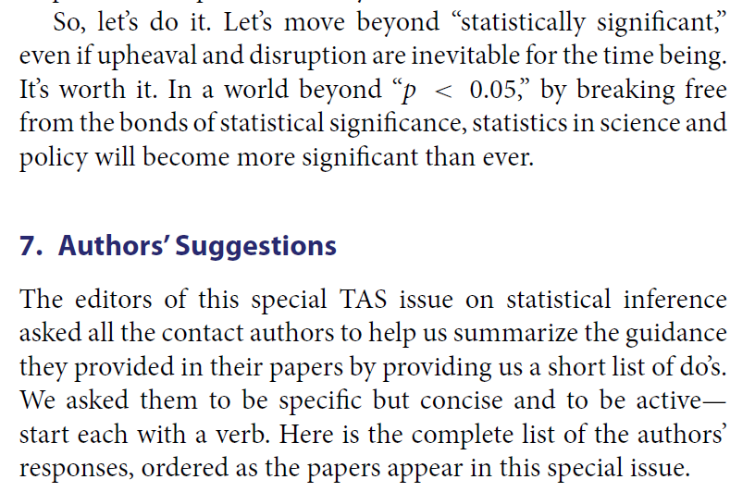

## Ten of the Many Insights from the “Authors’ Suggestions”

1. Do not use p-values, unless you have clearly thought about the need to use them and they still seem the best choice.
2. Develop and share teaching materials, software, and published case examples to help with all of the do’s above, and to spread progress in one discipline to others.
3. Ask quantitative questions and give quantitative answers.

## Ten of the Many Insights from the “Authors’ Suggestions”

1. Understand that subjective judgments are needed in all stages of a study.
2. Do not dichotomize, but embrace variation. Report and interpret inferential statistics like the p-value in a continuous fashion; do not use the word “significant.” Interpret interval estimates as “compatibility intervals,” showing effect sizes most compatible with the data, under the model used to compute the interval; do not focus on whether such intervals include or exclude zero.

## Ten of the Many Insights from the “Authors’ Suggestions”

1. Evaluate the strength of empirical evidence based on the precision of the estimates and the plausibility of the modeling choices. Seek out subject matter expertise when evaluating the importance and the strength of empirical evidence. Evaluate the importance of statistical results based on their practical implications.

## Ten of the Many Insights from the “Authors’ Suggestions”

1. Be transparent in the number of outcome variables that were analyzed.
2. Clearly describe data values that were excluded from analysis and the justification for doing so.
3. Provide sufficient details on experimental design so that other researchers can replicate the experiment.
4. Formulate a clear objective for variable inclusion in regression procedures.

## What’s Next?

Using a tidymodels approach to fit linear models.