432 Class 05

https://thomaselove.github.io/432-2025/

2025-01-28

## Today’s Agenda

* The HELP study
* Using tools from rms to fit:
  + linear models with ols()
  + logistic models with lrm()

## Today’s R Setup

knitr::opts_chunk$set(comment = NA)  
  
library(janitor)  
library(naniar)  
library(broom); library(gt); library(patchwork)  
  
library(haven) ## for zapping labels  
library(mosaic) ## auto-loads mosaicData - data source  
library(GGally) ## for scatterplot matrix  
library(rsample)  
library(yardstick)  
  
library(rms) ## auto-loads Hmisc  
library(easystats)  
library(tidyverse)  
  
theme_set(theme_bw())

# Data from the HELP study

## New Data (The HELP study)

Today’s main data set comes from the Health Evaluation and Linkage to Primary Care trial, and is stored as HELPrct in the mosaicData package.

HELP was a clinical trial of adult inpatients recruited from a detoxification unit. Patients with no primary care physician were randomized to receive a multidisciplinary assessment and a brief motivational intervention or usual care, with the goal of linking them to primary medical care.

## Key Variables for Today

| Variable | Description |
| --- | --- |
| id | subject identifier (note: $n$ = 453 subjects) |
| cesd | Center for Epidemiologic Studies Depression measure (scale is 0-60; higher scores indicate more depressive symptoms) |
| age | subject age (in years) |
| sex | female (n = 107) or male (n = 346) |
| subst | primary substance of abuse (alcohol, cocaine or heroin) |
| mcs | SF-36 Mental Component Score (lower = worse status) |
| pcs | SF-36 Physical Component Score (lower = worse status) |
| pss_fr | perceived social support by friends (higher = more support) |

* All measures from baseline during the subjects’ detoxification stay.
* More data and details at <https://nhorton.people.amherst.edu/help/>.

## help_rct data load

help_rct <- tibble(mosaicData::HELPrct) |>  
 select(id, cesd, age, sex, subst = substance, mcs, pcs, pss_fr) |>  
 mutate(across(where(is.character), as_factor)) |>  
 mutate(id = as.character(id))  
  
help_rct

# A tibble: 453 × 8  
 id cesd age sex subst mcs pcs pss_fr  
 <chr> <int> <int> <fct> <fct> <dbl> <dbl> <int>  
 1 1 49 37 male cocaine 25.1 58.4 0  
 2 2 30 37 male alcohol 26.7 36.0 1  
 3 3 39 26 male heroin 6.76 74.8 13  
 4 4 15 39 female heroin 44.0 61.9 11  
 5 5 39 32 male cocaine 21.7 37.3 10  
 6 6 6 47 female cocaine 55.5 46.5 5  
 7 7 52 49 female cocaine 21.8 24.5 1  
 8 8 32 28 male alcohol 9.16 65.1 4  
 9 9 50 50 female alcohol 22.0 38.3 5  
10 10 46 39 male heroin 36.1 22.6 0  
# ℹ 443 more rows

## What the data look like in help_rct

Note the labels.

str(help_rct)

tibble [453 × 8] (S3: tbl_df/tbl/data.frame)  
 $ id : chr [1:453] "1" "2" "3" "4" ...  
 $ cesd : int [1:453] 49 30 39 15 39 6 52 32 50 46 ...  
 ..- attr(*, "label")= chr "CESD at baseline"  
 $ age : int [1:453] 37 37 26 39 32 47 49 28 50 39 ...  
 ..- attr(*, "label")= chr "age (years)"  
 $ sex : Factor w/ 2 levels "female","male": 2 2 2 1 2 1 1 2 1 2 ...  
 ..- attr(*, "label")= chr "sex"  
 $ subst : Factor w/ 3 levels "alcohol","cocaine",..: 2 1 3 3 2 2 2 1 1 3 ...  
 ..- attr(*, "label")= chr "primary substance of abuse"  
 $ mcs : num [1:453] 25.11 26.67 6.76 43.97 21.68 ...  
 ..- attr(*, "label")= chr "SF-36 Mental Component Score"  
 $ pcs : num [1:453] 58.4 36 74.8 61.9 37.3 ...  
 ..- attr(*, "label")= chr "SF-36 Physical Component Score"  
 $ pss_fr: int [1:453] 0 1 13 11 10 5 1 4 5 0 ...  
 ..- attr(*, "label")= chr "perceived social support by friends"

## Getting rid of the labels

Suppose I don’t want the labels for some reason…

help1 <- help_rct |> zap_label()  
data_codebook(help1 |> select(-id))

select(help1, -id) (453 rows and 7 variables, 7 shown)  
  
ID | Name | Type | Missings | Values | N  
---+--------+-------------+----------+----------------+------------  
1 | cesd | integer | 0 (0.0%) | [1, 60] | 453  
---+--------+-------------+----------+----------------+------------  
2 | age | integer | 0 (0.0%) | [19, 60] | 453  
---+--------+-------------+----------+----------------+------------  
3 | sex | categorical | 0 (0.0%) | female | 107 (23.6%)  
 | | | | male | 346 (76.4%)  
---+--------+-------------+----------+----------------+------------  
4 | subst | categorical | 0 (0.0%) | alcohol | 177 (39.1%)  
 | | | | cocaine | 152 (33.6%)  
 | | | | heroin | 124 (27.4%)  
---+--------+-------------+----------+----------------+------------  
5 | mcs | numeric | 0 (0.0%) | [6.76, 62.18] | 453  
---+--------+-------------+----------+----------------+------------  
6 | pcs | numeric | 0 (0.0%) | [14.07, 74.81] | 453  
---+--------+-------------+----------+----------------+------------  
7 | pss_fr | integer | 0 (0.0%) | [0, 14] | 453  
-------------------------------------------------------------------

## Quantitative Summaries

df_stats(~ cesd + age + mcs + pcs + pss_fr, data = help1) |>  
 gt() |>   
 fmt_number(min:max, decimals = 1) |>  
 fmt_number(mean:sd, decimals = 2) |>   
 tab_options(table.font.size = 24) |>  
 opt_stylize(style = 1, color = "blue")

| response | min | Q1 | median | Q3 | max | mean | sd | n | missing |
| --- | --- | --- | --- | --- | --- | --- | --- | --- | --- |
| cesd | 1.0 | 25.0 | 34.0 | 41.0 | 60.0 | 32.85 | 12.51 | 453 | 0 |
| age | 19.0 | 30.0 | 35.0 | 40.0 | 60.0 | 35.65 | 7.71 | 453 | 0 |
| mcs | 6.8 | 21.7 | 28.6 | 40.9 | 62.2 | 31.68 | 12.84 | 453 | 0 |
| pcs | 14.1 | 40.4 | 48.9 | 57.0 | 74.8 | 48.05 | 10.78 | 453 | 0 |
| pss_fr | 0.0 | 3.0 | 7.0 | 10.0 | 14.0 | 6.71 | 4.00 | 453 | 0 |

## help1 categorical variables

help1 |> tabyl(sex, subst) |>   
 adorn_totals(where = c("row", "col")) |>  
 adorn_percentages(denominator = "row") |>  
 adorn_pct_formatting() |>  
 adorn_ns(position = "front") |>  
 adorn_title(placement = "combined") |>  
 gt() |> tab_options(table.font.size = 24) |>  
 opt_stylize(style = 2, color = "green")

| sex/subst | alcohol | cocaine | heroin | Total |
| --- | --- | --- | --- | --- |
| female | 36 (33.6%) | 41 (38.3%) | 30 (28.0%) | 107 (100.0%) |
| male | 141 (40.8%) | 111 (32.1%) | 94 (27.2%) | 346 (100.0%) |
| Total | 177 (39.1%) | 152 (33.6%) | 124 (27.4%) | 453 (100.0%) |

## Our quantitative outcome

* The CES-D is a 20-item measure that asks people to rate how often over the past week they experienced symptoms associated with depression, such as restless sleep, poor appetite, and feeling lonely.
  + Each item is rated on a 0-3 scale, and then summed, so possible scores range from 0 to 60.
  + Higher scores indicate more symptoms (or more frequent symptoms.)
* A version of the CES-D scale is available [here as a PDF](https://www.apa.org/depression-guideline/epidemiologic-studies-scale.pdf).

## A cutoff for CES-D: Our binary outcome

* Scores of 16 or higher on the CES-D scale are sometimes taken to indicate that a person is at risk for clinical depression.

help1 <- help1 |> mutate(cesd_hi = factor(as.numeric(cesd >= 16)))  
  
help1 |> tabyl(cesd_hi) |> adorn_pct_formatting()

cesd_hi n percent  
 0 46 10.2%  
 1 407 89.8%

## Quantitative Outcome (CES-D)

p1 <- ggplot(help1, aes(sample = cesd)) +  
 geom_qq(col = "slateblue") + geom_qq_line(col = "red") +   
 theme(aspect.ratio = 1) +  
 labs(y = "Sorted CES-D Scores",   
 x = "Standard Normal Distribution")  
  
bw = 5 # I tried a couple of things - this worked best for me with these data  
  
p2 <- ggplot(help1, aes(x = cesd)) +  
 geom_histogram(binwidth = bw, fill = "slateblue", col = "gold") +  
 stat_function(fun = function(x)   
 dnorm(x, mean = mean(help1$cesd), sd = sd(help1$cesd)) *   
 length(help1$cesd) * bw,  
 geom = "area", alpha = 0.5, fill = "thistle", col = "red") +   
 labs(y = "Number of Subjects", x = "CES-D Score")  
  
p3 <- ggplot(help1, aes(x = cesd, y = "")) +  
 geom_violin(fill = "slateblue") +  
 geom_boxplot(width = 0.3, col = "gold", notch = TRUE,   
 outlier.color = "slateblue") +  
 stat_summary(fun = "mean", geom = "point", col = "red") +  
 labs(x = "CES-D Score", y = "")  
  
p1 + (p2 / p3 + plot_layout(heights = c(4,1))) +  
 plot_annotation(title = "CES-D Depression Scores from help1 data",  
 subtitle = "Higher CES-D scores indicate more severe depressive symptoms",  
 caption = "n = 453, no missing data")

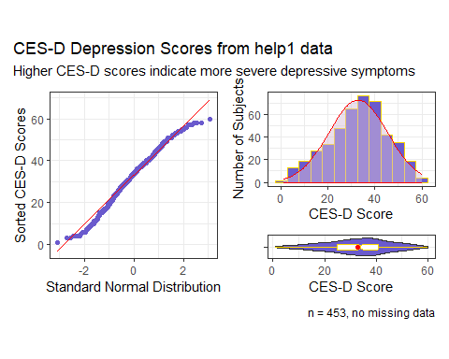

## Describing our outcome, CES-D (1/2)

describe(help1$cesd) ## describe comes from the Hmisc package

help1$cesd   
 n missing distinct Info Mean pMedian Gmd .05   
 453 0 58 0.999 32.85 33 14.23 10.0   
 .10 .25 .50 .75 .90 .95   
 15.2 25.0 34.0 41.0 49.0 52.4   
  
lowest : 1 3 4 5 6, highest: 55 56 57 58 60

* Info = variable’s information, between 0 and 1: the higher the Info, the more continuous the variable is (the fewer ties there are.)
* pMedian = Hodges-Lehman one-sample estimator of the pseudo-median. Median of all possible pairs of values.

## Describing our outcome, CES-D (2/2)

describe(help1$cesd)

help1$cesd   
 n missing distinct Info Mean pMedian Gmd .05   
 453 0 58 0.999 32.85 33 14.23 10.0   
 .10 .25 .50 .75 .90 .95   
 15.2 25.0 34.0 41.0 49.0 52.4   
  
lowest : 1 3 4 5 6, highest: 55 56 57 58 60

* Gmd = Gini’s mean difference, a robust measure of variation. If you select two subjects at random many times, the mean cesd difference will be 14.23 points.

More on the Hmisc package and describe() at [Frank Harrell’s website](https://hbiostat.org/r/hmisc/)

## The easystats approach

describe_distribution(help1$cesd, iqr = FALSE, range = FALSE, ci = 0.90)

Mean | SD | 90% CI | Skewness | Kurtosis | n | n_Missing  
----------------------------------------------------------------------  
32.85 | 12.51 | [31.85, 33.95] | -0.26 | -0.44 | 453 | 0

describe_distribution(help1$cesd,   
 centrality = "median", iqr = TRUE, quartiles = FALSE)

Median | MAD | IQR | Range | Skewness | Kurtosis | n | n_Missing  
------------------------------------------------------------------------------  
 34 | 11.86 | 16.50 | [1.00, 60.00] | -0.26 | -0.44 | 453 | 0

See [this link at the datawizard package](https://easystats.github.io/datawizard/reference/describe_distribution.html) for more

## Scatterplot Matrix (code)

temp <- help1 |>  
 select(age, mcs, pcs, pss_fr, sex, subst, cesd)  
  
ggpairs(temp) ## ggpairs from the GGally package

We place the outcome (cesd) last (result on next slide.)

### Saving the Data Set

write_rds(help1, "c05/data/help1.Rds")

## Scatterplot Matrix (result)

temp <- help1 |>  
 select(age, mcs, pcs, pss_fr, sex, subst, cesd)  
  
ggpairs(temp) ## ggpairs from the GGally package

`stat_bin()` using `bins = 30`. Pick better value with `binwidth`.  
`stat_bin()` using `bins = 30`. Pick better value with `binwidth`.  
`stat_bin()` using `bins = 30`. Pick better value with `binwidth`.  
`stat_bin()` using `bins = 30`. Pick better value with `binwidth`.  
`stat_bin()` using `bins = 30`. Pick better value with `binwidth`.  
`stat_bin()` using `bins = 30`. Pick better value with `binwidth`.  
`stat_bin()` using `bins = 30`. Pick better value with `binwidth`.  
`stat_bin()` using `bins = 30`. Pick better value with `binwidth`.  
`stat_bin()` using `bins = 30`. Pick better value with `binwidth`.  
`stat_bin()` using `bins = 30`. Pick better value with `binwidth`.

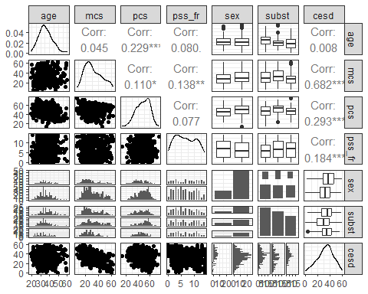

# Using ols() to fit a linear regression model

## Fitting using ols()

The ols function stands for ordinary least squares and comes from the rms package, by Frank Harrell and colleagues. Any model fit with lm can also be fit with ols.

* To predict var_y using var_x from the my_tibble data, we would use the following syntax:

dd <- datadist(my_tibble)  
options(datadist = "dd")  
  
model_name <- ols(var_y ~ var_x, data = my_tibble,  
 x = TRUE, y = TRUE)

This leaves a few questions…

## What’s the datadist stuff doing?

Before fitting an ols model to data from my_tibble, use:

dd <- datadist(my_tibble)  
options(datadist = "dd")

Run (the datadist code above) once before any models are fitted, storing the distribution summaries for all potential variables. Adjustment values are 0 for binary variables, the most frequent category (or optionally the first category level) for categorical (factor) variables, the middle level for ordered factor variables, and medians for continuous variables. (excerpt from datadist documentation)

## Why use x = TRUE, y = TRUE?

Once we’ve set up the summaries with datadist, we fit a model:

model_name <- ols(var_y ~ var_x, data = my_tibble,  
 x = TRUE, y = TRUE)

* ols stores additional information beyond what lm does
* x = TRUE and y = TRUE save even more expanded information for building plots and summarizing fit.
* The defaults are x = FALSE, y = FALSE, but in 432, we’ll want them saved.

## Using ols to fit a model

Let’s try to predict our outcome (cesd) using mcs and subst

* Start with setting up the datadist
* Then fit the model, including x = TRUE, y = TRUE

dd <- datadist(help1)  
options(datadist = "dd")  
  
mod1 <- ols(cesd ~ mcs + subst, data = help1,  
 x = TRUE, y = TRUE)

## Contents of mod1?

mod1

Linear Regression Model  
  
ols(formula = cesd ~ mcs + subst, data = help1, x = TRUE, y = TRUE)  
  
 Model Likelihood Discrimination   
 Ratio Test Indexes   
Obs 453 LR chi2 295.10 R2 0.479   
sigma9.0657 d.f. 3 R2 adj 0.475   
d.f. 449 Pr(> chi2) 0.0000 g 9.827   
  
Residuals  
  
 Min 1Q Median 3Q Max   
-25.43696 -6.74592 0.09334 6.16212 24.24842   
  
 Coef S.E. t Pr(>|t|)  
Intercept 55.3026 1.2724 43.46 <0.0001   
mcs -0.6570 0.0337 -19.48 <0.0001   
subst=cocaine -3.4440 1.0055 -3.43 0.0007   
subst=heroin -1.7791 1.0681 -1.67 0.0965

## New elements in ols

For our mod1,

* Model Likelihood Ratio test output includes LR chi2 = 295.10, d.f. = 3, Pr(> chi2) = 0.0000

The log of the likelihood ratio, multiplied by -2, yields a test against a $χ^{2}$ distribution. Interpret this as a goodness-of-fit test that compares mod1 to a null model with only an intercept term. In ols this is similar to a global (ANOVA) F test.

## New elements in ols

Under the $R^{2}$ values, we have g = 9.827.

* This is the $g$-index, based on Gini’s mean difference. If you randomly selected two of the subjects in the model, the average difference in predicted cesd will be 9.827.
* This can be compared to the Gini’s mean difference for the original cesd values, from describe, which was Gmd = 14.23.

## Validate summaries from an ols fit

* Can we validate summary statistics by resampling?

set.seed(432)  
validate(mod1)

index.orig training test optimism index.corrected n  
R-square 0.4787 0.4874 0.4737 0.0137 0.4650 40  
MSE 81.4606 79.7851 82.2361 -2.4510 83.9116 40  
g 9.8272 9.9133 9.8038 0.1095 9.7177 40  
Intercept 0.0000 0.0000 0.2793 -0.2793 0.2793 40  
Slope 1.0000 1.0000 0.9894 0.0106 0.9894 40

* The data used to fit the model provide an over-optimistic view of the quality of fit.
* We’re interested here in assessing how well the model might work in new data, using a resampling approach.

## Resampling Validation for $R^{2}$

| – | index.orig | training | test | optimism | index.corrected | n |
| --- | --- | --- | --- | --- | --- | --- |
| $R^{2}$ | 0.4787 | 0.4874 | 0.4737 | 0.0137 | 0.4650 | 40 |

* index.orig for $R^{2}$ is 0.4787. That’s what we get from the data used to fit mod1.
* With validate we create 40 (by default) bootstrapped resamples of the data and then split each of those into training and test samples.
  + For each of the 40 splits, R refits the model (same predictors) in the training sample to obtain $R^{2}$: mean across 40 splits is 0.4874
  + Check each model in its test sample: average $R^{2}$ was 0.4737
* optimism = training result - test result = 0.0137
* index.corrected = index.orig - optimism = 0.4650

While our *nominal $R^{2}$* is 0.4787; correcting for optimism yields *validated $R^{2}$* of 0.4650, so we conclude that $R^{2}$ = 0.4650 better estimates how mod1 will perform in new data.

## Resampling Validation for MS(Error)

| – | index.orig | training | test | optimism | index.corrected | n |
| --- | --- | --- | --- | --- | --- | --- |
| MSE | 81.4606 | 79.7851 | 82.2361 | -2.4510 | 83.9116 | 40 |

* index.orig for MSE = 81.4606. That’s what we get from the data used to fit mod1.
* For each of the 40 splits, R refits the model (same predictors) in the training sample to obtain MSE: mean across 40 splits is 79.7851
* Check each model in its test sample: average MSE was 82.2361
* optimism = training result - test result = -2.4510
* index.corrected = index.orig - optimism = 83.9116

While our *nominal* MSE is 81.4606 (so RMSE = $\sqrt{81.4606}=9.03$); correcting for optimism yields *validated* MSE of 83.9116 and validated RMSE = $\sqrt{83.9116}=9.16$.

## ANOVA for mod1 fit by ols

anova(mod1)

Analysis of Variance Response: cesd   
  
 Factor d.f. Partial SS MS F P   
 mcs 1 31182.7237 31182.72373 379.42 <.0001  
 subst 2 968.7563 484.37816 5.89 0.003   
 REGRESSION 3 33886.8359 11295.61195 137.44 <.0001  
 ERROR 449 36901.6542 82.18631

* This adds a line for the complete regression model (both terms) which can be helpful, but is otherwise the same as anova() after a fit using lm().
* As with lm, this is a sequential ANOVA table, so if we had included subst in the model first, we’d get a different SS, MS, F and p for mcs and subst, but the same REGRESSION and ERROR results.

## summary for mod1 fit by ols

summary(mod1, conf.int = 0.90)

Effects Response : cesd   
  
 Factor Low High Diff. Effect S.E. Lower 0.9  
 mcs 21.676 40.941 19.266 -12.6580 0.64984 -13.7290   
 subst - cocaine:alcohol 1.000 2.000 NA -3.4440 1.00550 -5.1013   
 subst - heroin:alcohol 1.000 3.000 NA -1.7791 1.06810 -3.5396   
 Upper 0.9   
 -11.587000  
 -1.786700  
 -0.018654

* How do we interpret the subst effects estimated by this model?
  + Effect of subst being cocaine instead of alcohol on ces_d is -3.44 assuming no change in mcs, with 90% CI (-5.10, -1.79).
  + Effect of subst being heroin instead of alcohol on ces_d is -1.78 assuming no change in mcs, with 90% CI (-3.54, -0.02).

But what about the mcs effect?

## summary for mod1 fit by ols

summary(mod1, conf.int = 0.90)

Effects Response : cesd   
  
 Factor Low High Diff. Effect S.E. Lower 0.9  
 mcs 21.676 40.941 19.266 -12.6580 0.64984 -13.7290   
 subst - cocaine:alcohol 1.000 2.000 NA -3.4440 1.00550 -5.1013   
 subst - heroin:alcohol 1.000 3.000 NA -1.7791 1.06810 -3.5396   
 Upper 0.9   
 -11.587000  
 -1.786700  
 -0.018654

* Effect of mcs: -12.66 is the estimated change in cesd associated with a move from mcs = 21.68 (see Low value) to mcs = 40.94 (the High value) assuming no change in subst.
* ols chooses the Low and High values from the interquartile range.

quantile(help1$mcs, c(0.25, 0.75))

25% 75%   
21.67575 40.94134

## Plot the summary to see effect sizes

* Goal: plot effect sizes for similar moves within predictor distributions.

plot(summary(mod1))

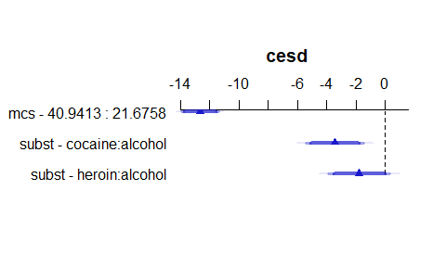

* The triangles indicate the point estimate, augmented with confidence interval bars.
  + The 90% confidence intervals are plotted with the thickest bars.
  + The 95% CIs are then shown with thinner, more transparent bars.
  + Finally, the 99% CIs are shown as the longest, thinnest bars.

## Plot the individual effects?

ggplot(Predict(mod1, conf.int = 0.95), layout = c(1,2))

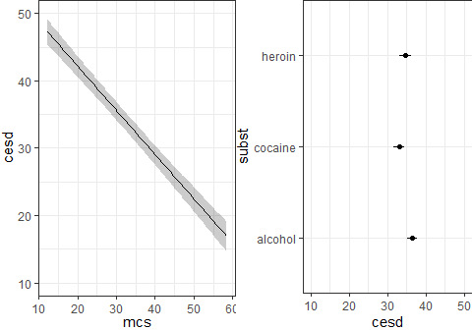

* At left, impact of changing mcs on cesd holding subst at its baseline (alcohol).
* At right, impact of changing subst on cesd holding mcs at its median (28.602417).
* Defaults: add 95% CI bands and layout tries for a square.

## Build a nomogram for the ols fit

plot(nomogram(mod1))

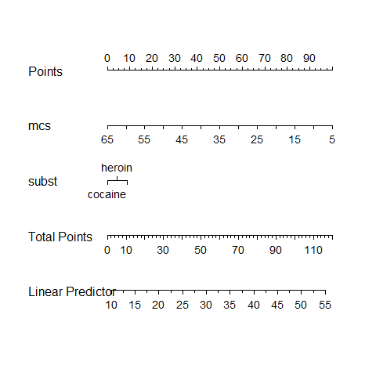

## Nomograms

For complex models (this model isn’t actually very complex) it can be helpful to have a tool that will help you see the modeled effects in terms of their impact on the predicted outcome.

A *nomogram* is an established graphical tool for doing this.

* Find the value of each predictor on its provided line, and identify the “points” for that predictor by drawing a vertical line up to the “Points”.
* Then sum up the points over all predictors to obtain “Total Points”.
* Draw a vertical line down from the “Total Points” to the “Linear Predictor” to get the predicted cesd for this subject.

## Using the nomogram for the mod1 fit

Predicted cesd if mcs = 35 and subst = heroin?

plot(nomogram(mod1))

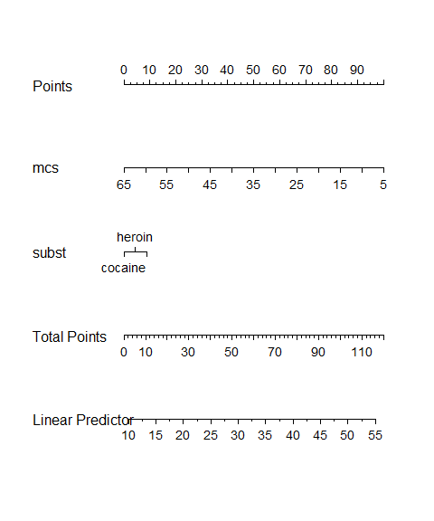

## Actual Prediction for this subject…

* The predict function for our ols fit provides fitted values.

predict(mod1, newdata = tibble(mcs = 35, subst = "heroin"))

1   
30.52766

# Using lrm() to fit a logistic regression model

## Fitting using lrm()

The lrm() function stands for logistic regression model and also comes from the rms package. Let’s predict our binary outcome (cesd_hi) using mcs and subst.

* Start with setting up the datadist Then fit model, including x = TRUE, y = TRUE

dd <- datadist(help1)  
options(datadist = "dd")  
  
mod2 <- lrm(cesd_hi ~ mcs + subst, data = help1, x = TRUE, y = TRUE)

## Contents of mod2?

mod2

Logistic Regression Model  
  
lrm(formula = cesd_hi ~ mcs + subst, data = help1, x = TRUE,   
 y = TRUE)  
  
 Model Likelihood Discrimination Rank Discrim.   
 Ratio Test Indexes Indexes   
Obs 453 LR chi2 134.24 R2 0.533 C 0.938   
 0 46 d.f. 3 R2(3,453)0.252 Dxy 0.875   
 1 407 Pr(> chi2) <0.0001 R2(3,124)0.653 gamma 0.875   
max |deriv| 6e-06 Brier 0.056 tau-a 0.160   
  
 Coef S.E. Wald Z Pr(>|Z|)  
Intercept 10.5778 1.2429 8.51 <0.0001   
mcs -0.1796 0.0235 -7.64 <0.0001   
subst=cocaine -1.5025 0.4811 -3.12 0.0018   
subst=heroin -1.2695 0.5979 -2.12 0.0337

## New elements in lrm

For our mod2,

* Model Likelihood Ratio test output includes LR chi2 = 134.24, d.f. = 3, Pr(> chi2) <0.0001

Again, the log of the likelihood ratio, multiplied by -2, yields a test against a $χ^{2}$ distribution. Interpret this as a goodness-of-fit test that compares mod2 to a null model with only an intercept term.

## Discrimination Indexes in lrm()

R2 = 0.533, R2(3,453) = 0.252, R2(3,124) = 0.653, Brier = 0.056

The R2 value is the *Nagelkerke $R^{2}$* , which is another pseudo- $R^{2}$ measure that provides a correction to the Cox-Snell $R^{2}$ so that the maximum value is 1.

* Other $R^{2}$ s [are detailed here](https://hbiostat.org/bib/r2)

## Discrimination Indexes in lrm()

R2 = 0.533, R2(3,453) = 0.252, R2(3,124) = 0.653, Brier = 0.056

The Brier score is the mean squared error between predictions and actual (1/0) observations. The lower the score (closer to 0), the better the model’s predictions are calibrated. It’s not really useful on its own, but helps when comparing models.

## Rank Discrimination Indexes in lrm()

C = 0.938, Dxy = 0.875, gamma = 0.875, tau-a = 0.160

* C is the C statistic, the area under the ROC curve
* Dxy is Somers’ d, and note that C = 0.5 + (Dxy/2)
* gamma is the Goodman-Kruskal $γ$ statistic
* tau-a is the Kendall $τ$ statistic (version a)

## Validate summaries from an lrm fit

* Can we validate summary statistics by resampling?

set.seed(432432)  
validate(mod2)

index.orig training test optimism index.corrected n  
Dxy 0.8751 0.8825 0.8707 0.0118 0.8634 40  
R2 0.5326 0.5421 0.5247 0.0174 0.5152 40  
Intercept 0.0000 0.0000 0.0069 -0.0069 0.0069 40  
Slope 1.0000 1.0000 0.9619 0.0381 0.9619 40  
Emax 0.0000 0.0000 0.0098 0.0098 0.0098 40  
D 0.2941 0.2988 0.2891 0.0097 0.2844 40  
U -0.0044 -0.0044 0.0001 -0.0045 0.0001 40  
Q 0.2985 0.3032 0.2890 0.0142 0.2843 40  
B 0.0560 0.0548 0.0571 -0.0022 0.0583 40  
g 2.7444 2.8543 2.7041 0.1502 2.5942 40  
gp 0.1577 0.1573 0.1569 0.0004 0.1574 40

## Resampling Validation after lrm()

| – | index.orig | training | test | optimism | index.corrected | n |
| --- | --- | --- | --- | --- | --- | --- |
| Dxy | 0.8751 | 0.8825 | 0.8707 | 0.0118 | 0.8634 | 40 |
| R2 | 0.5326 | 0.5421 | 0.5247 | 0.0174 | 0.5152 | 40 |

* Dxy = Somers’ d, and the area under the ROC curve is C = 0.5 + (Dxy/2)
* Our original Dxy = 0.8751, implying C = 0.9376
* Our validated Dxy = 0.8634, so validated C = 0.5 + (0.8634/2) = 0.9317
* While our *nominal $R^{2}$* is 0.5326; correcting for optimism yields *validated $R^{2}$* of 0.5152.

## ANOVA for mod2 fit by lrm

anova(mod2)

Wald Statistics Response: cesd_hi   
  
 Factor Chi-Square d.f. P   
 mcs 58.43 1 <.0001  
 subst 10.04 2 0.0066  
 TOTAL 62.30 3 <.0001

* Again, this is a sequential ANOVA table, so if we had included subst in the model first, we’d get a different Chi-Square, and p for mcs and subst, but the same TOTAL result.

## summary for mod2 fit by lrm

summary(mod2, conf.int = 0.90)

Effects Response : cesd_hi   
  
 Factor Low High Diff. Effect S.E. Lower 0.9  
 mcs 21.676 40.941 19.266 -3.460400 0.45270 -4.20500   
 Odds Ratio 21.676 40.941 19.266 0.031417 NA 0.01492   
 subst - cocaine:alcohol 1.000 2.000 NA -1.502500 0.48114 -2.29390   
 Odds Ratio 1.000 2.000 NA 0.222580 NA 0.10087   
 subst - heroin:alcohol 1.000 3.000 NA -1.269500 0.59788 -2.25290   
 Odds Ratio 1.000 3.000 NA 0.280980 NA 0.10509   
 Upper 0.9  
 -2.715800  
 0.066152  
 -0.711070  
 0.491120  
 -0.286070  
 0.751210

## summary for mod2 fit by lrm

Factor Low High Diff. Effect S.E. Lower 0.9 Upper 0.9  
 mcs 21.676 40.941 19.266 -3.46040 0.4527 -4.2050 -2.71580  
 Odds Ratio 21.676 40.941 19.266 0.03142 NA 0.0149 0.06615

* Odds of cesd_hi are 0.03 times as high for a subject with mcs = 40.94 (High) as compared to a subject with mcs = 21.68 (Low) assuming no change in subst.
* ols chooses the Low and High values from the interquartile range.

## summary for mod2 fit by lrm

Factor Low High Diff Effect S.E. Lower 0.9 Upper 0.9  
 subst - cocaine:alcohol 1 2 NA -1.5025 0.4811 -2.2939 -0.71107  
 Odds Ratio 1 2 NA 0.2226 NA 0.1009 0.49112  
 subst - heroin:alcohol 1 3 NA -1.2695 0.5979 -2.2529 -0.28607  
 Odds Ratio 1 3 NA 0.2810 NA 0.1051 0.75121

* Effect of subst being cocaine instead of alcohol on cesd_hi is an Odds Ratio of 0.22 (0.10, 0.49), assuming no change in mcs.
* Effect of subst being heroin instead of alcohol on cesd_hi is an Odds Ratio of 0.28 (0.11, 0.75), assuming no change in mcs.

## Plot the summary to see effect sizes

* Goal: plot effect sizes for similar moves within predictor distributions.

plot(summary(mod2))

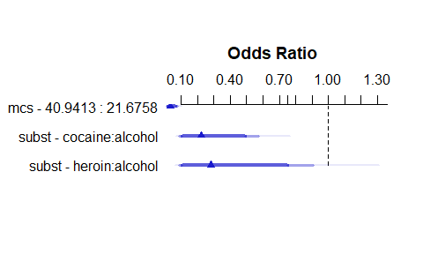

## Plot the individual effects?

ggplot(Predict(mod2, conf.int = 0.95), layout = c(1,2))

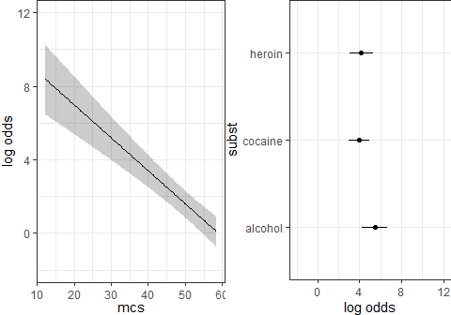

* At left, impact of changing mcs on cesd holding subst at its baseline (alcohol).
* At right, impact of changing subst on cesd holding mcs at its median (28.602417).
* Defaults: add 95% CI bands and layout tries for a square.

## Plot on probability scale?

Add fun = plogis.

ggplot(Predict(mod2, conf.int = 0.95, fun = plogis), layout = c(1,2))

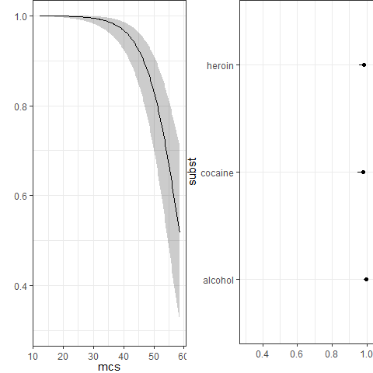

## Build a nomogram for the ols fit

plot(nomogram(mod2, fun = plogis, funlabel = 'Pr(cesd_hi = 1)'))

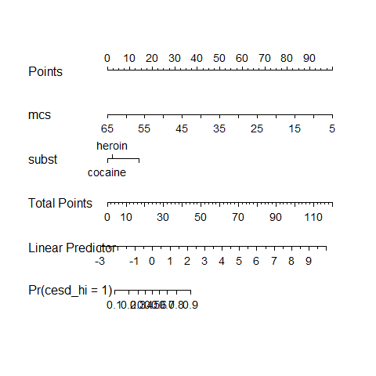

## Making a Prediction…

* The predict function for our lrm() fit provides fitted values, either on the log odds scale…

predict(mod2, newdata = tibble(mcs = 35, subst = "heroin"), type = "lp")

1   
3.021763

* or on the probability scale …

predict(mod2, newdata = tibble(mcs = 35, subst = "heroin"), type = "fitted")

1   
0.9535477

## Getting more good stuff

* Anything you can fit with ols() can also be fit with lm(), so you have access to everything in lm() as well, like check_model(), etc.
* Same goes for glm(..., family = binomial(link = "logit")) and lrm().

## Coming Soon

* Fitting more complex linear and logistic regression models
  + Adding non-linearity in the predictors through interactions, polynomials and splines
  + Spending degrees of freedom and the Spearman $ρ^{2}$ plot