432 Class 18

https://thomaselove.github.io/432-2025/

2025-03-20

## Today’s Agenda

* Can we fit a linear model to a count outcome?
* Selecting non-linear terms in light of Spearman $ρ^{2}$
* Fitting a Poisson regression with the rms package
* Checking Assumptions in Logistic Regression Models

## R Setup

knitr::opts_chunk$set(comment=NA)  
  
library(janitor); library(gt); library(broom)   
library(rsample); library(yardstick)  
library(car); library(here); library(conflicted)  
library(countreg) ## for rootograms  
library(topmodels) ## for rootograms  
library(rms)  
library(easystats)  
library(tidyverse)  
  
theme_set(theme_bw())  
  
conflicts_prefer(dplyr::select, rms::Predict, yardstick::rmse,  
 yardstick::mae)

# Could we fit a linear model for a count outcome?

## The medicare data from Class 1

medicare <- read_csv(here("c17/data/medicare.csv"),   
 show_col_types = FALSE) |>   
 mutate(across(where(is_character), as_factor),  
 subject = as.character(subject),   
 insurance = fct_relevel(insurance, "no", "yes"),  
 logvisits = log(visits + 1)) ## needed because some have 0 visits  
  
set.seed(432)  
med_split <- initial_split(medicare, prop = 0.75)  
  
med_train = training(med_split)  
med_test = testing(med_split)

## The medicare data

medicare

# A tibble: 4,406 × 9  
 subject visits hospital health chronic sex school insurance logvisits  
 <chr> <dbl> <dbl> <fct> <dbl> <fct> <dbl> <fct> <dbl>  
 1 1 5 1 average 2 male 6 yes 1.79   
 2 2 1 0 average 2 female 10 yes 0.693  
 3 3 13 3 poor 4 female 10 no 2.64   
 4 4 16 1 poor 2 male 3 yes 2.83   
 5 5 3 0 average 2 female 6 yes 1.39   
 6 6 17 0 poor 5 female 7 no 2.89   
 7 7 9 0 average 0 female 8 yes 2.30   
 8 8 3 0 average 0 female 8 yes 1.39   
 9 9 1 0 average 0 female 8 yes 0.693  
10 10 0 0 average 0 female 8 yes 0   
# ℹ 4,396 more rows

## Reiterating the Goal

Predict visits using these 6 predictors…

| Predictor | Description |
| --- | --- |
| hospital | # of hospital stays |
| health | self-rated health (poor, average, excellent) |
| chronic | # of chronic conditions |
| sex | male or female |
| school | years of education |
| insurance | subject (also) has private insurance? (yes/no) |

## Linear Model for our Count Outcome

Let’s fit a **linear regression** (mod_0: note *log* transformation) to go along with the Poisson regression (mod_1) we fit last time.

mod_0 <- lm(log(visits+1) ~ hospital + health + chronic + sex + school +   
 insurance, data = med_train)  
  
mod_1 <- glm(visits ~ hospital + health + chronic + sex + school +   
 insurance, data = med_train, family = "poisson")

## Linear Model Coefficients?

## linear model  
tidy(mod_0) |> gt() |> fmt_number(decimals = 3) |>   
 tab_options(table.font.size = 20)

| term | estimate | std.error | statistic | p.value |
| --- | --- | --- | --- | --- |
| (Intercept) | 0.678 | 0.054 | 12.661 | 0.000 |
| hospital | 0.174 | 0.020 | 8.678 | 0.000 |
| healthpoor | 0.234 | 0.048 | 4.872 | 0.000 |
| healthexcellent | -0.247 | 0.056 | -4.417 | 0.000 |
| chronic | 0.175 | 0.012 | 14.855 | 0.000 |
| sexfemale | 0.113 | 0.030 | 3.761 | 0.000 |
| school | 0.025 | 0.004 | 6.083 | 0.000 |
| insuranceyes | 0.234 | 0.038 | 6.189 | 0.000 |

## Poisson Model Coefficients?

## Poisson model  
tidy(mod_1) |> gt() |> fmt_number(decimals = 3) |>   
 tab_options(table.font.size = 20)

| term | estimate | std.error | statistic | p.value |
| --- | --- | --- | --- | --- |
| (Intercept) | 0.887 | 0.029 | 30.770 | 0.000 |
| hospital | 0.164 | 0.007 | 24.374 | 0.000 |
| healthpoor | 0.310 | 0.020 | 15.294 | 0.000 |
| healthexcellent | -0.359 | 0.035 | -10.287 | 0.000 |
| chronic | 0.137 | 0.005 | 26.082 | 0.000 |
| sexfemale | 0.098 | 0.015 | 6.641 | 0.000 |
| school | 0.031 | 0.002 | 14.808 | 0.000 |
| insuranceyes | 0.200 | 0.019 | 10.278 | 0.000 |

## Linear Regression Assumptions?

par(mfrow = c(1,2)); plot(mod_0, which = 1:2)

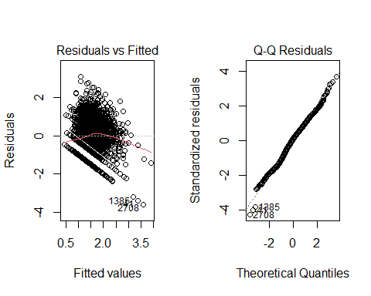

## Linear Regression Assumptions?

par(mfrow = c(1,2)); plot(mod_0, which = c(3,5))

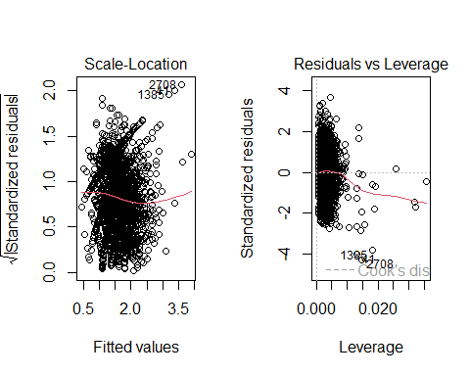

## Poisson Regression Plots?

par(mfrow = c(1,2)); plot(mod_1, which = 1:2)

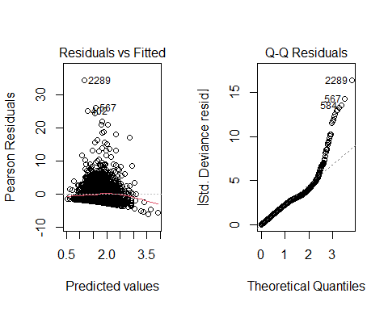

## Poisson Regression Plots

par(mfrow = c(1,2)); plot(mod_1, which = c(3, 5))

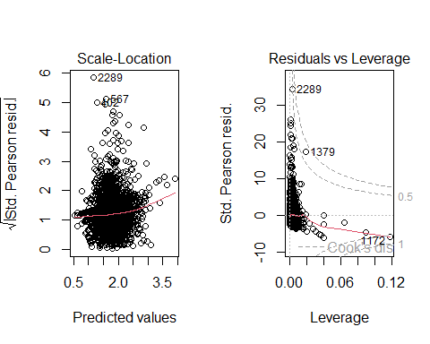

## Rootogram for Linear Model

rootogram(mod_0)

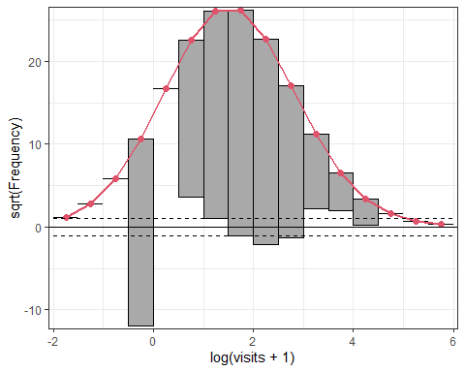

## Rootogram for Poisson Model

rootogram(mod_1)

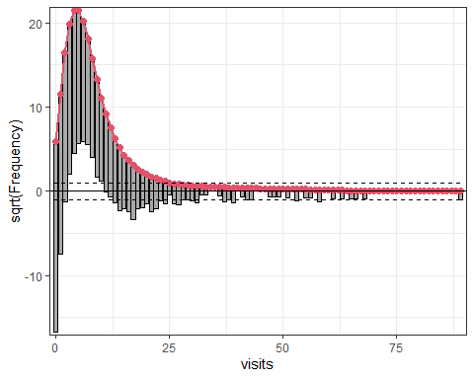

## Test Sample Results (1st 6 subjects)

Actual visits seen in the test sample:

head(med_test$visits)

[1] 1 16 9 3 0 44

Predicted visits From our linear model (mod_0):

test_0 <-   
 exp(predict(mod_0, newdata = med_test, type.predict = "response")) - 1  
  
head(test_0)

1 2 3 4 5 6   
 4.098644 4.730367 2.412072 2.412072 2.412072 10.658053

Predicted visits from our Poisson model (mod_1):

test_1 <- predict(mod_1, newdata = med_test, type = "response")  
  
head(test_1)

1 2 3 4 5 6   
 5.885106 6.878921 4.200529 4.200529 4.200529 12.235198

## Test Sample Predictions

No negative predictions with either model.

describe(test_0) ## predictions from Linear fit

test_0   
 n missing distinct Info Mean pMedian Gmd .05   
 1102 0 489 1 3.835 3.477 2.037 1.702   
 .10 .25 .50 .75 .90 .95   
 1.972 2.554 3.330 4.365 6.228 8.058   
  
lowest : 0.832359 0.836974 0.969082 1.05604 1.07177   
highest: 15.9109 16.8962 17.5769 24.3302 24.658

describe(test_1) ## predictions from Poisson fit

test_1   
 n missing distinct Info Mean pMedian Gmd .05   
 1102 0 489 1 5.71 5.363 2.225 3.270   
 .10 .25 .50 .75 .90 .95   
 3.591 4.334 5.228 6.385 8.429 9.839   
  
lowest : 1.94482 2.10986 2.32785 2.37599 2.40177  
highest: 17.5383 19.1728 19.3223 26.5918 26.5953

## Validation Results: These Two Models

mets <- metric_set(rsq, rmse, mae)  
  
test_res <- bind_cols(med_test, pre_m0 = test_0, pre_m1 = test_1)  
  
m0_sum <- mets(test_res, truth = visits, estimate = pre_m0) |>  
 mutate(model = "Linear")  
  
m1_sum <- mets(test_res, truth = visits, estimate = pre_m1) |>  
 mutate(model = "Poisson")   
  
test_sum <- bind_rows(m0_sum, m1_sum) |>  
 pivot_wider(names_from = model, values_from = .estimate)  
  
test_sum |> select(-.estimator) |> gt() |> fmt_number(decimals = 3) |>   
 tab_options(table.font.size = 20)

| .metric | Linear | Poisson |
| --- | --- | --- |
| rsq | 0.100 | 0.095 |
| rmse | 6.125 | 5.915 |
| mae | 3.793 | 4.021 |

# Selecting non-linear terms after Spearman $ρ^{2}$

## Spearman $ρ^{2}$ plot

plot(spearman2(visits ~ hospital + health + chronic + sex + school +   
 insurance, data = med_train))

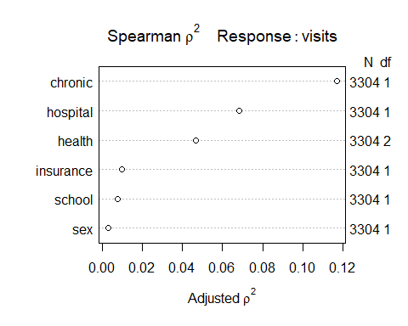

## Reiterating the Goal

This is the order of the predictors (chronic highest) on the Spearman $ρ^{2}$ plot from the previous slide.

| Predictor | Description |
| --- | --- |
| chronic | # of chronic conditions (all values 0-8) |
| hospital | # of hospital stays (all values 0-8) |
| health | self-rated health (poor, average, excellent) |
| insurance | subject (also) has private insurance? (yes/no) |
| school | years of education |
| sex | male or female |

## What might we do?

* chronic is a count (all values 0-8), then a gap to…
* hospital also quantitative, also a count (0-8)
* health is a 3-category factor

We might:

* include a restricted cubic spline with 4-5 knots in chronic
* include a rcs with fewer knots in hospital
* include an interaction between health and chronic or perhaps health and hospital

## Could we build an ols() fit?

Splines sometimes crash with discrete predictors (like counts.)

* For these data, it turns out that even a 3-knot spline in hospital fails (if we already have the four-knot spline in chronic), but the ols() function will let us add both interactions we’re considering.

d <- datadist(medicare); options(datadist = "d")  
  
mod_toobig <- ols(log(visits + 1) ~   
 rcs(chronic, 4) + hospital * health +   
 chronic %ia% health +  
 sex + school + insurance, data = med_train)

## Why is this model “too big”?

mod_toobig

Linear Regression Model  
  
ols(formula = log(visits + 1) ~ rcs(chronic, 4) + hospital *   
 health + chronic %ia% health + sex + school + insurance,   
 data = med_train)  
  
 Model Likelihood Discrimination   
 Ratio Test Indexes   
Obs 3304 LR chi2 664.03 R2 0.182   
sigma0.8363 d.f. 13 R2 adj 0.179   
d.f. 3290 Pr(> chi2) 0.0000 g 0.444   
  
Residuals  
  
 Min 1Q Median 3Q Max   
-2.42109 -0.55490 0.08359 0.56662 3.07394   
  
 Coef S.E. t Pr(>|t|)  
Intercept 0.5590 0.0575 9.73 <0.0001   
chronic 0.3011 0.0546 5.52 <0.0001   
chronic' -0.2051 0.2579 -0.80 0.4264   
chronic'' 0.2159 0.6311 0.34 0.7323   
hospital 0.2475 0.0249 9.95 <0.0001   
health=poor 0.5914 0.0952 6.21 <0.0001   
health=excellent -0.2022 0.0730 -2.77 0.0057   
chronic * health=poor -0.0931 0.0335 -2.78 0.0054   
chronic * health=excellent -0.0213 0.0565 -0.38 0.7058   
sex=female 0.1088 0.0297 3.66 0.0003   
school 0.0257 0.0041 6.20 <0.0001   
insurance=yes 0.2353 0.0375 6.28 <0.0001   
hospital * health=poor -0.2053 0.0421 -4.88 <0.0001   
hospital * health=excellent 0.1623 0.1493 1.09 0.2769

## Uh, oh.

plot(nomogram(mod_toobig, fun = exp, funlabel = "Visits + 1"))

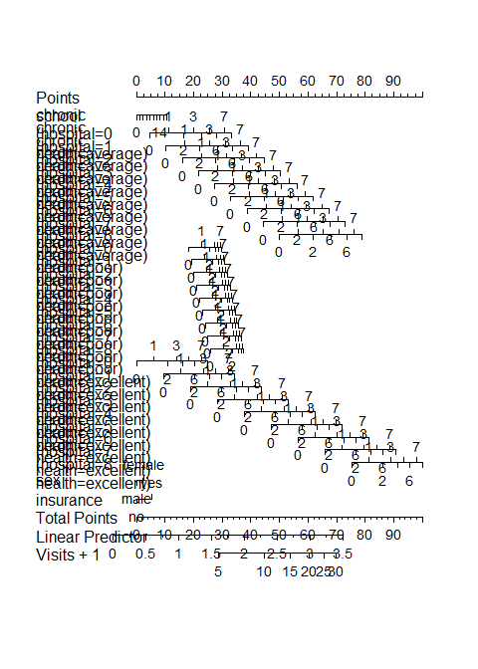

## A more reasonable option?

d <- datadist(medicare); options(datadist = "d")  
  
mod_new <- ols(log(visits + 1) ~   
 rcs(chronic, 4) + hospital + health +   
 chronic %ia% health +  
 sex + school + insurance, data = med_train)

## What does this mod_new show?

mod_new

Linear Regression Model  
  
ols(formula = log(visits + 1) ~ rcs(chronic, 4) + hospital +   
 health + chronic %ia% health + sex + school + insurance,   
 data = med_train)  
  
 Model Likelihood Discrimination   
 Ratio Test Indexes   
Obs 3304 LR chi2 637.75 R2 0.176   
sigma0.8393 d.f. 11 R2 adj 0.173   
d.f. 3292 Pr(> chi2) 0.0000 g 0.435   
  
Residuals  
  
 Min 1Q Median 3Q Max   
-3.06891 -0.54950 0.08035 0.56946 3.04632   
  
 Coef S.E. t Pr(>|t|)  
Intercept 0.5743 0.0576 9.97 <0.0001   
chronic 0.3036 0.0548 5.55 <0.0001   
chronic' -0.1710 0.2588 -0.66 0.5089   
chronic'' 0.1165 0.6331 0.18 0.8540   
hospital 0.1799 0.0199 9.02 <0.0001   
health=poor 0.5437 0.0951 5.72 <0.0001   
health=excellent -0.1940 0.0724 -2.68 0.0074   
chronic * health=poor -0.1199 0.0331 -3.62 0.0003   
chronic * health=excellent -0.0163 0.0563 -0.29 0.7718   
sex=female 0.1051 0.0298 3.53 0.0004   
school 0.0256 0.0042 6.16 <0.0001   
insurance=yes 0.2307 0.0376 6.14 <0.0001

## How many df did we add here?

anova(mod_new)

Analysis of Variance Response: log(visits + 1)   
  
 Factor d.f. Partial SS MS   
 chronic (Factor+Higher Order Factors) 5 189.349521 37.8699042  
 All Interactions 2 9.251314 4.6256570  
 Nonlinear 2 9.483346 4.7416730  
 hospital 1 57.342322 57.3423218  
 health (Factor+Higher Order Factors) 4 39.675076 9.9187689  
 All Interactions 2 9.251314 4.6256570  
 chronic * health (Factor+Higher Order Factors) 2 9.251314 4.6256570  
 sex 1 8.763370 8.7633703  
 school 1 26.694549 26.6945488  
 insurance 1 26.545793 26.5457929  
 TOTAL NONLINEAR + INTERACTION 4 31.942728 7.9856821  
 REGRESSION 11 493.787139 44.8897399  
 ERROR 3292 2319.211257 0.7044992  
 F P   
 53.75 <.0001  
 6.57 0.0014  
 6.73 0.0012  
 81.39 <.0001  
 14.08 <.0001  
 6.57 0.0014  
 6.57 0.0014  
 12.44 0.0004  
 37.89 <.0001  
 37.68 <.0001  
 11.34 <.0001  
 63.72 <.0001

## What does this ols() fit look like?

plot(summary(mod_new))

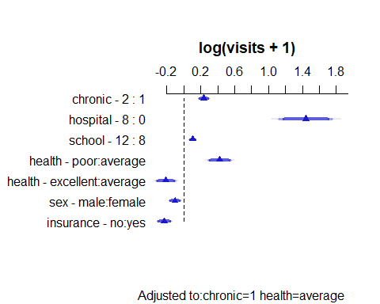

## What does this ols() fit look like?

ggplot(Predict(mod_new))

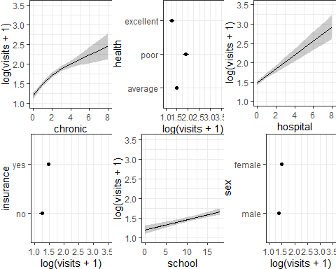

## How’s the nomogram?

plot(nomogram(mod_new, fun = exp, funlabel = "Visits + 1"))

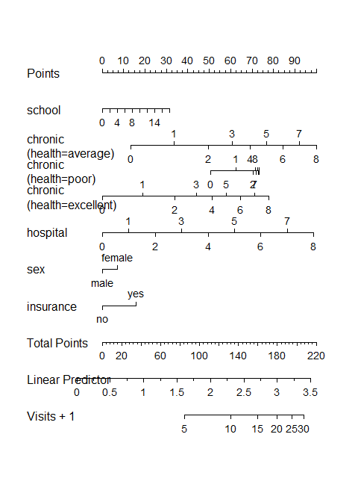

# Can we fit a Poisson model with a function from rms?

## The Glm() function in rms

d <- datadist(medicare); options(datadist = "d")  
  
mod_1_Glm <- Glm(visits ~ hospital + health + chronic + sex + school +   
 insurance, data = med_train, family = poisson())

and we could have used rcs() or polynomials or interactions if we wanted to do so.

Complete and updated documentation for the rms package is found at <https://hbiostat.org/r/rms/>.

### Does a Glm() fit do everything we are used to?

* Nope. No validate() or calibrate() methods exist.

## What’s in mod_1_Glm?

mod_1_Glm

General Linear Model  
  
Glm(formula = visits ~ hospital + health + chronic + sex + school +   
 insurance, family = poisson(), data = med_train)  
  
 Model Likelihood   
 Ratio Test   
 Obs3304 LR chi2 3019.53   
Residual d.f.3296 d.f. 7   
 g 0.386 Pr(> chi2) <0.0001   
  
 Coef S.E. Wald Z Pr(>|Z|)  
Intercept 0.8866 0.0288 30.77 <0.0001   
hospital 0.1636 0.0067 24.37 <0.0001   
health=poor 0.3096 0.0202 15.29 <0.0001   
health=excellent -0.3588 0.0349 -10.29 <0.0001   
chronic 0.1373 0.0053 26.08 <0.0001   
sex=female 0.0983 0.0148 6.64 <0.0001   
school 0.0313 0.0021 14.81 <0.0001   
insurance=yes 0.2002 0.0195 10.28 <0.0001

## What can we do: mod_1_Glm?

plot(summary(mod_1_Glm))

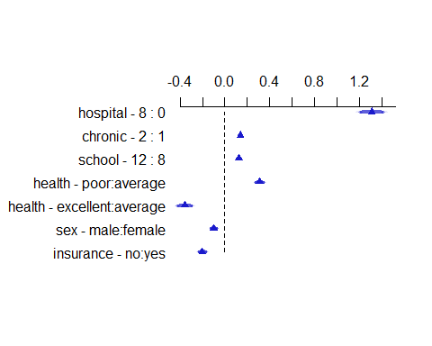

## What can we do: mod_1_Glm?

summary(mod_1_Glm)

Effects Response : visits   
  
 Factor Low High Diff. Effect S.E. Lower 0.95  
 hospital 0 8 8 1.308400 0.0536810 1.20320   
 chronic 1 2 1 0.137350 0.0052661 0.12702   
 school 8 12 4 0.125030 0.0084433 0.10848   
 health - poor:average 1 2 NA 0.309610 0.0202440 0.26992   
 health - excellent:average 1 3 NA -0.358760 0.0348750 -0.42714   
 sex - male:female 2 1 NA -0.098325 0.0148050 -0.12735   
 insurance - no:yes 2 1 NA -0.200250 0.0194840 -0.23845   
 Upper 0.95  
 1.413700   
 0.147670   
 0.141590   
 0.349300   
 -0.290380   
 -0.069297   
 -0.162050

## What can we do: mod_1_Glm?

ggplot(Predict(mod_1_Glm))

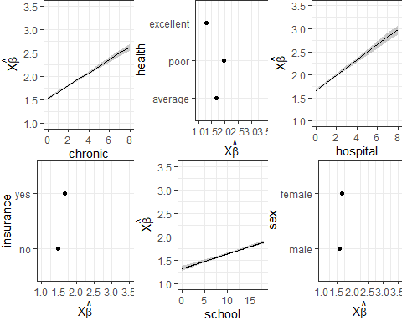

plot(nomogram(mod_1_Glm, fun = exp, funlabel = "Visits",  
 fun.at = c(1, 2, 3, 4, 5, 10, 15, 20, 25, 30)))

