432 Class 23

https://thomaselove.github.io/432-2025

2025-04-08

## Today’s Topic

**Cox models for time-to-event data**

* Rossi’s study of recidivism in people released from Maryland state prisons
* Reviewing what we’ve done so far using coxph()
* Using cph() from rms to fit three different Cox models

## Setup

knitr::opts_chunk$set(comment=NA)  
  
library(janitor)

Attaching package: 'janitor'

The following objects are masked from 'package:stats':  
  
 chisq.test, fisher.test

library(naniar)  
library(here)

here() starts at D:/Teaching/432/2025/432-slides-2025

library(conflicted)  
library(broom)  
library(gt)  
library(rms)

Loading required package: Hmisc

Attaching package: 'Hmisc'

The following object is masked from 'package:gt':  
  
 html

The following objects are masked from 'package:base':  
  
 format.pval, units

library(survival)  
library(survminer)

Loading required package: ggplot2

Loading required package: ggpubr

library(easystats)

# Attaching packages: easystats 0.7.4  
✔ bayestestR 0.15.2 ✔ correlation 0.8.7   
✔ datawizard 1.0.0 ✔ effectsize 1.0.0   
✔ insight 1.1.0 ✔ modelbased 0.9.0   
✔ performance 0.13.0 ✔ parameters 0.24.2  
✔ report 0.6.1 ✔ see 0.10.0

library(tidyverse)

── Attaching core tidyverse packages ──────────────────────── tidyverse 2.0.0 ──  
✔ dplyr 1.1.4 ✔ readr 2.1.5  
✔ forcats 1.0.0 ✔ stringr 1.5.1  
✔ lubridate 1.9.4 ✔ tibble 3.2.1  
✔ purrr 1.0.4 ✔ tidyr 1.3.1

theme_set(theme_bw())

## The Rossi Data

This data set is originally from Rossi et al. (1980). The data pertain to 432 convicts who were released from Maryland state prisons in the 1970s and who were followed up for one year after release. Half the released convicts were assigned at random to an experimental treatment in which they were given financial aid; half did not receive aid. Details on Rossi data variables and descriptions are provided [at this link](https://rdrr.io/cran/carData/man/Rossi.html).

* We will use a subset of the available variables today.
* Subject ID code (s_id) included in the rossi.csv file.

## Variable Descriptions for rossi_432

| Variable | Description |
| --- | --- |
| s_id | Subject ID code |
| week | week of first arrest after release or censoring; all censored observations are censored at 52 weeks. |
| arrest | 1 if arrested, 0 if not |
| fin | financial aid: no or yes (main treatment of study) |
| age | age in years at time of release |
| race | two categories: black or other |
| wexp | full-time work experience before incarceration: no or yes |
| prio | number of convictions prior to current incarceration |

## Ingesting the data into rossi_432

The rossi.csv file on our 432 data page includes 432 observations on 63 variables, but we’ll look at just the 8 we listed on the last slide.

rossi_432 <- read_csv(here("c23/data/rossi.csv"), show_col_types = FALSE) |>  
 select(s_id, week, arrest, fin, age, race, wexp, prio) |>  
 mutate(across(where(is.character), as_factor),  
 s_id = as.character(s_id))  
  
dim(rossi_432)

[1] 432 8

n_miss(rossi_432)

[1] 0

## The rossi_432 tibble

rossi_432

# A tibble: 432 × 8  
 s_id week arrest fin age race wexp prio  
 <chr> <dbl> <dbl> <fct> <dbl> <fct> <fct> <dbl>  
 1 S-001 20 1 no 27 black no 3  
 2 S-002 17 1 no 18 black no 8  
 3 S-003 25 1 no 19 other yes 13  
 4 S-004 52 0 yes 23 black yes 1  
 5 S-005 52 0 no 19 other yes 3  
 6 S-006 52 0 no 24 black yes 2  
 7 S-007 23 1 no 25 black yes 0  
 8 S-008 52 0 yes 21 black yes 4  
 9 S-009 52 0 no 22 black no 6  
10 S-010 52 0 no 20 black yes 0  
# ℹ 422 more rows

## Create a survival object

rossi_432$S <- with(rossi_432, Surv(week, arrest == 1))  
  
head(rossi_432$S)

[1] 20 17 25 52+ 52+ 52+

All subjects were followed either for 52 weeks after their release, or until they were (re-)arrested. So all “censored” subjects will have 52 weeks without re-arrest.

### Compare the two financial aid groups

km_fin <- survfit(S ~ fin, data = rossi_432)  
  
km_fin

Call: survfit(formula = S ~ fin, data = rossi_432)  
  
 n events median 0.95LCL 0.95UCL  
fin=no 216 66 NA NA NA  
fin=yes 216 48 NA NA NA

## Plot the K-M curves

ggsurvplot(km_fin, data = rossi_432,   
 palette = "aaas", ggtheme = theme_bw(),  
 pval = TRUE)

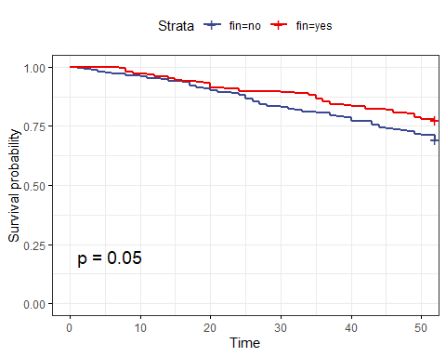

## Log - Log Plot for K-M estimation

* Do these curves cross?

plot(survfit(S ~ fin, data = rossi_432), col = c(1:2), fun = "cloglog")

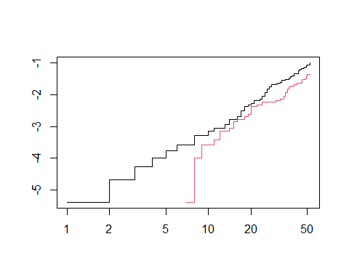

## Cumulative Hazard Plot

ggsurvplot(km_fin, data = rossi_432, fun = "cumhaz",  
 xlab = "Weeks of Follow-Up", palette = "aaas",  
 pval = TRUE, break.time.by = 13,  
 risk.table = TRUE, risk.table.height = 0.25)

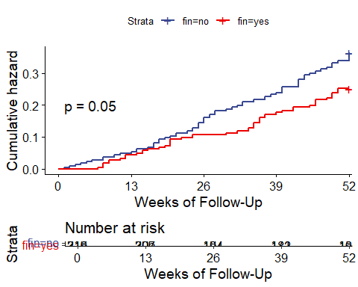

## Cox Model using fin only

fit1 <- coxph(S ~ fin, data = rossi_432)  
  
fit1

Call:  
coxph(formula = S ~ fin, data = rossi_432)  
  
 coef exp(coef) se(coef) z p  
finyes -0.3691 0.6914 0.1897 -1.945 0.0517  
  
Likelihood ratio test=3.84 on 1 df, p=0.05013  
n= 432, number of events= 114

* How do we interpret the hazard ratio estimate of 0.6914?

## fit1 model parameters

model_parameters(fit1, pretty_names = FALSE, exponentiate = TRUE,  
 ci = 0.90, digits = 3)

Parameter | Coefficient | SE | 90% CI | z | p  
-----------------------------------------------------------------  
finyes | 0.691 | 0.131 | [0.506, 0.945] | -1.945 | 0.052

Uncertainty intervals (equal-tailed) and p-values (two-tailed) computed  
 using a Wald z-distribution approximation.

## Model fit1 summaries

model_performance(fit1)

Response residuals not available to calculate mean square error. (R)MSE  
 is probably not reliable.

Warning: Can't calculate weighted residuals from model.

# Indices of model performance  
  
AIC | AICc | BIC | Nagelkerke's R2 | RMSE | Sigma  
----------------------------------------------------------------  
1348.924 | 1348.934 | 1352.993 | 0.009 | 0.513 | 0.000

glance(fit1) |> gt() |> fmt_number(decimals = 3)

| n | nevent | statistic.log | p.value.log | statistic.sc | p.value.sc | statistic.wald | p.value.wald | statistic.robust | p.value.robust | r.squared | r.squared.max | concordance | std.error.concordance | logLik | AIC | BIC | nobs |
| --- | --- | --- | --- | --- | --- | --- | --- | --- | --- | --- | --- | --- | --- | --- | --- | --- | --- |
| 432.000 | 114.000 | 3.837 | 0.050 | 3.827 | 0.050 | 3.780 | 0.052 | NA | NA | 0.009 | 0.956 | 0.546 | 0.023 | -673.462 | 1,348.924 | 1,351.660 | 114.000 |

## Forest Plot for fit1

ggforest(fit1)

Warning in .get_data(model, data = data): The `data` argument is not provided.  
Data will be extracted from model fit.

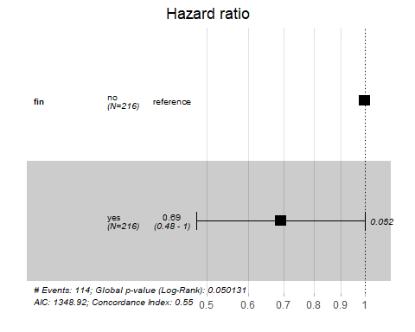

## Checking PH Assumption

cox.zph(fit1)

chisq df p  
fin 0.0301 1 0.86  
GLOBAL 0.0301 1 0.86

## Checking PH Assumption

ggcoxzph(cox.zph(fit1))

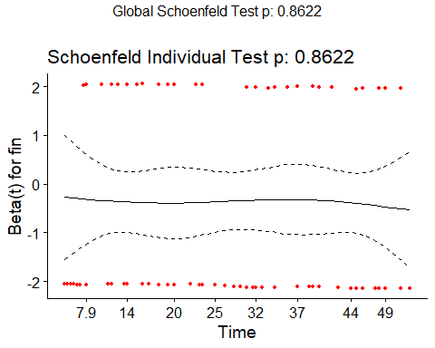

## A larger Cox model (fit2)

fit2 <- coxph(S ~ fin + age + race + wexp + prio, data = rossi_432)  
  
fit2

Call:  
coxph(formula = S ~ fin + age + race + wexp + prio, data = rossi_432)  
  
 coef exp(coef) se(coef) z p  
finyes -0.36572 0.69369 0.19074 -1.917 0.05518  
age -0.05991 0.94185 0.02199 -2.724 0.00645  
raceother -0.34582 0.70764 0.30736 -1.125 0.26053  
wexpyes -0.20788 0.81230 0.20905 -0.994 0.32003  
prio 0.09212 1.09649 0.02831 3.254 0.00114  
  
Likelihood ratio test=31.58 on 5 df, p=7.211e-06  
n= 432, number of events= 114

## fit2 model parameters

model_parameters(fit2, pretty_names = FALSE, exponentiate = TRUE,  
 ci = 0.90, digits = 3)

Parameter | Coefficient | SE | 90% CI | z | p  
-----------------------------------------------------------------  
finyes | 0.694 | 0.132 | [0.507, 0.949] | -1.917 | 0.055  
age | 0.942 | 0.021 | [0.908, 0.977] | -2.724 | 0.006  
raceother | 0.708 | 0.217 | [0.427, 1.173] | -1.125 | 0.261  
wexpyes | 0.812 | 0.170 | [0.576, 1.146] | -0.994 | 0.320  
prio | 1.096 | 0.031 | [1.047, 1.149] | 3.254 | 0.001

Uncertainty intervals (equal-tailed) and p-values (two-tailed) computed  
 using a Wald z-distribution approximation.

* How do we interpret the fin hazard ratio estimate of 0.694?
* How about the prio hazard ratio estimate of 1.096?

## Model fit2 summaries

model_performance(fit2)

Response residuals not available to calculate mean square error. (R)MSE  
 is probably not reliable.

Warning: Can't calculate weighted residuals from model.

# Indices of model performance  
  
AIC | AICc | BIC | Nagelkerke's R2 | RMSE | Sigma  
----------------------------------------------------------------  
1329.186 | 1329.327 | 1349.528 | 0.074 | 0.514 | 0.000

glance(fit2) |> gt() |> fmt_number(decimals = 3)

| n | nevent | statistic.log | p.value.log | statistic.sc | p.value.sc | statistic.wald | p.value.wald | statistic.robust | p.value.robust | r.squared | r.squared.max | concordance | std.error.concordance | logLik | AIC | BIC | nobs |
| --- | --- | --- | --- | --- | --- | --- | --- | --- | --- | --- | --- | --- | --- | --- | --- | --- | --- |
| 432.000 | 114.000 | 31.575 | 0.000 | 31.994 | 0.000 | 30.720 | 0.000 | NA | NA | 0.070 | 0.956 | 0.639 | 0.027 | -659.593 | 1,329.186 | 1,342.867 | 114.000 |

## Checking PH Assumption

cox.zph(fit2)

chisq df p  
fin 0.0599 1 0.8066  
age 6.0792 1 0.0137  
race 2.0365 1 0.1536  
wexp 4.1107 1 0.0426  
prio 0.5348 1 0.4646  
GLOBAL 17.0813 5 0.0043

## Checking PH Assumption

ggcoxzph(cox.zph(fit2))

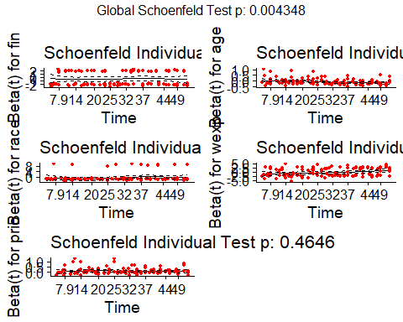

## Compare our two models

plot(compare_performance(fit1, fit2))

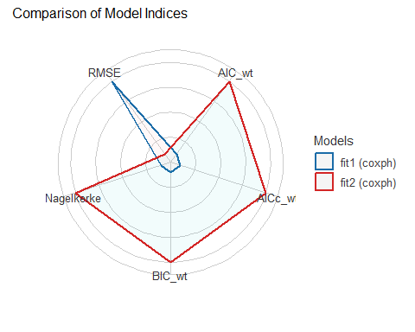

## Using cph() from the **rms** package

dd <- datadist(rossi_432); options(datadist = "dd")

Warning in datadist(rossi_432): S is a matrix or has incorrect length; ignored

fit1_cph <- cph(S ~ fin, data = rossi_432,  
 x = TRUE, y = TRUE, surv = TRUE)  
  
fit2_cph <- cph(S ~ fin + age + race + wexp + prio, data = rossi_432,  
 x = TRUE, y = TRUE, surv = TRUE)

## fit1_cph results

fit1_cph

Cox Proportional Hazards Model  
  
cph(formula = S ~ fin, data = rossi_432, x = TRUE, y = TRUE,   
 surv = TRUE)  
  
 Model Tests Discrimination   
 Indexes   
Obs 432 LR chi2 3.84 R2 0.009   
Events 114 d.f. 1 R2(1,432)0.007   
Center -0.1845 Pr(> chi2) 0.0501 R2(1,114)0.025   
 Score chi2 3.83 Dxy 0.091   
 Pr(> chi2) 0.0504   
  
 Coef S.E. Wald Z Pr(>|Z|)  
fin=yes -0.3691 0.1897 -1.95 0.0517

## fit1_cph Effects Plot

plot(summary(fit1_cph))

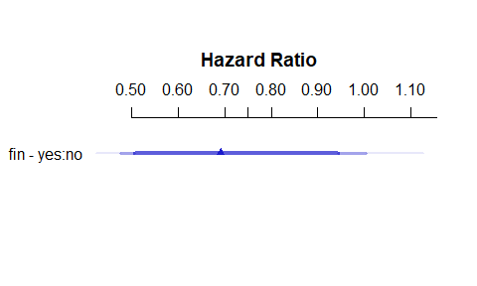

summary(fit1_cph)

Effects Response : S   
  
 Factor Low High Diff. Effect S.E. Lower 0.95 Upper 0.95  
 fin - yes:no 1 2 NA -0.36907 0.18972 -0.74092 0.0027804   
 Hazard Ratio 1 2 NA 0.69138 NA 0.47668 1.0028000

## Proportional Hazards Assumption?

cox.zph(fit1_cph, transform = "km", global = TRUE)

chisq df p  
fin 0.0301 1 0.86  
GLOBAL 0.0301 1 0.86

## Proportional Hazards Assumption?

ggcoxzph(cox.zph(fit1_cph, transform = "km", global = TRUE))



## Bootstrap Validated fit1_cph summaries

set.seed(432)  
validate(fit1_cph, B = 300)

index.orig training test optimism index.corrected n  
Dxy 0.0915 0.0889 0.0872 0.0017 0.0898 300  
R2 0.0092 0.0108 0.0092 0.0016 0.0077 300  
Slope 1.0000 1.0000 1.8983 -0.8983 1.8983 300  
D 0.0021 0.0026 0.0021 0.0005 0.0016 300  
U -0.0015 -0.0015 0.0007 -0.0022 0.0007 300  
Q 0.0036 0.0041 0.0014 0.0027 0.0009 300  
g 0.1850 0.1804 0.1850 -0.0046 0.1896 300

* Validated C statistic = 0.5 + (0.0898/2) = 0.5449
* Validated Nagelkerke $R^{2}$ = 0.0077

## survplot() from **rms** fit1_cph

survplot(fit1_cph, fin = c("yes", "no"),  
 time.inc = 13, type = "kaplan-meier",  
 xlab = "Study Time in Weeks")

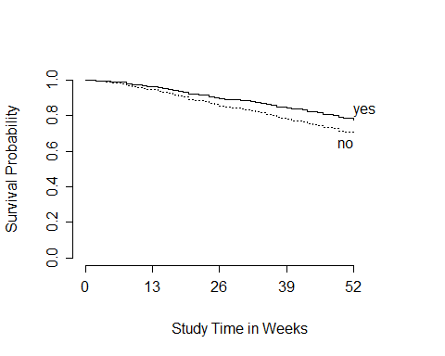

## fit1_cph Prediction Plot (1/3)

ggplot(Predict(fit1_cph))

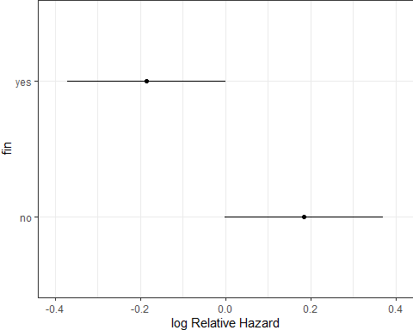

## fit1_cph Prediction Plot (2/3)

ggplot(Predict(fit1_cph, fun = exp))

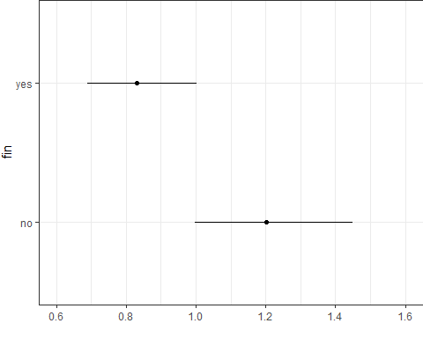

## fit1_cph Prediction Plot (3/3)

ggplot(Predict(fit1_cph, fun = plogis))

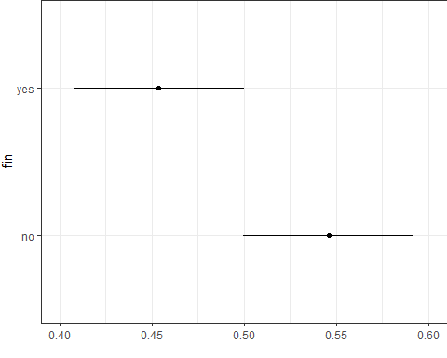

## fit1_cph Nomogram

sv <- Survival(fit1_cph)  
surv52 <- function(x) sv(52, lp = x)  
  
plot(nomogram(fit1_cph, fun = surv52, funlabel = c("52 week survival")))

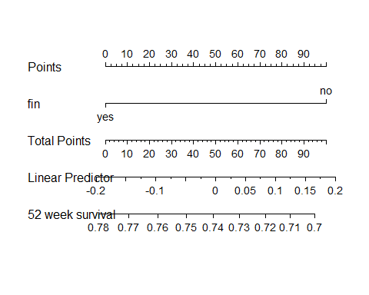

## fit2_cph results

fit2_cph

Cox Proportional Hazards Model  
  
cph(formula = S ~ fin + age + race + wexp + prio, data = rossi_432,   
 x = TRUE, y = TRUE, surv = TRUE)  
  
 Model Tests Discrimination   
 Indexes   
Obs 432 LR chi2 31.58 R2 0.074   
Events 114 d.f. 5 R2(5,432)0.060   
Center -1.5427 Pr(> chi2) 0.0000 R2(5,114)0.208   
 Score chi2 31.99 Dxy 0.277   
 Pr(> chi2) 0.0000   
  
 Coef S.E. Wald Z Pr(>|Z|)  
fin=yes -0.3657 0.1907 -1.92 0.0552   
age -0.0599 0.0220 -2.72 0.0065   
race=other -0.3458 0.3074 -1.13 0.2605   
wexp=yes -0.2079 0.2091 -0.99 0.3200   
prio 0.0921 0.0283 3.26 0.0011

## fit2_cph Effects Plot

plot(summary(fit2_cph))

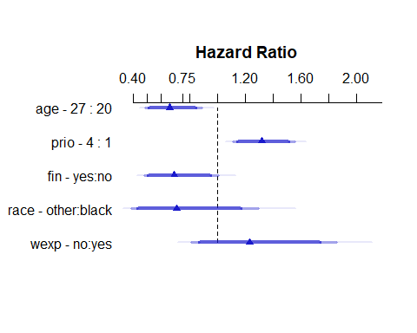

## fit2_cph Effects Table

summary(fit2_cph)

Effects Response : S   
  
 Factor Low High Diff. Effect S.E. Lower 0.95 Upper 0.95  
 age 20 27 7 -0.41932 0.153950 -0.72105 -0.1175800  
 Hazard Ratio 20 27 7 0.65750 NA 0.48624 0.8890700  
 prio 1 4 3 0.27642 0.084911 0.10999 0.4428400  
 Hazard Ratio 1 4 3 1.31840 NA 1.11630 1.5571000  
 fin - yes:no 1 2 NA -0.36571 0.190740 -0.73955 0.0081226  
 Hazard Ratio 1 2 NA 0.69370 NA 0.47733 1.0082000  
 race - other:black 1 2 NA -0.34585 0.307360 -0.94825 0.2565600  
 Hazard Ratio 1 2 NA 0.70762 NA 0.38742 1.2925000  
 wexp - no:yes 2 1 NA 0.20790 0.209060 -0.20184 0.6176400  
 Hazard Ratio 2 1 NA 1.23110 NA 0.81723 1.8546000

## survplot() from **rms** fit2_cph

* Looking at the fin effect

survplot(fit2_cph, fin = c("no", "yes"),  
 time.inc = 13, type = "kaplan-meier",  
 xlab = "Study Time in Weeks")

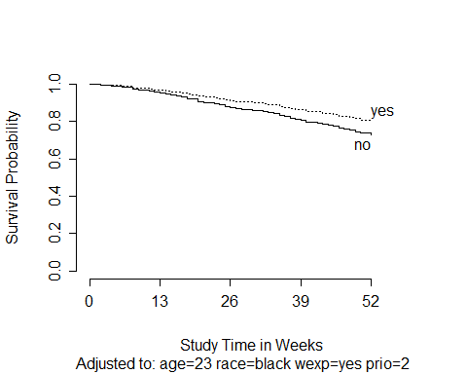

## survplot() from **rms** fit2_cph

* Looking at the race effect

survplot(fit2_cph, race = c("black", "other"),  
 time.inc = 13, type = "kaplan-meier",  
 xlab = "Study Time in Weeks")

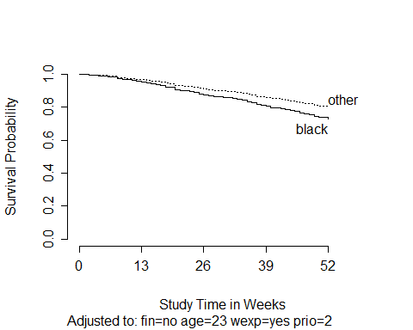

## survplot() from **rms** fit2_cph

* Looking at the age effect

survplot(fit2_cph, age = c(15, 25, 35, 45),  
 time.inc = 13, type = "kaplan-meier",  
 xlab = "Study Time in Weeks")

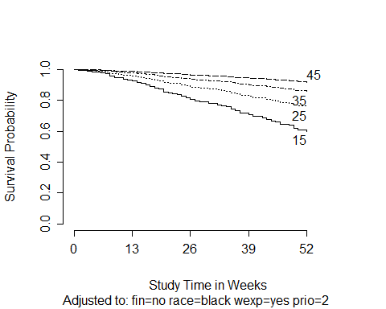

## survplot() from **rms** fit2_cph

* Looking at the wexp effect

survplot(fit2_cph, wexp = c("no", "yes"),  
 time.inc = 13, type = "kaplan-meier",  
 xlab = "Study Time in Weeks")

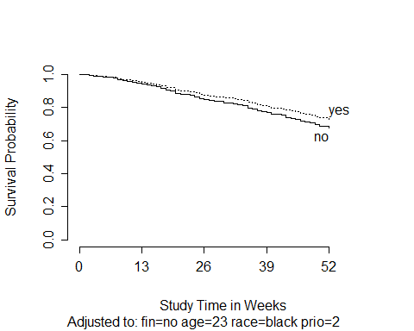

## survplot() from **rms** fit2_cph

* Looking at the prio effect

survplot(fit2_cph, prio = c(0, 2, 8, 16),  
 time.inc = 13, type = "kaplan-meier",  
 xlab = "Study Time in Weeks")

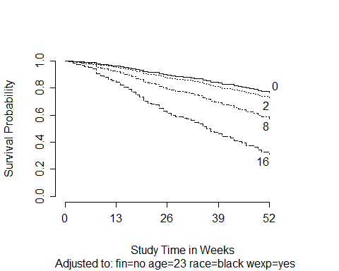

## fit2_cph Prediction Plots (1/3)

ggplot(Predict(fit2_cph))

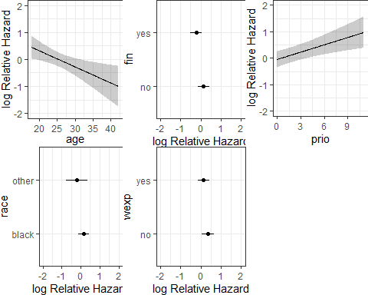

## fit2_cph Prediction Plots (2/3)

ggplot(Predict(fit2_cph, fun = exp))

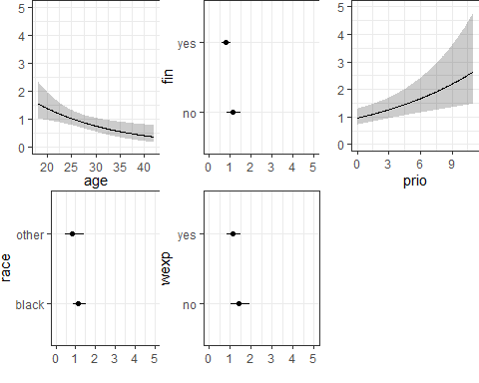

## fit2_cph Prediction Plots (3/3)

ggplot(Predict(fit2_cph, fun = plogis))

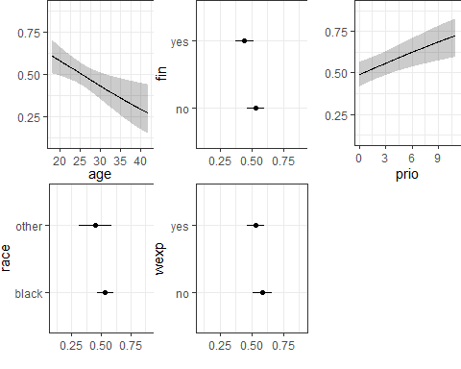

## Proportional Hazards Assumption?

cox.zph(fit2_cph, transform = "km", global = TRUE)

chisq df p  
fin 0.0599 1 0.8066  
age 6.0790 1 0.0137  
race 2.0366 1 0.1536  
wexp 4.1106 1 0.0426  
prio 0.5346 1 0.4647  
GLOBAL 17.0806 5 0.0043

## Proportional Hazards Assumption?

ggcoxzph(cox.zph(fit2_cph, transform = "km", global = TRUE))

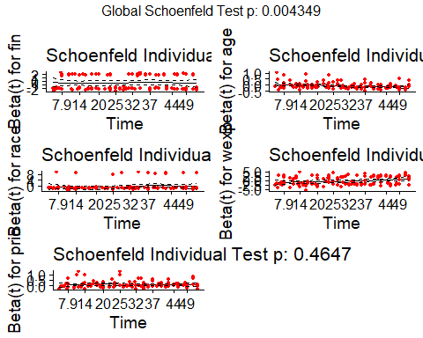

## Bootstrap Validated fit2_cph summaries

set.seed(432)  
validate(fit2_cph, B = 300)

index.orig training test optimism index.corrected n  
Dxy 0.2774 0.3002 0.2657 0.0345 0.2429 300  
R2 0.0737 0.0851 0.0652 0.0199 0.0538 300  
Slope 1.0000 1.0000 0.8892 0.1108 0.8892 300  
D 0.0226 0.0265 0.0199 0.0067 0.0159 300  
U -0.0015 -0.0015 0.0012 -0.0027 0.0012 300  
Q 0.0241 0.0280 0.0187 0.0094 0.0147 300  
g 0.6301 0.6808 0.5889 0.0919 0.5382 300

* Validated C statistic = 0.5 + (0.2429/2) = 0.62145
* Validated Nagelkerke $R^{2}$ = 0.0538

## Compare Performance

plot(compare_performance(fit1_cph, fit2_cph))

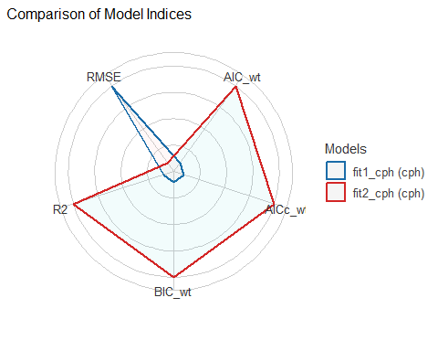

## fit2_cph Nomogram

sv <- Survival(fit2_cph)  
surv52 <- function(x) sv(52, lp = x)  
  
plot(nomogram(fit2_cph, fun = surv52, funlabel = c("52 week survival")))

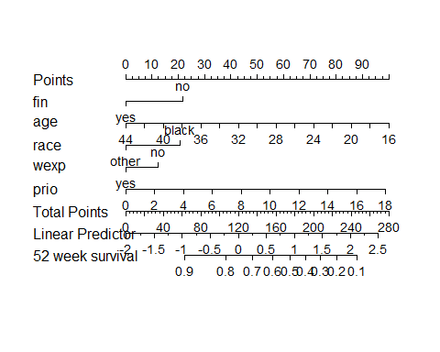

## Add Non-Linear Terms?

* Notice use of week rather than S here…

plot(spearman2(week ~ fin + age + race + wexp + prio, data = rossi_432))

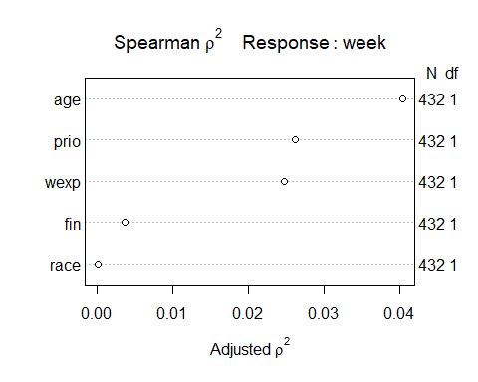

## Model fit3_cph

* We’ll include a four-knot restricted cubic spline in age, and the interaction between prio and wexp.

fit3_cph <- cph(S ~ rcs(age, 4) + prio * wexp + fin + race,   
 data = rossi_432, x = T, y = T, surv = T)

## fit3_cph

fit3_cph

Cox Proportional Hazards Model  
  
cph(formula = S ~ rcs(age, 4) + prio * wexp + fin + race, data = rossi_432,   
 x = T, y = T, surv = T)  
  
 Model Tests Discrimination   
 Indexes   
Obs 432 LR chi2 35.99 R2 0.084   
Events 114 d.f. 8 R2(8,432)0.063   
Center -5.4645 Pr(> chi2) 0.0000 R2(8,114)0.218   
 Score chi2 41.91 Dxy 0.298   
 Pr(> chi2) 0.0000   
  
 Coef S.E. Wald Z Pr(>|Z|)  
age -0.2617 0.1074 -2.44 0.0148   
age' 1.7834 1.2207 1.46 0.1440   
age'' -3.1846 2.3664 -1.35 0.1784   
prio 0.0985 0.0331 2.98 0.0029   
wexp=yes -0.1092 0.3097 -0.35 0.7245   
fin=yes -0.3441 0.1920 -1.79 0.0730   
race=other -0.3828 0.3105 -1.23 0.2176   
prio * wexp=yes -0.0100 0.0663 -0.15 0.8806

## fit3_cph Effects Plot

plot(summary(fit3_cph))

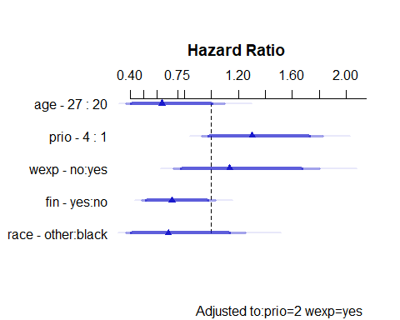

## fit3_cph Effects Table

summary(fit3_cph)

Effects Response : S   
  
 Factor Low High Diff. Effect S.E. Lower 0.95 Upper 0.95  
 age 20 27 7 -0.45052 0.27623 -0.991920 0.090883   
 Hazard Ratio 20 27 7 0.63730 NA 0.370870 1.095100   
 prio 1 4 3 0.26574 0.17154 -0.070485 0.601960   
 Hazard Ratio 1 4 3 1.30440 NA 0.931940 1.825700   
 wexp - no:yes 2 1 NA 0.12909 0.23346 -0.328480 0.586660   
 Hazard Ratio 2 1 NA 1.13780 NA 0.720010 1.798000   
 fin - yes:no 1 2 NA -0.34414 0.19198 -0.720420 0.032138   
 Hazard Ratio 1 2 NA 0.70883 NA 0.486550 1.032700   
 race - other:black 1 2 NA -0.38281 0.31051 -0.991400 0.225770   
 Hazard Ratio 1 2 NA 0.68194 NA 0.371060 1.253300   
  
Adjusted to: prio=2 wexp=yes

## survplot() from **rms** fit3_cph

* Looking at the fin effect

survplot(fit3_cph, fin = c("no", "yes"),  
 time.inc = 13, type = "kaplan-meier",  
 xlab = "Study Time in Weeks")

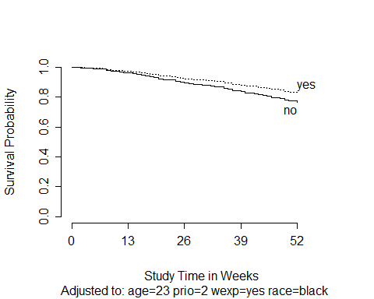

## survplot() from **rms** fit3_cph

* Looking at the age effect

survplot(fit3_cph, age = c(15, 25, 35, 45),  
 time.inc = 13, type = "kaplan-meier",  
 xlab = "Study Time in Weeks")

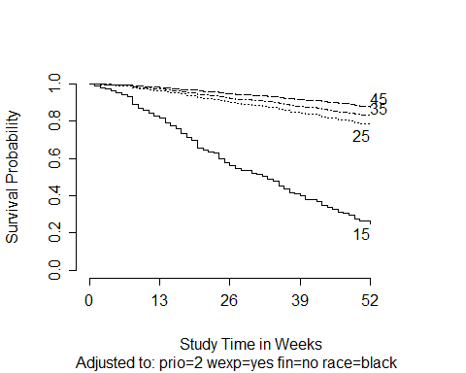

## fit3_cph Prediction Plots (raw)

ggplot(Predict(fit3_cph))

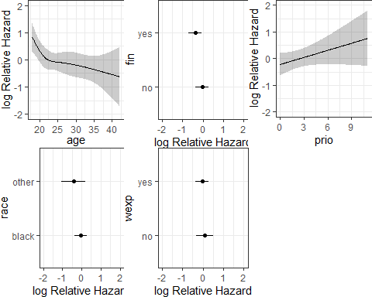

## fit3_cph Prediction Plots (plogis)

ggplot(Predict(fit3_cph, fun = plogis))

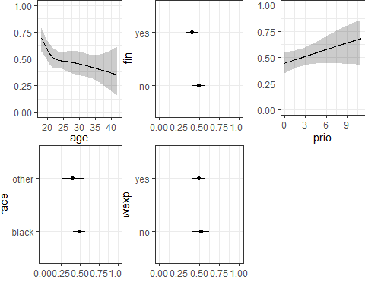

## Proportional Hazards Assumption?

ggcoxzph(cox.zph(fit3_cph, transform = "km", global = TRUE))

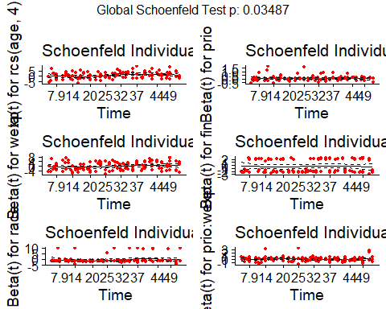

## Bootstrap Validated fit3_cph summaries

set.seed(432)  
validate(fit3_cph, B = 300)

index.orig training test optimism index.corrected n  
Dxy 0.2981 0.3269 0.2706 0.0564 0.2417 300  
R2 0.0836 0.1016 0.0690 0.0326 0.0510 300  
Slope 1.0000 1.0000 0.8319 0.1681 0.8319 300  
D 0.0259 0.0321 0.0211 0.0110 0.0149 300  
U -0.0015 -0.0015 0.0019 -0.0034 0.0019 300  
Q 0.0274 0.0336 0.0192 0.0144 0.0130 300  
g 0.6038 0.6922 0.5651 0.1271 0.4766 300

* Validated C statistic = 0.5 + (0.2417/2) = 0.62085
* Validated Nagelkerke $R^{2}$ = 0.0510

## Compare Performance

plot(compare_performance(fit1_cph, fit2_cph, fit3_cph))

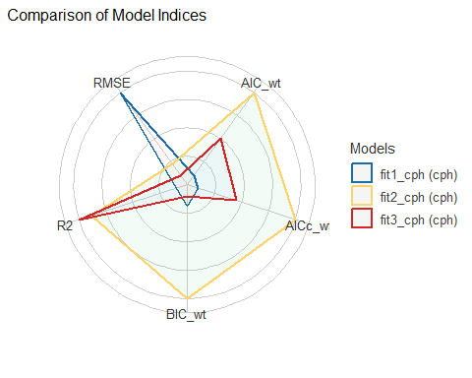

## fit3_cph Nomogram

sv <- Survival(fit3_cph)  
surv52 <- function(x) sv(52, lp = x)  
  
plot(nomogram(fit3_cph, fun = surv52, funlabel = c("52 week survival")))

