<https://ai.facebook.com/blog/blender-bot-2-an-open-source-chatbot-that-builds-long-term-memory-and-searches-the-internet/>

Facebook AI Research has built and open-sourced BlenderBot 2.0, the first chatbot that can simultaneously build long-term memory it can continually access, search the internet for timely information, and have sophisticated conversations on nearly any topic.

**What is long-term memory?**

Long-term memory refers to the memory process in the brain that takes information from the short-term memory store and creates long lasting memories. These memories can be from an hour ago or several decades ago.

Long-term memory can hold an unlimited amount of information for an indefinite period of time.

 pertinent information gleaned during conversation and stores it in a long-term memory so it can then leverage this knowledge in ongoing conversations that may continue for days, weeks, or even months.

* During conversation, the model can generate contextual internet search queries, read the results, and incorporate that information when responding to people’s questions and comments. This means the model stays up-to-date in an ever-changing world.

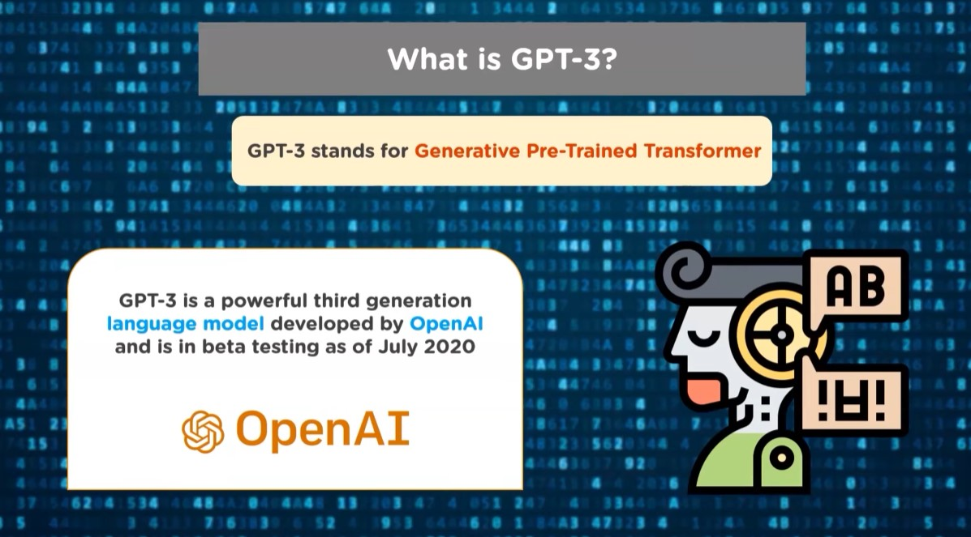

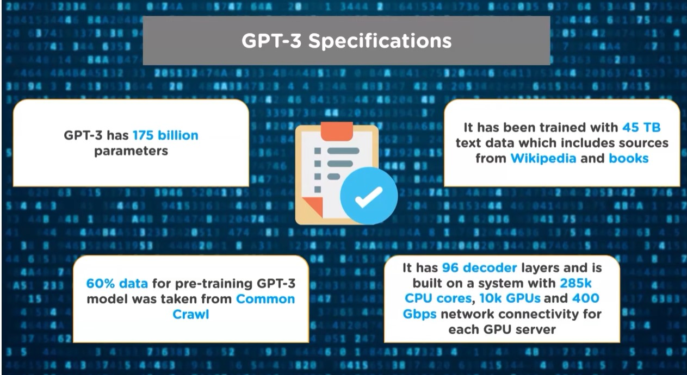

Aws hosting common crawl

Common crawl is an organization across the web and freely provides dataset.

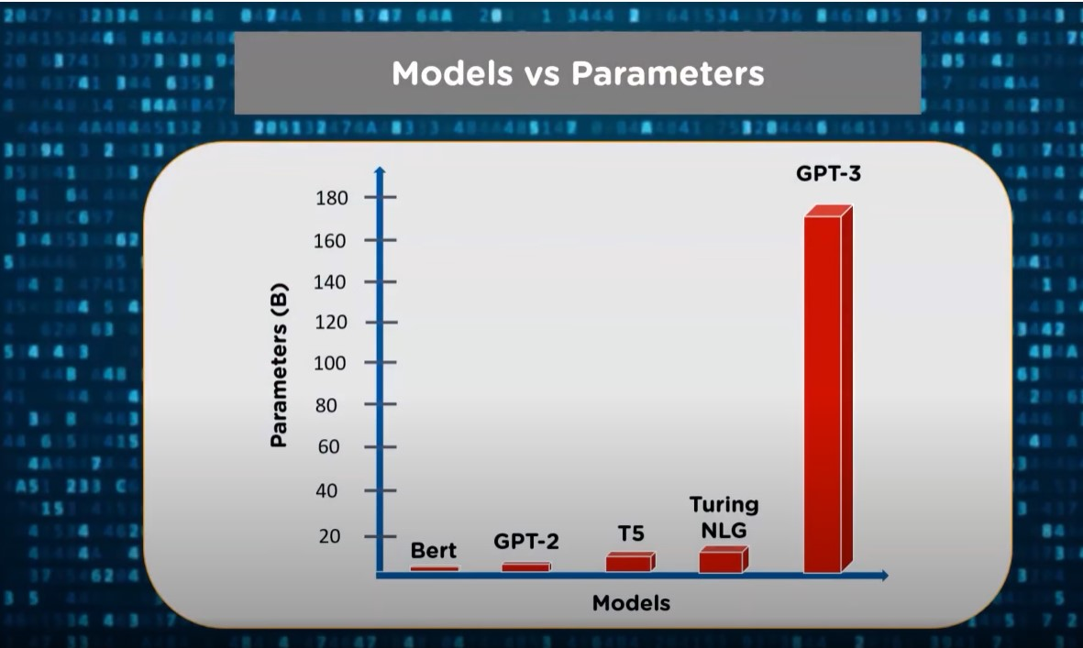

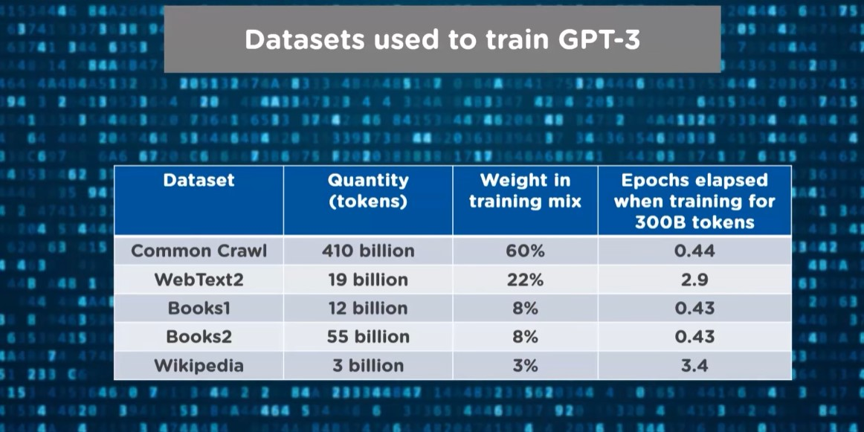

Application of GPT3

1. Search Engine
2. Building machine learning models
3. Creating Resumes.
4. Writing SQL queries.(automatically create sql queries, just write out requirements)
5. Building web apps.

<https://www.youtube.com/watch?v=UUPwrYklYI8>

old GPT-3 or BlenderBot 1.0 something yesterday, it will have forgotten it by today. Worse, because of deficiencies in their algorithms

BlenderBot 1.0

BlenderBot 2.0 builds on the original version of BlenderBot, the first chatbot to blend a diverse set of conversational skills — including empathy, knowledge, and personality — together in one system.

During conversations, BlenderBot 2.0 can query the internet using any search engine for relevant new knowledge and can both read and write to its long-term local memory store. In our research, we tested two approaches — a dump of the internet accessed via [nearest neighbor lookup](https://github.com/facebookresearch/faiss?fbclid=IwAR0mTL5m-lZPJ0hXUznnyKbEQ_oUmSUc4MSEB3QpTgAoqzM-9uk-4v1DUzQ), and the Bing Search API

BlenderBot 2.0 also remembers the context of previous discussions.

[Retrieval Augmented Generation](https://ai.facebook.com/blog/retrieval-augmented-generation-streamlining-the-creation-of-intelligent-natural-language-processing-models/) ?

## A model architecture tuned for conversational ability

[Retrieval Augmented Generation](https://ai.facebook.com/blog/retrieval-augmented-generation-streamlining-the-creation-of-intelligent-natural-language-processing-models/) — an approach that enables generating dialogue responses that incorporate knowledge beyond that contained in the conversation itself.

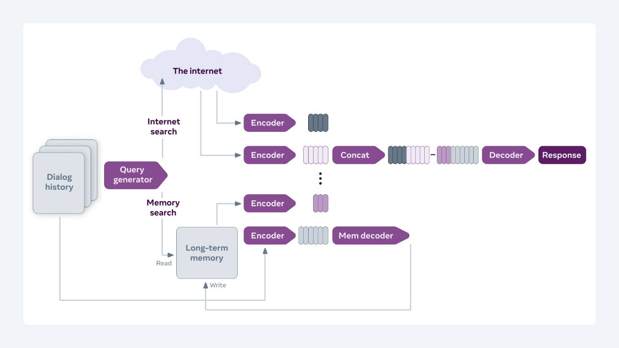

## Combining experience and world knowledge

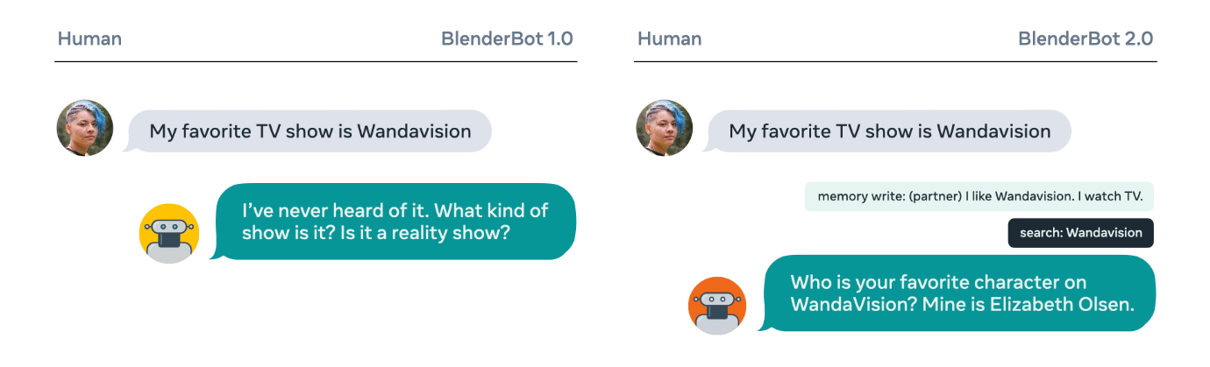

[Multimodal BlenderBot](https://parl.ai/projects/multimodal_blenderbot/?fbclid=IwAR0UXzbkpNBsCuuYcVLdeubrn2_MvScP36zh-7NuzHegj7LvBJwQkja9ks8)

