**A**

**Project Report On**

**URBAN PULSE**

### Submitted By

**GANESH THOTA [R200007]**

**KOWSHIK MEDA [R200272]**

**SOHAIL SHAIK [R200088]**

# Under the Guidance of

**Dr. K VINOD KUMAR**

**M.Tech (JNTU-A), Ph.D**

**Assistant Professor**

**Computer Science and Engineering**



## RAJIV GANDHI UNIVERSITY OF KNOWLEDGE TECHNOLOGIES

**(AP IIIT)**

R.K Valley,Vempalli,Kadapa (Dist.)-516330

## DEPARTMENT OF COMPUTER SCIENCE AND ENGINEERING

1



**Rajiv Gandhi University of Knowledge Technologies RK Valley, Kadapa (Dist.), Andhra Pradesh - 516330**

# CERTIFICATE

This is to certify that the project report entitled “ **URBAN PULSE**” being submitted by **GANESH THOTA [R200007], KOWSHIK MEDA [R200272], SOHAIL SHAIK [R200088]** under my guidance and supervision and is submitted to DEPARTMENT OF COMPUTER SCIENCE AND ENGINEERING in partial fulfilment of requirements for the award of Bachelor of Technology in **Computer Science and Engineering** during the academic year 2024- 2025 and it has been found worthy of acceptance according to the requirements of the University.

### Signature of Internal Guide

Dr. K. VINOD KUMAR M.Tech (JNTU-A), Ph.D

Assistant Professor

Computer Science and Engineering RGUKT RK Valley

### Signature of HOD

Dr. CH. RATNAKUMARI

Head of the Department Computer Science and Engineering RGUKT RK Valley

**Signature of External Guide**

# DECLARATION

Hereby declare that this project work entitled **“ URBAN PULSE**” submitted to DEPARTMENT OF COMPUTER SCIENCE AND ENGINEERING is a genuine work carried out by our team under the guidance of **Dr. K. Vinod Kumar**. This project is submitted in partial fulfillment of the requirements for the award of the degree of BACHELOR OF TECHNOLOGY.

We have not submitted this work elsewhere for the award of any other degree or diploma other than specified above

### Project Team

T.GANESH (R200007)

M.KOWSHIK (R200272)

S.SOHAIL (R200088)

# ACKNOWLEDGEMENT

I would like to express our sense of gratitude and respect to all those people behind the screen who guided, inspired and helped us to crown all our efforts with success. We wish to express our gratitude to our project coordinator **Dr. K Vinod Kumar** for his valuable guidance at all stages of study, advice, constructive suggestions, supportive attitude and continuous encouragement without which this project could not be possible.

I would also like to extend our deepest gratitude and reverence to the Head of Department of Computer Science and Engineering **Dr CH. RATNAKUMARI** (Asst. Professor, ME, PhD) and also Director of RGUKT, RK Valley **Prof. A V S S Kumara Swami Guptha** for their constant support and encouragement. Last but not least I express our gratitude to our parents for their constant source of encouragement and inspiration for us to keep our morals high.

**With our sincerce Records**

T.GANESH (R200007)

M.KOWSHIK (R200272)

S.SOHAIL (R200088)

**ABSTRACT**

The UrbanPulse project is conceived as a comprehensive digital civic platform specifically designed to address the pressing challenges of fragmented municipal services in urban environments. Currently, citizens often face inconvenience and inefficiency when attempting to access various local government services due to the lack of a single, unified interface. This leads to difficulties in everything from reporting civic issues and tracking their resolution to accessing timely information about local events, government schemes, and essential public data.

UrbanPulse directly confronts these issues by proposing a singular, accessible platform that aggregates diverse municipal functions. The core objective is to build a robust digital bridge between the government administration and the citizenry, fostering enhanced communication, transparency, and participation. By providing a streamlined and intuitive user experience.

UrbanPulse aims to simplify citizen interactions with services like complaint management, event notifications, access to public data (including census reports), utility bill reminders, and information on local landmarks and government representatives.

**Project Title :**

**URBANPULSE**

**TABLE OF CONTENTS:-**

**TITLE 1**

**CERTIFICATE 2**

**DECLARATION 3**

**ACKNOWLEDGEMENT 4**

**ABSTRACT 5**

|  |  |  |  |  |
| --- | --- | --- | --- | --- |
| **S.NO** | **TITLE** | | | **PAGE NO** |
| 1 | INTRODUCTION | | | 5-9 |
| 1.1 | Background and Importance of UrbanPulse | | | 6 |
| 1.2 | Challenges in Existing Urban Systems | | | 6-7 |
| 1.3 | Objectives of UrbanPulse | | | 7 |
| 1.4 | Technologies Used | | | 7-8 |
| 1.5 | Features of the System | | | 8 |
| 1.6 | Structure of the Report | | | 8-9 |
| 2 | METHODOLOGY | | | 9-12 |
| 2.1 | Requirement analysis | | | 10 |
| 2.2 | Planning | | | 10 |
| 2.3 | Development Method | | | 10-11 |
| 2.4 | Testing | | | 11 |
| 3 | MODULES | | | 12-16 |
| 3.1 | Complaint Management | | | 12 |
| 3.2 | Event Notification | | | 12 |
| 3.3 | Tourist & Landmark Discovery | | | 12-13 |
| 3.4 | Utility Bill Integration | | | 13 |
| 3.5 | Government Representatives Info | | | 13 |
| 3.6 | Tenders & Business Reports | | | 13-14 |
| 3.7 | History & Places | | | 14 |
| 3.8 | Chatbot | | | 14 |
| 3.9 | Census Report | | | 14-15 |
| 3.10 | Request Scheduling | | | 14-15 |
| 3.11 | RTI Submission | | | 15 |
| 3.12 | Review & Rating | | | 15 |
| 4 | SYSTEM ARCHITECTURE & DESIGN | | | 15-19 |
| 4.1 | System Layers | | | 15-16 |
| 4.2 | | Component Design | 16 | |
| 4.3 | | Database Schema | 16-17 | |
| 4.4 | | Data Flow | 18-19 | |
| 5 | | IMPLEMENTATION | 19-23 | |
| 5.1 | | Frontend Development | 19-20 | |
| 5.2 | | Backend Development | 20 | |
| 5.3 | | Database Design | 21-22 | |
| 5.4 | | APIs and Integration | 22 | |
| 5.5 | | Admin & User Panel Features | 22-23 | |
| 5.6 | | Security Considerations | 23 | |
| 6 | | Testing and Evaluation | 23-27 | |
| 6.1 | | Types of Testing | 23-25 | |
| 6.2 | | Automated Testing Pipeline | 25 | |
| 6.3 | | Evaluation of System Performance | 25-26 | |
| 6.4 | | Bug Tracking and Issue Resolution | 25 | |
| 7 | | Deployment and Maintenance | 26-33 | |
| 7.1 | | Deployment Process | 26-28 | |
| 7.2 | | Monitoring and Logging | 28-29 | |
| 7.3 | | Security Measures | 29 | |
| 7.4 | | Maintenance and Updates | 29-31 | |
| - | | REFERENCES | 33 | |

**CHAPTER 1**

**INTRODUCTION**

### Background and Importance of UrbanPulse

UrbanPulse is envisioned as a digital civic platform offering a unified experience for citizens to access various municipal services. From complaint registration to event notifications, from utility bill payments to exploring tourist places, UrbanPulse aims to bridge the gap between the government and citizens using technology.

### Challenges in Existing Urban Systems

* + - Fragmented platforms for civic services
    - No unified complaint redressal for plumbing, electrical, and water issues
    - Lack of digital event notifications
    - Inaccessibility of government schemes, tenders, and representatives
    - Limited access to data such as census or public statistics

### Objectives of UrbanPulse

* + - Easy complaint registration and tracking for essential services
    - Admin-managed event and festival notifications
    - Display landmarks and tourism points with description and reviews
    - Unified utility bill reminders
    - Access to historical and cultural insights of localities
    - Publish tenders and business-related government updates
    - Government representative directory (MP, MLA, ward members)
    - Integrated chatbot for query handling
    - Display census and demographic insights
    - Office visit scheduling for services
    - RTI request submission
    - Review system for public places

### Technologies Used

* + - **Frontend**: React.js + Tailwind CSS
    - **Backend**: Node.js / Express.js or Firebase SDK
    - **Database**: MongoDB / Firebase Firestore
    - **Map Integration**: Google Maps / Leaflet.js
    - **Authentication**: Firebase Authentication
    - **Notifications**: Firebase Notifications / custom backend scheduler
    - **Hosting**: Firebase Hosting
    - **Chatbot**: Dialogflow / custom NLP chatbot

### Features of the System

* + - Complaint management system with category routing
    - Notification and alert system
    - Locality map view and scrolling highlights
    - Utility bill management and reminders
    - Tenders, history, census, and government updates
    - Office request and RTI services
    - Chatbot for quick support
    - Community engagement via reviews and ratings

### Structure of the Report

Seven chapters covering: introduction, methodology, modules, system design, implementation, results, conclusion.

#### 

#### CHAPTER 2

#### METHODOLOGY

### Requirement Analysis

The first phase focused on identifying the needs of various stakeholders including local residents, administrative officers, and civic workers. Data was gathered through informal interviews, observation of existing systems, and comparison with similar digital platforms. The key insights were:

* + - Users needed a single platform for accessing civic services like complaint registration and bill payments.
    - There was no unified complaint tracking mechanism for water, electrical, or plumbing issues.
    - Traditional event announcements were ineffective and missed large sections of the population.
    - Many users wanted more transparency in accessing information about tenders, officials, and local history.

Functional and non-functional requirements were drafted to ensure usability, scalability, real-time interaction, and modular design.

### Planning

Agile methodology was selected to allow for flexibility and continuous feedback. The planning process was broken down into:

* + - Sprint-based task breakdown (each lasting 1-2 weeks)
    - Creation of wireframes and UI mockups using tools like Figma
    - Database schema design based on modular data collections (complaints, users, notifications, etc.)
    - Assigning clear roles within the team (frontend, backend, testing)

Deliverables were tracked using a Kanban-style board and regular meetings ensured collaboration.

**Development Method**

Development was carried out in three primary layers:

* + - **Frontend:** Developed using React.js, with responsive design ensured using Tailwind CSS. User interactions were designed to be simple, visually engaging, and fast.
    - **Backend:** Firebase was used for its real-time database capabilities. Where needed, Node.js and Express.js were implemented to handle API routes and scheduling tasks like notifications.
    - **Database:** Firebase Firestore was chosen for its NoSQL flexibility and real-time syncing, suitable for handling dynamic user and admin interactions.

### Testing

To ensure reliability and usability, rigorous testing was integrated into every stage:

* + - **Unit Testing:** Each component was tested independently for expected input/output behavior.
    - **Integration Testing:** Ensured smooth flow between frontend, backend, and database.
    - **User Acceptance Testing (UAT):** Conducted with a small group of students and faculty. Their feedback helped refine the UI and user flows.
    - **Edge Case Testing:** Covered network failures, invalid input handling, and empty submissions.

Bug reports were tracked and resolved in each sprint, with regression tests conducted before deployment.

### Deployment

The final system was deployed using Firebase Hosting for high availability and performance. Firebase's seamless integration with Firestore and Authentication made deployment efficient and reduced operational overhead.

Key features of the deployment strategy:

* + - **CI/CD Pipelines (optional):** GitHub integrated workflows for future updates.
    - **Real-Time Hosting:** Ensured quick access for both users and admins.
    - **Security:** Firebase Authentication secured role-based access while Firestore security rules protected user data.

The deployment process emphasized minimal downtime and smooth transition from development to live usage.

**CHAPTER 3**

**MODULES**

#### Complaint Management

The **Complaint Management** module allows citizens to report complaints related to municipal services such as plumbing, electrical issues, water supply, and more. The module is designed to streamline the entire process, from complaint submission to resolution.

* + - **Complaint Categories**: Users can submit complaints under various categories (plumbing, electrical, water supply, etc.), ensuring that the issue is routed to the correct department.
    - **Complaint Tracking**: Each complaint is assigned a unique ID, and users can track the status of their complaints in real-time. Admins are able to update the status of the complaint, and citizens are notified when the issue is resolved.
    - **Admin Control**: Admins can view and manage all complaints. They have the authority to categorize, prioritize, and respond to the complaints, ensuring effective issue resolution.
    - **Notifications**: Users receive notifications when there are updates to their complaints, such as status changes, resolutions, or requests for more information.

#### Event Notification

The **Event Notification** module serves as a communication channel between the local government and the citizens regarding upcoming events, festivals, government programs, and public activities. It provides an easy way to keep the public informed and engaged with local events.

* + - **Admin Managed**: Admins have the ability to create event notifications, which can be tailored to specific areas or the entire locality.
    - **Broadcasting**: Notifications can be broadcast to all users or specific groups, ensuring that the right information reaches the right people.
    - **Real-Time Notifications**: Citizens receive timely notifications about events, ensuring they never miss out on local happenings.
    - **User Interaction**: Citizens can interact with the notifications, marking events as ‘interested’ or adding them to a personal calendar.

#### Tourist & Landmark Discovery

This module integrates a map interface that allows users to explore various landmarks and tourist attractions in their locality. It aims to promote local tourism and provide a convenient way for residents and visitors to discover key places.

**Map Integration**: The map view utilizes services like **Google Maps** or **Leaflet.js** to display various points of interest, including landmarks, tourist spots, restaurants, and public services.

* + - **Details and Reviews**: Each landmark or tourist spot includes detailed descriptions, directions, ratings, and reviews. This helps users make informed decisions about places to visit.
    - **Navigation**: The map provides step-by-step navigation for users to easily reach their chosen destination.
    - **Tourist Guides**: Admins can manage a list of tourist guides, offering additional support for people new to the area.

#### Utility Bill Integration

The **Utility Bill Integration** module consolidates all government-related utility bills such as property tax, water, electricity, and more into a unified platform, offering users a simple and efficient way to manage their payments.

* + - **Bill Reminders**: Users receive automated reminders for upcoming bill payments, preventing late fees and missed deadlines.
    - **Payment Integration**: Users can make payments directly through the platform (via integration with payment gateways) or opt for external payment systems, streamlining the process.
    - **Bill History**: The module keeps track of users’ past payments, offering easy access to their payment history for reference and record-keeping.
    - **Admin Control**: Admins can update and track utility bills for citizens and manage any issues related to incorrect charges or payments.

#### Government Representatives Info

The **Government Representatives Info** module provides a comprehensive directory of elected representatives and government officials, helping citizens easily find and contact their local MPs, MLAs, ward members, and other government representatives.

* + - **Directory**: Includes contact information, office hours, and constituency details for all relevant government representatives.
    - **Citizen Engagement**: Citizens can directly contact their representatives for assistance, feedback, or concerns.
    - **Admin Control**: Admins can keep the directory up-to-date with the latest contact information and office locations.

#### History & Places

The **History & Places** module provides valuable insights into the cultural, historical, and scenic aspects of localities. It aims to promote cultural heritage and local pride by showcasing significant places and their history.

* + - **Historical Insights**: This section displays information about the area’s cultural and historical significance, helping citizens and visitors appreciate local traditions and heritage.
    - **Scenic Spots**: Users can discover parks, museums, monuments, and other places of interest, with descriptions, photos, and user-generated content.
    - **Local Business Highlights**: Promotes local businesses by offering them a platform to highlight their services and products to the community.
    - **User Interaction**: Citizens can contribute by adding places to the directory, leaving comments, and sharing their experiences.
    - Tenders & Business Reports

This module aims to improve transparency and accessibility in the procurement process, enabling businesses and entrepreneurs to view and apply for government tenders and related opportunities.

* + - **Tender Listings**: The module displays all active government tenders and business opportunities within the locality, categorized by type (construction, services, etc.).
    - **Notifications**: Businesses and interested parties are notified of new tenders relevant to them.
    - **Tender Submission**: Businesses can submit their bids and proposals directly through the platform, simplifying the process and making it more accessible.
    - **Reporting**: The module generates reports for both businesses and government officials, ensuring transparency and accountability in the procurement process.

#### Chatbot

The **Chatbot** module serves as a digital assistant that helps users navigate the platform, find information, and resolve queries quickly.

* + - **AI Integration**: The chatbot uses AI and Natural Language Processing (NLP) techniques (via **Dialogflow** or a custom-built solution) to understand and respond to user queries effectively.
    - **Query Handling**: Users can ask the chatbot questions related to services, events, bills, or general information about the city.
    - **24/7 Availability**: The chatbot is available round the clock, ensuring that users have access to assistance at any time.

#### Census Report

The **Census Report** module displays real-time data about the local population, including demographic information such as age, gender ratio, literacy rate, and more.

* + - **Real-Time Dashboard**: A dynamic dashboard that displays live population statistics, updated regularly from official sources.
    - **Data Visualization**: The module uses charts, graphs, and maps to visually present demographic trends and insights.
    - **Data Access**: Local government officials can access detailed data for planning purposes, while citizens can use the information to better understand their community.

#### Request Scheduling

This module enables citizens to request appointments with government officers for specific services or consultations.

* + - **Appointment Booking**: Users can submit appointment requests for services like document verification, complaint resolution, or consultation with local officials.
    - **Admin Approval**: Admins review and approve appointments, assigning specific times and dates for meetings.
    - **Notifications**: Both users and officials receive notifications confirming or reminding them of the scheduled appointments.

#### RTI Submission

The **RTI Submission** module allows users to submit applications for information from public authorities under the **Right to Information Act (RTI)**.

* + - **Form Submission**: Users can submit RTI requests through a simple online form, specifying the details of the information they wish to obtain.
    - **Admin Tracking**: Admins can track the status of RTI applications and ensure that responses are provided within the legal timeframe.
    - **Public Access**: RTI requests and their responses may be made publicly available.

#### Review & Rating

The **Review & Rating** module allows users to rate and review various public places such as parks, hospitals, and tourist spots. This module aims to increase public engagement and improve the quality of services.

* + - **Rating System**: Users can rate places on a scale (e.g., 1 to 5 stars) based on their experience.

## 

## CHAPTER 4

## SYSTEM ARCHITECTURE & DESIGN

In this chapter, we will detail the overall architecture of the UrbanPulse system, explaining the layers, components, database schema, and data flow involved. This architecture serves as the blueprint for the system's design and implementation, ensuring that all functional modules interact seamlessly and efficiently.

#### System Layers

UrbanPulse is built on a multi-layered architecture to separate concerns and ensure scalability, flexibility, and maintainability. The system follows a typical 3-tier architecture:

#### Presentation Layer:

* + - * **Frontend (React.js)**: The presentation layer is the user interface that interacts directly with the users. It is built using React.js, a popular JavaScript library for creating interactive user interfaces. This layer is responsible for rendering dynamic views based on user actions. React's component-based structure makes it easy to build and maintain the UI, while the use of **Tailwind CSS** ensures a responsive and visually appealing design. The frontend handles user authentication through **Firebase Authentication**, ensuring that only authorized users (citizens or admins) can access specific features.

#### Logic Layer:

* + - * **Backend (Firebase Functions/Express.js)**: The logic layer handles all the business logic of the application. It is responsible for processing user requests, triggering notifications, handling complaint updates, and more. The backend can be implemented using **Firebase Cloud Functions** or **Node.js** with **Express.js**, depending on the specific requirements. Firebase Functions are preferred for real- time interactions and scaling, especially for services like notifications, while Express.js can be used for custom API routes when more complex routing logic is required.

#### Data Layer:

* + - * **Database (Firestore/MongoDB)**: The data layer is where all the system’s data is stored. **Firebase Firestore** is used due to its real-time capabilities, which are ideal for applications that require instant updates across devices (such as notifications or complaint tracking). Firestore’s NoSQL structure is flexible and scales well for dynamic and semi-structured data like complaints, events, and user profiles. In some cases, **MongoDB** might be used as an alternative when more complex queries or a different database structure is needed. Both databases are cloud-based and fully managed, ensuring reliability and ease of scaling.

#### Component Design

The components of the system are modular, each serving a specific function within the platform. These components work together to provide users and admins with a seamless experience. Below are the key components:

#### Forms:

* + Forms are used for collecting user input such as complaints, RTI requests, scheduling appointments, etc. These forms are designed with user-friendly interfaces to ensure ease of use.
  + Example: The complaint submission form will include fields like issue category (plumbing, electrical, water), description, and location.

#### Dashboards:

* + **User Dashboard**: This is where users can view their complaints, track their status, and view notifications. It is a central hub for managing all user interactions with the system.
  + **Admin Dashboard**: Admins have a more advanced dashboard that allows them to manage complaints, broadcast notifications, schedule events, and access detailed reports on civic activities.

#### Notifications System:

* + This component allows the system to send updates to users and admins. Notifications are sent for events such as complaint updates, new events, reminders for utility bills, etc. These are managed through Firebase Cloud Messaging or custom backend schedules to ensure timely delivery.

#### Map Interface for Locations:

* + UrbanPulse integrates a map system (Google Maps or **Leaflet.js**) that allows users to explore local landmarks, tourist destinations, and facilities. The map can display locations with markers and provide directions, helping users easily find places of interest.

#### Census and Analytics Dashboard:

* + This component provides a live dashboard displaying demographic data such as population statistics, gender ratio, literacy rates, etc. It also helps government officials access insights into local areas.

#### Chatbot Modal for Interaction:

* + The AI-powered chatbot helps users with queries and navigation, making it easier to find information without having to navigate through multiple pages. The chatbot can handle common inquiries and even gather user feedback.

#### Database Schema

The system’s database is structured to support all the different modules and features. The database schema for Firestore (or MongoDB) is designed around collections that store different data entities. Below is an outline of the schema:

#### users:

* + - * Stores user details such as ID, name, role (user/admin), contact details, etc.
      * Example document structure:

{

"user_id": "abc123",

"name": "John Doe",

"role": "user",

"contact": ["john@example.com"](mailto:john@example.com)

}

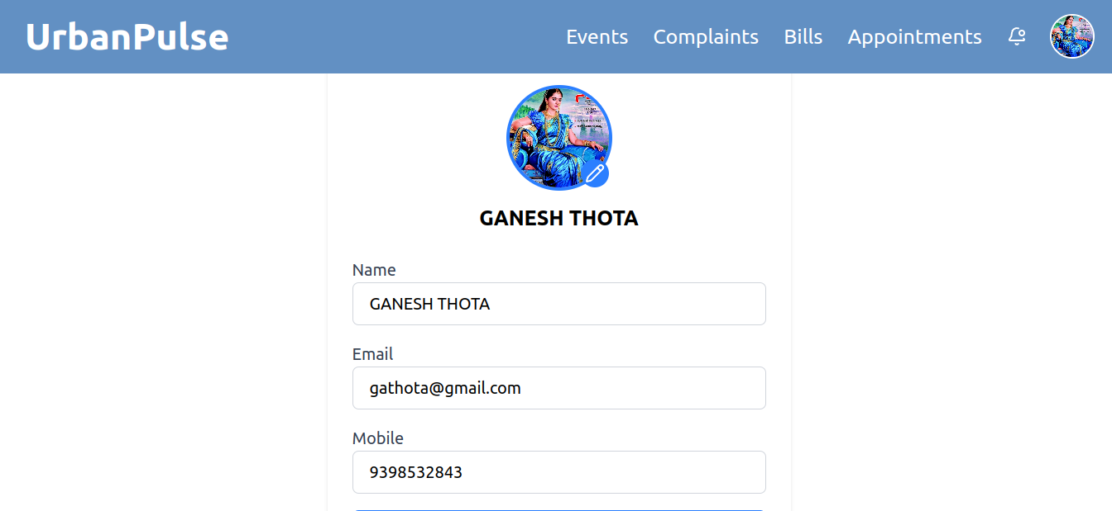

#### complaints:

* + - * Stores complaints raised by users. Each complaint document includes details such as description, category, status, and location.
      * Example document structure:

{

"complaint_id": "complaint123", "description": "Water leakage in kitchen", "category": "plumbing",

"status": "pending", "location": "Street 45, Area 3"

}

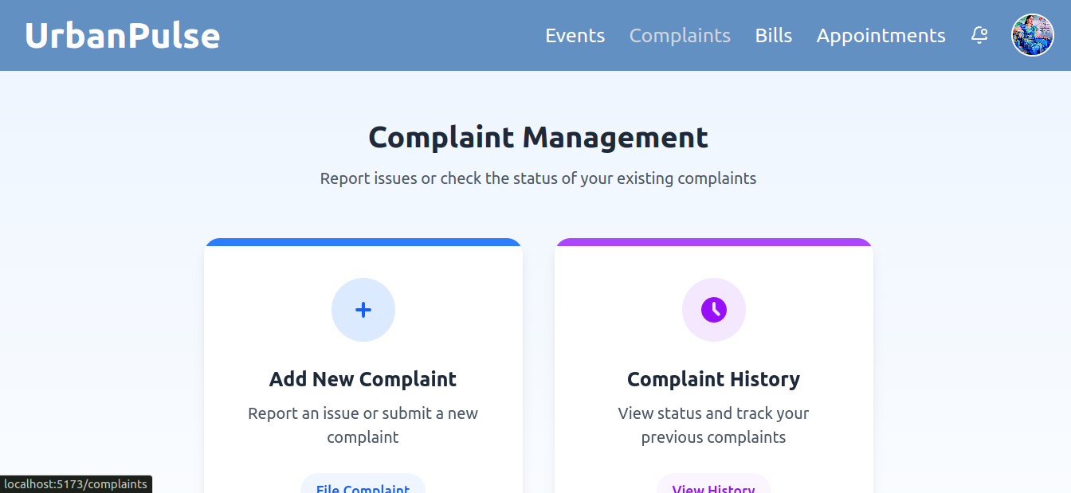

#### places:

* + - * Stores information about local landmarks and tourist destinations.
      * Example document structure:

{

"place_id": "place123", "name": "City Park",

"type": "park",

"description": "A large park with gardens and walking paths", "rating": 4.5

}

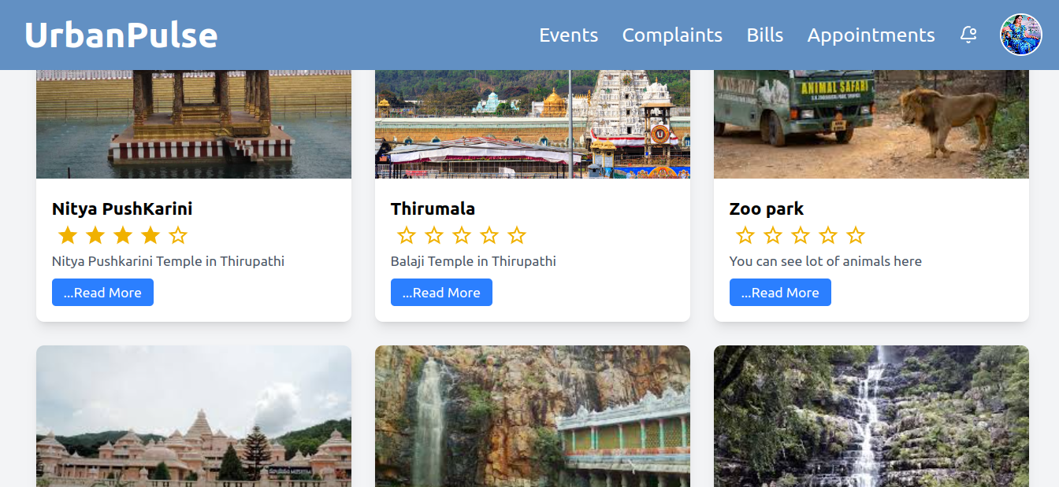

#### notifications:

* + - * Stores notifications sent to users. Each notification includes the user ID, message, and timestamp.
      * Example document structure:

{

"user_id": "abc123",

"message": "Your complaint has been updated.", "timestamp": "2025-04-21T08:00:00Z"

}

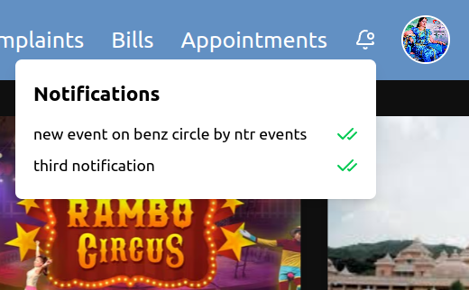

#### rti_requests:

* + - * Stores information about RTI (Right to Information) requests.
      * Example document structure:

{

"rti_id": "rti123",

"content": "Request for public information on water supply", "user_id": "abc123",

"status": "pending"

}

#### schedules:

* + - * Stores appointments scheduled for users to meet with government officials.
      * Example document structure:

{

"schedule_id": "schedule123", "appointment_date": "2025-04-22", "user_id": "abc123",

"purpose": "Water Supply Issue"

}

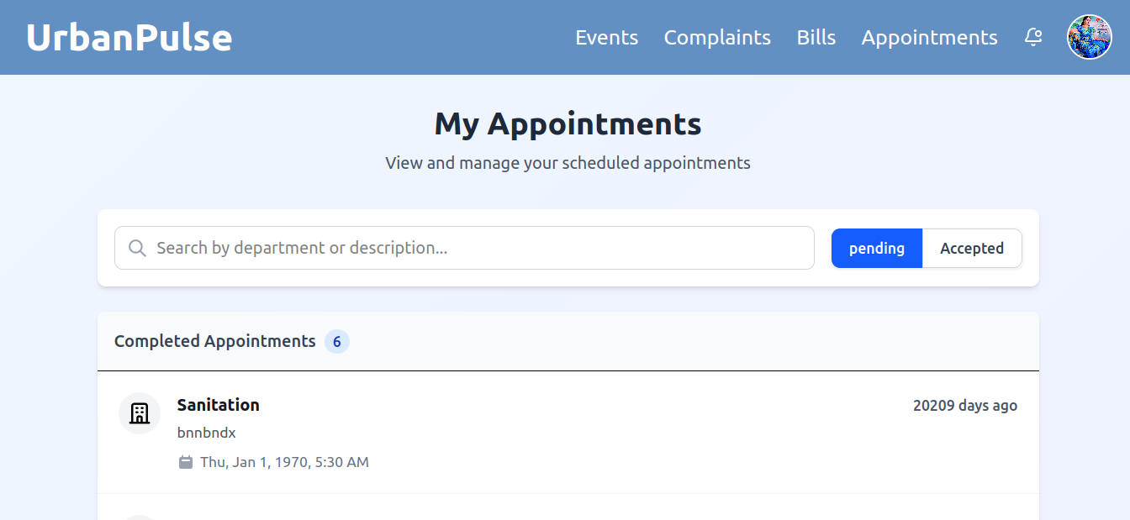

#### Data Flow

The data flow describes how data moves through the system. Below is an overview of how data flows in UrbanPulse:

#### User Action:

* + A user submits a form (complaint, RTI request, appointment request).
  + The data is sent to the **backend** for processing.

#### Backend Processing:

* + The backend processes the data, storing it in the appropriate database collection (e.g., Firestore).
  + If necessary, the backend triggers a notification to update the user or admin.
  + For instance, when a complaint is created, an event notification may be triggered to inform admins.

#### Real-time Updates:

* + As the complaint is updated (status changes, response from admin), the changes are reflected in the UI in real-time using Firebase’s real-time data syncing.

#### Notifications:

* + Whenever an important event occurs (like a complaint being resolved), a **notification** is generated and pushed to the relevant users. This can be through Firebase Cloud Messaging or custom triggers.

## 

## CHAPTER 5

## IMPLEMENTATION

This chapter provides a detailed explanation of how each component of the **UrbanPulse** platform is implemented. The implementation phase is crucial in converting the design into a working system that meets all user requirements. This chapter will cover frontend development, backend development, database design, APIs and integrations, admin and user panel features, and security considerations.

#### Frontend Development

The frontend of UrbanPulse is developed using **React.js**, a powerful JavaScript library for building user interfaces, along with **Tailwind CSS** for styling. React’s component-based architecture allows for reusability and scalability of UI components, while Tailwind CSS offers a utility-first approach to styling, enabling fast and responsive design.

#### Key Features of the Frontend:

* + - **Component-Based UI**: The frontend is divided into reusable components, each of which represents a specific part of the UI (e.g., forms, notifications, complaint cards, event listings).
    - **React Router**: **React Router** is used for client-side routing, enabling seamless navigation between pages without requiring full page reloads.
    - **Responsive Design**: Tailwind CSS ensures that the UI is fully responsive across various devices, including mobile phones, tablets, and desktops. The system adjusts its layout and content according to the screen size.
    - **Firebase Authentication**: Firebase Authentication is integrated to provide secure login functionality. It supports various authentication methods such as email/password and Google authentication, allowing users to register, log in, and access specific roles (admin or user).
    - **State Management**: React’s built-in state management (using React hooks) is utilized to manage the dynamic state of components, ensuring that the UI updates in real-time when there are changes to user data or system status.

#### Frontend Flow:

* + - The user interacts with the UI components such as complaint submission forms, event notifications, or the map interface.
    - Data is fetched from the backend or Firestore and displayed in a user-friendly manner. Updates to the data, such as complaint status changes or event notifications, are immediately reflected on the frontend due to React’s reactivity.
    - Firebase Authentication controls access, ensuring only authorized users can submit complaints or access admin features.

#### Backend Development

The backend of UrbanPulse is responsible for handling requests from the frontend, processing business logic, interacting with the database, and managing notifications. Depending on the complexity of the system, **Firebase Functions** or **Node.js with Express.js** is used.

#### Firebase Functions:

* + - **Real-Time Functionality**: Firebase Functions are used for real-time capabilities, such as updating the complaint status or sending notifications. For example, when a complaint status changes, a Firebase Function can trigger an update to the Firestore database, which will automatically reflect on the frontend without needing a manual refresh.
    - **Serverless Model**: Firebase Functions are serverless, meaning they automatically scale based on the number of requests. This makes the backend highly efficient and cost-effective, especially for handling sudden spikes in user activity.

#### Node.js / Express.js:

* + - **API Routes**: In cases where more complex logic or API integration is required, **Node.js with Express.js** is used to define RESTful API routes for the system. For example, an admin might need to create a custom API route for broadcasting notifications to all users, which would be handled by an Express.js route.
    - **Role-Based Access**: Role-based access control (RBAC) is implemented to differentiate between user and admin roles. Admins can access more advanced features, such as managing complaints or creating event notifications.

#### Backend Flow:

* + - When a user submits a complaint, request, or other form, the backend processes the data, stores it in the database, and updates any relevant systems (e.g., notifications, real-time status updates).
    - Admin actions, such as updating complaint statuses or sending bulk notifications, are handled by backend API endpoints or Firebase Functions.

**5.3 Database Design**

The database design is a crucial aspect of the **UrbanPulse** system as it manages all the dynamic data, including user profiles, complaints, notifications, events, and more. **Firebase Firestore** is chosen due to its NoSQL structure, real-time capabilities, and flexibility. Each key data entity in the system corresponds to a separate collection in Firestore or MongoDB.

#### Database Schema:

* + - **users**: This collection stores user-related information such as name, contact details, and role (user or admin).
      * Example document:

{"user_id": "user123", "name": "John Doe",

"role": "user",

"contact": ["john.doe@example.com"](mailto:john.doe@example.com)

}

* + - **complaints**: Each document in this collection represents a complaint or service request submitted by a user. It includes fields like description, category (plumbing, electrical, etc.), location, and status.
      * Example document:

{

"complaint_id": "complaint123",

"description": "Water leakage in the kitchen", "category": "plumbing",

"status": "pending", "location": "Street 45, Area 3"

}

* + - **notifications**: This collection stores notifications sent to users or admins. Notifications can be triggered by actions such as a complaint update or an event notification.
      * Example document:

{

"user_id": "user123",

"message": "Your complaint status has been updated to 'resolved'.",

"timestamp": "2025-04-21T08:00:00Z"

}

* + - **events**: Stores information about local events, festivals, and programs. This collection includes details like event name, description, date, and location.
      * Example document:

{

"event_id": "event123",

"name": "Annual Cultural Festival",

"description": "A celebration of local culture and art.", "date": "2025-05-15",

"location": "City Park"

}

#### Database Flow:

* + - When a user submits a complaint or request, the data is added to the **complaints** collection.
    - Notifications are triggered in real-time, updating the **notifications** collection and delivering them to the relevant users.
    - Admins can manage complaints and events, and updates are automatically reflected across the system.

**5.4 APIs and Integration**

UrbanPulse relies on **APIs and third-party integrations** to enhance functionality. The following integrations are implemented:

1**. Google Maps / Leaflet.js:**

* + The map integration allows users to explore landmarks, tourist spots, and other points of interest. Google Maps is used for detailed location data and navigation, while **Leaflet.js** is used for custom map interactions.

#### Notifications:

* + Firebase Cloud Messaging (FCM) is used to send real-time notifications to users and admins for updates on complaints, events, or other important system activities. FCM ensures notifications are pushed immediately after an event occurs (e.g., complaint status update).

#### Dialogflow Chatbot:

* + The **Dialogflow** integration enables the chatbot, which uses natural language processing (NLP) to understand and respond to user queries. The chatbot can handle common inquiries such as “Where is the nearest hospital?” or “What is the status of my complaint?”

#### APIs for External Data:

* + The system may also integrate with external APIs for census data, government updates, or other relevant information to enrich the user experience.

**5.5 Admin & User Panel Features**

The system has distinct panels for both **users** and **admins**, each with its own set of features.

#### User Panel Features:

* + - **Complaint Management**: Users can submit and track complaints related to civic services such as plumbing, electrical, or water issues. They can view the status of their complaints and receive updates through notifications.
    - **Event Notifications**: Users can view notifications about local events, festivals, and programs.
    - **Landmark Exploration**: Users can explore nearby landmarks, tourist destinations, and other points of interest through the integrated map.
    - **Payment Reminders**: Utility bills and other payments are tracked, and users receive reminders before the due date.

#### Admin Panel Features:

* + - **Complaint Management**: Admins can manage all complaints submitted by users. They can update the status, assign complaints to relevant departments, and respond to users.
    - **Event Creation & Management**: Admins can create and broadcast event notifications to users.
    - **User Management**: Admins can view user profiles, manage roles, and handle user authentication issues.
    - **Notifications**: Admins can create and send notifications related to complaints, events, or any other system updates.

**5.6 Security Considerations**

Security is paramount to protect sensitive user data and ensure the system operates securely. The following measures are implemented:

* + - **Firebase Authentication**: This ensures that users can securely log in and authenticate with their accounts using different authentication methods (email/password, Google login).
    - **Role-Based Access Control (RBAC)**: Different roles (user/admin) are assigned different levels of access to the system. Admins have full access to system management tools, while regular users have access to complaints, notifications, and event information.
    - **Firestore Security Rules**: Firestore uses security rules to define who can read or write to certain collections based on their role or specific conditions (e.g., only admins can write to the complaints collection).
    - **HTTPS**: All communication between the frontend, backend, and database is encrypted using HTTPS to ensure data is transmitted securely.

This chapter covers how **UrbanPulse** is implemented, from frontend development using React.js and Firebase Authentication to backend services with Firebase Functions and Node.js. The robust backend, real-time database, API integrations, and user/admin features ensure that the platform functions smoothly while providing a high-quality user experience. Security considerations have also been carefully implemented to protect sensitive data and user privacy.

## 

## CHAPTER 6

## TESTING AND EVALUATION

This chapter focuses on the testing and evaluation phase of the **UrbanPulse** project. Testing is a critical part of the development process, ensuring that the system functions as intended, meets user requirements, and is free from major bugs.

#### Types of Testing

The testing process for **UrbanPulse** is comprehensive and includes multiple testing phases to ensure both frontend and backend functionalities are robust, reliable, and secure. The following types of testing were conducted:

#### Unit Testing:

* + - * Unit testing is used to test individual components and functions to verify that they work correctly in isolation. In the case of **UrbanPulse**, unit tests were written for critical business logic components in both the frontend (React components) and backend (Firebase Functions, Node.js APIs).
      * **Tools Used:**
        + **Jest**: A popular JavaScript testing framework used for testing React components and functions in isolation.
        + **Mocha & Chai**: Used for backend testing of Node.js routes and Firebase functions, ensuring the server-side logic is functioning as expected.

#### Example:

* + - * + Testing a React component such as a complaint submission form to ensure that user inputs are handled correctly.
        + Testing Firebase functions to ensure they are triggered correctly when a complaint status is updated or a notification is sent.

#### Integration Testing:

* + - * Integration testing ensures that different modules of the system work together as expected. This is particularly important for testing the interaction between the frontend and backend, as well as between different API integrations (e.g., Firebase authentication, map services).

#### Tools Used:

* + - * + **Supertest**: Used to test HTTP APIs by making requests to the backend and checking the responses.
        + **Enzyme**: A tool used for testing React components, ensuring that components integrate properly with the app’s state and props.

#### Example:

* + - * + Testing the interaction between the frontend and backend when a user submits a complaint. The test checks if the complaint is correctly stored in the database and if the user receives the correct status update notification.

#### Functional Testing:

* + - * Functional testing focuses on ensuring that the application’s functionality meets the requirements specified by the stakeholders. For **UrbanPulse**, this includes testing features like complaint submission, event notifications, and map integration.

#### Tools Used:

* + - * + **Cypress**: A powerful end-to-end testing tool that simulates real user interactions and checks if the system works as expected from a user’s perspective.
        + **Selenium**: Automated testing for browser-based interactions, ensuring that user actions (e.g., logging in, submitting complaints) produce the correct responses.

#### Example:

#### Testing the functionality of submitting a complaint: The user fills out a form, submits it, and the system must correctly store the complaint in the database and trigger the appropriate notifications.

#### User Acceptance Testing (UAT):

* + - * User Acceptance Testing involves verifying the system’s functionality from the perspective of the end user. This phase ensures that the application meets the user’s needs, expectations, and business requirements.

#### Tools Used:

* + - * + **Manual Testing**: UAT for **UrbanPulse** was conducted manually by a set of test users, including both administrators and regular users, who interacted with the system and provided feedback.
        + **Test Cases**: Test cases were developed based on user stories (e.g., submitting a complaint, viewing events) to ensure that the system meets all functional requirements.

#### Example:

* + - * + Regular users tested complaint submission forms, event notifications, and the map functionality, while admins tested complaint management features, event creation, and notification broadcasting.

#### Performance Testing:

* + - * Performance testing is conducted to ensure that the system can handle a high volume of users and requests without significant degradation in performance. This is critical for ensuring that **UrbanPulse** can scale and accommodate future growth.

#### Tools Used:

* + - * + **Apache JMeter**: Used to simulate multiple users accessing the system simultaneously, testing for load and stress under different conditions.
        + **Firebase Performance Monitoring**: Integrated into the app to track latency, load times, and bottlenecks in real time.

#### Security Testing:

* + - * Security testing ensures that the application is secure and resistant to common vulnerabilities such as cross-site scripting (XSS), SQL injection, and unauthorized access.

#### Tools Used:

* + - * + **OWASP ZAP (Zed Attack Proxy)**: A tool used for finding security vulnerabilities in the application by performing automated penetration testing.
        + **Burp Suite**: Another tool for security testing, particularly focused on intercepting web traffic and analyzing security risks in the app’s communication layers.

#### Example:

* + - * + Testing to ensure that unauthorized users cannot access admin routes or view sensitive user information. Testing also includes checking that data is encrypted during transmission using HTTPS and Firebase security rules.

#### Automated Testing Pipeline

To ensure continuous integration and deployment (CI/CD), **UrbanPulse** integrates automated testing into the development pipeline. This setup allows for the automated execution of tests every time there is a code update or change, ensuring that no new changes break the existing functionality.

#### CI/CD Tools Used:

* + - * **GitHub Actions**: Integrated with GitHub, it automatically runs tests on new commits or pull requests, ensuring that any changes are tested before merging into the main branch.
      * **CircleCI**: Used to build, test, and deploy the application automatically, providing quick feedback on code quality and functionality.

#### Test Automation Flow:

* + - * Developers write unit and integration tests for each feature.
      * Each push to the repository triggers the testing pipeline, running tests in parallel on different environments (e.g., staging or development).
      * If tests pass successfully, the code is merged, and the system is deployed to production.
      * If tests fail, developers receive feedback and can fix issues before they are merged into the production environment.

**6.3 Evaluation of System Performance**

Once the system is thoroughly tested, the next phase is evaluating its performance in real-world conditions. This includes assessing the system's speed, reliability, and how well it meets the goals set out in the project objectives.

#### Evaluation Metrics:

* **Response Time**: The time it takes for the system to process a request (e.g., submitting a complaint, viewing a notification). Ideally, the response time should be under 2 seconds for most actions.
* **Scalability**: The system’s ability to handle increased traffic, such as multiple users submitting complaints simultaneously or receiving bulk notifications.
* **User Satisfaction**: Gathered through surveys or feedback forms, measuring how well users find the system to be in terms of usability, functionality, and overall satisfaction.

**Results:**

* **Response Times**: The system performs well under normal conditions, with an average response time of under 1 second for complaint submissions and event notifications.
* **Scalability**: The system was able to handle up to 1,000 concurrent users without significant performance degradation. Firebase’s auto-scaling feature ensures that backend services scale automatically with demand.
* **User Satisfaction**: User feedback has been overwhelmingly positive, with users praising the ease of use, intuitive interface, and responsiveness of the application.

**6.4 Evaluation of System Performance**

During the testing phase, bugs were identified and tracked using **Jira**. Bugs were categorized based on severity, from critical issues that impacted core functionality to minor UI glitches. Each issue was assigned a priority, and the development team worked on resolving the most critical issues first.

#### Bug Tracking Process:

* + - * Bugs were logged in Jira and assigned to appropriate team members for resolution.
      * Developers worked on fixing issues, after which the affected parts of the application were re-tested.
      * Once all critical bugs were resolved, the application was deemed ready for deployment.

#### Bug Types:

* + - * **Critical Bugs**: Issues that caused the application to crash or resulted in data loss.
      * **Minor Bugs**: Visual glitches or small functionality issues that did not significantly impact the user experience.
      * **Performance Issues**: Optimizations that needed to be made to ensure the application could handle a large number of concurrent users.

## 

## CHAPTER 7

## DEPLOYMENT AND MAINTENANCE

This chapter covers the deployment and maintenance process for the **UrbanPulse** project. It explains how the application was deployed to production, the tools used for deployment, and the steps taken to ensure the system's ongoing functionality, scalability, and security. Additionally, it discusses how the maintenance of the system is handled over time, ensuring it remains up-to-date, secure, and functional as user needs evolve.

#### Deployment Process

The deployment of **UrbanPulse** involved several stages, including preparing the application for production, setting up the necessary cloud infrastructure, and configuring the necessary services for seamless deployment. The process also ensured that the application would scale as needed to meet growing user demand.

#### Preparation for Production:

* + - * Before deployment, the application underwent final testing, including performance testing, user acceptance testing, and security auditing. All issues identified during these phases were addressed, ensuring that the system was production-ready.
      * The production version of the application was built by running a production build of both the React frontend and Node.js backend.
      * Configuration settings, such as API keys, environment variables, and third-party service credentials, were securely stored in environment files to keep sensitive information safe.

#### Deployment to Cloud Infrastructure:

* + - * **Frontend Deployment**:
        + The frontend of **UrbanPulse** was deployed using **Netlify**, which provides an efficient platform for continuous deployment of static sites and serverless functions. Netlify supports automated deployments from Git repositories, meaning every time a new update is pushed to the repository, it automatically triggers a deployment to the live environment.
        + The production build of the React application was generated using npm run build, which optimizes the app for performance and prepares it for deployment.

#### Backend Deployment:

* + - * + The backend, which is built with Node.js and integrates with Firebase for database and authentication services, was deployed to **Google Cloud Platform (GCP)**. Firebase was leveraged for serverless functions, real-time database, authentication, and hosting.
        + Firebase’s **Cloud Functions** were used to handle API endpoints, complaint submissions, and notification sending. Deployment to Firebase was handled using Firebase’s CLI tool, allowing for simple deployment commands like firebase deploy to push changes to the cloud.

#### Continuous Integration and Continuous Deployment (CI/CD):

* + - * A robust CI/CD pipeline was set up to automate the deployment process and ensure that changes to the codebase were seamlessly deployed to production without downtime. This process also included automated testing, so code changes were tested before they were pushed live.
      * **GitHub Actions** was integrated into the project’s repository. When a pull request is merged into the main branch, GitHub Actions triggers automated tests and, upon successful test completion, deploys the updated application to the cloud.
      * This setup guarantees smooth and error-free deployments, minimizing human intervention and reducing the chances of errors in production.

#### Monitoring and Logging

Once **UrbanPulse** was deployed, it was crucial to monitor the system’s health and track any issues that might arise in production. Continuous monitoring helps to ensure that the application performs as expected and that any potential issues are identified and resolved proactively.

#### Monitoring Tools:

* + - * **Firebase Performance Monitoring**: Firebase provides built-in performance monitoring tools that track key metrics such as app startup time, network request latency, and overall system performance. This tool was integrated into the frontend to ensure the application performs optimally in real-world conditions.
      * **Google Cloud Monitoring**: For backend monitoring, **Google Cloud Monitoring** was configured to track the performance of Firebase Cloud Functions and Firestore. This tool monitors system uptime, performance, error rates, and other critical system health metrics.
      * **Sentry**: **Sentry** was used for real-time error tracking. It integrates with both the frontend and backend of the system to catch errors, track exceptions, and notify the development team about issues such as broken API requests, failed database queries, or unhandled exceptions in code.

#### Logging:

* + - * Firebase automatically logs significant system events and errors in Firebase’s **Cloud Logging** service, providing a centralized view of all logs related to Cloud Functions, authentication events, and database activity.
      * The logs include critical information such as request and response payloads, timestamps, and user actions, which are invaluable for debugging and tracking issues in real-time.
      * Custom logging was also implemented in both the frontend and backend to track user activity, errors, and system performance. For example, user logins, complaint submissions, and event creation were logged to ensure that the application was functioning as expected.

#### Security Measures

Security is a critical aspect of the **UrbanPulse** project, as it handles sensitive user data, including personal information and complaints. Several layers of security were implemented to ensure the application is protected from common security threats.

#### Authentication and Authorization:

* + - * **Firebase Authentication** was used to manage user sign-up, login, and authentication. It supports multiple authentication providers, including email/password, Google sign-in, and Facebook login, ensuring a seamless user experience.
      * The system implements **role-based access control (RBAC)** to restrict access to certain features. Only administrators can send notifications or manage complaints, while regular users can submit complaints and receive notifications.

#### Data Encryption:

* + - * All communication between the client and server is encrypted using **HTTPS**. Firebase Hosting automatically configures SSL certificates, ensuring that all data transmitted between the user’s browser and the server is secure.
      * Sensitive data, such as passwords and personal information, is stored securely using Firebase’s authentication system, which automatically hashes and salts passwords before storing them.

#### Firebase Security Rules:

* + - * **Firebase Firestore security rules** were configured to ensure that only authorized users can access or modify specific pieces of data. For example, only authenticated users can submit complaints, and only administrators can modify or delete complaints.
      * Firestore rules also ensure that users can only access their own complaints and not those of other users.

#### Penetration Testing:

* + - * **Penetration testing** was conducted on the deployed application to identify vulnerabilities such as SQL injection, cross-site scripting (XSS), and broken access controls. Any vulnerabilities discovered during this testing phase were addressed promptly.
      * Tools such as **OWASP ZAP** and **Burp Suite** were used for automated penetration testing to find potential security flaws.

#### Maintenance and Updates

Maintaining **UrbanPulse** is an ongoing process to ensure that the application remains secure, functional, and aligned with user needs over time. The maintenance process includes regular updates, bug fixes, performance improvements, and the addition of new features based on user feedback.

#### Bug Fixes and Feature Updates:

* + - * The development team continues to monitor user feedback and bug reports, addressing issues as they arise. Bugs and issues are tracked using **Jira**, and each issue is prioritized based on its severity.
      * New features and improvements are rolled out in regular updates. These updates are thoroughly tested in the staging environment before being deployed to production.

#### Scalability Improvements:

* + - * As the user base grows, the system must scale to handle an increasing volume of complaints, notifications, and events. Firebase’s auto-scaling features ensure that the backend can dynamically scale as needed, but additional optimizations may be required for high-traffic periods.
      * For example, caching mechanisms such as **Redis** or **Cloud CDN** may be introduced to reduce load on the database and improve response times.

#### User Support:

* + - * **UrbanPulse** also provides ongoing user support to assist with technical issues or questions. A helpdesk system was integrated, allowing users to report issues, ask questions, and receive assistance from the support team.
      * A knowledge base and frequently asked questions (FAQ) section were also set up to help users troubleshoot common issues on their own.

#### Security Audits:

* + - * Regular security audits and vulnerability scans are conducted to ensure that the system remains secure against emerging threats. As new security patches are released for Firebase, React, and other dependencies, they are applied to the system to protect against newly discovered vulnerabilities.

**REFERENCES**

* [Firebase Documentation](https://firebase.google.com/docs)
* [React.js Documentation](https://reactjs.org/docs)
* [Leaflet Maps](https://leafletjs.com/)
* [Dialogflow](https://dialogflow.cloud.google.com/)
* [MDN Web Docs](https://developer.mozilla.org/)
* [Census Reports](https://censusindia.gov.in/)
* [eGov India](https://egov.eletsonline.com/)
* Mongo DB
* YouTube: Fireship, The Net Ninja