**UNPLUGGING INTO THE FUTURE: AN EXPLORATION OF ELECTRICITY CONSUMPTION PATTERNS**

**1.INTRODUCTION**

Electricity consumption represents the amount of electrical energy that has been consumed over a specific time, in units of Wh (or kWh),electricity demand represents that rate at which electrical energy is consumed for a needed output rating, in units of W (or kW). If an electromagnetic force releases an electron from orbit around an atom, it becomes a free electron. Free electrons can move from atom to atom. Electricity is defined as the flow of electrons, specifically free electrons. If an electron is forced to move from one atom to another, electricity is produced.

* Overview

Electricity is both a basic part of nature and one of the most widely used forms of energy. The electricity that we use is a secondary energy source because it is produced by converting primary sources of energy such as coal, natural gas, nuclear energy, solar energy, and wind energy, into electrical power.

* Purpose

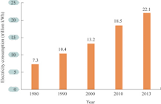

Annual electricity consumption per capita serves as an important measure of a country's electric power development. Generally speaking, electricity consumption grows faster when the industrialization process develops quickly and goes down rapidly when industrialization is completed or near completion.

**2.PROBLEM DEFINITION AND DESIGN THINKING**

Electric power consumption measures the production of power plants and combined heat and power plants less transmission, distribution, and transformation losses and own use by heat and power plants.  Technological advances that lead to an increased reliance on capital might increase energy-use per unit output, as more energy would be required to run additional machines. However, the energy may be used more efficiently than before. Computers, data centers and networks consume 10% of the world's electricity. 30% of this electricity goes to power terminal equipment (computers, mobiles and other devices), 30% goes to data centers and 40% goes to the network. A router may consume 1KW and a large data center consumes nearly 100 MW.

**Design thinking is an iterative process in which you seek to understand your users,**[challenge assumptions](https://www.interaction-design.org/literature/topics/challenge-assumptions)**, redefine problems and create innovative solutions which you can prototype and test.**The overall goal is to identify alternative strategies and solutions that are not instantly apparent with your initial level of understanding. Design thinking is more than just a process; it opens up an entirely new way to think, and it offers a collection of hands-on methods to help you apply this new mindset.

* Revolves around a deep interest to understand the people for whom we design products and services.
* Helps us observe and develop [empathy](https://www.interaction-design.org/literature/topics/empathy) with the target users.
* Enhances our ability to question: in design thinking you question the problem, the [assumptions](https://www.interaction-design.org/literature/topics/assumptions) and the implications.
* Proves extremely useful when you tackle problems that are ill-defined or unknown.
* Involves ongoing experimentation through sketches, prototypes, testing and trials of new concepts and ideas.
* **EMPATHY MAP**

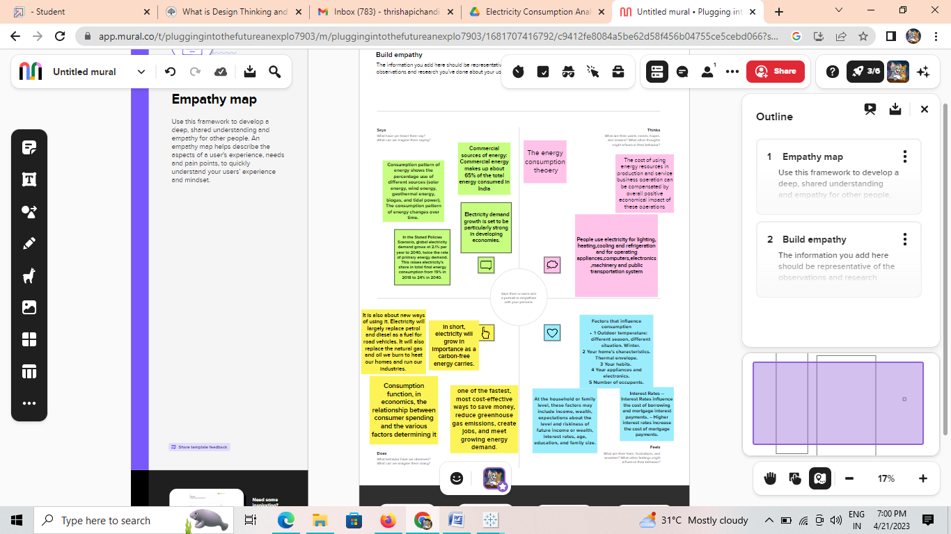

* **IDEATION AND BRAINSTORM MAP**

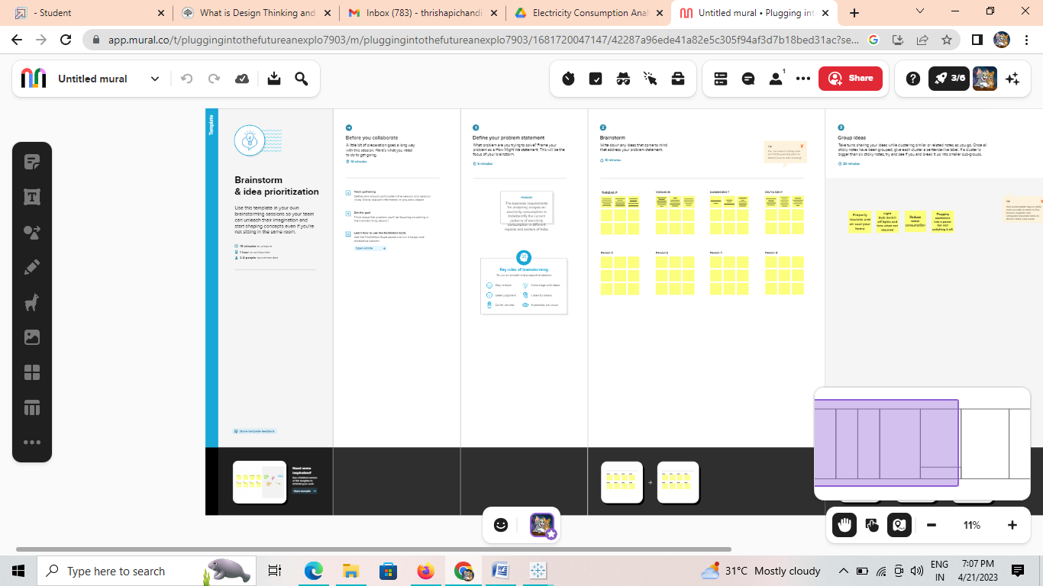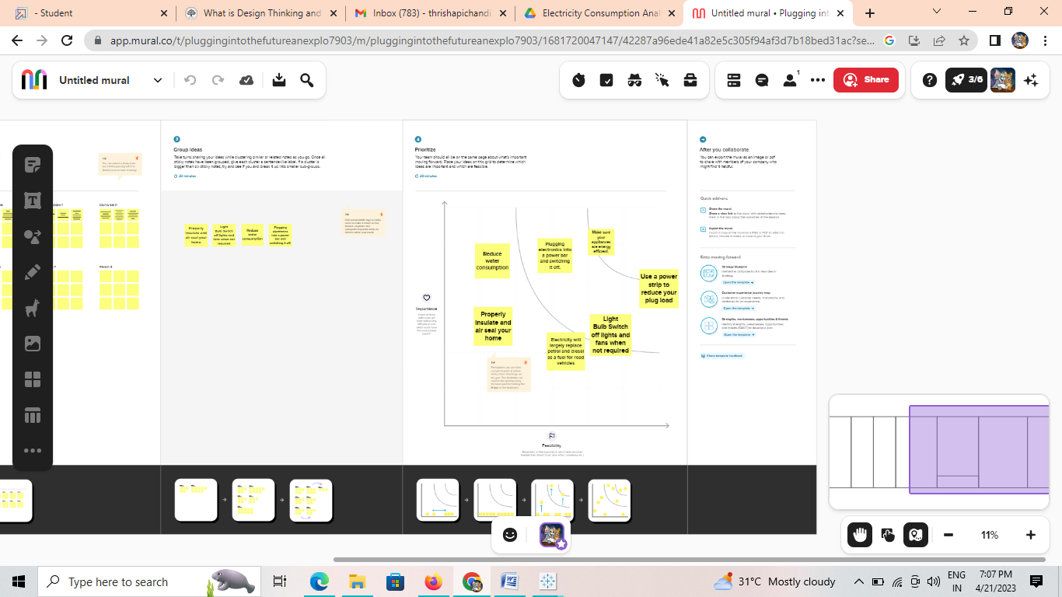

**3.RESULT:**

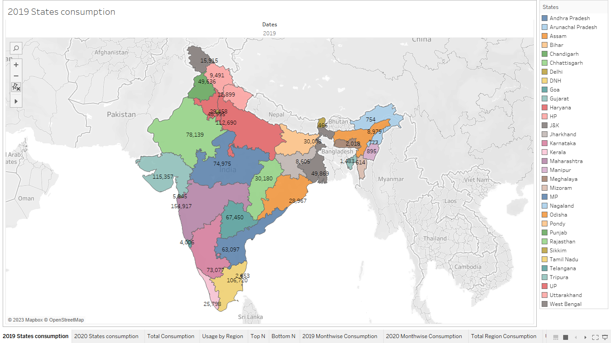

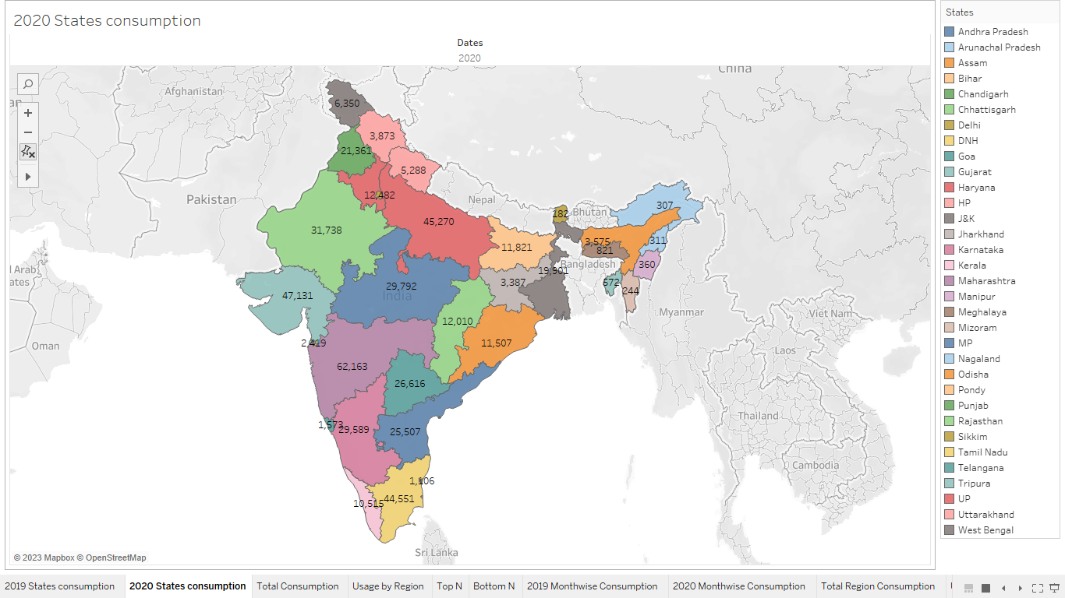

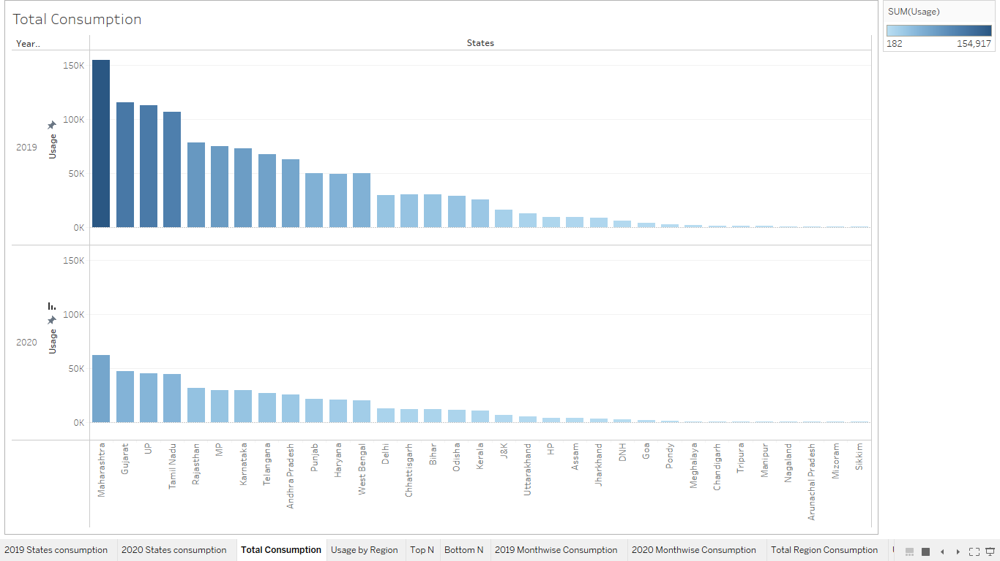

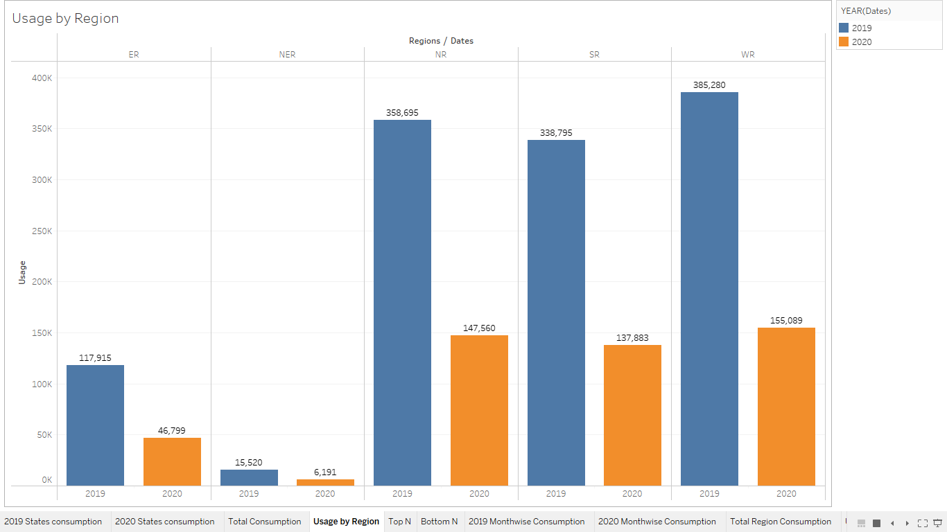

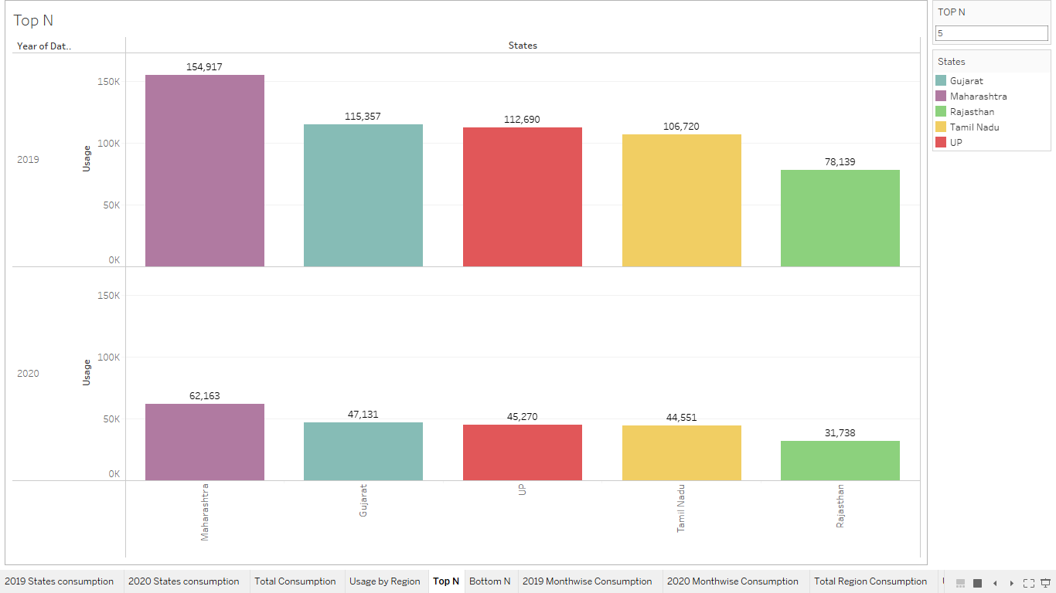

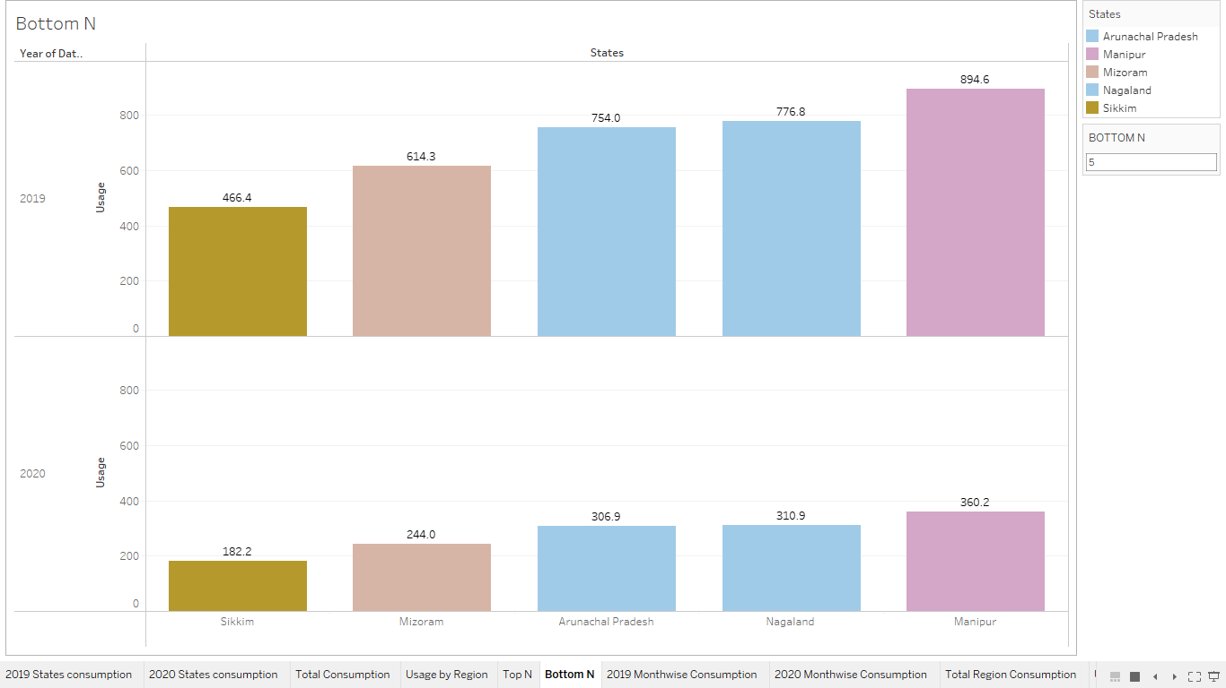

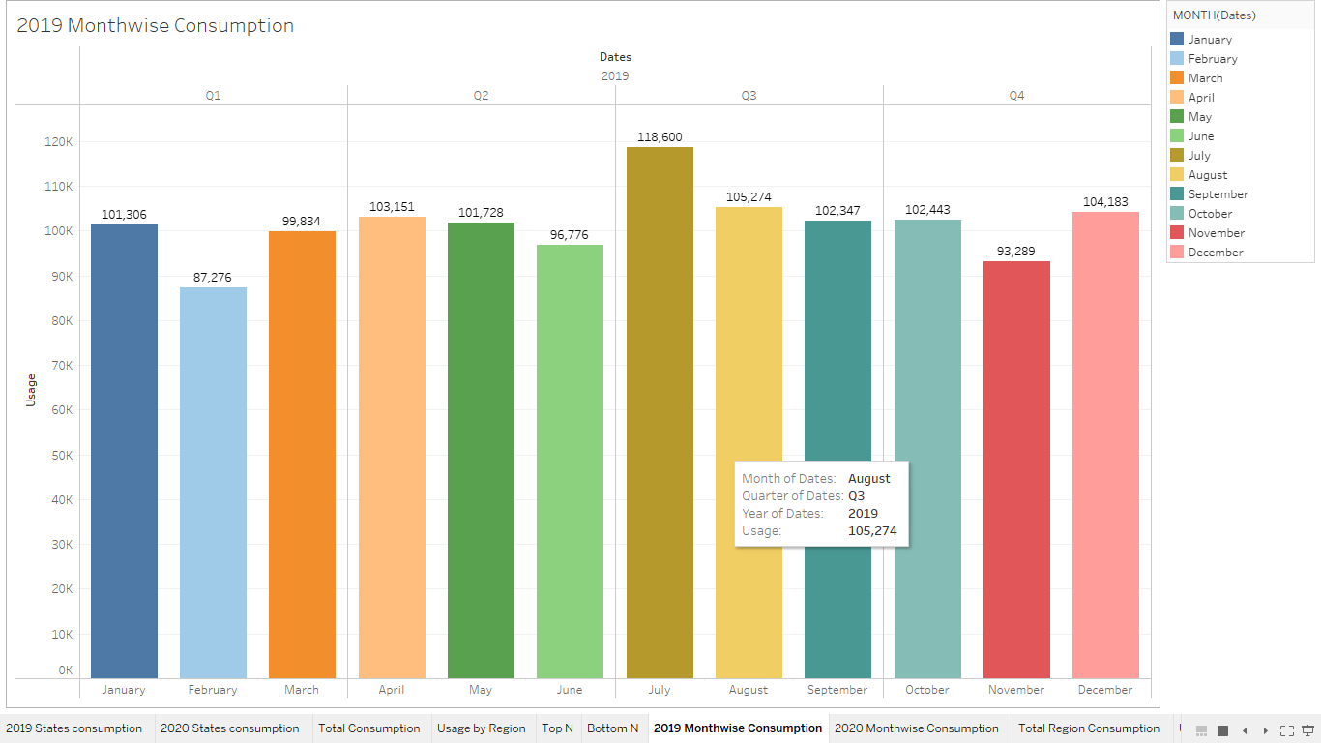

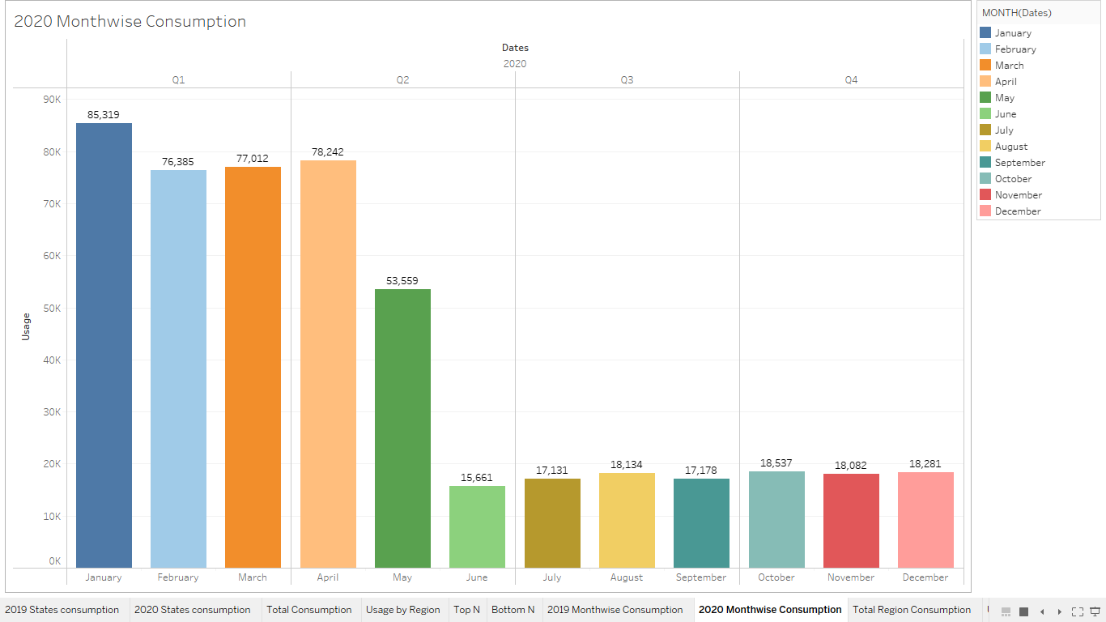

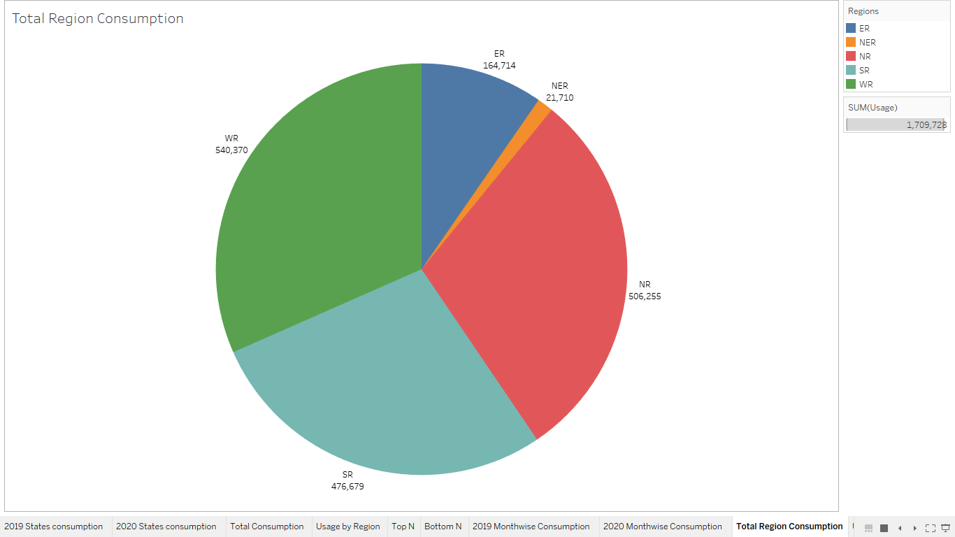

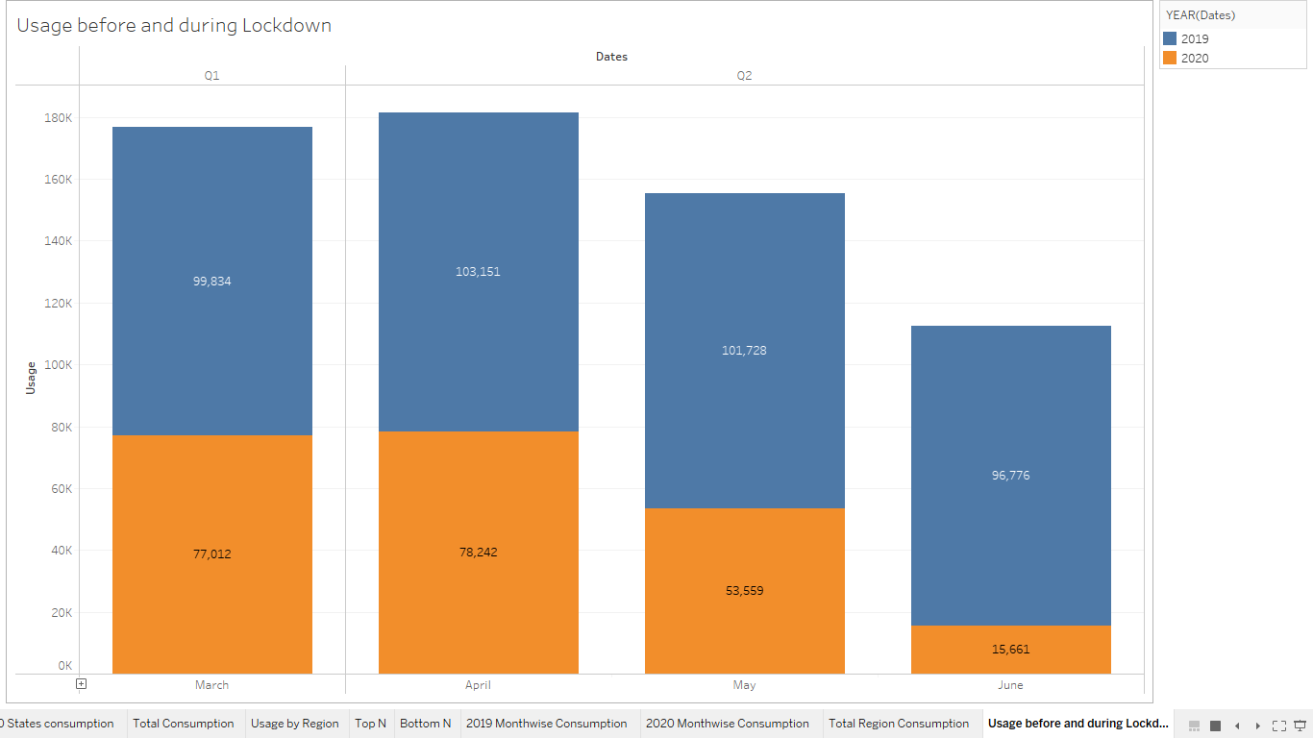

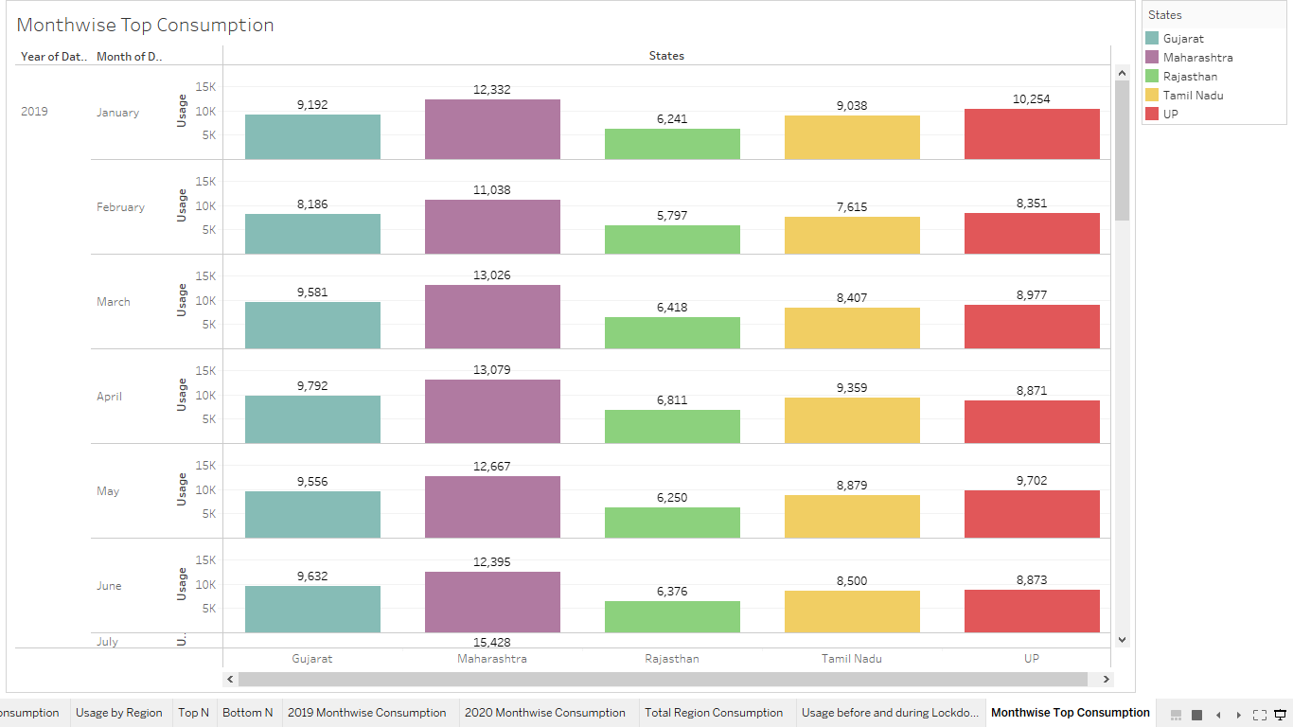

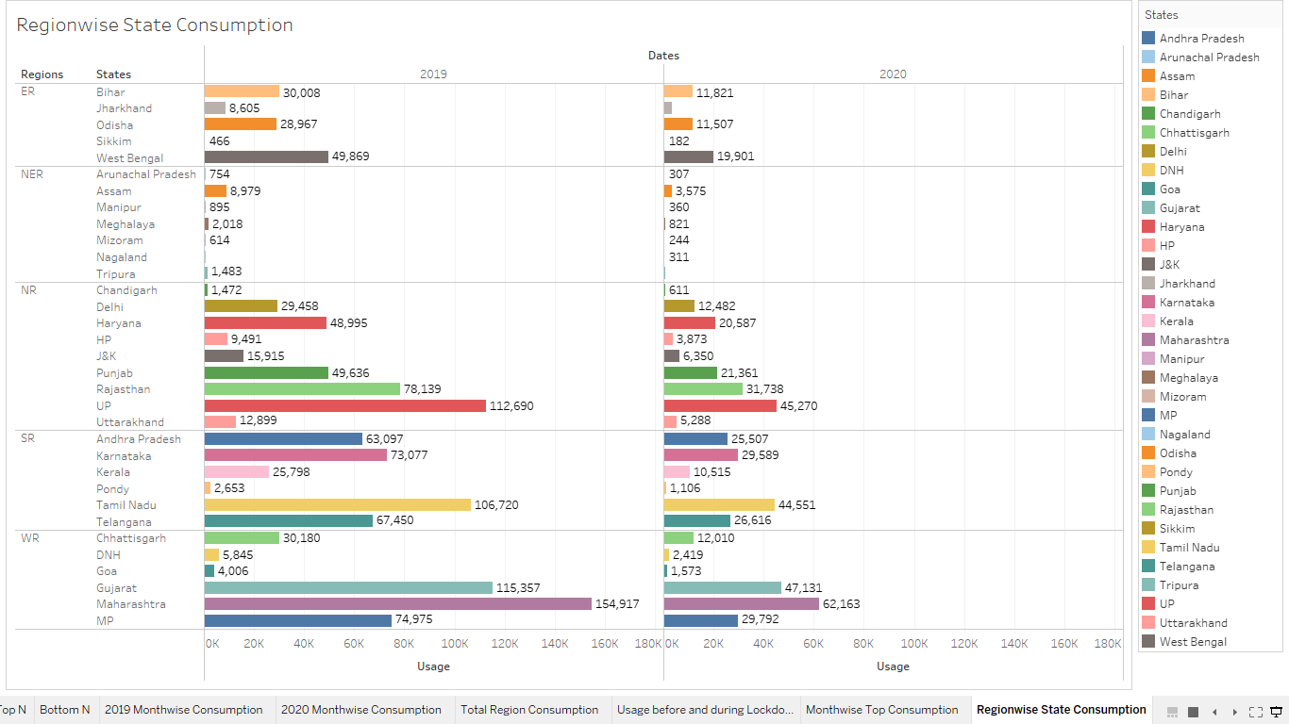

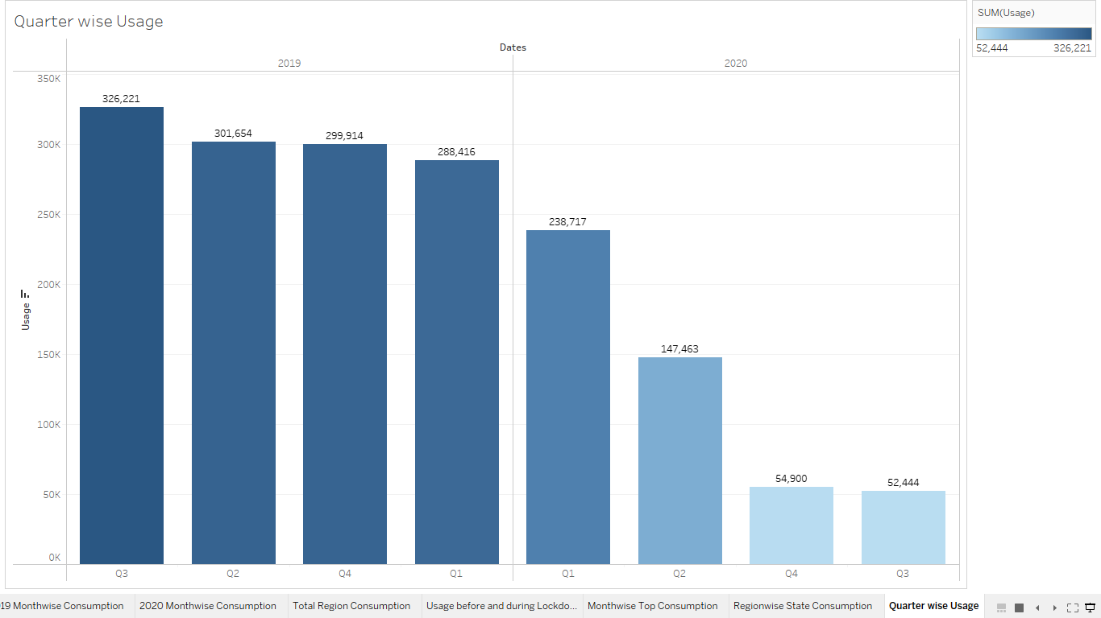

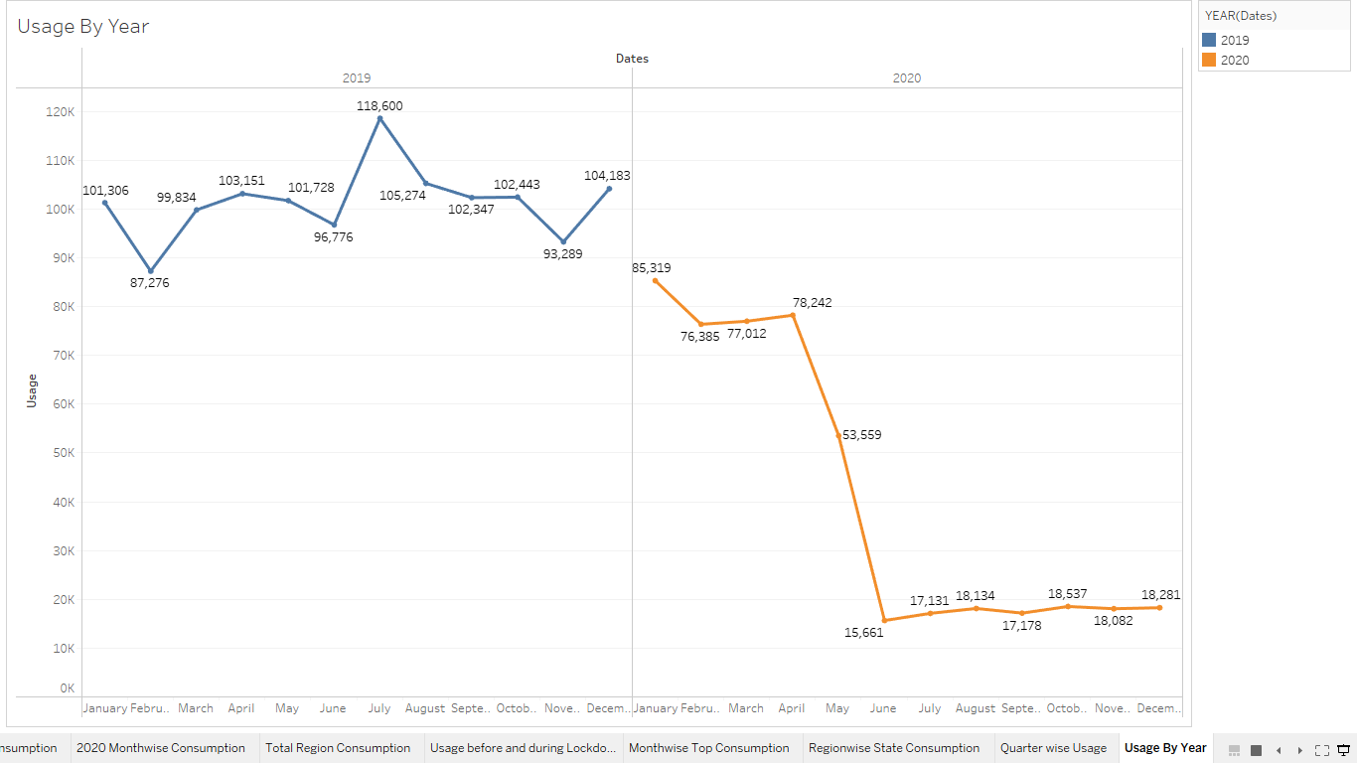

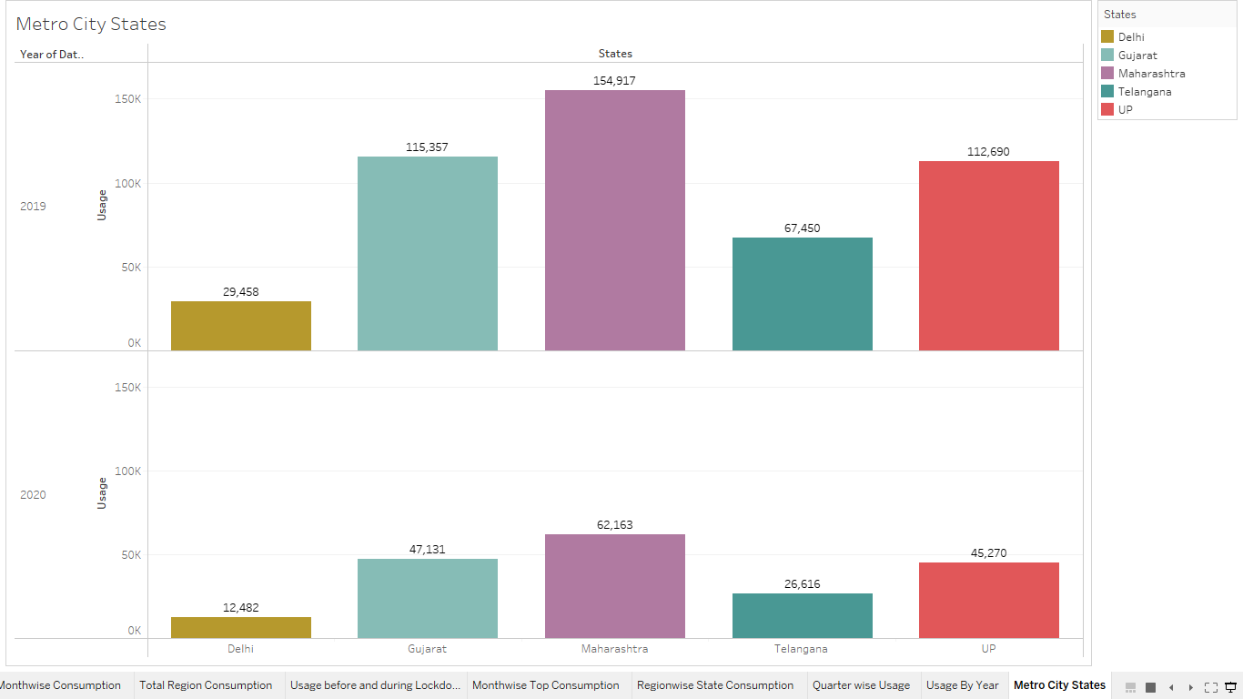

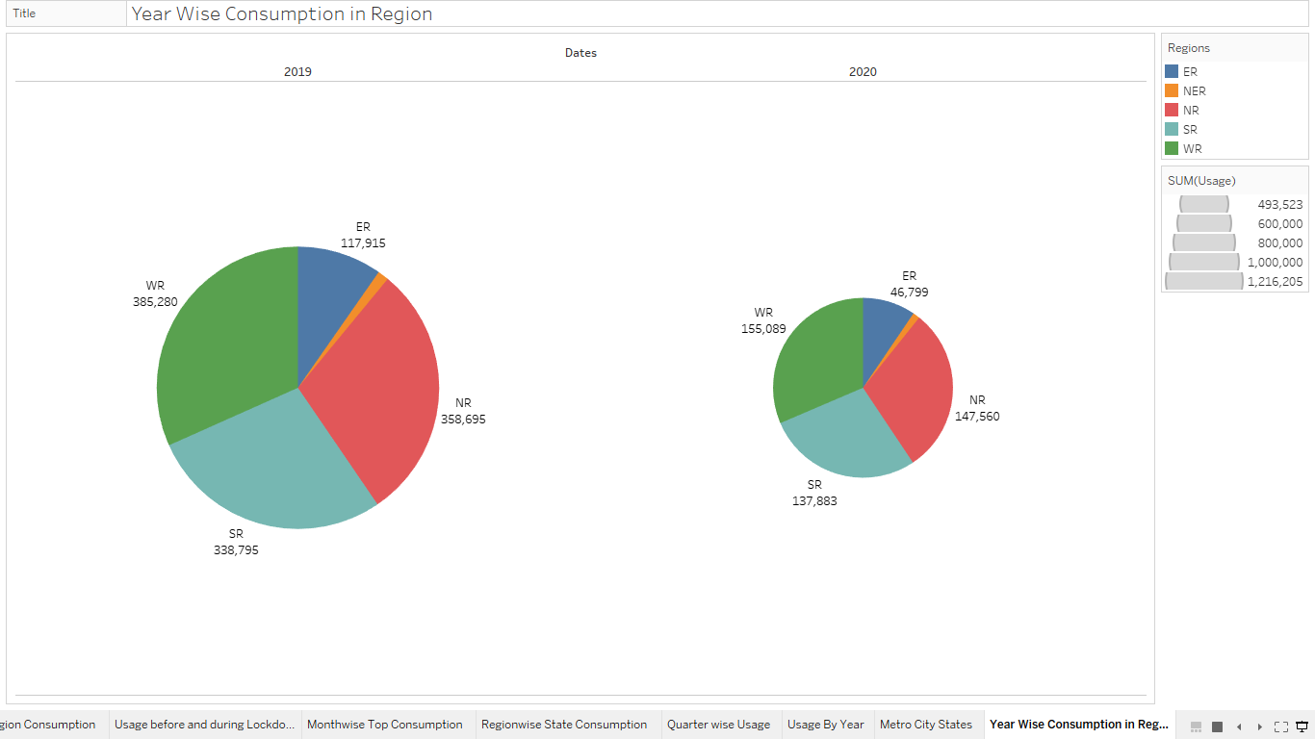

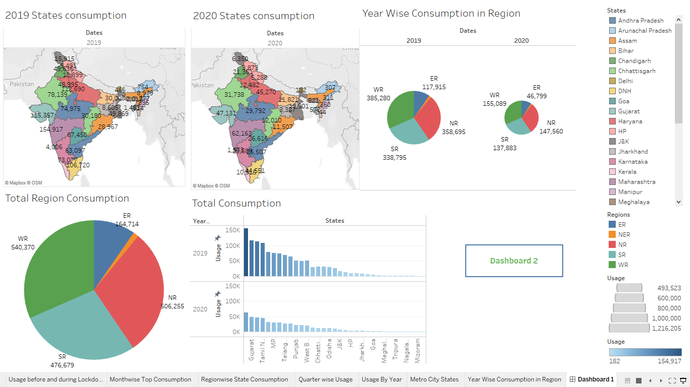

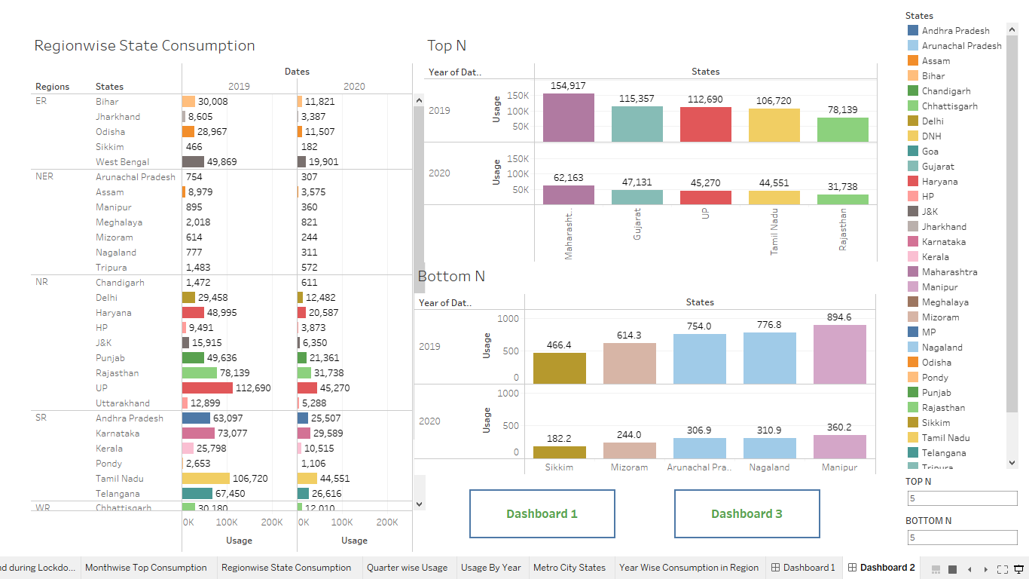

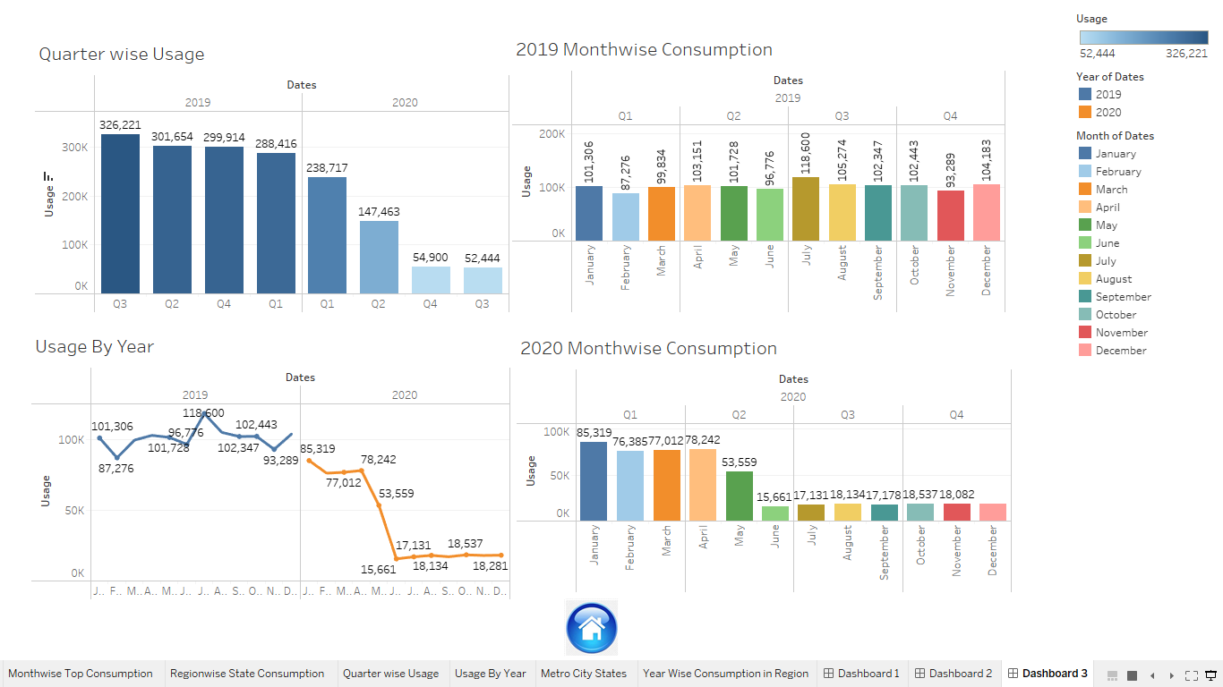

**4.ADVANTAGES AND DISADVANTAGES:**

* **ADVANTAGES:**

Lower energy bills

Fuel-burning appliances and equipment waste some energy during combustion. By contrast, electric devices are 100% efficient, meaning all the power used goes right into heating your food or lighting your home. Some electric equipment — such as heat pump technology — is even more than 100% efficient. That efficiency, combined with the steady, low-cost nature of electric rates, can reduce your energy costs.

Improved air indoor quality

Gas appliances can create indoor air pollutants by burning fossil fuels in a closed environment. Pollutants such as carbon monoxide can cause illness or death if they build up to dangerous levels. You can improve your health and safety by switching to electric appliances and equipment.

### Cleaner environment

Electric appliances and equipment produce no on-site emissions, reducing your environmental footprint. Although generating electricity does produce greenhouse gas emissions, the growing presence of renewable energy sources, — such as solar and wind — on the grid is helping to create a cleaner environment for everyone. Petrol and diesel use is destroying our planet. The availability of fossil fuels is limited, and their use is destroying our planet. Toxic emissions from petrol and diesel vehicles lead to long-term, adverse effects on public health. The emissions impact of electric vehicles is much lower than petrol or diesel vehicles. From an efficiency perspective, electric vehicles can covert around 60% of the electrical energy from the grid to power the wheels, but petrol or diesel cars can only convert 17%-21% of the energy stored in the fuel to the wheels. That is a waste of around 80%. Fully electric vehicles have zero tailpipe emissions, but even when electricity production is taken into account, petrol or diesel vehicles emit almost 3 times more carbon dioxide than the average EV. To reduce the impact of charging electric vehicles, India is ambitious to achieve about 40 percent cumulative electric power installed capacity from non-fossil fuel-based energy resources by the year 2030. Therefore, electric vehicles are the way forward for Indian transport, and we must switch to them now.

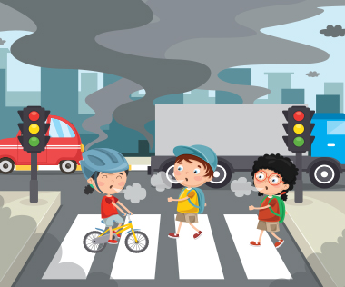

* **DISADVANTAGES:**

**High initial cost**

Electric vehicles continue to be quite expensive, and many buyers believe they are not as inexpensive as traditional automobiles.

**Charging station limitations:**

People who need to travel long distances are concerned about finding adequate charging stations in the middle of their journey, which are not always accessible.

**Recharging takes time:**

Unlike conventional automobiles, which require only a few minutes to replenish their gas tanks, charging an electric vehicle takes many hours.

**Limited options:**

Currently, there aren’t many electric car models to pick from in terms of appearance, style, or customized variations.

**Less driving range:**

When compared to conventional automobiles, electric vehicles have a shorter driving range. Electric cars can be convenient for short-distance travel but are inconvenient for long-distance travel.

Electricity consumption

* More expensive than gasoline
* Loss of fish species
* Sometimes messes up wildlife
* Dependent on precipitation
* More power plants and more pollution
* Damming can cause loss of land suitable for agriculture as well as recreation
* Cost for construction
* Change in river or stream quality
* An electric vehicle is not completely emission free
* In electricity, there are a limited number of feasible sites for a large number of dams
* Drought can affect power production
* Hydroelectric natural seasonal changes in river and ecosystems can be destroyed

**5.APPLICATION:**

When we talk about residential uses of energy, these are the most basic uses of energy. They include watching television, washing clothes, heating and lighting the home, taking a shower, working from home on your laptop or computer, running appliances and cooking.

* 1. **Residential uses of energy**

Waste in this category of use is also the highest globally. This can be attributed to the lack of education offered to the public on how to conserve the energy they use daily, or to the lack of energy conseration products available in the market. Most people are ignorant to the fact that there are avenues or companies and innovations available that can help them monitor and reduce the amount of energy they use.

* 1. **Commercial uses of energy**

Commercial use of energy is what energy is used for in the commercial sector. This includes heating, cooling and lighting of commercial buildings and spaces, power used by companies and business throughout our cities for computers, fax machines, workstations, copiers just to name but a few. The uses of energy in the commercial space is more or less similar to the uses in the industrial space save for personal uses. Energy saving here though, is targeted at the corporate world rather than at individuals.

* 1. **Transportation**

Transportation is one hundred percent dependent on energy. Over seventy percent of petroleum used goes into the transport sector. The transport sector includes all vehicles from personal cars to trucks to buses and motorcycles. It also includes aircrafts, trains, ship and pipelines. The transportation sector can be very vital in the overall quest for energy conservation. Innovations such as the introduction of more fuel efficient vehicles and development of alternative sources of energy for our transport system can greatly help in the saving of energy.

**6. CONCLUSION**

Current through a given area of a conductor is the net charge that passes per unit time through the conductor. To keep up a gradual current, we must have a circuit within which an electrical phenomenon occurs from lower to higher mechanical energy.

Energy is conserved to reduce consumption costs and to preserve the limited available energy resources. Energy conservation refers to efforts made to reduce energy consumption. The supply of energy on Earth is not infinite. Furthermore, it can take a long time to regenerate energy.

1. Restate your research topic. Your first step when writing your conclusion should be to restate your research topic.
2. Restate the thesis.
3. Summarize the main points of your research.
4. Connect the significance or results of the main points.
5. Conclude your thoughts.

 In a series circuit, the current flowing in each resistor is the same all throughout the circuit while the voltage drop across each resistor differs from each other.

Good equipments should be used such as the resistors, connecting wires, voltage supply and multi tester.

**7.FUTURESCOPE**

In the Stated Policies Scenario, global electricity demand grows at 2.1% per year to 2040, twice the rate of primary energy demand. This raises electricity's share in total final energy consumption from 19% in 2018 to 24% in 2040. The scope of the power sector in India includes thermal power, hydro power, nuclear power, geothermal power, and renewable energy sources (RES). RES includes power generated from sources like solar, wind, small hydro, biomass, and urban and industrial waste.  The electricity generation target (Including RE) for the year 2023-24 has been fixed as 1750 Billion Unit (BU). i.e. growth of around 7.2% over actual generation of 1624.158 BU for the previous year (2022-23). New resources that are being researched or developed include hydrogen, nuclear fusion, ocean thermal energy conversion, and tidal and wave energy. (Solar, wind, and geothermal energy are dealt with in separate fact sheets). One fuel that has the potential of being widely used in the future is hydrogen gas (H2). Is power engineering a good career? A. Job opportunities in power engineering are ample, considering the demand in power generation and distribution, transmission companies. With the joining of private sector like Reliance and Torrent power, future career opportunities are also good in power engineering. The objective of Power system analysis is for designing entire power systems consisting of generators, transformers, capacitor banks, shunt elements, transmission lines and so on. In February 2022, power consumption stood at 108.03 billion units (BU), higher than the 103.25 BU in the same month of 2021, the data showed. Electricity consumption in February 2020 stood at 103.81 BU. The peak power demand met, which is the highest supply in a day, rose to 209.66 gigawatt (GW) in February 2023. Renewable electricity is growing at a faster rate in India than any other major economy, with new capacity additions on track to double by 2026. The country is also one of the world's largest producers of modern bioenergy and has big ambitions to scale up its use across the economy.

**8.APPENDIX**

* **Source code**

**PROJECT 1**

1. **CODE:**

<div class='tableauPlaceholder' id='viz1682058729010' style='position: relative'><noscript><a href='#'><img alt='Story on Electricity Consumption in India  ' src='https:&#47;&#47;[public.tableau.com](http://public.tableau.com/)&#47;static&#47;images&#47;M5&#47;M5J69ZCJQ&#47;1_rss.png' style='border: none' /></a></noscript><object class='tableauViz'  style='display:none;'><param name='host_url' value='https%3A%2F%[2Fpublic.tableau.com](http://2fpublic.tableau.com/)%2F' /> <param name='embed_code_version' value='3' /> <param name='path' value='shared&#47;M5J69ZCJQ' /> <param name='toolbar' value='yes' /><param name='static_image' value='https:&#47;&#47;[public.tableau.com](http://public.tableau.com/)&#47;static&#47;images&#47;M5&#47;M5J69ZCJQ&#47;1.png' /> <param name='animate_transition' value='yes' /><param name='display_static_image' value='yes' /><param name='display_spinner' value='yes' /><param name='display_overlay' value='yes' /><param name='display_count' value='yes' /><param name='language' value='en-US' /><param name='filter' value='publish=yes' /></object></div>                <script type='text/javascript'>                    var divElement = document.getElementById('viz1682058729010');                    var vizElement = divElement.getElementsByTagName('object')[0];                    vizElement.style.width='1016px';vizElement.style.height='991px';                    var scriptElement = document.createElement('script');                    scriptElement.src = '<https://public.tableau.com/javascripts/api/viz_v1.js>';                    vizElement.parentNode.insertBefore(scriptElement, vizElement);                </script>

1. **LINK:**

<https://public.tableau.com/shared/M5J69ZCJQ?:display_count=n&:origin=viz_share_link>

**PROJECT 2**

1. **CODE:**

<div class='tableauPlaceholder' id='viz1682058716361' style='position: relative'><noscript><a href='#'><img alt='Story on Electricity Consumption in India  ' src='https:&#47, &#47, [public.tableau.com](http://public.tableau.com/)&#47, static&#47, images&#47, Pr&#47, Project2_16820584971010&#47, StoryonElectricityConsumptioninIndia&#47, 1_rss.png' style='border: none' /></a></noscript><object class='tableauViz'  style='display:none, '><param name='host_url' value='https%3A%2F%[2Fpublic.tableau.com](http://2fpublic.tableau.com/)%2F' /> <param name='embed_code_version' value='3' /> <param name='site_root' value='' /><param name='name' value='Project2_16820584971010&#47, StoryonElectricityConsumptioninIndia' /><param name='tabs' value='no' /><param name='toolbar' value='yes' /><param name='static_image' value='https:&#47, 1.png' /> <param name='animate_transition' value='yes' /><param name='display_static_image' value='yes' /><param name='display_spinner' value='yes' /><param name='display_overlay' value='yes' /><param name='display_count' value='yes' /><param name='language' value='en-US' /><param name='filter' value='publish=yes' /></object></div>                <script type='text/javascript'>                    var divElement = document.getElementById, 'viz1682058716361', var vizElement = divElement.getElementsByTagName, 'object', [0], vizElement.style.width='1016px', vizElement.style.height='991px', var scriptElement = document.createElement, </script>, scriptElement.src = '<https://public.tableau.com/javascripts/api/viz_v1.js>', vizElement.parentNode.insertBefore, scriptElement, vizElement

1. **LINK:** <https://public.tableau.com/views/Project2_16820584971010/StoryonElectricityConsumptioninIndia?:language=en-US&publish=yes&:display_count=n&:origin=viz_share_link>

|  |  |  |  |
| --- | --- | --- | --- |
|  |  |  | https://mail.google.com/mail/u/0/images/cleardot.gif  https://mail.google.com/mail/u/0/images/cleardot.gif |
|  | | |

|  |  |  |  |
| --- | --- | --- | --- |
|  |  |  |  |