SIGCHI Extended Abstracts Sample   
File: Note Initial Caps

Paste the appropriate copyright/license statement here. ACM now supports three different publication options:

• ACM copyright: ACM holds the copyright on the work. This is the historical approach.

• License: The author(s) retain copyright, but ACM receives an exclusive publication license.

• Open Access: The author(s) wish to pay for the work to be open access. The additional fee must be paid to ACM.

This text field is large enough to hold the appropriate release statement assuming it is single-spaced in Verdana 7 point font. Please do not change the size of this text box.

Each submission will be assigned a unique DOI string to be included here.

# Abstract

First Author

1. University of Author
2. Authortown, CA 94022, USA
3. author1@anotherco.edu

Second Author

1. VP, Authoring
2. Authorship Holdings, Ltd.
3. Awdur SA22 8PP, UK author2@author.ac.uk

Third Author

Fourth Author

1. Lēkhaka Interaction Labs
2. Bengaluru 560 080, India
3. author3@anotherco.com  
   author4@hci.anotherco.com

Fifth Author

1. YetAnotherCo, Inc.
2. Authorton, BC V6M 22P Canada
3. author5@yetanotherco.ca

Sixth Author

1. Université de Auteur-Sud
2. 40222 Auteur, France
3. author6@author.fr

Seventh Author

1. Department of Skrywer,
2. University of Umbhali,
3. Cape Town, South Africa author7@umbhaliu.ac.za

UPDATED—31 July 2015. This sample paper describes the formatting requirements for SIGCHI Extended Abstract Format, and this sample file offers recommendations on writing for the worldwide SIGCHI readership. Please review this document even if you have submitted to SIGCHI conferences before, as some format details have changed relative to previous years. Abstracts should be about 150 words and are required.

# Author Keywords

Authors’ choice; of terms; separated; by semicolons; include commas, within terms only; required.

# ACM Classification Keywords

H.5.m. Information interfaces and presentation (e.g., HCI): Miscellaneous; See<http://acm.org/about/class/1998> for the full list of ACM classifiers. This section is required.

# Introduction

This format is to be used for submissions that are published in the conference publications. We wish to give this volume a consistent, high-quality appearance. We therefore ask that authors follow some simple guidelines. In essence, you should format your paper exactly like this document. The easiest way to do this is to replace the content with your own material.

# ACM Copyrights & Permission Policy

# Good Utilization of the Side Bar

**Preparation**: Do not change the text box size or position. Do copy text box to other pages. You may change the surrounding box to be visible or invisible, up to you.

**Materials:** This cannot appear higher or lower on the page because of pagination and specific headers added during the indexing and pagination process. A 0.75 inch rule is beneficial to break this apart from the body text. The text in this text box should remain the same size as the Body Text: 8.5 Verdana or Arial (with use of **bold** and *italics* to highlight points)

**Images & Figures:** Images and figures can be placed in this section. They should be captioned in the manner of other images and figures.

Accepted extended abstracts and papers will be distributed in the Conference Publications. They will also be placed in the ACM Digital Library, where they will remain accessible to thousands of researchers and practitioners worldwide. To view ACM’s copyright and permissions policy, see: <http://www.acm.org/publications/policies/copyright_policy>

# Page Size

All SIGCHI submissions should be US letter (8.5x11 inches) and not A4. US Letter is a standard option on all versions of Microsoft Word, as well as most other document preparation programs.

# Text Formatting

Please use an 8.5-point Verdana font, or other sans serifs font as close as possible in appearance to Verdana in which these guidelines have been set. (The “Normal” style for this document automatically gives you this font setting.) Arial 9-point font is a reasonable substitute for Verdana as it has a similar x-height. Please use serif or non-proportional fonts only for special purposes, such as distinguishing source code text.

## Text styles

The template uses MS Word text styles to facilitate text formatting, and we highly recommend you use these Styles instead of manually applying formatting. The applicable text styles are:

* Normal—for body text. Don’t use “Default Paragraph Font”.
* Heading 1, Heading 2, Heading 3
* Bullet list
* Numbered list
* Caption
* References—for bibliographic entries

Additionally, here is an example of footnoted text.[1] (The footnote is created with the “footnote…” command under the “Insert” menu in MS Word). As stated in the footnote, footnotes should rarely be used.

## Quotes

Quotes may be italicized and“placed inline”(Anab, 22F).

Longer quotes, when placed in their own paragraph, need not be italicized or in quotation marks. (Ramon, 39M).

## Figures

The examples on these pages should help you get a feel for how figures should be placed in the template. *Be sure to make images large enough so the important details are legible and clear.* Your document may use color figures, which are included in the page limit; the figures *must* be legible and usable when printed in black and white. If you aren’t familiar with Word’s handling of pictures, we offer one tip: placing images and their captions in text boxes can be useful to keep them bother and to control the position of pictures and the flow of text around them. We recommend using Photoshop, Preview, or other graphics software to scale images, rather than scaling them after you have placed them in Word. Figure 3 shows a treatment of large figures, too big to fit inside a single column of text. All figures should include alt text for improved accessibility. In Word, right click the figure, and select Format Picture | Alt Text).



**Figure 1**: Insert a caption below each figure. We suggest selecting the image and then using Insert, Caption. Make sure you use the Caption style for text formatting. All 1-line captions should be centered; justify longer captions.

## Tables

Tables should be clearly formatted, and may be as wide as the two text columns. Large tables should be placed in a Text Box for easier formatting control, similar to large images.

| Name | First | Second | Last |
| --- | --- | --- | --- |
| Marsden | 223.0 | 44 | 432,321 |
| Nass | 22.2 | 16 | 234,333 |
| Borriello | 22.9 | 11 | 93,123 |
| Karat | 34.9 | 2200 | 103,322 |

Table 1. Table captions should be below the table. We recommend table lines be 1pt, 75% brightness grey. Minimize use of unnecessary table lines. Avoid spurious degrees of precision. For larger tables, consider banded rows (select table, then click Tables, Banded Rows) to guide the eye. In Word, we recommend using the Table Grid - SIGCHI table format.

For improved accessibility, header rows of tables should be marked. In Word, right-click a selected header row, and select Table Properties | Row | Repeat as header row at the top of each page. All tables should include alt text for accessibility.

# Language, style, and content

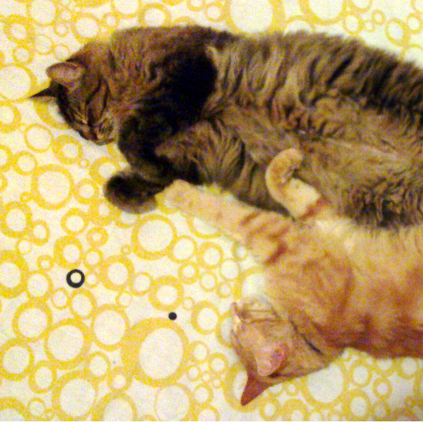

Figure In this image, the cats are tesselated to save space. You, too, can save space by placing images in the sidebar. Images should have captions and be within the boundaries of the text box on Page 2. Photo CC-BY jofish on Flickr.

The written and spoken language of SIGCHI is English. Spelling and punctuation may use any dialect of English (e.g., British, Canadian, US, etc.) provided this is done consistently. Hyphenation is optional. To ensure suitability for an international audience, please pay attention to the following:

* Write in a straightforward style. Try to avoid long sentences and complex sentence structures. Use semicolons carefully.
* Use common and basic vocabulary (e.g., use the word “unusual” rather than the word “arcane”).
* Briefly define or explain all technical terms. The terminology common to your practice/discipline may be different in other design practices/disciplines.
* Explain all acronyms the first time they are used in your text—e.g., “Digital Signal Processing (DSP)”.
* Explain local references (e.g., not everyone knows all city names in a particular country).
* Explain “insider” comments. Ensure that your whole audience understands any reference whose meaning you do not describe (e.g., do not assume that everyone has used an Android phone or a particular application).
* Explain colloquial language and puns. Understanding phrases like “red herring” requires a cultural knowledge of English. Humor and irony are difficult to translate.
* Use unambiguous forms for culturally localized concepts, such as times, dates, currencies, and numbers (e.g., “1-5- 97” or “5/1/97” may mean 5 January or 1 May, and “seven o’clock” may mean 7:00 am or 19:00). For currencies, indicate equivalences: “Participants were paid ₩22, or roughly US$29.”
* Be careful with the use of gender-specific pronouns (*he*, *she*) and other gendered words (*chairman*, *manpower*, *man-months*). Use inclusive language that is gender-neutral (e.g., *she* *or* *he*, *they*, *s/he*, *chair*, *staff*, *staff-hours*, *person-years*). See the *Guidelines for Bias-Free Writing* for further advice and examples regarding gender and other personal attributes [9]. Be particularly aware of considerations around writing about people with disabilities.

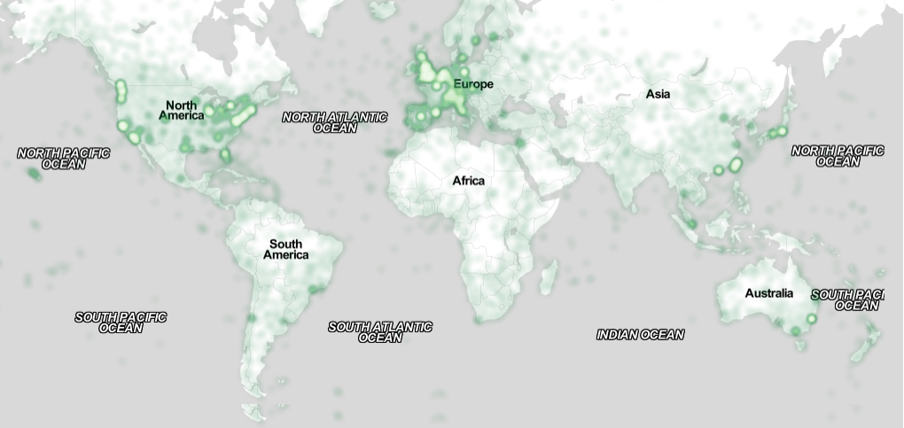

Figure 3. You can make figures as wide as you need, up to a maximum of the full width of both columns. To achieve this, create a text box using Insert | Text Box and resize it to the full width. Image CC-BY-ND ayman on Flickr.

So long as you don’t type outside the right margin, it’s okay to put annotations over here on the right, too. This caption is near Hawaii.

|  |  |  |
| --- | --- | --- |
| Name | First | Location |
| Liza | 22.5 | Melbourne |
| Becca | 22.25 | Bogotá |
| Woolfie | 22 | Athens |
| Anaïs | 34.5 | Stockholm |
| Eloise | 28 | Nairobi |

Table : A sample narrow table in the margin. Use Table – SIGCHI formatting for the table and Caption formatting for the caption.

* If possible, use the full (extended) alphabetic character set for names of persons, institutions, and places (e.g., Grønbæk, Lafreniére, Sánchez, Nguyễn, Universität, Weißenbach, Züllighoven, Århus, etc.). These characters are already included in most versions and variants of Times, Helvetica, and Arial fonts.

# Accessibility

The Executive Council of SIGCHI has committed to making SIGCHI conferences more inclusive for researchers, practitioners, and educators with disabilities. As a part of this goal, the all authors are asked to work on improving the accessibility of their submissions. Specifically, we encourage authors to carry out the following five steps:

Add alternative text to all figures

Mark table headings

Generate a tagged PDF

Verify the default language

Set the tab order to “Use Document Structure”

For links to instructions and resources, please see:

http://chi2016.acm.org/accessibility

# Producing and Testing PDF Files

We recommend that you produce a PDF version of your submission well before the final deadline. Your PDF file must be ACM DL Compliant. Requirements are at:

http://www.sheridanprinting.com/typedept/ACM-distilling-settings.htm

Test your PDF file by viewing or printing it with the same software the publisher will use, Adobe Acrobat Reader Version 10, which is widely available at no cost. Note that most reviewers will use a North American/European version of Acrobat Reader, so please check your PDF accordingly.

# Acknowledgements

We thank all the volunteers, publications support, staff, and authors who wrote and provided helpful comments on previous versions of this document. As well authors 1, 2, & 3 gratefully acknowledge the grant from NSF (#1234-2222-ABC). Author 4 for example may want to acknowledge a supervisor/manager from their original employer. This whole paragraph is just for example. Some of the references cited in this paper are included for illustrative purposes only.

# References format

Your references should be published materials accessible to the public. Internal technical reports may be cited only if they are easily accessible and may be obtained by any reader for a nominal fee. Proprietary information may not be cited. Private communications should be acknowledged in the main text, not referenced (e.g., [Golovchinsky, personal communication]). References *must* be the same font size as other body text. References should be in alphabetical order by last name of first author. Use a numbered list of references at the end of the article, ordered alphabetically by last name of first author, and referenced by numbers in brackets. For papers from conference proceedings, include the title of the paper and the name of the conference. Do not include the location of the conference or the exact date; do include the page numbers if available. References should be in ACM citation format: <http://acm.org/publications/submissions/latex_style>. Format your references like the examples in this document. Example reference formatting for individual journal articles [3], an entire journal special issue [6], websites [14], tweets [1], patents [5], articles in conference proceedings [7], videos [8], books [9], theses [10] and book chapters [11] is given here. This formatting is a slightly abbreviated version of the format automatically generated by the ACM Digital Library http://dl.acm.org as “ACM Ref”: the easiest method is to look the reference up in the Digital Library, click on the ACM Ref link, and cut and paste the result and edit to match the examples. DOI or URL links, and authors’ full first names, are optional but encouraged. Do your best! Your paper won’t get rejected for not having DOI links or authors’ first names. More details of reference formatting are available at:

<http://acm.org/publications/submissions/latex_style>

Note that the hyperlink style used throughout this document uses blue links; URLs that appear in the references section may appear in black.

# References

1. @_CHINOSAUR. 2014. VENUE IS TOO COLD. #BINGO #CHI2016. Tweet. (1 May, 2014). Retrieved February 2, 2014 from https://twitter.com/_CHINOSAUR/status/461864317415989248
2. ACM. How to Classify Works Using ACM’s Computing Classification System. 2014. Retrieved August 22, 2014 from http://www.acm.org/class/how_to_use.html.
3. Ronald E. Anderson. 1992. Social impacts of computing: Codes of professional ethics. *Soc Sci Comput Rev* 10, 2: 453-469.
4. Anna Cavender, Shari Trewin, Vicki Hanson. 2014. Accessible Writing Guide. Retrieved August 22, 2014 from http://www.sigaccess.org/welcome-to-sigaccess/resources/accessible-writing-guide/
5. Morton L. Heilig. 1962. Sensorama Simulator, U.S. Patent 3,050,870, Filed January 10, 1961, issued August 28, 1962.
6. Jofish Kaye and Paul Dourish. 2014. Special issue on science fiction and ubiquitous computing. *Personal Ubiquitous Comput*. 18, 4 (April 2014), 765-766. http://dx.doi.org/10.1007/s00779-014-0773-4
7. Scott R. Klemmer, Michael Thomsen, Ethan Phelps-Goodman, Robert Lee, and James A. Landay. 2002. Where do web sites come from?: capturing and interacting with design history. In *Proceedings of the SIGCHI Conference on Human Factors in Computing Systems* (CHI '02), 1-8. http://doi.acm.org/10.1145/503376.503378
8. Psy. 2012. Gangnam Style. Video. (15 July 2012.). Retrieved August 22, 2014 from https://www.youtube.com/watch?v=9bZkp7q19f0
9. Marilyn Schwartz. 1995. *Guidelines for Bias-Free Writing.* Indiana University Press, Bloomington, IN.
10. Ivan E. Sutherland. 1963. *Sketchpad, a Man-Machine Graphical Communication System*. Ph.D Dissertation. Massachusetts Institute of Technology (MIT), Cambridge, MA.
11. Langdon Winner. 1999. Do artifacts have politics? In *The Social Shaping of Technology* (2nd. ed.), Donald MacKenzie and Judy Wajcman (Eds.). Open University Press, Buckingham, UK, 28-40.

1. Use footnotes sparingly, if at all.