Kitten Mortality Report

Contents
Overview 1
Purpose and Scope 2
Purpose 2
Rationale 2
Scope 2
Operational Areas Encompassed 2
Methodology 2
Decisions 3
Stratification 3
Age Group Classification Over Time 3
Location 5
Timeframe 5
Numerator 5
Denominator 5
Calculations 6
Data Visualization 6
Quality Control 10
Technical Implementation 10
Source Data Updates 10
Current Code Repository 11
Report Generation Logic 11
Data Outputs 11
Excel-based Reporting File 11
Online Summary Dashboard 11
Automation and Operations 11
Scheduled Execution 11
Report Change Log 12

Overview

Purpose and Scope

Purpose
Kitten mortality rates serve as a barometer of quality of care.

Rationale
Kittens, particularly neonates, are the most vulnerable subpopulation in a shelter.

Scope
The report summarizes kitten mortality (deaths and euthanasias) stratified by age group.

Operational Areas Encompassed
Each report is strategically selected to be a critical measure of shelter care, with emphasis on medical care. Kitten mortality rates are impacted by:

Medical Care
- Quality of medical care
- Quality and frequency of monitoring
- Decision-making (death vs. euthanasia)

Other
- Risk identification and response
- Risk at source (e.g. owner surrender, transfer in)
- Capacity for care
- Infection control
- Availability of foster homes
- Staff and foster training
- Husbandry (housing, temperature control, feeding, cleaning)
- Policies (euthanasia vs treatment)

Methodology

Decisions

Population Scope | Kittens chosen because they are the most vulnerable population in the shelter – kitten mortality is a key indicator of quality of care.
Stratification | - Age-based strata (0–2, 3–6, 7–12, 13–20 weeks) chosen to reflect biologically and clinically distinct risk periods.  - Separated Died and Euthanized because Died in Care can highlight problems with decision-making and/or monitoring
Inclusion/Exclusion | - Included all kittens admitted, located both in the shelter and in foster homes.  - Excluded Dead on Arrival, as not part of the population at risk. No other exclusions.

Stratification
Age groups are stratified as 0-2, 3-6, 7-12, and 13-20 weeks of age.
Kittens are classified as Alive, Euthanized or Died (= died in care).

Age Group Classification Over Time
Outcome categories (Alive, Euthanized, Died) are based on the kittens’ status during the month of interest, and adjusted as they pass through different age groupings. Within the month, the same kitten may be reported in more than one category, as the report prioritizes risk by age over overall risk of mortality. For example, a kitten may enter the month at 2 weeks of age and exit the month alive at 6 weeks of age. In this case, they would be counted as Alive in both the 0-2 and 3-6 week age group reports. As another example, a kitten may enter the month at 2 weeks of age and be euthanized at 4 weeks of age. This kitten would count as Alive in the 0-2 week category, but Euthanized in the 3-6 week category. In this way, we can assess risk of death of 0-2 week-old kittens and risk of death of 3-6 week-old kittens.

Calculations for age groups and mortality status
Ages are calculated based on recorded date of birth.

To ensure that the kitten is placed within all age categories it passes through within the month, the age group of each kitten is calculated on a weekly basis throughout the month of interest.

Example
The example reports three kittens (A, B and C), who entered the shelter on May 1. The kittens were born on April 28.

May report
The kittens began in the 0-2 week age group and entered the 3-6 week age group during the month.

Kitten | Age Group | Category
A | 0-2 weeks | Alive
B | 0-2 weeks | Alive
C | 0-2 weeks | Alive
A | 3-6 weeks | Alive
B | 3-6 weeks | Alive
C | 3-6 weeks | Alive

June report
A was euthanized on June 5. C was adopted on June 20.

Kitten | Age Group | Category
A | 3-6 weeks | Euthanized
B | 3-6 weeks | Alive
C | 3-6 weeks | Alive
B | 7-12 weeks | Alive
C | 7-12 weeks | Alive→ adopted

July report
B died on July 5.

Kitten | Age Group | Category
B | 7-12 weeks | Died

A kitten cannot be assigned two different outcome categories within the same age group in the same month. For instance, consider a kitten that arrives at 7 weeks of age and dies at 9 weeks of age. Although this kitten arrives in the 7–12 week age group in the Alive category, its final outcome in that age category is Died. It is categorized in the Died category for the 7-12 week age group. This distinction ensures accurate reporting and avoids confusion or overlap between age groups and outcome categories.

Location
All kittens in care are included in the report i.e. both in the shelter and in foster homes. These are not tracked separately.

Timeframe
Annual and monthly mortality is calculated. Previous reports are retained for analysis of trends over time.

Numerator

Included
Kittens 0-20 weeks of age with:
- Euthanasia outcome
- Died outcome

Excluded
Dead on arrival (DOA)

Denominator

Included
Kittens 0-20 weeks of age at risk of mortality = all kittens in care that were alive at the beginning of the month

Calculations

Death rate | Total Died in age group | x 100 %
 | Total kittens in age group

Euthanasia rate | Total Euthanized in age group | x 100 %
 | Total kittens in age group

Mortality rate | Total Died + Euthanized in age group | x 100 %
 | Total kittens in age group

Data Visualization

This section provides selected screenshots of reports as they currently appear, to illustrate the output.

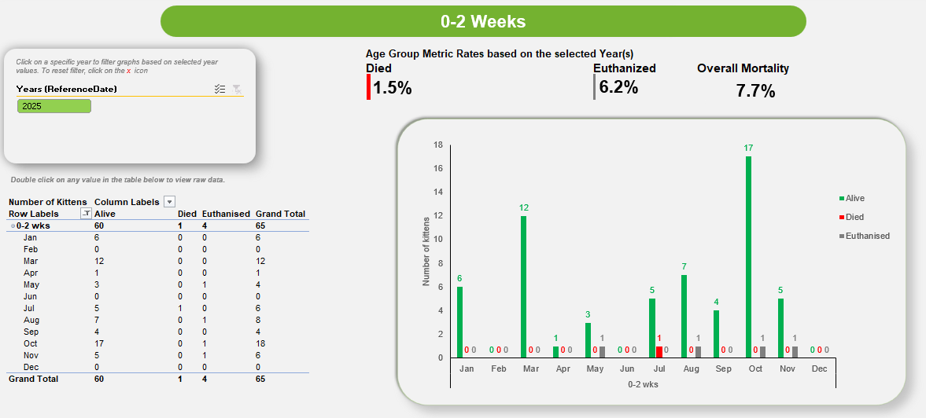

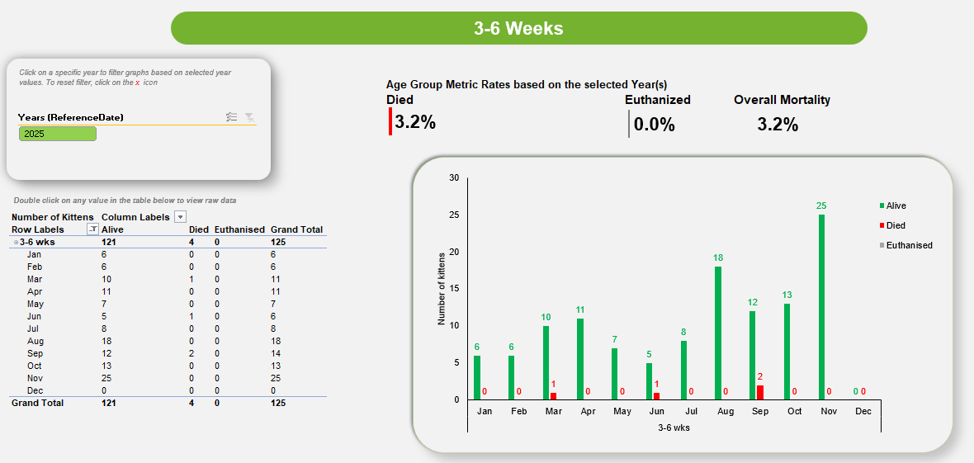

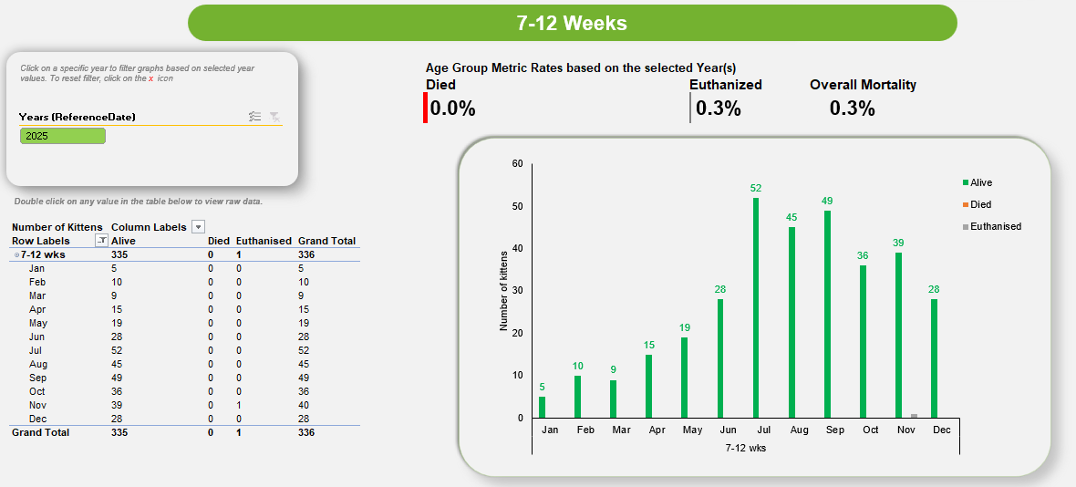

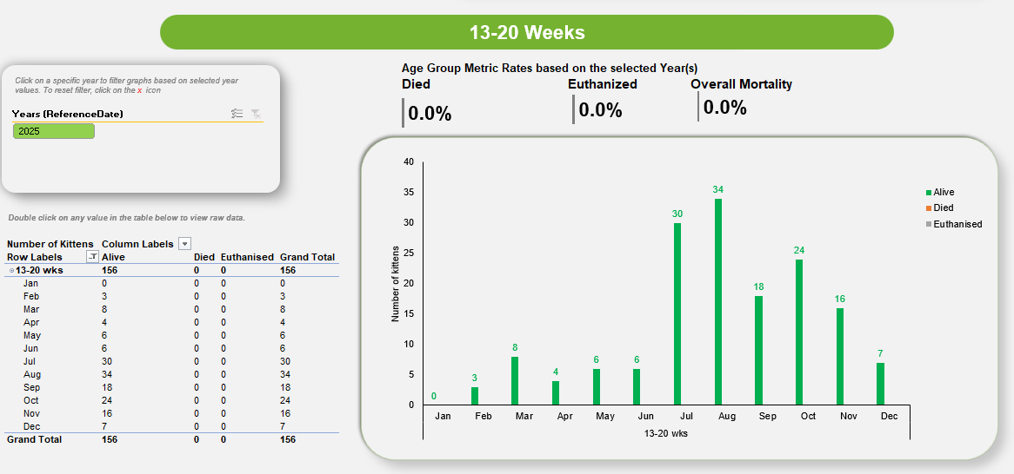

By double-clicking within the table for 7-12 week old kittens for May (as an example), a tab is created with the details of the kittens represented in that graph (unique IDs and numbers are included but cropped out in this example). This streamlines investigations. End-user changes are overwritten when the report is next opened.

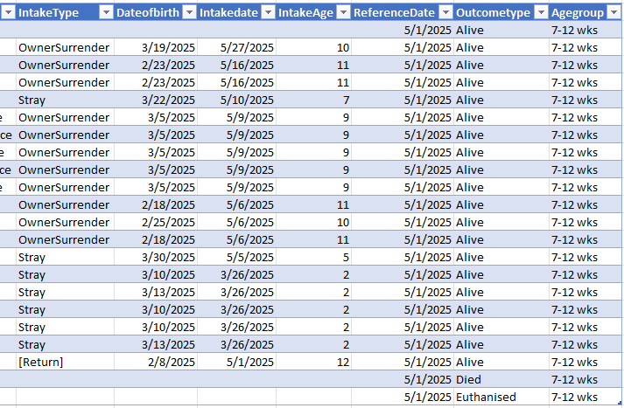

The image below shows a simplified report, presented in the PowerBI Dashboard for high-level “at a glance” monitoring (see next section). Note that the top section shows % mortality while the bottom section shows number of admissions.

Quality Control

During development of the report, it is important to verify that outputs are valid. Errors may originate in the data itself (e.g. entry errors) or in data processing. Manual reports are compared for errors with the coded report to identify any systemic issues. The quality control is dependent on adequate documentation of the logic of the report generation process.

Technical Implementation

The execution script combines Python user-defined functions and SQL queries to extract the report files from a SQL server. By leveraging the capabilities of both Python and SQL, the script facilitates the retrieval and processing of the required data for generating the report files.

Source Data Updates
Source data are received from PetPoint on a recurring monthly basis via an automated file transfer process. The reporting process is designed to run after the monthly data file is received. Python code is used to refine source data and generate an output.

Current Code Repository
The current technical implementation for this report is available in GitHub:
THS-Metrics/metric-reports.

Report Generation Logic
Necessary information in the database is pulled into a data sheet using SQL server. Data is stored in tables where animal's records can be associated using unique numbers to create a data sheet with all necessary information associated with that animal in a single downloadable excel sheet. Note that it is important to check that these table connections are associating information correctly.

The Numerator sheet extracts kittens categorized as Died or Euthanized. The Denominator sheet retrieves data from the database, including details about the kittens, age groups, and their outcome classification. The age group of each kitten for every week is calculated within the month of interest within the SQL server. The Weeks sheet is structured to generate a comprehensive table comprising the 1st, 8th, 15th, 22nd, and 28th of each month.

Python is used to generate a consolidated data sheet from these three sheets. The output is written to an Excel file, which serves as the primary output of the data processing step and as the interface between the automated data extraction and the downstream reporting. Within this Excel file, the denominator data are saved to one worksheet, and the numerator data are derived from the consolidated data sheet and saved to a separate worksheet. Storing both components in the same Excel file allows the data to be reviewed, reused, and linked directly to reporting tools.

Data Outputs

Excel-based Reporting File
The report’s Excel-based reporting file has been predesigned with tables and visualizations, with the data source being the output Excel file generated by the python script. generated by the Python script. Whenever the script is executed, the reporting file refreshes automatically, ensuring that it remains updated with changes in the underlying data.

Online Summary Dashboard
An online summary dashboard presents a simplified view of selected metrics derived from the same underlying data. The dashboard uses PowerBI. It is intended for high-level monitoring “at a glance” and does not expose the full underlying dataset available in the Excel-based reporting file. It is available to all staff in our organization.

Automation and Operations

Scheduled Execution
The reporting process is designed to be run automatically on a scheduled basis. Automation consists of executing the Python reporting script at a defined interval in an environment where required dependencies and credentials are available.

For this report, automation is intended to run once per month. Each execution refreshes the processed output files, which in turn update any downstream reporting or summary views that depend on them. Successful execution can be verified by confirming that output files have been updated for the current reporting period.

Automation may be implemented using any scheduling system capable of running a Python script (e.g. task schedulers, cron jobs, or workflow tools), provided the script is executed in a configured Python environment.

Report Change Log
MMDDYY | Change | Initials

