**Ex No:02 BOOK BANK REGISTRATION SYSTEM**

**USE CASE DIAGRAM:**

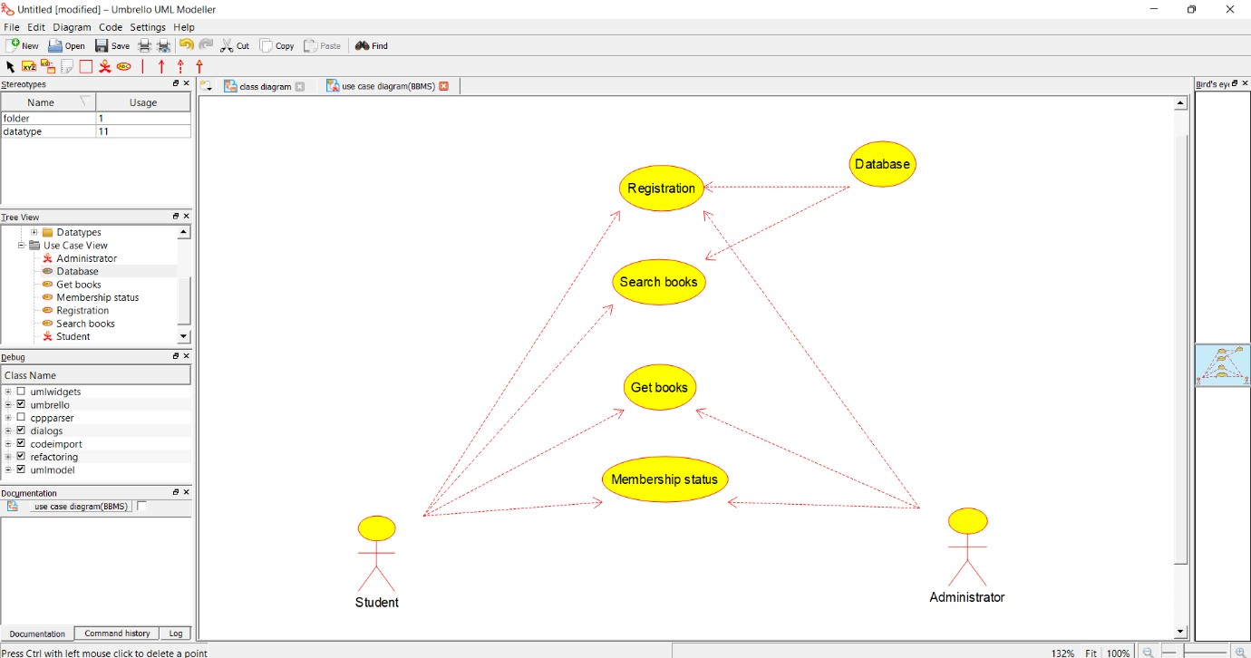

**CLASS DIAGRAM:**

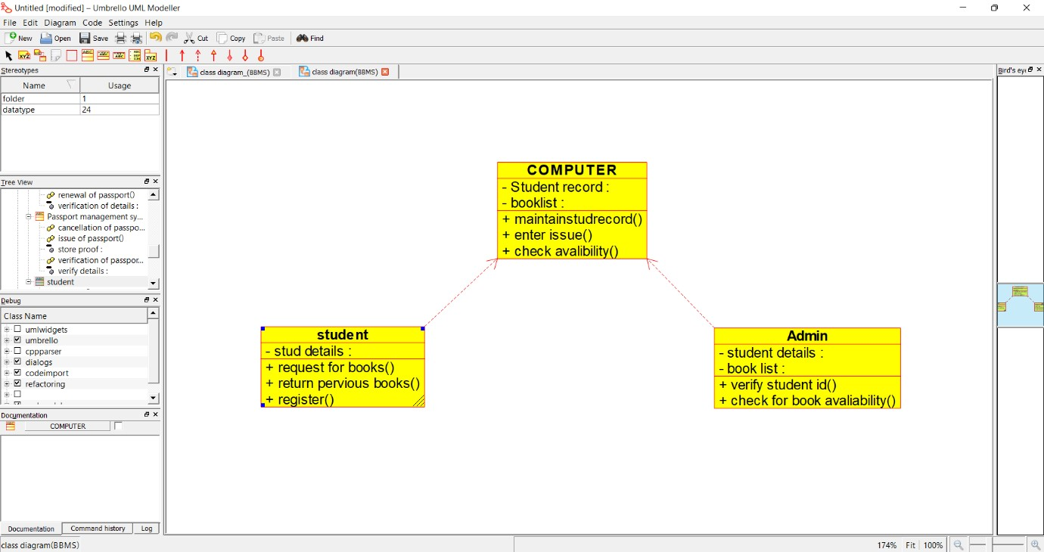

**ACTIVITY DIAGRAM:**

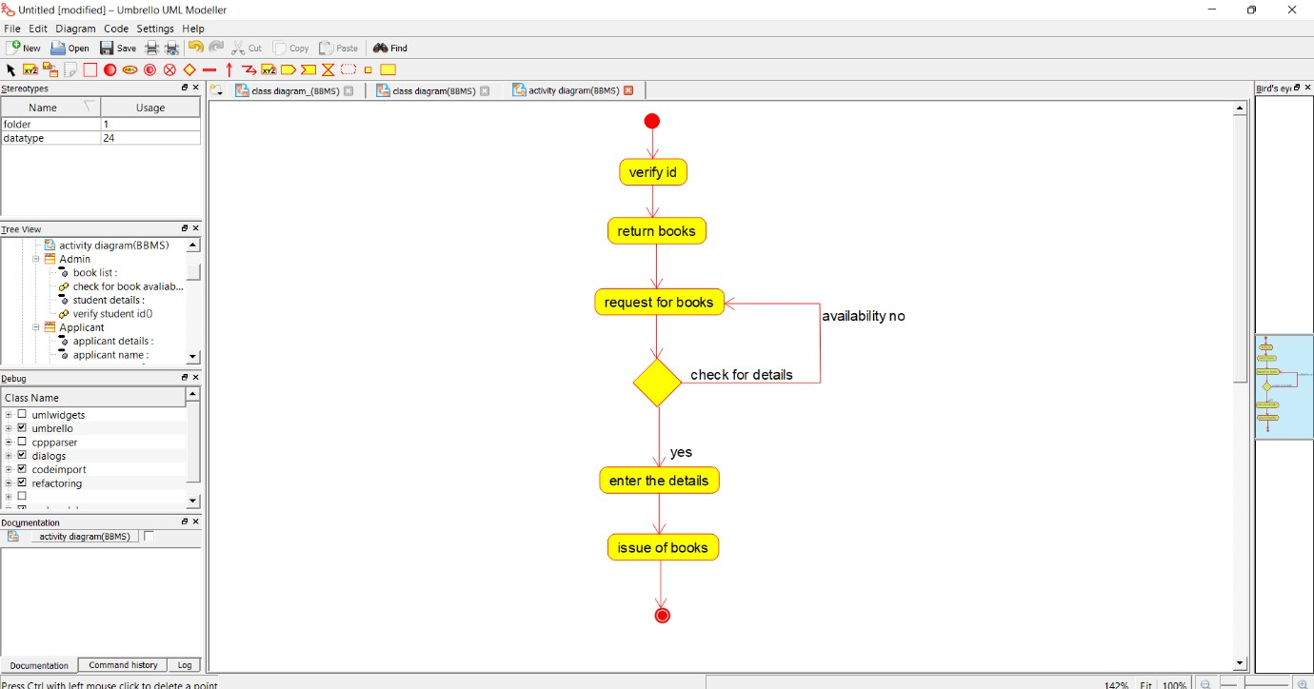

**SEQUENCE DIAGRAM:**

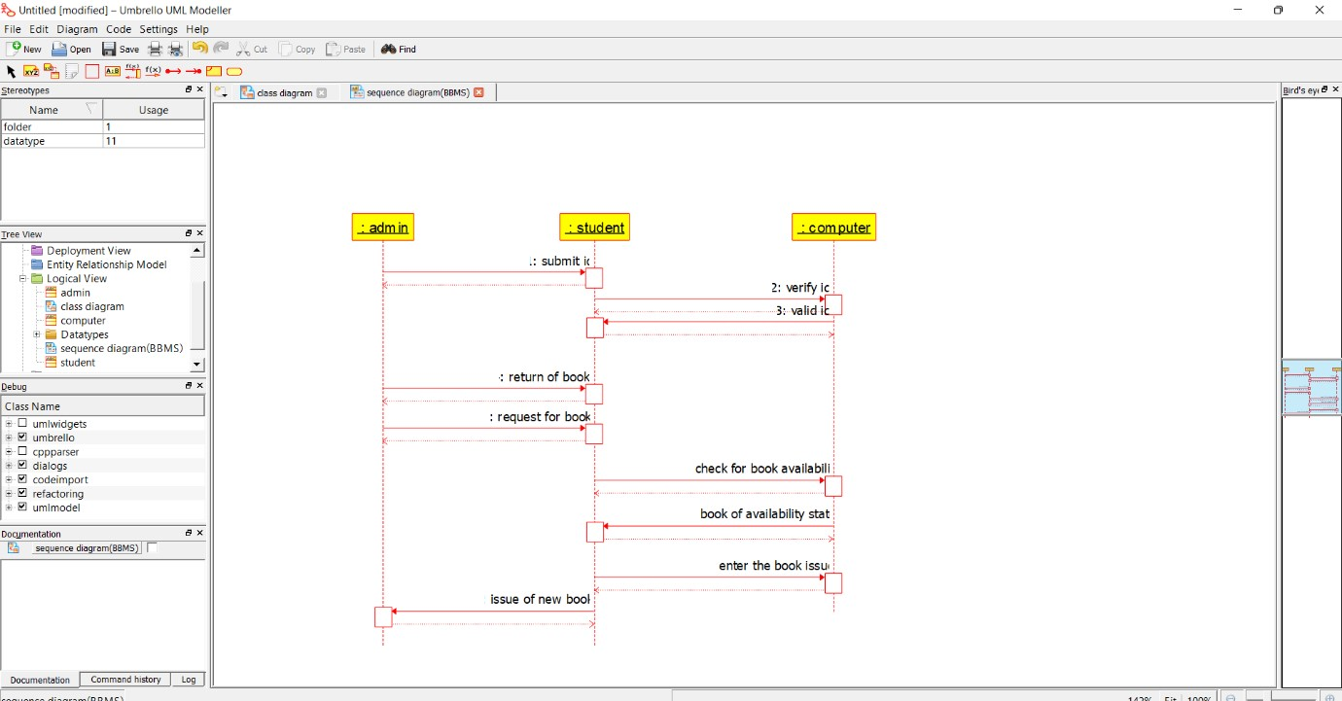

**COLLABORATION DIAGRAM:**

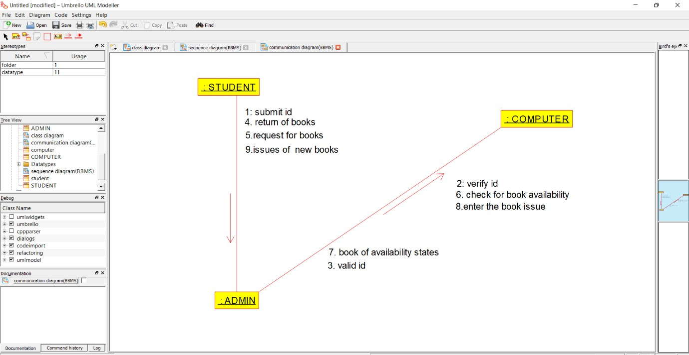

**STATE CHART DIAGRAM:**

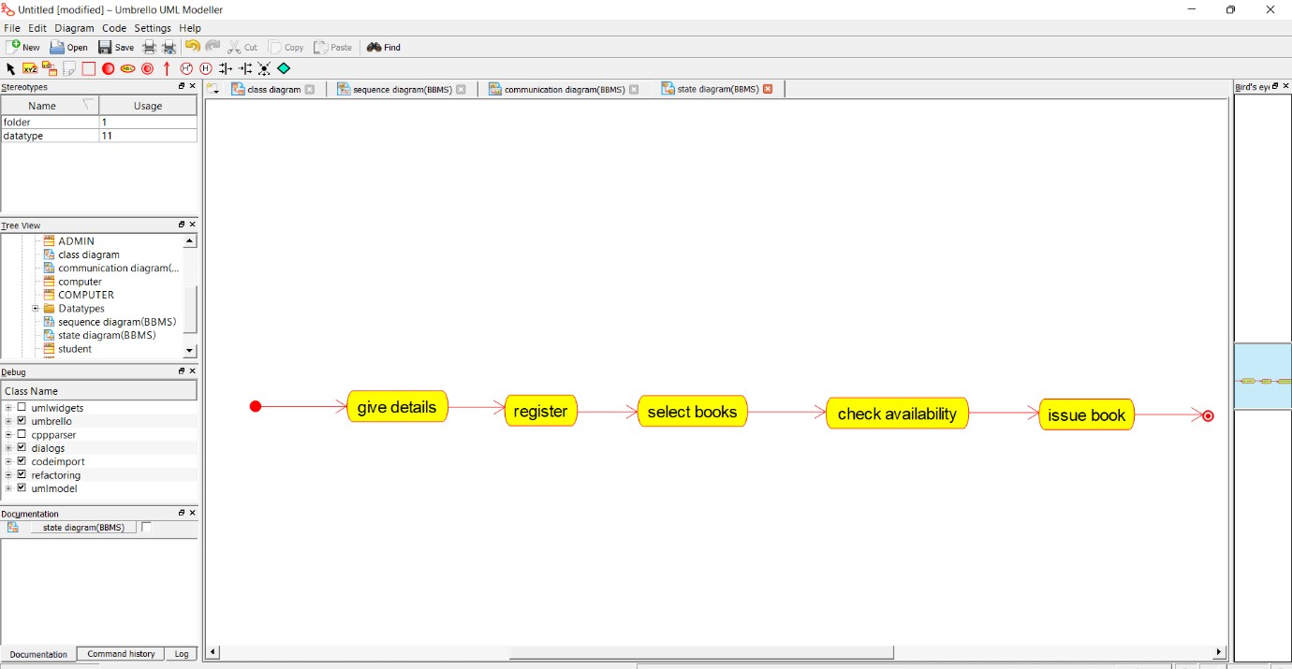

**COMPONENT DIAGRAM**

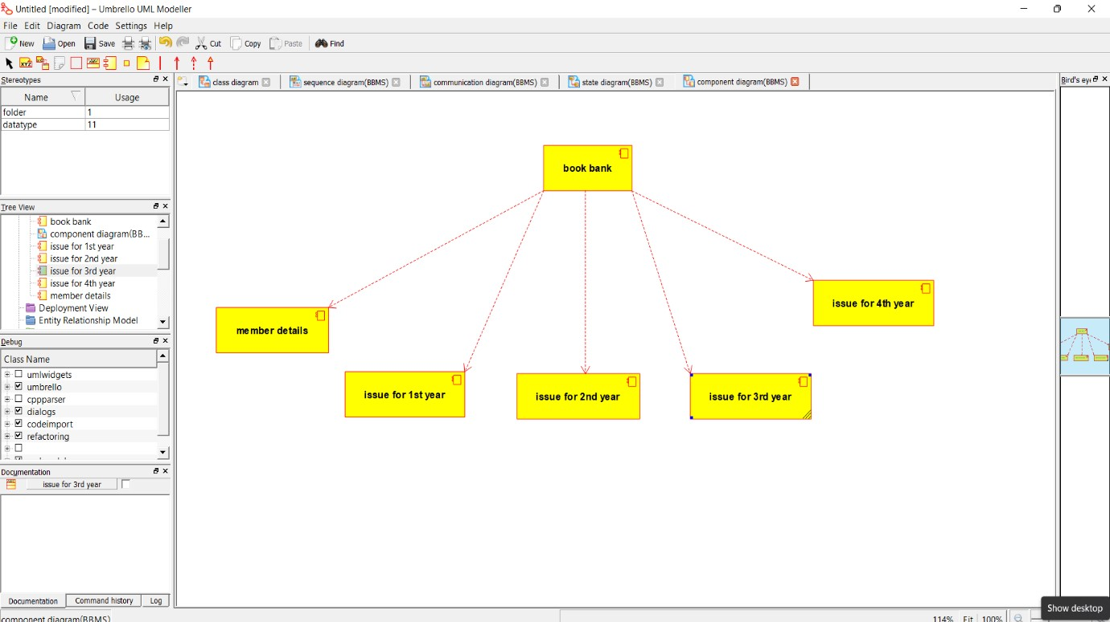

**DEPLOYMENT DIAGRAM :**

