6/9/2025

**Name : A.J.M.T.N.Aberathna**

**S Number : S92061630**

**Register No : 621421630**

**Mini Project Documentation EEI3346**

2. Problem Statement

Main Problem:

Dambulla faces significant urban challenges including wildlife conflicts, waste management issues, that hinder sustainable development and quality of life for residents.

Sub-Problems:

1. Human-wildlife conflicts (monkeys and elephants entering urban areas)
2. Inefficient waste management systems leading to environmental pollution
3. Traffic congestion in market areas
4. Lack of community engagement in urban solutions
5. Poor drainage systems causing flooding

Constraints:

1. Front-end only implementation (no backend)
2. Must use Vue.js for interactive elements
3. Original content required (no templates)
4. Limited time for development (4 weeks)
5. Must use locally relevant images and solutions

## 3. Solution Approach

### Technical Implementation:

1. **Multi-page Website**: HTML5 structure with consistent CSS styling
2. **Vue.js Integration**: For dynamic feedback forum
3. **Responsive Design**: Mobile-friendly layout using CSS Flexbox/Grid
4. **Interactive Elements**: JavaScript-powered features
5. **Local Content**: Original photos and research about Dambulla

### Urban Solutions Proposed:

1. Smart waste bins with animal-proof mechanisms
2. Community composting programs
3. AI-powered traffic management system
4. Urban wildlife corridors
5. Rainwater harvesting initiatives

**4. Architectural Diagram**

[User]

|

[Browser / UI]

|

[HTML/CSS/JavaScript + Vue.js Components]

|

[Client-side only — no backend]

**5.Site Map**

index.html → Home

local-issues.html → Local urban problems

solutions.html → Proposed smart city solutions

events.html → List of community events

feedback.html → Vue.js comment forum

### ****6. Technologies Used****

| **Technology** | **Use Case** |
| --- | --- |
| HTML5 | Page structure |
| CSS3 | Responsive, futuristic UI styling |
| JavaScript | UI interactivity |
| Vue.js | Dynamic comment forum on Feedback page |

### ****7. Test Results****

**Navigation between pages**

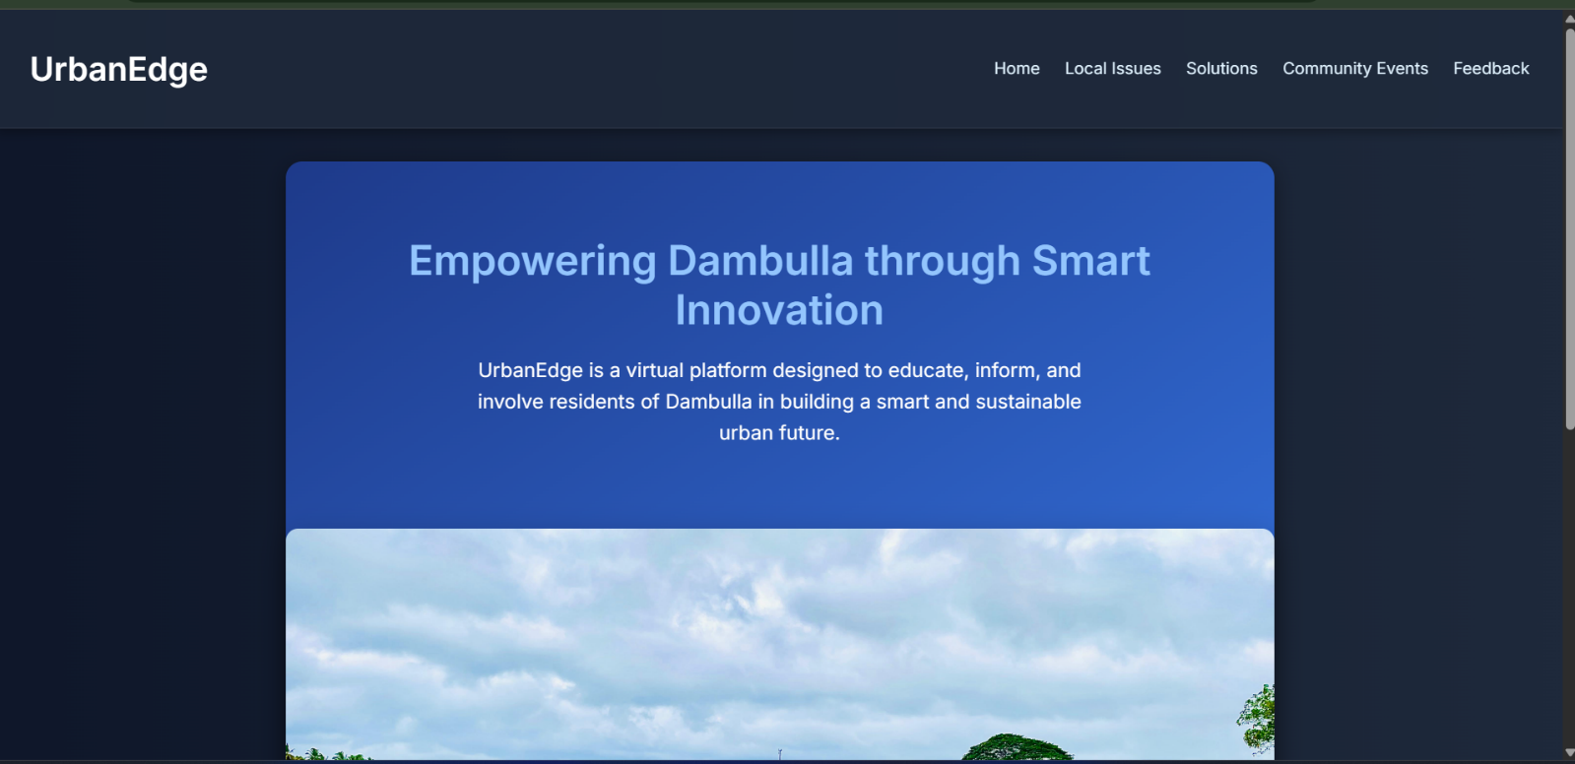

**Comment forum adds posts live**

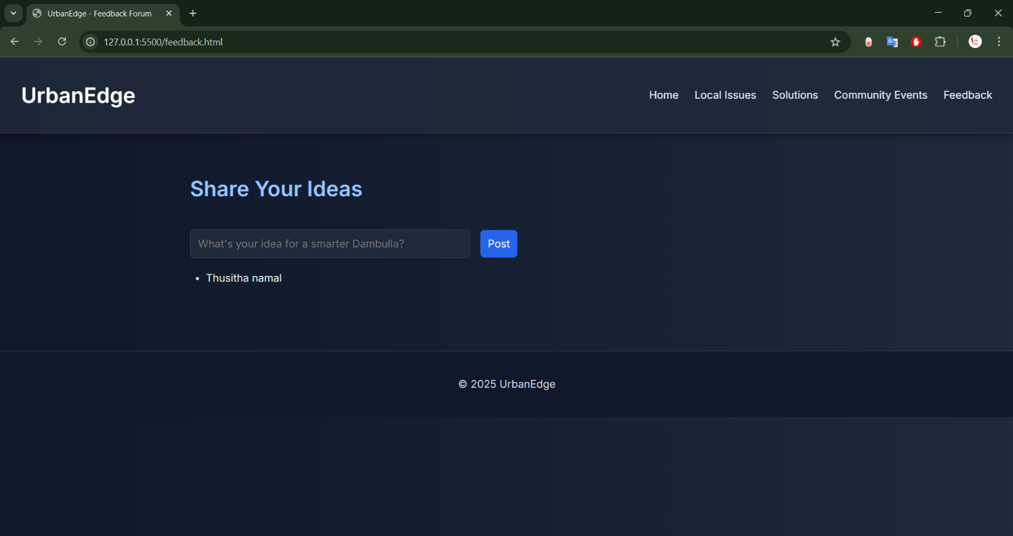

**Site loads on mobile**

**CSS responsiveness & layout**

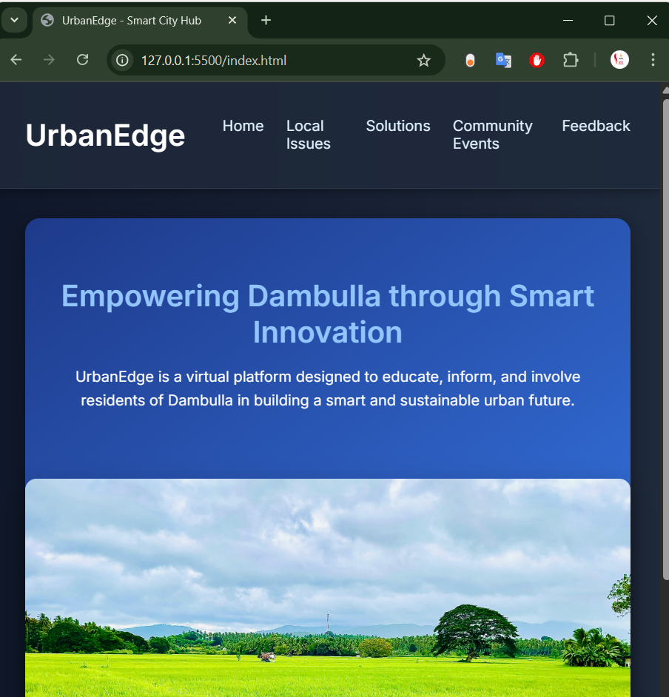

**All images render correctly**

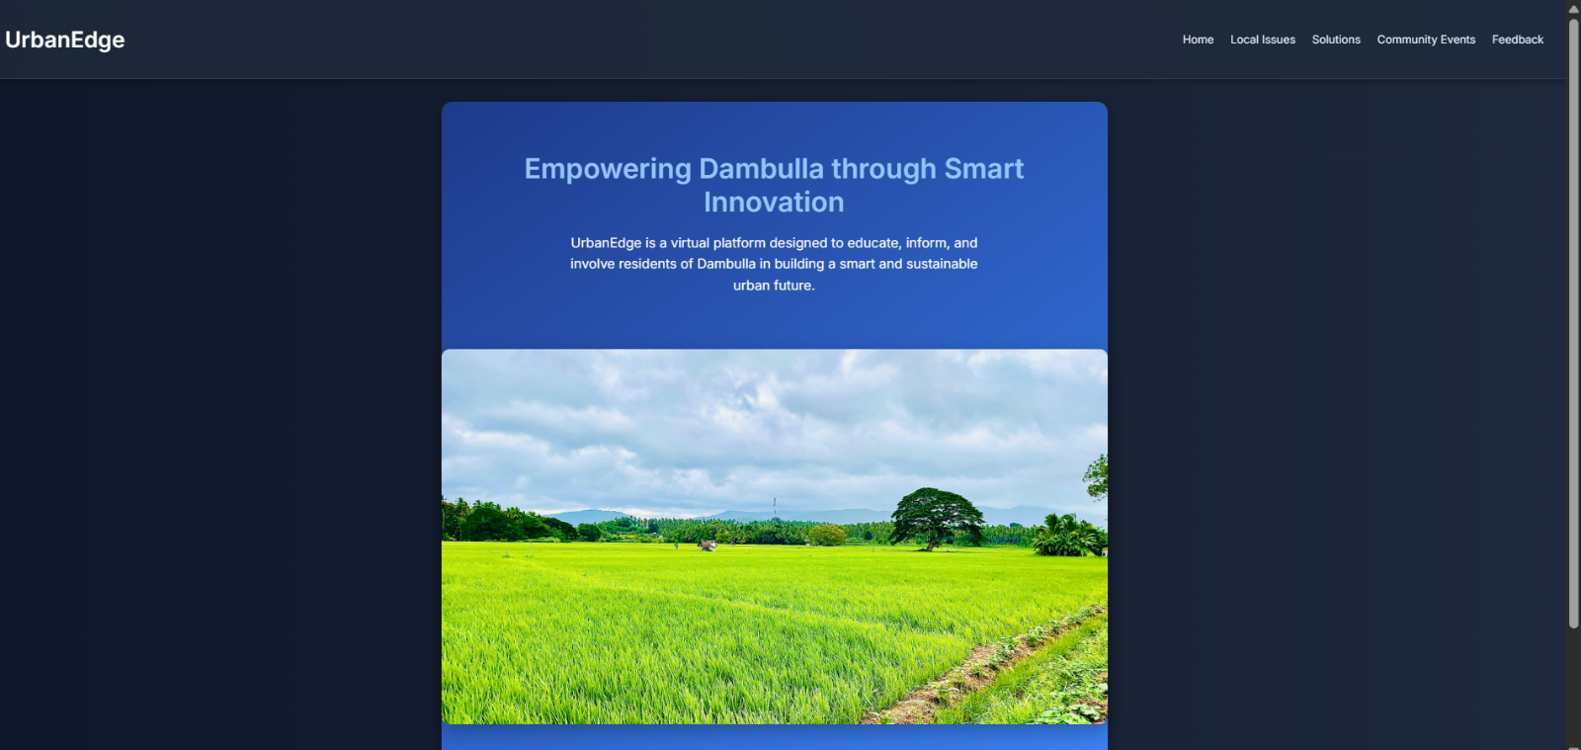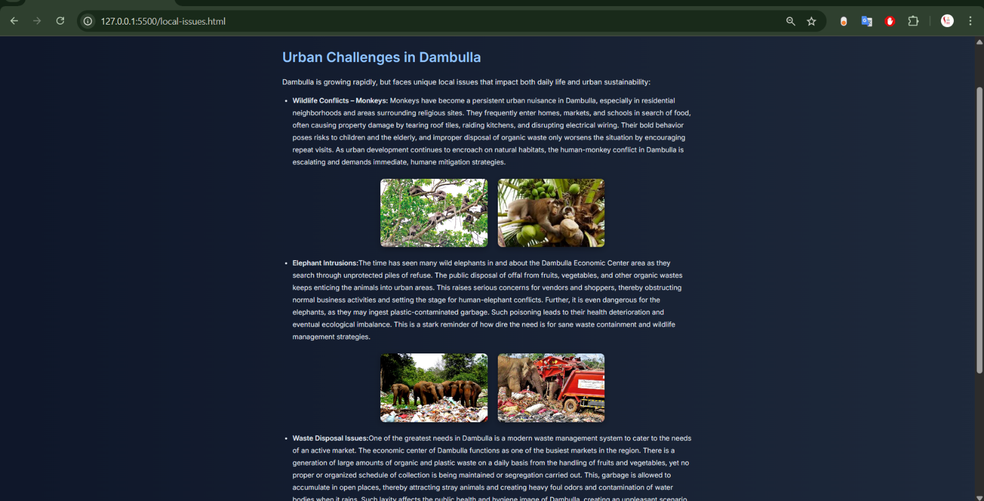

**8. Conclusion**

**UrbanEdge renders a visually appealing, informative, and interactive web portal that caters to the urban needs of Dambulla with the flair of modern web technology. The site, acting as a virtual smart city hub, educates citizens, suggests innovations, and promotes community feedback-all elements that are perfectly in line with the project objective.**