1. List 3 different protocols: TCP, UDP, DNS
2. How long did it take from when the HTTP GET message was sent until the HTTP OK reply was received?
→ 0.065981721 seconds
3. What is the Internet address of the gaia.cs.umass.edu?
→ 128.119.245.12
What is the Internet address of your computer?
→ 192.168.0.16

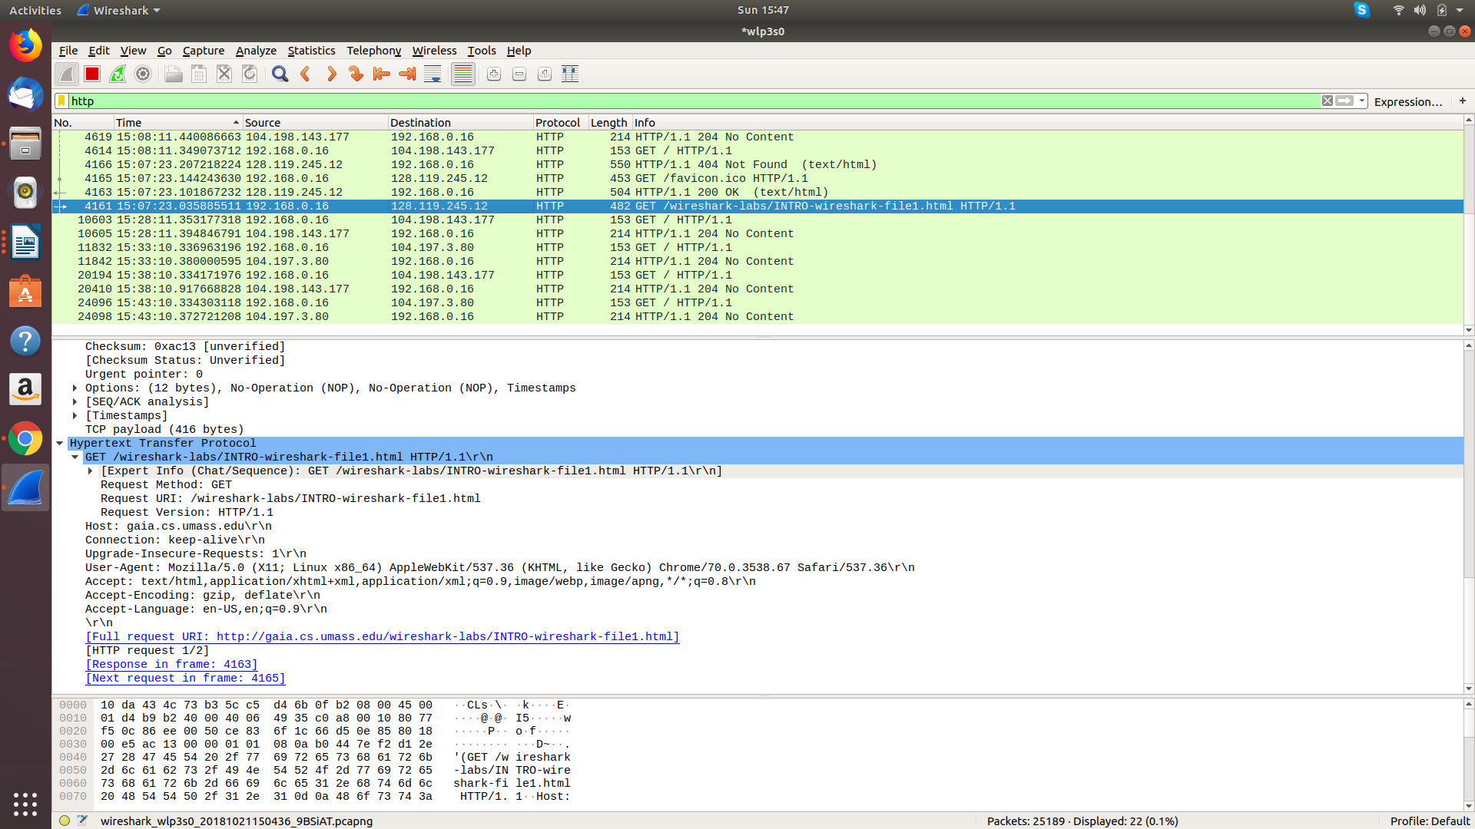
I hereby declare that this submission is my own original work and to the best of my knowledge it contains no materials previously published or written by another person.
Thuy Hong Ha

