**Solution**

Problem 2

(f)

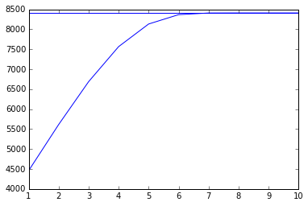

This plot shows the log-likelihood vs. iteration number. The horizontal line represents the log-likelihood of the true $α$

The estimated model parameters are

(9.7480297, 4.94267744, 14.45786025, 19.3713438, 48.90068215)

Problem 4

(a)

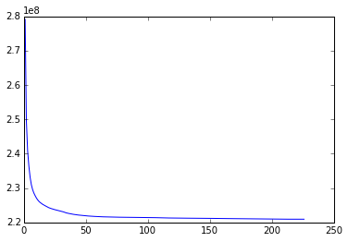

This plot shows the k-means objective function vs. iteration number

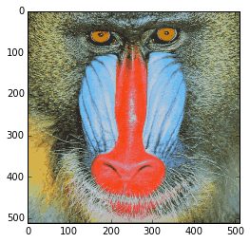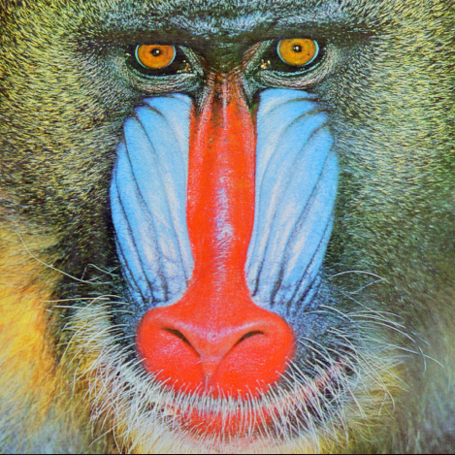

Left: compressed. Right: original.

The compressed image looks similar to the original image. Most of the parts are preserved well, except for the yellow eyeballs and fur. The compression ratio is 0.0635. The relative mean absolute error is 0.0505.

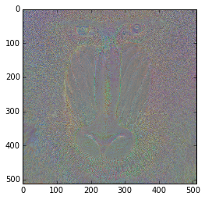

The figure is the picture of difference.

(b) For the uncompressed image, it takes $24×N^{2}$ bits of space. For the compressed image, it takes $\frac{N^{2}}{M^{2}}*\log_{2}{k}+k*3M^{2}*8$ bits of space based on our strategy. Thus, the compression ratio, according to the definition given in the question, is $\frac{\log_{2}{k}}{24M^{2}}+k×\frac{M^{2}}{N^{2}}$.

Problem 5

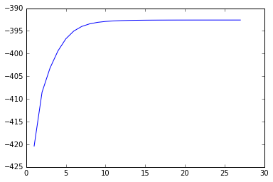

The plot of the log-likelihood vs. iteration number

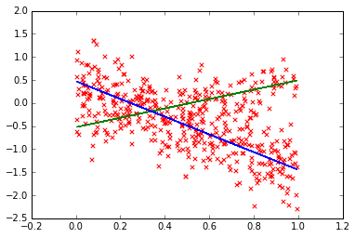

The plot showing the data and two estimated lines. Two lines are plotted based on two sets of estimated parameters and the generated x values.

${\hat{π}}_{1}$ is 0.357424057578 , ${\hat{π}}_{2}$ is 0.642575942422

${\hat{w}}_{1}$ is 1.06952163851 , ${\hat{w}}_{2}$ is -1.91814062139

${\hat{b}}_{1}$ is -0.538503076118 , ${\hat{b}}_{2}$ is 0.445332535286

${\hat{σ}}_{1}$ is 0.276081799521 , ${\hat{σ}}_{2}$ is 0.401958457328