Climate Variability and Change Analysis: Pretoria

# 1. Introduction

Pretoria, situated in Gauteng Province, has undergone significant urban development over the past six decades. Studying climate variability here  
provides insights into both regional climate trends and the influence of microenvironmental changes such as urbanization.

# 2. Methodology

We used TerraClimate data (1964–2024) for monthly temperature and precipitation. Data was processed using Python (pandas, seaborn, matplotlib).  
Seasonal grouping, anomaly detection, and extreme event classification were applied.

# 3. Results

The following visualizations illustrate key trends in temperature, precipitation, seasonal variation, and extreme events:

Figure: Annual Temperature Trends

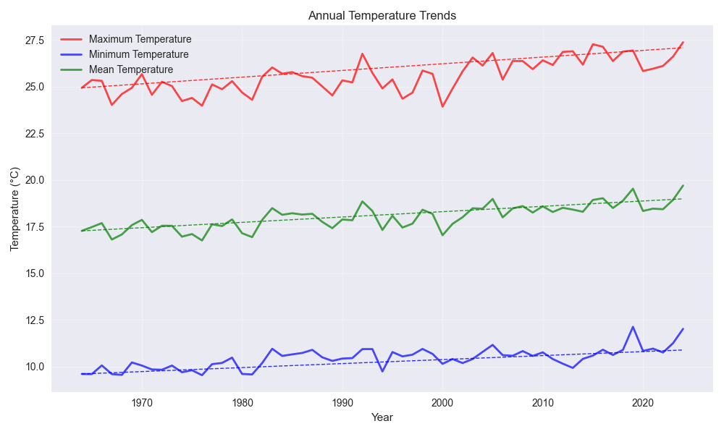

Figure: Annual Precipitation Trend

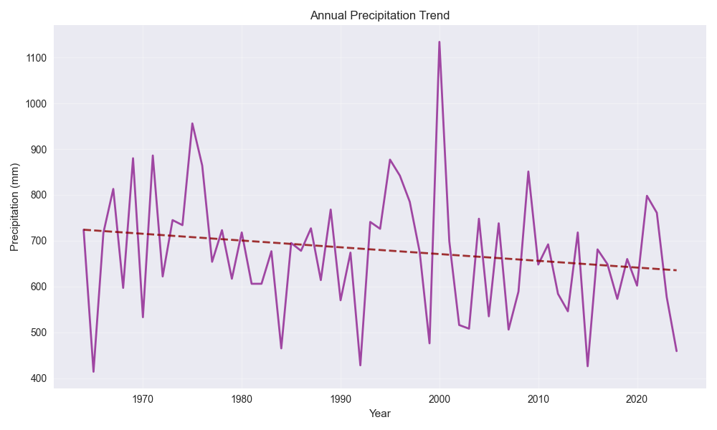

Figure: Diurnal Temperature Range

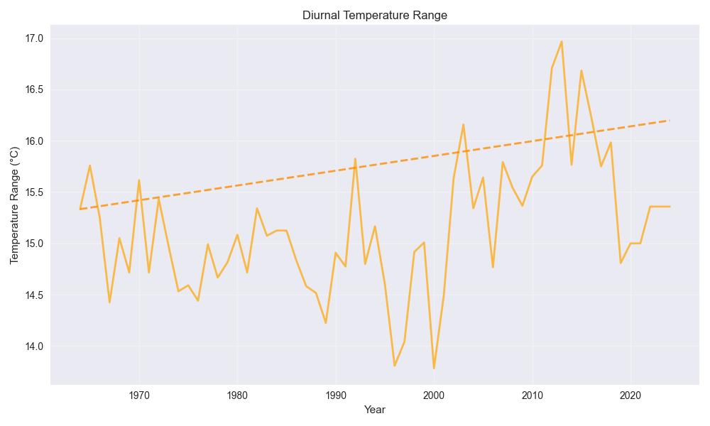

Figure: 10-Year Moving Averages

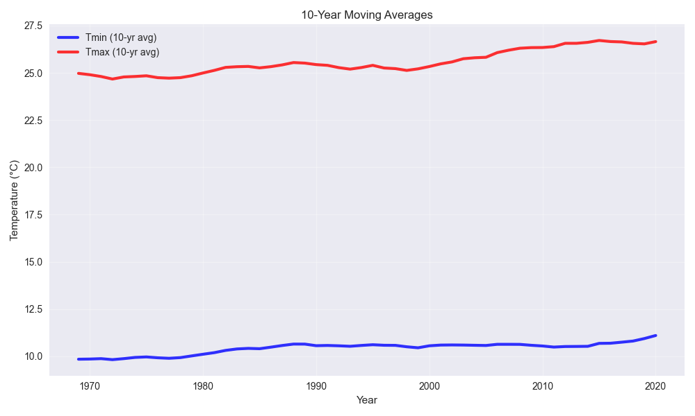

Figure: Summer Temperature Trends

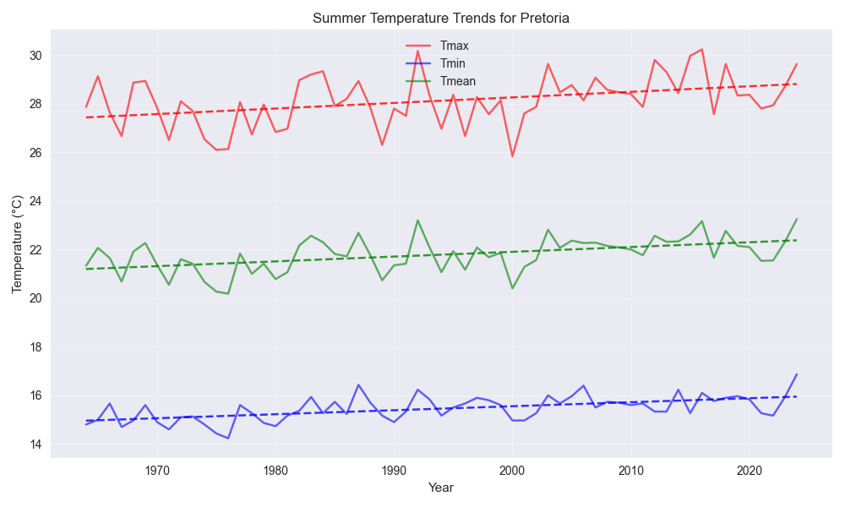

Figure: Autumn Temperature Trends

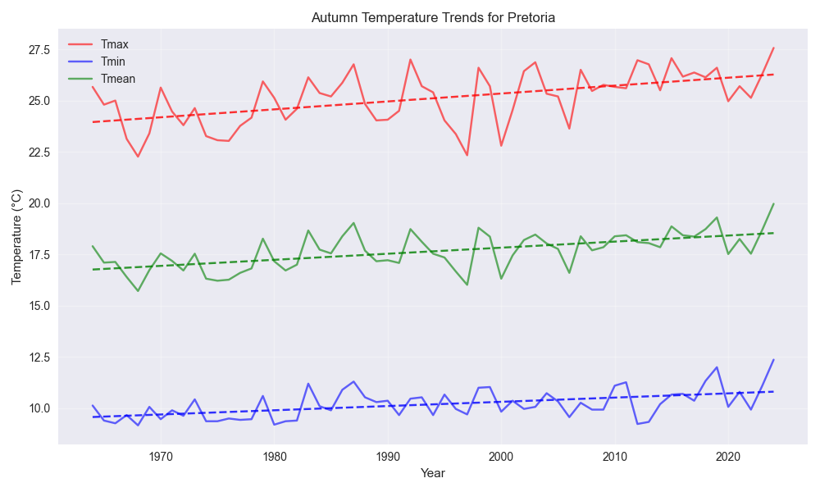

Figure: Winter Temperature Trends

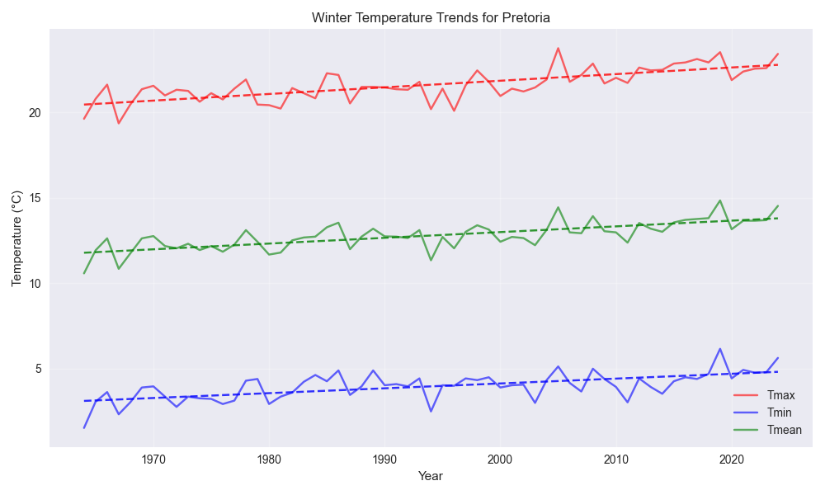

Figure: Spring Temperature Trends

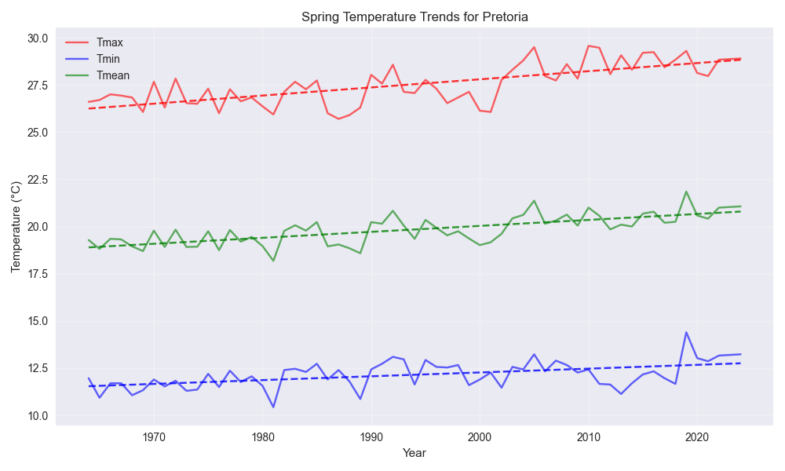

Figure: Seasonal Tmax Distribution

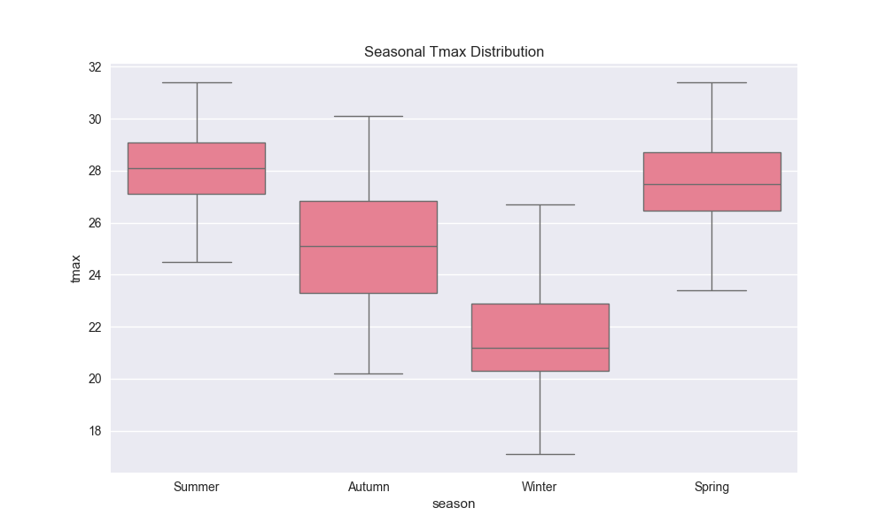

Figure: Extreme Temperature Events per Year

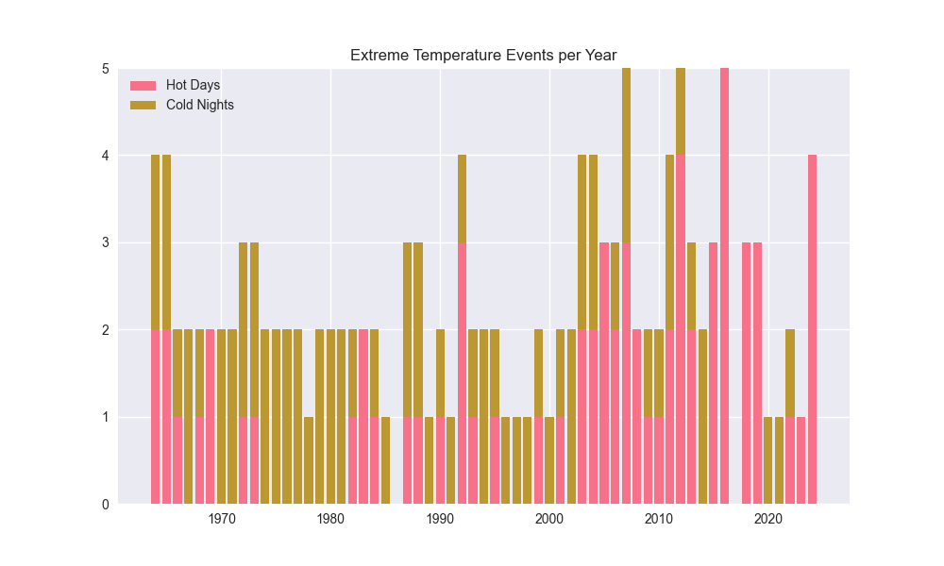

Figure: Annual Precipitation Anomalies

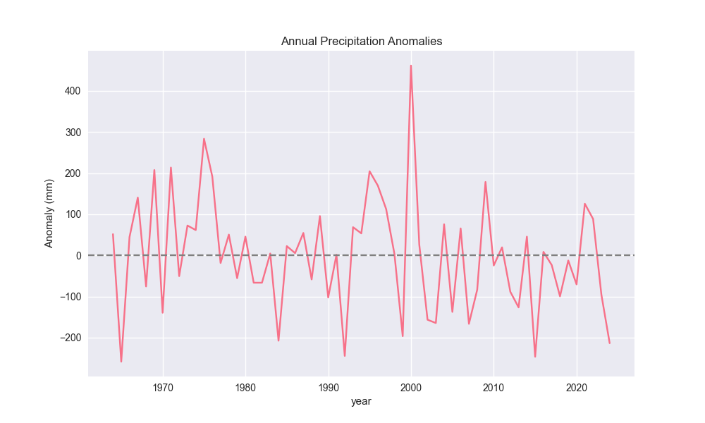

Figure: Minimum Temperature Trends by Period

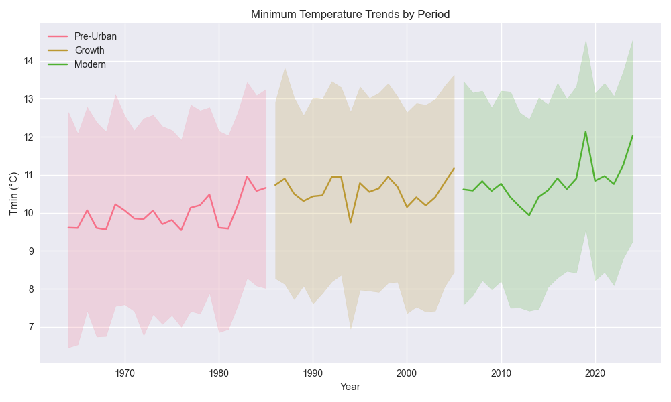

Figure: Overall Temperature Trend

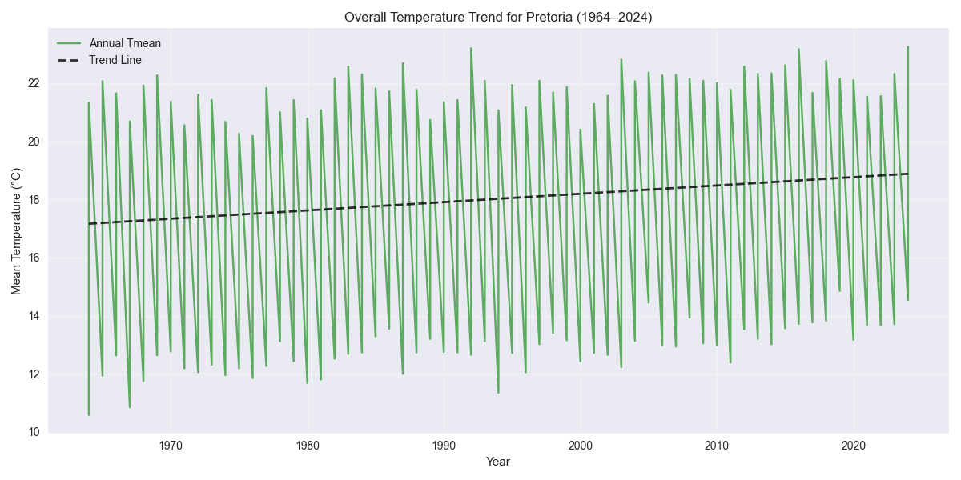

## Seasonal Temperature Trends Summary

|  |  |  |  |
| --- | --- | --- | --- |
| Season | Variable | Trend (°C/decade) | Significant |
| Summer | tmax | 0.229 | Yes |
| Summer | tmin | 0.165 | Yes |
| Summer | tmean | 0.197 | Yes |
| Autumn | tmax | 0.386 | Yes |
| Autumn | tmin | 0.206 | Yes |
| Autumn | tmean | 0.296 | Yes |
| Winter | tmax | 0.388 | Yes |
| Winter | tmin | 0.284 | Yes |
| Winter | tmean | 0.336 | Yes |
| Spring | tmax | 0.43 | Yes |
| Spring | tmin | 0.202 | Yes |
| Spring | tmean | 0.316 | Yes |

## Summary of Temperature Trends

|  |  |  |  |  |  |
| --- | --- | --- | --- | --- | --- |
| Variable | Trend (°C/decade) | P-value | Significant | R² | Period |
| TMAX | 0.358 | 0.0000 | Yes | 0.511 | 1964-2024 |
| TMIN | 0.214 | 0.0000 | Yes | 0.478 | 1964-2024 |
| TMEAN | 0.286 | 0.0000 | Yes | 0.586 | 1964-2024 |

## Microenvironmental Analysis Summary

|  |  |  |
| --- | --- | --- |
| Indicator | Value | Interpretation |
| Minimum Temperature Trend | 0.214°C/decade | Consistent with urban heat island effects |
| Temperature Range Trend | 0.144°C/decade | Stable or increasing range |
| Tmin Trend (Early Period (1964-1985)) | 0.364°C/decade | Period-specific warming |
| Tmin Trend (Growth Period (1986-2005)) | 0.009°C/decade | Period-specific warming |
| Tmin Trend (Modern Period (2006-2024)) | 0.549°C/decade | Period-specific warming |

# 4. Discussion

The warming trend is most pronounced post-2000, coinciding with rapid urban expansion. Seasonal shifts suggest increased summer Tmax variability.  
The rise in hot days and reduction in cold nights reflect broader warming patterns, potentially amplified by local land cover changes.

# 5. Conclusion

Pretoria’s climate has warmed significantly, with notable changes in seasonal patterns and extreme events. These findings underscore the need for  
localized climate adaptation strategies and further research into microenvironmental influences.