TRAFFIC PERFORMANCE
& OPTIMIZATION REPORT
Urban Traffic Flow, Congestion Management & Mobility Optimization
Data Analyst Project Report
Prepared by: T Harshalatha

Project Detail | Value
Dataset | Banglore_traffic_Dataset.csv
Processed Dataset | Bangalore_traffic_processed.csv
Records | 8,936
Analysis Period | 01 January 2022 – 09 August 2024
Areas | 8
Roads / Intersections | 16
Tools | Python, Pandas, NumPy, Matplotlib, Seaborn, Plotly, Jupyter Notebook

Contents
1. Executive Summary
2. Introduction
3. Project Objectives
4. Dataset Overview
5. Data Preparation & Data Quality
6. KPI Framework
7. Traffic Performance Analysis
8. Area-Wise Performance
9. Traffic Relationships & Correlation Analysis
10. Bottleneck & High-Risk Analysis
11. Advanced Analytics
12. Scenario Simulation
13. Key Structural Weaknesses
14. Urban Mobility Improvement Roadmap
15. Monitoring & Evaluation Framework
16. Dashboard Overview
17. Visual Analysis
18. Limitations
19. Conclusion
20. Appendix

1. Executive Summary
This project analyzes historical traffic observations across major areas and road/intersection locations in Bangalore. The analysis focuses on traffic volume, congestion, speed, road capacity utilization, travel time conditions, traffic signals, public transport usage, parking usage, incidents, weather and roadwork activity.
The overall results show considerable traffic pressure. Average congestion is 80.82% and average road capacity utilization is 92.03%. Average traffic volume is 29,236 vehicles and average speed is 39.45 km/h. The average Travel Time Index is 1.38, indicating that travel conditions are meaningfully slower than the reference travel condition represented by the index.
Koramangala is the strongest location-level concern, with the highest average congestion at 93.99%, the highest average traffic volume at 40,832 vehicles, the lowest average speed at 36.06 km/h, and the highest average road capacity utilization at 97.43%. Electronic City has the lowest average congestion at 54.45% and the lowest average capacity utilization at 76.26%.
The historical data shows a strong positive relationship between traffic volume and congestion (0.84), and an even stronger relationship between road capacity utilization and congestion (0.87). Average speed has a negative relationship with congestion (-0.36). These results describe relationships in the observed data and do not prove causation.
The advanced analysis identified observations where actual traffic volume was substantially above an area/month/day baseline. Examples include CMH Road and Sony World Junction. A high-risk method was also used to identify observations with both high congestion and high capacity utilization.
A scenario simulation tested a 15% reduction in traffic demand. Average traffic volume fell from 29,236.05 to 24,850.64 vehicles. Using the historical volume-congestion relationship, estimated average congestion fell from 80.82% to 70.67%, an estimated improvement of 12.56%. This is an analytical scenario estimate, not a guaranteed real-world result.
Based on the findings, the main priorities are traffic signal coordination, bottleneck and junction management, better public transport integration, demand-management measures and continuous smart traffic monitoring.

2. Introduction
Bangalore has a large and complex road network with traffic pressure that can vary by location, day and operating conditions. For transport planning, measurable indicators are useful for showing where traffic pressure is highest and which parts of the network need attention.
This project uses historical traffic data to examine traffic flow, congestion, road capacity utilization, speed, travel time conditions, bottlenecks and other mobility indicators. Python was used for data preparation, validation, KPI calculation, analysis, visualization and the interactive dashboard.
The aim is not only to describe traffic conditions, but also to turn the results into practical mobility actions and a monitoring framework.

3. Project Objectives
- Measure overall traffic volume, congestion, speed, capacity utilization and travel time conditions.
- Compare traffic performance across Bangalore areas and road/intersection locations.
- Identify high-congestion observations and recurring bottleneck locations.
- Examine relationships between traffic demand, speed, road capacity and congestion.
- Review monthly, yearly, weekday, weather and roadwork patterns available in the dataset.
- Estimate expected traffic conditions and identify unusually high traffic volume deviations.
- Identify high-risk traffic observations using congestion and capacity thresholds.
- Test a traffic-demand reduction scenario and estimate its potential effect on congestion.
- Translate analytical findings into practical urban mobility recommendations.
- Define a monitoring framework for ongoing traffic performance evaluation.

4. Dataset Overview
The notebook contains 8,936 traffic observations. The original traffic fields cover location, traffic demand, speed, congestion, capacity, travel time, incidents and other mobility/environmental indicators. After preparation, the analytical dataset contains 20 columns, including the original fields and date-derived features.
Metric | Value
Rows | 8,936
Columns after preparation | 20
Original traffic fields | 16
Analysis period | 01 Jan 2022 – 09 Aug 2024
Areas | 8
Roads / intersections | 16
Weather categories | Clear, Overcast, Fog, Rain, Windy
Roadwork categories | Yes, No

Main Data Fields
Field | Business Meaning
date | Date of the traffic observation
area_name | Area where traffic was observed
road/intersection_name | Road or intersection being analyzed
traffic_volume | Traffic volume recorded at the observation
average_speed | Average vehicle speed
travel_time_index | Indicator of travel time conditions
congestion_level | Level of traffic congestion
road_capacity_utilization | Degree to which road capacity is being used
incident_reports | Number of reported traffic incidents
public_transport_usage | Public transport usage level
traffic_signal_compliance | Level of traffic signal compliance
parking_usage | Parking usage level
pedestrian_and_cyclist_count | Number of pedestrians and cyclists
weather_conditions | Weather condition during the observation
roadwork_and_construction_activity | Roadwork/construction indicator

5. Data Preparation & Data Quality
The analysis then created year, month, day and day_name features from the date.
Validation Check | Result
Missing values | 0 across the analytical columns
Duplicate rows | 0
Congestion range | 5.16 to 100.00
Invalid congestion records outside 0–100 | 0
Average speed range | 20.00 to 89.79 km/h
Invalid average speed records (≤ 0) | 0
Traffic volume range | 4,233 to 72,039
Travel Time Index range | 1.0000 to 1.5000
Road capacity utilization range | 18.74% to 100.00%

No missing-value filling was required because the validation output showed zero missing values. The source contains dates, but there is no valid hour/time column in the final dataset; therefore morning and evening peak-hour comparisons were not treated as available results.

6. KPI Framework
The KPI framework summarizes traffic performance and supports comparisons across locations and operating conditions.
KPI | Value | Business Meaning
Average Traffic Volume | 29,236.05 | Overall traffic demand level
Average Speed | 39.45 km/h | Overall movement speed
Average Congestion Level | 80.82% | Overall congestion pressure
Average Road Capacity Utilization | 92.03% | Network infrastructure pressure
Average Travel Time Index | 1.38 | Travel time condition indicator
Average Traffic Signal Compliance | 79.95% | Signal compliance level
Average Public Transport Usage | 45.09 | Public transport usage indicator
Average Parking Usage | 75.16 | Parking demand indicator
Average Incident Reports | 1.57 | Average reported incidents
Average Pedestrian & Cyclist Count | 114.53 | Non-motorized mobility activity
Traffic Reliability | 56.54% | Share of observations below the high-congestion threshold

7. Traffic Performance Analysis

7.1 Yearly Congestion
Average congestion remained high across all three years: 81.13% in 2022, 80.36% in 2023 and 81.05% in 2024. The year-to-year difference is relatively small, so the analysis does not show a strong long-term improvement.
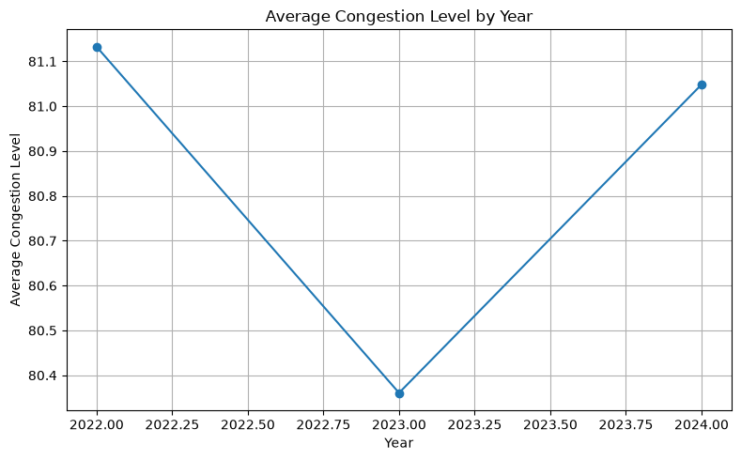
Figure 1. Average Congestion Level by Year

7.2 Monthly Congestion
Monthly congestion stayed within a relatively narrow range. November had the highest average congestion at 81.73%, while January had the lowest at 79.53%.
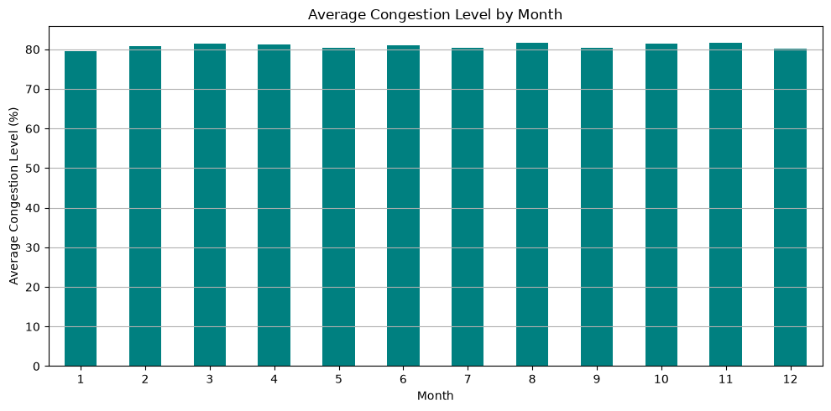
Figure 2. Average Congestion Level by Month

7.3 Day-of-Week Pattern
Monday had the highest average congestion at 81.42%, followed by Wednesday at 81.28%. Friday was the lowest at 80.27%, with Saturday very close at 80.28%. The differences are small, so weekday effects appear limited in this dataset.
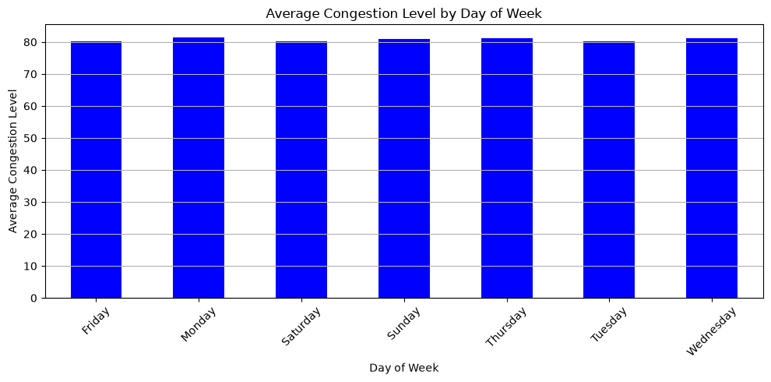
Figure 3. Average Congestion Level by Day of Week

7.4 Weather and Roadwork
Windy observations had the highest average congestion at 82.37%, followed by Fog at 81.61%. Overcast observations had the lowest at 80.30%. The differences are modest, so the notebook does not support a strong weather effect.
Roadwork observations had average congestion of 80.78%, compared with 80.82% for observations without roadwork. The difference is negligible in this dataset and should not be used to claim that roadwork has no real-world effect.

8. Area-Wise Performance
Area | Avg Volume | Avg Congestion | Avg Speed (km/h) | Capacity Utilization | Interpretation
Koramangala | 40,832 | 93.99% | 36.06 | 97.43% | Highest congestion; lowest speed; highest capacity pressure
M.G. Road | 35,300 | 90.58% | 37.54 | 96.55% | Very high congestion and capacity pressure
Indiranagar | 32,284 | 87.64% | 38.64 | 95.76% | High congestion and high capacity utilization
Hebbal | 26,533 | 80.09% | 40.15 | 92.72% | High congestion with high utilization
Jayanagar | 24,601 | 77.00% | 39.79 | 91.52% | Moderate-high pressure
Whitefield | 21,295 | 69.05% | 42.14 | 86.88% | Lower congestion than central hotspots
Yeshwanthpur | 18,932 | 62.37% | 43.45 | 82.40% | Lower congestion and higher speed
Electronic City | 16,347 | 54.45% | 43.66 | 76.26% | Lowest congestion and capacity pressure

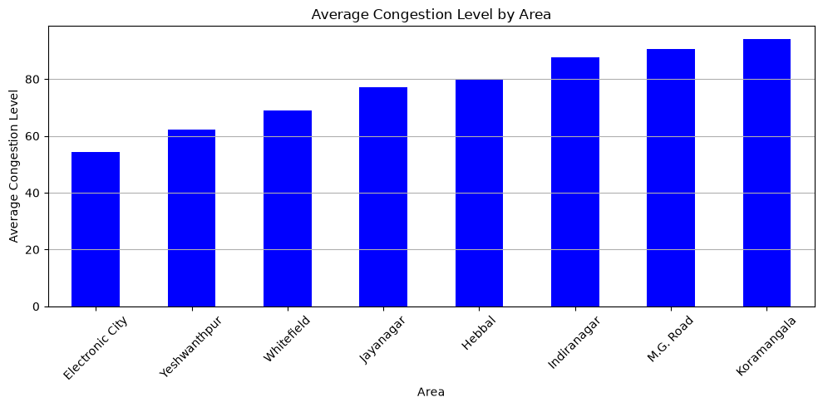
Figure 4. Average Congestion Level by Area
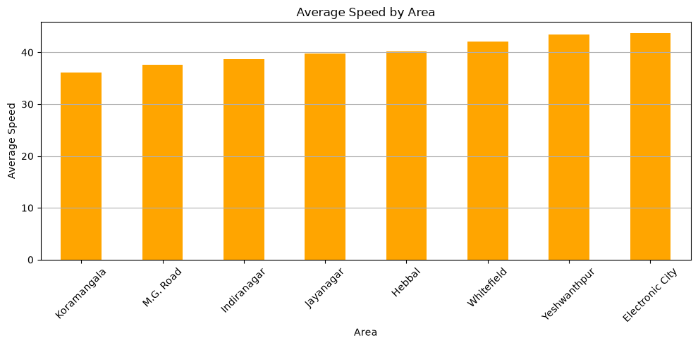
Figure 5. Average Speed by Area
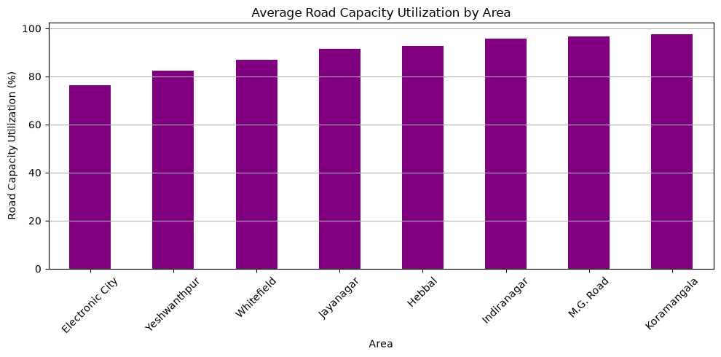
Figure 6. Average Road Capacity Utilization by Area

9. Traffic Relationships & Correlation Analysis
Relationship | Correlation | Interpretation
Traffic Volume vs Congestion | 0.8372 | Strong positive relationship
Road Capacity Utilization vs Congestion | 0.8650 | Strong positive relationship
Travel Time Index vs Congestion | 0.7516 | Strong positive relationship
Traffic Volume vs Road Capacity Utilization | 0.6529 | Moderate-to-strong positive relationship
Traffic Volume vs Average Speed | -0.3411 | Moderate negative relationship
Average Speed vs Congestion | -0.3603 | Moderate negative relationship
Average Speed vs Travel Time Index | -0.3762 | Moderate negative relationship

The strongest relationship is between road capacity utilization and congestion (0.87), followed by traffic volume and congestion (0.84). The negative correlations with speed are directionally consistent with traffic performance: higher congestion is associated with lower average speed. These results describe relationships in the dataset; they do not establish that one variable directly causes another.
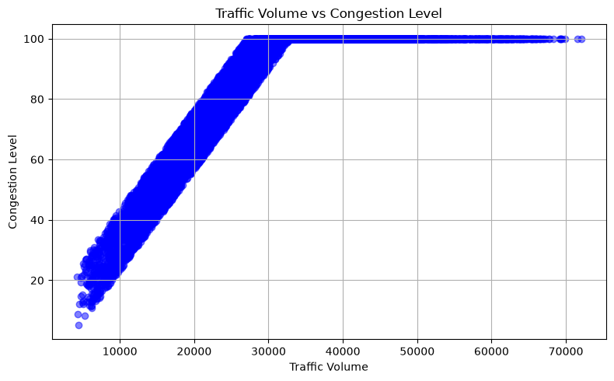
Figure 7. Traffic Volume vs Congestion Level

10. Bottleneck & High-Risk Analysis
High-congestion records were first reviewed using a congestion level of 90% or above. The notebook also created a high-risk method using the 75th percentile of congestion and the 75th percentile of road capacity utilization. Observations meeting both conditions were treated as priority high-risk traffic conditions.
Road / Intersection | Evidence | Risk / Interpretation
Sony World Junction | 94.13% | Highest average congestion among grouped road/intersection results
Sarjapur Road | High / recurring | Appears repeatedly in high-volume deviation observations
Anil Kumble Circle | High / recurring | Appears repeatedly in high-volume deviation observations
CMH Road | High / recurring | Appears in high-volume deviation observations and high-congestion records
Trinity Circle | High / recurring | Appears in high-congestion and high-risk observations

The breakdown analysis used the 95th percentile of volume_gap. Several observations had traffic volume far above their area/month/day baseline. For example, CMH Road recorded a volume gap of about 26,505 vehicles in one observation, while Sony World Junction recorded a gap of about 20,447 vehicles.

11. Advanced Analytics

11.1 Expected Traffic Baseline
Expected traffic volume was calculated using the mean traffic volume for each combination of area, month and day of week. The volume_gap was then calculated as actual traffic volume minus expected volume. A positive gap means traffic was above the historical baseline; a negative gap means it was below the baseline.

11.2 High-Risk Detection
The high-risk method combines congestion and capacity pressure. It uses the 75th percentile of congestion and the 75th percentile of capacity utilization as thresholds. In this dataset, both 75th percentile values are 100%, so the resulting high-risk observations are those with both measures at 100%.

11.3 Traffic Breakdown Analysis
The top 5% of positive volume_gap observations were treated as unusually high traffic conditions. The examples identified in the notebook are concentrated in recurring locations including Koramangala, Indiranagar, M.G. Road and Hebbal.

11.4 Demand vs Capacity
Traffic volume and road capacity utilization have a correlation of 0.65, while capacity utilization and congestion have a correlation of 0.87. This suggests that capacity pressure is closely associated with congestion in the historical observations.

12. Scenario Simulation
Scenario Metric | Original | Simulated / Estimated
Average Traffic Volume | 29,236.05 | 24,850.64
Traffic Demand Reduction | N/A | 15.00%
Average Congestion | 80.82% | 70.67%
Estimated Congestion Reduction | N/A | 10.15 percentage points
Estimated Congestion Improvement | N/A | 12.56%

The scenario applies a 15% reduction to traffic volume. The estimated congestion change is calculated using the observed correlation between traffic volume and congestion. This is useful for understanding the possible direction and scale of an intervention, but it is not a predictive traffic simulation and should not be treated as a guaranteed real-world outcome.

13. Key Structural Weaknesses
Issue | Analytical Evidence | Business / Urban Impact
High overall congestion | Average congestion 80.82% | Congestion is a major network performance concern
High road capacity utilization | Average utilization 92.03% | High infrastructure pressure limits spare capacity
Low-speed area | Koramangala: 36.06 km/h | Movement efficiency needs attention in the most congested areas
High-congestion area | Koramangala: 93.99% | Priority area for traffic operations and capacity management
Recurring bottleneck | Sony World Junction: 94.13% average congestion | Junction-level intervention should be investigated
Traffic reliability risk | 56.54% reliability measure | A significant share of observations reaches the high-congestion range

14. Urban Mobility Improvement Roadmap
Area | Recommended Action | Analytical Evidence | Priority
Traffic Signals | Optimize signal timing and coordinate signals along high-congestion corridors. | Signal compliance ≈79.95% | High
Road Infrastructure | Prioritize capacity improvement and junction management at recurring bottlenecks. | Capacity utilization ≈92.03% | High
Public Transport | Strengthen public transport integration in high-congestion areas. | Public transport usage indicator ≈45.09 | Medium
Demand Management | Promote demand-management measures where traffic pressure is high. | Volume-congestion correlation ≈0.84 | Medium
Smart Traffic Systems | Use smart cameras, monitoring and data-driven alerts to identify congestion early. | Historical traffic, speed, congestion and capacity indicators | High

15. Monitoring & Evaluation Framework
Frequency | Indicator | Purpose
Daily | Traffic Volume | Track changes in traffic demand and flow.
Daily | Average Speed | Monitor movement efficiency and identify speed deterioration.
Daily | Congestion Level | Track overall congestion conditions and emerging problems.
Monthly | Bottleneck Roads / Intersections | Identify recurring locations requiring operational intervention.
Monthly | High-Risk Areas | Monitor areas with persistent high congestion and capacity pressure.
Yearly | Infrastructure Impact | Evaluate the long-term effect of infrastructure improvements.

16. Dashboard Overview
The interactive mobility dashboard was built using Python, Plotly and ipywidgets, with HTML/CSS used for dashboard layout and styling. It allows users to explore traffic conditions using area and year filters.
- Area filter for location-level exploration.
- Year filter for comparing available years.
- KPI cards for average traffic volume, congestion, speed and capacity utilization.
- Traffic volume trend, congestion trend and average speed trend.
- Top high-risk roads/intersections.
- Traffic reliability and high-congestion observation summary.
The dashboard supports interactive exploration of the same analytical results presented in this report.
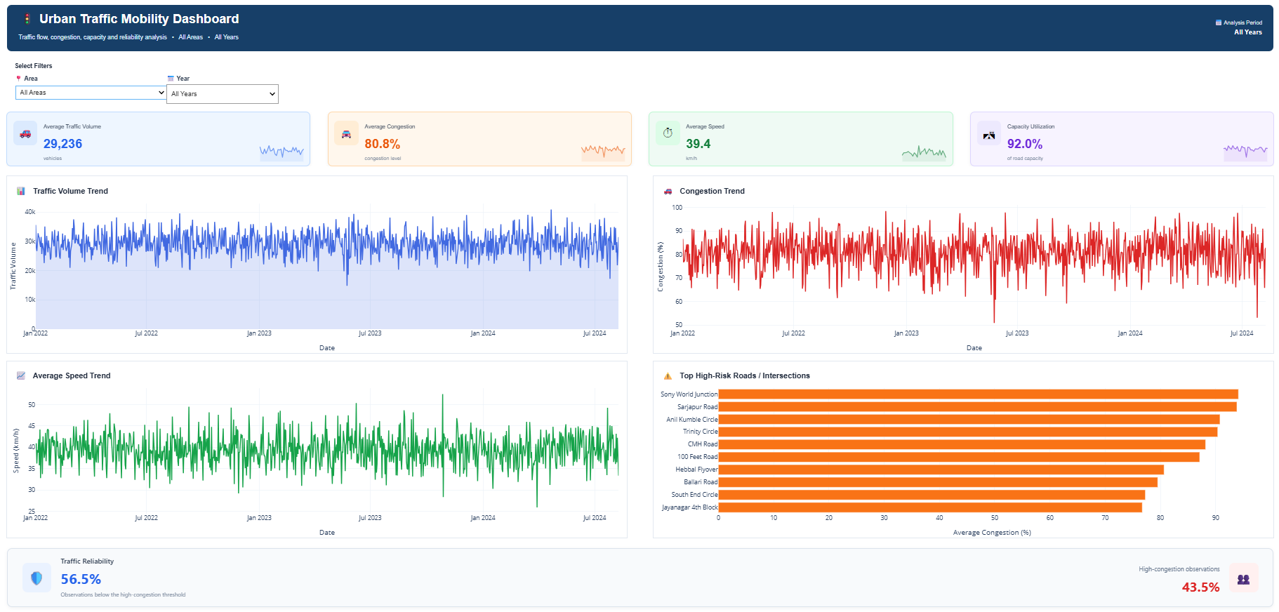
Figure 8. Interactive Urban Traffic Mobility Dashboard

17. Visual Analysis
The report uses the charts above as the main visual evidence. Additional charts are available in the project outputs folder and notebook, but they are not repeated here to avoid duplication and keep the report focused.
The selected visuals cover the most important areas of the analysis: overall trends, location differences, capacity pressure, traffic demand and congestion relationships.

18. Limitations
- The final dataset contains dates but does not contain a valid time-of-day field. Morning and evening peak-hour traffic could therefore not be analyzed directly.
- The analysis is based on historical observations and does not use live traffic feeds.
- Correlation results describe relationships in the dataset and do not establish causation.
- The scenario simulation is an analytical estimate based on the historical volume-congestion relationship, not a full traffic-flow simulation.
- Weather and roadwork comparisons are descriptive; other external factors may also influence traffic conditions.
- The high-risk threshold is percentile-based, and the 75th percentile of congestion and capacity utilization is 100% in this dataset.

19. Conclusion
The analysis shows that the Bangalore traffic observations in this dataset have high overall congestion and high road capacity utilization. The strongest location-level concern is Koramangala, which has the highest congestion, highest traffic volume, lowest average speed and highest capacity utilization.
The relationship analysis shows that congestion is strongly associated with traffic volume and road capacity utilization. The advanced analysis further highlights recurring locations where observed traffic volume is much higher than the expected baseline.
The main practical priorities are better signal coordination, focused management of recurring bottlenecks, capacity and junction improvements, public transport integration, demand-management measures and smart traffic monitoring. The monitoring framework can then be used to track whether these actions are improving traffic performance over time.
Overall, the project demonstrates how Python-based data analysis can turn traffic observations into measurable KPIs, location-level insights, risk identification, scenario analysis and practical mobility recommendations.

20. Appendix

A. Key KPI Definitions
KPI / Measure | Definition used in the analysis
Average Traffic Volume | Mean traffic_volume across observations.
Average Speed | Mean average_speed across observations.
Average Congestion | Mean congestion_level across observations.
Capacity Utilization | Mean road_capacity_utilization across observations.
Travel Time Index | Mean travel_time_index across observations.
Traffic Reliability | Share of observations with congestion below the 75th-percentile congestion threshold.
Expected Volume | Mean traffic volume for an area/month/day-of-week combination.
Volume Gap | Actual traffic volume minus expected volume.
High-Risk Observation | Observation meeting both congestion and capacity 75th-percentile thresholds.

B. Chart Insertion Plan
Figure | Chart Name | File Name | Report Section
1 | Average Congestion Level by Year | congestion_trend_by_year.png | Traffic Performance Analysis
2 | Average Congestion Level by Month | Congestion_Trend_by_Month.png | Traffic Performance Analysis
3 | Average Congestion Level by Day of Week | Congestion_Level_by_Day_of_Week.png | Traffic Performance Analysis
4 | Average Congestion Level by Area | congestion_by_area.png | Area-Wise Performance
5 | Average Speed by Area | Average_Speed_by_Area.png | Area-Wise Performance
6 | Average Road Capacity Utilization by Area | Road_Capacity_Utilization_by_Area.png | Area-Wise Performance
7 | Traffic Volume vs Congestion Level | Traffic_Volume_vs_Congestion.png | Correlation Analysis
8 | Interactive Urban Traffic Mobility Dashboard | Dashboard screenshot | Dashboard Overview

C. Final Quality Check
- Report values were taken from the completed notebook calculations.
- No time-of-day analysis is presented because no valid time field is present.
- Correlation findings are presented as relationships, not causal effects.
- The scenario simulation is clearly labeled as an estimate.
- The dashboard, strategy and monitoring work completed in the notebook are represented.
- Repeated charts were removed so that the same visual is not shown twice.

