# **Week 4: Chapter 7 & 8 Lab – Setting Up and Troubleshooting a Local Network**

**This lab requires the use of your Netlab Windows 10 VM**

**Make sure to reserve a FULL 2.5 hours for this lab and/or extend time aa necessary.**

**Step 1:** Log into your **Online NDG Netlab Account, create a reservation, and launch a VM:**

1. Navigate to: <https://netlabve2.flc.losrios.edu/home.cgi>

**Username:** **EXACTLY the same as your Canvas username**

* *Username is case-sensitive – use* ***lowercase letters*** *ONLY*
* *Enter first initial + last name + last 3 digits of your student id*

**Password:** **98repair** *(no spaces/case-sensitive)*

***Warning:*** *Do NOT use the CAPS LOCK key when using the VMs.*

*If you are having trouble* ***logging in****,* ***creating a reservation****,* ***entering your reservation****, or* ***logging into the VM student account****, please review last week’s tutorial video:*

**Tutorial video:** [**Using NDG NETLAB**](https://www.3cmediasolutions.org/privid/299535?key=659999806e0ca72f4b88510658dce8cde011f19c)

**AFTER ENTERING INTO YOUR WIN10 VM, ALWAYS CHANGE THESE PERFORMANCE SETTINGS BELOW **BEFORE** YOU START:**

Search for Adjust the appearance
 Choose best performance


**WARNING: This lab requires entering command-line commands.**

**Making TYPOS/MISTAKES when entering commands will cause the commands to FAIL – be VERY CAREFUL throughout this lab to enter commands EXACTLY how you see them.**

**VERIFY you see the expected result BEFORE continuing on to the next step and ALWAYS RERUN any commands you have entered incorrectly.**

**1. Custom Project 1: Viewing Network Connection Settings**

Review **pgs**. **421-422** (item **#3**) for information on the **ipconfig** command. Review **pgs. 337-339** for key terms such as **IPv4**/**IPv6**, **subnet mask**, **default** **gateway**, **DNS/DHCP server**.

**Step 1:** Enter **cmd** into the **Windows Search** bar located on the taskbar of your **Windows 10 VM** 🡪 click on **Command Prompt** **App** to open it.

**Step 2:** While the **Command Prompt** window is open, right-click on its icon on the taskbar and click **pin to taskbar**. *(You will be using it frequently)*

how to open the command prompt


**Step 3:** At the command prompt, CAREFULLY type **ipconfig /all** (NO typos) and press **Enter** key to view detailed information about your network connection settings.

**Step 4:** Take a **screenshot** of the entire **Command Prompt** window displaying your current **network** **settings**. *(expand the window if necessary – make sure to get the* ***entire output*** *of the* ***ipconfig /all*** *command) SCORING****: approx****. 2 pts. per question, 4 points per screenshot. Partially correct questions/screenshots can earn half of the points.*

* **Screenshot** of **ipconfig /all** commandoutputinthe **Command Prompt** window**:**

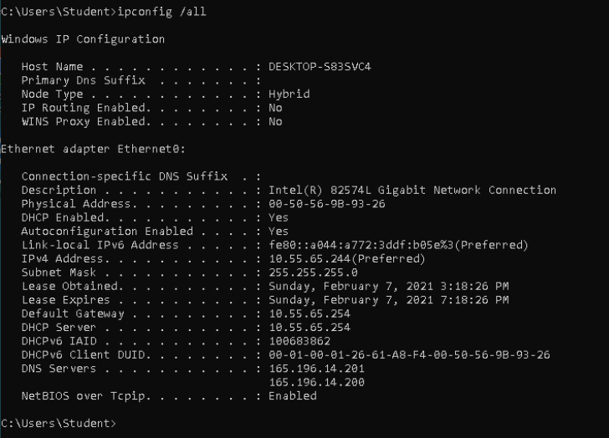

**Step 5:** Using the output generated from the **ipconfig /all** command in the **Windows 10** VM *(or your screenshot above)*, answer the following questions about your network connection settings below:

* What is your **IPv4** **address**? **10.55.65.244 (answers vary)**
* What is your **subnet mask? 255.255.255.0**
* What is your **default gateway address? 10.55.65.254**
* **Look carefully at the various settings. Is your IPv4 address statically set or automatically configured***? (Hint: look for configuration setting(s) that can be enabled/disabled)* **Automatically configured.** *Automatically assigned – DHCP and Autoconfiguration enabled.*
* How long is your **IPv4 address leased for** *(approx. number of hours)*? **4.0 hours (answers vary)**
* Look at the **Description** of your ethernet adapter (Network interface card/NIC). What is its make and model? **Intel 82574L** *Gigabit Network Connection*
* **Pg. 342** of your textbook describes a MAC address, also called a “physical address”. What is your NIC’s MAC address? **00-50-56-9b-93-26 (answers vary)**
* How many **DNS server addresses** are configured? **two**

**Step 6:** Review **pg. 423**, item #4 in your textbook to view the commands to **release** and **renew** your IP address. In your **Windows 10** VM **Command Prompt** window, run the command to **RELEASE** your IP address ONLY (do **NOT** renew at this time).

* What **command** did you enter? **ipconfig /release**

**Step 7:** Type **ipconfig /all** into the **Command Prompt** window. Take a **screenshot** of the output generated by the command:

* **Screenshot** of **ipconfig /all** commandoutputinthe **Command Prompt** window**:**

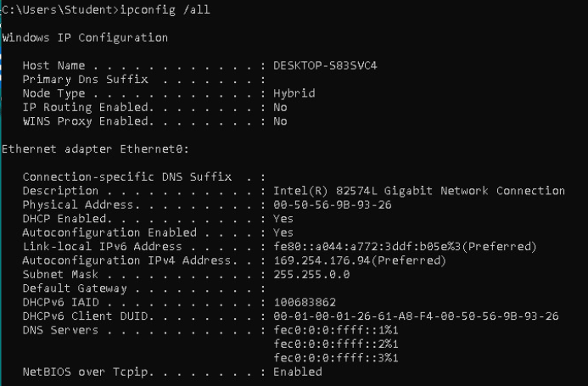

**Step 8:** Answer the following questions about the **results** of **releasing** your IP address:

* What is your **IPv4** **address** now? ? **169.254.176.94 (answers vary)**
* View pg. **422 Figure 8-51** of your textbook. What is the significance of a **169.254.x.x** address *(what does it indicate)*? **Indicates an APIPA IP address; you were not able to lease an IP address, etc. answers vary.**
* What is your **subnet mask** now? **255.255.0.0**
* What is your **default gateway** address? **Blank/doesn’t exist**
* Has your **physical (MAC) address** changed? **No**
* Type **ping 8.8.8.8** in the **Command Prompt** windowtoping **Google’s DNS server** andtest network connectivity.What **error message** is displayed? **Ping: transmit failed. General Failure. x4**
* Launch the **Edge** browser from the **Windows 10 VM** taskbar. **Click and wait** **patiently** *( it takes a minute or two)* and click “No thanks” if you see a popup message. After the page loads, what **error message** is displayed? **You’re not connected…let’s get you back online** *(or similar)*

**Step 9:**

**FIRST:** Close the **Edge** browser window to return to the **Command Prompt** window. **Warning:** if the Edge Browser won’t close, click just click on the Command Prompt icon on your taskbar to relaunch its window. Don’t worry about the browser; it will eventually close.

**SECOND:** Review **pg. 423**, item **#4** in your textbook to view the command to **renew** your IP address. Run the command to **RENEW** your IP address ONLY. WARNING: BE PATIENT - it takes a minute.

* What **command** did you enter? **ipconfig /renew**

**Step 10:** Type **ipconfig /all** into the **Command Prompt** window. Take a **screenshot** of the output generated by the command:

* **Screenshot** of **ipconfig /all** commandoutputinthe **Command Prompt** window**:**

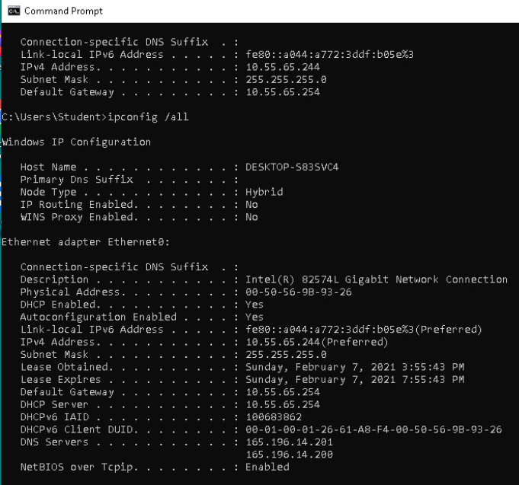

**Step 11:** Answer the following questions about the **results** of **renewing** your IP address:

* What is your **IPv4** **address** now? **10.55.65.244 (answers vary)**
* Is it the same or different than your **ORIGINAL IP address** in **Step 5**? **The same.**
* Look at your screenshot in **Step 4**. Has your lease time changed *(not the overall time but the actual time of day it was obtained and expires)*? **Yes**
* Type **ping 8.8.8.8** in the **Command Prompt** windowtoping **Google’s DNS server** andtest network connectivity.What **connectivity message** is displayed? **Reply from 8.8.8.8: bytes=32 time=6ms TTL=52 x4** *(or similar)*
* Launch the **Edge** browser from the **Windows 10 VM** taskbar. Do you have network/Internet connectivity? **yes**

**Step 12:** Close the **Edge Browser** and **Command Prompt** window.

**2. Custom Project 2: Changing Adapter Settings and Setting a Static IP address**

Review **pgs. 338-339** on how to configure your network adapter.

**Step 1:** **Right-click** the **Windows 10 VM Start** icon and click **Network Connections**. Click on **Change adapter options**.

**Step 2:** Right-click **Ethernet0** 🡪 click **Properties** from the drop-down menu.

**Step 3:** In the **Ethernet0 Properties** window, double-click **Internet Protocol Version 4 (TCP/IPv4)** to launch it.

* How are you currently set to receive your **IP** AND **DNS server** address? **Obtaining both automatically**

**Step 4:** Click **Use the following IP address**. Choosing this option informs the network that you are going to **statically (manually) assign** the **IP address** for this client.

**Step 5:** For the IP address on your Ethernet Network Adapter (NIC), CAREFULLY enter **192.168.1.10**

**Step 6:** Enter **255.255.255.0** for the subnet mask

**Step 7:** Leave “**Default Gateway**”, “**Preferred DNS server**”, and “**Alternative DNS server**” **BLANK**.

**Step 8:** Take a screenshot of the **Internet Protocol Version 4 (TCP/IPv4) Properties** window displaying your static IPv4 settings.

* **Screenshot:**

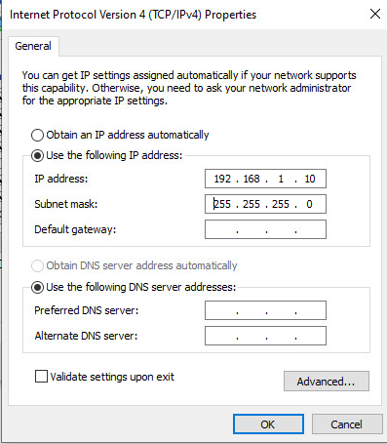

**Step 9: Close the open dialog boxes** by clicking **OK TWICE (**and **Close** ifnecessary) **ONLY** your **Network Connections** window should still be open.

**WARNING 🡪 IF YOU DO NOT CLOSE ALL NETWORK CONFIGURATION WINDOWS BY CLICKING OK, YOUR IP ADDRESS WILL NOT BE CHANGED/SET TO THE NEW ADDRESS.**

***Note:*** *Because we are in a* ***managed VM environment*** *that we do not control, our IP address has not actually changed to the address we just statically set. Therefore, we will NOT bother verifying it in the* ***Command Prompt*** *window. Normally you WOULD verify it by running another ipconfig /all.*

**Step 10: Return to AND repeat steps 1-3 of THIS project** *(above)* to **reset** your **Ethernet adapter** back to **Obtaining BOTH** an **IP** and **DNS Server addresses automatically**. *(change* ***BOTH*** *radio buttons back)*

**Step 11: Close the open dialog boxes** by clicking **OK TWICE (**and **Close** ifnecessary) **ONLY** your **Network Connections** window should still be open.

**Step 12:** Return to the Windows 10 VM **Command Prompt** window (relaunch from the taskbar if necessary).

**Step 13:** Type **ping google.com** into the **Command Prompt** window to verify you can ping successfully, meaning you have connectivity.

* + If you **CANNOT** successfully ping **Google**, **troubleshoot** BEFORE proceeding.
  + FYI – you should receive **4 replies** from an IP address belonging to Google. **General Failure** is **NOT** a successful ping.
* **What IP address (belonging to Google) are you receiving replies from? 216.58.194.206 (answers vary)**

**Step 14:** Close all **Network Connections** windows, and if necessary, browser windows. Just the **Command Prompt** window should be left open for the next project.

**3. Custom Project 3: Pipe the output of troubleshooting commands to a text file**

Review **pg. 366** **ipconfig /displaydns** & **ipconfig /flushdns** commands; review **pg. 369 NETSTAT** command that includes the “**>>**” description. **Warning:** a single “**>**” carrot *(right-facing arrow/greater-than sign)* **OVERWRITES** the original text file each time its run, while a double “**>>**” carrot *(right-facing arrow/greater-than sign)* **APPENDS** the text file, adding the new entry to the end of the file.

**Step 1:** Inside the Windows 10 VM **Command Prompt** window (relaunch from the taskbar if necessary), type **ipconfig /displaydns** and press **Enter** to display all stored DNS entries. How many records are stored (scroll up and count each record name).

* **Approximately how many records are listed? *(count the approx. number of “record blocks” - NO need to be exact if you encounter a lot)*: 42 (Answers vary)**

**Step 2:** CAREFULLY type **cd Desktop** at the command prompt and press **Enter** to change to change your current working directory to the **Desktop**. This step lets us save to the **Desktop** without having to specify the path to it in our command. *(Notice how the prompt changed:* ***C:\Users\Student\Desktop>*** *is* ***where*** *we’re currently located in the* ***file system*** *while working in the* ***command-line*** *window)*

**Step 3:** Type **ipconfig /displaydns >> troubleshooting.txt** which will automatically create, name, and save “**troubleshooting.txt**” text file to the **Windows 10** VM **Desktop** that has the **generated** **output** of the **ipconfig /displaydns** command **saved** within.

**Command clarification:**

**ipconfig[space]/displaydns[space]>>[space] troubleshooting.txt**

**Step 4:** **Minimize** the **Command Prompt** window, and locate the new **troubleshooting.txt** file that just appeared on your **Desktop**. **Open** the file and quickly scroll through it. Then take a **screenshot** displaying **its contents** *(not all of the entries, just make sure two or so records are showing)*.

* **Screenshot of OPEN text file troubleshooting.txt:** 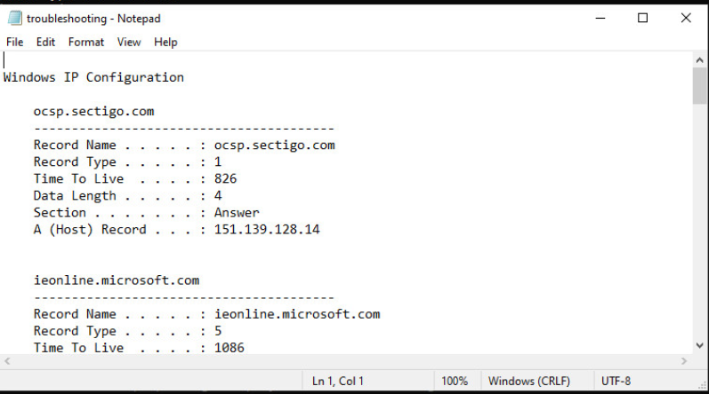

**Step 5:** You MUST **CLOSE** the **troubleshooting.txt** text file **BEFORE** proceeding to step 6.

**Step 6:** Using **ONE** **carrot** *(right-facing arrow/greater-than sign)* instead of two this time, type **ipconfig /flushdns > troubleshooting.txt** to **OVERWRITE** the **displaydns** information written earlier to the “**troubleshooting.txt**” text file.

**Command clarification:**

**ipconfig[space]/flushdns[space]>[space] troubleshooting.txt**

**Step 7:** Locate the **troubleshooting.txt file** on the **Desktop** and **reopen** it. Take a **screenshot** displaying its modified contents.

* **Screenshot of OPEN text file troubleshooting.txt:** 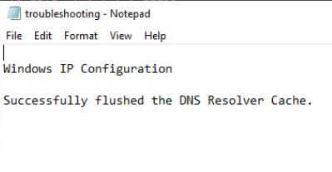

**Step 8:** You MUST **CLOSE** the **troubleshooting.txt** text file **BEFORE** proceeding to step 9.

**Step 9:** Using **TWO** **carrots** *(right-facing arrows/greater-than signs)* instead of one this time, type **netstat** **>> troubleshooting.txt** to **APPEND** or **ADD** theEthernet Network Adapter’s **Active Connections** informationto the “**troubleshooting.txt”** file **BENEATH** the output of the **ipconfig** /**flushdns** command.

**Command clarification:**

**netstat[space]>>[space] troubleshooting.txt**

**Step 10:** Locate the **troubleshooting.txt** file on the **Desktop** and **reopen** it. Take a **screenshot** displaying its modified contents.

* **Screenshot of OPEN text file troubleshooting.txt:**

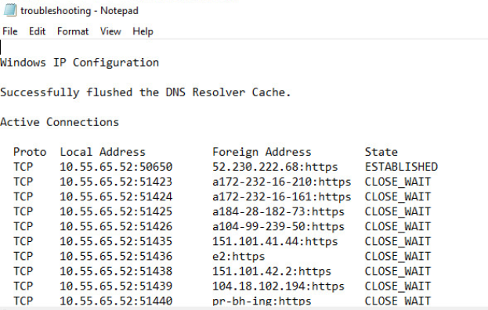

**SUBMIT** **one word processed document** to Canvas under WK4CH7-8 Lab, named *yourfirst initial+lastname+WK#CH#Lab.docx*

*(Ex. amurphyWK4CH7-8Lab.docx)*