Report of the final research project

Aimar Alustiza and Fermín Barrena
UNITBV
Data mining and data warehouse

23/05/2026

Repository: https://github.com/THeFeRTXo/Research-Project-Data-Mining

Abstract
This research explores the structural dependencies between machine learning classifiers and their preprocessing pipelines within the context of predicting term deposit subscriptions using the highly imbalanced Bank Marketing dataset. Addressing a critical gap in current literature, which frequently treats preprocessing as a universal and model-agnostic preliminary step, this study formulates a two-phase experimental methodology to evaluate the non-transferability of pipelines across divergent algorithmic architectures. We specifically unite the "distance family" (K-Nearest Neighbors and Logistic Regression) against the "partition family" (Decision Trees and Random Forest). Phase 1 identifies the optimal preprocessing configuration for each classifier via an extensive GridSearch, utilizing the F1-Score to properly account for the severe class imbalance. Phase 2 introduces a cross-assignment "swap protocol," where models are forced to operate within the optimal environments of the opposing family to measure performance degradation.

The empirical results demonstrate that algorithms share a fundamental mathematical dependency on how the feature space is structured. The distance family converged on a pipeline requiring PCA for dimensionality reduction and undersampling (Neighbourhood Cleaning Rule) to establish clean geometric boundaries. Conversely, the partition family rejected PCA and the Random Forest favored oversampling (SMOTE) to inject synthetic variance. The swap protocol revealed severe incompatibilities: KNN experienced a drastic F-Score drop (-0.0753) when saturated by the interpolated noise of SMOTE. We conclude that there is no universal preprocessing pipeline; data preparation must be approached as an intrinsic, dynamic extension of the algorithm. Finally, the Random Forest classifier emerged as the optimal model (F-Score: 0.5898). Crucially, its architectural rejection of PCA preserved the original feature space, enabling the successful integration of SHAP values to provide global and local explainability, thereby satisfying strict regulatory transparency requirements.

Problem Description

Bank Marketing

For this research project, the bank-full.csv dataset was used [1]. This dataset contains detailed information on multiple direct marketing campaigns carried out by a Portuguese banking institution. The main classification objective is to predict whether a customer will ultimately subscribe to a fixed-term deposit (represented by the target variable y).

The dataset is structured into 45,211 records (contacted customers) and 17 variables (16 predictive attributes and 1 target variable). After an initial data quality analysis, it is noteworthy that the dataset does not contain any explicit null values ​​in any of its columns. However, it is important to note that certain categorical variables contain the label "unknown," which required imputation or coding strategies during the preprocessing phase.

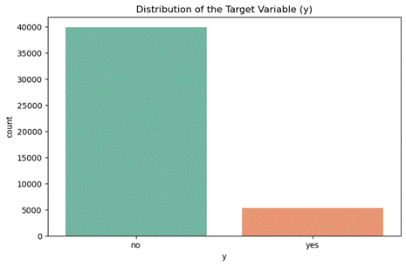
Fig. 1: Distribution of the Target Variable (y) in the bank-full dataset.
The most critical aspect of this dataset, and the main methodological challenge of our research, lies in the distribution of its target variable. As shown in Figure 1, we face a problem of severely unbalanced classes:

● Majority Class ('no'): Represents 88.3% of the records (39,922 cases).
● Minority Class ('yes'): Represents only 11.7% of the records (5,289 cases).

Literature Review and Research Gap

The Bank Marketing dataset [2] is now a well‑known benchmark for predicting term deposit subscriptions. Much of the existing work has centred on comparing different classifiers, frequently handling data preprocessing as a routine, one‑size‑fits‑all step. A concrete example comes from Nandini et al., who apply several re‑sampling strategies, including SMOTE, K‑Means SMOTE, and SMOTE+ENN, to the same Portuguese banking dataset, aiming to improve a Logistic Regression model [3]. Their empirical results show that although different re‑sampling methods do raise performance (K‑Means SMOTE reaches 94% accuracy, for instance), their effectiveness differs considerably. This variation indirectly suggests that no single preprocessing technique works best in all situations [3].
However, a more critical gap remains. Even when acknowledging that different re-sampling methods yield different results, the vast majority of published solutions apply a monolithic, uniform preprocessing pipeline to the dataset before feeding it into different classifiers. Preprocessing is still generally viewed as a generic, one-size-fits-all cleaning step, rather than being intrinsically linked to the chosen algorithm's mathematical family (e.g., distance-based algorithms like K-Nearest Neighbors vs. partition-based ones like Decision Trees).
This research project is designed to address this specific methodological gap. Rather than simply comparing final classifier performances under a static environment, we empirically investigate the non-transferability of preprocessing pipelines across divergent algorithmic architectures. By demonstrating how an optimized preprocessing strategy for one family can degrade the performance of another, this study aims to prove that preprocessing must be treated as an integral, dynamic extension of the algorithm itself.

Research Objectives
While the main classification objective of this project is to predict whether a customer will ultimately subscribe to a fixed-term deposit, our research goes beyond standard predictive modeling. The core focus of this study is to analyze the structural dependencies between machine learning algorithms and their preprocessing environments. We postulate that a dataset optimized for one family of algorithms will be deficient for a fundamentally different family.
To systematically guide our experimentation and analysis, we have formulated the following two research questions:
- Research Question 1 (RQ1): How does the cross-assignment of optimal preprocessing pipelines between the "distance family" (KNN and Logistic Regression) and the "partition family" (Decision Trees and Random Forest) impact classifier performance? By executing a pipeline swap protocol, we aim to measure the quantitative degradation between families and understand the reasons for these performance shifts.
- Research Question 2 (RQ2): To what extent do the preprocessing methods selected by the winning model limit or enhance its explainability? Given the strict regulatory requirements in the banking sector, we aim to evaluate how techniques like PCA affect model transparency, and how SHAP values can be utilized to overcome these limitations and provide clear, local and global predictions.

Experimentation Methodology

1. Experiment Structure and Metrics.
Note: All experimental implementations, pipelines, and results discussed in this paper are executed within the single repository notebook research_code.ipynb. References to specific findings are mapped directly to their corresponding execution cells below.
We have divided the research into two different phases with our four models (two per family). In Phase 1, we identified the optimal preprocessing pipeline and the optimal hyperparameters for each classifier. In Phase 2, we execute a swap protocol. We freeze the pipelines of all classifiers and force the models of the opposite family to make predictions on them. This way, we measure the real impact of the compatibility between families.
To evaluate success, we completely discarded Accuracy. Our banking dataset is quite imbalanced. Using accuracy would generate a false sense of success. Therefore, we exclusively used the F1-Score [2]. This metric penalizes false positives and false negatives in the minority class.

2. Search Space and Combinatorics.
We designed a preprocessing architecture divided into a static and a dynamic stage. In the static stage, we applied SimpleImputer(strategy='most_frequent') and an OrdinalEncoder to all categorical variables.
This design decision is deliberated. First, we wanted to avoid a gigantic combinatorics space. We also wanted to avoid smoothing out the results. We know that OrdinalEncoder assigns numerical values (1, 2, 3) to categories with no real order. For trees, this is a comfortable environment. For the distance family, it's an uncomfortable starting point [3]. The goal is to force each classifier to "take a stand" within the pipeline, to choose techniques to generate different pipelines.
For the dynamic part, we configured a massive GridSearchCV [4]. We chose enough methods so that the customization is broad, but without creating an unmanageable computational load. We configured our massive GridSearchCV to evaluate a comprehensive set of techniques grouped into four main preprocessing stages. For each category, we included passthrough as a baseline option. It is important to clarify that passthrough is not a transformation method itself, but rather an explicit configuration that allows the algorithm to opt out of that particular preprocessing step, thereby leaving the data unaltered at that specific stage.
- Outlier Considerations: We evaluated the impact of handling outliers using IQR and MeanStd (methods custom-coded by us to detect outliers based on percentiles and standard deviation, respectively), alongside the passthrough option.
- Scaling and Normalization: We tested StandardScaler and MinMaxScaler to manage the numerical scale of the features, or passthrough to leave original scales intact.
- Data Balancing: We experimented with SMOTE (for oversampling) and NeighbourhoodCleaningRule (for undersampling) to address the minority class, as well as a passthrough option to preserve the original distribution.
- Dimensionality Reduction: We offered the models the capability to use PCA (Principal Component Analysis) to handle collinearity, or passthrough to maintain the full original feature space.
Within our GridSearchCV pipeline, dimensionality reduction was integrated as the final preprocessing stage, applied after all the coding, scaling, and data balancing steps, and immediately before the classifier. Dimensionality reduction was applied to all data in our dataset (as mentioned, the categorical variables were transformed into numeric variables using the OrdinalEncoder). Instead of testing an arbitrary number of components, the PCA was parameterized with a fixed 95% explained variance threshold (n_components=0.95). This specific threshold is a widely accepted heuristic in multivariate statistics, chosen to optimally filter out multicollinearity and noise without sacrificing critical predictive information [5].
Crucially, these preprocessing choices are not evaluated in isolation. GridSearchCV simultaneously optimizes both the preprocessing sequence and the classifier's specific hyperparameters within each complete pipeline configuration. This approach ensures the algorithm is perfectly tuned to the data it receives, squeezing the best possible results out of every pipeline setup.

Experiment 1: Optimization of Environments
In this initial phase, we analyzed the optimal preprocessing configurations identified by the GridSearchCV. The resulting combinations for the four classifiers are visually summarized in Figure 2 (generated via the code executed in Cell {13}).
Each row of this matrix corresponds to one classifier, and the columns show the preprocessing stages we tested: Outliers, Scaling, Sampling, and PCA. Reading across a row tells us exactly which methods that classifier ended up picking for its pipeline. To facilitate visual comparison, each column (preprocessing stage) is assigned a distinct baseline color, with specific chosen methods represented by varying brightness of each color. The 'passthrough' option, indicating that a step was bypassed, is uniformly represented in neutral gray across all stages. Finally, the last column displays the maximum F1-Score achieved by each model operating within its customized environment.
Looking at the matrix (Figure 2), distinct structural patterns emerged. It becomes clear that the algorithms did not select these techniques randomly; rather, their choices directly reflect their internal mathematical mechanics and how they naturally process data.
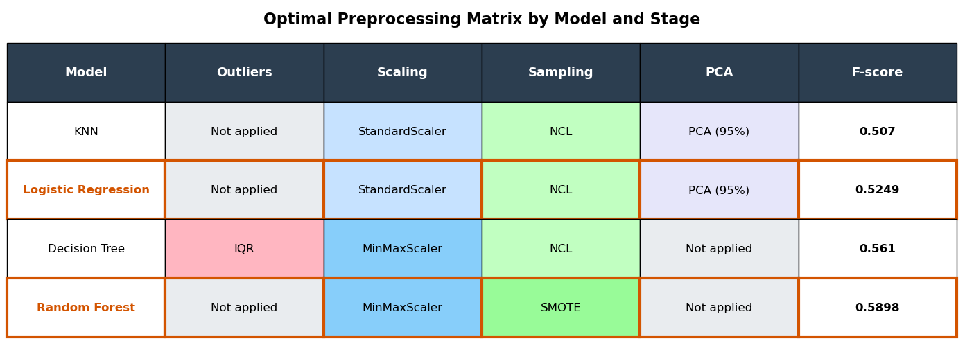
Fig. 2: Optimal preprocessing pipelines selected by each classification model.

KNN and Logistic Regression Results.

Overview
KNN and Logistic Regression constitute the "distance family" in our experimentations. Analyzing the Phase 1 optimization results, we observed a highly significant mathematical convergence: both classifiers independently selected the exact same optimal preprocessing pipeline. Specifically, both models configured their environment to retain outliers (passthrough), apply standard scaling (StandardScaler), balance classes via undersampling (NeighbourhoodCleaningRule), and reduce dimensionality using PCA (the execution and results for KNN can be observed in Cell {9}, while the Logistic Regression convergence is detailed in Cell {10}).

Hypotheses
To understand this structural convergence, it is necessary to interpret these factual choices through the lens of the algorithm's internal mechanics. We hypothesize that this shared pipeline perfectly addresses the specific mathematical vulnerabilities of the distance family:
- Geometric and Regulatory Necessities (StandardScaler): The universal selection of standardization stems from how these models calculate boundaries. For K‑nearest neighbors, proper scaling is a strict geometric must‑have. When variables differ widely in magnitude, say, one in the thousands and another near zero, the Euclidean distance becomes skewed toward the larger‑scale feature, drowning out the smaller ones [6]. For Logistic Regression, uniform scaling is critical to satisfy its default L2 regularization, ensuring that the penalty is applied evenly across features regardless of their native magnitude.
- Boundary Clarity (NCL): Distance-based models require exceptionally clean decision borders to avoid misclassification. NCL addresses this specific topological need by selectively erasing noisy or overlapping instances from the majority class, establishing a clear margin without interpolating artificial data points that could distort local distances.
- Collinearity Mitigation (PCA): In financial datasets, numerical attributes (e.g., account balance, age, call duration) frequently exhibit high collinearity. The selection of PCA acts as a mathematical filter for this correlated noise. By projecting the data onto orthogonal axes, PCA provides these classifiers with a non-redundant, independent feature space.
- Outlier Tolerance (passthrough): The rejection of outlier removal indicates that, in this specific domain, extreme values likely represent legitimate, high-value client behaviors rather than erroneous data. For linear and distance-based global boundaries, retaining these instances provides valuable predictive signals without fatally disrupting the model's overall topology.

2. Decision Tree and Random Forest Results.

Overview

The Decision Tree (DT) and Random Forest (RF) algorithms, which operate through conditional entropy splits, constitute the "partition family". Unlike the distance family, the optimal preprocessing pipelines for DT and RF exhibited both shared characteristics and significant internal divergences. Tracing the final two rows of the matrix (Figure 2), both models rejected Dimensionality Reduction (selecting passthrough instead of PCA) and opted for MinMaxScaler for feature scaling. However, their approaches to outlier management and data balancing were fundamentally opposite (the DT setup can be audited in Cell {11}, whereas the optimal RF configuration is executed in Cell {12}).

Hypotheses
These selected preprocessing parameters can be analytically justified by the differences between a single tree and an ensemble method:
- Preservation of Univariate Rules (Rejection of PCA): Partition-based algorithms seek pure nodes by splitting individual, interpretable variables. Because PCA applies linear transformations that blend all original features into abstract principal components, it inherently degrades the decision tree's ability to extract clean, univariate splitting rules.
- Invariance to Scale (MinMaxScaler): Since tree-based models make decisions via orthogonal splits (greater or less than a threshold), they are theoretically invariant to monotonic transformations of independent variables. The selection of MinMaxScaler over passthrough is interpreted as a computationally neutral effect rather than a structural necessity.
- Robustness vs. Vulnerability to Variance (Outlier Handling): The isolated Decision Tree's reliance on IQR highlights its vulnerability to extreme values; a single, unpruned tree is highly unstable and requires explicit boundaries to prevent wasting entire branches isolating anomalous instances [7]. Conversely, the Random Forest demonstrates the inherent robustness of ensemble methods; by averaging predictions across multiple randomized trees, the ensemble naturally absorbs and regularizes atypical variance without requiring explicit data removal.
- Diversity Requirements for Ensembles (Data Balancing): While the single Decision Tree utilized undersampling (NCL) to establish simpler, generalized rules, the Random Forest inherently requires maximum data diversity to construct uncorrelated trees. Removing instances via undersampling restricts this necessary variance. SMOTE offers a different solution: it creates synthetic examples, injecting artificial diversity into the data. This gives the ensemble enough volume to develop a robust forest, a benefit that has been documented in imbalanced learning studies [8]. This also explains why the Random Forest ended up with the highest F1‑Score in our experiment (0.5898).

Experiment 2: Validation of Non-Transferability (Swap)
In this second phase, we tested how well each model handles the preprocessing pipeline that was optimized for the opposite family. To ensure a rigorous comparison, we froze the preprocessing stages (outliers, scaling, resampling, and dimensionality reduction) of the assigned pipeline. But we did allow the model being tested to re‑tune its own hyperparameters to fit that new environment. This isolation guarantees that any performance degradation is attributable exclusively to pipeline incompatibility, rather than a poor hyperparameter configuration.

Empirical Results
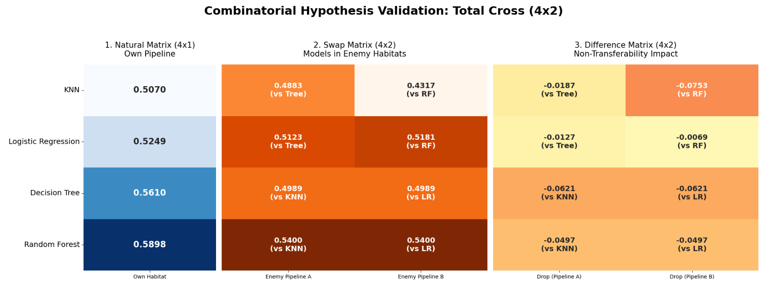
Fig. 3: F1-Score results matrix evaluating combinatorial cross-pipeline performance.

To clearly illustrate the impact of the swap protocol, the results in the Figure 3 (the figure itself is plotted using the code in Cell {19}) are organized into three distinct comparative heat maps:
- Baseline Matrix (Left): This initial column shows the maximum F1 score achieved by each of the four models when operating within their optimal pipelines.
- Cross-Assignment Matrix (Center): This matrix details the raw F1-Scores obtained when each model (rows) is evaluated using the pipelines of the opposing algorithmic family (columns). Below each F1-score, a reference indicates which opposing classifier provided the pipeline for that specific evaluation.
- Degradation Matrix (Right): This final matrix calculates the exact difference between the baseline (left) and the cross-assigned results (center), providing a direct measure of performance variance.

Examining the Degradation Matrix (right), the data reveals severe penalties in all cases. For example, when the K-Nearest Neighbors (KNN) algorithm was subjected to the Random Forest (RF) pipeline, it suffered the most drastic performance drop of the entire experiment (-0.0753). Similarly, both partition-based models (Decision Tree and Random Forest) showed significant negative differences when subjected to the distance family environment.

Hypotheses
The empirical performance drops observed in the swap protocol suggest fundamental algorithmic incompatibilities. We formulate the following hypotheses to explain these structural degradations:
- Partition Family Degradation (The Impact of PCA): Both the Decision Tree and Random Forest experienced symmetric performance penalties (-0.0621 and -0.0497, respectively) when inheriting the Distance family pipeline (the execution of the swap protocol for the DT can be observed in Cell {17}, and for the RF in Cell {18}). We hypothesize that PCA is the primary source of this structural incompatibility. By applying linear transformations that rotate axes and mix original variables, PCA obscures the univariate feature boundaries that partition-based algorithms rely on to establish pure splits.
- Distance Family Degradation (The Impact of SMOTE): The K-Nearest Neighbors (KNN) algorithm exhibited the most severe degradation (-0.0753) when subjected to the Random Forest pipeline (the setup, execution, and evaluation of this specific swap are located in Cell {15}). We theorize this drop results from a compounding structural conflict: the simultaneous loss of PCA and the forced application of SMOTE. To understand this degradation, it is crucial to consider SMOTE's operational mechanism: it addresses class imbalance by creating synthetic points via linear interpolation between existing minority class data. While this synthetic inflation benefits ensemble methods like Random Forest by "fattening" the dataset and providing the necessary volume to maintain tree diversity, it fundamentally alters the local geometry of the feature space. For a strictly distance-based algorithm like KNN, which makes decisions based purely on the spatial distribution of its nearest neighbors, these interpolated points act as localized noise. Consequently, SMOTE saturates the local neighborhoods with synthetic instances, destroying the integrity of its real Euclidean distance calculations.
- Global vs. Local Robustness: Notably, Logistic Regression demonstrated significant resilience to the Random Forest pipeline, experiencing only a marginal drop of -0.0069 (this swap experiment is defined and executed in Cell {16}). We hypothesize that because Logistic Regression optimizes a global hyperplane across the entire dataset, it is more robust to the localized geometric perturbations introduced by SMOTE, unlike the strictly localized KNN algorithm.

SHAP values

SHAP (SHapley Additive exPlanations) [9] is a tool that helps us look inside the 'black box' of a machine learning model to understand exactly why it makes certain decisions. Simply put, it calculates how much each individual feature (like age, balance, or call duration) contributes to a specific prediction. A positive SHAP value means that a feature is pushing the model to predict a 'yes' (subscribing to the deposit), while a negative value means it is pushing the prediction towards a 'no'. This method is highly valuable because it breaks down the model's logic, allowing us to see both the overall trends across all customers and the exact reasons behind an individual customer's prediction.

Although Logistic Regression and KNN obtained competitive results, the optimization of their pipelines revealed an absolute dependence on PCA (Principal Component Analysis) to handle the geometric structure of the data.
In the context of banking marketing, interpretability is not optional. Various regulations, such as the GDPR (General Data Protection Regulation), require the 'Right to Explanation' regarding automated decisions. PCA transforms the original variables (such as age, balance, or employment) into abstract linear combinations (Component 1, Component 2).

Conversely, the Tree family (and specifically the Random Forest, our winning model with an F-score of 0.5898) rejected PCA. This allows us to preserve the original feature space. Therefore, we selected the Random Forest as the final model: not only does it have the highest predictive performance, but it is also the only one capable of opening its 'black box' using SHAP values ​​to offer transparent explanations to the bank.

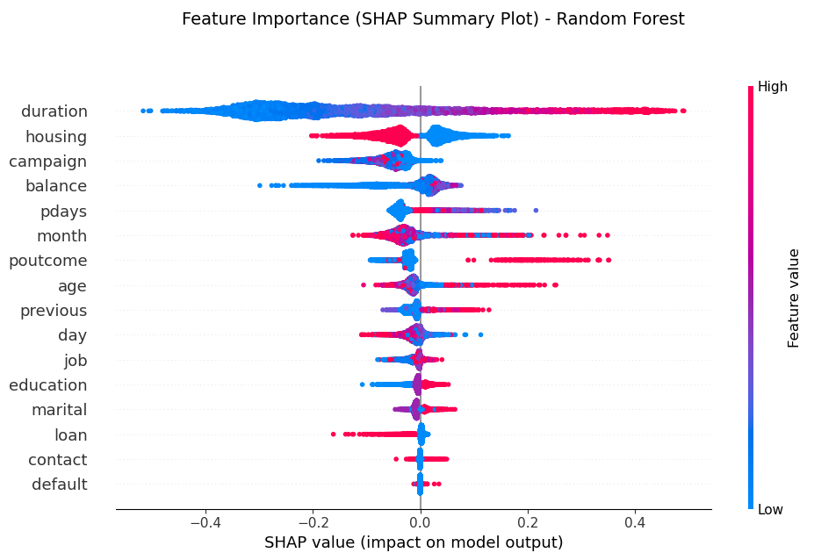
Fig. 4: SHAP Summary Plot detailing global feature importance and directional impact.

The summary plot (Figure 4) reveals which variables are the most relevant within the trained model (this plot is generated in Cell {20}):
● The “duration” of the call is the critical factor: There is a direct and robust correlation. High values ​​(red dots) are located to the right of the axis, indicating that keeping the customer on the phone longer increases the likelihood of them signing up for the deposit. Conversely, short calls (blue dots on the left) are almost certainly synonymous with rejection.
● The “housing” loan: The model reveals an interesting pattern regarding mortgage loans. We observe that customers without a mortgage (red dots on the left) have a negative impact on the probability of acceptance. Conversely, customers with an existing mortgage (blue dots on the right) are more likely to take out the fixed-term deposit.
● Results of the previous campaign (“poutcome”): Since this is a categorical variable, it's important to remember that the OrdinalEncoder technique was used for its quantification, and the highest number was assigned to the "success" value. This allows us to observe that a customer who has responded positively to a bank campaign in the past has an exponentially greater likelihood of doing so again, as shown by the number of red points to the right of the axis.

In addition to evaluating the variables globally, it is very interesting to see what the model relies on to make predictions for specific examples. This leads us to the question: what characteristics of the example make the probability of the positive class greater (or less) than the prior probability of that class?

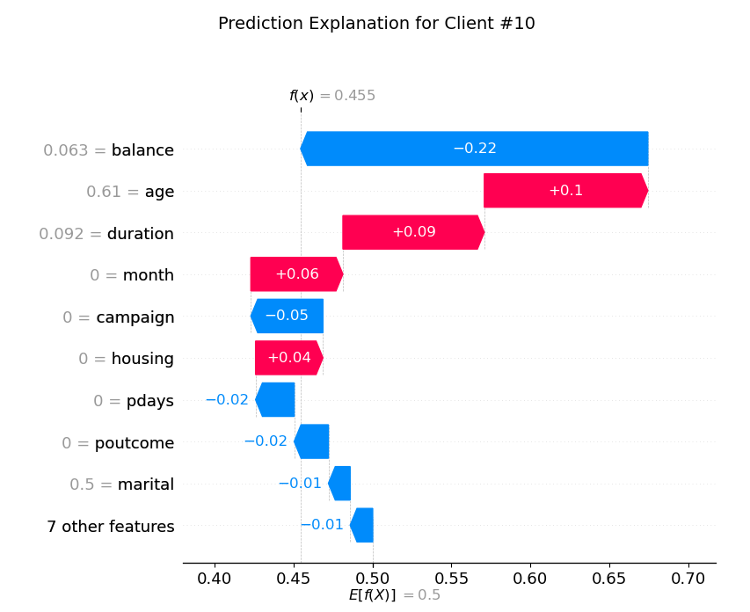
Fig. 5: SHAP Waterfall Plot explaining the local prediction components for Customer #10.

Figure 5 (Waterfall Plot) illustrates the model's local explainability for a specific instance (Customer #10) (the calculation and visualization of this local explanation are performed in Cell {20}). The expected base value, denoted as $E[f(x)]$, is 0.5 (50%). This value is a direct consequence of the data balancing stage (SMOTE) applied during preprocessing, which artificially adjusts the prior probability compared to the 13% prevalence in the original dataset. For this specific customer, the model estimates a final acceptance probability of 45.5% ($f(x)$ = 0.455). The individual contribution analysis reveals that the dominant predictive factor is the 'balance' variable. With a scaled value of 0.063, it negatively impacts the final probability by 22% (-0.22). Conversely, variables such as 'age' (0.61) and call 'duration' (0.092) act as the primary positive drivers, increasing the probability by 10% (+0.1) and 9% (+0.09). As seen in the overall interpretability of the model, 'duration' is directly related to the prediction.

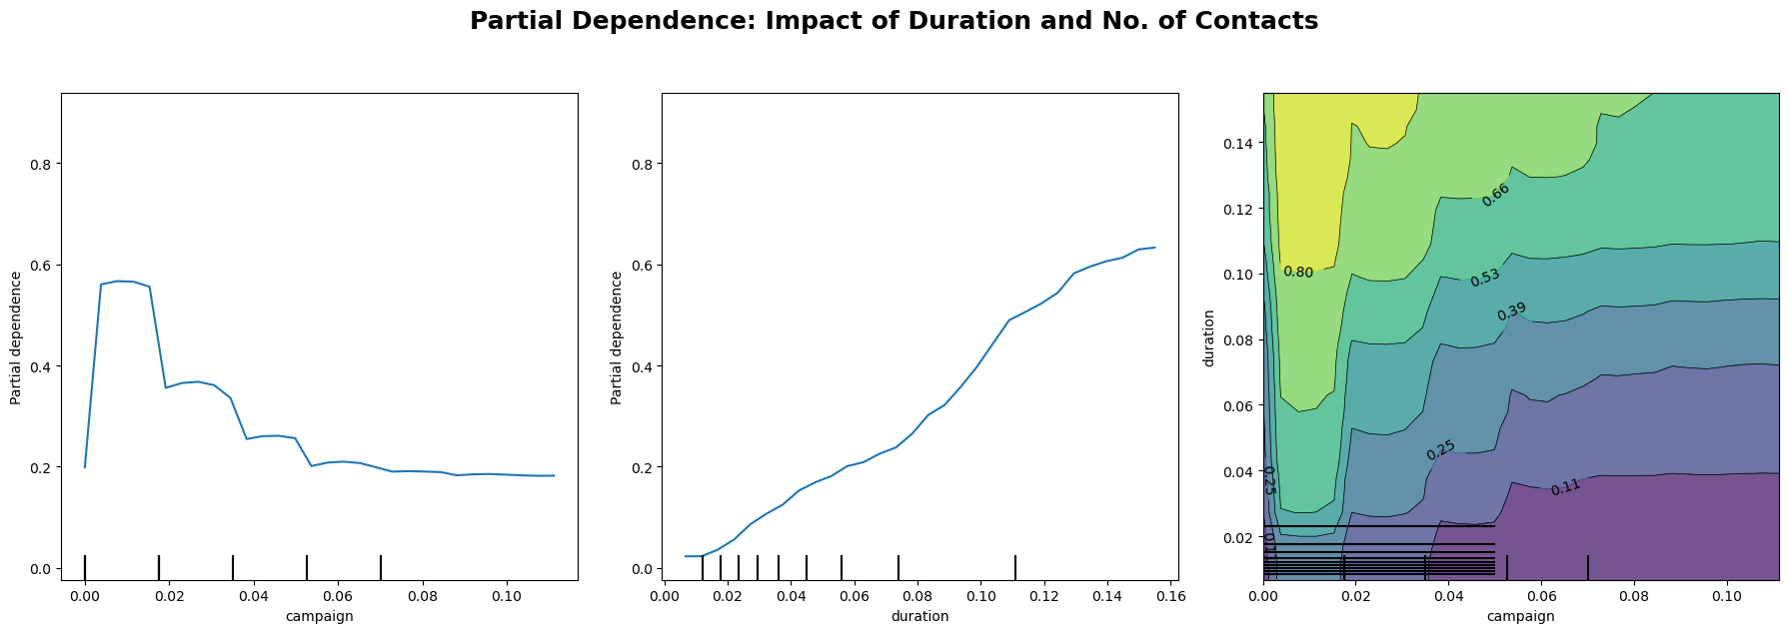
Fig. 6: Partial Dependence Plots illustrating the marginal effect and interaction of 'duration' and 'campaign'.

Figure 6 (this plot is generated in Cell {21}) presents the Partial Dependence Plots (PDP), which model the marginal effect of selected features on the predicted probability. The left plot demonstrates a non-linear, decreasing relationship for the 'campaign' variable: fewer contacts during the campaign maximize the probability of success, while this probability sharply declines and stabilizes as the number of contacts increases. The central plot shows a nearly linear positive correlation regarding the 'duration' variable, indicating that longer telephone interactions significantly increase the likelihood of conversion.

Finally, the contour plot (Figure 6, right) exhibits the bivariate interaction between 'duration' and 'campaign'. The regions of highest probability (highlighted in lighter green and yellow tones) consistently concentrate in areas combining high call duration values with a low number of campaign contacts, clearly defining the optimal interaction profile for securing a deposit subscription.

Conclusions
This research project aimed to transcend the conventional predictive modeling of bank marketing datasets by investigating the structural dependencies between machine learning algorithms and their preprocessing environments. Based on our empirical experiments and interpretability analysis, we can definitively answer our initial research questions:
Addressing RQ1 (Impact of Cross-Assigned Preprocessing Pipelines):
Our results unequivocally demonstrate that there is no "universal pipeline" in machine learning. The experiments revealed that performance drops in cross-assigned environments are not random failures, but fundamental incompatibilities; what feeds one algorithmic family effectively poisons the opposing one. Specifically, we found that PCA cleans numerical correlation for the distance family, but makes partition-based trees blind by destroying pure univariate boundaries. Conversely, SMOTE injects essential synthetic data that gives life to Random Forest trees, but saturates KNN neighborhoods with noise, destroying its real geometric predictions. Consequently, preprocessing should not be seen as a prior cleaning step, but rather as an intrinsic part of the algorithm itself.
Addressing RQ2 (Explainability Limits and SHAP Value Integration):
Our investigation revealed a critical trade-off between optimized preprocessing and model transparency. Although Logistic Regression and KNN obtained competitive predictive results, the optimization of their pipelines revealed an absolute dependence on PCA to handle the geometric structure of the data. PCA transforms the original variables into abstract linear combinations. In a banking context, interpretability is not optional; regulations like the GDPR require the 'Right to Explanation'. Conversely, the Random Forest model (our winning classifier) rejected PCA, which allows us to preserve the original feature space. This structural compatibility permitted the successful integration of SHAP values, enabling us to open the 'black box' and offer transparent, compliant explanations for both global trends and individual automated decisions.

References
[1] | "UCI Machine Learning Repository. Bank Marketing.," 30 04 2026. [Online]. Available: https://archive.ics.uci.edu/dataset/222/bank+marketing.
[2] | S. Moro, P. Cortez, and P. Rita, “A data-driven approach to predict the success of bank telemarketing,” Decision Support Systems, vol. 62, pp. 22–31, 2014. [Online]. Available: https://acortar.link/UHrJxa . [Accessed 30 04 2026].
[3] | K. R. Nandini, P. S. R. Chandra, P. S. R. Chowdary, and P. S. R. Krishna, "A Comparative Study of Re-Sampling Techniques on Machine Learning Model Performance," Academia.edu, Dec. 2022. Accessed: May 23, 2026. [Online]. Available: https://www.academia.edu/94075710/A_Comparative_Study_of_Re_Sampling_Techniques_on_Machine_Learning_Model_Performance. [Accessed 30 04 2026].
[4] | G. F. a. N. V. C. Troy Raeder1, "Learning from Imbalanced Data: Evaluation," 2012. [Online]. Available: https://link.springer.com/chapter/10.1007/978-3-642-23166-7_12#preview. [Accessed 30 04 2026].
[5] | A. I. A. K. A Udila, "Encoding methods for categorical data: A comparative analysis for linear models, decision trees, and support vector machines," 2023. [Online]. Available: https://repository.tudelft.nl/file/File_9e5e5225-4c53-4362-862e-1b7072e82b6a. [Accessed 30 04 2026].
[6] | A. K. V. S. R. Ranjan G S K, "K-Nearest Neighbors and Grid Search CV Based Real Time Fault Monitoring System for Industries," 2019. [Online]. Available: https://www.researchgate.net/profile/Amar-Verma/publication/339909406_K-Nearest_Neighbors_and_Grid_Search_CV_Based_Real_Time_Fault_Monitoring_System_for_Industries/links/5ef040d1a6fdcc73be943334/K-Nearest-Neighbors-and-Grid-Search-CV-Based-Real-Time-Fault. [Accessed 30 04 2026].
[7] | I. T. Jolliffe, Principal Component Analysis, New York: Springer, 2002.
[8] | M. Z. C. Muasir Pagan, "Investigating the impact of data scaling on the k-nearest neighbor algorithm.," 2023. [Online]. Available: https://www.iaesprime.com/index.php/csit/article/view/279/102. [Accessed 30 04 2026].
[9] | G. H. John, "Robust Decision Trees: Removing Outliers from Databases," 1995. [Online]. Available: https://cdn.aaai.org/KDD/1995/KDD95-044.pdf. [Accessed 30 04 2026].
[10] | R. C. Bhagat and S. S. Patil, "Enhanced SMOTE algorithm for classification of imbalanced big-data using Random Forest," 2015. [Online]. Available: https://ieeexplore.ieee.org/abstract/document/7154739. [Accessed 30 04 2026].
[11] | S.-I. L. Scott M. Lundberg, "A Unified Approach to Interpreting Model," 2017. [Online]. Available:https://proceedings.neurips.cc/paper_files/paper/2017/file/8a20a8621978632d76c43dfd28b67767-Paper.pdf. [Accessed 30 04 2026].

