

**Module Title : DATABASES**

**Assignment Title : POINT OF SALE SYSTEM**

**Examination Cycle : WINTER 2022**

**Candidate Name : THI HAN NAING**

**Candidate No : 00189889**

**Centre Name : KMD COMPUTER CENTRE (YANGON)**

**Submission Date : - January - 2022**

**Important Notes:**

* Please refer to the Assignment Presentation Requirements for advice on how to set out your assignment. These can be found on the NCC Education *Campus*. Scroll down the left hand side of the screen until you reach Personal Support. Click on this, and then on Policies and Advice. You will find the Assignment Presentation Requirements under the Advice section.
* You must familiarize yourself with the NCC Education Academic Dishonesty and Plagiarism Policy and ensure that you acknowledge all the sources which you use in your work. The policy is available on Campus. Follow the instructions above, but click on Policies rather than Advice.
* You must complete the **‘Statement and Confirmation of Own Work’**. The form is available on the Policies section of *Campus*. Scroll down the left hand side until you reach Personal Support. Click on this and then click on Policies and Advice.
* Please make a note of the recommended word count. You could lose marks if you write 10%more or less than this.
* You must submit a paper copy and digital copy (on disk or similarly acceptable medium).Media containing viruses, or media which cannot be run directly, will result in a fail grade being awarded for this module.
* All electronic media will be checked for plagiarism.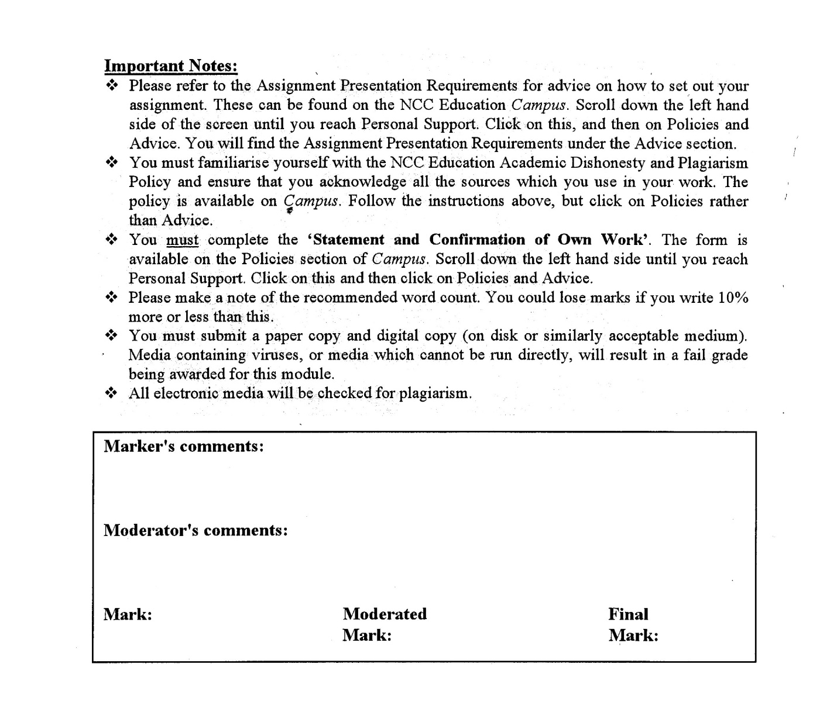



**Statement and Confirmation of Own Work**

**Programmer/Qualification name: L4DC**

*All NCC Education assessed assignments submitted by students must have this statement as the cover page or it will not be accepted for marking. Please ensure that this statement is either firmly attached to the cover of the assignment or electronically inserted into the front of the assignment.*

**Student declaration**

I have read and understood NCC Education’s Policy on Academic Dishonesty and Plagiarism.

I can confirm the following details.

Student ID/Registration number : 00189889

Name : THI HAN NAING

Centre Name : KMD COMPUTER CENTRE (YANGON)

Module Name : DATABASES

Module Leader : Sandi Chit

Number of words : (1800) words

I confirm that this is my own work and that I have not plagiarized any part of it. I have also noted the assessment criteria and pass mark for assignments.

Due Date : 7 - January - 2022

Student Signature :THIHANNAING

Submission Date : 23 – January - 2022

Table of Contents

Introduction 4

Task 1 6

1.1 Summary Report 6

1.2 Normalization and ERD 6

1.2.1 Normalization 6

1.2.2 ERD (Entity Relationship Diagram) 6

1.3 Data Dictionary 7

Task 2 9

2.1 Create statement all data tables 9

2.2 Insert data in all tables 9

2.3 Select, Update and Delete in all tables 9

Task 3 11

3.1 Evaluation 11

3.1.1 Your database meets the data and information requirements of your chosen organization. 11

3.1.2 How the use of ER modelling is important in the design of a database solution. 11

3.1.2 Assumptions 11

3.1.3 How the database supports the transactions 11

References 12

Candidate Checklist 13

# Introduction

This assignment is about a company (called TechAce) that requiring a database system. The assignment includes analysis and design, implementation, assessment and evaluation. In task1, the normalizing and making ERDs and data dictionaries are included. In task2 is about implementation of the database system. In this task, database tables creating, adding the data to the system, updating the data, deleting the data are included. In task3, the importance of this assignment and how the assignment teaches for the real world database creating are mainly included. (TechAce).

**Task 1**

# Task 1

## Analysis

The company sells various types of computers and their accessories. As the company is growing, the manpower isn’t enough for the POS system. Other systems can be done with humans but in POS system, humans can make a lot of mistakes, So, they need to make a database system for the company The database should contain the orders and the sale for the main. The system also needed to be updated, deleted, inserted functions.

Assumption

## Introduction, outline and Initial Analysis

In order to create a database, the entities are clearly needed. To make sure entities, the normalization and ERD are need.

## b) Normalization and ERD

### Normalization

|  |  |  |  |  |  |
| --- | --- | --- | --- | --- | --- |
| **UNF** | Level | 1NF | 2NF | 3NF | Entity Name |
| SerialNo  SupplierName  PurchaseDate  StaffName  ProductCode  ProductType  BrandName  UnitQuantity  UnitPrice  UnitAmount  TotalQuantity  Discount  TotalPrice  StaffName | 1  1  1  1  5  5  5  5  5  5  1  1  1  1 | SerialNo(PK)  SupplierName  PurchaseDate  StaffName  TotalQuantity  Discount  TotalPrice  SerialNo(FK)  ProductCode(PK)  ProductType  BrandName  UnitQuantity  UnitPrice  UnitAmount  StaffName | SerialNo(PK)  SupplierName  PurchaseDate  StaffName  TotalQuantity  Discount  TotalPrice  SerialNo(FK)  ProductCode(FK)  SerialNo(FK)  ProductCode(PK)  ProductType  BrandName  UnitQuantity  UnitPrice UnitAmount  StaffName | StaffID(PK)  StaffName  SupplierID(OK)  SupplierName  StaffID(FK)  CustomerID(FK)  BrandName(FK)  ProductTypeID(FK)  SerialNo(PK)  PurchaseDate  TotalQuantity  Discount  TotalPrice  ProductCode(pk)  BrandID(Fk)  ProductTypeID(Fk)  Price  Quantity  Description  SerialNo(FK)  ProductCode(FK)  BrandNameID(PK)  BrandName  ProductTypeID(PK)  ProductType | Staff  Supplier  Purchase  Product  PurchaseDetail  Brand  Category |

### ERD (Entity Relationship Diagram)



|  |  |  |  |  |  |
| --- | --- | --- | --- | --- | --- |
| UNF | Level | 1NF | 2NF | 3NF | Entity Name |
| |  | | --- | | OrderCode | | OrderDate | | CustomerName | | Product Code | | ProductType | | BrandName | | Unit Quantity | | Unit Price | | Unit Amount | | TotalQuantity | | Discount | | TotalPrice | | 1  1  1  2  2  2  2  2  2  2  2  2  1  1  1 | |  | | --- | | OrderCode(pk)  OrderDate | | CustomerName | | | TotalQuantity | | | Discount | | | TotalPrice | | |  | | | OrderCode(fk) | | | ProductCode(pk) | | | ProductType | | | BrandName | | | UnitQuantity | | | UnitPrice | | | UnitAmount | | | |  | | --- | | OrderCode(pk) | | OrderDate | | CustomerName | | TotalQuantity | | Discount | | TotalPrice | |  | | OrderCode(fk) | | ProductCode(fk) | |  | |  | | OrderCode(fk) | | ProductCode(pk) | | ProductType | | BrandName | | UnitQuantity | | UnitPrice | | UnitAmount | | |  | | --- | | CustomerID(pk) | | CustomerName | |  | |  | | BrandID(pk) | | BrandName | |  | | CustomerID(fk) | | BrandID(fk) | | OrderCode(fk) | | ProductCode(pk) | | ProductTypeID(fk) | | BrandName | | UnitQuantity | | UnitPrice | | UnitAmount  ProductCode(pk)  BrandID(Fk)  ProductTypeID(Fk)  Price  Quantity  Description | |  | | OrderCode(fk) | | ProductCode(fk) |   ProductTypeID(pk)  ProductType  BrandNameID(pK)  BrandName | |  | | --- | | Customer | |  | |  | |  | | Brand | |  | |  | | Order | |  | |  | |  | |  | |  | |  | |  | |  | | Product | | OrderDetail | |  |   Category    Brands |

### ERD (Entity Relationship Diagram)



ERD (ALL)



## Data Dictionary

1. Customer Table

|  |  |  |  |
| --- | --- | --- | --- |
| Entity : Customer  Primary Key: CustomerID  Foreign Key: | | | |
| **Name** | **Type** | **Size** | **Description** |
| CustomerID | Varchar | 20 | Unique identification for customer no. |
| CustomerName | Varchar | 30 | Name of the customer |
| Gender | Varchar | 15 | Gender of customer |
| DOB | Date |  | Birthday date of customer` |
| Email | Varchar | 30 | Email of customer |
| PhoneNumber | Varchar | 30 | Phone number of customer |
| Address | Varchar | 50 | Address number of customer |

1. Staff Table

|  |  |  |  |
| --- | --- | --- | --- |
| Entity : Staff  Primary Key: StaffID  Foreign Key: | | | |
| **Name** | **Type** | **Size** | **Description** |
| StaffID | Varchar | 20 | Unique identification for staff no. |
| StaffName | Varchar | 30 | Name of the staff |
| Email | Varchar | 30 | Email of staff |
| PhoneNumber | Varchar | 30 | Phone number of staff |

1. Supplier

|  |  |  |  |
| --- | --- | --- | --- |
| Entity : Supplier  Primary Key: SupplierID  Foreign Key: | | | |
| **Name** | **Type** | **Size** | **Description** |
| SupplierID | Varchar | 20 | Unique identification for supplier no. |
| SupplierName | Varchar | 30 | Name of the supplier |
| Gender | Varchar | 15 | Gender of supplier |
| Email | Varchar | 30 | Email of supplier |
| PhoneNumber | Varchar | 30 | Phone number of supplier |
| Address | Varchar | 50 | Address of supplier |

1. Brand

|  |  |  |  |
| --- | --- | --- | --- |
| Entity : Brand  Primary Key: BrandID  Foreign Key: | | | |
| **Name** | **Type** | **Size** | **Description** |
| BrandID | Int |  | Unique identification for brand no of product |
| BrandName | Varchar | 30 | Name of the brand |

1. Category

|  |  |  |  |
| --- | --- | --- | --- |
| Entity : Category  Primary Key: CategoryID  Foreign Key: | | | |
| **Name** | **Type** | **Size** | **Description** |
| CategoryID | Varchar | 20 | Unique identification for category no of product |
| CategoryName | Varchar | 30 | Name of the category |

1. Product

|  |  |  |  |
| --- | --- | --- | --- |
| Entity : Product  Primary Key: ProductID  Foreign Key: BrandID, CategoryID | | | |
| **Name** | **Type** | **Size** | **Description** |
| ProductID | Varchar | 20 | Unique identification for product no |
| Price | Int |  | Price of the product |
| Quantity | Int |  | Amount of product |
| Description | Varchar | 100 | Letters from the store |
| BrandID | Int |  | Brand no of the product |
| CategoryID | Varchar | 20 | Category no of the product |

1. Purchase

|  |  |  |  |
| --- | --- | --- | --- |
| Entity : Purchase  Primary Key: PurchaseID  Foreign Key: StaffID, SupplierID | | | |
| **Name** | **Type** | **Size** | **Description** |
| PurchaseCode | Varchar | 20 | Unique identification for purchase no |
| PurchaseDate | Date |  | Date of purchased product |
| StaffID | Varchar | 20 | Responsible staff’s ID |
| UnitPrice | Int |  | Price of each purchased product |
| UnitQunatity | Int |  | Amount of purchased product |
| SupplierID | Varchar | 20 | Supplier’s ID who supplied the purchased product |

1. PurchaseDetail

|  |  |  |  |
| --- | --- | --- | --- |
| Entity : PurchaseDetail  Primary Key: PurchaseCode, ProductCode  Foreign Key: PurchaseCode,ProductC | | | |
| **Name** | **Type** | **Size** | **Description** |
| PurchaseCode | Varchar | 20 | Needs details of purchase so taken as foreign code |
| ProductCode | Varchar | 20 | Needs details of product so taken as foreign code |
| UnitPrice | Int |  | Pirce of each product |
| TotalQuantity | Int |  | Total number of purchased items |
| TotalAmount | Int |  | Total price of purchased items |

1. Orders

|  |  |  |  |
| --- | --- | --- | --- |
| Entity : Orders  Primary Key: OrderCode  Foreign Key: StaffID, SupplierID | | | |
| **Name** | **Type** | **Size** | **Description** |
| OrderCode | Varchar | 20 | Unique identification for order no |
| OrderDate | Date |  | Date of order product |
| StaffID | Varchar | 20 | Responsible staff’s ID |
| UnitPrice | Int |  | Price of each ordered product |
| UnitQunatity | Int |  | Amount of the ordered product |
| SupplierID | Varchar | 20 | Supplier’s ID who supplied the ordered product |

1. Order Detail

|  |  |  |  |
| --- | --- | --- | --- |
| Entity : OrderDetail  Primary Key: OrderCode,ProductCode  Foreign Key: OrderCode,ProductCode | | | |
| **Name** | **Type** | **Size** | **Description** |
| OrderCode | Varchar | 20 | Needs details of order so taken as foreign code |
| ProductCode | Varchar | 20 | Needs details of product so taken as foreign code |
| UnitPrice | Int |  | Pirce of each product |
| TotalQuantity | Int |  | Total number of ordered items |
| TotalAmount | Int |  | Total price of ordered items |

**Task 2**

# Task 2

## Create statement all data tables

1. Customer Table

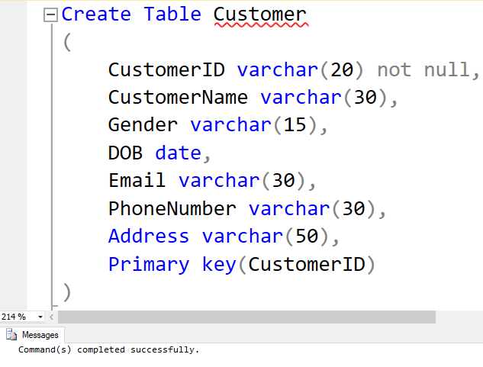

Result or Output

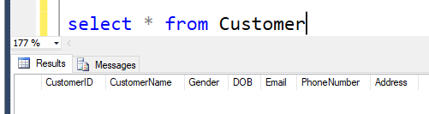

1. Staff Table

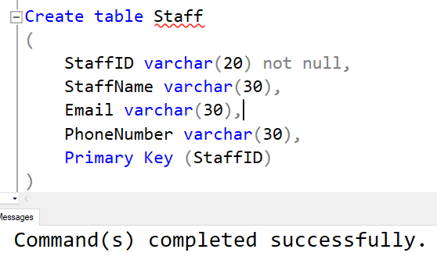

Result

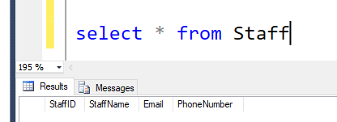

1. Supplier Table

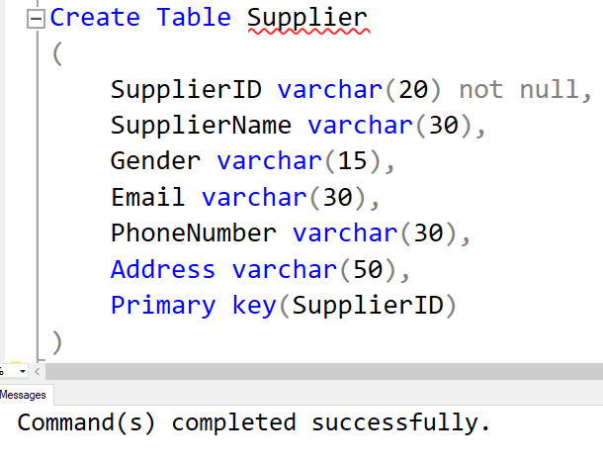

Result

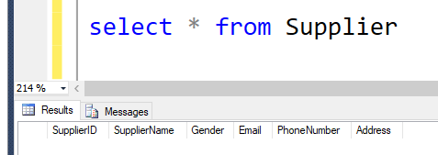

1. Brand Table

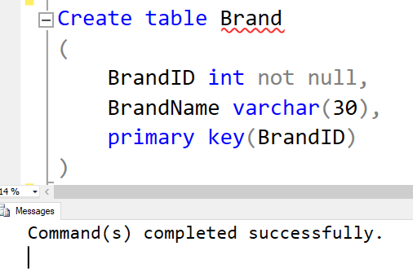

Result

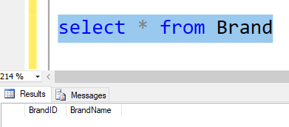

1. Category Table

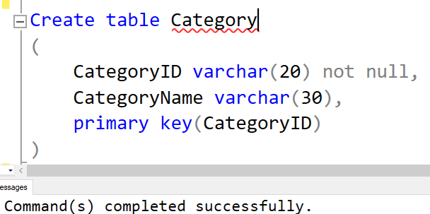

Result

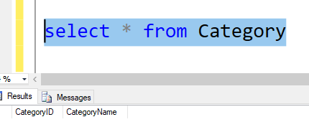

1. Create Product

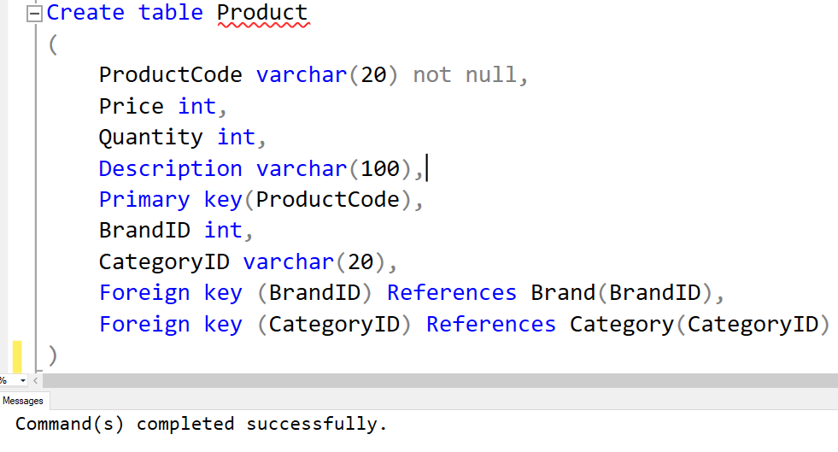

Result

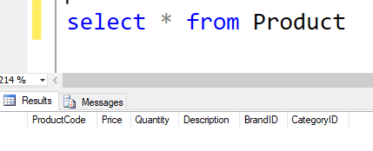

1. Purchase Table

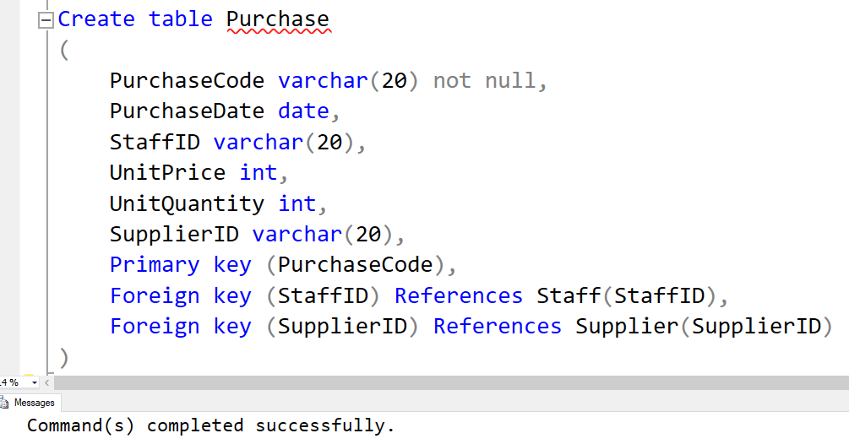

Result

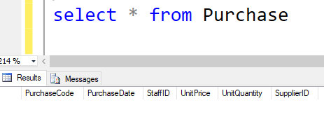

1. Purchase Table

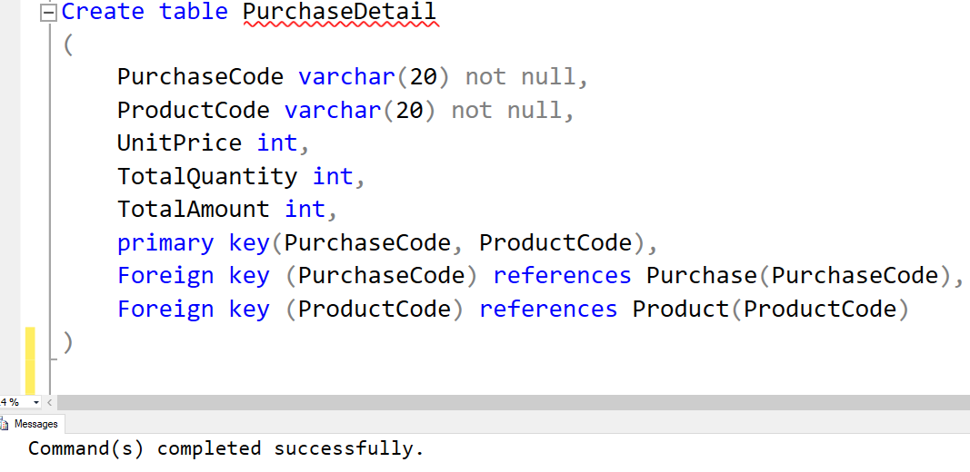

Result

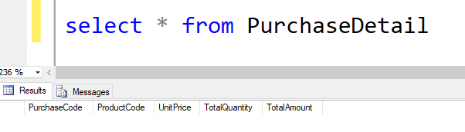

1. Order Table

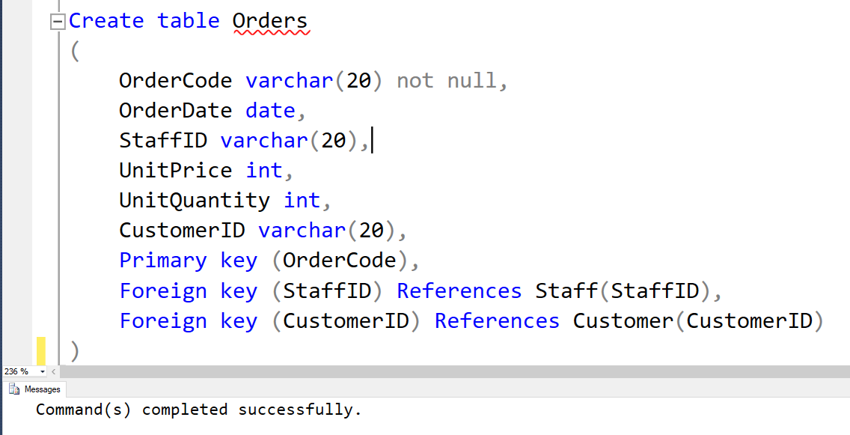

Result

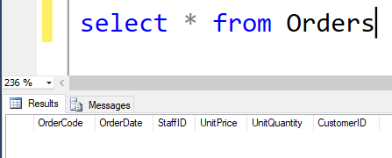

1. OrderDetail Table

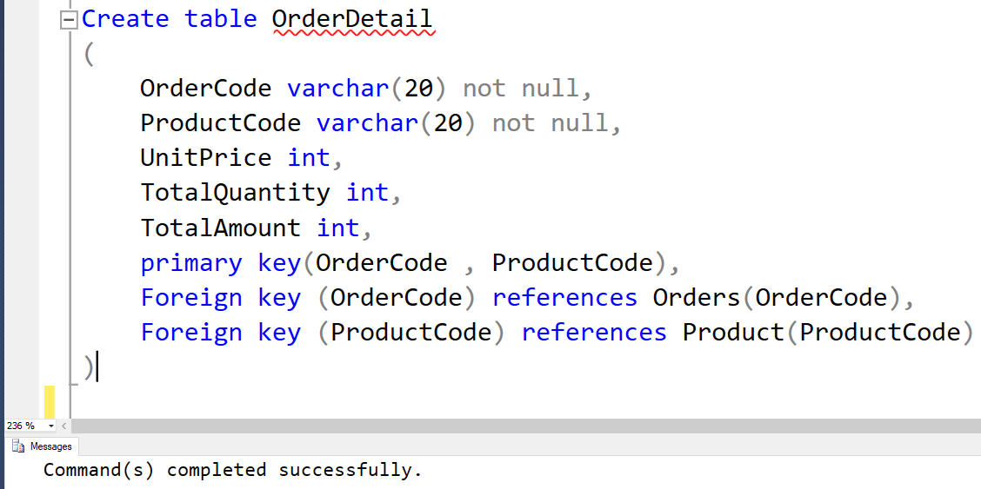

Result

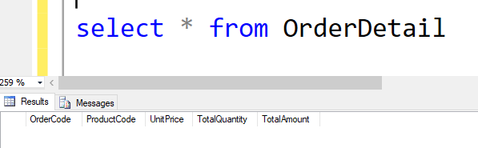

## Adding data into corresponding tables

**Insert Data**

1. Customer Table

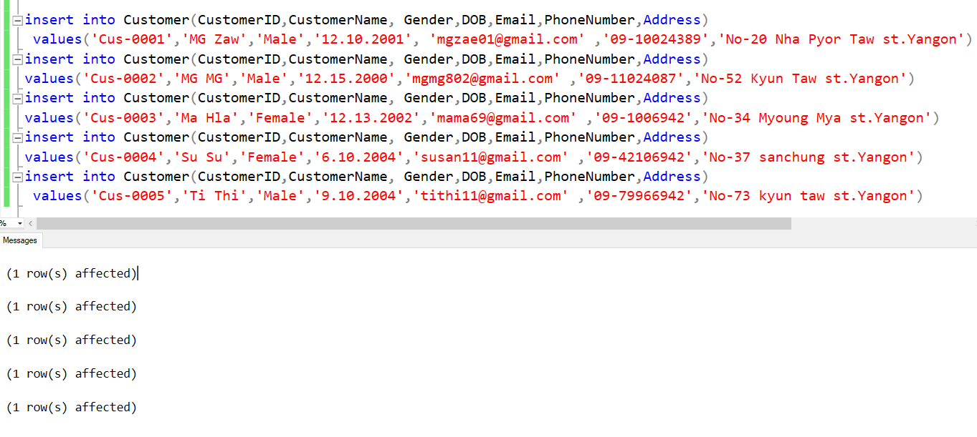

Result

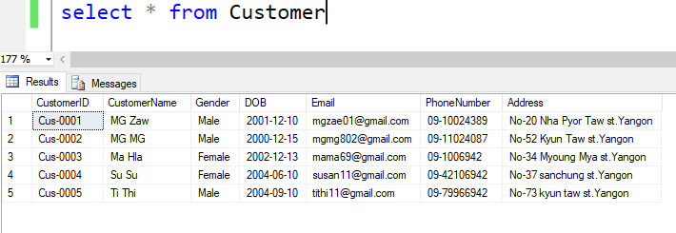

1. Staff Table

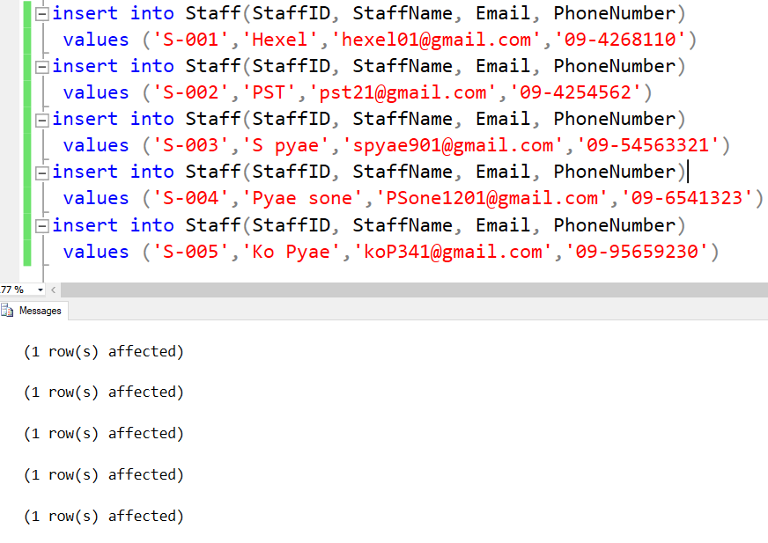

Result

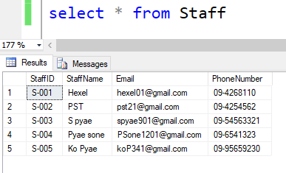

1. Supplier Table

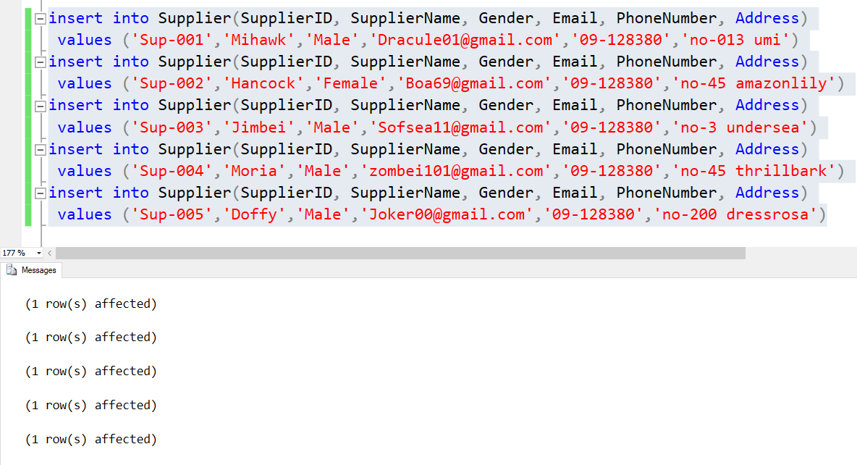

Output

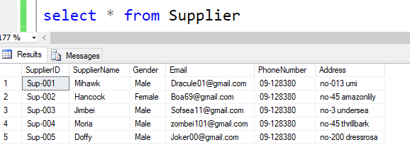

1. Brand Table

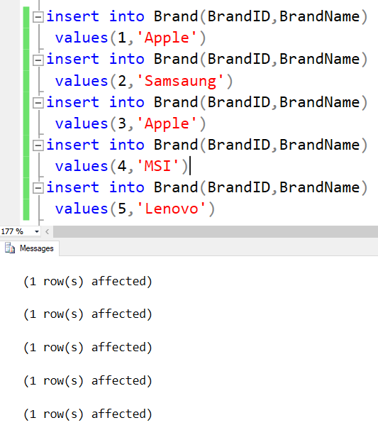

Output

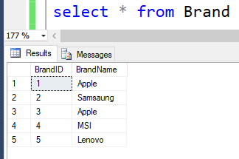

1. Category Table

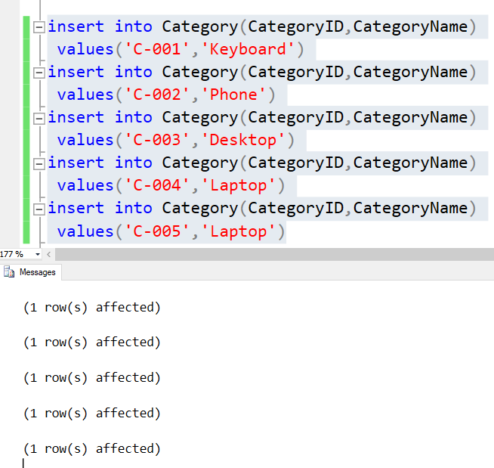

Result

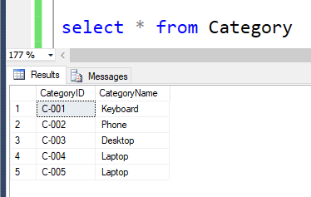

1. Product Table

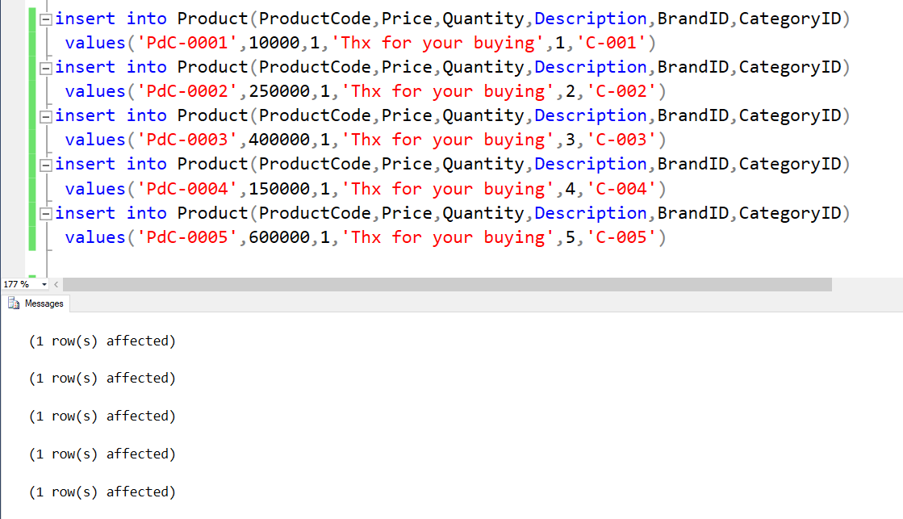

Result

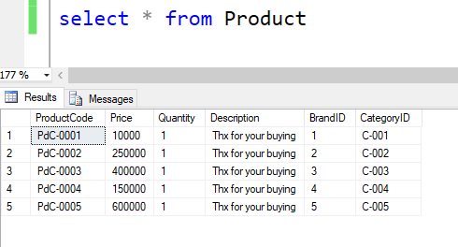

1. Purchase

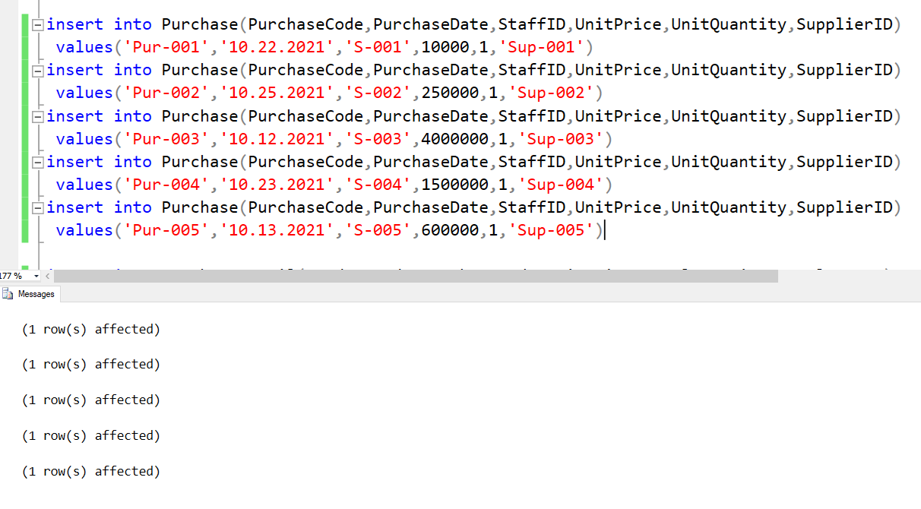

Result

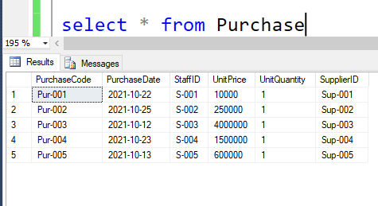

1. PurchaseDetail

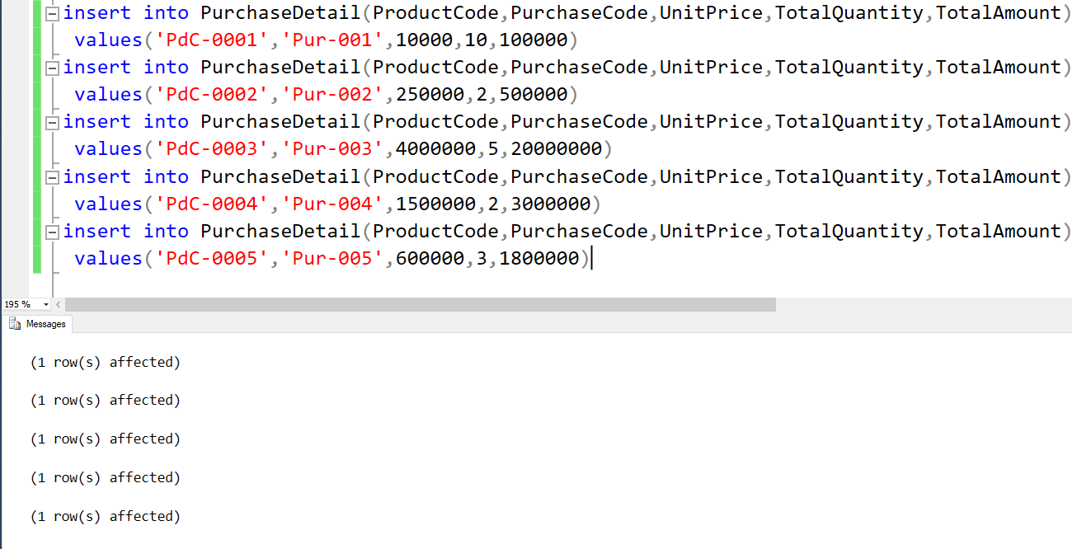

Result

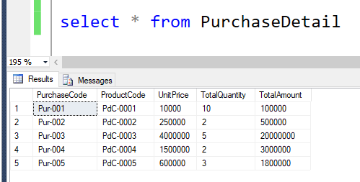

1. Order Table

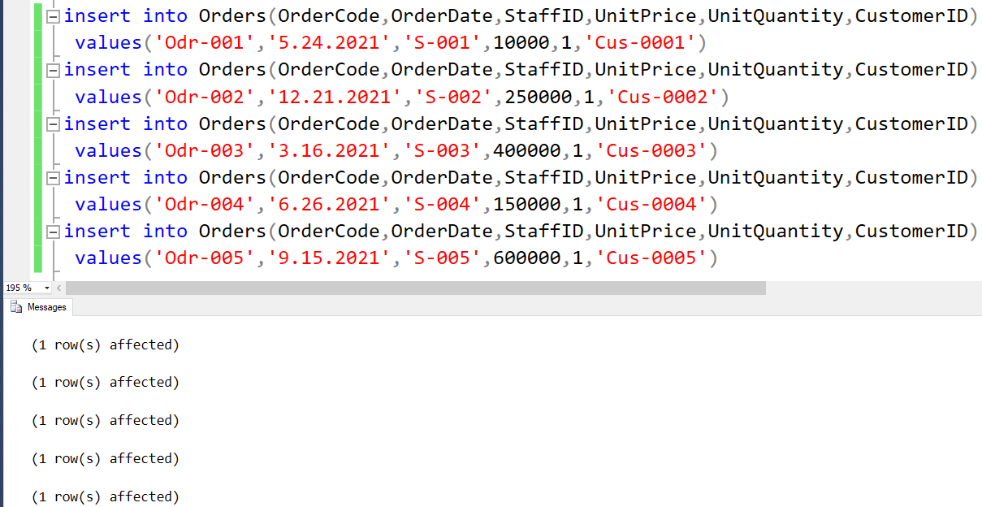

Result

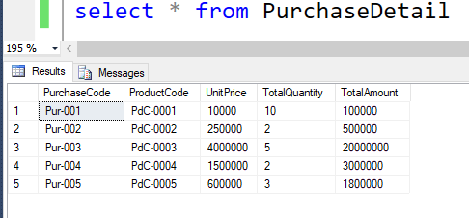

1. OrderDetail Table

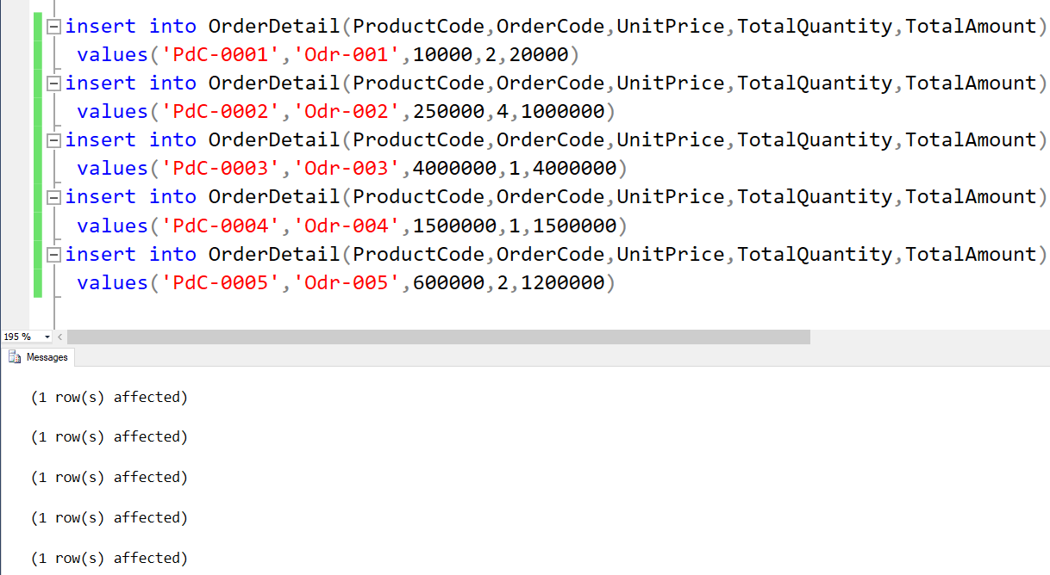

Result

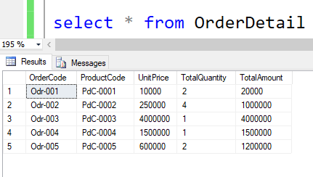

## A query that selects the entity

**Select and Result Table**

1. Selecting PurchaseDate, ProductCode and PurchaseCode

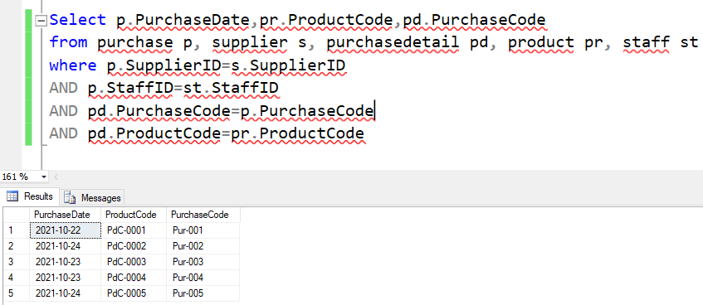

1. Selecting PurchaseDate, ProductCode and SupplierName

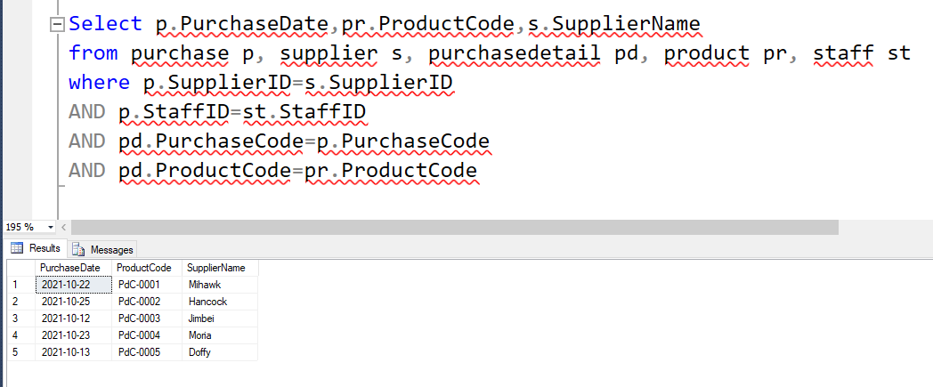

**D] Drop the unwanted tables from database**

1. Drop PurchaseDetail Table

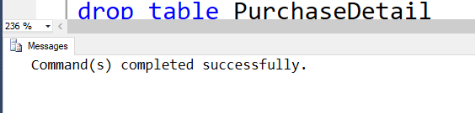

Result

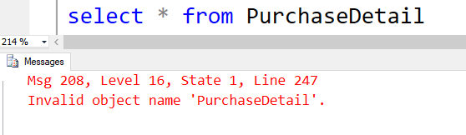

2. Drop OrderDetail Table

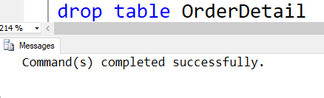

Result

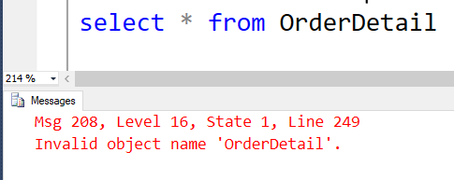

## E] Delete the unwanted data rows from tables

1. Delete OrderDetail Table

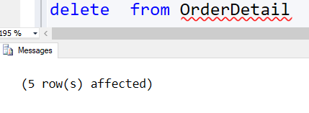

Result

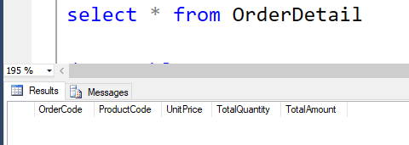

1. Delete PurchaseDetail Table

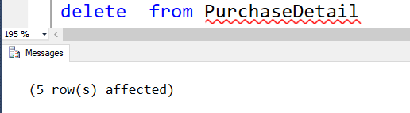

Result

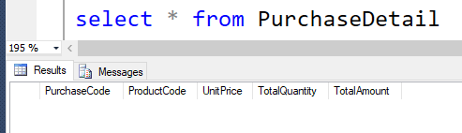

## F] Updating the data from the tables

1. Updating Quantity of Product using ProductCodes

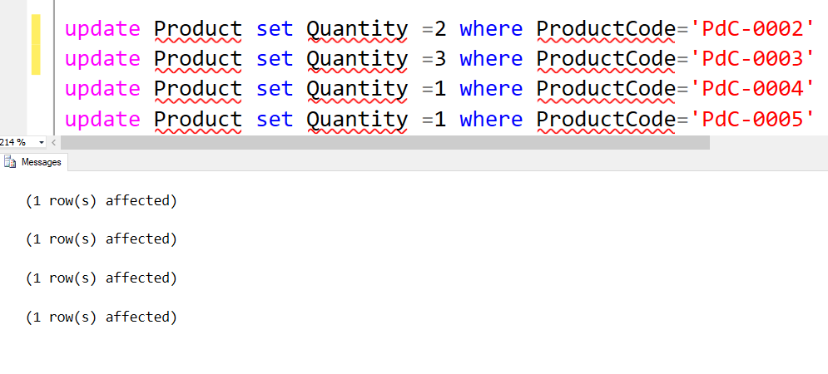

Result

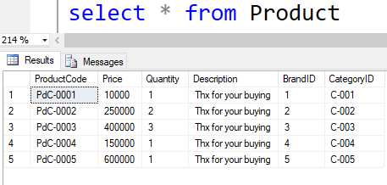

1. Updating PurchaseDate from Purchase using PurchaseCodes

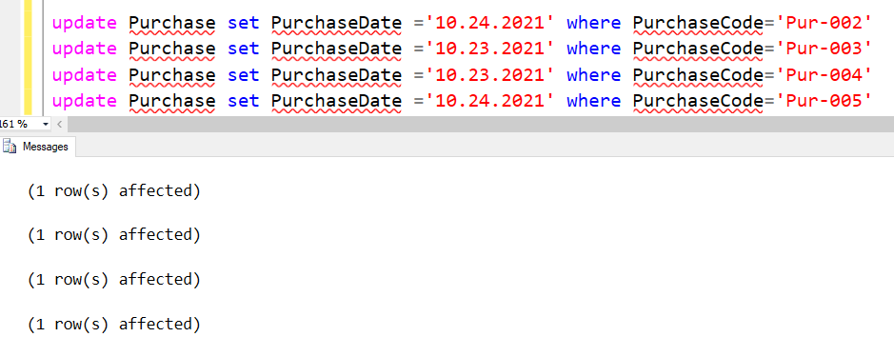

Result

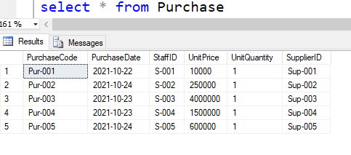

## G] Using select, from where, and, order, sum, count and ascending together

Taking some data from selected tables when

1. TotalQuantity = 2

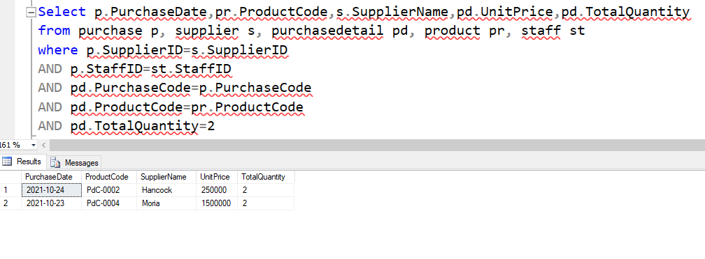

1. PurchaseDate = 10.23.2021

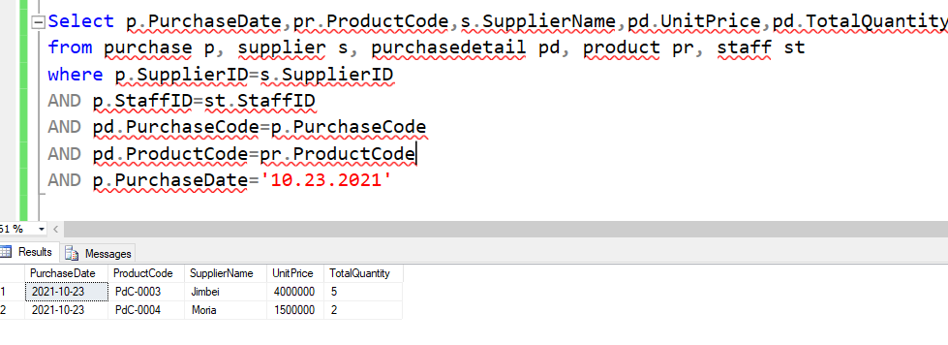

This time will use Order by query.

1. Using ProuctCode

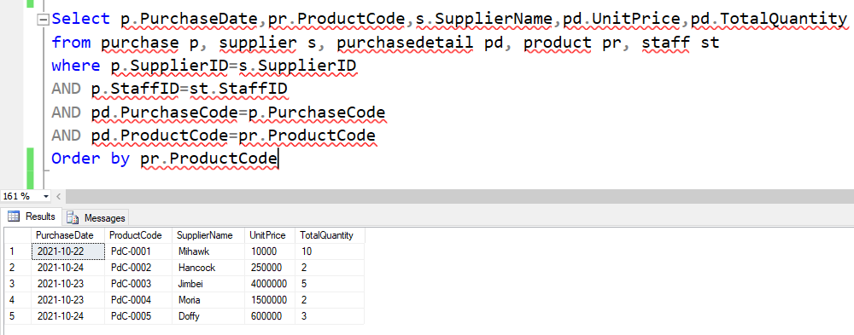

1. Using PurchaseDate

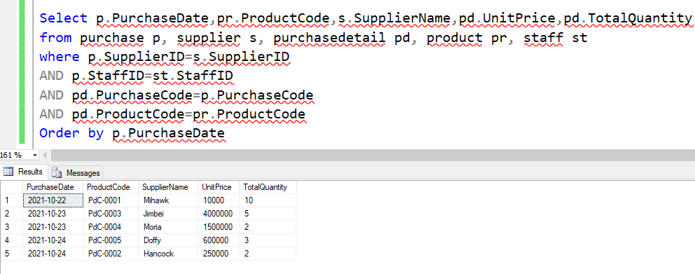

Using sum statement.

1. Sum all UnitPrice as Purchased UnitPrice from PurchaseDetail Table

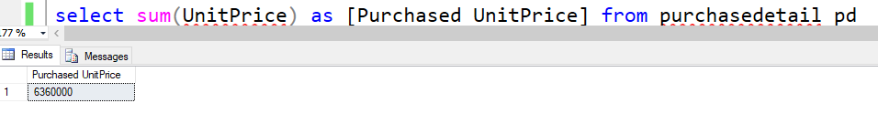

1. Sum all UnitQuantity as Purchased Items from Purchase Table

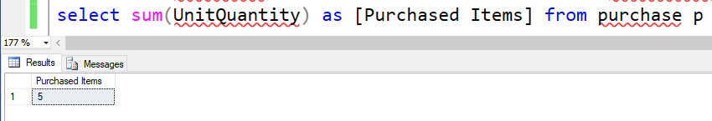

Using Min, Max, Avg and Count statements

1. PurchaseDetail Table

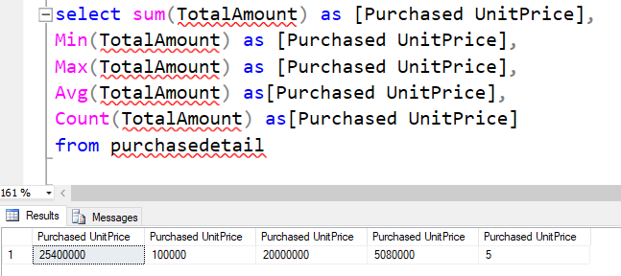

1. OrderDetail Table

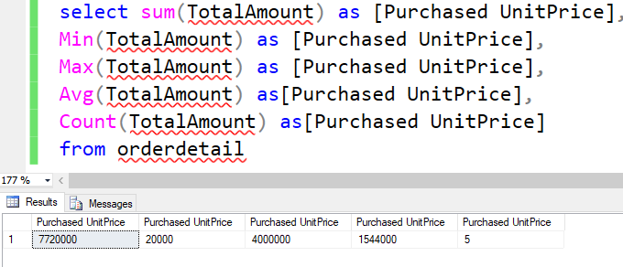

**Task 3**

# Task 3

## Evaluation

Before creating a database, we have to think about the high level entities. Then, it is needed to create main entities. Those entities must be created with the data that the organization will use. In this assignment, there are two high level entities which are purchasing and ordering since the assignment is about point of sale system. Then depending on these entities, main entities like customer, staff, brands, supplier, category, order, product, purchase, purchase detail and order detail are created.

ER diagram is really important in creating a database because entities are created based on it. If the ERD data is wrong, the database will have to make from the start again. It is really helped to create a database. With the help of ERD, the developers can think about the entities systematically and correctly. After making a suitable and correct ERD, the data is normalized upon ERD.

When creating database, there was a lot of error happened because of the ERD and normalization was wrong. And data input were wrong so have to update the data with update query and sometime it is needed to rebuild the entity because of a lot of wrong data inputs.

The database supports the transactions in better way because it is easy to save. It is also easy to put data when using in the organization. Not only those but also the database helps the humans to save the data in list by list and when the data need to research, it is only need to search for the IDs and codes because all the data are saved by those IDs and codes.

# References

# Bibliography

*TechAce*. (n.d.). Retrieved from https://www.facebook.com/TechAceComputer

# Candidate Checklist

Please use the following checklist to ensure that your work is ready for submission.



Have you read the NCC Education documents 'What is Academic Misconduct? Guidance for Candidates' and 'Avoiding Plagiarism and Collusion: Guidance for Candidates' and ensured that you have acknowledge all the sources that you have used in your work?

Have you completed the 'Statement and Confirmation of Own Work' form and attached it to your assignment? You must do this.



Have you ensured that your work has not gone over or under the recommended word count by more than 10%?



Have you ensured that your work does not contain viruses and can be run directly?

