Hello,

This is time for the coolest part of the whole thing; what you see here is an ML model being built, this is rather straightforward compared to TensorFlow, but you see the model go through 20 epochs, with each epoch being a cycle through the machine learning model.

Most important is the two right columns, ‘loss’ and ‘accuracy,’ where obviously accuracy is the gradual improvement of the model to correctly determine the correct answer, whatever that might be. In this case, it goes from a low of **23.26%** to a high of **89.61%** accuracy after the **20 epoch**.

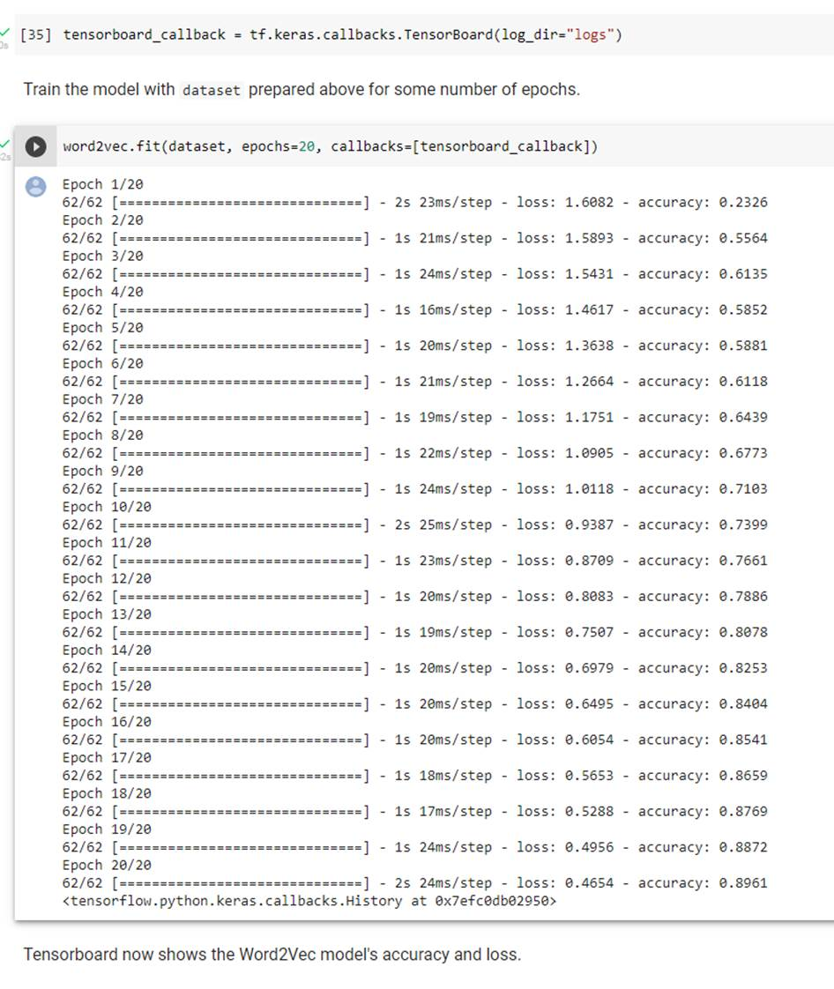

* Tensor board illustrates the learning process.

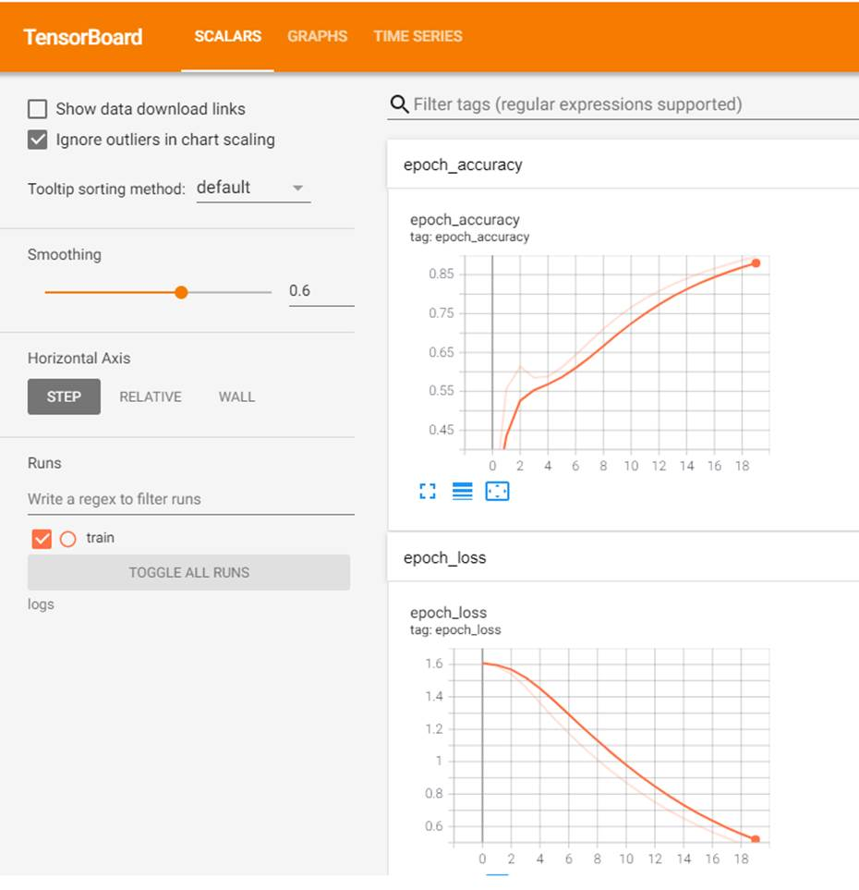

The final step will provide you with two files, a file containing the ‘metadata’ and a file containing the ‘vectors,’ which describe the words in the vector file.

* The process creates two files saved to a directory on the Desktop and will be used in the mapping phase of the project.

This is the contents of the **metadata** file:

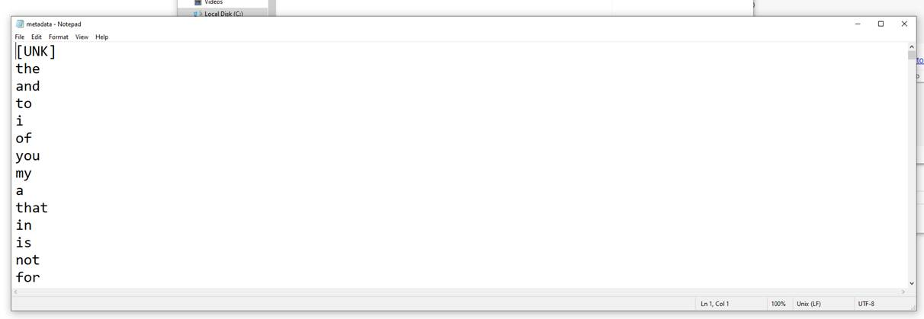

This is the contents of the **vectors** file:

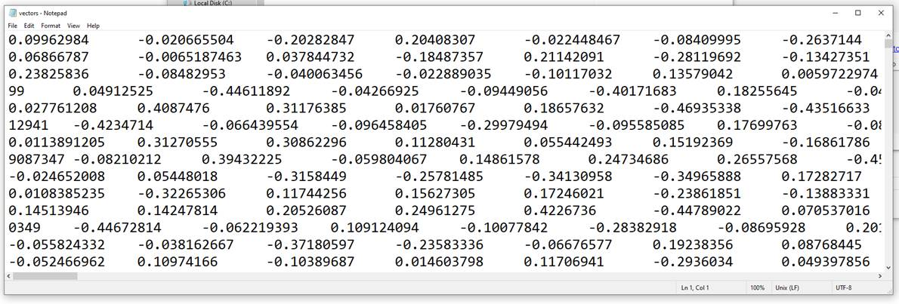

* And now you can make pretty pictures by going to this website.
* <https://projector.tensorflow.org/>

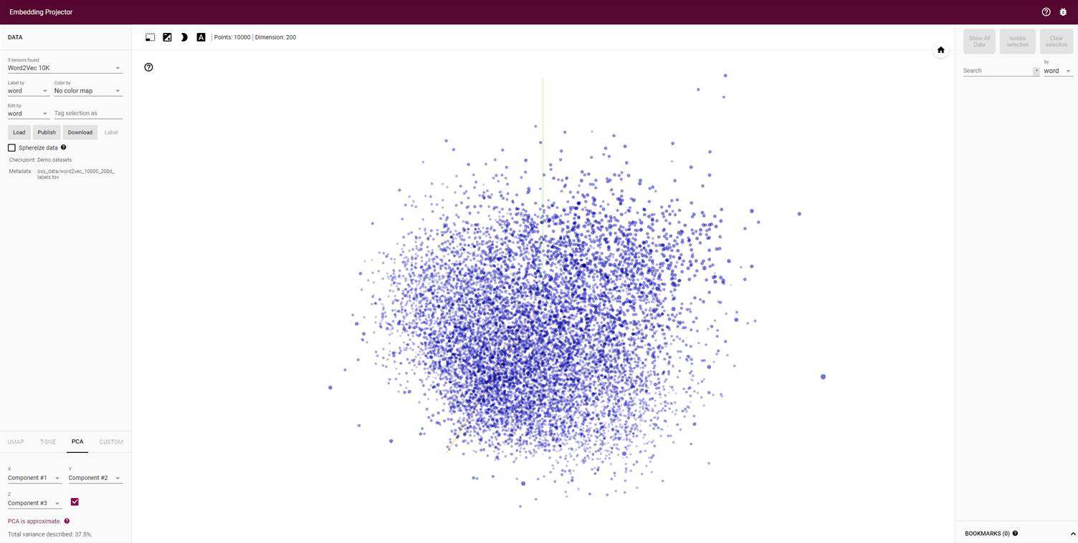

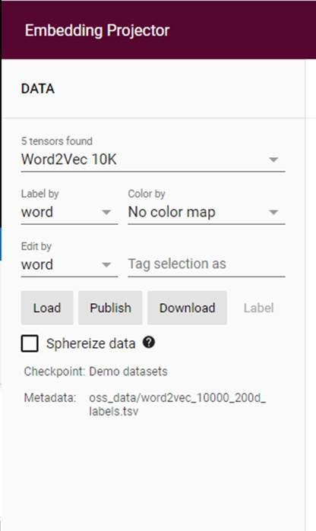

* Click on the Load button

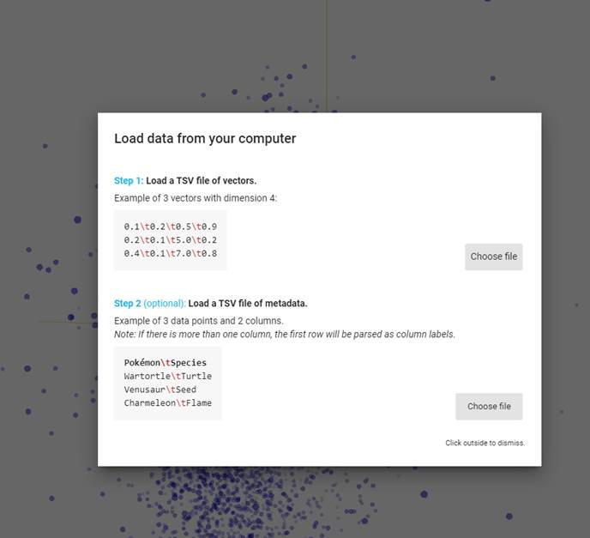

* Load the vector file

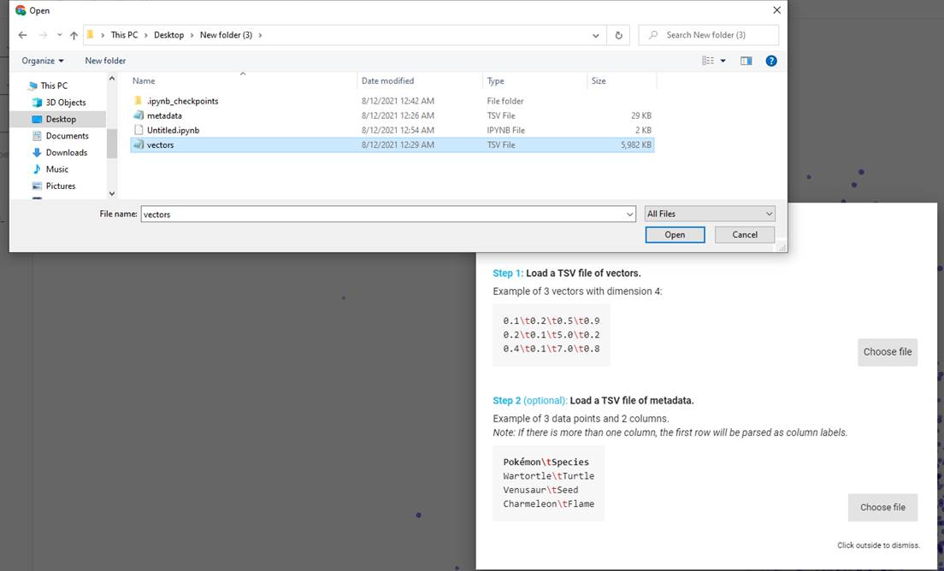

* Load the metadata file

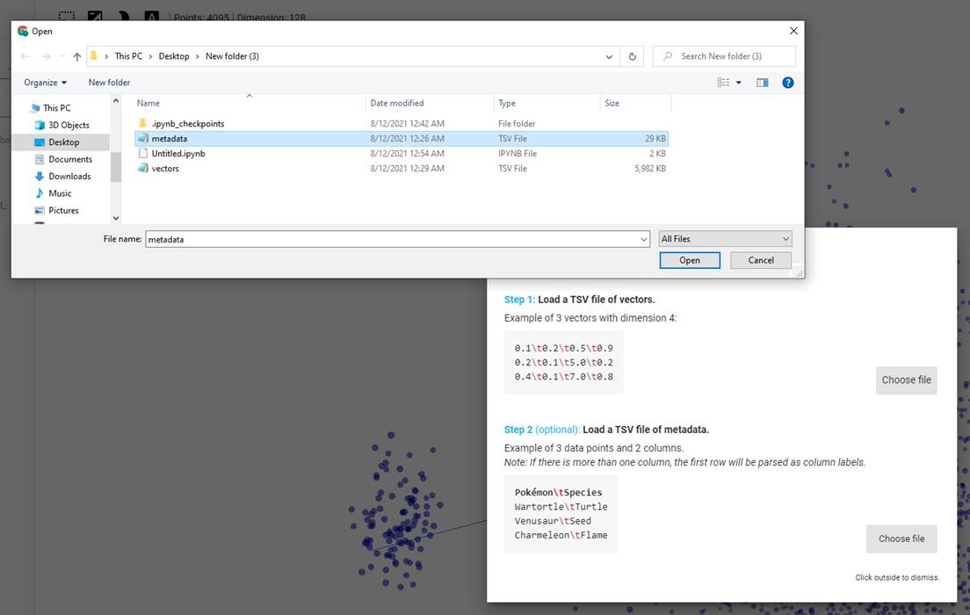

* At this point, you will see the checkpoint and Metadata files from the default screen changed to the files you have just created.

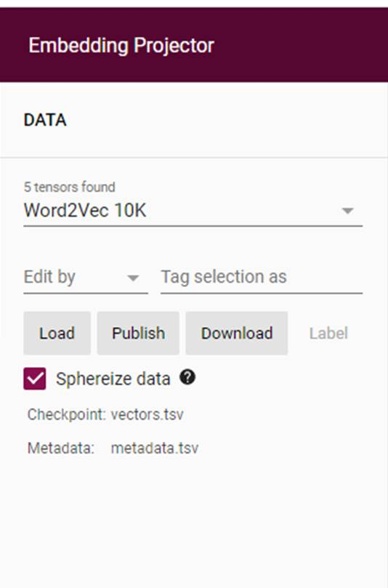

* Also note that your data contains 4095 points and has 128 dimensions



* one of the display modes that can be selected is the Principle Component Analysis (PCA) display mode, but one can also toggle the capital ‘A.’ You can toggle views

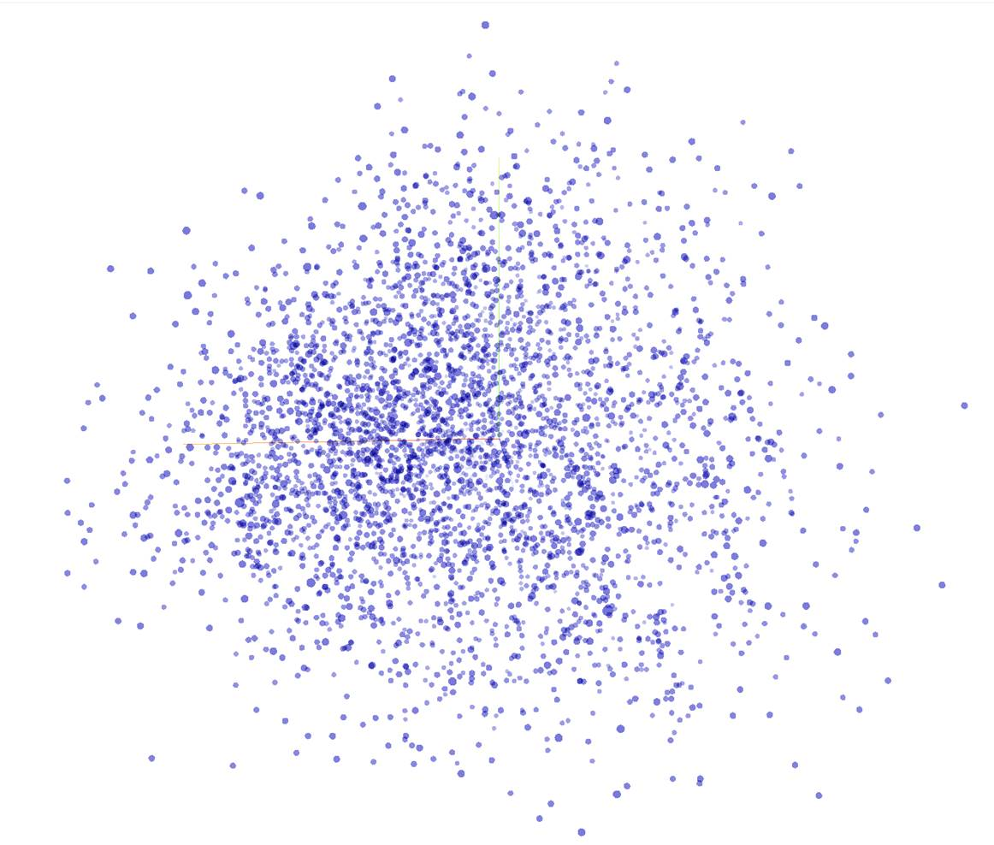

* And this view with the actual words in 3D space can be rotated using the cursor.

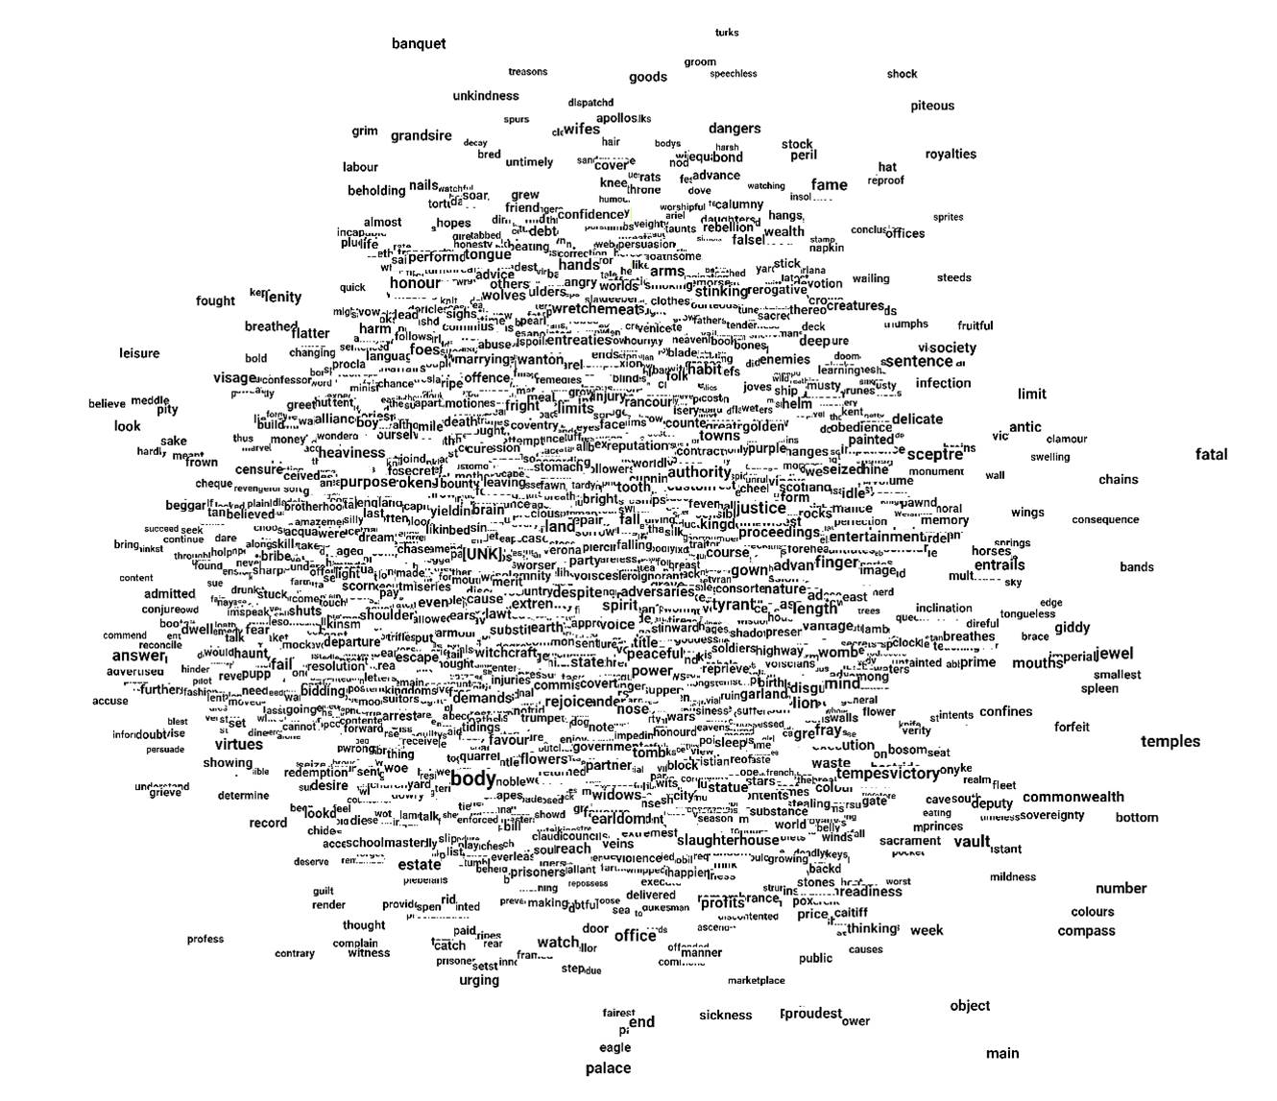

* Then you can experiment with the different models, such as UMAP, which has separated a small cluster of words from all of the others, and try to figure out what, if anything, is the significance of this.

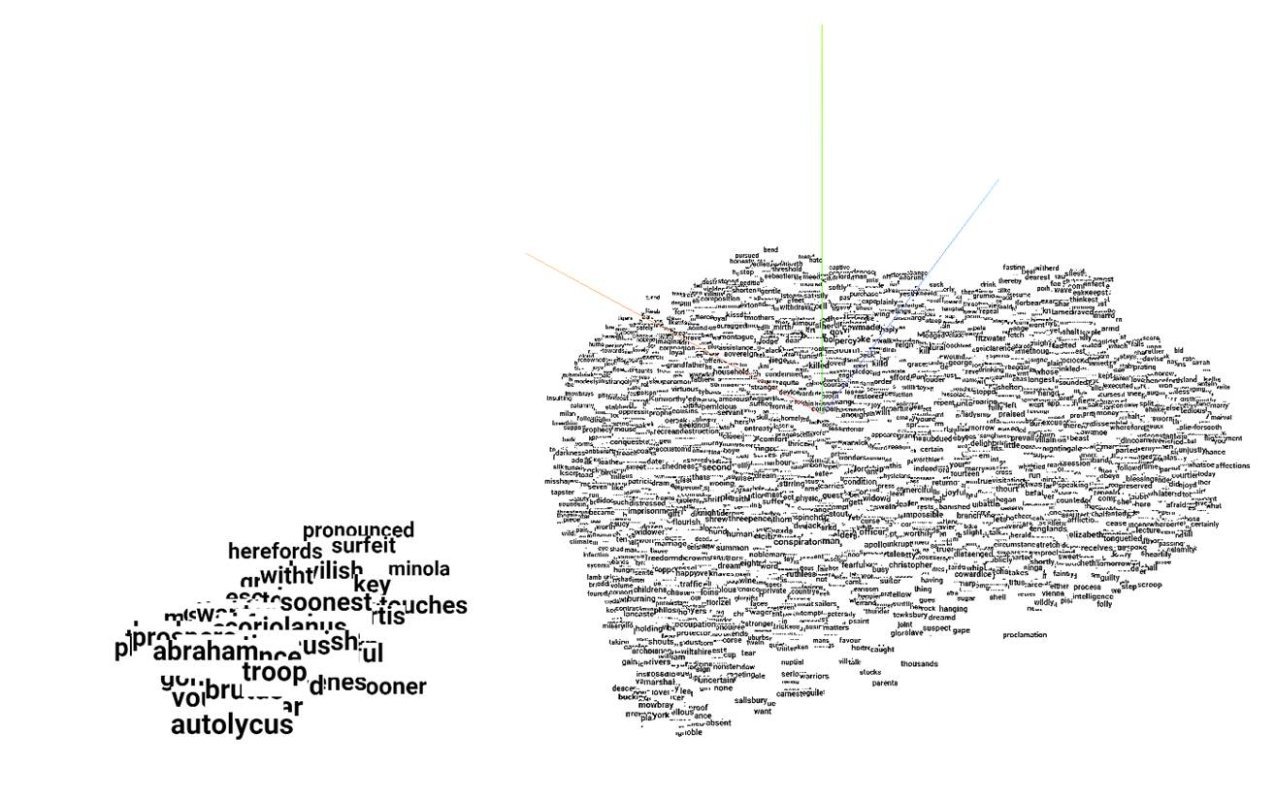

And with the lasso at the upper left-hand side of the screen, one can even select those words in a searchable format and see them displayed on the right-hand side of the screen.

Also, please note that just above the list of words on the middle bottom, one is told that one has isolated 65 words from the corpus of 4095 words using the UMPA mapping process.

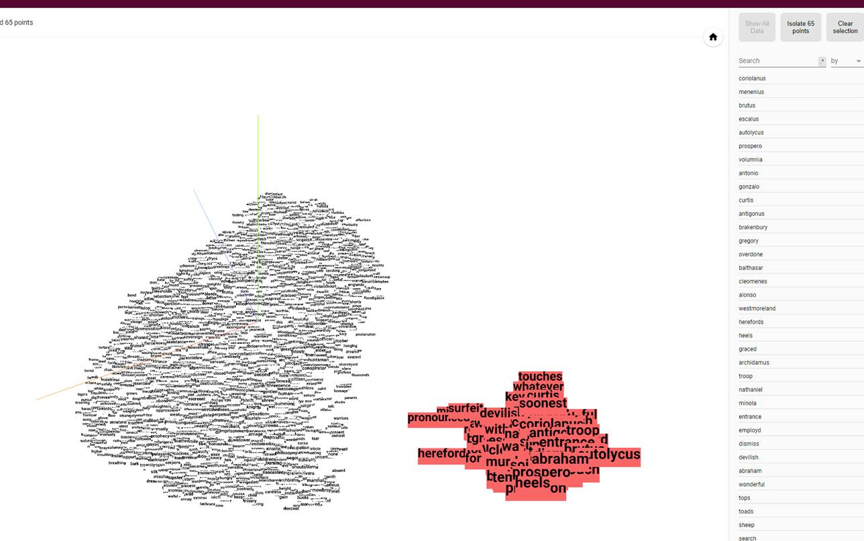

And if you click that button, you can start the whole process again with the 3D mapping of that 65 words and observe their cosine relationship to one another in space.

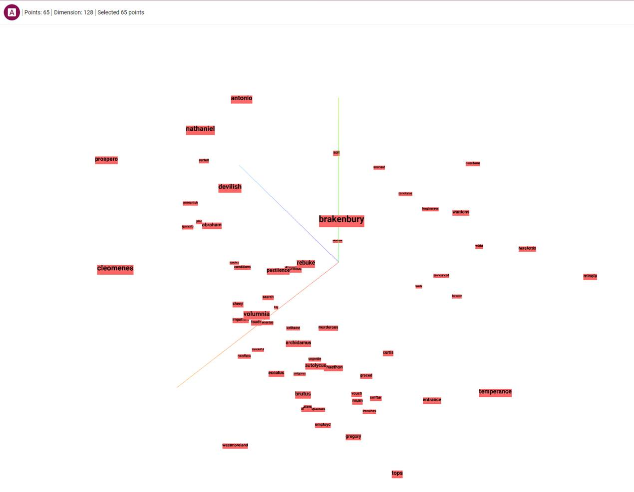

* This time, only 65 points (objects) occupy 128 Dimensions rather than over 4000.

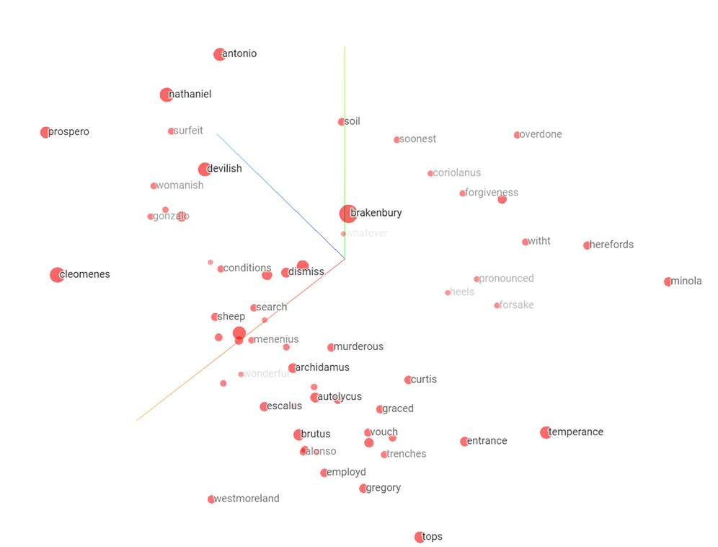

* And one can even toggle the view with the big ‘A’ at the top of the screen to get a better view of the data with which one is working.

Enjoy!