Assessment Purpose
This report assesses the patentability of the technology described herein across three core dimensions: novelty, non-obviousness, and commercial feasibility. It is intended to provide leadership with a structured evaluation to support decisions regarding patent filing, further R&D investment, and strategic IP positioning.
Technology Overview
*Brief (2-3 sentences) overview of what the proposed technology is, explained so a non-expert can understand
Key Novelty Statement
*2-3 sentence explanation of what is novel about the proposed technology.*
Non-Obviousness Statement
*Explanation of why the proposed technology is a genuine, unexpected advancement rather than an obvious, trivial tweak to existing technology*
Overall Patentability Assessment
Intellectual Property Key Terms: Before a patent can be granted, an invention must clear three legal tests set by U.S. patent law. The following table is a summary of our assessment based on the metrics below.
See Appendix 1 for Ranking System – Fill in this table using Appendix 1 ranking system (Example n the Novelty Category – replace with relevant explanation. In the overall recommendations, copy/paste the Action item from the ranking chart. Then delete this yellow direction.
Novelty (35 U.S.C. § 102): Is the invention new? Has it been publicly disclosed or patented? | Moderate – Likely: It is unique to confer piezoelectric property into a material that would not have the property without using microfibers produced from wet-spinning.
Non-Obviousness (35 U.S.C. § 103): Is this invention a meaningful creative step beyond what already exists?
Utility (35 U.S.C. § 101): Does the invention work and does it serve a significant purpose?
Overall Recommendations

Section 1: Key Novel Factors
This section identifies the specific technical elements of the invention that distinguish it from existing prior art.

1.1 Primary Novel Element
*Provide a one-paragraph explanation of the most novel aspect of the proposed technology, including what differentiates it from existing solutions. Incorporate any relevant experimental results or supporting data from the IDF that demonstrate novelty or feasibility. If there are multiple novel innovations, create additional subsections and order them from most to least novel.*
1.2 Prior Art Landscape
*Make a copy of this table for each key piece of prior art (patents and publications). Organize in order of most to least relevant.*
Prior Art #1: *Indicate here whether the prior art is a patent or publication.*
Prior Art Reference
Date Published
Key Distinction
Most Competitive Claims

Section 2: Commercial Feasibility
A strong patent application is most valuable when underlying technology has a viable path to commercialization. This section evaluates the market opportunity, return on investment, and competitive positioning of the technology.

2.1 Market Opportunity
Values concerning market size and growth can be found below.
*Create multiple copies of this table and fill out for each potential market or market segment. Most values can be found using TIBI’s Pitchbook account.
Target Market
Market Size
Projected Marekt Growth
Market Growth Rate

2.2 Competitive Landscape
This section should have potential competitive companies.

*Company Name*
Description and Company History:
*Provide a paragraph here detailing a description of the company and its history.*

If available, provide a funding timeline for the competitor. (Example below)
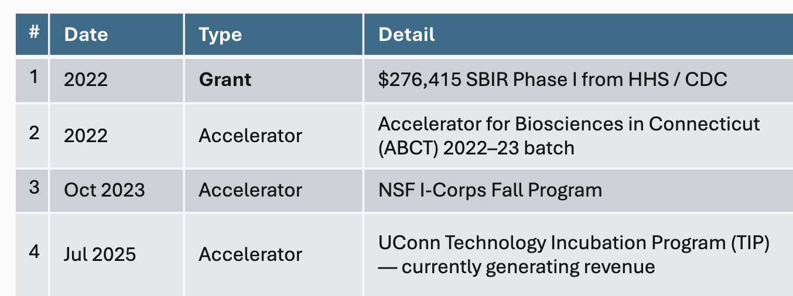
Key Competitive Patent:
- *List potential competitive patents from the company*

Section 3: Future Directions & Data Requirements
This section outlines the additional research, experimentation, and data collection needed to strengthen the patent application, support non-obviousness arguments, and advance the technology toward commercialization.

3.1 Data Needed to Strengthen Patent Claims
The following are ideas of data to collect to prove some of the claims that will allow for the broadest IP coverage:
Fill in the following table with potential experiments or data the inventors need to collect to make a better case for their proposed technology.

Priority | Experiment | Why
1
2
3
4
5

3.2 Licensing Opportunities
Separate licensing opportunities into categories if applicable (should mirror the different markets explored in Section 2.1).

{#categories}Category {categoryNumber}: {categoryName}

Key Players  (ranked with decreasing revenue) | Potential Market
Big players:  {#bigPlayers}  - {name} ({fit}% fit)  {/bigPlayers}  Startups:  {#smallerCompanies}  - {name} ({fit}% fit)  {/smallerCompanies} | {#potentialMarketSpaces}  {.}  {/potentialMarketSpaces}
{/categories}
{disclaimer}

Appendix 1: Patentability Ranking System
Patentability Rating Scale for IDF Assessments
Patentability rating scale
■ ■ ■ ■ ■  Not patentable  Score: 0–20 | The invention is almost certainly blocked by existing patents or disclosures. Filing would likely be rejected at examination or challenged post-grant.  Action: Do not file. Consider design-arounds or licensing.
■ ■ ■ ■ ■  Low  Score: 21–40 | Meaningful prior art overlaps with core aspects of the invention. Some claim narrowing may be possible, but protection would be thin.  Action: Conduct a deeper prior art search before committing to a filing.
■ ■ ■ ■ ■  Moderate  Score: 41–60 | Some prior art exists but the invention has meaningfully distinct features. Grant is achievable with well-crafted claims, but uncertainty remains.  Action: Consult patent counsel and refine claim scope before filing.
■ ■ ■ ■ ■  Likely  Score: 61–80 | The invention appears novel and non-obvious. A well-prepared application has a good probability of advancing through examination.  Action: Proceed to filing with counsel. Prioritize claim drafting.
■ ■ ■ ■ ■  Highly patentable  Score: 81–100 | No meaningful prior art identified. The invention represents a clear creative step. Strong likelihood of broad claim allowance.  Action: File promptly. Consider international (PCT) coverage.

