The Hidden Cost of Employee Disengagement: An $8.9 Trillion Problem AI Can Solve
Key Takeaways
- Employee disengagement is a multi-trillion-dollar problem impacting productivity, culture and retention
- Disengagement is rarely sudden. It starts with small, almost invisible signs-skipped meetings, reduced participation, or declining collaboration
- Traditional engagement methods are reactive, too slow and fragmented; Annual surveys and periodic check-ins provide "static snapshots" of the past

- Solving the $8.9T problem requires moving from periodic snapshots to Continuous Workforce Intelligence- an AI-powered approach Nexohra brings to life by detecting early signals of disengagement and guiding timely, data-driven targeted interventions

Employee disengagement is no longer just an HR concern; it is a global economic challenge. Gallup research estimates that disengaged employees cost the world economy up to $8.9 trillion annually, roughly 9% of global GDP. For organizations, this isn’t an abstract statistic. It is a compounding drag on productivity, innovation and growth that quietly accumulates, often undetected, until the damage is expensive to reverse.
Disengagement Does Not Announce Itself.
This is what makes it so costly. It does not arrive with a resignation letter or a difficult conversation. It builds quietly, through small behavioral shifts that are individually easy to dismiss but collectively tell a clear story.
The core drivers- unfair treatment, inadequate recognition, unmanageable workloads, poor manager communication and role ambiguity- exist in almost every organization. What varies is whether anyone is watching closely enough to see what they produce.
The Signals Are Always There
These drivers broadcast constant signals - just not in ways traditional HR tools are built to read: declining collaboration, Sentiment shifts (negative tones in meetings/ communications), presenteeism, absenteeism spikes, Performance dips.
In the din of daily operations, these cues blend into noise. Periodic surveys miss them; intuition falters. None of these signals trigger an alert in a traditional HR system. They do not surface in the performance review that happens twice a year. And by the time they become visible- in a resignation, in a performance dip, in a team that has quietly stopped delivering - the cost has already been incurred.
The Anatomy of the $8.9 Trillion Leak
Disengagement does not show up as a line item on a balance sheet, but it erodes the bottom line.
- Productivity Slumps
Disengaged workers are often "present but absent," fuelling presenteeism. The cost compounds through stalled projects, quality issues, innovation that never materializes and customer interactions that fall consistently short of their potential
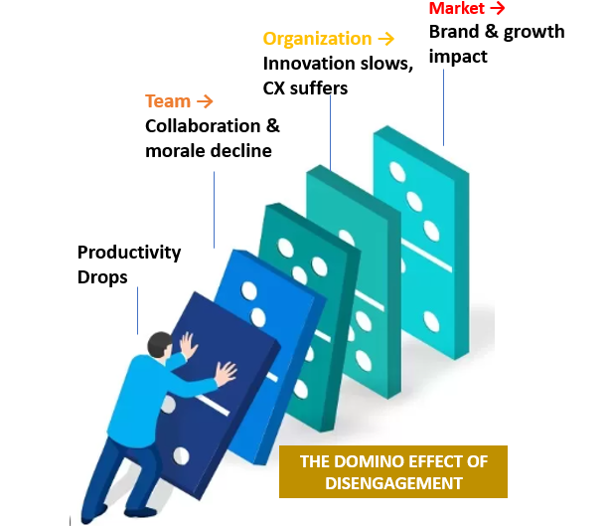
- High Turnover
When disengagement boils over, exits follow. Replacing an employee costs between 1.5 to 2 times their annual salary- accounting for hiring, training and knowledge transition. For specialized roles, that figure climbs higher still.
- Ripple Impacts on Teams and Culture
Disengagement is contagious. Its impact radiates through teams, departments and the broader organization, creating a domino effect
- Managerial Multiplier
Disengaged managers further amplify the problem, dragging down team performance and engagement
Gallup states managers account for up to 70% of the variability in engagement scores

The gap is not awareness. It is visibility. And visibility requires intelligence.

The fundamental problem is that current systems fragment understanding across tools and time horizons:
  - Surveys capture sentiment, but only periodically
  - Performance systems capture outcomes, but not behavioral pathways
  - HRIS platforms capture events, but not underlying dynamics
This creates a structural blind spot between observation points.

How AI changes the Equation
AI shifts engagement monitoring from episodic measurement to continuous behavioral interpretation. Instead of relying on delayed indicators, organizations can identify emerging disengagement patterns as they form, within context and over time.
- Key shift: not more data, but earlier interpretation
This enables responses to become more contextual, more timely and more targeted. Instead of generic interventions, organizations can enable better-informed manager conversations, prioritized HR focus where risk is emerging and early support before disengagement escalates.
This changes engagement from a reporting function to a continuous awareness system.

Nexohra - Built for This Problem
Nexohra is specifically built to operationalize this intelligence layer by continuously translating workforce signals into actionable engagement insights.
It enables organizations to see how engagement evolves across teams, roles and time, surfacing early signals that traditional systems miss.
This allows organizations to:
- detect disengagement patterns earlier
- prioritize attention where risk is emerging
- enable structured interventions across managers and HR
- reduce dependency on lagging indicators like attrition or performance decline
The result is a shift from reactive workforce management to early, informed intervention.

The $8.9 trillion disengagement problem is not inevitable. With the right intelligence infrastructure, it is detectable, manageable and measurably reducible.
Talk to Us | Explore Our Product

