Onboarding Reimagined: The Strategic ROI of Predictive Assimilation

Key Takeaways
- The first 90 days are the most critical phase of the employee lifecycle, shaping long-term engagement, productivity and retention

- Traditional onboarding focuses on checklist-based task completion, but completion does not guarantee meaningful assimilation

- Predictive assimilation shifts onboarding from static execution to continuous understanding of early employee integration

- Nexohra operationalizes this shift through AI-driven onboarding intelligence, helping organizations compress onboarding cycles and strengthen early-stage employee success

Most organizations treat onboarding as a process to complete. The most effective ones treat it as an intelligence opportunity to act on.
The difference between the two is significant. It shows up in how quickly new hires contribute, how long they stay and how much of the recruitment investment the organization ultimately protects.
The Stakes Are Higher Than Most Organizations Realize
The first 90 days of employment are the most consequential period in a new hire's journey. Research consistently shows that the experiences, relationships and signals a new employee encounters in this window shape their long-term performance, engagement and retention.
Get it right and you accelerate contribution, build cultural alignment and protect the investment made in attracting and hiring talent.
Get it wrong or simply leave it to chance and the consequences compound quickly.
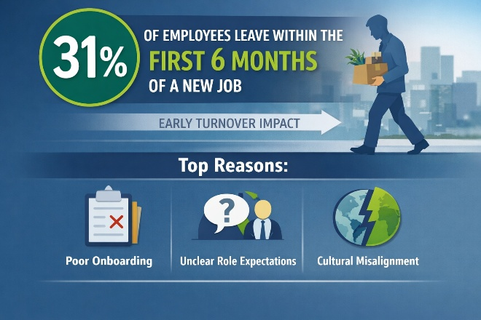
The cost of early attrition in recruitment, lost productivity and team disruption typically far exceeds what a structured onboarding approach would require.
Yet despite these stakes, onboarding in most organizations remains an administrative exercise:
- Paperwork
- System access
- Introductory meetings
- A checklist that gets ticked and archived
What is often missing is the intelligence around how a new hire is integrating into the role, the team and the organization.

The Problem with Traditional Onboarding
Traditional onboarding operates on assumption.
If a new hire attends inductions, completes learning modules and meets key stakeholders, the process is considered successful.
But completion is not assimilation. A new hire can complete every onboarding activity and still be struggling with role clarity, cultural alignment or their manager relationship.

They may feel overwhelmed, underutilized or disconnected without those signals surfacing in a process built around task completion rather than experiences. By the time these issues become visible, often during a 3-month review or a resignation within 6 months, the opportunity for early intervention has already passed.
The first 90 days are not simply a transition phase. They represent the highest-leverage window in the employee lifecycle. Yet most organizations navigate it with limited visibility.

What Predictive Assimilation Changes
Predictive assimilation reframes onboarding to a system of continuous workforce intelligence. Instead of focusing only on task completion, organizations begin to understand how new hires are progressing in their ability to contribute, connect and adapt. This creates a more responsive onboarding experience, where managers are better equipped to guide early conversations, HR has clearer visibility into integration challenges and employees receive more relevant support during their early journey.
Onboarding becomes less about tracking steps and more about enabling successful transition.

The ROI Case Is Compelling
The business case for predictive assimilation becomes clear when the numbers are examined. Replacing an employee who leaves within their first year typically costs 1.5 to 2 times their annual salary, once recruitment effort, onboarding investment, lost productivity and team disruption are considered.
Reducing early attrition even slightly across a workforce can generate meaningful financial savings. But retention is only one part of the equation here.
Time-to-productivity is one of the most powerful, yet underleveraged performance levers available to organizations. Every week a new hire spends ramping up before reaching full contribution represents a week of unrealized output. Compressing that window through intelligent, adaptive onboarding accelerates the return on every hiring investment.

This is where AI-driven intelligent onboarding mechanism create measurable impact. Instead of relying on delayed signals, Nexohra surfaces early integration patterns across:
- how employees are adapting to their roles
- how effectively they are integrating into teams
- where additional support may be required
By bringing structure and clarity to this early phase, organizations can enable faster alignment, stronger engagement and more consistent early contribution.
The outcome is a more effective transition from hiring to meaningful participation in a shorter time frame.
Organizations that treat onboarding as a strategic capability, rather than an administrative obligation, are the ones that see its impact most clearly in their retention data, their time-to-productivity metrics and the quality of their new hire experience.
Predictive assimilation is not simply a technology upgrade to an existing process. It is a fundamental redefinition of what onboarding should accomplish and what becomes possible when organizations finally have the intelligence to guide it effectively.

Nexohra gives organizations the intelligence to onboard smarter by compressing the ramp-up cycle, surfacing potential risks sooner and ensuring new hires receive the right support to contribute, connect and stay.
Because the recruitment investment deserves more than a checklist.

Ready to see what intelligent onboarding looks like in practice?
Book a Demo | Explore Nexohra

