Factory Ticket System
System Design & Architecture
Spring Boot · AWS · Thymeleaf
Version 2.0 — Updated

1. Project Overview
A web-based order ticket management system for an internal factory environment. Workers at each production stage confirm tickets through a simple role-based interface. The system is event-driven using AWS SQS priority queues, ensuring rush orders are always processed first. Built as a portfolio project demonstrating Spring Boot, AWS integration, and event-driven architecture.

1.1 Design Philosophy
Build simple for Phase 1. Design for scale from the start. Add complexity only when needed.

- Order tickets are generic — no product-specific logic in Phase 1
- Each order moves as one unit through the pipeline
- One screen for all worker roles — role-aware buttons via Thymeleaf
- Sort orders in Java — no complex DynamoDB queries needed at portfolio scale
- Two environments — dev uses local tools, prod uses real AWS — zero code changes between them

1.2 Tech Stack
Layer | Technology | Notes
Backend | Spring Boot 4.x / Java 21 | Controllers, services, repositories
Frontend | Thymeleaf + Bootstrap 5 | Server-rendered, one template for all roles
Auth (Dev) | Spring Security form login | Hardcoded test users, no JWT needed — session cookie
Auth (Prod) | AWS Cognito hosted UI | OAuth2 JWT, role-based via Cognito groups
Database (Dev) | DynamoDB Local | Exact same behavior as real DynamoDB
Database (Prod) | AWS DynamoDB | On-demand capacity, no schema migrations
Queues | AWS SQS FIFO | 15 queues total — 3 priority levels x 5 stages
Notifications | AWS SNS | Notifies next worker when order advances
File Storage | AWS S3 | Shipping labels and Spring Batch quota reports
Batch Jobs | Spring Batch | Daily and weekly quota reports written to S3
Scheduler | AWS EventBridge | Triggers Spring Batch and starvation promotion
Deployment | AWS Elastic Beanstalk | Dockerized Spring Boot app
Container Registry | AWS ECR | Docker image storage
Monitoring | AWS CloudWatch | Logs, metrics, alerts
IaC | AWS CloudFormation | All infrastructure defined as code

2. Environments
Two Spring Boot profiles. No code changes between environments — only configuration differs.

Concern | Dev Profile | Prod Profile
Activate | mvn spring-boot:run -Dspring-boot.run.profiles=dev | SPRING_PROFILES_ACTIVE=prod (Beanstalk env var)
Login | Spring Security form login (/login page) | Cognito hosted UI — your login page is bypassed
Session | JSESSIONID cookie (server session) | JWT token (stateless)
Database | DynamoDB Local on localhost:8000 | AWS DynamoDB (SDK connects automatically)
AWS Credentials | Dummy keys in application-dev.properties | IAM role on Elastic Beanstalk — no keys needed
Secrets | Local properties file | Elastic Beanstalk environment variables only

2.1 Security Config — Profile Switching
@Bean @Profile("dev")
SecurityFilterChain devSecurity(HttpSecurity http) {
return http.formLogin(...) // your own login page
.authorizeHttpRequests(auth -> auth
.requestMatchers("/tickets").hasAnyRole(...)
).build();
}

@Bean @Profile("prod")
SecurityFilterChain prodSecurity(HttpSecurity http) {
return http.oauth2Login(...) // Cognito hosted UI
.authorizeHttpRequests(auth -> auth
.requestMatchers("/tickets").hasAnyRole(...)
).build();
}

2.2 DynamoDB Connection — Profile Switching
@Value("${amazon.dynamodb.endpoint:}")
private String endpoint;

DynamoDbClientBuilder builder = DynamoDbClient.builder().region(Region.US_EAST_1);
if (!endpoint.isEmpty()) {
builder.endpointOverride(URI.create(endpoint)); // dev only
}

3. Order Lifecycle
Orders enter from an external system and move through five worker stages as one unit.

3.1 Stages
Stage | Role | Actions | Pass | Fail
Intake | External system | Submits order to SQS queue | → Sales | —
Sales | SALES | Confirm or Reject | → Line Worker | → Cancelled
Production | LINE_WORKER | Start, End | → Quality | —
Quality | QUALITY | Pass or Fail | → Packer | → Line Worker (RUSH)
Packing | PACKER | Confirm Packed | → Shipping | —
Shipping | SHIPPING | Upload label, Confirm Shipped | → Delivered | —

3.2 Quality Fail — Return Flow
Quality clicks Fail
→ order.currentStage = LINE_WORKER
→ order.returnCount + 1
→ order.returnReason saved
→ history entry: RETURNED_TO_LINE
→ message dropped into line-worker-RUSH queue

Phase 1: whole order fails or passes as one unit. Phase 2 adds per-item pass/fail.

3.3 Priority Queue Structure
Queue Name Pattern | Priority | Polled
{stage}-rush-queue.fifo | RUSH | 1st — always
{stage}-high-queue.fifo | HIGH | 2nd — only if Rush is empty
{stage}-normal-queue.fifo | NORMAL | 3rd — only if Rush and High are empty

3.4 What Happens At Each Confirmation
- Worker clicks action button
- Spring Boot controller calls OrderService
- DynamoDB: order record updated (currentStage, assignedTo, updatedAt)
- DynamoDB: new history row appended to orderHistory table
- SQS: message deleted from current stage queue
- SQS: new message sent to next stage queue
- SNS: notification sent to next worker role

4. DynamoDB Schema

4.1 orders Table
One record per order. orderId is the only key — no sort key needed.

Attribute | Type | Key | Description
orderId | String | PK | UUID — unique order identifier
customer | String |  | Customer name or ID
priority | String |  | RUSH | HIGH | NORMAL — set by external system on intake
orderType | String |  | What to produce e.g. 4x6 white label
quantity | Number |  | How many units to produce
currentStage | String |  | SALES | LINE_WORKER | QUALITY | PACKER | SHIPPING | DELIVERED | CANCELLED
returnCount | Number |  | How many times this order has been returned. Default 0
returnReason | String |  | Null unless returned. Set by Quality on fail
parentOrderId | String |  | Reserved for Phase 2 — split order tracking
createdAt | String |  | ISO 8601 timestamp
dueDate | String |  | ISO 8601 — displayed on worker screen for urgency
notes | String |  | Free text from external system
assignedTo | String |  | userId of worker currently holding the ticket
updatedAt | String |  | ISO 8601 — updated on every stage change

4.2 orderHistory Table
Append-only audit log. Nothing is ever updated or deleted.

Attribute | Type | Key | Description
orderId | String | PK | Links to orders table
timestamp | String | SK | ISO 8601 — ensures chronological sort
stage | String |  | Which stage this entry belongs to
workerId | String |  | Username of the actor
action | String |  | CONFIRMED | REJECTED | STARTED | COMPLETED | PASSED | FAILED | RETURNED_TO_LINE | PACKED | SHIPPED | DELIVERED
notes | String |  | Optional — rejection reason, tracking number etc.

4.3 Sorting — Java, Not DynamoDB
orders.sort(Comparator
.comparingInt(o -> o.getPriority().getOrder()) // RUSH=1, HIGH=2, NORMAL=3
.thenComparing(Order::getDueDate) // then soonest due date first
);

Phase 2: add DynamoDB GSI on currentStage + dueDate when order volume requires server-side sorting.

5. UI Design — Industrial Dark Theme
All screens use a consistent industrial dark aesthetic. Monospace typography throughout, amber accents for branding, vivid priority badge colors for at-a-glance urgency.

5.1 Color Palette
Token | Hex | Usage
Background primary | #0f1117 | Page and screen background
Background secondary | #1f2937 | Navbar, table rows (even)
Background tertiary | #172033 | Table rows (odd), alternating
Accent amber | #f59e0b | Sign In button, Order ID text, navbar badge
Text primary | #f9fafb | Main content, navbar title
Text secondary | #e5e7eb | Table cell content
Text muted | #9ca3af | Labels, subtitles, secondary info
Text dim | #6b7280 | Field labels, queue count
Border | #374151 | Table row dividers, input underlines
RUSH badge | #dc2626 | Priority badge background — red
HIGH badge | #d97706 | Priority badge background — amber
NORMAL badge | #16a34a | Priority badge background — green
Confirm / Pass button | #16a34a | Positive action buttons
Reject / Fail button | #dc2626 | Negative action buttons
Start / End button | #2563eb | Neutral action buttons
Shipped button | #0f766e | Shipping action button

5.2 Typography
- Font: Courier New, monospace throughout — reinforces industrial/technical aesthetic
- Navbar title: 13px, 700 weight, letter-spacing 1px, uppercase
- Field labels: 10px, letter-spacing 3px, uppercase, muted color
- Table headers: 10px, letter-spacing 1px, uppercase, dim color
- Table content: 12px, primary/secondary color
- Order IDs: 11px, amber color, monospace — visually distinct
- Priority badges: 10px, 700 weight, letter-spacing 0.5px, white text on colored background

5.3 Login Screen

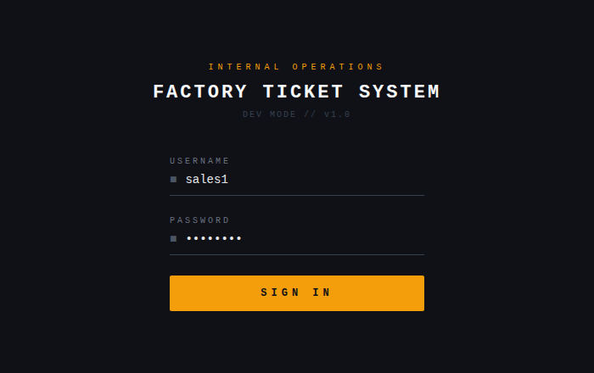

5.4 Ticket Screen — Sales Role

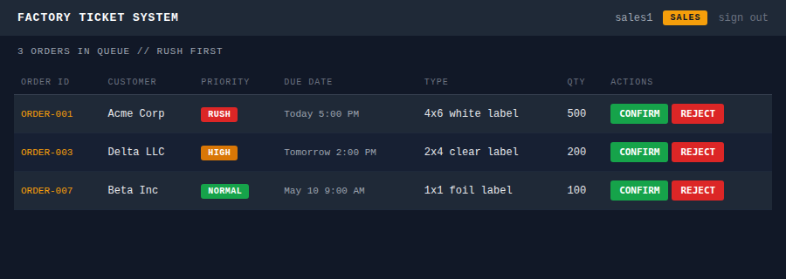

5.5 One Screen, All Roles
The ticket screen is a single Thymeleaf template. Buttons change per role using sec:authorize. All roles see the same table layout — only the Actions column changes.

Role | Action buttons shown
SALES | Confirm (green) · Reject (red)
LINE_WORKER | Start (blue) when pending · End (blue) when in progress
QUALITY | Pass (green) · Fail (red)
PACKER | Confirm Packed (green)
SHIPPING | Confirm Shipped (teal)

6. Project Structure

com.factoryapp/
├── config/
│ ├── SecurityConfig.java @Profile(dev) form login / @Profile(prod) OAuth2
│ ├── AwsConfig.java DynamoDB, SQS, SNS, S3 beans
│ └── BatchConfig.java Spring Batch job definitions
│
├── controller/
│ └── TicketController.java GET /tickets · POST /tickets/{id}/action
│
├── service/
│ ├── OrderService.java Stage transitions, return flow
│ ├── QueueService.java SQS poll (Rush first), send, delete
│ ├── NotificationService.java SNS publish to next worker
│ └── ReportService.java Spring Batch trigger
│
├── repository/
│ ├── OrderRepository.java DynamoDB orders table
│ └── OrderHistoryRepository.java DynamoDB orderHistory table
│
├── model/
│ ├── Order.java
│ ├── OrderHistory.java
│ ├── Priority.java Enum: RUSH(1) / HIGH(2) / NORMAL(3)
│ ├── Stage.java Enum: SALES / LINE_WORKER / QUALITY / PACKER / SHIPPING / DELIVERED
│ └── Action.java Enum: CONFIRMED / REJECTED / STARTED / COMPLETED / PASSED / FAILED / RETURNED_TO_LINE / PACKED / SHIPPED
│
├── poller/
│ └── StageQueuePoller.java @Scheduled — Rush then High then Normal
│
└── batch/
├── QuotaJobConfig.java
├── OrderItemReader.java
├── QuotaItemProcessor.java
└── ReportItemWriter.java Writes report to S3

src/main/resources/
├── templates/
│ ├── tickets.html Role-aware Thymeleaf template
│ └── login.html Dev only
├── application.properties
├── application-dev.properties DynamoDB Local + form login
└── application-prod.properties Real AWS + Cognito

7. AWS Services Summary

Service | Purpose | Dev Alternative
DynamoDB | Orders and history storage | DynamoDB Local via Docker on port 8000
SQS FIFO | 15 priority queues across 5 stages | Same SQS or @Scheduled mock
SNS | Notify next worker on stage advance | Console log
S3 | Shipping labels + batch reports | Local filesystem
EventBridge | Spring Batch trigger + starvation check | @Scheduled
Cognito | User Pool with role groups, hosted UI | Spring Security form login
Elastic Beanstalk | Runs Dockerized Spring Boot app | mvn spring-boot:run
ECR | Docker image registry | Local Docker image
CloudWatch | Logs, metrics, alerts | Console and file logging
CloudFormation | All infrastructure as code | Manual dev setup

8. Recommended Build Order

- DynamoDB tables — orders and orderHistory tables locally, Order and OrderHistory models, repositories, AwsConfig
- Mock order generator — drops orders into SQS at all three priority levels
- Queue poller + Sales screen — first end-to-end slice
- Full stage chain — Line Worker, Quality (pass and fail + return), Packer, Shipping + S3 label
- Role-based UI — Single tickets.html with Thymeleaf sec:authorize buttons
- Dev auth — Spring Security form login with test users for all roles
- Spring Batch reports — Daily quota job reading orderHistory, writing to S3
- Starvation prevention — EventBridge promoting aged Normal orders to High
- Prod auth — Cognito User Pool, groups, prod Spring Security config
- CloudFormation + deploy — All AWS resources, Docker to ECR, Elastic Beanstalk

9. Future Phases

Phase 2 — Admin Dashboard
- All tickets with current stage, history timeline, return count
- Filter by priority, stage, customer, date range
- Spring Batch report viewer from S3
- Add DynamoDB GSI on currentStage + dueDate for server-side queries

Phase 3 — Item-Level Quality Control
- Per-item pass/fail with quantityPassed and quantityFailed fields
- Split order: passed items advance, failed items return as new linked ticket
- parentOrderId links redo ticket to original

Phase 4 — Product and Inventory
- Migrate to separate orderItems table — orderId (PK) + itemId (SK)
- Inventory table for raw material stock levels
- Low stock SNS alerts and order-to-inventory consumption linking

Phase 5 — Defect Tracking
- Defect record linked to order — machine, shift, worker, root cause
- Defect rate trending — CloudWatch alarm when rate spikes

