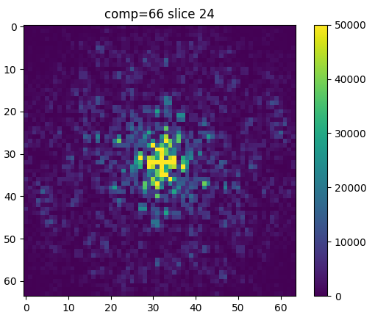
Spiral Cleaning Pipeline

Pre-processing: Minimal preprocessing is perfomed on the scans. The FSL functions called in Step 1 motion correct, brain extract, and register the images using the subjects own 2nd volume. Smoothing, slice time correction and any other desired fMRI prepocessing steps can be performed after recombination.
Step 1: Set up file structure required to run FSL Melodic either manually or using s1_folder_setup.py
1a) s1_folder_setup.py with
Step 2: Run FSL's Melodic ICA (s2_design_file_setup.py will rewrite .fsf design file template to contain all necessary paths, and place inside subject folders)
Step 3: Run s3_1_identify_components.py which reads in the output file melodic_IC.nii, from the melodic output directory. The output of this pipeline includes a csv detailing the components to be removed, and a detailed scoring assessment.
Step 4: Review the csv output, and edit the final line of components to be removed, if desired. Remeber to include the leading and ending braces (e.g [1,3,6,8]).
Step 5: Run s4_1_remove_flagged_components.py to regress out the unwanted components using fsl_regfilt.
Algorithm:
The sorting algorithm is called by s3_1_identify_components.py, and can be found on github as “check_slices.py”

In order to classify a Melodic component as noise, the following calculations are performed:

1. A 2D-fft is perfomed on each slice of each ICA component. This produces a matrix where the low freqency spatial loading are repesented by values at the centre of the matrix, and high frequency spatial loadings are represented by values at the edge of the matrix.
2. Two circular masks are defined to capture the average value of low and mid range spatial frequency intensity.
- The low frequency mask, shown below in red, encompasses a circle 1/8th the radius of the full spatial frequency map
- The mid frequency map, shown below in orange, encompasses a donut ranging between 1/8th and 1/2 the radius of the full spatial frequency map.
- Slices which are heavily loaded in the low frequency range contain real brain signal. Slices which contain much more mid frequency loading indicate the presence of spiral noise.

3. The noise/signal criteria is calculated as followed:
a) Calculate mean signal content of values within low and mid frequency masks for each slice
b) Calculate the ratio between the low and mid frequency masks (low/mid = ratio) for each slice
c) Calculate the first and third quartile for each set of low, mid and ratio data on a per subject basis
d) Calculate a threshold value for each of the low frequency, mid frequency, and ratios:
i) Thresholds are calculated as follows: (Quartile 3 – Quartile 1)*1.5 + Quartile 3
e) compare each slice’s ratio, low and mid frequency loadings, to the respective threshold
f) The thresholds for the first and last 15% of slices (refered to as “outside slices”) are calculated independantly, but by the same method just detailed.

4. Slices are given a score if one or more of the three slice parameters exceeds its respective threshold, calculated in 3d). There are slightly different scores assigned to center slices, than there are to outside slices. In order to be flagged as noise, the slice must acheive a total score greater than or equal to 4. The table below details the scoring system:

Threshold(s) Exceeded | Score: Center/ Outside | Justification/Notes
Mid | +1/+1 | Exceeding the mid frequency threshold only could be a sign of noise, but its overall frequency content is likely small because it did not also exceed the low frequency content threshold.
Mid + Low | +6/+6 | This condition almost certainly indicates presence of the artifact. Exceeding the mid frequency threshold denotes presence of nonuniform loadings (i.e. the characteristic “stripes”), while the low frequency loading indicates general presence of more information on that slice. This case can only be executed once per slice.
Mid + Low + Ratio | -6/-4 | This condition is almost never predictive of the spiral artifact. Crossing the ratio threshold, in addition to the other two indicates that there is a lot of loading generally, but also that the quantity low frequency loading well exceeds the quantity of mid frequency information.
Low | -1/-1 | There is a relatively large amount of frequency information contained on this slice, however, it is not know whether this information is signal or noise. The score is reduced just in case.
Low + Ratio | -1/-1 | There is a relatively large amount of frequency information contained on this slice, and it is likely to be signal information
Ratio | -1/-1 | There is much more low frequency loading than mid frequency loading. This is likely to be signal information.
5. The output csv file contains a row for each slice which includes the mean frequency loading, low frequency loading, ratio, and the points associated with that slice (if any). At the top of each csv are the threshold values for each measure (low, mid, ratio), for both the centre and outside slices. The last line of each csv lists the components to be removed. This list is used by fsl_regfilt to regress out the noise components; adjust it as you see fit. It is important to keep the square brackets as is!
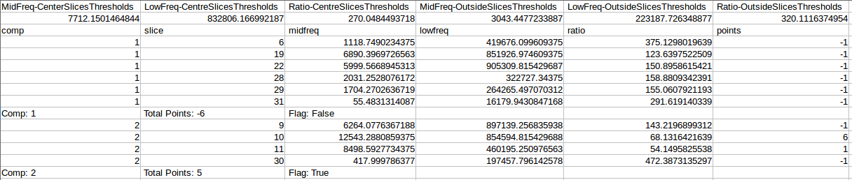
The figures below highlight the important features of the csv:
1

2
3
1. The thresholds calculated in 3d)i for each of the low and mid frequency loadings, as well as the ratio. As described in 3f), the “outside” slice thresholds are calculated independantly.

2. A standard slice output. From left to right, this row lists the component number, the slice number, the mean mid frequency loading, the low frequency loading, the ratio between these values, and the points associated with the slice, if applicable.

3. This component summary row includes a points total and decicion flag. If the flag is “true”, then the component will be removed; if the flag is “false”, then the component will be kept.

Sample ICA components and FFT Matricies:
The following examples highlight some of the common classification cases. For each, the thresholded IC map, the FFT matrix visualization, and the csv output are provided.

Example #1: Spiral Artifact – One Slice

Slices on the thresholded IC map are refered to by number, starting at 1. In the following image there are 31 slices total, with the artifact appearing on slice 20. On the thresholded IC map, the artifact appears as alternating, striated lines.
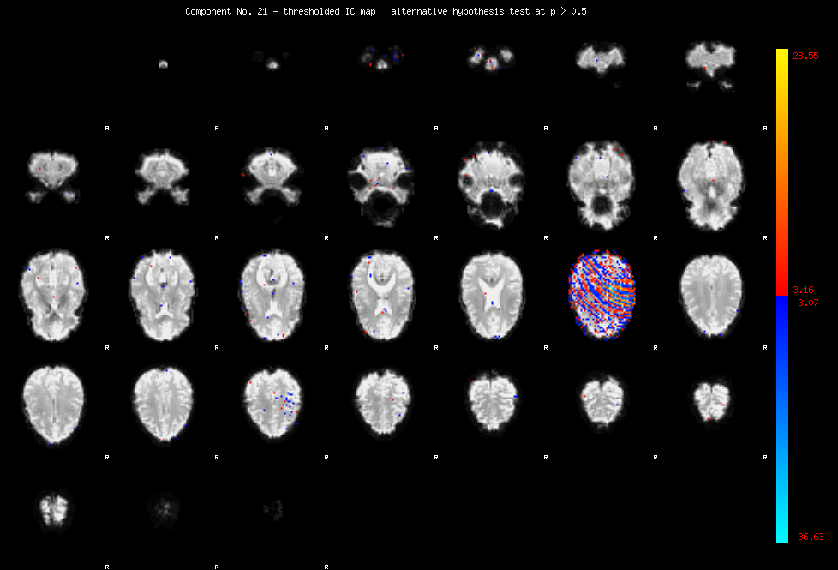
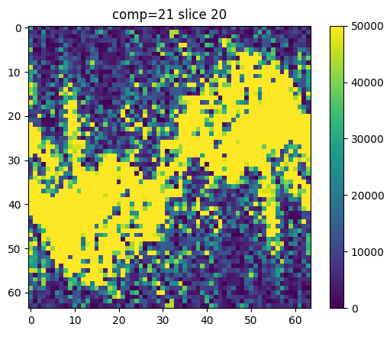

The FFT of an artifact containing slice may look similar to the image below:

Note: Yellow indicates only that the value at that location of the 64x64 FFT matrix exceeds 50000. However, the total value of the low frequency information (in the centre) will always be higher than the values closer to the edges.

The check_slices.py algorithm output the following data in the .csv for this example component:
Although there is potential signal in slices 16 and 29, the value of this signal (as determined by the scoring table in 4) does not outscore the obvious noise in slice 21.
Example # 2: Signal Only

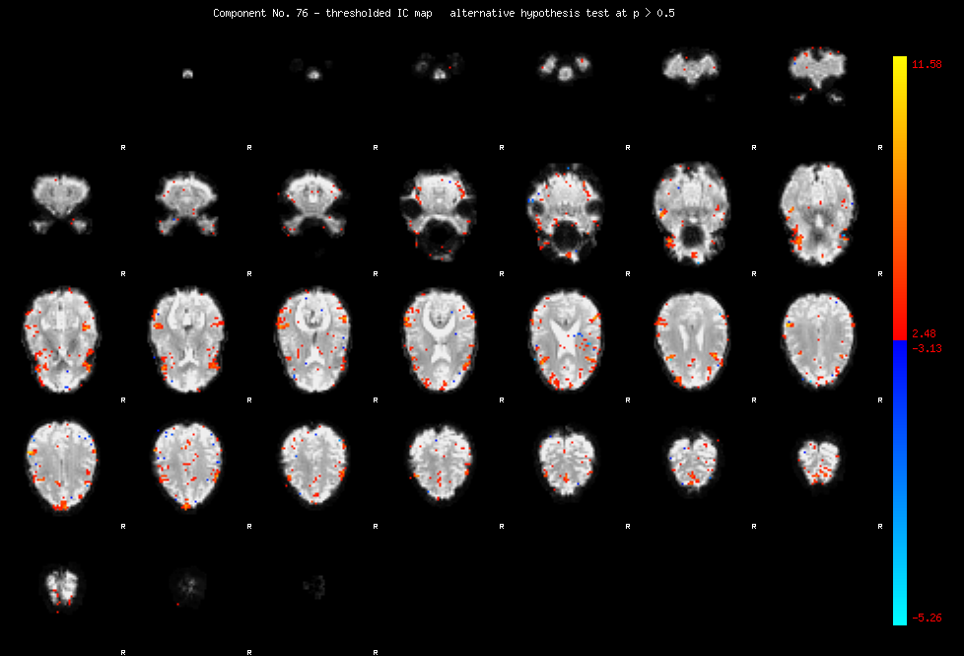

The FFT of a slice containing only brain signal may look like the one below. These slices contain mostly low frequency information which is clustered near the centre of the FFT matrix.
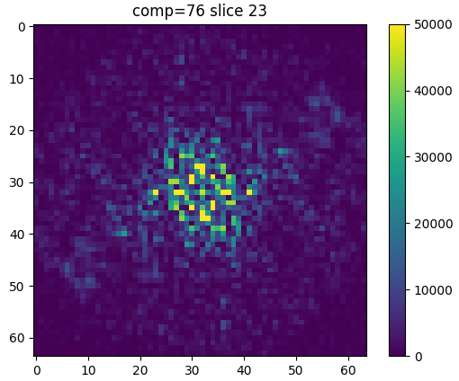

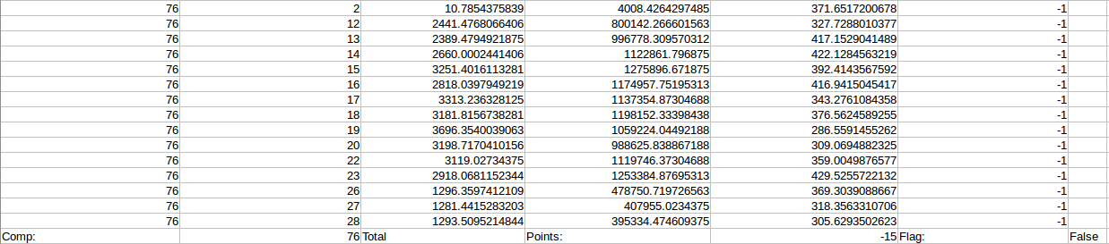
The .csv output flags most slices in the component as containing signal. Additionally, no artifact is detected (all point values are negative).
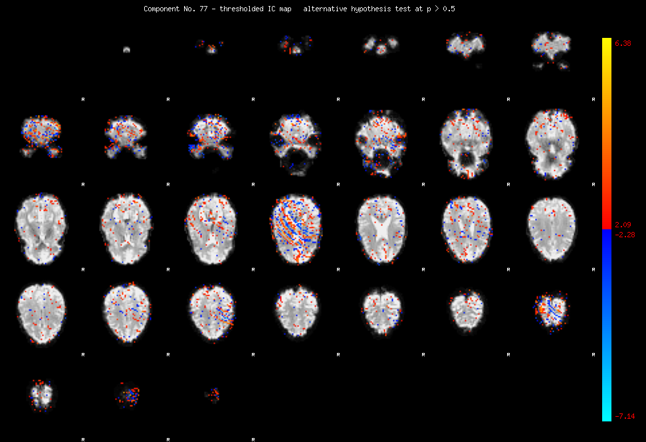
Example #3: Artifact -Multiple Slices

