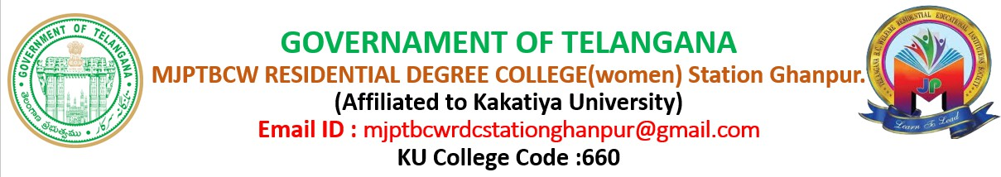

Department of English

About the Department:
A Computer Science degree offers a wide range of career paths and opportunities for students. It focuses on the study of computers and computing, encompassing theoretical and practical aspects of software and hardware. Students learn programming languages, algorithms, data analysis, and the principles behind software development, which are essential for solving technological problems in various industries

Vision:
A vision for a degree college should articulate its aspirations for student development, academic excellence, and societal contribution. It should aim to create a vibrant learning environment that fosters critical thinking, innovation, and ethical values, while also preparing students for future challenges and opportunities

Mission:
Educate and mentor students in the field of computer science, fostering their understanding of fundamental concepts and practical skills. This includes imparting knowledge through effective teaching methods, nurturing ethical values, and encouraging creativity and innovation. Ultimately, the goal is to prepare students to become competent professionals, researchers, or entrepreneurs in the ever-evolving field of computer science, capable of contributing to society and addressing its challenges.

Academic Programs:
M.A in English ; B.Ed B.A[ Hons]

Faculty
K. TEJA M.A , B Ed.

Educational Qualifications:
Completed M.A in 2019, Maulana Azad National Urdu University

Completed B Ed in 2021 to2023, Vikas College Affilieted MGU Rayunigudam, Suryapet Nalgondal.
Completed B.A[Hons] in 2013 to 2016 at English and foreign Language university .

Teaching Experience:

  - I have total 4.5 Years of Teaching Experience.

  - Worked as Degree Lecturer In English & at Social Welfare Degree college Suryapet from 2021 to 2025.

  - Currently working as a Degree Lecturer in English at MJPTBCWRDC, Station Ghanpur located at Pembarti, Jangaon.

Contact Details:
E Mail:- kattateja98@gmail.com Mobile: +9177616822

MJPTBCWRDC STATION GHANPUR
LOCATED AT PEMBERTHI

(AFFILIATED TO KAKATIYA UNIVERSITY)

DEPARTMENT OF

ENGLISH

Name of the department :ENGLISH

Year of Establishment:2022

FACULITY PROFILE
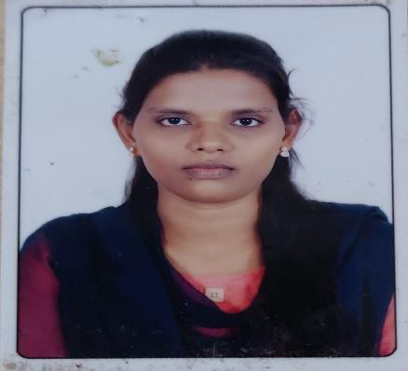

NAME | QULIFICATION | DESIGNATION
M.NIROSHA | M.A.ENGLISH,B.ED, TS TET, M.A.TELUGU..  (LLB) | FACULTY OF ENGLISH  niroshamadugula@gmail.com

Course offered:
- B.A(H.E.P) ,MPCS,MECS ,MSCS, B,COM (BA),(CA)

Pattern of teaching learning and evaluation:

Semester | Credit system
I,II,III,IV,V,VI | Choice based credit system  (CBCS).

About the Department of English
The Department of English is a vibrant academic unit dedicated to the study and exploration of English language, literature, and related fields. It plays a crucial role in fostering critical thinking, creativity, and communication skills among students. The department typically offers undergraduate, postgraduate, and sometimes doctoral programs, with a curriculum designed to balance traditional literary studies with contemporary and interdisciplinary approaches.

Key Areas of Study
  - English Literature: Covering major literary periods, movements, and authors from British, American, and world literatures.
  - Language and Linguistics: Studying the structure, history, and usage of the English language.
  - Cultural and Media Studies: Exploring how literature and language interact with culture, identity, film, media, and society.
  - Creative Writing: Encouraging original writing in poetry, fiction, drama, and nonfiction.
  - Postcolonial and Gender Studies: Examining literature from formerly colonized nations and analyzing texts through gender and feminist perspectives.

Mission and Vision
  - Mission: To cultivate an understanding and appreciation of the English language and its literatures, fostering analytical, interpretive, and expressive skills that prepare students for a range of careers and lifelong learning.
  - Vision: To be a center of excellence in literary and language studies, promoting intellectual growth, cultural awareness, and ethical engagement.

What the Department Offers
  - Courses and Degrees: BA, MA, MPhil, and PhD in English (varies by institution).
  - Research Opportunities: Faculty and student-led research in literature, linguistics, and theory.
  - Extracurricular Activities: Literary clubs, drama societies, poetry readings, debates, and writing workshops.
  - Career Pathways: Education, journalism, publishing, content writing, civil services, translation, and more.

Why Study English?
Studying English equips students with:

  - Strong communication and writing skills
  - Critical and analytical thinking
  - A deep understanding of culture, history, and society
  - Versatility in career choices

Objectives of the Department of English

To Develop Language Proficiency
Enhance students’ command over the English language in reading, writing, speaking, and
listening, enabling effective communication in academic, professional, and social contexts.

To Foster Critical and Analytical Thinking
Cultivate the ability to think critically and analytically through the study of literature, language, and theory, encouraging deeper understanding and interpretation of texts.

To Promote Literary Appreciation
Encourage an appreciation of English literature across genres, periods, and cultures, fostering a love for reading and a nuanced understanding of human experiences.

To Encourage Interdisciplinary and Cultural Awareness
Broaden students’ horizons by exploring connections between literature, culture, history, gender, politics, and media in both local and global contexts.

To Support Creative and Academic Writing
Develop students' creative, academic, and professional writing abilities through practice-based learning in essay writing, poetry, storytelling, and technical writing.

To Nurture Research and Scholarly Inquiry
Inspire students to undertake literary and linguistic research with academic integrity, and contribute original ideas to the field of English studies.

To Prepare for Diverse Careers
Equip students with transferable skills such as communication, analysis, creativity, and empathy, preparing them for careers in education, media, writing, public service, and beyond.

To Instill Ethical and Humanistic Values
Use literature and language as tools to promote empathy, ethical reflection, and a deep understanding of cultural and social issues.

English Syllabus (Semesters I–VI)

Semester |  | Unit Themes & Topics
Sem I | An Astrologer’s Day (R.K. Narayan), Of Studies (Francis Bacon),  A Poison Tree (W. Blake), The Rising of the Moon (Lady Gregory)  , grammar, phonetics, soft skills.
Sem II | With the Photographer, A Treatise on Good Manners, Ode on Solitude, A Marriage Proposal,  grammar, vocabulary, pronunciation, presentations.
Sem III | Themes: Gender Equality, Gender Roles, Ending Violence Against Women  Prose & Poetry Samples: - “Achieving Gender Equality in India…” (Smriti Sharma)  - “They Shut me up in Prose” (Emily Dickinson)  - “The Wonder Story of Kalpana Saroj” (Rakhi Chakraborthy)  - “The Kitchen” (Vimala)  - “What is my Name?” (P. Sathyavathi)  - “Voice of the Unwanted Girl” (Sujatha Bhatt)  Language Skills: Prepositions, Phrasal Verbs, Voice, Technical Vocabulary, Connectives, Idioms
Sem IV | Themes: Environment, Pollution, Conservation, Biodiversity  Texts: - “Jadav Payeng”  - “The Tame Bird was in a Cage” (Tagore)  - “Climate Change and Global Warming” (Michael Shafer)  - “A Requiem for Earth” (O.N.V. Kurup)  - “The Ungrateful Man: A Conversation between Trees” (Swathi Shenoy)  - “The Felling of the Banyan Tree” (Dilip Chitre)  Language Skills: Reported Speech, Commonly Confused Words, Conditionals, Suffixes, Common Errors, Collocations
Sem V | Theme: Communication Skills and Human Values (English through Human Values & Ethics)  Focus Areas: Paragraph Writing, Note-making, Public Speaking  Texts: - “Tolerance is a moral virtue” (Rivka T. Witenberg)  - “How happy is the little stone” (Emily Dickinson)  - “When cities were Nature’s haven” (Harini Nagendra)  - “Where the mind is without fear” (Tagore)  - “Why we love holiday rituals and traditions” (Dimitris Xygalatas)  - “Sonnets are full of love” (Christina Rossetti)

Sem VI Prose: Sreelakshmi Suresh
Poetry: For Whom the Bell Tolls – John Donne
Language Focus: Official Letters

Prose: How Work Can Be Made Meaningful – Katie Bailey
Poetry: Teamwork – Edgar Albert Guest
Language Focus: Job Application Letters, CVs
Prose: How the Coronavirus Sparked a Wave of Innovation – Sreevas Sahasranamam

Poetry: See It Through – Edgar Albert Guest
Language Focus: Email Etiquette

Department of English – Programme Overview
The Department of English offers a dynamic and comprehensive academic programme that explores the richness of the English language, literature, and its global impact. The programme is designed to develop critical thinking, linguistic proficiency, literary appreciation, and creative expression among students, preparing them for diverse academic and professional careers.

Programmes Offered

Undergraduate Programme (B.A. in English Language and Literature)
Introduces students to classical and contemporary literature, literary theory, linguistics, and communication skills, providing a strong foundation in reading, writing, and analysis.
- Postgraduate Programme (M.A. in English Literature/Language and Literature) Offers in-depth study of literary periods, genres, critical theories, cultural studies, and advanced language studies, while encouraging scholarly research and academic writing.
- Doctoral Programme (Ph.D. in English) (if applicable)
Focused on advanced research in literature, language, theory, and interdisciplinary studies, enabling original contributions to the field of English studies.

Objectives of the Programme
- To enhance proficiency in the English language across academic and professional contexts.
- To develop critical and analytical thinking through literary and linguistic studies.
- To promote a deep understanding of literary traditions, cultural contexts, and contemporary issues.
- To foster creativity, research skills, and ethical scholarship.
- To prepare students for careers in teaching, research, media, publishing, writing, and civil services.

Curriculum Highlights

Core Areas of Study:
    - British, American, Indian, and World Literatures
    - Literary Criticism and Theory
    - Linguistics and Phonetics
    - Academic and Creative Writing
    - Postcolonial, Gender, and Cultural Studies

Electives (varies by institution):
    - Film and Media Studies
    - Translation Studies
    - English for Professional Communication
    - Environmental and Dalit Literature

Learning Outcomes
Upon completion of the programme, students will be able to:

  - Critically interpret and analyze literary texts.
  - Communicate ideas clearly and effectively in both spoken and written English.
  - Conduct independent research using literary and theoretical frameworks.
  - Understand the relationship between literature, society, and culture.
  - Apply linguistic skills in real-world contexts, including teaching, editing, and content creation.

Career Opportunities
Graduates of the English programme can pursue careers in:

  - Education and Academia
  - Journalism and Mass Communication
  - Content Writing and Editing
  - Publishing and Translation
  - Civil Services and Public Administration
  - Creative Writing and Media Production

Department Activities :
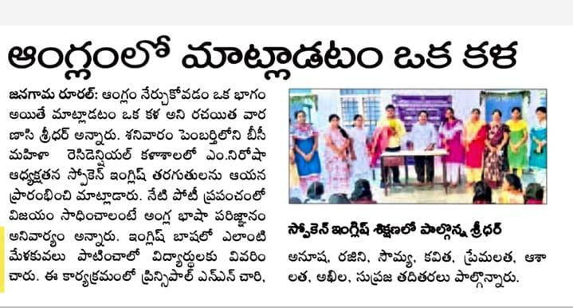

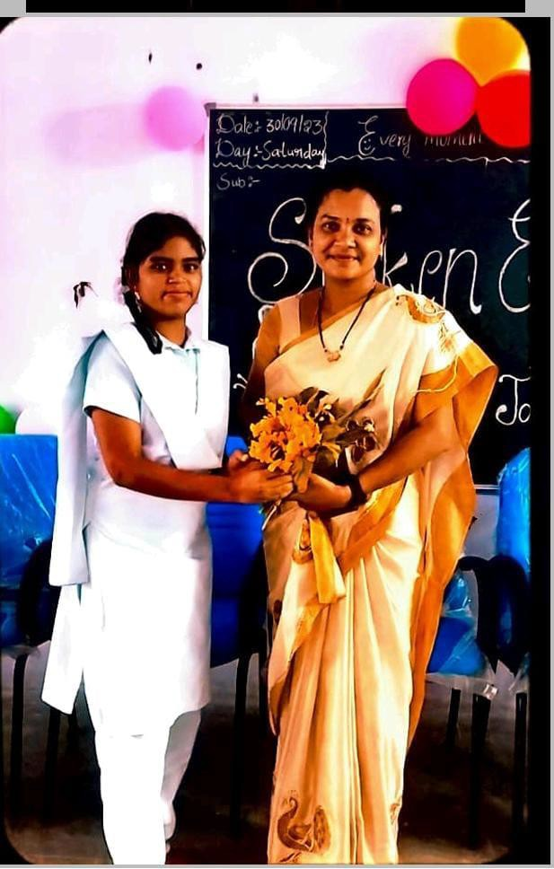

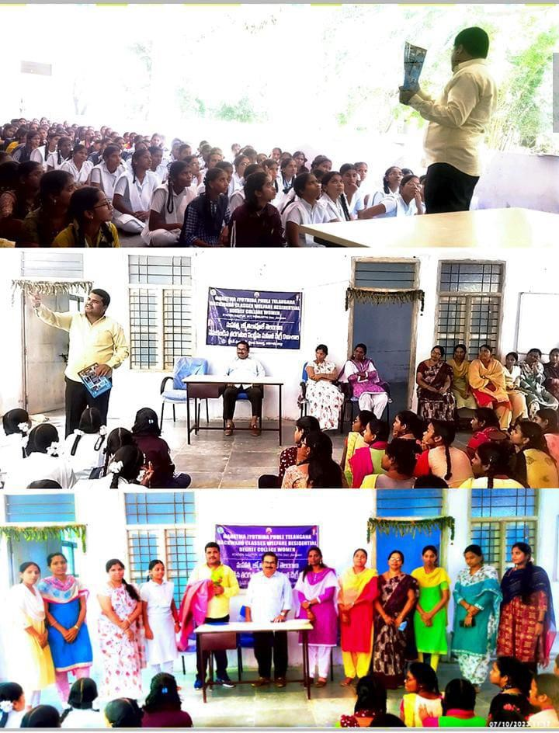

eon e.,a� pt>raJo 4t1�o1&>�e>
z�� l1JltSv, �tS�t»S: ��el �� @�iSod
cn�®o ;ool;)o�e,�. . ��K� �t).) 'd'o:,o� e:90Q 4'°� �!)�o el�J��6� ��� e:9��ot; ���5, e:90Q 6iScmel 0:,06�:V �00 e:9��- �8.)�6'6�
��� £2'6sl,oo� �� de:>o�� I:)� o:Va�dS:>6
��1,70 �flTJ-l"e:>6'6 e:90Q tf OSJOOaJ �ef'� �os6so6'6
:!�0:,060 ��cv00 �6s�o��- ���o �$. �e e:90S
tel;5 �ef\;5 -::;�-;!;:aod �oo �$)S e:9l,fb� ���
�l?��- �oao ;j�Js,o� ��iSod� � �:aoo6
�� �t?�oSiSi)�, �oS�oiSoSiSJ�' cnois, �dsKo i3® oSiSi)� cn��e,SJ �Do��- So6S��d' �� dS.))aJ, �8.)a)Ot!> e:9�� 6��, ��, �end, ��e:>el,
�-i"e:>el, S!)el, e:9&)e,, ��� ����-

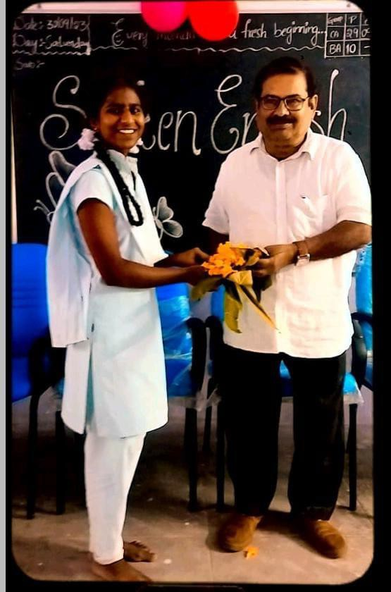

QUIZ ON ENGLISH :

One-Word Substitution Quiz
- A person who studies the universe —
Answer: Astronomer
- A person who knows everything —
Answer: Omniscient
- A speech made without preparation —
Answer: Extempore
- A person who never wastes money —
Answer: Miser
- One who eats only plants —

Answer: Vegetarian
- A government run by a king or queen —
Answer: Monarchy
- A life story written by oneself —
Answer: Autobiography
- A person who does not believe in God —
Answer: Atheist
- A handwriting that can’t be read —
Answer: Illegible
- A person who looks on the bright side of things —
Answer: Optimist …..etc…..

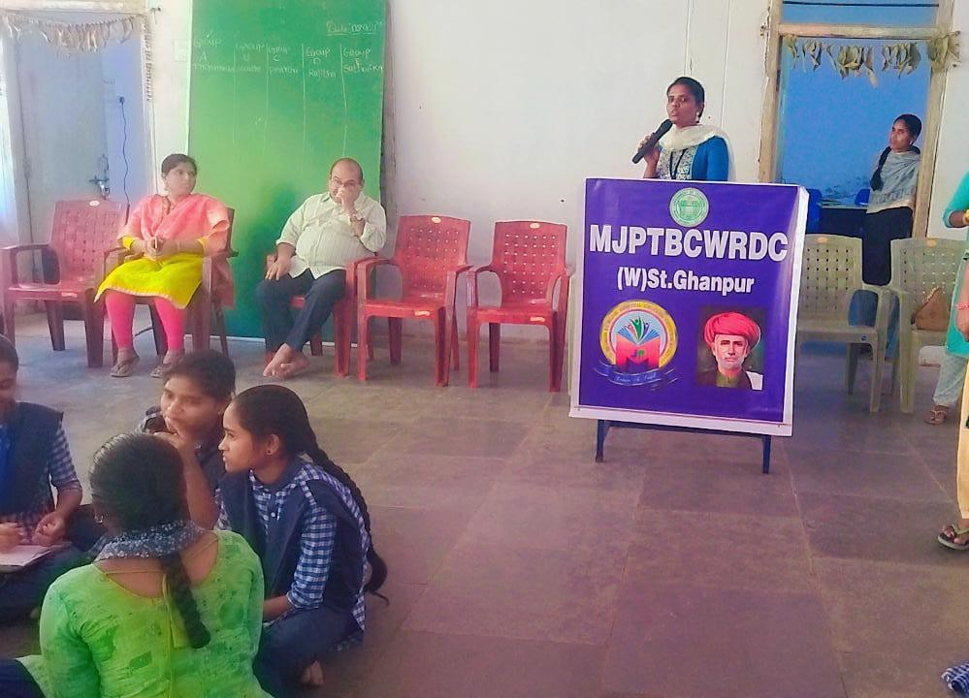

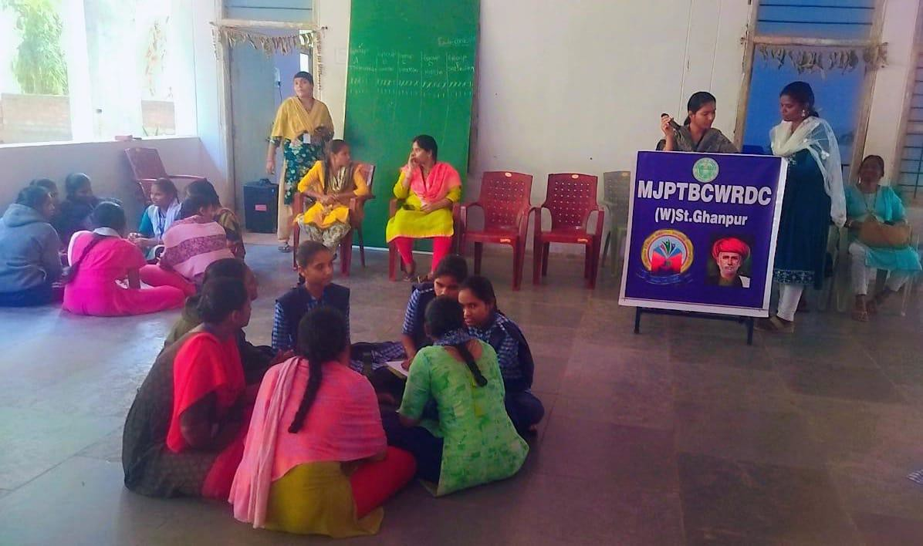

✅ Key Features of Spoken English

Pronunciation & Accent
  - Clarity in how words are pronounced.
  - Accents can vary (e.g., American, British, Indian, Australian).

Intonation & Stress
  - How the pitch of your voice rises and falls.
  - Emphasis on certain syllables or words to convey meaning or emotion.

Fluency
  - Speaking smoothly and without too many pauses or fillers ("uh", "um", "you know").

Grammar (Relaxed)
  - Spoken grammar is often less formal:
    - "I'm gonna go" instead of "I am going to go."
    - "Did you eat?" might sound like "Didja eat?"

Vocabulary (Conversational)
  - More idioms, phrasal verbs, and informal words:
    - "Hang out", "Catch up", "Chill", etc.

Listening & Responding
  - Good spoken English involves understanding others and replying naturally.

🧩 Common Challenges
- Hesitation or nervousness
- Limited vocabulary
- Unclear pronunciation
- Translating from native language instead of thinking in English

🛠️ How to Improve Spoken English

Practice Regularly
  - Speak with friends, tutors, or even to yourself.
  - Use apps like HelloTalk, Tandem, or Cambly.

Listen Actively
  - Watch English movies, shows, YouTube channels, or podcasts.
  - Mimic native speakers (shadowing technique).

Expand Vocabulary
  - Learn and use new words daily.
  - Focus on phrases used in daily conversations.

Record Yourself
  - Play it back to check pronunciation and fluency.

Join Speaking Clubs
  - English speaking clubs, online or in person, can offer real-life practice.

ALL INDIA RADIO PARTICIPATION :

- Wide Reach – Covers almost the entire nation, even remote villages.

- Multilingual Service – Broadcasts in 20+ languages and 100+ dialects.

- Education & Awareness – Spreads knowledge on health, farming, culture, and current affairs.

- Entertainment – Music, drama, sports commentary, and cultural programs.

- Emergency Communication – Quick and reliable medium during disasters and national crises.

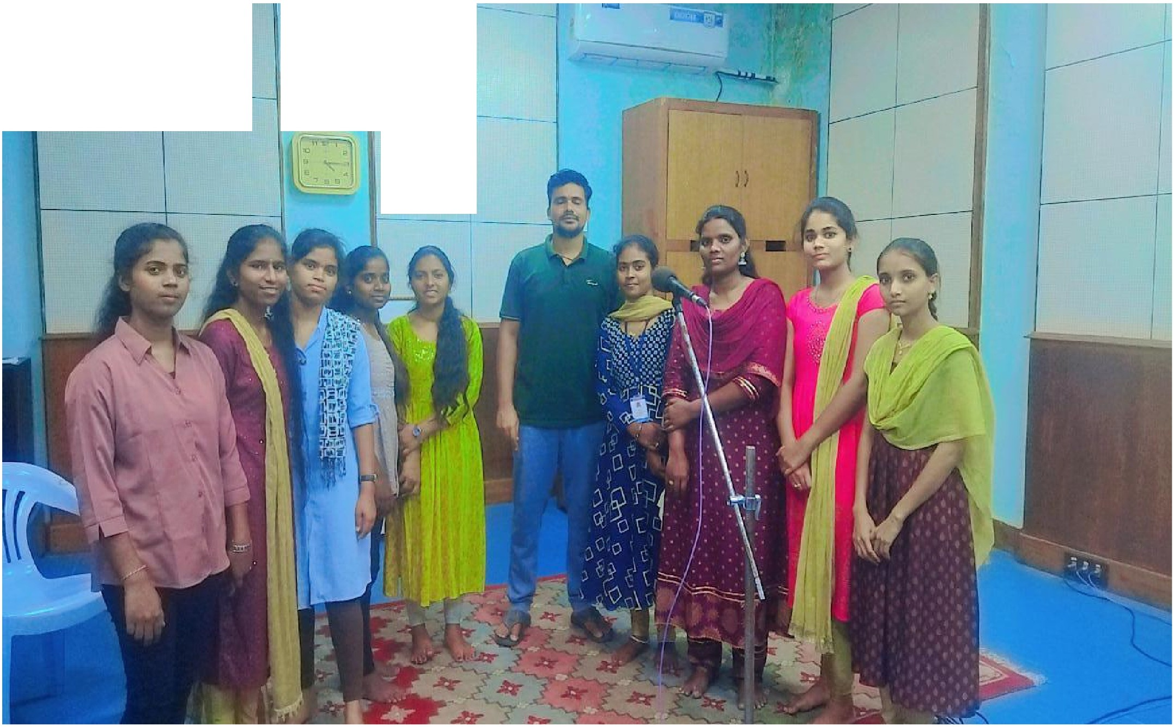
I
J
I

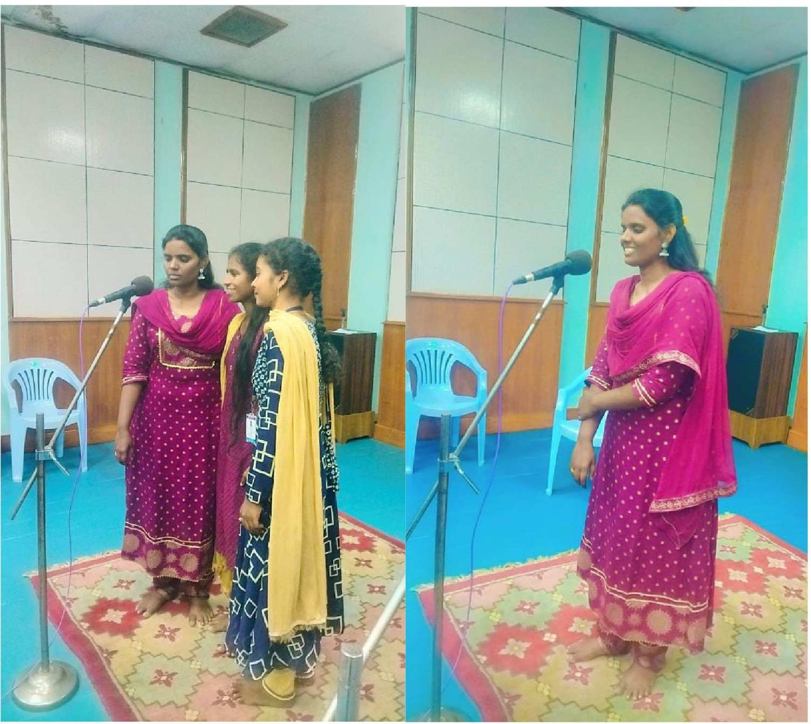

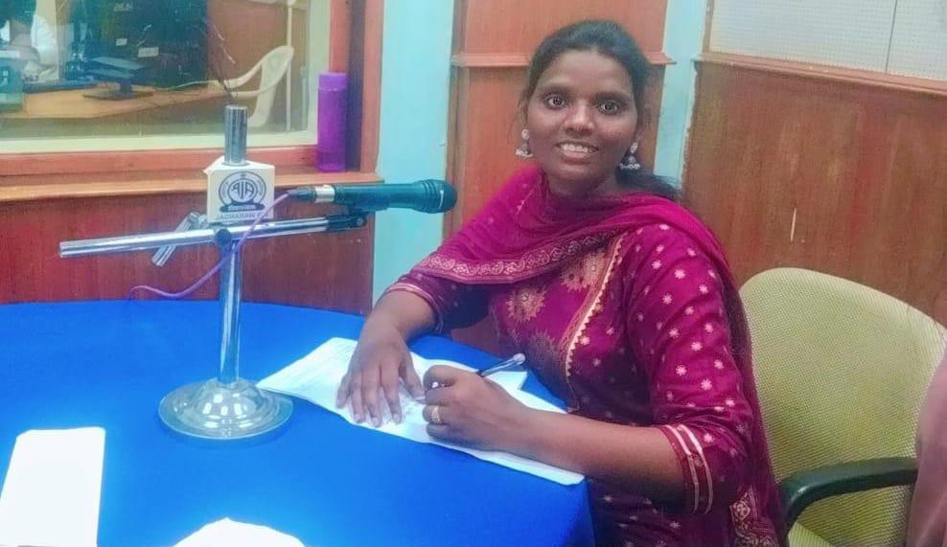
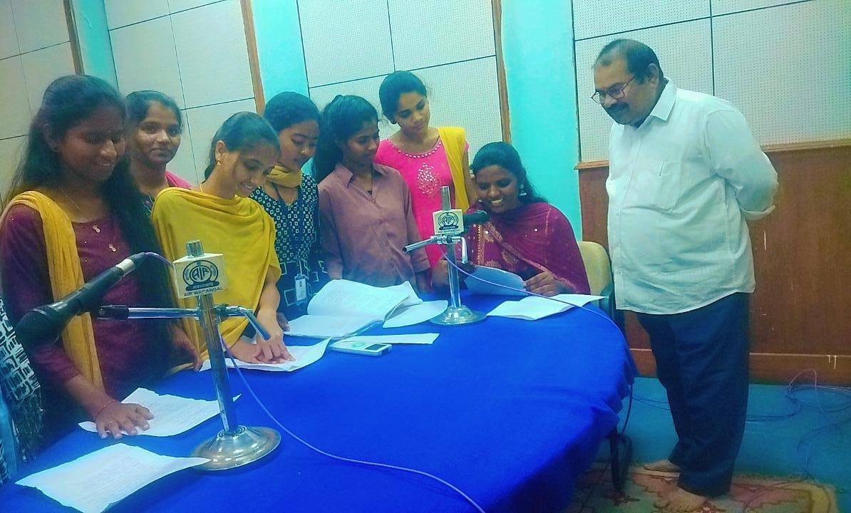

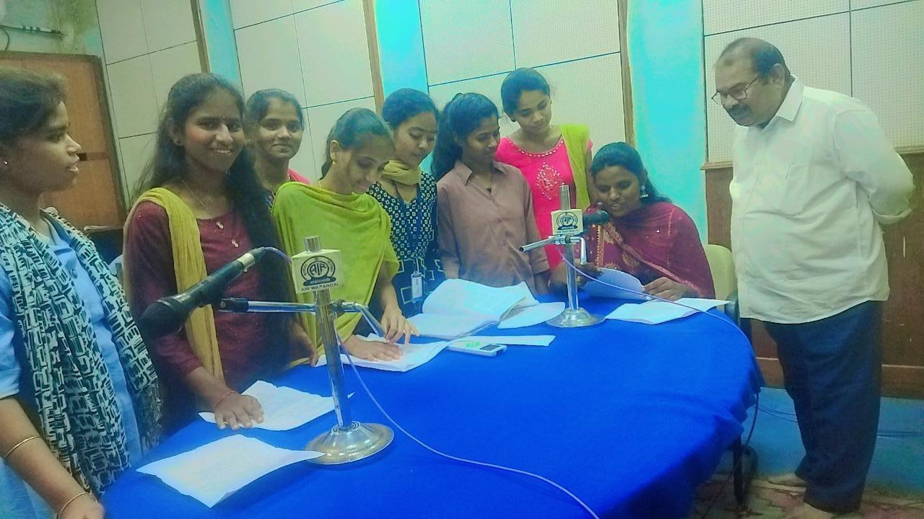

SKIT PARTICIPATION :
National Voters’ Day (NVD) is celebrated every year on 25th January to mark the foundation day of the Election Commission of India (1950). Started in 2011, it aims to encourage voter awareness and participation, especially among young and first-time voters. On this day, new electors receive their Voter ID cards, and awareness campaigns are held under yearly themes promoting inclusive, accessible, and participative elections. Our students won 10,000 rupees cash price on the hands of jangoan dist collector .

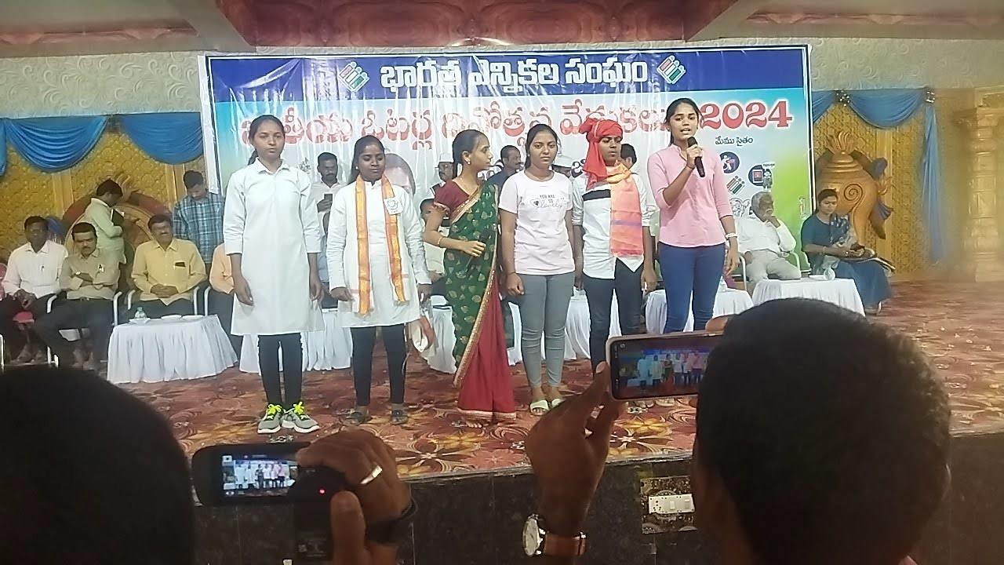

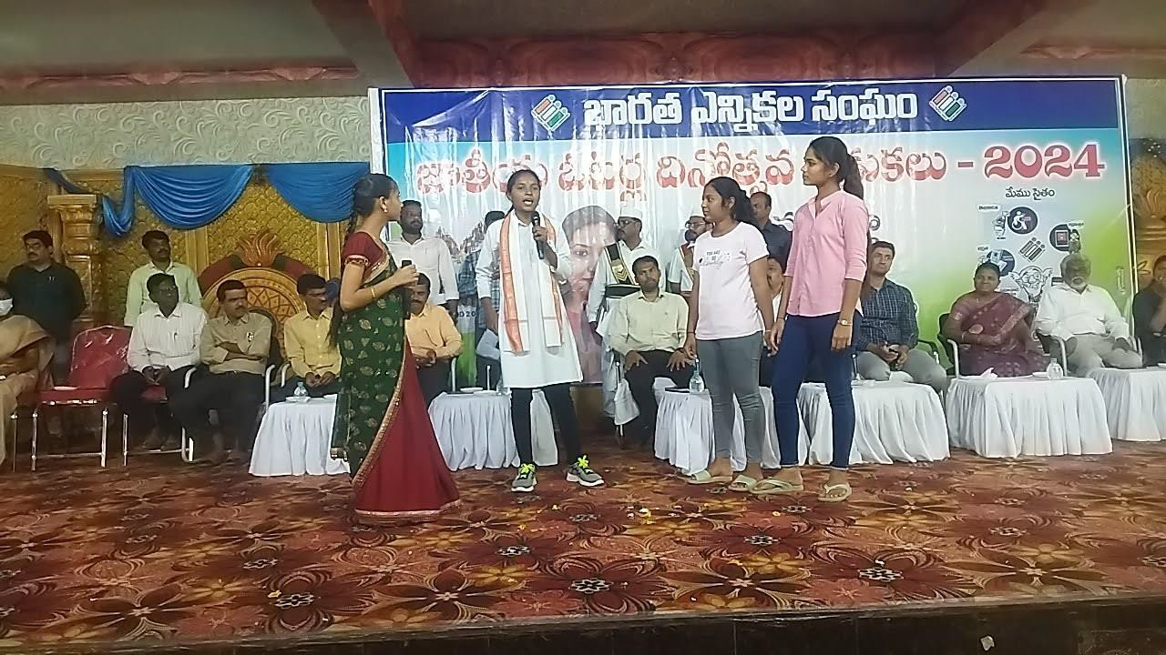

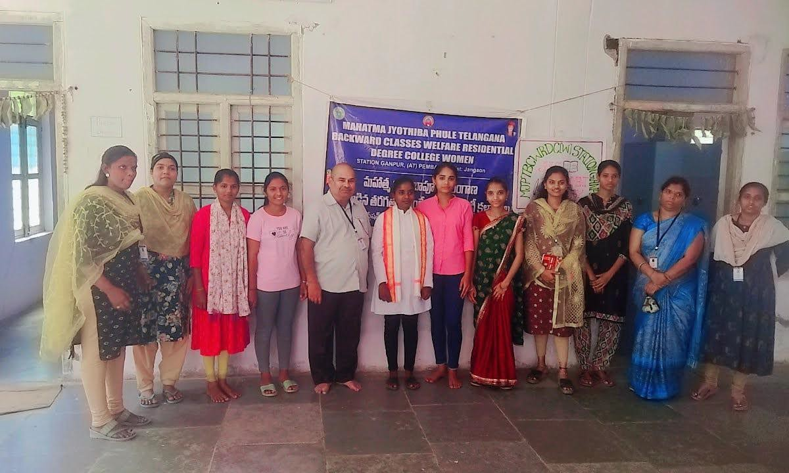

SKILL DEVELOPMENT PROGRAMME :

12-Day Skill Development Programme
Program Title: CWW Training Program (AI & Life and Employability Skills) Organized For: Students (Non-CS & CS Participants)
Duration: 11th August 2025 – 25th August 2025 Timings: 2:30 PM – 5:30 PM (Daily)
Total Duration: 12 Days
Program Structure
The training program was designed to cover two main areas:
- Artificial Intelligence (First 6 Days)
- Soft Skills, Life Skills & Employability Skills (Next 6 Days)
AI Module (Day 1 – Day 6)
  - Day 1: Fundamentals of AI, Key Concepts of AI
  - Day 2: Generative AI, ChatGPT Deep Dive
  - Day 3: Prompt Engineering & ChatGPT Practice
  - Day 4: AI with Excel
  - Day 5: AI with Presentation
  - Day 6: Personal Readiness, Professional Readiness, Future Readiness

Students explored AI fundamentals, generative AI applications, and hands-on exercises using ChatGPT and Excel for productivity.

Soft Skills & Employability Module (Day 7 – Day 12)
  - Day 7: Communication Skills
  - Day 8: Problem Solving & Critical Thinking
  - Day 9: Time Management
  - Day 10: Networking
  - Day 11: Interview Preparation
  - Day 12: Self – Awareness & Confidence Building
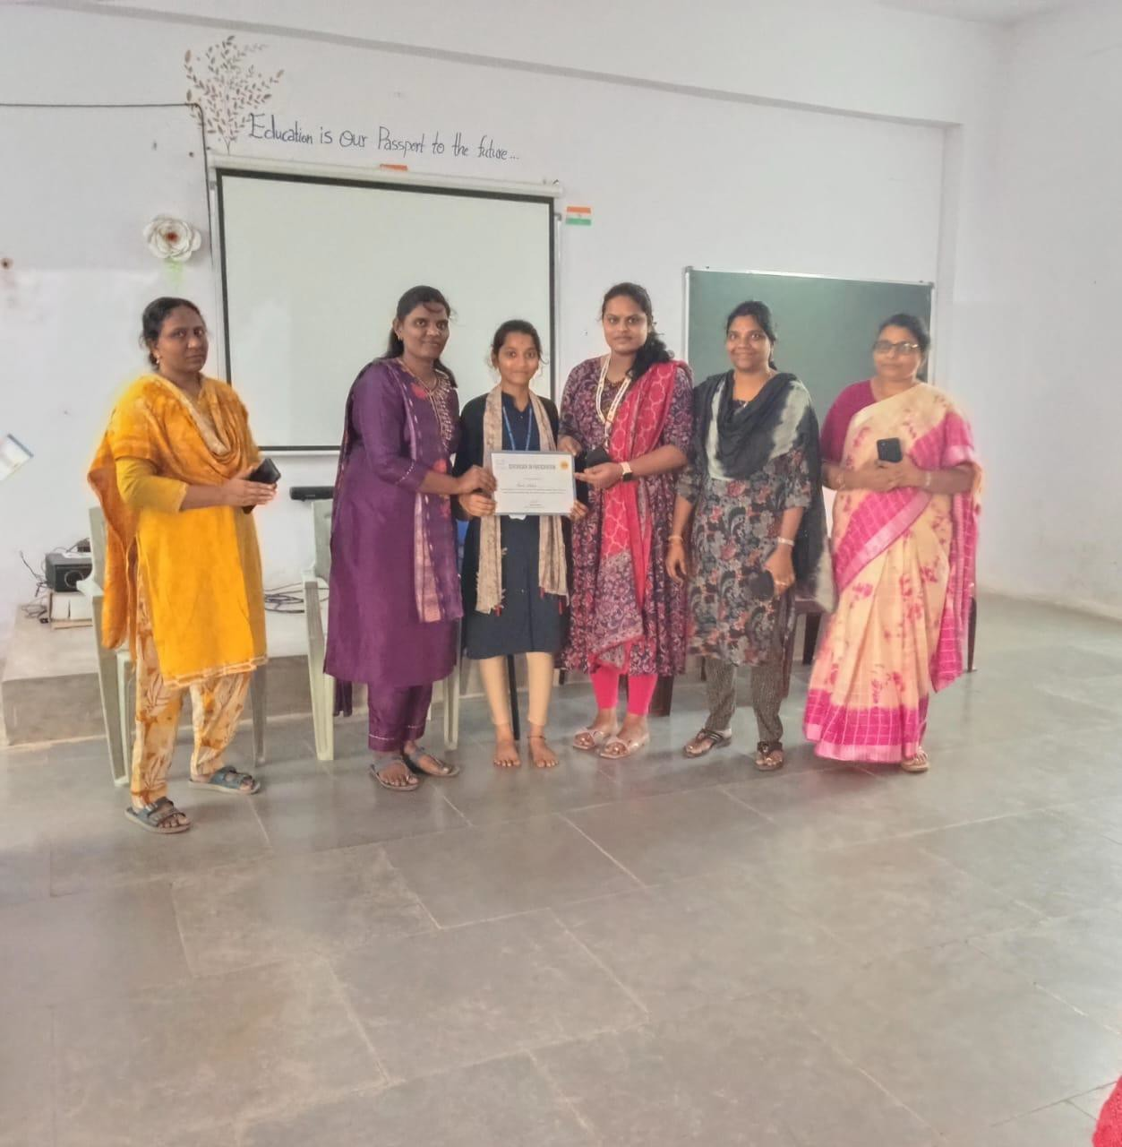

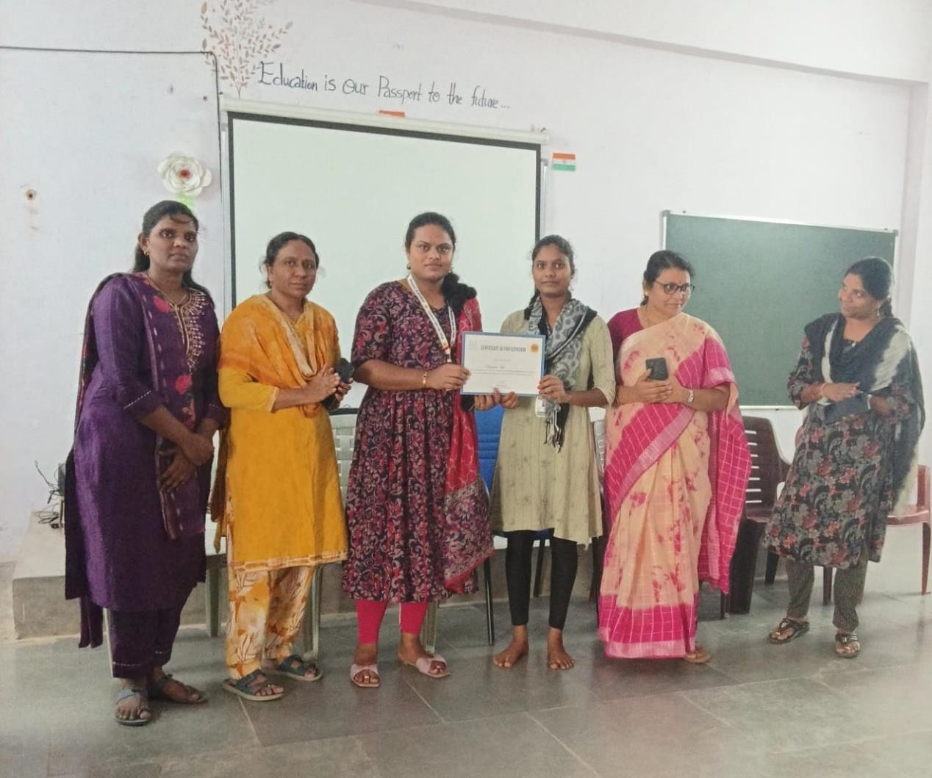

Principal sign: ATP sign:

