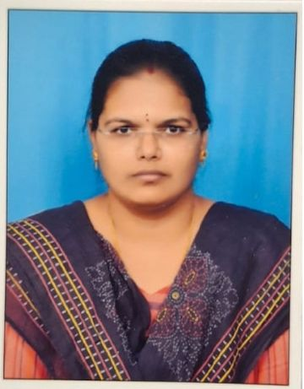
FACULTY PROFILE
1.Name of the faculty: H.B. INDU
2.Designation: Degree Lecturer in Mathematics
3.Department: Mathematics
4.Educational qualifications: 1. M.Sc (Maths with computer science)
From Koti Women’s college, OU in
2015.
2. TS -SET, Ou in 2018.
3. B.Ed. from Shahnaz college of
Education, OU in 2020.
4. M.lisc from B.R. Ambedkar open
University in 2024.
5.Specialization: 1. Pure Mathematics
- Alegbra
- Real Analysis
2. Applied Mathematics
      - Differential Equations
      - Partial Differential Equations
      - Operation Research
3. Statistics and Computational Mathematics
- Probability and Statistics
- Numerical Analysis
6.Teaching experience: 1) Worked as Degree lecturer in Mathematics in
Ellenki degree college, Sangareddy
from 2017 to 2022.
2) Worked as Junior lecturer in Mathematics in
Sri Teja junior college, Sangareddy
from 2022 to 2024.
3) Working as Degree lecturer in Mathematics in
MJPTBCWRDC(WOMEN), Station Ghanpur
located at pembarthi from 2024 to till now.
7.Subjects taught: 1. Differential Equations
2. Real Analysis
3. Differential and vector calculus
4. Algebra
5. linear Algebra
6. Analytical Solid Geometry
7. Numerical Analysis
8. Integral calculus
8.Conferences: Attended one day training program on Real Analysis
(Departmental Conference) organized by Department of
Mathematics, Kakatiya University, Warangal.

9. Academic Responsibilities: Incharge of Examination Branch(2026)
10. Email ID : hotkerindu007@gmail.com

