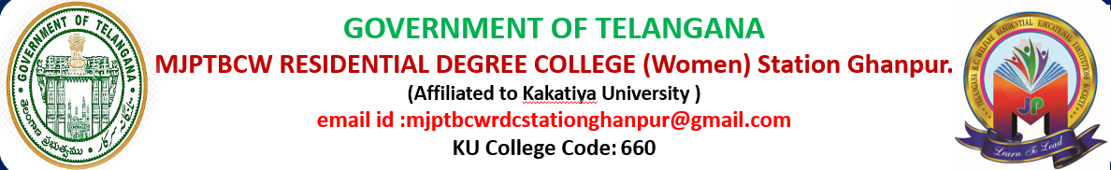

Department of Mathematics
Introduction
- The Department of Mathematics is committed to fostering analytical thinking ,logical reasoning and problem solving skills among students. Established in year 2022,the department has been a cornerstone of academic excellence ,offering undergraduate and postgraduate programs that combine theoretical foundations with practical applications.

Vision
- To cultivate a culture of mathematical inquiry, innovation, and excellence, empowering students to apply mathematics in diverse fields of science, technology, and society.
- To build a strong foundation in mathematical concepts and reasoning.
- To develop problem solving and decision -making skils.

Mission
To provide a strong foundation in pure and applied mathematics.
- To nurture research and innovation through interdisplinary approaches.
- To equip students with quantitative and analytical skills for academic, industrial and professional success.
- To inspire lifelong learning and appreciation for the beauty of Mathematics.
Objectives
- Develop logical thinking.
- Strength problem -solving skills.
- Build mathematical reasoning.
- Apply mathematics to real life situations.
- Prepare for higher studies and careers.

Academic programs
- B.Sc. (MPCs)- {Maths, Physics, Computer science}
- B.Sc. (MSCs)- {Maths, Statistics, Computer science}
- B.Sc. (MECs)- { Maths, Economics, Computer science}
- B.Sc. (MPC)- {Maths, Physics, Computer science}

Faculty profile
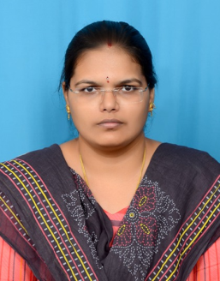
H.B. INDU [M.Sc., B.Ed., TS-SET, M. lisc]
- from She has completed her M.Sc. (Maths with computer science) in 2015 from department of mathematics, University College of women koti, Osmania University, Hyderabad.
- She has qualified TS-SET In 2018 conducted by Osmania University in the subject Mathematics.
- She has completed her M. lisc in 2022 Dr.B.R. Ambedkar University.

TEACHING EXPERIENCE
- She has total 07 years of Teaching experience.
- She worked as a degree lecturer in mathematics in Ellenki degree college, sangareddy, Telangana for 5 years from 2017 to 2022.
- H.B.INDU currently working as a Degree Lecturer in Mathematics since 2024 at MJPTBCWRDC, Station Ghanpur located at Penberthy, Jangaon.
- She went as a jury at Inspire and science fair 2024 in Jangaon district.
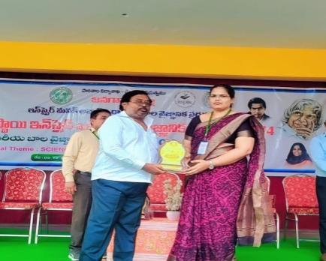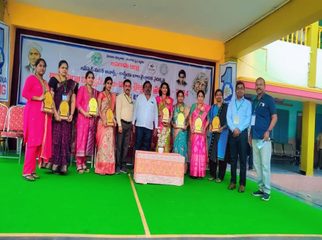
V. Sowmya [M.sc, B.ED, TS-SET]

- She has completed her M.Sc. from kakatiya university hanamkonda .
- She has qualified TS-SET In 2018 conducted by Osmania University in the subject Mathematics.
Areas of Specialization
- Algebra
- Analysis
- Linear Algebra
- Number Theory
- Differential Equations
- Operations Research
- Mathematical Modeling
- Probability and Statistics
- Numerical Analysis
- Solid geometry

Career opportunities
Graduates from the department pursue careers in:
- Academia and research
- Data science and Analytics
- Banking and financial services
- Information Technology
- Civil services and public sector
- Education and Training

Infrastructure and Facilities
- Well experienced faculty.
- Dedicated classrooms with modern teaching aids.
- Access to e-resources and research journals.
- Seminar hall for guest lectures and workshops.
- Library resources specific for mathematics department.

Academic achievements

RESULT ANALYSIS FOR B.SC MPCS 2022-2025

COURSE  (B.SC MPCS) 2022-2025 | SEM I | SEM II | SEM III | SEM IV | SEM V | SEM VI
No. of students appeared | 13 | 13 | 10 | 10 | 10 | 10
No. of students passed | 11 | 12 | 10 | 10 | 10 | 10
No. of students failed | 2 | 1 | 0 | 0 | 0 | 0
Pass percentage | 84 | 92 | 100 | 100 | 100 | 100

RESULT ANALYSIS FOR B.SC MPCS 2023-2026
COURSE  (B.SCMPCS)  2023-2026 | SEM I | SEM II | SEM III | SEM IV
No. of students appeared | 26 | 25 | 24 | 23
No. of students passed | 26 | 24 | 24 | 19
No. of students failed | 0 | 1 | 0 | 4
Pass percentage | 100 | 96 | 100 | 82
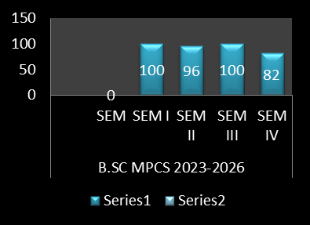

RESULT ANALYSIS FOR B.SC MECS 2023-2026
COURSE  (B.SC MECS)  2023-2026 | SEM I | SEM II | SEM III | SEM IV
No. of students appeared | 4 | 2 | 2 | 2
No. of students passed | 3 | 2 | 2 | 2
No. of students failed | 1 | 0 | 0 | 0
Pass percentage | 75 | 100 | 100 | 100

COURSE  (B.SC MPCS)  2024-2027 | SEM I | SEM II
No. of students appeared | 31 | 31
No. of students passed | 30 | 31
No. of students failed | 1 | 0
Pass percentage | 96 | 100
RESULT ANALYSIS FOR B.SC MPCS 2024-2027

RESULT ANALYSIS FOR B.SC MSCS 2024-2027
COURSE  (B.SC MSCS)  2024-2027 | SEM I | SEM II
No. of students appeared | 3 | 3
No. of students passed | 3 | 3
No. of students failed | 0 | 0
Pass percentage | 100 | 100

Course objectives:

PAPER I: DIFFERENTIAL EQUATIONS
- CO1: Understand the fundamental concepts, terminology, and classification of differential equations.
- CO2: Solve first-order differential equations using standard analytical methods.
- CO3: Solve higher-order linear differential equations with constant and variable coefficients.
- CO4: Apply differential equations to model real-world problems in science, engineering, and technology.
- CO5: Use methods such as Laplace transforms to solve differential equations and initial-value problems.
- CO6: Analyze systems of differential equations and obtain their solutions.

PAPER II: REAL ANALYSIS
- CO1: Understand the fundamental concepts and principles of real numbers, sequences, and series.
- CO2: Develop a rigorous understanding of limits, continuity, and differentiability of real-valued functions.
- CO3: Analyze the convergence and divergence of sequences and infinite series using appropriate tests and techniques.
- CO4: Understand the concepts of open sets, closed sets, compactness, and connectedness in the real line.
- CO5: Apply the Bolzano–Weierstrass theorem, Heine–Borel theorem, and related results in problem solving.
- CO6: Understand the Riemann integral and its fundamental properties.

PAPER III: DIFFERENTIAL AND VECTOR CALULUS
- CO1: Understand the fundamental concepts of differential calculus, partial differentiation, and their applications.
- CO2: Apply differentiation techniques to analyze functions of one and several variables.
- CO3: Use partial derivatives, total derivatives, and chain rules in solving mathematical and engineering problems.
- CO4: Apply concepts such as Taylor and Maclaurin series to approximate functions and solve practical problems.
- CO5: Understand the fundamental concepts of vectors, vector functions, and vector fields.
- CO6: Compute and interpret the gradient, divergence, and curl of vector fields.
- CO7: Apply line, surface, and volume integrals to solve problems involving vector fields.
- CO8: Understand and apply important vector calculus theorems, including Green’s theorem, Gauss’s divergence theorem, and Stokes’ theorem.
PAPER IV: ALGEBRA
- CO1: Understand the fundamental concepts and structures of groups, subgroups, rings, integral domains, and fields.
- CO2: Develop proficiency in applying basic group-theoretic concepts, including homomorphisms, isomorphisms, cosets, and quotient groups.
- CO3: Understand and apply the fundamental theorems of group theory to solve algebraic problems.
- CO4: Analyze the properties of rings, ideals, quotient rings, and ring homomorphisms.
- CO5: Understand the concepts of polynomial rings and factorization of polynomials over different algebraic structures.
- CO6: Apply algebraic methods to study permutations, cyclic groups, and finite groups
PAPER V: LINEAR ALGEBRA
- CO1: Understand the fundamental concepts of vectors, matrices, and systems of linear equations.
- CO2: Apply matrix operations, determinants, and inverse matrices to solve mathematical problems.
- CO3: Understand the concepts of vector spaces, subspaces, and linear combinations.
- CO4: Determine and apply the concepts of linear independence, basis, dimension, and rank.
- CO5: Understand linear transformations and their representation using matrices.
- CO6: Find and interpret eigenvalues and eigenvectors and apply them to mathematical problems.
- CO7: Understand concepts such as inner product spaces, orthogonality, and orthogonal projections.
- CO8: Apply linear algebra techniques to problems in mathematics, science, engineering, and computer applications.
PAPER VI: SOLID GEOMETRY
- CO1: Understand the fundamental concepts of three-dimensional coordinate geometry and the Cartesian coordinate system.
- CO2: Apply concepts of vectors, direction cosines, and direction ratios in three-dimensional space.
- CO3: Determine the angle between lines and planes and calculate distances between points, lines, and planes.
- CO4: Understand and derive the equations of spheres and other standard surfaces in three dimensions.
- CO5: Analyze cylinders, cones, conicoid, and quadric surfaces using analytical methods.
- CO6: Develop the ability to visualize and interpret geometric objects and their relationships in three-dimensional space.
- CO7: Develop analytical reasoning, mathematical modelling, and problem-solving skills through applications of solid geometry.
PROGRAMME OUTCOMES:
- PO1 – Mathematical Knowledge: Demonstrate a strong understanding of fundamental concepts in mathematics, including algebra, calculus, differential equations, real analysis, linear algebra, and geometry.
- PO2 – Analytical Thinking: Develop logical, analytical, and critical thinking skills for solving mathematical problems.
- PO3 – Problem-Solving Skills: Apply appropriate mathematical methods, techniques, and theories to solve theoretical and real-world problems.
- PO4 – Mathematical Reasoning: Formulate, analyze, and prove mathematical statements using precise definitions, logical arguments, and appropriate mathematical tools.
- PO5 – Computational Skills: Use mathematical and computational techniques and appropriate software to perform calculations, analyze data, and solve complex problems.
- PO6 – Application of Mathematics: Apply mathematical concepts and models to problems in science, technology, economics, and other interdisciplinary areas.

ACADEMIC ACTION PLAN:
- I-SEM: DIFFERENTIAL EQUATIONS
- Introduce the basic concepts, terminology, and classification of differential equations
- Explain methods of solving first-order differential equations
- Teach higher-order linear differential equations
- Conduct problem-solving sessions on exact, linear, Bernoulli, and related equations

- II-SEM: REAL ANALYSIS
- Introduce the basic concepts of real numbers, sets, and functions
- Explain sequences and their convergence with suitable examples
- Explain concepts of open sets, closed sets, boundedness, and compactness
Introduce infinite series and different convergence tests
- Explain the Riemann integral and its properties
- Provide remedial teaching and additional examples for slow learners

- III-SEM: DIFFERENTIAL AND VECTOR CALCULUS
- Introduce the basic concepts of differential calculus and functions of several variables
- Explain total derivatives and the chain rule with suitable examples
- Introduce Taylor and Maclaurin expansions for functions of several variables
- Introduce vectors, vector functions, and vector fields
- Explain gradient, directional derivatives, divergence, and curl
- Conduct exercises on line, surface, and volume integrals
- Explain and apply Green’s theorem, Gauss’s divergence theorem, and Stokes’ theorem

- IV-SEM: ALGEBRA
- Introduce basic algebraic structures and their properties
- Explain groups, subgroups, and examples from different mathematical systems
- Conduct problem-solving sessions on cyclic and permutation groups
- Introduce rings, subrings, integral domains, and fields
- Explain ideals, quotient rings, and ring homomorphisms
- V-SEM: LINEAR ALGEBRA
- Introduce the basic concepts of matrices, determinants, and systems of linear equations
- Conduct problem-solving sessions on determinants and inverse matrices
- Introduce vector spaces, subspaces, and linear combinations
- Explain rank, nullity, and the Rank–Nullity Theorem
- Teach eigenvalues and eigenvectors with practical examples
- Introduce inner product spaces, orthogonality, and orthogonal projections
- Provide remedial classes and additional exercises for slow learners

- VI-SEM: ANALATICAL SOLID GEOMETRY
- Introduce the three-dimensional Cartesian coordinate system and basic concepts of solid geometry
- Introduce the equation and properties of a sphere
- Explain cones, cylinders, and other standard surfaces
- Introduce conicoid and quadric surfaces using standard equations
- Provide remedial teaching and additional practice for students who need support
TIME TABLE
DAY/TIME | I  (8:15 TO 9:15 AM) | II  (9:15 TO 10:15 AM) | III  (10:15 TO 11:15 AM) | IV  (11:30 TO 12:30 PM) | V  (12:30 PM TO 1:30 PM) | VI  (2:30 PM TO 3:30 PM) | VII  (3:30 PM TO 4:30 PM)
MONDAY | III MPCS+MSCS |  | I MPCS | I MSCS |  | II MPCS+MSCS
TUESDAY | II MPCS+MSCS | I MPCS |  | I MSCS | III MPCS+MSCS | RC (II MPCS+MSCS)
WEDNESDAY | III MPCS+MSCS | II MPCS+MSCS |  | I MPCS | I MSCS | RC (III MPCS+MSCS)
THRUSDAY | I MPCS | III MPCS+MSCS |  |  | II MPCS+MSCS | I MSCS
FRIDAY | I MPCS | IMSCS |  | II MPCS+MSCS | I MPCS |  | RC (MPCS I)
SATURDAY | II MPCS+MSCS | I MSCS |  | III MPCS+MSCS | I MPCS |  | RC (MSCS I)
SYLLABUS OF I SEMISTER
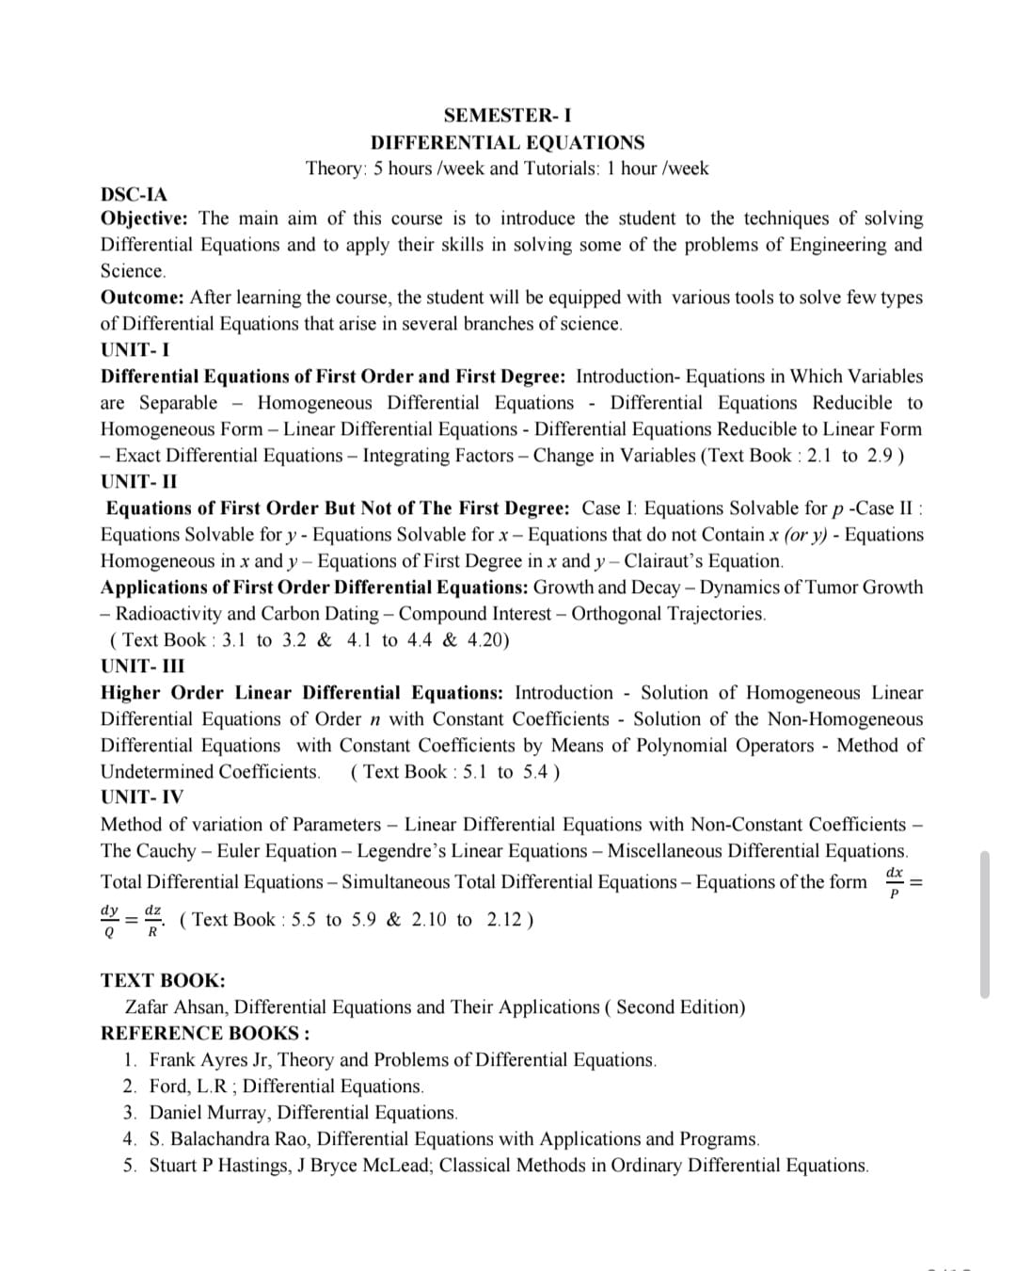

SYLLABUS OF II SEMISTER
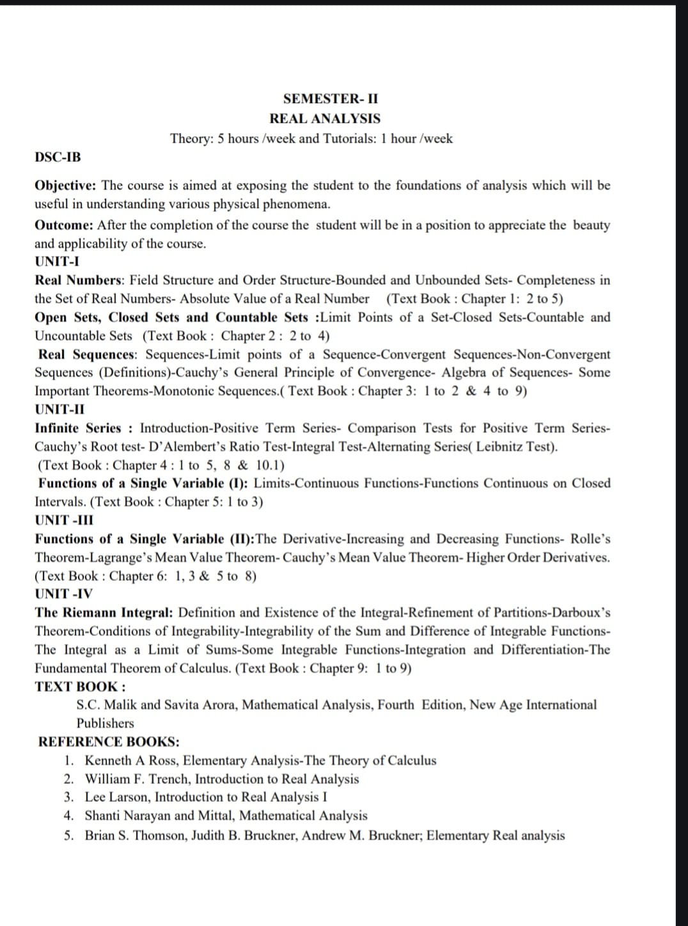

SYLLABUS OF III SEMISTER
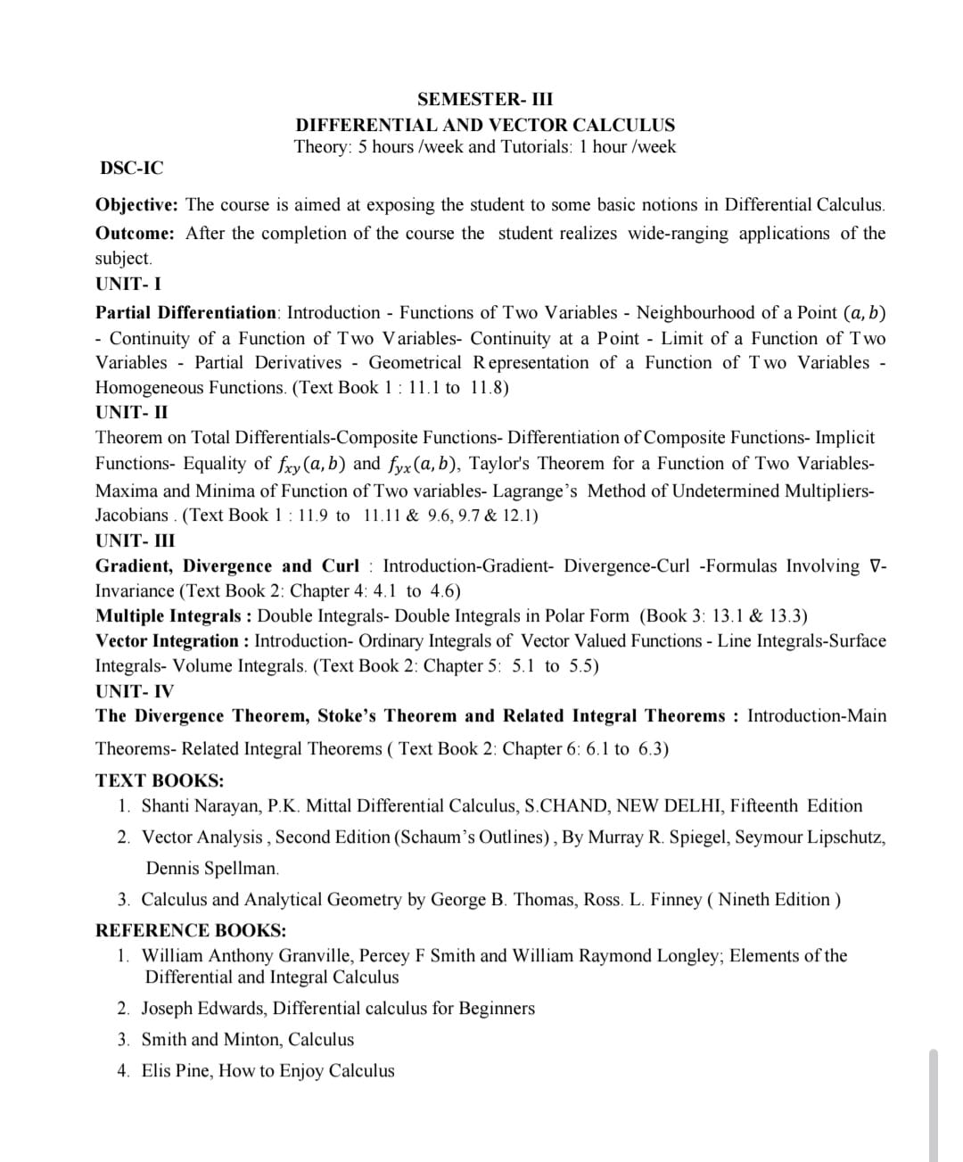

SYLLABUS OF IV SEMISTER
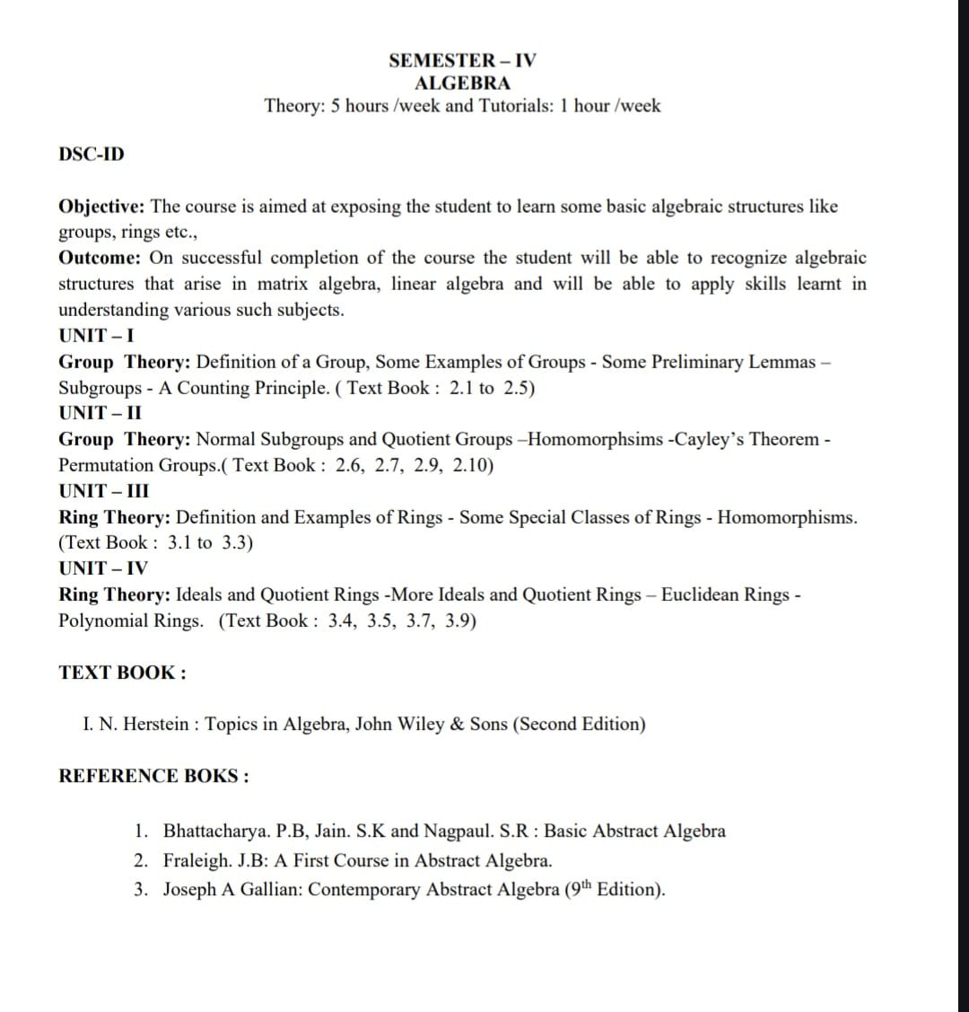

SYLLABUS OF V SEMISTER
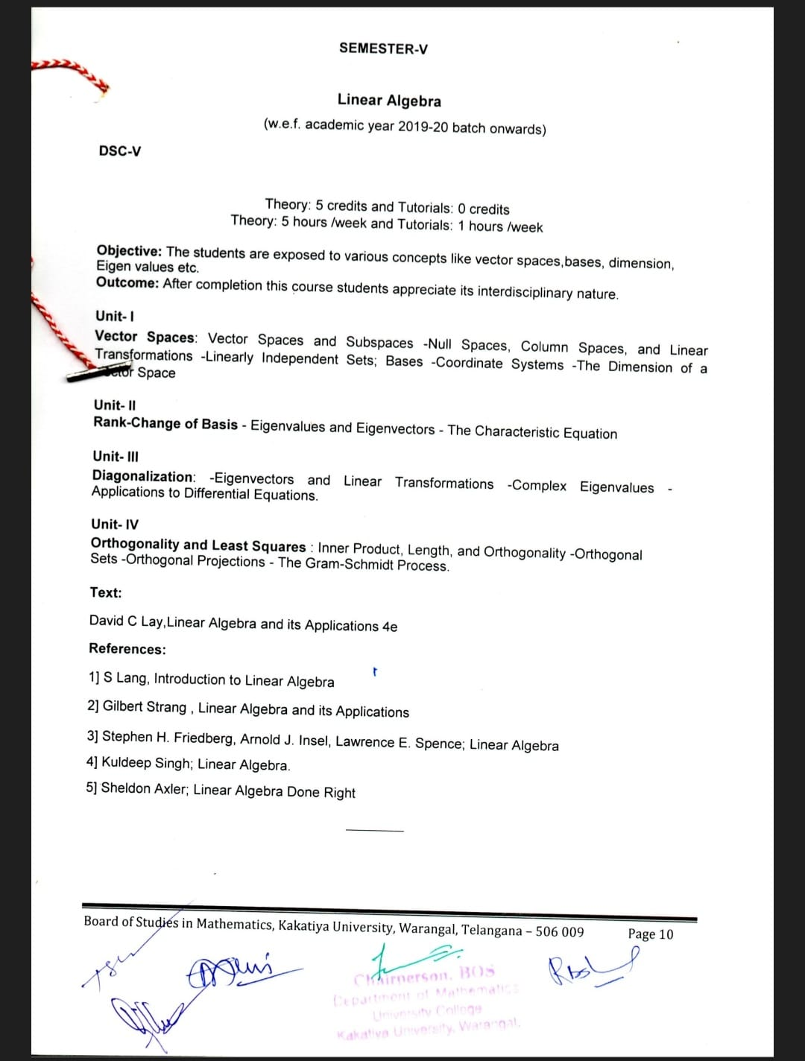

SYLLABUS OF VI SEMISTER
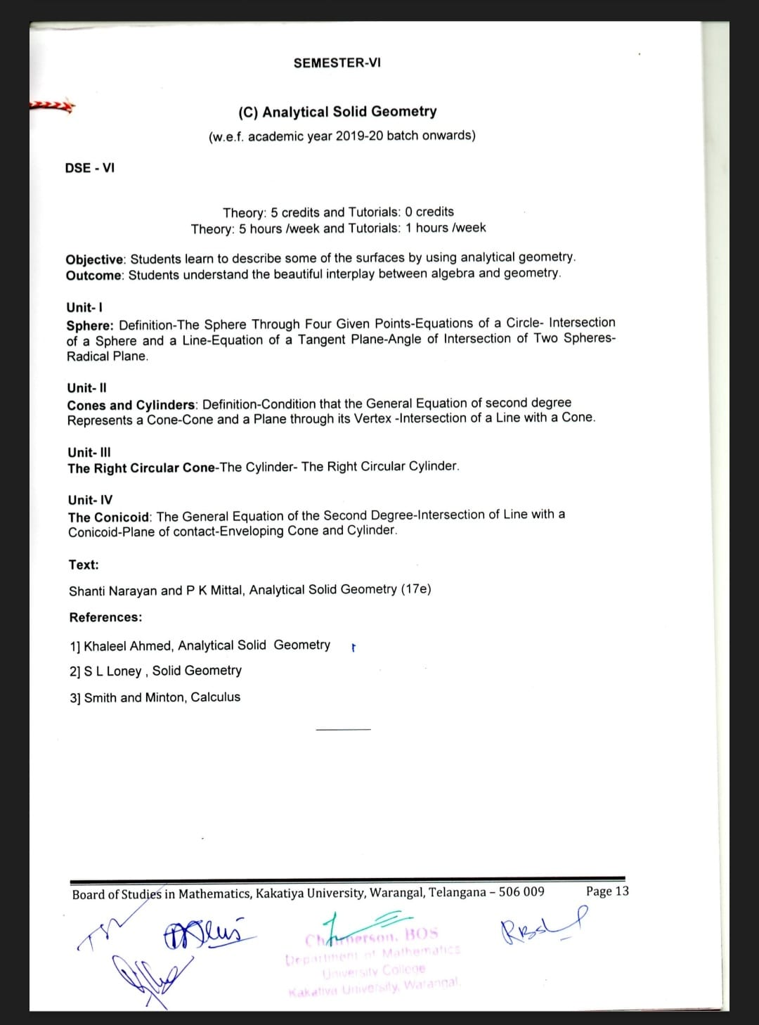

STUDENT ACTIVITIES
- Seminar sessions given by the students on the subject.
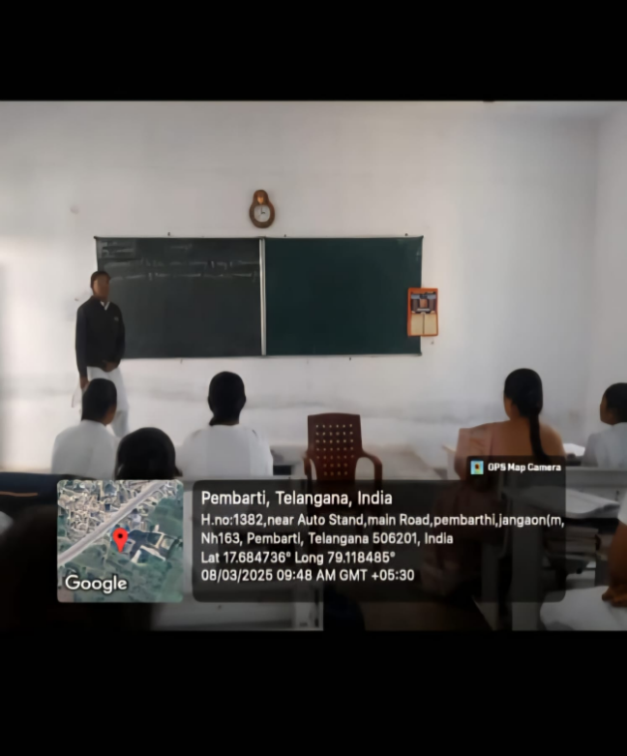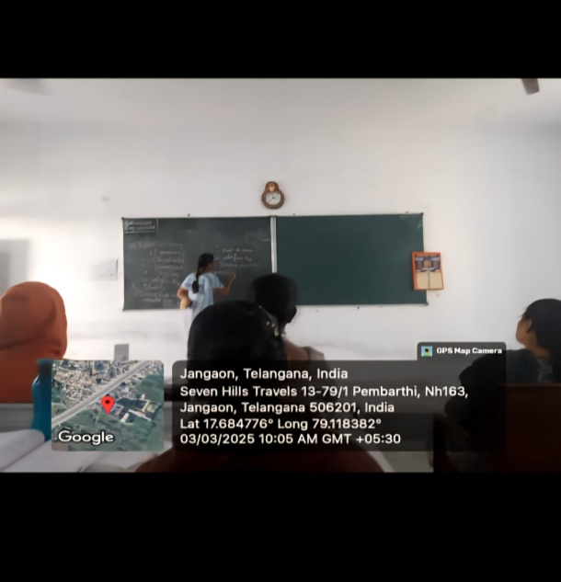
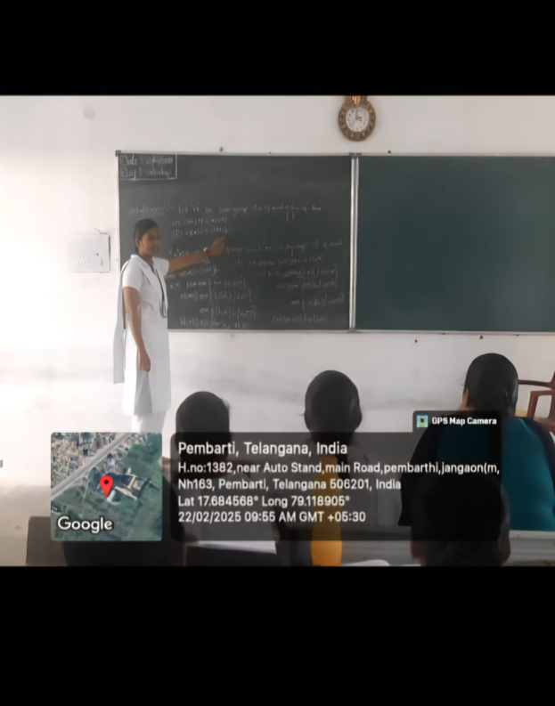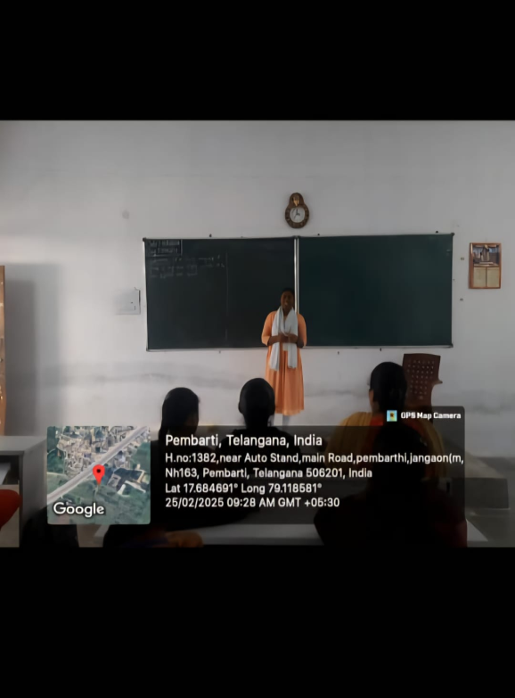
- National mathematics day celebration.
- Math club.
- Intercollegiate mathematics competitions and quiz.

Best Practices of a Mathematics Department

1. Effective Lesson Planning
- Prepare well-structured lesson plans with clear learning objectives.
- Connect mathematical concepts with real-life applications.

2. Activity-Based Learning
- Mathematical activities, puzzles, quizzes, and games.
- Using manipulatives, models, and classroom demonstrations.
- Encouraging students to discover mathematical concepts rather than only memorize formulas.

3. Use of Technology
- Integrate digital tools such as GeoGebra and Desmos.
- Provide students with appropriate e-resources for independent learning.

4. Continuous Assessment
- Conduct regular class tests, worksheets, quizzes, and assignments.
- Use formative assessment to identify learning gaps.

5. Remedial Teaching
- Identify students who need additional support.
- Organize remedial classes and individual guidance.
- Provide simplified explanations and additional practice materials.
- Monitor improvement after remedial interventions.

7. Mathematics Club
- Organize a Mathematics Club to promote interest in the subject.
- Conduct activities such as:
  - Mathematics quizzes
  - Puzzle-solving competitions
  - Math exhibitions
  - Mathematical model making
  - Poster and essay competitions
  - Guest lectures

8. Real-Life Application of Mathematics
- Demonstrate how mathematics is used in finance, science, technology, architecture, business, statistics, and everyday life.
- Use real-world data and situations in classroom problems.
- Encourage students to collect, analyze, and interpret data.

9. Collaborative Learning
- Encourage peer learning and group problem-solving.
- Use pair and group activities.
- Give students opportunities to explain solutions to their classmates.

