

DEPARTMENT OF STATISTICS

About the Department:
The department of statistics was established in 2024 with the aim of providing quality education and fostering research in the field of statistics. Since its inception, the department has been committed to equipping students with strong analytical, quantitative and problem-solving skills. The curriculum is designed to meet both academic excellence and the practical demands of industry, government and research organizations.

Vision:
To be a center of excellence in statistics by nurturing analytical thinking, innovation and research that contribute to development of society and nation.

Mission:
- To impact high-quality education in statistics at undergraduate level.
- To encourage research and development in statistical theory, methodology and applications.
- To prepare students for careers in academia, research, industry, government and data driven fields.
- To cultivate ethical values, critical thinking and social responsibility among students.

Courses offered:
- B.Sc(MSCs)- (Mathematics, Statistics, Computer Science) - {semester and choice based credit system}

Faculty profile:

Name | G. MANASA
Designation | Degree Lecturer
Qualification | M.Sc(Statistics), B.Ed, TS-SET
Contact number | 9666199909, 8919360244
Email id | manasa.gaddampally@gmail.com
Experience | 5 years

- She has completed her M.Sc(Statistics) in 2026 from Department of Statistics, University college of Science, Osmania University, Hyderabad.
- She has qualified TS-SET in 2018 conducted by Osmania University in the subject Mathematical Sciences.
- She has completed her B.Ed in 2019 from CLR College of Education, Palamuru University, and Nagarkurnool.

Teaching experience:
- She has total 6 years of Teaching Experience.
- She worked as a degree lecturer in statistics in TSWRDC(W), Nagarkurnool, Telangana for 2 years(2016-2017 & 2018-2019) and Sadhana degree college, Nagarkurnool, Telangana for 2 years(2017-2018 & 2019-2020).
- G. Manasa currently working as a Degree Lecturer in Statistics since 2024 at MJPTBCWRDC(W), Station Ghanpur located at Pembarthy, Jangaon.

Areas of Specialization:
- Probability and Distribution theory
- Statistical Inference
- Theory of Estimation
- Sampling Techniques and Design of Experiments
- Operations Research
- Multivariate analysis
- Time series analysis
- Business Statistics and Bio Statistics

Career opportunities:
- Data Analysts, Data Scientists and IT Industries
- Banking , Finance and Insurance
- Higher education and Research organizations
- Health, Education and Social research sectors
- Central government jobs like ISS, SSC
- State government jobs like ASO, MPSO

Infrastructure and Facilities :
- Well experienced faculty
- Well equipped computer lab with statistical software.
- College library with text books, reference books and journals.
- Smart classroom facilities for interactive and technology-aided learning.

Academic Achievements:

Result analysis:
Academic year: 2024-2025
S No | Subject | Group | Semester | Appeared | Pass | Percentage
1 | Statistics | BSc(MSCs) | I | 3 | 3 | 100%
2 | Bio Statistics | BSC(MPCs) | III | 24 | 24 | 100%
3 | Bio Statistics | BSC(MECs) | III | 2 | 2 | 100%
4 | Bio Statistics | BSc(BZC) | III | 29 | 29 | 100%
5 | Business statistics-I | BCom(CA) | III | 32 | 30 | 93.75%
6 | Business statistics-I | BCom(BA) | III | 8 | 7 | 87.5%
Total |  |  |  | 98 | 95 | 96.9%

Academic Year: 2024-2025
S No | Subject | Group | Semester | Appeared | Pass | Percentage
1 | Statistics | BSc(MSCs) | II | 3 | 3 | 100%
2 | Business Statistics-II | BCom(CA) | IV | 30 | 30 | 100%
3 | Business Statistics-II | BCom(BA) | IV | 8 | 8 | 100%
Total |  |  |  | 41 | 41 | 100%

Academic Year: 2025-2026
S no | Subject | Group | Semester | Appeared | Pass | Percentage
1 | Statistics | BSc(MSCs) | I | 19 | 17 | 89.4%
2 | Statistics | BSc(MSCs) | III | 3 | 3 | 100%
3 | Bio Statistics | BSC(MPCs) | III | 27 | 27 | 100%
4 | Bio Statistics | BSc(BZC) | III | 14 | 14 | 100%
5 | Bio Statistics | BSc(MSCs) | III | 3 | 3 | 100%
6 | Business Statistics | BCom(CA) | III | 33 | 33 | 100%
7 | Business Statistics | BCom(BA) | III | 8 | 8 | 100%
Total
Academic Year: 2025-2026
S No | Subject | Group | Semester | Appeared | Pass | Percentage
1 | Statistics | BSc(MSCs) | II | 18 | 18 | 100%
2 | Statistics | BSc(MSCs) | IV | 3 | 3 | 100%
Total |  |  |  | 41 | 41 | 100%
Course objects and outcomes:
I SEMESTER
Paper–I: BASIC STATISTICS AND PROBABILITY
Course Objectives
- To introduce students to the basic concepts, definitions and importance of Statistics.
- To develop knowledge of measures of central tendency, dispersion, moments, skewness and kurtosis.
- To provide a fundamental understanding of probability and its applications.
- To introduce random variables, probability functions and bivariate distributions.
- To develop understanding of mathematical expectation, generating functions and probability inequalities.
- To familiarize students with the application of statistical techniques in data analysis and interpretation.
Course Outcomes
After completion of the course, students will be able to:
CO1: Explain the basic concepts and importance of Statistics and classify and summarize data.
CO2: Calculate and interpret measures of central tendency, dispersion, moments, skewness and kurtosis.
CO3: Apply the basic laws of probability, conditional probability, independence and Bayes' theorem to solve problems.
CO4: Understand discrete and continuous random variables, probability mass/density functions and distribution functions.
CO5: Calculate mathematical expectations, moments and covariance and apply generating functions.
CO6: Interpret statistical results and apply basic statistical methods to real-life data.

II SEMESTER

Paper–II: PROBABILITY DISTRIBUTIONS

Course Objectives

To introduce students to important discrete and continuous probability distributions.

To develop understanding of the properties and characteristics of standard probability distributions.

To teach students the computation of moments and generating functions of probability distributions.

To explain the real-life applications of probability distributions.

To introduce exact sampling distributions and their importance in statistical inference.

To develop problem-solving skills involving probability models.

Course Outcomes

CO1: Identify and distinguish between discrete and continuous probability distributions.

CO2: Derive and calculate the mean, variance, moments and generating functions of standard distributions.

CO3: Apply Binomial, Poisson, Negative Binomial, Geometric and Hyper-geometric distributions to practical problems.

CO4: Apply Normal, Exponential, Gamma, Beta and Cauchy distributions in real-life situations.

CO5: Explain the relationships and approximations among different probability distributions.

CO6: Understand χ², t and F sampling distributions and their role in statistical inference.
III SEMESTER
Paper–III: STATISTICAL INFERENCE
Course Objectives
- To introduce the fundamental concepts of statistical inference.
- To develop an understanding of point and interval estimation.
- To explain the properties of good estimators such as consistency, unbiasedness and sufficiency.
- To familiarize students with methods of estimation including MLE, method of moments and least squares.
- To develop knowledge of parametric and non-parametric tests of hypotheses.
- To enable students to make statistical decisions based on sample information.
Course Outcomes
CO1: Explain the concepts of population, sample, parameter, statistic and sampling distributions.
CO2: Evaluate estimators based on consistency, unbiasedness and other desirable properties.
CO3: Apply the method of moments, maximum likelihood estimation and least squares methods.
CO4: Construct and interpret confidence intervals for population parameters.
CO5: Formulate and conduct appropriate large-sample and small-sample tests of hypotheses.
CO6: Apply χ² tests and appropriate non-parametric tests to practical data.
CO7: Interpret statistical test results and make appropriate statistical decisions.
IV SEMESTER
Paper–IV: ANALYSIS OF CORRELATION, REGRESSION AND BASIC EXPERIMENTAL DESIGNS
Course Objectives
- To introduce the concepts and methods of correlation analysis.
- To develop skills in measuring and interpreting relationships between variables.
- To provide knowledge of simple and multiple regression analysis.
- To introduce ANOVA and its applications.
- To familiarize students with the principles and methods of experimental design.
- To develop practical skills in analysing statistical data using Excel and R.
Course Outcomes
CO1: Explain the concept and importance of correlation and association.
CO2: Calculate and interpret Karl Pearson's, Spearman's and other correlation coefficients.
CO3: Fit and interpret simple, multiple and non-linear regression models.
CO4: Calculate and interpret R², adjusted R² and regression coefficients.
CO5: Apply ANOVA techniques for appropriate experimental data.
CO6: Explain the principles of experimental design and analyse CRD, RBD and LSD.
CO7: Use statistical software to analyse correlation, regression and experimental data.
V SEMESTER
DSE–1(A) / Paper–V(A): APPLIED STATISTICS–I
Course Objectives
- To introduce the concepts and principles of sample surveys.
- To develop knowledge of probability and non-probability sampling methods.
- To understand estimation of population parameters under different sampling designs.
- To introduce time series analysis and forecasting techniques.
- To familiarize students with statistical quality control and control charts.
- To develop the ability to apply sampling and quality control techniques to real-world problems.
Course Outcomes
CO1: Explain the concepts of population, sample, sampling unit, parameter, statistic and sampling errors.
CO2: Apply Simple Random Sampling with and without replacement.
CO3: Apply stratified and systematic sampling methods and compare their efficiencies.
CO4: Analyse time series data and determine trend and seasonal variations.
CO5: Fit growth curves such as modified exponential, Gompertz and logistic curves.
CO6: Construct and interpret control charts for variables and attributes.
CO7: Apply sampling, time series and SQC techniques to practical problems.
VI SEMESTER
DSE–2(A) / Paper–VI(A): APPLIED STATISTICS–II
Course Objectives
- To provide advanced knowledge of ANOVA and design of experiments.
- To develop understanding of CRD, RBD and LSD and their applications.
- To introduce concepts and measures of vital statistics.
- To familiarize students with life tables and population statistics.
- To introduce Indian official statistics and national income statistics.
- To develop knowledge of index numbers and their applications.
Course Outcomes
CO1: Explain the principles and applications of ANOVA and experimental designs.
CO2: Analyse CRD, RBD and LSD and compare their efficiencies.
CO3: Calculate and interpret mortality, fertility and reproduction rates.
CO4: Construct and interpret life tables and abridged life tables.
CO5: Explain the role of Indian official statistical organizations and national income statistics.
CO6: Construct and interpret simple and weighted index numbers.
CO7: Apply Laspeyres, Paasche and Fisher's index numbers and assess their properties.
CO8: Apply cost-of-living index numbers and techniques such as base shifting, splicing and deflation.
ACADEMIC ACTION PLAN – B.Sc. STATISTICS
I Semester – Basic Statistics & Probability
- Introduce basic concepts and applications of Statistics.
- Teach measures of central tendency, dispersion, moments, skewness and kurtosis.
- Explain basic concepts of probability and random variables.
- Conduct numerical problem-solving and practical exercises.
- Introduce MS Excel/R for basic statistical analysis.
- Conduct unit tests, assignments and remedial classes.
II Semester – Probability Distributions
- Explain discrete and continuous probability distributions.
- Teach Binomial, Poisson, Normal and other important distributions.
- Explain sampling distributions such as χ², t and F.
- Demonstrate distributions using real-life examples and software.
- Conduct practical exercises using Excel/R.
- Assess learning through tests, assignments and quizzes.
III Semester – Statistical Inference
- Introduce estimation and properties of estimators.
- Teach Method of Moments, MLE and Least Squares.
- Explain confidence intervals and hypothesis testing.
- Teach large-sample, small-sample and non-parametric tests.
- Demonstrate statistical tests using Excel/R.
- Conduct practical tests, assignments and remedial teaching.
IV Semester – Correlation, Regression & Experimental Designs
- Explain correlation and regression techniques.
- Teach simple and multiple regression and interpretation of R².
- Introduce ANOVA and its applications.
- Teach CRD, RBD and LSD.
- Analyse real-life datasets using Excel/R.
- Conduct assignments, practicals, tests and student presentations.
V Semester – Applied Statistics-I
- Teach sampling methods and sampling errors.
- Explain SRS, systematic and stratified sampling.
- Introduce time-series analysis and forecasting.
- Teach Statistical Quality Control and control charts.
- Provide practical training using Excel/R.
- Conduct seminars, assignments, tests and remedial classes.
VI Semester – Applied Statistics-II
- Teach ANOVA and experimental designs.
- Explain vital statistics and life tables.
- Introduce Indian official statistics and index numbers.
- Introduce multivariate statistical techniques.
- Apply statistical methods using Excel/R and real datasets.
- Conduct revision, model examinations and practical assessment.
TIME TABLE:
DAY/TIME | 8:15-9:15 | 9:15-10:15 | 10:15-11:15 | 11:30-12:30 | 12:30-1:30 | 2:30-3:30 | 3:30-4:30
MONDAY |  | MSCS-I |  | MSCS-III |  |  | MSCS-II
TUESDAY | MSCS-I |  | RC MSCS-II | MSCS-III | MSCS-II | RC MSCS-III
WEDNESDAY | MSCS-II | MSCS-I
THURSDAY | MSCS-III | MSCS-II |  | MSCS-I
FRIDAY | MSCS-II LAB |  |  |  | MSCS-III LAB
SATURDAY | MSCS-III |  |  | MSCS-I LAB |  | RC MSCS-I

SYLLABUS
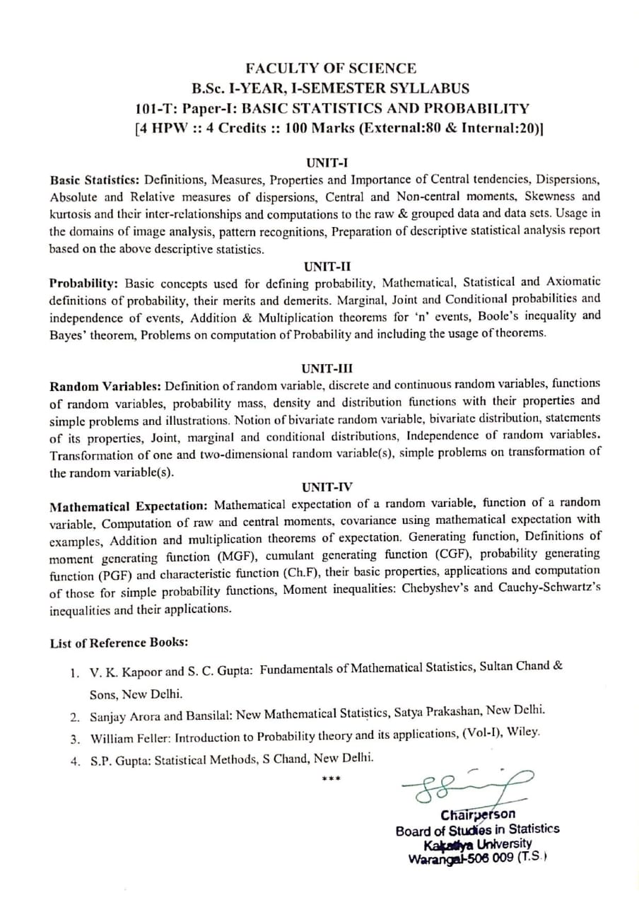
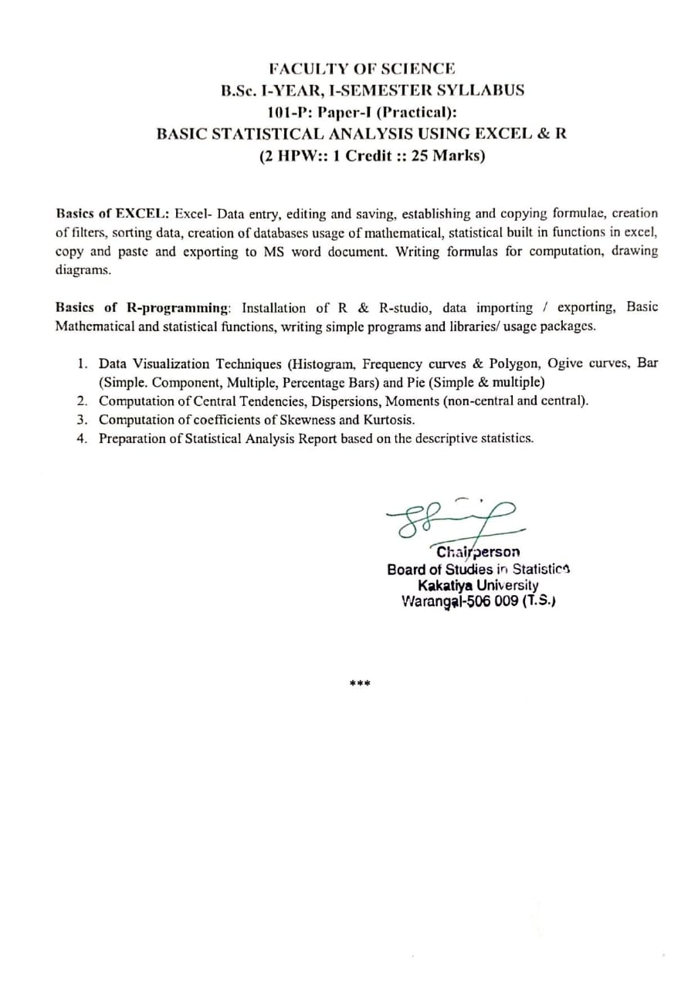
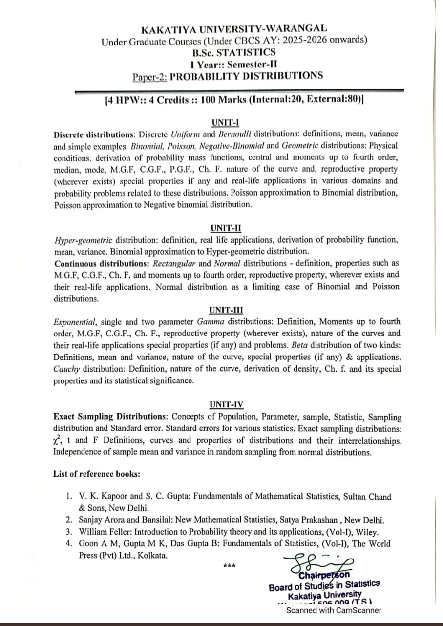
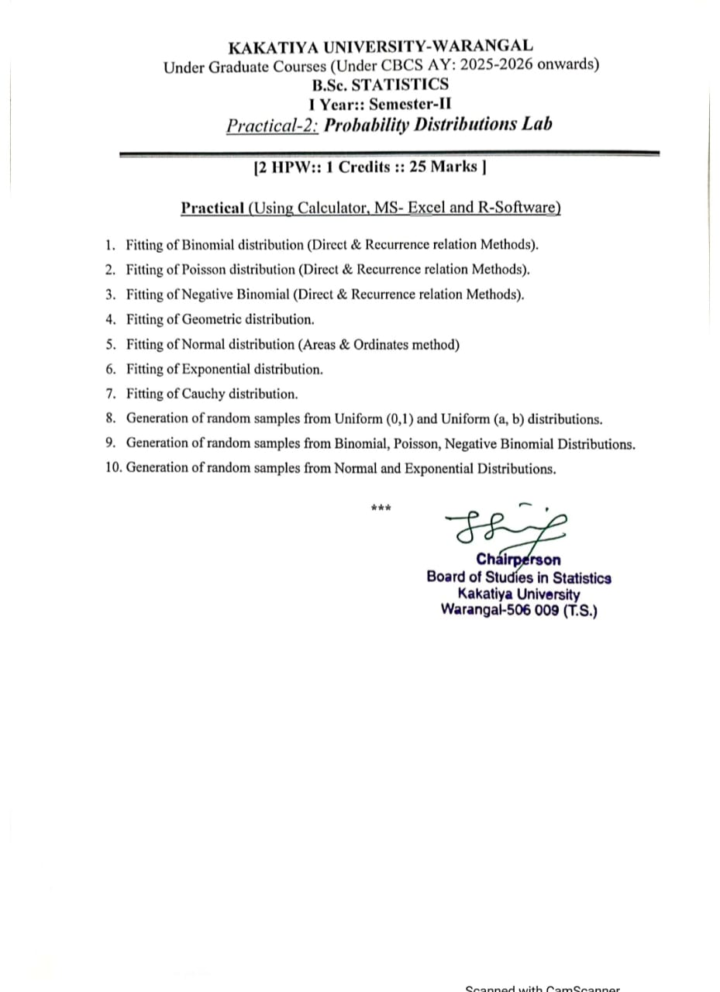
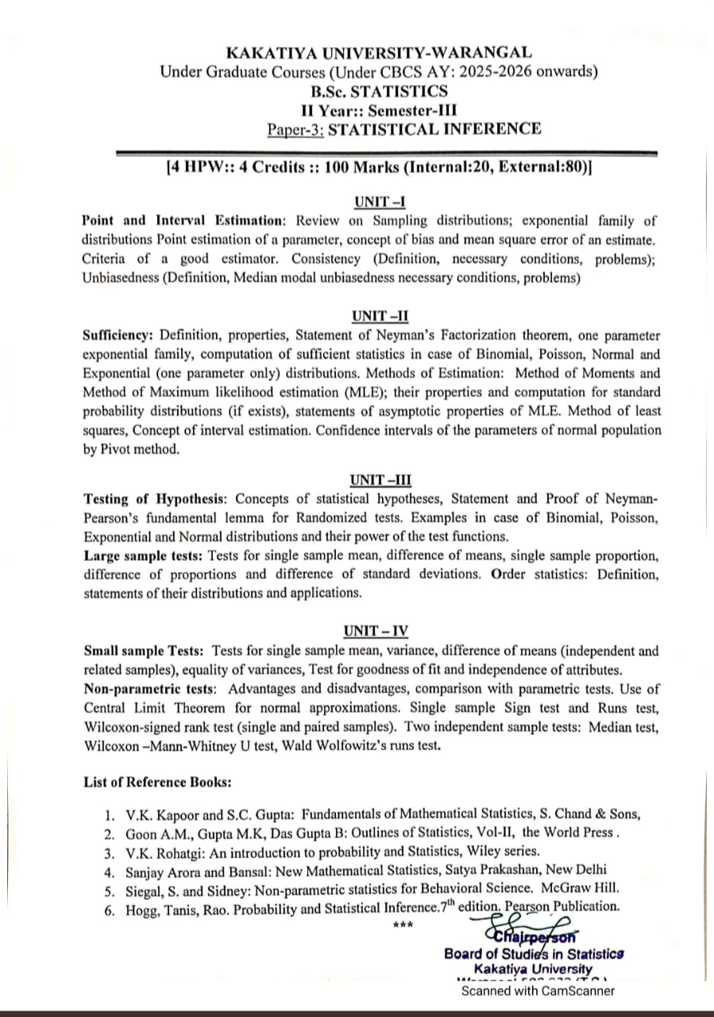
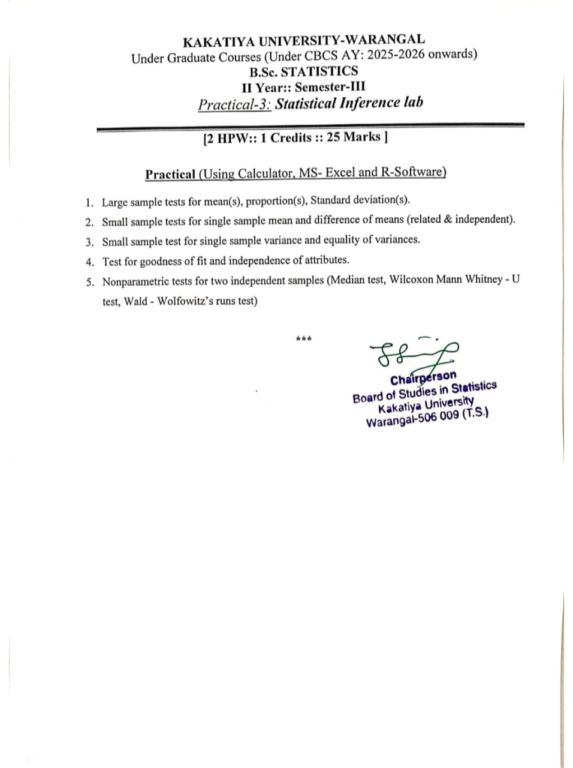
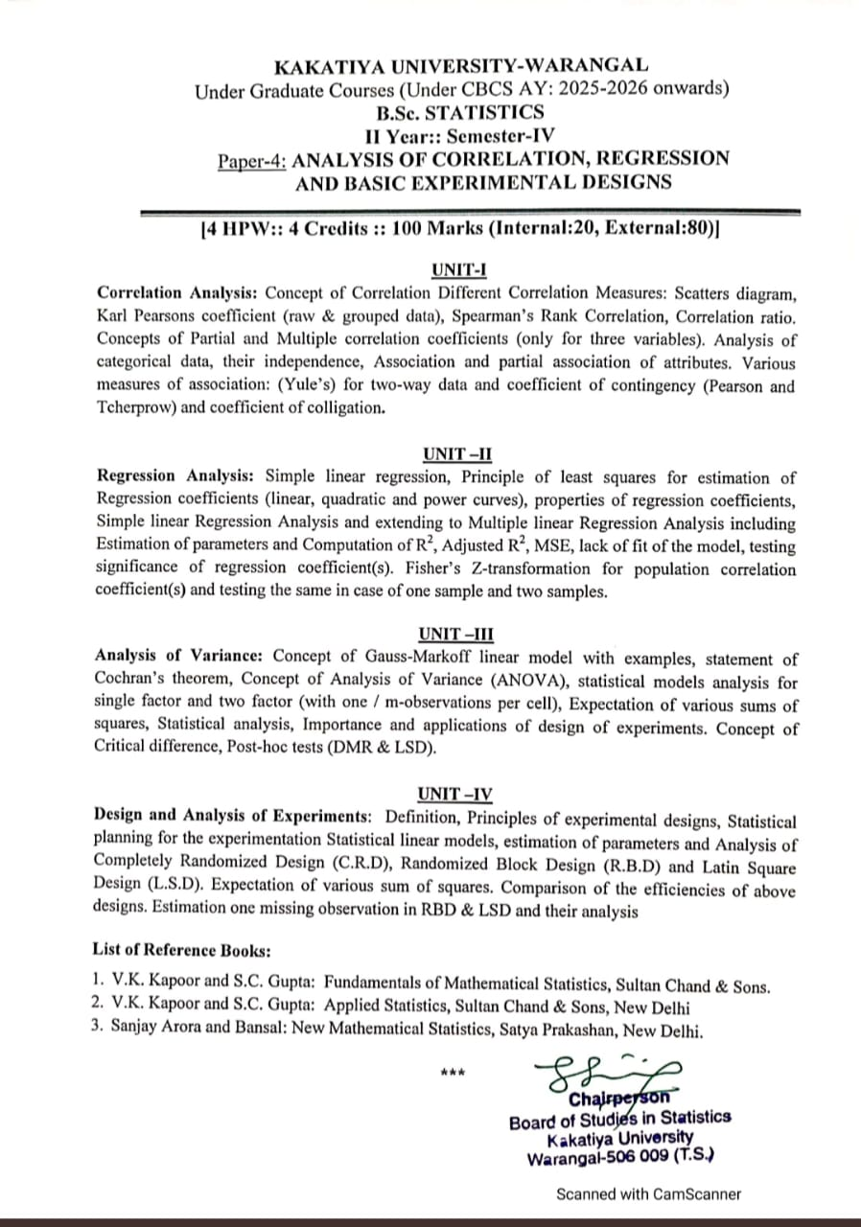
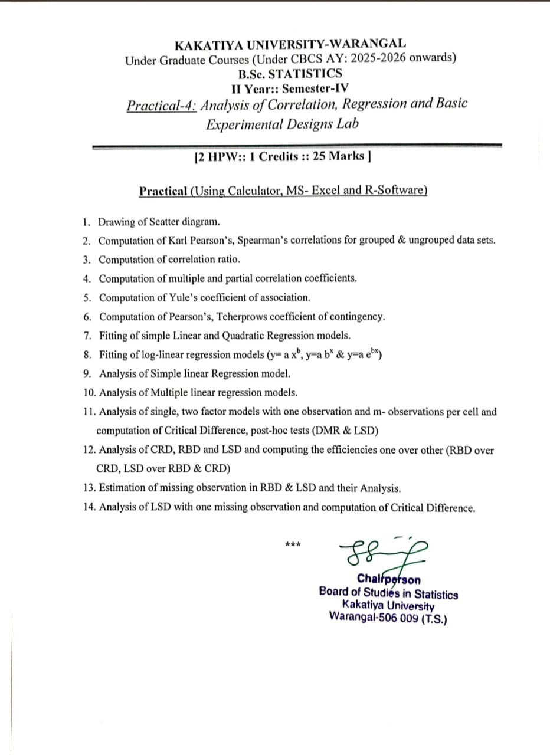
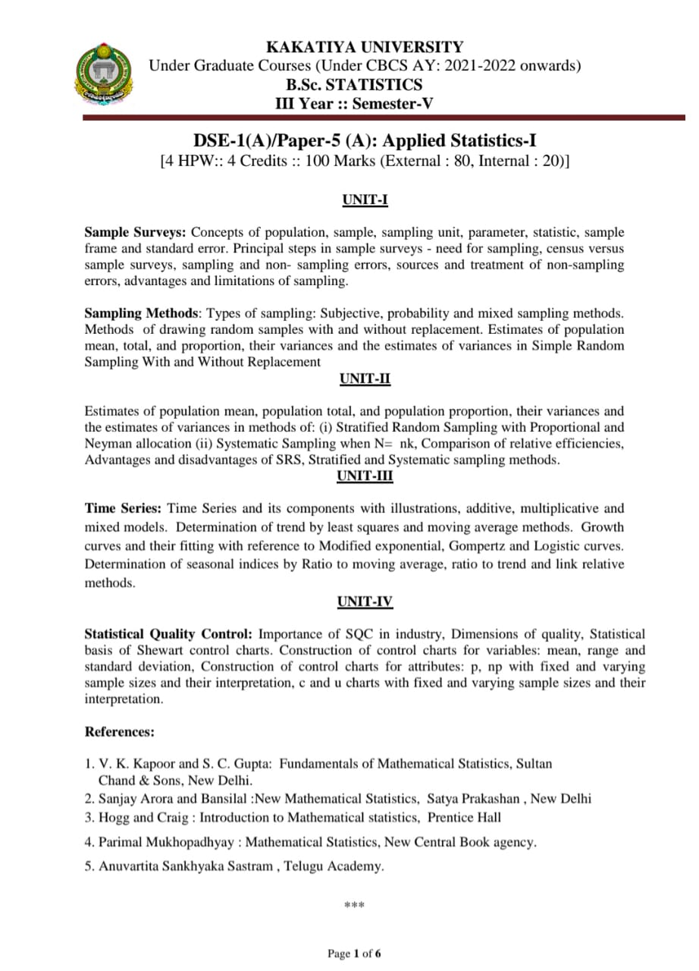
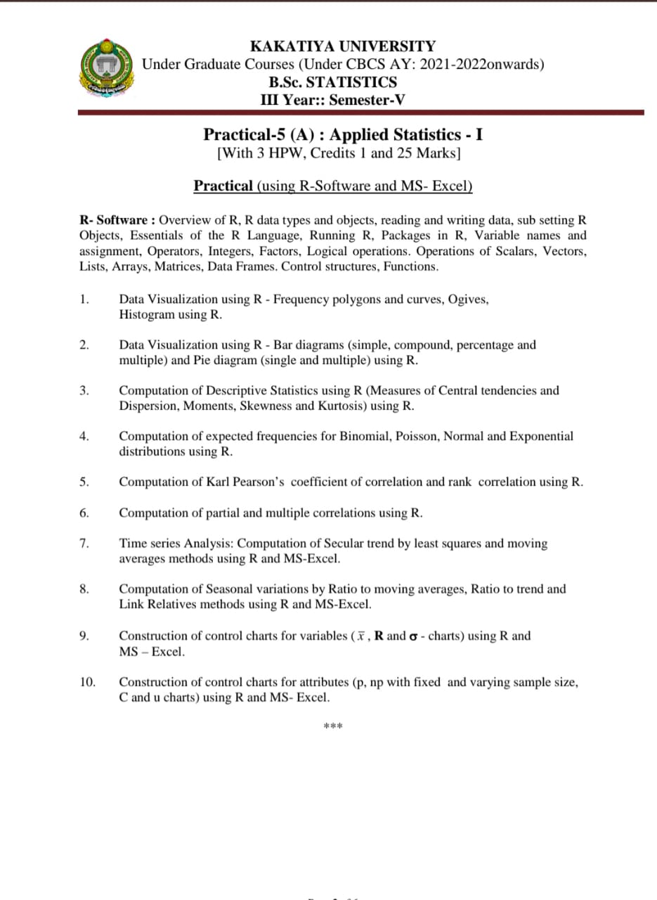
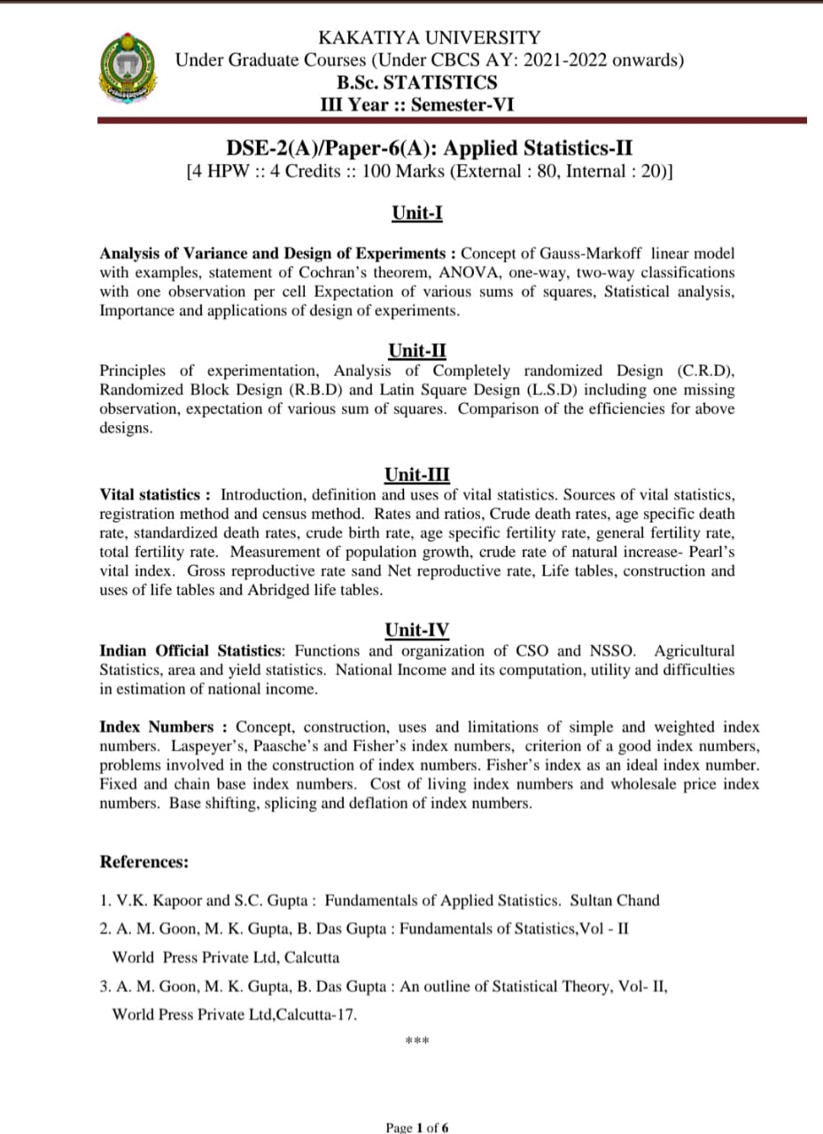
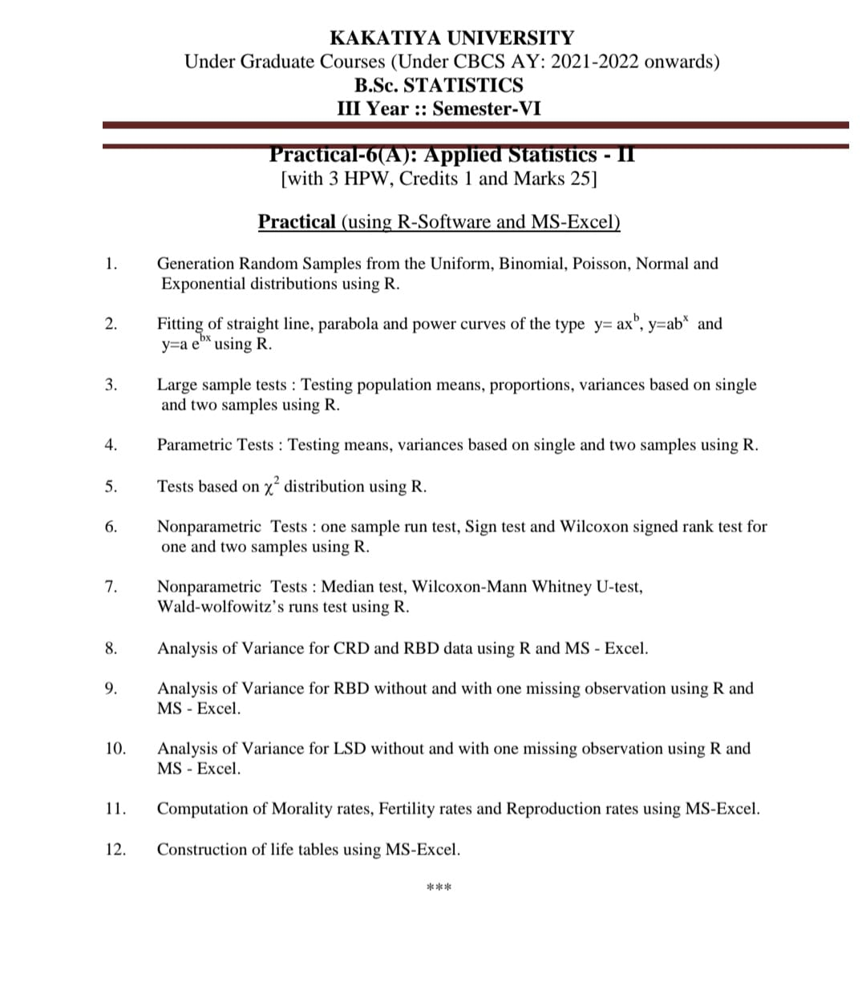

Activities :
- Organization of Seminars, Quiz, Paper presentation.
- Student participation in research projects, s tatistical surveys and data analysis.
- Celebration of National Statistics Day to honor the contribution of Prof. P.C. Mahalanobis.

Student activities:
