Task 5 Subreport: PI Hyperconnected Transportation
This subreport addresses the Task 5 case questions on network design, simulation-backed performance, and PI-versus-non-PI comparison. The writeup uses the case PDF, the Task 5 notebook and source pipeline, and the final CSV and figure outputs stored under Task5/output and comparison/.

Network Design
The implemented design is a phased multi-tier network. Rotterdam is the fixed port entry; Euro DCs open from 2027 to 2030; peri-urban hubs are created from the metro-city layer; and non-metro demand centroids are kept as sinks for coverage checks. Relay hubs are set algorithmically whenever a DC-to-market trip exceeds the 11-hour single-driver threshold. Candidate relays are placed at the mid-journey point, clustered within 80 km to avoid hub proliferation, and merged with nearby peri-urban hubs when possible so the network reuses existing nodes instead of adding unnecessary infrastructure.
Lane generation follows the same logic as the case brief: port-to-DC trunk legs, DC-to-DC transfer links, direct DC-to-hub lanes for markets within four driving hours, DC-to-relay lanes for long-haul coverage, relay-to-hub feeder legs, and short hub corridors. Routes are then chosen by shortest elapsed time, not just distance, using one hour of dwell at relay-only stops and two hours at consolidation-capable hubs. This gives a defensible layered design that prioritizes daily flow, relay feasibility, and low detour. By 2030 the network stabilizes at 4 DCs, 269 peri-urban hubs, 167 relay hubs, and 8,151 active lanes, with mean detour held to 1.021.
Figure 1. 2030 Task 5 network map from the final roadmap output.
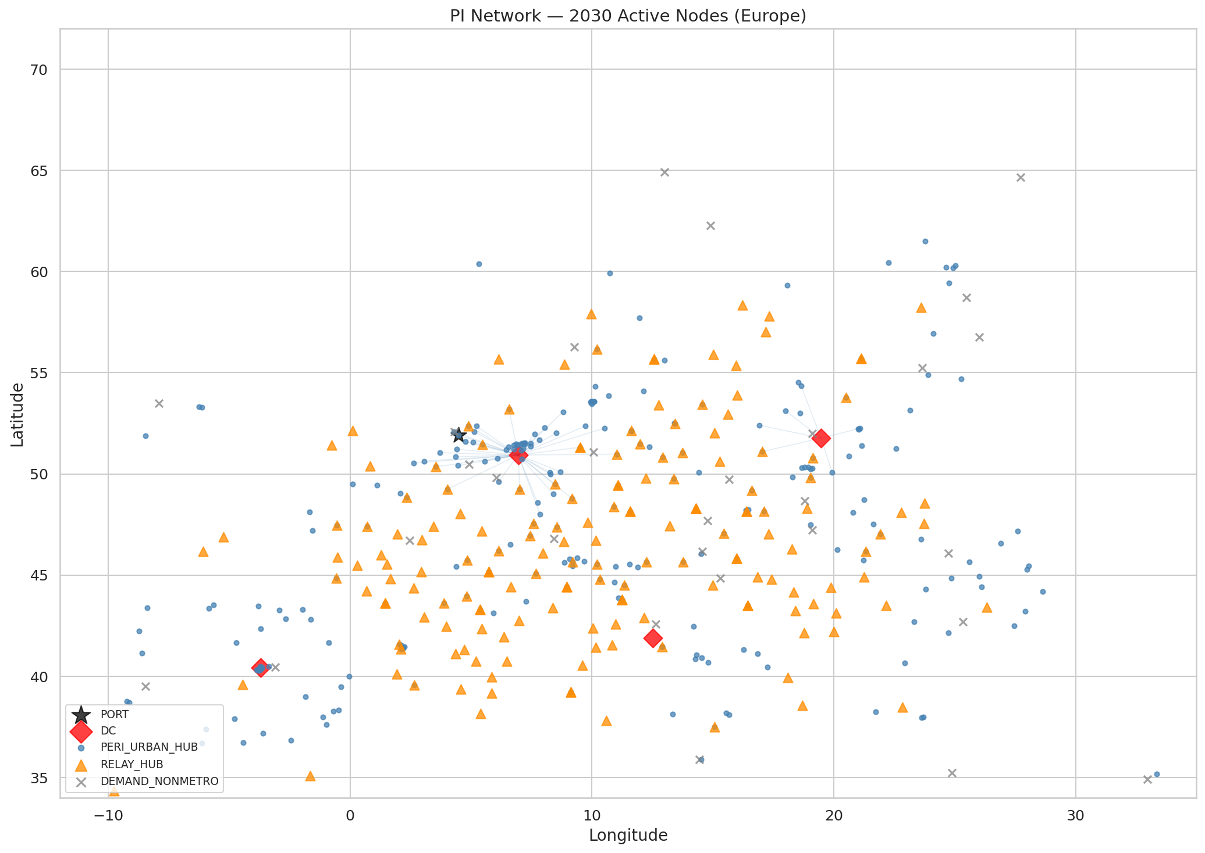

Simulation Results
The yearly pipeline activates nodes, builds routes, simulates demand and service, sizes DC capacity, and then evaluates cost, carbon, autonomy, and profitability. In 2030 the PI design reaches 97.4% feasible-pair coverage with 69.28% relay readiness. Mean service OTD is 11.45 hours and the p95 is 28.19 hours, which shows the network is fast on average but still carries a long multi-hop tail. Container and packaging logic materially improve transport density: the PI design cuts pallet need by 33.3%, TEU need by 57.9%, and unit cube by 40.0%. In 2030 that reduces ocean loads from 2,838 TEUs to 1,194 TEUs while supporting a PI margin of EUR 75.0M (75.69%).
Figure 2. Monte Carlo OTD output used for Task 5 service assessment.
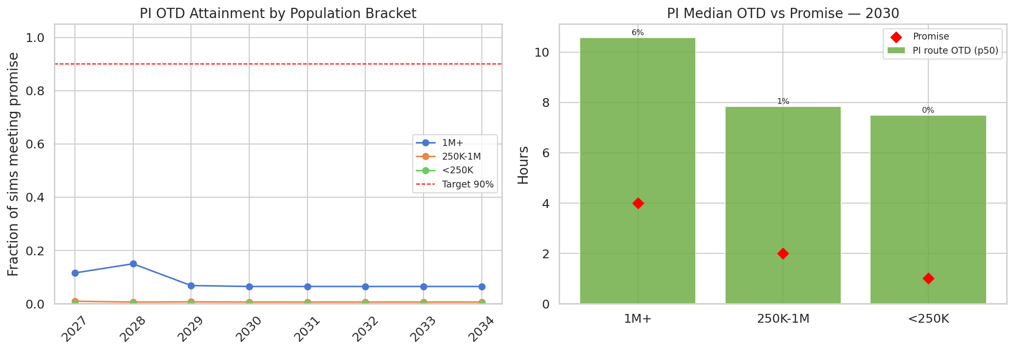
Figure 3. Simulation-backed DC capacity sizing across the rollout horizon.
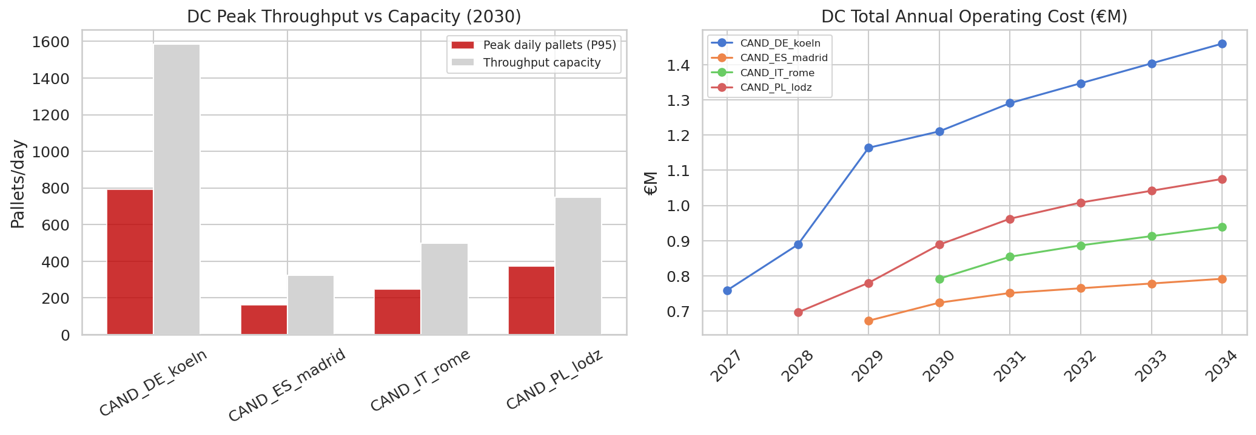

Comparison Against the Old Network
The strongest evidence for the PI design is the matched comparison against the Task 4 old network. In 2030 realized demand rises from 73,403 units to 218,466 units, a 197.6% uplift. Transport cost per unit falls from EUR 354.05 to EUR 69.26, and matched network-scope cost per unit falls from EUR 1084.48 to EUR 110.29, a 89.8% reduction. Across the full 2027-2034 horizon, PI delivers 201.5% more realized units, 78.2% lower transport cost per unit, and 88.2% lower network-scope cost per unit.
The tradeoff is orchestration complexity rather than economics. In 2030 the remaining gaps are a 2.60 percentage-point coverage shortfall to full coverage, 30.7% of the relay mesh not fully ready, and a 16.74-hour gap between mean and p95 service time. These are consistent with a network that wins on reach and unit economics by adding many more operating touchpoints and more multi-hop coordination.
Figure 4. Task 5 versus Task 4 matched KPI comparison.
