tTask 2 Report
Identification of Major Global, Continental, and National Interface Nodes
for the Northeast Megaregion
Executive Summary
- The Northeast megaregion’s global freight interface is anchored by Hampton Roads and Philadelphia on the maritime side, and by a concentrated air gateway system led by JFK, Philadelphia, and Newark.
- Continental connectivity is dominated by New York’s northern gateways—especially Buffalo Niagara Falls, Champlain–Rouses Point, and Alexandria Bay—with Vermont and Maine crossings forming the supporting tier.
- National interfaces are strongly concentrated in a limited set of external domestic hubs, especially in Ohio, Texas, Illinois, Kentucky, North Carolina, and Michigan.

1. Objective
The objective of Task 2 was to identify the principal global, continental, and national interface nodes through which the Northeast megaregion connects with external freight systems. These interface nodes represent the main gateways linking the megaregion to overseas markets, Canada-facing continental flows, and major domestic freight hubs elsewhere in the United States. The task also aimed to estimate the expected flow intensity associated with these nodes and to represent them through distinct maps for clarity and interpretability.

2. Methodology

2.1 Isolation of External Freight Flows
The county-to-county freight flow matrix developed in Task 1 was used as the analytical base. All flows were classified relative to the Northeast megaregion boundary into internal flows, inbound flows, and outbound flows. Task 2 focused exclusively on inbound and outbound flows because these represent the external interfaces of the megaregion rather than the internal freight structure.

2.2 Identification of Candidate Interface Nodes
Three classes of candidate interface nodes were prepared. Global interface candidates were represented by strategic seaports and major cargo airports. Continental interface candidates were represented by freight-relevant U.S.–Canada border crossings in New York, Vermont, New Hampshire, and Maine. National interface candidates were derived directly from the external county-level freight matrix by identifying the largest outside domestic counties interacting with the Northeast.

2.3 Throughput Estimation Logic
A pragmatic first-pass throughput allocation logic was adopted. Global maritime nodes received the external water-related flow bucket. Global air nodes received the air-relevant external flow bucket, with airport throughput allocated in proportion to the aggregated estimated area of associated air-to-truck freight facilities (EST_AREA). Continental interface intensity was represented using border crossing activity as a proxy because the domestic county-level freight matrix does not explicitly identify Canadian county counterparts. National interface nodes were weighted using the aggregated external freight tonnage derived directly from the county flow matrix.

2.4 Visualization Approach
Three separate interface maps were produced to avoid visual clutter and preserve interpretability: a global interface map, a continental interface map, and a national interface map. This separation allowed each interface class to be examined at the appropriate geographic scale.
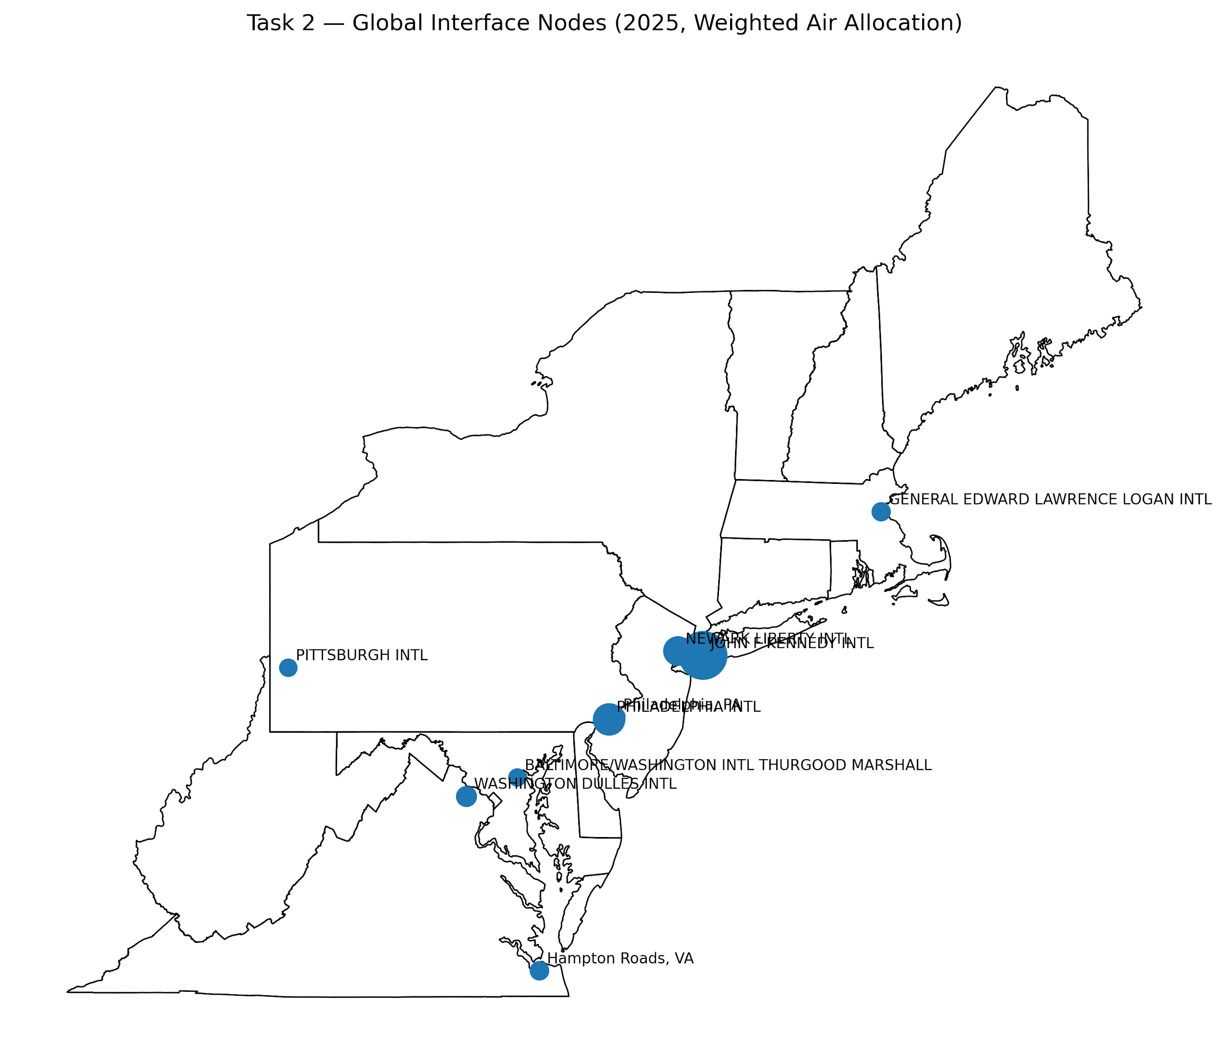

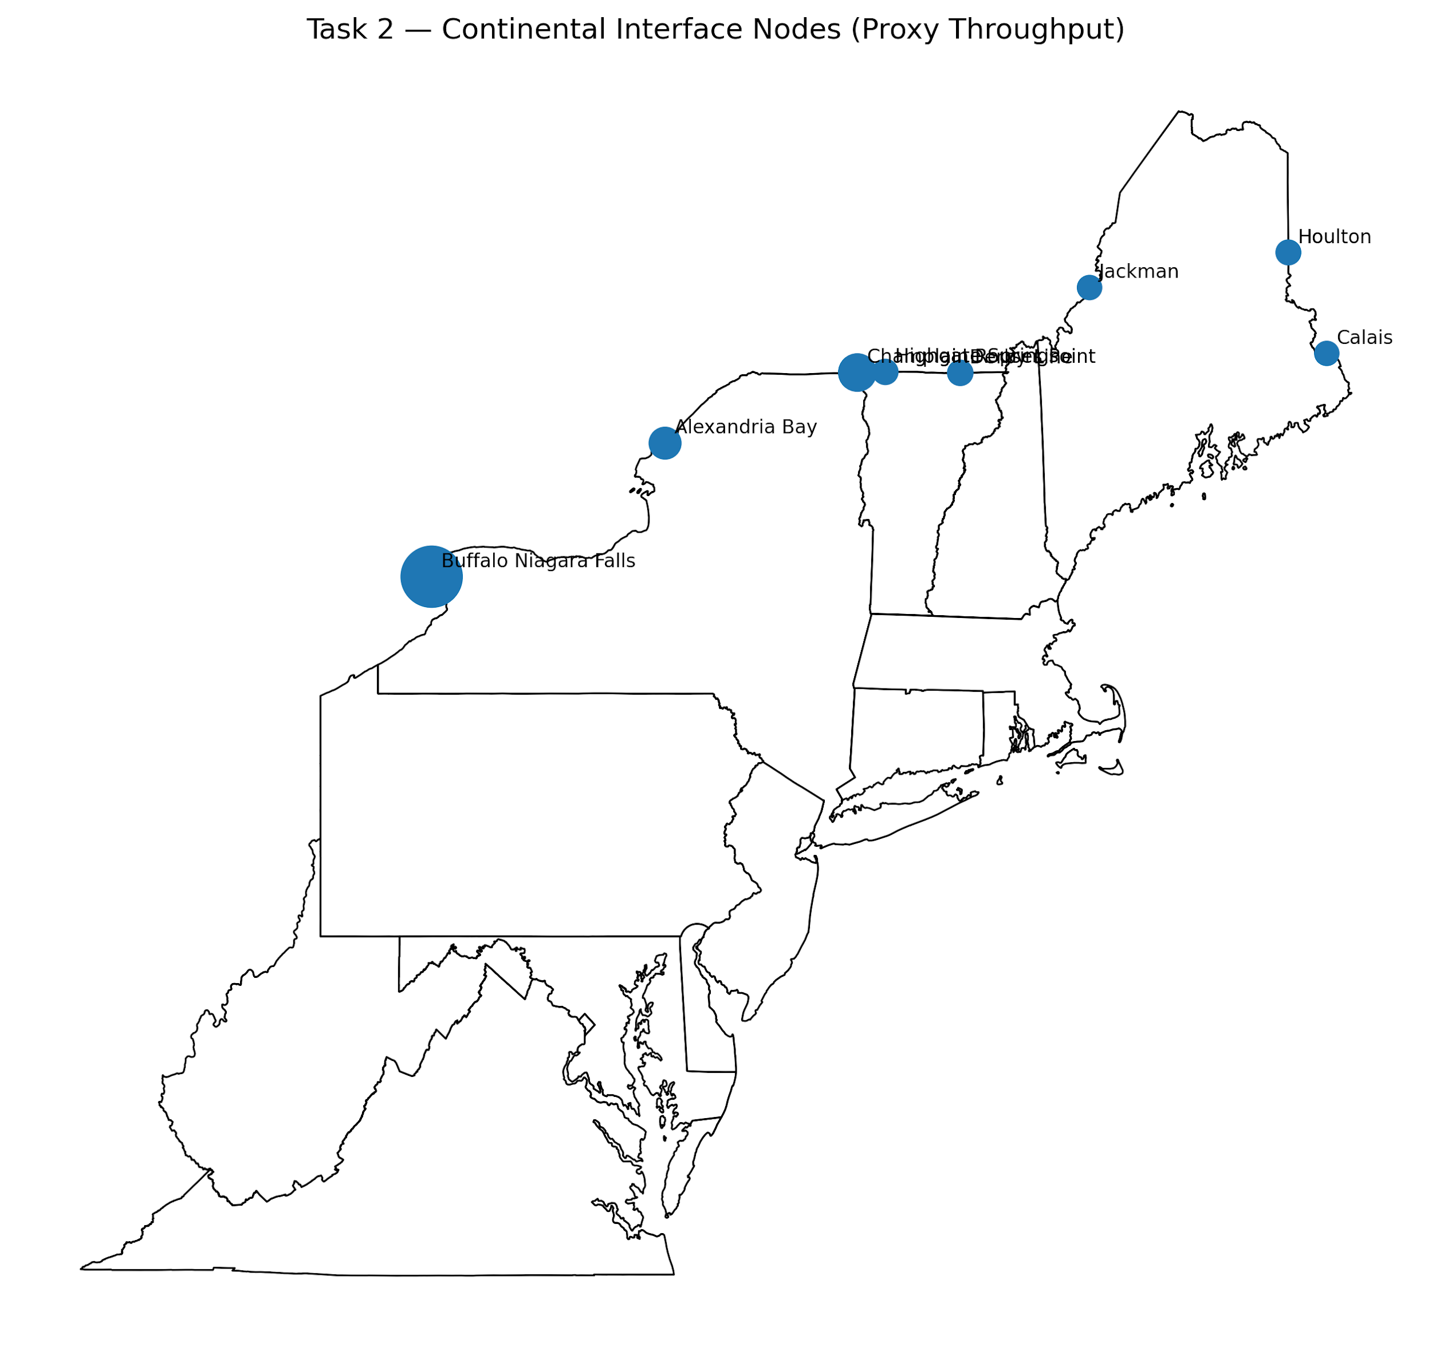

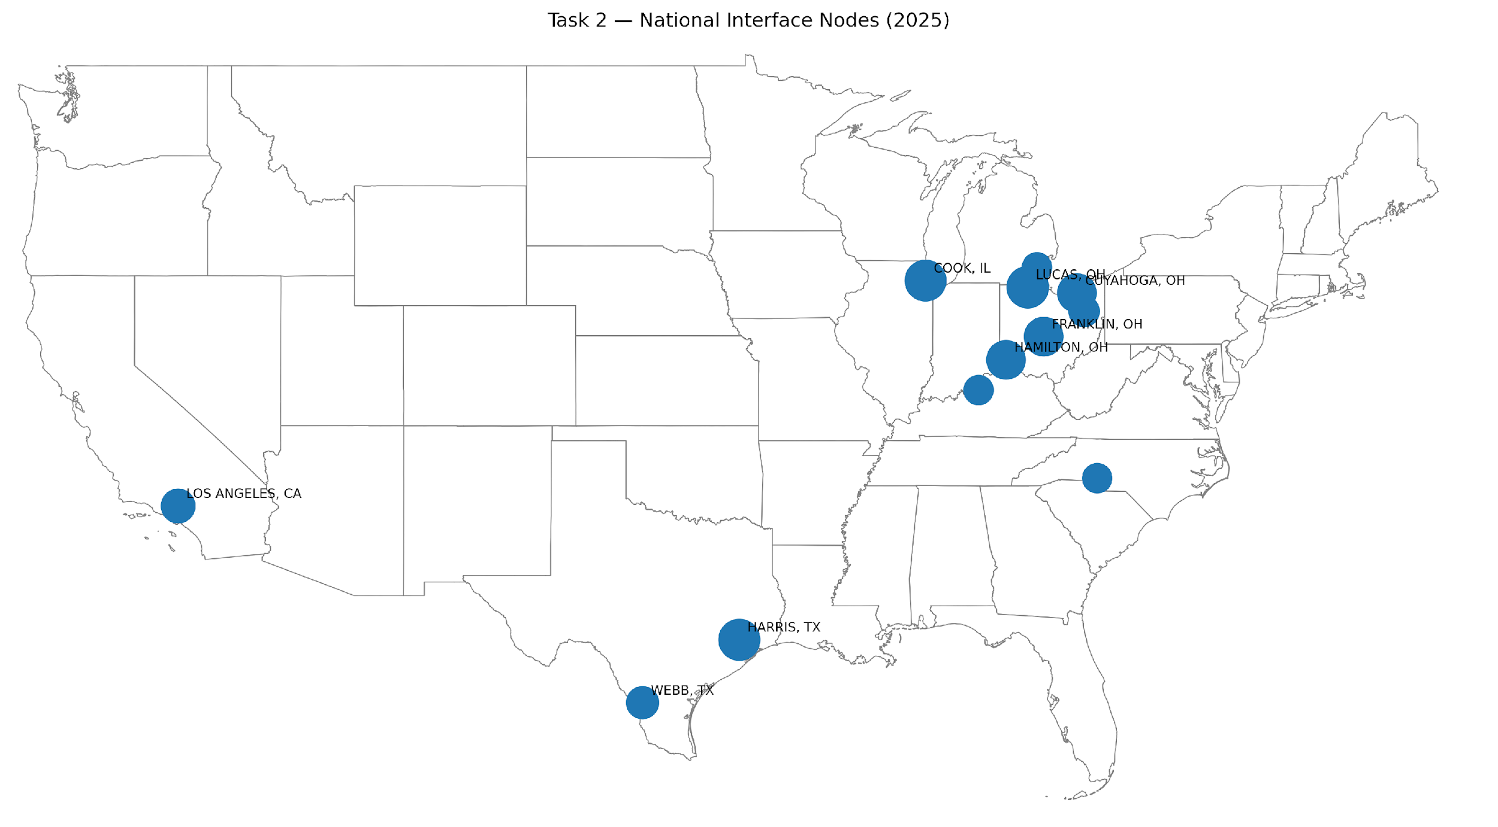

3. Results

3.1 Global Interface Nodes
The global interface structure of the Northeast megaregion is represented by a combination of maritime gateways and cargo airports. The strategic seaport analysis identified two principal maritime gateways: Hampton Roads, Virginia, and Philadelphia, Pennsylvania. Together, these nodes form the most relevant maritime gateway pair in the available strategic seaport dataset.
The cargo-air analysis produced a more differentiated hierarchy after weighting airport throughput by aggregated air-to-truck facility area. The dominant global air gateways are John F. Kennedy International Airport (JFK), Philadelphia International Airport (PHL), and Newark Liberty International Airport (EWR). Secondary but still important air gateways include Washington Dulles, Boston Logan, Pittsburgh International, and Baltimore/Washington International. This weighted allocation is materially more realistic than an equal-split assumption because it reflects actual freight-supporting facility footprint.

Node name | State | Type | Interpretive weight
JOHN F KENNEDY INTL | NEW YORK | Cargo airport | 49.3%
PHILADELPHIA INTL | PENNSYLVANIA | Cargo airport | 19.2%
NEWARK LIBERTY INTL | NEW JERSEY | Cargo airport | 15.3%
WASHINGTON DULLES INTL | DIST. OF COLUMBIA | Cargo airport | 5.5%
GENERAL EDWARD LAWRENCE LOGAN INTL | MASSACHUSETTS | Cargo airport | 4.0%
PITTSBURGH INTL | PENNSYLVANIA | Cargo airport | 3.3%
BALTIMORE/WASHINGTON INTL THURGOOD MARSHALL | MARYLAND | Cargo airport | 3.2%
Hampton Roads, VA | VA | Seaport | Maritime gateway
Philadelphia, PA | PA | Seaport | Maritime gateway
Table 1. Final global interface nodes.

3.2 Continental Interface Nodes
The continental interface structure is dominated by New York, Vermont, and Maine border crossings. Buffalo Niagara Falls is by far the strongest Canada-facing gateway in the available border dataset, followed by Champlain–Rouses Point and Alexandria Bay. Derby Line and Highgate Springs reinforce Vermont’s role as a supporting interface belt, while Houlton, Jackman, and Calais provide an important Maine tier of continental connectivity.
Because the county-level freight matrix used for the analysis is domestic and does not explicitly identify Canadian county counterparts, continental node intensity was represented using freight-relevant border crossing activity as a proxy rather than by direct OD assignment. This remains a sound first-pass approach for identifying the most important Canada-facing gateways.
Node name | State | Type | Proxy throughput
Buffalo Niagara Falls | New York | Border crossing | 30,162,118
Champlain Rouses Point | New York | Border crossing | 9,776,473
Alexandria Bay | New York | Border crossing | 6,417,140
Derby Line | Vermont | Border crossing | 3,204,800
Highgate Springs | Vermont | Border crossing | 3,179,169
Houlton | Maine | Border crossing | 2,991,741
Jackman | Maine | Border crossing | 2,777,799
Calais | Maine | Border crossing | 2,738,811
Table 2. Final continental interface nodes.

3.3 National Interface Nodes
The national interface structure was derived directly from the external freight matrix and reveals a strong concentration of external domestic connectivity with the Midwest, Texas, and selected major U.S. logistics corridors. Ohio is especially prominent, with Lucas, Franklin, Cuyahoga, Hamilton, and Stark counties all appearing in the final node set. Harris County and Webb County highlight the importance of Texas freight corridors, while Cook County, Illinois reinforces the structural role of the Chicago region.
The final national interface shortlist shows that the Northeast megaregion is deeply connected to a relatively small number of high-intensity domestic hubs rather than to a uniformly distributed national field. This is analytically important because it suggests that later regional and gateway hub design tasks should pay special attention to these concentrated external corridors.
Node name | State | Type | 2025 throughput
LUCAS, OH | OH | External domestic hub | 24,970
HARRIS, TX | TX | External domestic hub | 24,363
COOK, IL | IL | External domestic hub | 24,108
FRANKLIN, OH | OH | External domestic hub | 21,339
CUYAHOGA, OH | OH | External domestic hub | 21,279
HAMILTON, OH | OH | External domestic hub | 21,234
LOS ANGELES, CA | CA | External domestic hub | 15,785
WEBB, TX | TX | External domestic hub | 13,995
STARK, OH | OH | External domestic hub | 12,445
JEFFERSON, KY | KY | External domestic hub | 11,356
MECKLENBURG, NC | NC | External domestic hub | 11,290
WAYNE, MI | MI | External domestic hub | 11,273
Table 3. Final national interface nodes.

4. Key Insights
- The Northeast’s external gateway system is distinctly multi-layered. Global access is provided by maritime gateways and a concentrated air network, continental access is organized around a limited set of strong northern crossings, and national access is dominated by a relatively small set of powerful domestic freight hubs.
- Global air connectivity is more concentrated than global maritime connectivity. The weighted air allocation shows that JFK, Philadelphia, and Newark dominate the global air layer, while the maritime layer is anchored by only two strategic seaport gateways in the available dataset.
- New York dominates the continental gateway system. Buffalo Niagara Falls, Champlain–Rouses Point, and Alexandria Bay together confirm that New York functions as the principal northern continental interface belt for the Northeast megaregion.
- Domestic external connectivity is heavily concentrated in the Midwest and Texas. The repeated appearance of Ohio counties and major Texas hubs indicates that the Northeast’s domestic external structure is deeply tied to a limited number of strong inland and corridor-based freight systems.

5. Limitations
This Task 2 analysis provides a strong and defensible first-pass structure, but several limitations should be acknowledged. First, the county-level freight matrix is domestic and therefore does not explicitly identify Canadian county counterparts. As a result, continental interface intensity was represented using border crossing activity proxies rather than direct OD assignment to Canada.
Second, the maritime shortlist was derived from the available strategic seaport dataset rather than from a complete inventory of all Northeast port facilities. The identified maritime nodes should therefore be interpreted as a strategic first-pass shortlist rather than as an exhaustive seaport system.
Third, global air throughput was allocated using air-to-truck facility area rather than direct airport cargo tonnage. Although this remains a proxy-based approach, it is materially more realistic than equal allocation and is appropriately grounded in freight-supporting infrastructure evidence.

6. Conclusion
Task 2 successfully identified the major global, continental, and national interface nodes of the Northeast megaregion and established a transparent first-pass estimate of their relative importance. The results show that the megaregion’s global interfaces are anchored by Hampton Roads, Philadelphia, and a concentrated air-gateway system led by JFK, Philadelphia, and Newark; its continental interfaces are dominated by Buffalo Niagara Falls and a small set of strong northern border crossings; and its national interfaces are strongly tied to a concentrated set of external domestic freight hubs, especially in Ohio, Texas, Illinois, Kentucky, North Carolina, and Michigan.
Taken together, these findings provide a strong foundation for the subsequent stages of megaregional freight network design, including county clustering, selection of regional hubs, and development of lower-tier territorial and gateway structures.

