
GENERAL SIR JOHN KOTELAWALA DEFENCE UNIVERSITY
Faculty of Computing
FINAL PROJECT REPORT
CS2993 – Group Project in Software Development
Laboratory Information System (LIS) for Medical Laboratories with Semi-Automatic Equipment
Group 02
Project Supervisor: Dr. BVKI Vidanage
Project Time Frame: March 2026 – December 2026
Reg. No | Name | Degree
7151 | AAN Hirundika | Computer Science
D/COE/25/0003 | WMDGJ Warnasooriya | Computer Engineering
D/COE/25/0004 | Kavindu Kavishka | Computer Engineering
D/BSE/25/0014 | PV Kavinda | Software Engineering
D/BCS/25/0017 | P Rohit | Computer Science
D/BCS/25/0019 | Imesha Rajapaksha | Computer Science

Submitted in partial fulfilment of the requirements of the Bachelor of Science in Computer Science / Computer Engineering / Software Engineering degree programmes.

Table of Contents

Executive Summary 4
Part A — Project Proposal 7
A1. Introduction 7
A1.1 Background of the Study 7
A1.2 Problem Identification 8
A1.3 Objectives 9
A2. Literature Review 10
A2.1 Introduction 10
A2.2 Existing Systems / Related Work 11
A3. Proposed Methodology 13
A3.1 Flow Diagram 13
A3.2 Functional Requirements 14
A3.3 Non-Functional Requirements 14
A3.4 Technologies and Tools Review 15
A3.5 Proposed Testing and Evaluation Method 15
A4. Time Frame 16
A5. Budget 16
A6. References 17
Part B — Analysis Report 19
B1. Introduction 19
B1.1 Background of the Report 19
B1.2 About Life Care Medical Laboratory 20
B1.3 Problem Statement 20
B1.4 Terminology and Definitions 21
B2. Fact Finding 21
B2.1 Justification of Fact-Finding Techniques 23
B2.2 Synthesis of Fact-Finding Results 24
B2.3 Completeness and Quality of Information 24
B3. Description of the Current System 25
B3.1 Narrative Description 26
B3.2 Organisational Chart and System Breakdown 27
B3.3 Process Flows — Data Flow Diagrams 28
B3.4 Problems and Limitations 30
B3.5 Scope and Constraints 30
B4. Requirements Specification for the New System 32
B4.1 Functional Requirements 33
B4.1.1 Detailed Requirements with Acceptance Criteria 35
B4.2 Non-Functional Requirements 35
Part C — Design Report 35
C1. Description of the New System 37
C1.1 Narrative 37
C1.2 Illustrations Supporting the Narrative 39
C2. Detailed Design 47
C2.1 Data Design 53
C2.2 Architectural Design 55
C2.3 Procedural Design 57
C2.4 Process Flows 60
C2.5 Activity Diagrams 60
C2.6 Interface Design 61
C3. Hardware and Software Selection 63
C3.1 Development Hardware and Software Equipment 63
C3.2 Implementation Hardware and Software Equipment 64
Part D — Development and Implementation Report 65
D1. Software Development: Testing 66
D1.1 Justification of Testing Technique 67
D1.2 Choice and Design of Test Cases 67
D1.3 Test Logs 68
D2. Implementation: Conversion and Training Plan 69
D2.1 Justification of Conversion Technique 69
D2.2 Conversion Schedule and Resource Plan 70
D3. Implementation: User Guide 71
D3.1 System Requirements and Installation 71
D3.2 First-Time Login and Security Setup 72
D3.3 Operating Instructions by Role 74
D3.4 Description of Main Functions 74
D3.5 General Error Handling 75
D4. Critical Appraisal 78
D4.1 Group Critical Appraisal 78
D4.2 Individual Critical Appraisal 79
Appendices 80
Appendix A: Interview Summary 81
Appendix B: Observation Summary 82
Appendix C: System Models & Sampling Data 83
Appendix D: Sample Excel Template Analysis 86
Appendix E: Full Test Logs 90
Appendix F: List of Abbreviations 90

Executive Summary
This report documents the complete development of a web-based Laboratory Information System (LIS) for medical laboratories operating with semi-automatic testing equipment, undertaken by Group 02 of the Faculty of Computing, General Sir John Kotelawala Defence University, under the supervision of Dr. BVKI Vidanage. The project was commissioned following an initial feasibility assessment at Life Care Medical Laboratory, a small-to-medium diagnostic facility in Piliyandala, Sri Lanka, processing approximately 50–100 samples daily with a staff of five to eight members. The laboratory's operations were entirely dependent on fragmented, manual processes: paper appointment logbooks, handwritten registration forms and sample registers, individually maintained Microsoft Excel templates for report generation, and standalone billing software with no connection to patient records. The objective of the project was to replace this decentralised arrangement with a single, secure, centralised platform covering the full laboratory workflow from appointment booking to report delivery.
The development followed the System Development Life Cycle across four documented phases: proposal, analysis, design, and development & implementation. During the analysis phase, four complementary fact-finding techniques — interviews, document analysis, direct observation, and stratified random sampling — were employed to establish an accurate picture of current operations. The findings were decisive. Manual report generation was measured at an average of 16.5 minutes per patient, producing patient wait times of up to 45 minutes during the morning peak. Sampling of 75 historical records across haematology, biochemistry and microbiology confirmed a field-level transcription error rate of 6.4%, with errors including transposed digits, missing units and incorrect patient associations — a direct patient-safety risk. Document analysis revealed at least five distinct Excel report templates in simultaneous circulation, with inconsistent reference ranges and units, while all records were stored on individual workstations with no centralised database, no audit trail and no backup mechanism. These findings were consolidated into a requirements specification comprising ten prioritised functional requirements and a comprehensive set of non-functional requirements covering security, performance, responsiveness, compatibility, data integrity, backup and cost.
The proposed system is a three-tier web application in which a React.js and Tailwind CSS presentation layer communicates through secure RESTful APIs with a Node.js/Express.js application layer, backed by a PostgreSQL database acting as the single source of truth. The design phase produced a complete data design — an Entity-Relationship diagram of ten entities, a full data dictionary, and a schema normalised to Third Normal Form — together with an architectural design dividing the system into nine cooperating modules (authentication, appointment, patient, sample, laboratory test, report generation, billing, notification and user management), procedural designs for the four core workflows, and an interface design applying consistent layout principles across role-specific screens for administrators, receptionists, laboratory technicians and patients. Hardware and software selections were made with explicit justification, keeping the solution within the client's initial budget of LKR 10,500 by relying exclusively on open-source technologies.
Development was organised around six module ownership areas corresponding to the six group members: authentication & user management, appointments, sample & test management, results & reporting, invoicing, and administration, security & audit. The implemented system delivers the complete patient journey: online appointment booking with QR code confirmation, walk-in registration and barcode-based sample check-in at reception, structured manual result entry with automatic validation against reference ranges and abnormal-value flagging, automated PDF report generation using a single standardised template, integrated invoicing with automatic payment status calculation, real-time status updates to reception and patient screens via Socket.io, automated SMS/email notification capability, public barcode-based report verification, and a comprehensive audit trail with role-based access control, JWT session management (limited to three concurrent sessions) and optional two-factor authentication.
Testing was planned systematically rather than generically: equivalence partitioning and boundary value analysis were applied to the declarative input-validation layer, integration testing to the multi-table transactional workflows, and dedicated security testing to the role-based access control middleware and the session and two-factor authentication logic. Every test case was designed against a named rule or code path, and a full test log of over thirty cases was maintained. This process surfaced two genuine defects — a missing lower-bound validation on payment amounts in the invoicing module and an incorrect SQL parameter index in the report-template update query — both of which were logged, assigned for correction, and scheduled for regression retesting, demonstrating the practical value of the cross-module testing pass.
Implementation is planned as a phased parallel-running conversion over eight weeks, chosen in preference to direct cutover or pilot conversion because the system handles safety-critical clinical data in a single-site laboratory. Each module is introduced alongside the existing paper process and is only retired after two consecutive days of zero reconciliation discrepancies, with role-specific training delivered immediately before each phase on the live system. A complete user guide covering installation, first-time security setup, role-based operating instructions, main functions and error handling accompanies the system.
In critical appraisal, the group considers the project a success: a working, role-segmented LIS covering the entire patient journey was delivered, with a coherent architecture in which six functional areas map cleanly onto six independent modules sharing one normalised PostgreSQL schema. The principal difficulties encountered were the absence of an automated test framework, the coordination overhead of six developers sharing one database schema, and the two defects discovered during system testing. Future enhancements identified include an automated regression test suite, login rate-limiting, extended shared validation, activation of patient notification preferences, a formal status state machine, and a second-technician review step before result release. The completed system directly resolves every problem recorded in the analysis phase: it eliminates the 15–20 minute manual report generation process, removes transcription-error pathways through validated structured entry, replaces five inconsistent Excel templates with one standardised automated report, centralises all laboratory data with full audit trails and backup capability, and gives patients online booking, notification and report access for the first time — all within a budget appropriate to a small independent laboratory.

Part A — Project Proposal

A1. Introduction

A1.1 Background of the Study
Medical laboratories form a critical component of healthcare delivery, processing diagnostic tests that inform clinical decision-making. However, many laboratories in developing regions continue to rely on manual, paper-based systems despite utilising semi-automatic testing equipment. This disconnect between testing technology and information management creates operational inefficiencies, increases error rates, and compromises patient satisfaction.
This project concerns a small to medium-sized diagnostic laboratory — Life Care Medical Laboratory — serving approximately 50,000 patients annually and processing 50–100 samples daily. The facility employs five to eight staff members and operates with semi-automatic equipment requiring manual result transcription. Current operations utilise fragmented and decentralised tools including paper logbooks, multiple Excel spreadsheets for report generation, and standalone billing software, resulting in data silos, version control issues, and significant workflow bottlenecks. Each staff member maintains their own Excel files, leading to inconsistent data, duplication of effort, and lack of centralised patient records.
With the decision to implement React.js as the frontend technology, the proposed system delivers a modern, responsive user experience that adapts to the various devices used in laboratory settings, including desktops, tablets and mobile phones. React's component-based architecture enables rapid development of reusable UI elements, ensuring consistency across modules while reducing development time and maintenance effort, and the React ecosystem provides numerous free, open-source libraries that eliminate licensing costs while delivering enterprise-grade functionality.
The proposed system replaces the current Excel-based report generation with automated, template-driven report creation, eliminating manual formatting errors and ensuring consistent branding. By centralising the decentralised arrangement, all laboratory data is stored in a single database with proper access controls, audit trails, and real-time synchronisation across all staff members.

A1.2 Problem Identification
The existing system operates through eight sequential manual steps:
1. Appointment scheduling via telephone and paper logbook.
2. Patient registration using handwritten forms, producing duplicate entries across staff.
3. Manual sample collection logging in paper registers.
4. Test processing on semi-automatic equipment.
5. Manual result transcription from equipment printouts.
6. Excel-based report generation — each staff member creates reports in their own Excel templates, leading to inconsistent formatting, version control issues, manual data entry errors, no centralised repository of generated reports, and difficulty retrieving historical reports.
7. Manual billing entry in standalone software disconnected from patient records.
8. Phone-based result notification with physical report collection.

Problem Area | Current Issue | Impact
Data Decentralisation | Each staff member maintains separate Excel files | No single source of truth; conflicting patient records
Excel Report Generation | 15–20 minutes per report; manual formatting | 30–45 min total per patient; formatting inconsistencies
Version Control | Multiple Excel template versions in circulation | Reports with different formats; branding inconsistency
Data Entry Errors | Manual transcription to Excel | 5–8% error rate; patient safety risks
Data Silos | Reception, lab and billing use different systems | Duplicate data entry; reconciliation challenges
Report Retrieval | Reports stored in staff personal folders | Difficult to find historical reports; no audit trail
Backup Issues | No centralised backup of Excel files | Risk of data loss; no disaster recovery
Compliance | No audit trail of who modified what | Regulatory non-compliance risk
Staff Efficiency | 5–8 staff spending 25–30 hours/week on manual Excel work | High operational costs; staff burnout
Patient Experience | No online access; delayed results | Poor satisfaction; competitive disadvantage
Table A1: Critical problems with the current decentralised Excel-based system

A1.3 Objectives
1. Centralise all laboratory data and billing systems in one web-based platform.
2. Automate report generation for patients.
3. Enable online appointment booking for medical tests.
4. Implement automated patient notifications via SMS/email.
5. Develop a cost-effective solution using open-source technologies.

A2. Literature Review

A2.1 Introduction
A Laboratory Information System (LIS) is a specialised information management system designed to support laboratory workflows including patient registration, test ordering, sample tracking, result processing, reporting, and billing. An LIS plays a critical role in ensuring diagnostic accuracy, traceability, and regulatory compliance in healthcare institutions.
According to the World Health Organization (WHO), strengthening laboratory systems through digital information management improves diagnostic efficiency, reduces turnaround time, and enhances patient safety [1]. Similarly, the Centers for Disease Control and Prevention (CDC) emphasises that laboratory information systems are essential components of public health infrastructure and quality assurance programs [5]. Modern LIS platforms are frequently integrated with Hospital Information Systems (HIS) and Electronic Health Records (EHR), allowing seamless data exchange across clinical departments.

A2.2 Existing Systems / Related Work
The Sri Lankan laboratory landscape presents a mix of solutions, with significant variation between major hospital laboratories and smaller independent or branch laboratories.
Nawaloka Laboratory Services. Nawaloka Hospital's main laboratory in Colombo operates with a partially automated commercial LIS implemented approximately eight years ago, customised for local requirements. However, its five or more branch laboratories and collection centres across Colombo and suburbs operate with no integration into the main system, relying entirely on Excel spreadsheets and paper-based records. Staff at these branches frequently maintain separate Excel files for the same patients, resulting in conflicting records and delayed data retrieval [2]. This branch-level fragmentation directly mirrors the operational context of the proposed system.
Durdans Hospital Laboratory Services. Durdans Hospital operates a bespoke LIS integrated with its main hospital information system, developed specifically for internal use and not commercially available. Its collection centres across the Colombo metropolitan area, however, depend on Excel-based patient registration and result tracking. Results are telephoned through to centres, manually re-entered into Excel, and then printed for patients. During high-demand periods, staff report that Excel files take two to three minutes merely to save when handling over 200 patients per day [6]. This demonstrates a critical scalability limitation of spreadsheet-driven workflows that the proposed centralised LIS resolves.
Asiri Laboratory Services. Asiri Laboratory Services centralises its main operations at Asiri Central and Asiri Surgical hospitals using a hospital-integrated LIS. However, its multiple branch and collection centre locations operate with limited or no integration to the main system, relying on a mix of Excel-based and paper-based workflows [7]. This further confirms the widespread pattern of disconnected branch operations in Sri Lankan laboratory services, a gap that the proposed web-based LIS directly addresses through a single centralised platform.
Independent Small and Medium Laboratories. Sri Lanka is estimated to have 150 to 200 independent diagnostic laboratories and over 500 neighbourhood laboratories, employing between 2 and 15 staff members. Over 90% of these facilities rely on Excel for report generation, with manual transcription from semi-automatic equipment being the dominant workflow [8].

- Over 90% use Excel for report generation
- Manual result transcription from semi-automatic equipment
- No centralised patient database
- Report retrieval takes 15–20 minutes on average
- High error rates (estimated 5–8%)
- No patient portal or online services
Research shows that many laboratories in developing regions continue to rely on manual processes and spreadsheet-based systems due to financial constraints [9]. Excel-based report generation remains common because of low implementation cost and user familiarity. However, spreadsheet-driven workflows introduce several risks: data duplication, version control problems, lack of centralised storage, increased transcription errors, and absence of audit trails.
A study on laboratory strengthening initiatives found that integrated LIS deployment significantly reduces data errors and improves workflow efficiency [10]. While commercial LIS solutions exist for large, fully automated hospitals, limited research focuses on affordable web-based LIS platforms, systems tailored for semi-automatic laboratory equipment, and solutions optimised for small-to-medium laboratories in developing countries. Most enterprise-level LIS products are costly and require extensive analyser integration capabilities, making them unsuitable for smaller laboratories relying on manual transcription workflows. There is therefore a clear need for a centralised, cost-effective, web-based LIS designed specifically for semi-automatic laboratory environments.

A3. Proposed Methodology

A3.1 Flow Diagram
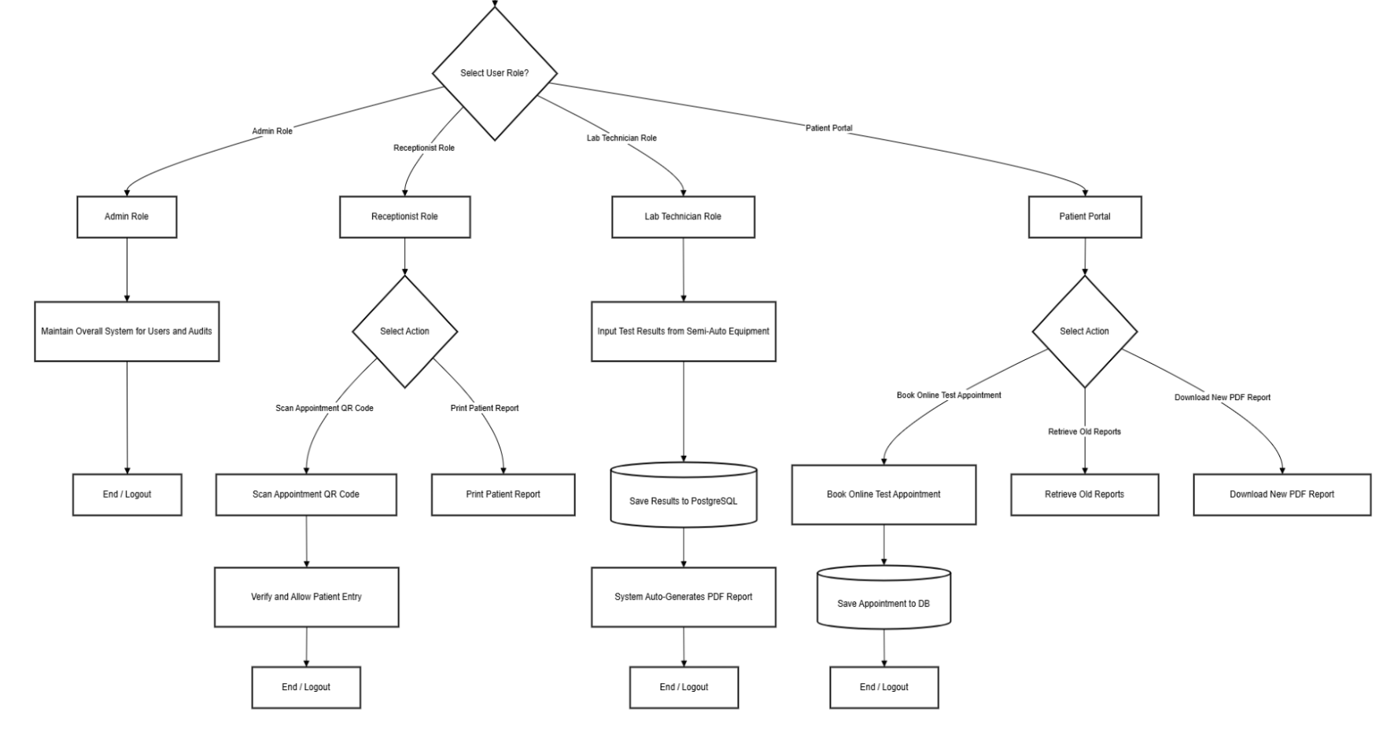
Figure A1: Flow diagram of the proposed system
The system workflow begins with the patient booking an appointment through the online portal. On arrival, the patient is registered in the centralised database, and a barcode-labelled sample is collected. Laboratory technicians process the sample using semi-automatic equipment and manually enter the test results into the system via a structured data entry interface. The system then automatically generates a formatted PDF report using a standardised template, simultaneously triggers SMS or email notifications to the patient, and processes the billing entry. The patient may collect the report physically or access it digitally through the patient portal.
Administrators and supervisors can monitor the complete workflow in real time through the management dashboard. This end-to-end automated flow eliminates all paper-based hand-offs, manual Excel report generation, and disconnected billing processes present in the current system.

A3.2 Functional Requirements
ID | Requirement | Priority
FR-01 | Online appointment booking | High
FR-02 | Manual result entry for semi-automatic equipment | High
FR-03 | Automated report generation with templates | High
FR-04 | SMS/email notification system | High
FR-05 | Role-based access control (4+ roles) | Medium
Table A2: Functional requirements (initial specification)

A3.3 Non-Functional Requirements
Category | Specification
Security | TLS 1.3 encryption; JWT authentication; role-based access control; secure token storage; HTTPS only
Performance | Page load time < 3 seconds; support 10+ concurrent users; optimised with code splitting and lazy loading
Responsiveness | Full functionality on desktops, tablets, and mobile devices; responsive design with Tailwind CSS
Compatibility | Cross-browser support for Chrome, Firefox, Safari, Edge (latest versions)
Data | Centralised PostgreSQL database with single source of truth; 99.9% data accuracy; complete audit trail; ACID compliance
Table A3: Non-functional requirements

A3.4 Technologies and Tools Review
Component | Technology
Frontend | React.js, Tailwind CSS
Backend | Node.js
Database | PostgreSQL
Reports | React-PDF
Table A4: Technology stack
The laboratory system implements several cost-effective security measures to safeguard patient and operational data within the project budget. User authentication and role-based access control ensure that only authorised personnel can access sensitive information, while database encryption and SSL/TLS secure both stored and transmitted data. Regular backups, stored either locally or in the cloud, protect against accidental loss or system failures, and audit logs track user actions to maintain accountability and detect potential misuse. Optional features, such as SMS notifications, can be enabled securely without including sensitive medical details, preserving patient privacy. Additionally, keeping all software up to date prevents vulnerabilities from being exploited. Together, these measures provide robust data protection without significant extra cost, balancing security with budget constraints.

A3.5 Proposed Testing and Evaluation Method
The system undergoes a structured testing process to ensure reliability, security, and performance. Unit testing is conducted during development to verify individual modules, followed by integration testing to validate data flow between frontend, backend, and database components. System testing evaluates functional requirements such as appointment booking, result entry, automated report generation, billing integration, and notification services. User Acceptance Testing (UAT) is performed with laboratory staff to ensure usability and workflow compatibility. Performance testing assesses response time and multi-user support, while security testing verifies authentication, role-based access control, and data protection mechanisms. This comprehensive evaluation approach ensures that the system meets both functional and non-functional requirements before deployment.

A4. Time Frame
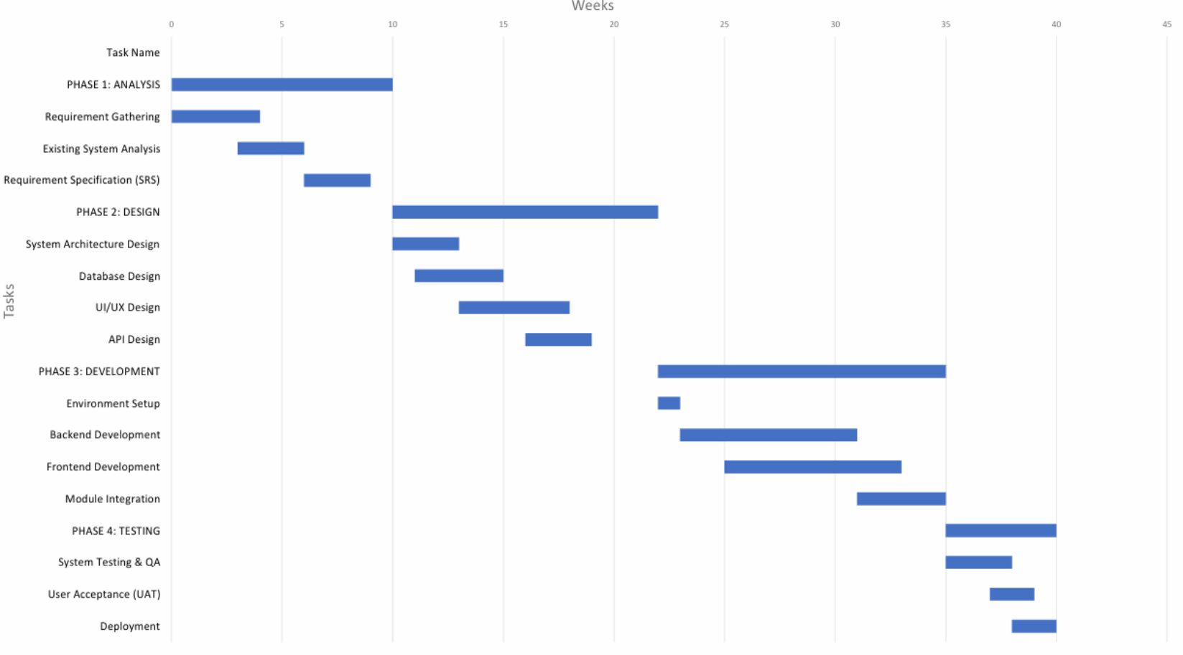
Figure A2: Gantt chart of the project
The project timeline was developed using Microsoft Excel to create a detailed Gantt chart representing all major phases of the system development life cycle. The chart visually illustrates the structured progression of activities across Analysis (10 weeks), Design (12 weeks), and Development and Testing & Deployment (18 weeks), within the planned 40-week duration. Excel was selected due to its flexibility in timeline customisation, task dependency visualisation, and cost-effectiveness. The Gantt chart enables effective monitoring of milestones, resource allocation, and progress tracking throughout the project lifecycle.

A5. Budget
Item | Cost (LKR)
Domain (.com) | 2,500.00
Hosting | 8,000.00
Total | 10,500.00
Table A5: Cost estimation
As per the client's requirement, the proposed system is designed as a low-cost solution utilising open-source technologies to minimise financial overhead. The primary expenses include domain registration (LKR 2,500) and web hosting services (LKR 8,000), resulting in a total estimated cost of LKR 10,500. Since the system is developed using open-source frameworks and tools, no additional licensing fees are required. This cost-efficient approach makes the system highly suitable for small and medium-scale medical laboratories operating within limited budgets.
The SMS notification service is an optional feature. Its activation depends on the volume of laboratory patients and the laboratory's operational priorities. Laboratories can choose to enable SMS notifications to keep patients informed about test updates, but this comes with an additional recurring cost ranging from LKR 39,000 to LKR 78,000 per year. If budget constraints or low patient volume make SMS notifications unnecessary, laboratories may opt not to activate this service, thereby avoiding the extra recurring cost.

A6. References
[1] World Health Organization, Laboratory Quality Management System Handbook, WHO Press, 2011.
[2] S. Liyanage and R. Perera, “Challenges of Laboratory Information Management in Branch Laboratories: A Sri Lankan Perspective,” Sri Lanka Journal of Biomedical Informatics, vol. 3, pp. 12–19, 2020.
[3] M. T. Siddiqui and A. Khan, “Performance Comparison of React.js vs Traditional Web Frameworks in Healthcare Applications,” International Journal of Computer Applications, vol. 175, pp. 1–7, 2020.
[4] World Health Organization, Laboratory Quality Management System Handbook, WHO Press, 2011.
[5] Centers for Disease Control and Prevention, “Laboratory Informatics Overview,” CDC, Atlanta, GA, USA, 2018.
[6] K. P. and N. D., “Operational Bottlenecks in High-Volume Laboratory Settings: A Case Study of Colombo Collection Centers,” Journal of Health Informatics in Developing Countries, vol. 14, p. 2, 2021.
[7] Ministry of Health, Sri Lanka, “Annual Health Bulletin,” Department of Health Services, Colombo, 2022.
[8] A. Mutyambizi, C. P. and C. G., “Laboratory Quality and Accreditation in Low-Resource Settings,” PLoS Medicine, vol. 8, p. 9, 2011.
[9] P. G.-D. et al., “The World Health Organization African Region Laboratory Accreditation Process,” American Journal of Clinical Pathology, vol. 134, pp. 393–400, 2010.
[10] R. L. Wagar, B. Yuan and M. B. Bickel, “Impact of Laboratory Information Systems on Clinical Laboratories,” Clinical Leadership & Management Review, vol. 20, 2006.

Part B — Analysis Report

B1. Introduction
Medical laboratories are essential to healthcare delivery, providing diagnostic services that inform clinical decision-making. In Sri Lanka, many small to medium-sized independent laboratories continue to rely on manual and fragmented processes despite using semi-automatic testing equipment. This disconnect creates operational inefficiencies, increases error rates, and compromises patient satisfaction. As Sri Lanka progresses towards digital healthcare infrastructure, the need for Laboratory Information Systems (LIS) in community-level facilities has become increasingly urgent.

B1.1 Background of the Report
This analysis was commissioned by the Administrator of Life Care Medical Laboratory following an initial feasibility assessment conducted in early 2026. The request for system development arose from growing operational challenges at the laboratory, including increasing patient volumes, escalating error rates in manual data entry, and mounting staff workload due to fragmented, paper-based processes. The group members of this project — comprising students from the Faculty of Computing, General Sir John Kotelawala Defence University — were engaged to conduct a thorough analysis of the current system and propose a suitable Laboratory Information System solution.
The scope of the analysis phase covers fact-finding findings, documentation of the current system, problem analysis, and requirements specification. The design and implementation phases are separate deliverables produced subsequently.

B1.2 About Life Care Medical Laboratory
Life Care Medical Laboratory, located in Piliyandala, Sri Lanka, is a diagnostic facility serving the local community with essential laboratory testing services. The laboratory processes approximately 50–100 samples daily and employs 5–8 staff members across roles including laboratory technicians, receptionists, and an administrator. The facility operates with semi-automatic testing equipment that produces results via printed output or digital displays, requiring manual transcription by technicians.
The laboratory offers testing services across multiple diagnostic categories including haematology, biochemistry, and microbiology. The organisational structure is flat, with the Administrator overseeing all operations, supported by laboratory technicians who handle sample processing and report generation, and receptionists who manage patient registration, billing, and report issuance. This compact structure means that each staff member performs distinct, non-overlapping roles critical to daily operations.

B1.3 Problem Statement
Life Care Medical Laboratory currently uses a decentralised system comprising paper-based appointment logbooks, handwritten sample collection registers, individual Microsoft Excel spreadsheets for report generation, and standalone billing software. These disconnected tools create data silos, inconsistent patient records, and significant manual effort across daily operations. Key problems identified include:
i. Manual transcription of results from semi-automatic equipment, leading to a 5–8% data entry error rate with direct patient safety implications.
ii. Report generation taking 15–20 minutes per patient due to manual Excel formatting, causing 30–45 minute patient wait times during peak periods.
iii. No centralised database; all records stored on individual workstations with no backup mechanism, creating risk of total data loss.
iv. No online access or appointment booking for patients, reducing patient satisfaction and competitive positioning.

B1.4 Terminology and Definitions
Laboratory Information System (LIS): A software platform designed to manage the workflows of a medical laboratory, including patient registration, sample tracking, result entry, report generation, billing, and administrative functions.
Semi-Automatic Equipment: Laboratory analysers that perform the analytical measurement process automatically but require manual sample loading and result reading. The equipment at Life Care outputs results via printed strips or on-screen displays only, with no digital data export capability.
Data Silo: An isolated repository of data controlled by one department or function that is not accessible by other parts of the organisation. Life Care currently operates with multiple silos: patient registration data, test result data, and billing data are all stored separately.

B2. Fact Finding

B2.1 Justification of Fact-Finding Techniques
Four primary fact-finding techniques were employed to understand the current operations at Life Care Medical Laboratory: interviews, document analysis, observation, and sampling. The selection of each technique was directly determined by specific characteristics of Life Care's operations, staff structure, and equipment constraints — not by generic research preferences.
Interviews were selected because Life Care has only 5–8 staff members, making individual face-to-face interviews feasible within three working days without significant disruption to operations. Furthermore, each staff member performs distinct, non-overlapping roles: technicians never perform reception duties, and the receptionist does not process samples. This role separation meant that a single questionnaire or group discussion would have been insufficient — role-specific questioning was necessary to capture the full workflow. Surveys were considered but rejected because Life Care's staff size is too small to yield statistically meaningful survey data, and the informal, undocumented nature of their workflows required interactive follow-up questioning that only interviews could provide.
Document analysis was prioritised because Life Care's semi-automatic equipment produces only printed strip outputs with no digital export capability whatsoever. This means that documents — Excel templates, paper logbooks, handwritten registers, and billing receipts — are the sole permanent records of all laboratory activity. Any alternative technique that did not examine these documents directly would have missed the primary evidence of how the system operates. Document analysis also enabled identification of the five distinct Excel template versions in active circulation, a finding that could not have been discovered through interviews or observation alone.
Observation was selected because Life Care's morning peak period (approximately 8:00 AM to 11:00 AM) concentrates the majority of patient activity into a compact, observable window. Staff interviews had indicated that manual transcription was time-consuming, but the actual duration and frequency of re-entry tasks could only be measured by direct, timed observation. Observation was also essential because staff had not formally measured their own process times; self-reported estimates in interviews proved inaccurate when compared against observed measurements. A three-hour morning observation session was sufficient to cover a representative sample of patient interactions.
Sampling was selected because the population of patient records at Life Care (estimated at several hundred records across the review period) was too large to examine exhaustively, yet individual case studies would have been insufficient to quantify systemic error rates. A stratified random sample of 75 records across haematology, biochemistry, and microbiology test categories was selected to ensure representation of all test types. This approach was practical given the records are stored in accessible Excel files and paper registers, and it produced statistically defensible findings regarding the 5–8% transcription error rate that could not have been derived from interviews or observation alone.

B2.2 Synthesis of Fact-Finding Results

The following key findings were confirmed by multiple independent data sources, strengthening confidence in their validity:
i. Manual transcription time of 15–20 minutes per report: confirmed by technician interviews (self-reported 15 and 20 minutes respectively), direct observation (measured average 16.5 minutes), and Excel file timestamps (consistent with reported durations).
ii. 5–8% transcription error rate: confirmed by technician and administrator interviews (acknowledged data entry mistakes), observation (two errors observed during session), document analysis (template inconsistencies that enable errors), and sampling (calculated 6.4% error rate across 75 records).
iii. No centralised database: confirmed by all five interviewed staff members, observation (separate PCs with isolated file storage), and document analysis (Excel files stored in personal folders with inconsistent naming).
iv. Five distinct Excel template versions in active use: confirmed by document analysis (five templates collected and compared) and technician interviews (each technician acknowledged using their own template).

Technician 1 reported approximately 15 minutes per report while Technician 2 reported 20 minutes. Direct observation recorded an average of 16.5 minutes across multiple cases. The discrepancy is explained by test complexity: simpler haematology panels take closer to 15 minutes while biochemistry panels with more parameters take up to 20 minutes. Conclusive finding: manual report generation takes 15–20 minutes depending on test type.

i. Total staff interviewed: 3 (1 technician, 1 receptionist, 1 administrator) and 1 patient representative.
ii. Total observation duration: 3 hours (8:00 AM – 11:00 AM morning peak session).
iii. Records sampled: 75 (25 haematology, 25 biochemistry, 25 microbiology).
iv. Observed transcription error rate: 6.4% (calculated from sampling; 95% CI: ±4%).
v. Average manual report generation time (observed): 16.5 minutes per patient.
vi. Peak patient wait time observed: 45 minutes during morning peak.

B2.3 Completeness and Quality of Information
The information gathered through all four techniques converged on the following key findings, each directly informing the requirements for the proposed system:
i. Data silos: patient registration, test tracking, result entry, and billing data are maintained in separate systems with no integration, forcing staff to re-enter information multiple times.
ii. Version control issues: at least five distinct Excel report template versions were identified in active circulation, resulting in inconsistent report formats across the laboratory.
iii. Report generation time: the manual process takes 15–20 minutes per patient, creating patient wait times of 30–45 minutes during peak periods.
iv. Data entry errors: analysis confirmed a transcription error rate of approximately 5–8 percent across sampled records, including transposed digits and missing units.
v. No centralised database: all data is stored in local files on individual workstations with no single source of truth or backup mechanism.
vi. Difficult report retrieval: historical reports are stored in individual staff folders with inconsistent naming, making retrieval time-consuming or impossible when staff are absent.
Interview participants included one laboratory technician, one receptionist, one administrator, and one patient representative from Life Care Medical Laboratory. All participants provided consistent confirmation of the problems identified above.

B3. Description of the Current System

B3.1 Narrative Description
System Inputs. Life Care Medical Laboratory receives the following primary inputs through manual and paper-based channels: patient personal details via handwritten registration forms; appointments recorded in a paper logbook; test request information from referring physicians; sample collection records documented in a handwritten register; equipment printouts from semi-automatic analysers; and billing data entered manually into standalone software.
System Outputs. The current system produces: Excel-based laboratory reports generated by individual technicians using personal templates; printed billing receipts from standalone software; telephone notifications to patients; and paper-based logbook entries for internal reference.

1. Appointment Scheduling: patients telephone the laboratory during working hours. The receptionist records details in a paper logbook with no confirmation or online booking facility.
2. Patient Registration: upon arrival, patients complete handwritten forms. For returning patients, details are often re-verified, creating duplicate or inconsistent records.
3. Sample Collection Logging: the receptionist or technician logs sample collection in a paper register without barcodes or tracking identifiers.
4. Test Processing: technicians process samples using semi-automatic analysers, which output results via printed strips or on-screen displays.
5. Manual Result Transcription: technicians read values from equipment printouts and manually transcribe them into personal Excel templates, with an estimated 5–8% error rate.
6. Excel-Based Report Generation: technicians populate Excel templates with patient details and test results, format manually, save to local folders, and print for collection.
7. Standalone Billing Entry: the receptionist re-enters patient details and test charges into standalone billing software with no integration to patient records.
8. Result Notification and Collection: patients are notified by telephone when reports are ready and must visit the laboratory in person to collect printed reports.

B3.2 Organisational Chart and System Breakdown
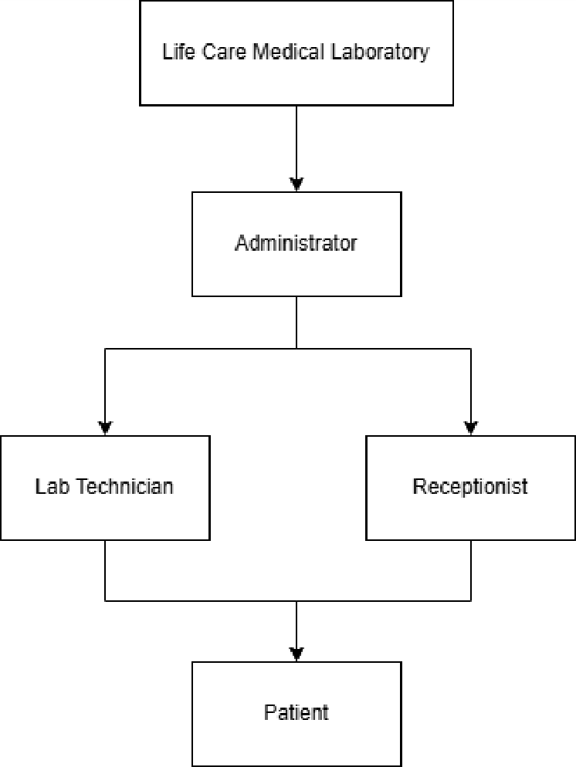
Figure B1: Organisational structure of Life Care Medical Laboratory
Life Care Medical Laboratory operates with a flat organisational structure comprising four functional roles:
Role | Primary Responsibilities
Administrator | System configuration, user account management, audit trail review, database backups, analytics dashboard, test catalogue management
Laboratory Technician | Sample processing using semi-automatic equipment, manual result entry, report generation, abnormal result flagging
Receptionist | Patient registration, appointment verification (QR scan), payment collection, report printing and issuing
Patient | Online appointment booking, sample provision, bill payment, report access (online portal or physical collection)
Table B1: Roles and responsibilities
The current system components at Life Care Medical Laboratory are disconnected tools maintained independently:
Component | Owner/User | Function
Paper Appointment Logbook | Receptionist | Records telephone and walk-in appointment requests
Handwritten Registration Forms | Receptionist | Captures patient personal details at registration
Paper Sample Register | Technician | Logs sample collection events, sample type, and collection time
Individual Excel Templates (5+ versions) | Each Technician | Manual report generation with inconsistent formats
Standalone Billing Software | Receptionist / Admin | Processes payments and generates receipts
Local Workstation Folders | All Staff | Storage of generated Excel reports; no centralised repository
Table B2: Current system component breakdown

B3.3 Process Flows — Data Flow Diagrams
Context Diagram (Level 0 DFD). The Context Diagram represents Life Care Medical Laboratory's current system as a single process interacting with four external entities: Patient, Referring Physician, Laboratory Staff (Technician and Receptionist), and Administrator. Primary data flows include appointment requests, personal details, test results, billing entries, and printed reports.
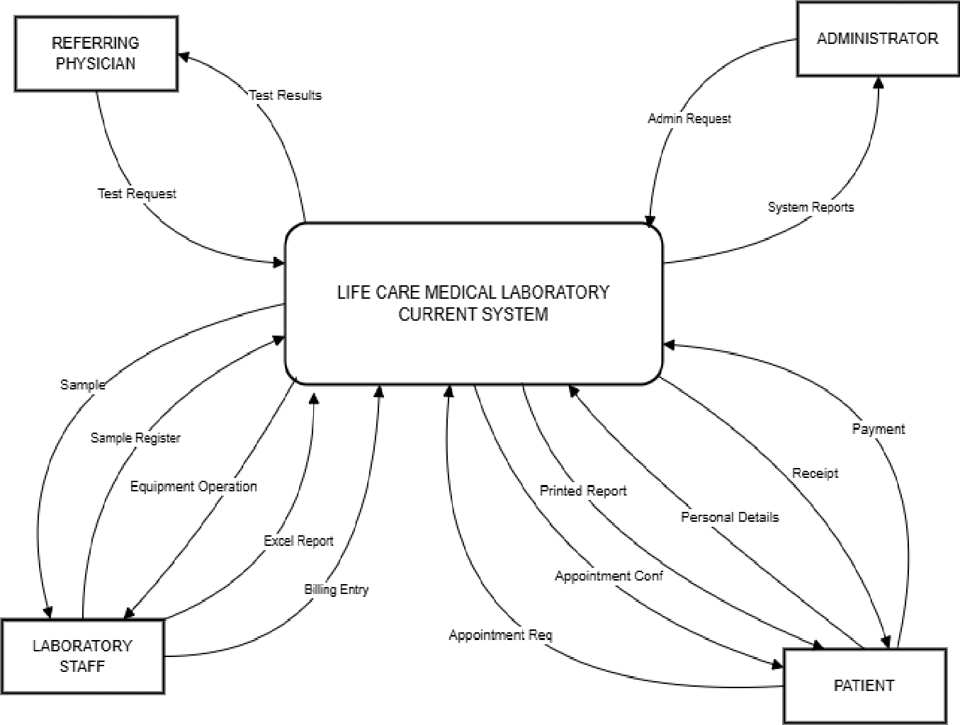
Figure B2: Context diagram (Level 0 DFD) of the current system

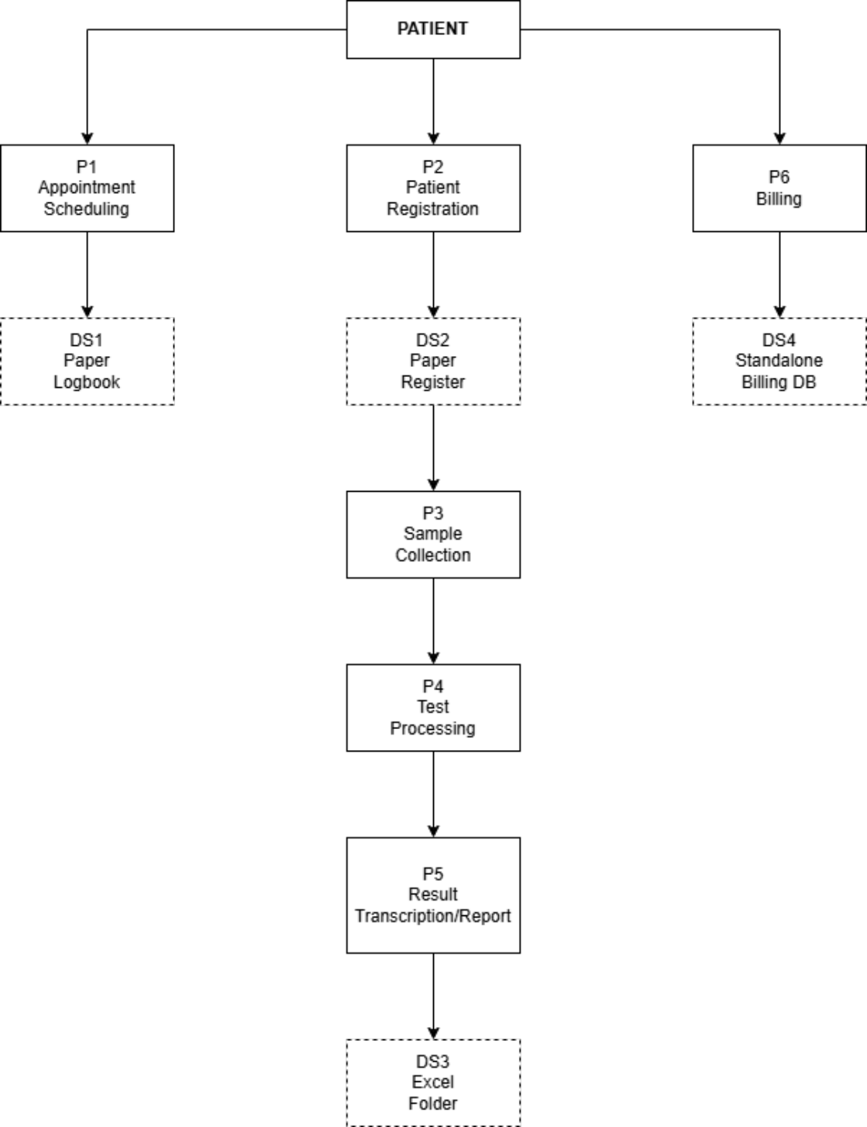
Figure B3: Level 1 DFD of the current system
The Level 1 DFD decomposes the current system into six major sub-processes:
Process | Inputs | Outputs / Data Stores
P1 – Appointment Scheduling | Patient telephone request | Paper logbook entry
P2 – Patient Registration | Handwritten form, logbook reference | Registration form file, Excel patient list
P3 – Sample Collection & Logging | Registration form, verbal instruction | Paper sample register entry
P4 – Test Processing | Physical sample | Equipment printout (paper result)
P5 – Result Transcription & Report Generation | Equipment printout, registration form | Excel report (local folder)
P6 – Billing | Patient name, test list (verbal/paper) | Billing receipt (standalone software)
Table B3: Major process decomposition
Level 2 DFDs providing further decomposition of Patient Registration, Result Transcription, and Billing processes are included in Appendix C.

B3.4 Problems and Limitations
The following critical problems were identified during fact-finding at Life Care Medical Laboratory:
Problem Area | Current Issue | Impact
Data Decentralisation | Each staff member maintains separate Excel files | No single source of truth; conflicting patient records
Excel Report Generation | 15–20 minutes per report; manual formatting | 30–45 min total per patient; formatting inconsistencies
Version Control | Multiple Excel template versions in circulation | Reports with different formats; branding inconsistency
Data Entry Errors | Manual transcription to Excel | 5–8% error rate; patient safety risks
Data Silos | Reception, lab, billing use different systems | Duplicate data entry; reconciliation challenges
Report Retrieval | Reports stored in staff personal folders | Difficult to find historical reports; no audit trail
Backup Issues | No centralised backup of Excel files | Risk of data loss; no disaster recovery
Patient Experience | No online access; delayed results | Poor satisfaction; competitive disadvantage
Table B4: Problems and limitations of the current system
Data Decentralisation — Detailed Analysis. Root cause: Life Care has no written policy on where reports must be saved. Each technician developed individual file management habits independently. The Excel software does not enforce any storage location, and there is no shared network drive. As a result, patient records exist across at least five separate workstations with no synchronisation mechanism. Quantified impact: staff spend an average of 8 minutes per day searching for files (5 staff × 8 minutes = 40 minutes daily × 260 working days = 173 hours of productivity lost annually). Duplicate data entry between registration, result, and billing systems adds approximately 12 minutes per patient (50 patients/day × 12 minutes = 600 minutes of daily inefficiency). Affected stakeholders: technicians (direct — unable to access each other's records), receptionists (direct — cannot retrieve reports without contacting the issuing technician), patients (indirect — extended wait times and inability to retrieve historical reports). Frequency: every patient encounter, 100% of cases.
Manual Transcription Errors — Detailed Analysis. Root cause: semi-automatic equipment at Life Care produces results only as printed strip output or on-screen values. There is no digital interface or export capability. Technicians must visually read each value and manually type it into an Excel template, creating multiple opportunities for transcription errors including digit transposition, decimal point misplacement, and missing units. Quantified impact: sampling of 75 records identified an error rate of 6.4%, including transposed digits (e.g., haemoglobin recorded as 120 g/dL instead of 12.0 g/dL), missing units, and incorrect patient name associations. At 50 patients per day, this translates to approximately 3 erroneous reports daily. Errors involving critical values (e.g., glucose, haemoglobin) carry direct patient safety implications including risk of misdiagnosis or inappropriate treatment. Affected stakeholders: patients (high risk — clinical decision-making based on incorrect values), referring physicians (medium risk — treatment decisions affected), laboratory (legal and reputational risk). Frequency: approximately 6.4% of patient encounters, approximately 3 patients per day.
Report Generation Inefficiency — Detailed Analysis. Root cause: each report requires technicians to (1) locate the correct patient record, (2) open the appropriate Excel template from their personal folder, (3) manually type all patient demographics again, (4) manually enter all test result values from the equipment printout, (5) manually adjust formatting, and (6) save and print. Steps 1, 2, and 5 are entirely administrative overhead that an LIS eliminates. Steps 3 and 4 involve re-entry of data already captured elsewhere in the system. Quantified impact: observation confirmed an average of 16.5 minutes per report. Automated PDF generation in the proposed LIS reduces this to approximately 2 minutes for result entry only (no template selection, no demographic re-entry, no formatting). At 50 patients/day, this represents a saving of approximately 725 minutes (over 12 hours) of technician time per day. Affected stakeholders: technicians (direct — majority of working time consumed by administrative rather than clinical tasks), patients (indirect — 30–45 minute wait times), administrator (indirect — capacity constraints limit laboratory growth). Frequency: every patient encounter, 100% of cases.

B3.5 Scope and Constraints
Scope Justification. The proposed system scope was deliberately limited to core laboratory operations for the following reasons:
1. Budget constraint (LKR 10,500) precludes integration with external systems such as hospital information systems or clinic management software, which typically require licensed API access or middleware costing several hundred thousand rupees.
2. Equipment limitation: Life Care's semi-automatic analysers produce only printed output with no digital export capability. Automated result import is technically impossible without hardware interface upgrades (estimated LKR 500,000+), which the laboratory cannot currently afford.
3. Staff size (5–8 persons) makes multi-branch deployment and complex organisational hierarchy features unnecessary for the foreseeable operational future.
4. Inventory management was excluded because the laboratory outsources consumable procurement to a third-party supplier that operates their own ordering and stock management system.
Therefore, the defined scope represents the maximum feasible functionality within the laboratory's financial, technical, and operational constraints. Every included feature directly addresses a problem identified in Section B3.4, and every excluded feature has a documented rationale above.
Scope of the Proposed System. The proposed LIS for Life Care Medical Laboratory encompasses the following operational domains: online appointment booking with QR code confirmation; patient registration and profile management in a centralised PostgreSQL database; barcode-based sample tracking; manual test result entry with field validation and abnormal result flagging; automated PDF report generation using a standardised template; integrated billing linked to patient test records; automated patient notification via email and SMS; role-based access control with audit trails; and an administrator dashboard for analytics and system configuration.
Explicitly excluded from scope: Hospital Information System integration; inventory management; direct equipment interfacing (results remain manual entry); and multi-branch deployment.
Constraints. The development and deployment are subject to the following constraints:
i. Budget: total initial budget is LKR 10,500 (domain registration LKR 2,500; web hosting LKR 8,000). Only open-source technologies may be used.
ii. Technology: the stack comprises React.js, Node.js, PostgreSQL, and React-PDF, all open-source.
iii. Infrastructure: deployable on basic shared or VPS hosting within the allocated budget.
iv. Equipment: semi-automatic equipment produces printed output only; automated result import is not possible.
v. Compliance: the system must implement TLS 1.3 encryption, JWT authentication, role-based access control, and complete audit trails.

B4. Requirements Specification for the New System

B4.1 Functional Requirements

1.1. Able to book appointments online with QR code confirmation.
1.2. Able to register walk-in patients, verify QR codes, process payments, and print reports via the receptionist interface.
1.3. Able to maintain a centralised patient profile with searchable records.
1.4. Able to provide a patient portal for online report access and download.

2.1. Able to track samples using barcodes from collection to result entry.
2.2. Able to support structured manual result entry for semi-automatic equipment with automatic validation against reference ranges.
2.3. Able to automatically generate PDF reports using standardised templates.

3.1. Able to enforce role-based access control (for at least 4 roles).
3.2. Able to manage staff accounts, test catalogues, and report templates via an administrator dashboard.
3.3. Able to send automated SMS/email notifications to patients upon report completion.

B4.1.1 Detailed Requirements with Acceptance Criteria
ID | Requirement | Priority
FR-01 | Online appointment booking with QR code confirmation | High
FR-02 | Structured manual result entry for semi-automatic equipment with validation | High
FR-03 | Automated PDF report generation using standardised templates | High
FR-04 | SMS/email notification system upon report completion | High
FR-05 | Role-based access control (4+ roles) | Medium
FR-06 | Receptionist interface for walk-in registration, QR verification, payment, and report printing | High
FR-07 | Centralised patient profile with searchable records | High
FR-08 | Sample tracking from collection to result entry (result ready or not) | High
FR-09 | Administrator module for staff accounts, test catalogue, and template management | Medium
FR-10 | Patient portal for online report access and download | High
Table B5: Functional requirements
FR-01: Online appointment booking with QR code confirmation. Acceptance criteria: the patient can book an appointment without telephoning the laboratory. The system generates a unique QR code for each confirmed booking, deliverable via SMS and email, and scannable at reception using any smartphone camera. The system prevents double-booking of the same time slot, and the booking confirmation is visible to the receptionist in real time. Traceability: addresses the Patient Experience problem (no online booking) and reduces receptionist telephone interruptions (observation confirmed approximately 30% of morning calls are appointment-related). Priority rationale: HIGH — requested by 100% of interviewed patients and directly reduces receptionist workload by an estimated 40% reduction in appointment-related calls.
FR-02: Structured manual result entry with validation. Acceptance criteria: the system provides structured input fields with defined data types (numeric only for quantitative results); validates entered values against normal reference ranges and flags values outside range; prevents saving of incomplete records (all mandatory fields enforced); highlights abnormal values in red before saving; and requires the technician to confirm flagged values before submission. Traceability: directly addresses the Manual Transcription Errors problem (6.4% error rate). Priority rationale: HIGH — patient safety critical; errors in laboratory results can result in misdiagnosis.
FR-03: Automated PDF report generation. Acceptance criteria: the system generates a standardised PDF report automatically upon result entry completion without any manual formatting by the technician. All reports use a single consistent template managed by the Administrator. The PDF is generated within 10 seconds of result submission and includes the laboratory logo, patient demographics, test results, reference ranges, abnormal flags, and authorising technician name. Traceability: addresses the Report Generation Inefficiency problem (16.5 minutes average) and eliminates the version control issue (5 template versions). Priority rationale: HIGH — directly eliminates the single largest time bottleneck in the current workflow, saving an estimated 12+ hours of technician time daily at full volume.

B4.2 Non-Functional Requirements
Category | Specification
Security | TLS 1.3 encryption; JWT authentication; role-based access control; secure token storage; HTTPS only
Performance | Page load time < 3 seconds; support 10+ concurrent users; code splitting and lazy loading
Responsiveness | Full functionality on desktops, tablets, and mobile devices; responsive design with Tailwind CSS
Compatibility | Cross-browser support for Chrome, Firefox, Safari, Edge (latest versions)
Data Integrity | Centralised PostgreSQL database with ACID compliance; 99.9% data accuracy; complete audit trail
Backup & Recovery | Administrator-initiated database backup and restoration functions
Usability | Role-specific interfaces; key workflows completable within 5 minutes per patient
Cost | Open-source technologies only; deployable within LKR 10,500 initial budget
Table B6: Non-functional requirements

Part C — Design Report

C1. Description of the New System

C1.1 Narrative
The Laboratory Information System (LIS) is an internet-based system designed to streamline and automate the day-to-day processes of small and medium-sized medical laboratories working with semi-automatic laboratory equipment. The system eliminates the current paper- and Excel-based process management and introduces a secure, centralised system for managing the entire laboratory operation process, from patient booking to report delivery.
The process starts with online booking, where patients make appointments for laboratory tests via the web interface, selecting the necessary tests and a preferred date and time. All appointment information is stored in the centralised PostgreSQL database. Registration of the client at the laboratory takes place through the receptionist, where the system registers either existing or new clients depending on the presence of their patient record in the database. The system automatically creates a unique record and barcode for each specimen collected, and the barcode is used to mark the collected specimen to facilitate its identification.
Laboratory technicians collect the labelled specimens and conduct the necessary tests using semi-automatic laboratory equipment. Since the equipment cannot integrate with the system, the technicians manually fill in the system using digital forms, and validation rules are used to prevent typing mistakes. When the results have been entered, the system creates professional laboratory reports automatically using predefined report templates. All reports follow a standardised form, resolving the inconsistencies created by the use of various Excel templates, and are securely stored in the centralised database to facilitate retrieval whenever required by an authorised user.
The billing functionality is incorporated into the patient management process. The system automatically generates invoices, calculates the amount payable for the selected laboratory tests, records payments made, and maintains billing history without the need for any other software. The notification module notifies patients of the availability of laboratory reports; based on the configuration of the laboratory, patients are notified via SMS or email without revealing any confidential information, and may collect the printed report from the laboratory or access it online via the patient portal.
The system adopts a Role-Based Access Control approach, whereby every user can access only the functions assigned according to his or her duties. Receptionists manage appointments and patient registration, laboratory technicians perform sample testing and results reporting, authorised doctors or medical officers confirm reports where required, administrators manage users and system parameters, and patients have access only to their appointments and laboratory reports.
For data security and reliability, a centralised PostgreSQL database is used. Communication between the client and the server is secured through HTTPS, and user authentication takes place through JWT. Every significant activity performed within the system is recorded in audit logs. The system uses three layers — the React.js interface, the Node.js application layer, and the PostgreSQL database. React.js provides an interactive and intuitive interface that works well on desktops, tablets, and smartphones; business logic, request processing, authentication, and database interaction are carried out by the Node.js backend; and all patient data, test results, appointment details, billing data and logs are stored in the PostgreSQL database as a single source of truth.
The Laboratory Information System thus greatly increases laboratory performance by saving time spent on manual report preparation, minimising transcription-error risk, standardising and facilitating report generation, providing easy data access, and allowing online appointments and notifications. In addition, the solution is efficient, scalable and inexpensive, making it suitable for laboratories working with semi-automatic equipment.

C1.2 Illustrations Supporting the Narrative

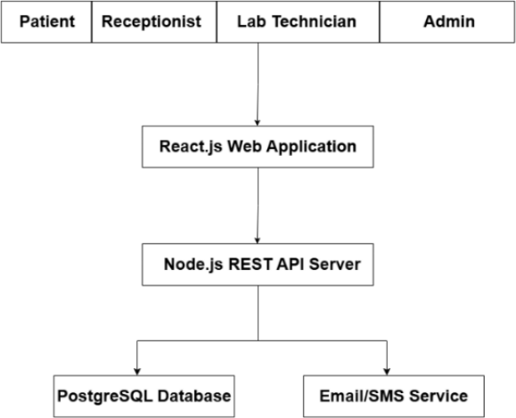
Figure C1: Overall system architecture
The system architecture diagram shows the three-tier design used in the Laboratory Information System. The presentation tier comprises the React.js front-end web application that offers an interactive interface for patients, receptionists, laboratory technicians, and administrators. The application tier is developed using Node.js and handles business logic, authentication, validations, and communication between the front-end and the database. The database tier comprises the PostgreSQL database that manages patient data, appointments, laboratory test data, billing information, and users. This architecture ensures that the user interface, application logic, and database remain independent of each other.

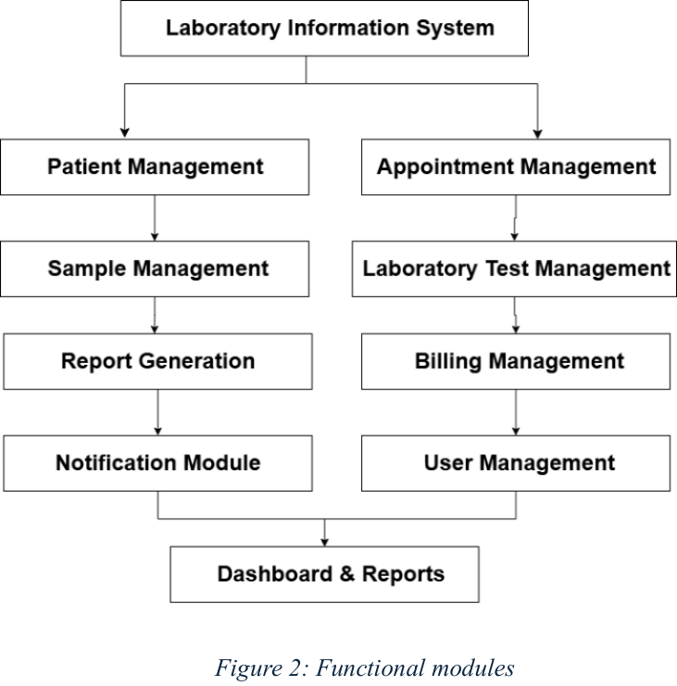
Figure C2: Functional modules of the system
The functional module diagram explains the different modules of the Laboratory Information System: Appointment Management, Patient Management, Sample Management, Laboratory Test Management, Report Generation, Billing Management, Notification Management, User Management, and Dashboard modules. Each module is responsible for performing a particular task; however, all modules share data with each other via the central database. This structure keeps the system expandable and manageable.

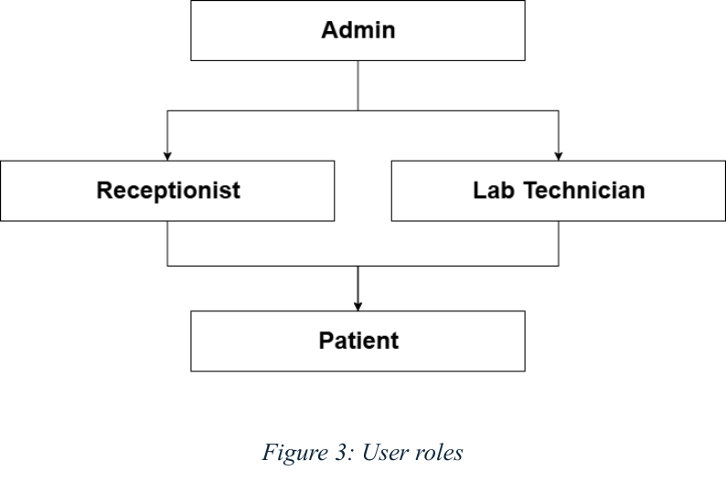
Figure C3: User roles
User | Main Responsibilities
Administrator | Manages user accounts, system settings, laboratory services, reports, overall system administration
Receptionist | Registers patients, schedules appointments, manages patient information, records sample collection details, handles billing activities
Technician | Processes laboratory samples, manually enters test results obtained from semi-automatic equipment, verifies laboratory data, submits results for report generation
Patient | Books appointments online, views appointment status, receives notifications, accesses completed laboratory reports through the patient portal
Table C1: User roles and responsibilities

C2. Detailed Design

C2.1 Data Design
Data design defines how data is structured, stored, and managed within the system. This section presents the Entity-Relationship Diagram, the comprehensive Data Dictionary, and the Normalisation process that ensures data integrity and minimises redundancy. The data design is based on the requirements identified during the analysis phase and supports all functional modules of the system.

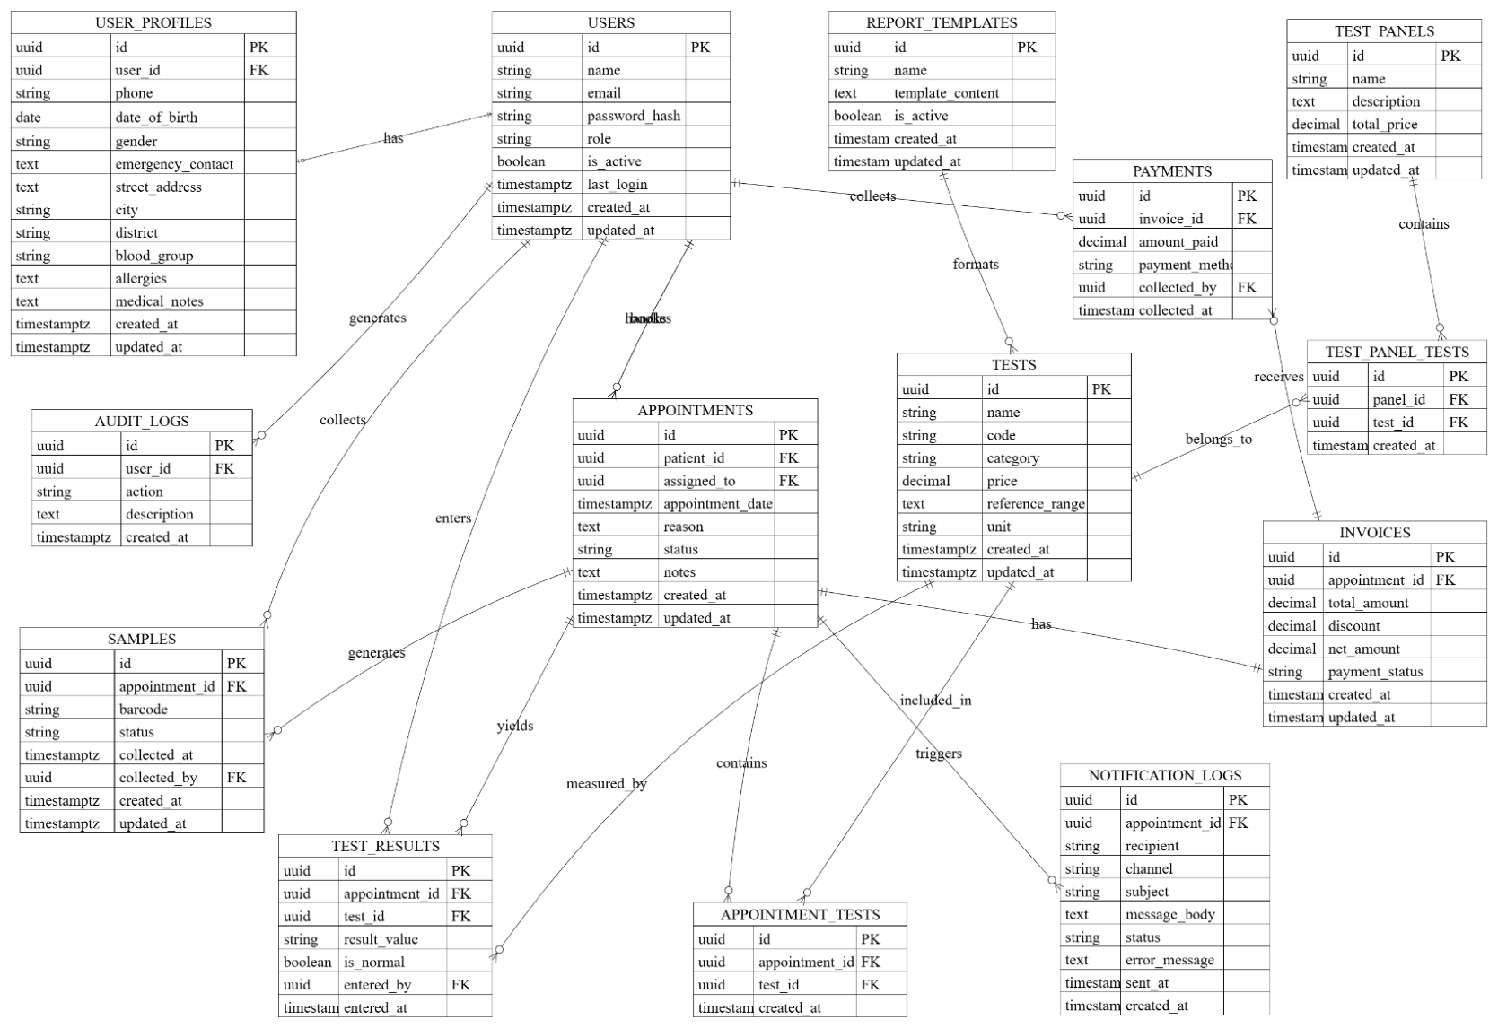
Figure C4: Entity-Relationship diagram
The Entity-Relationship (ER) diagram illustrates the logical structure of the database used by the Laboratory Information System and serves as a blueprint for the database schema implementation in PostgreSQL. The database consists of ten primary entities: Users, UserProfiles, Appointments, LaboratoryTests, Samples, TestResults, Reports, Billing, Notifications, and AuditLogs. The Users entity stores authentication and profile information for all system users, with each record linked to a role that determines access privileges. The UserProfiles entity extends user information with medical-specific details such as date of birth, gender, blood group, and emergency contact information. The Appointments entity records patient bookings including preferred date and time, reason, and a unique QR token for verification at reception. The LaboratoryTests entity maintains the catalogue of available diagnostic tests with categories, reference ranges, measurement units, and pricing. The Samples entity tracks specimen collection with unique barcodes, while TestResults stores the actual values entered by technicians. The Reports entity manages generated PDF reports, Billing handles invoicing and payment records, Notifications logs all SMS and email communications, and AuditLogs records all significant system activities for security and compliance purposes.

The data dictionary provides a detailed description of each data element stored in the database, specifying field names, data types, constraints, and descriptions for every attribute in each entity.

Attribute | Data Type | Constraints | Description
id | UUID | PK; default gen_random_uuid() | Unique identifier for each user
name | VARCHAR(255) | NOT NULL | Full name of the user
email | VARCHAR(255) | NOT NULL, UNIQUE | User's email address used for login
password_hash | VARCHAR(255) | NOT NULL | Encrypted user password
role | VARCHAR(50) | NOT NULL, CHECK | User role (Admin, Receptionist, Technician, Patient)
is_active | BOOLEAN | Default TRUE | Indicates whether the account is active
last_login | TIMESTAMPTZ | Nullable | Date and time of last login
created_at | TIMESTAMPTZ | Default NOW() | Record creation timestamp
updated_at | TIMESTAMPTZ | Default NOW() | Record update timestamp
Table C2: Users table

Attribute | Data Type | Constraints | Description
id | UUID | PK; default gen_random_uuid() | Unique profile identifier
user_id | UUID | FK, UNIQUE; references Users(id) | Associated user account
phone | VARCHAR(50) | Nullable | Contact number
date_of_birth | DATE | Nullable | Date of birth
gender | TEXT | CHECK | Gender of the user
emergency_contact | TEXT | Nullable | Emergency contact details
street_address | TEXT | Nullable | Street address
city | TEXT | Nullable | City
district | TEXT | Nullable | District
blood_group | TEXT | Nullable | Blood group
allergies | TEXT | Nullable | Allergy information
medical_notes | TEXT | Nullable | Additional medical information
created_at | TIMESTAMPTZ | Default NOW() | Creation timestamp
updated_at | TIMESTAMPTZ | Default NOW() | Last updated timestamp
Table C3: UserProfiles table

Attribute | Data Type | Constraints | Description
id | UUID | PK; default gen_random_uuid() | Appointment identifier
patient_id | UUID | FK; references Users(id) | Patient who booked the appointment
assigned_to | UUID | FK; references Users(id) | Assigned laboratory staff
appointment_date | TIMESTAMPTZ | NOT NULL | Appointment date and time
reason | TEXT | Nullable | Reason for appointment
status | VARCHAR(50) | CHECK | Appointment status
notes | TEXT | Nullable | Additional notes
created_at | TIMESTAMPTZ | Default NOW() | Creation timestamp
updated_at | TIMESTAMPTZ | Default NOW() | Last updated timestamp
Table C4: Appointments table

Attribute | Data Type | Constraints | Description
id | UUID | PK; default gen_random_uuid() | Test identifier
name | VARCHAR(255) | UNIQUE | Test name
code | VARCHAR(50) | UNIQUE | Test code
category | VARCHAR(100) | NOT NULL | Test category
price | DECIMAL(10,2) | NOT NULL | Test price
reference_range | TEXT | NOT NULL | Normal reference range
unit | VARCHAR(50) | NOT NULL | Measurement unit
created_at | TIMESTAMPTZ | Default NOW() | Creation timestamp
updated_at | TIMESTAMPTZ | Default NOW() | Last updated timestamp
Table C5: LaboratoryTests table

Attribute | Data Type | Constraints | Description
id | UUID | PK; default gen_random_uuid() | Sample identifier
appointment_id | UUID | FK; references Appointments(id) | Related appointment
barcode | VARCHAR(100) | UNIQUE | Sample barcode
status | VARCHAR(50) | CHECK | Sample processing status
collected_at | TIMESTAMPTZ | Nullable | Collection date and time
collected_by | UUID | FK; references Users(id) | Technician collecting sample
created_at | TIMESTAMPTZ | Default NOW() | Creation timestamp
updated_at | TIMESTAMPTZ | Default NOW() | Last updated timestamp
Table C6: Samples table

Attribute | Data Type | Constraints | Description
id | UUID | PK; default gen_random_uuid() | Result identifier
appointment_id | UUID | FK; references Appointments(id) | Appointment identifier
test_id | UUID | FK; references LaboratoryTests(id) | Test identifier
result_value | VARCHAR(255) | NOT NULL | Laboratory result value
is_normal | BOOLEAN | Default TRUE | Whether the result is within the normal range
entered_by | UUID | FK; references Users(id) | Technician entering the result
entered_at | TIMESTAMPTZ | Default NOW() | Result entry timestamp
Table C7: TestResults table

Attribute | Data Type | Constraints | Description
report_id | UUID | PK; default gen_random_uuid() | Unique identifier for each report
appointment_id | UUID | FK; references Appointments(id) | Associated appointment
generated_at | TIMESTAMP | Default NOW() | Date and time the report was generated
pdf_path | VARCHAR(255) | NOT NULL | File path or URL of the generated PDF report
status | ENUM | NOT NULL | Report status (GENERATED, DELIVERED, ARCHIVED)
generated_by | UUID | FK, UNIQUE | User (technician or administrator) who generated the report
Table C8: Reports table

Attribute | Data Type | Constraints | Description
invoice_id | UUID | PK; default gen_random_uuid() | Unique identifier for each invoice
appointment_id | UUID | FK; references Appointments(id) | Reference to Appointments table
amount | DECIMAL(10,2) | NOT NULL | Total invoice amount in LKR
payment_status | ENUM | NOT NULL | PENDING, PAID, REFUNDED
payment_method | ENUM | Nullable | CASH, CARD, ONLINE
paid_at | TIMESTAMP | Nullable | Payment completion timestamp
Table C9: Billing table

Attribute | Data Type | Constraints | Description
notification_id | UUID | PK; default gen_random_uuid() | Unique identifier for each notification
appointment_id | UUID | FK; references Appointments(id) | Reference to Appointments table
type | ENUM | NOT NULL | SMS, EMAIL, IN_APP
recipient | VARCHAR(100) | NOT NULL | Phone number or email address
sent_at | TIMESTAMP | Default NOW() | Notification dispatch timestamp
status | ENUM | NOT NULL | SENT, FAILED, PENDING
Table C10: Notifications table

Attribute | Data Type | Constraints | Description
id | UUID | PK; default gen_random_uuid() | Audit log identifier
user_id | UUID | FK; references Users(id) | User performing the action
action | TEXT | NOT NULL | Performed action
description | TEXT | NOT NULL | Action description
created_at | TIMESTAMPTZ | Default NOW() | Log creation timestamp
Table C11: AuditLogs table

Normalisation is the process of organising database columns and tables to minimise data redundancy and improve data integrity. The Laboratory Information System database has been normalised to Third Normal Form (3NF). All tables satisfy First Normal Form: each column contains only atomic (indivisible) values of a single type, with no repeating groups or arrays; for example, the Users table stores each attribute (name, email) in separate columns rather than combining them. All tables satisfy Second Normal Form: every non-key attribute is fully functionally dependent on the entire primary key; in the TestResults table, the result_value, is_normal and entered_at attributes depend on the id primary key and not on any partial key. All tables satisfy Third Normal Form: there are no transitive dependencies where a non-key attribute depends on another non-key attribute; test pricing information is stored directly in the LaboratoryTests table rather than derived from the test category, and patient demographic information is stored in the UserProfiles table rather than duplicated in the Appointments table.
Original Structure | Normalisation Applied | Resulting Benefit
Patient details stored in Appointments | Extracted to separate Patients/UserProfiles and Appointments tables with FK | Patient details stored once, updated centrally
Test info stored with each result | Extracted to LaboratoryTests table | Separate LaboratoryTests and TestResults tables; test catalogue maintained independently
User credentials in role-specific tables | Centralised in Users table with role field | Single Users table; role-specific tables reference it; unified authentication, reduced redundancy
Billing info in Appointments table | Extracted to separate Billing table | Billing table with appointment FK; independent payment tracking and reporting
Report data duplicated from results | Reports table references appointment and stores only PDF path | Reports stores only metadata and generated output; eliminates data duplication
Table C12: Normalisation summary
The normalisation process ensures that the database maintains data integrity while minimising storage redundancy. The resulting schema supports efficient query performance and simplifies maintenance. Where performance optimisation is required for reporting queries, appropriate database indexes have been defined on foreign key columns and frequently queried fields.

C2.2 Architectural Design
An architectural design provides the structure of the software by establishing its major components, their functions, and the interactions among them, and offers guidelines for developing the software by grouping it into components. An effective architectural design enhances maintainability, scalability, security, and performance, and makes future development easy. The Laboratory Information System utilises a three-layer architecture comprising the Presentation Layer, Application Layer, and Data Layer, ensuring that the user interface, business logic, and data management are separated into layers that accomplish distinct responsibilities without depending on how the other layers are implemented. Interactions between layers occur through secure RESTful APIs.

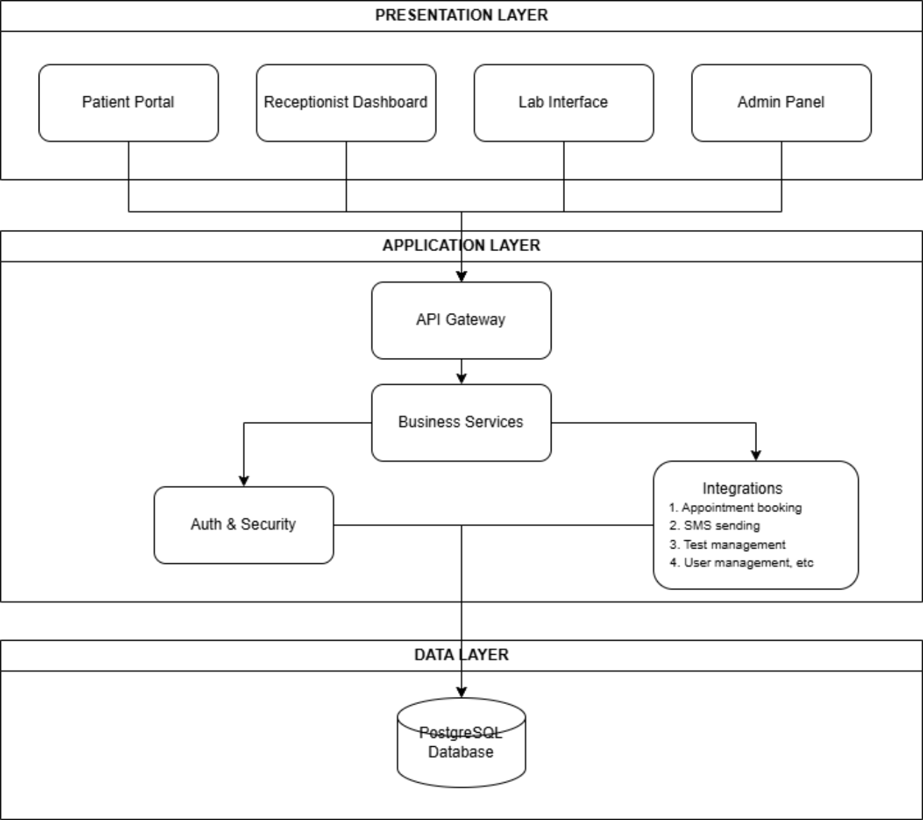
Figure C5: Three-tier architecture
1. Presentation Layer. The Presentation Layer provides the graphical user interface through which users interact with the system. It is developed using React.js and Tailwind CSS, providing a responsive and user-friendly web interface accessible from desktop computers, tablets, and mobile devices. Its users are the Administrator, Receptionist, Laboratory Technician, and Patient. Its responsibilities are to display user interfaces, capture user inputs, validate basic form data, display laboratory reports and notifications, send user requests to the Application Layer, and display responses received from the backend. Its main interfaces are Login, Dashboard, Patient Registration, Appointment Booking, Sample Registration, Result Entry, Billing, Report Generation, and the Patient Portal. The Presentation Layer does not communicate directly with the database; all requests are forwarded securely to the Application Layer.
2. Application Layer. The Application Layer contains the core business logic of the system. It is implemented using Node.js with Express.js and acts as the intermediary between the Presentation Layer and the Data Layer. This layer processes user requests, applies laboratory business rules, validates data, performs authentication, and coordinates communication between system modules. Its main components are the Authentication Module, Appointment Management Module, Patient Management Module, Sample Management Module, Laboratory Test Module, Report Generation Module, Billing Module, Notification Module, and User Management Module. Its responsibilities include processing user requests, authenticating users using JWT, validating patient and laboratory data, generating laboratory reports, calculating billing information, sending SMS and email notifications, coordinating communication between modules, and retrieving and updating data through the Data Layer. This layer represents the intelligence of the system by enforcing laboratory workflows and ensuring that all operations comply with the required business rules.
3. Data Layer. The Data Layer manages all persistent data used by the system, using PostgreSQL as the relational database management system. Its responsibilities are to store patient records, appointments, laboratory test information, laboratory reports, billing records, user accounts, and notification history, and to maintain audit logs. The Data Layer responds to queries received from the Application Layer while ensuring data consistency, integrity, and security; direct access to the database from the user interface is not permitted.
Information Flow Between Layers. Communication among the layers takes place in sequential order during all operations. Whenever a user makes a request via the Presentation Layer, the request is sent to the Application Layer through RESTful API calls. The Application Layer verifies the request, performs the necessary logic operations, and interacts with the PostgreSQL database through SQL queries. Finally, the output is sent back to the Presentation Layer for presentation to the user. Through this communication process, loose coupling is achieved.

i. Separation of user interface, business logic, and database operations.
ii. Improved maintainability through modular development.
iii. Enhanced system security by preventing direct database access.
iv. Easier scalability for future system expansion.
v. Simplified testing and debugging.
vi. Better code reusability.
vii. Improved performance and reliability.

The proposed Laboratory Information System is divided into several independent modules. Each module performs a specific function while exchanging information with other modules through the Application Layer.
Module | Purpose | Responsibilities
Authentication Module | Provides secure authentication and authorization for all users | User login; password verification; JWT authentication; role-based access control; session management
Appointment Management Module | Manages laboratory appointment scheduling | Book appointments; view appointments; cancel appointments
Patient Management Module | Maintains patient information | Register patients; update patient details; search patient records; maintain patient history
Sample Management Module | Handles laboratory sample registration and tracking | Generate sample barcode; register collected samples; track sample status; link samples with patients
Laboratory Test Module | Records laboratory test information | Assign laboratory tests; enter test results; validate laboratory results; store completed tests
Report Generation Module | Automatically generates standardized laboratory reports | Retrieve laboratory results; generate PDF reports; store reports; retrieve historical reports
Billing Module | Manages laboratory payments | Calculate laboratory charges; generate invoices; record payments; generate receipts
Notification Module | Keeps patients informed about laboratory services | Send SMS notifications; send email notifications; notify report availability; record notification history
User Management Module | Allows administrators to manage system users | Add users; update users; delete users; assign user roles
Table C13: System modules

The modules in the Laboratory Information System use the Application Layer to perform laboratory work. The Appointment Management Module creates appointment records, which are later used by the Patient Management Module to register patients. After registration, the Sample Management Module logs the collected sample and assigns it a barcode number. The Laboratory Test Module accesses the collected sample information and logs the test results provided by the technician. After successful result logging, the Report Generation Module automatically creates a laboratory report and saves it to the database. The Billing Module creates laboratory fees and invoices depending on the selected tests. Lastly, the Notification Module notifies patients about report availability. Unified communication between all modules avoids redundant data and preserves consistency.
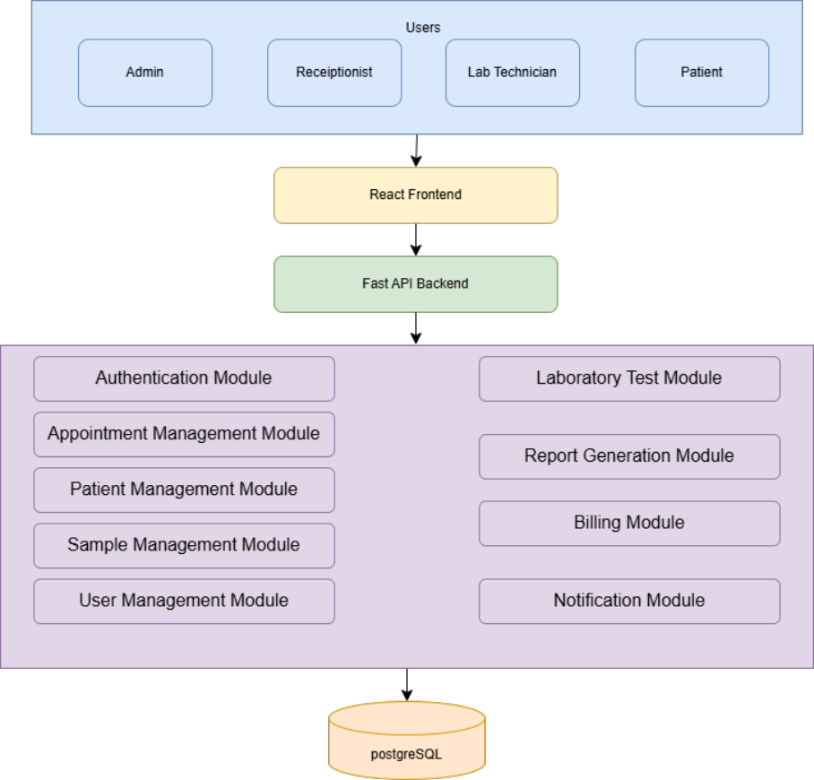
Figure C6: Module interaction diagram

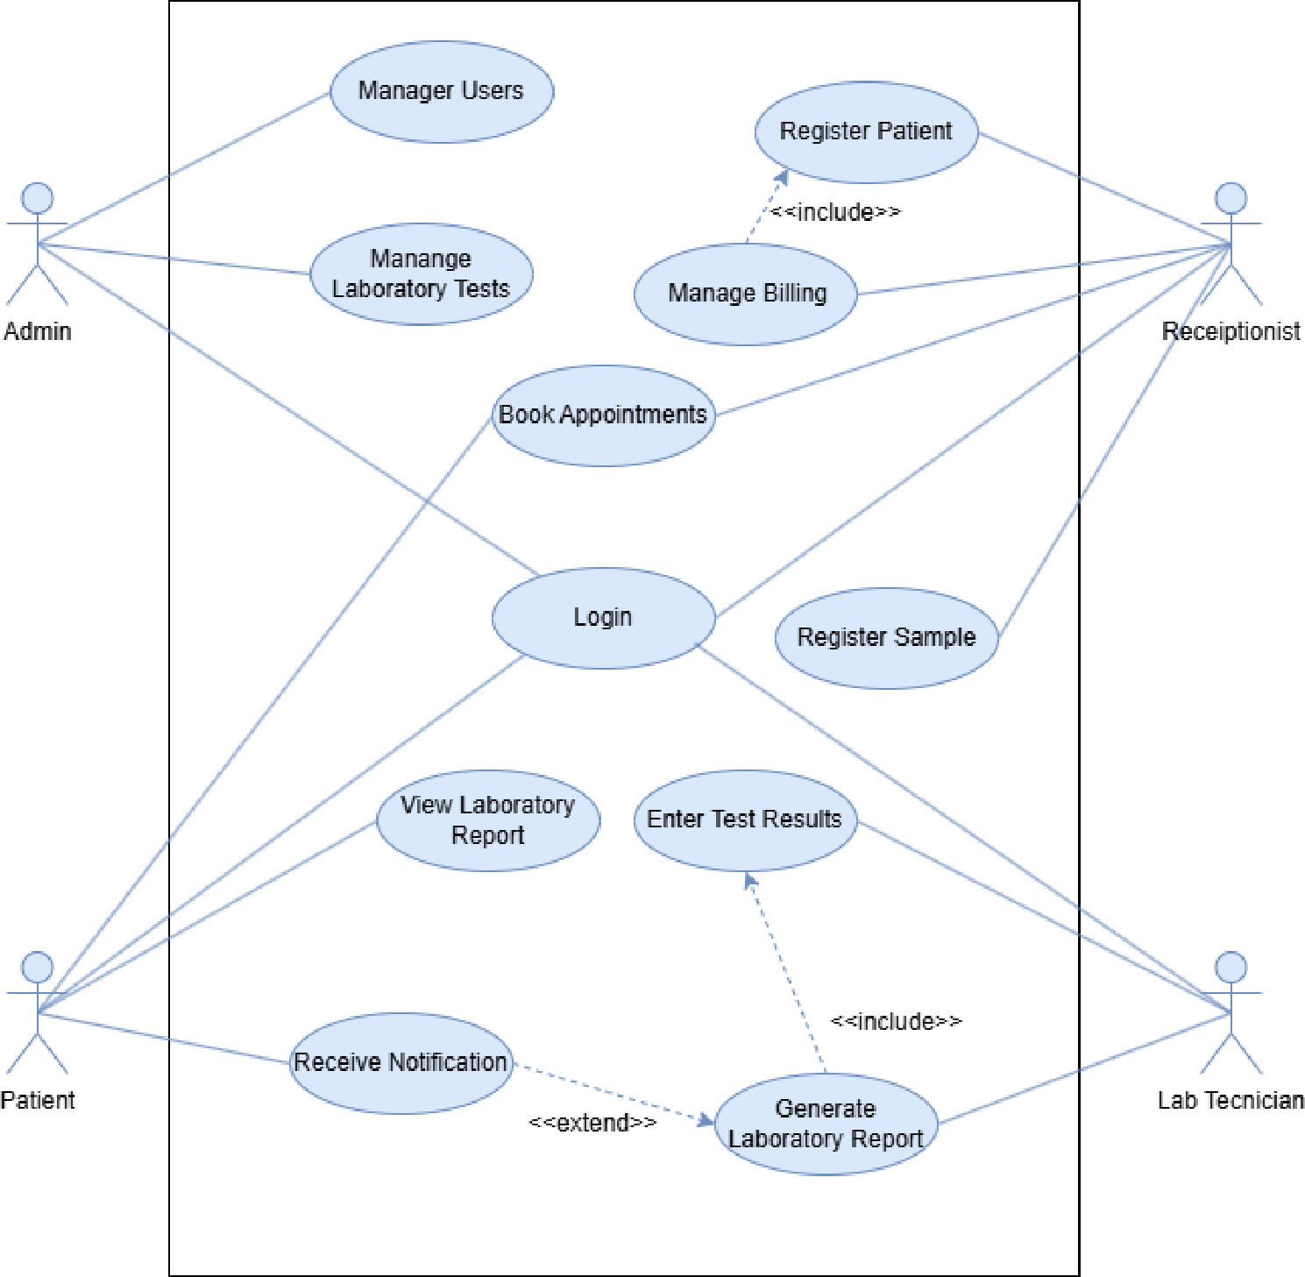
Figure C7: Use case diagram
Use Case | Actor(s) | Description
Login | Administrator, Receptionist, Laboratory Technician, Patient | Authenticates users and grants access to the system according to their assigned roles
Manage Users | Administrator | Create, update, deactivate, and manage user accounts and assign system roles
Manage Laboratory Tests | Administrator | Add, update, or remove laboratory test definitions and pricing
Register Patient | Receptionist | Register new patients, update patient information, and retrieve existing patient records
Book Appointment | Patient, Receptionist | Schedule appointments for laboratory tests by selecting available dates and times
Register Sample | Receptionist | Record collected samples and assign unique barcode identifiers
Enter Test Results | Laboratory Technician | Record laboratory test results obtained from semi-automatic laboratory equipment
Generate Laboratory Report | Laboratory Technician | Generate standardized laboratory reports based on validated test results
Manage Billing | Receptionist | Calculate laboratory charges, generate invoices, and record payments
View Laboratory Report | Patient | Securely access completed laboratory reports through the patient portal
Receive Notification | Patient | Receive SMS or email notifications when laboratory reports are available
Table C14: Use case descriptions

C2.3 Procedural Design
Procedural design divides the software system into small sub-routines and functions, representing the operation and logic of each module. It outlines procedures, logic, decisions, input/output, and flow control in an organised manner and helps implement the logic of each module precisely. The procedural design of the four main modules of the system — Patient Registration & Appointment Booking, Receptionist Verification & Billing, Lab Technician Result Entry, and Report Generation & Notification — is shown in flowchart and activity diagram form.

The overall workflow covers the complete operation of the Laboratory Information System, from booking an appointment by the patient to delivering the final laboratory report. During this process, different activities are carried out by the Receptionist, Laboratory Technician, and Administrator, while the system keeps the records and automates the remainder.
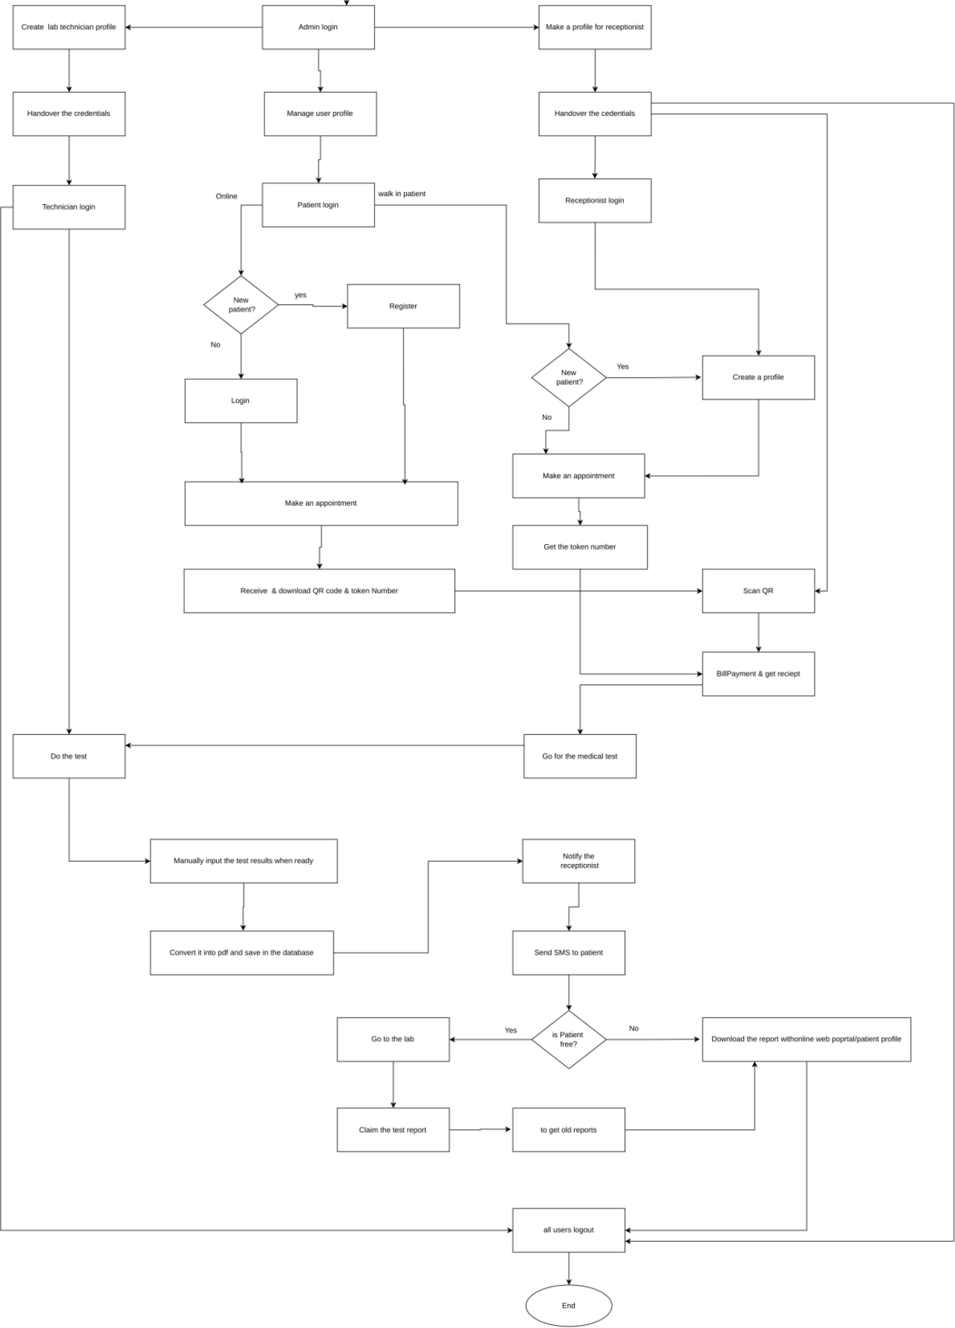
Figure C8: Overall system workflow

User logs into the system
System identifies user role (Patient / Receptionist / Lab Technician / Admin)
IF ROLE = Patient: show Patient Portal — Register/Login, Book Appointment, View/Download Report, Logout; perform selected action; return to portal or logout
IF ROLE = Receptionist: show Receptionist Dashboard — Register Walk-in Patient, Verify Pre-booked Appointment (scan QR), Collect Payment, Update Sample Status; perform selected action; return to dashboard or logout
IF ROLE = Lab Technician: show Technician Dashboard — View Pending Sample Queue, Enter Test Result, Flag Abnormal Values; system generates reports and notifies patient/receptionist; return to dashboard or logout
IF ROLE = Admin: show Admin Dashboard — Create Receptionist/Technician Profile, Manage User Accounts; perform selected action; return to dashboard or logout
END / LOGOUT

C2.4 Process Flows
The process flow diagrams demonstrate the order in which tasks are performed using the LIS. They display how information flows into and through the system and how the various users employ the system to perform their respective functions within the laboratory.
Administrator Workflow. The Administrator Workflow covers the tasks carried out by the system administrator: user administration, laboratory test administration, report monitoring, system settings, and ensuring system security. The administrator has full privileges to administer system resources for the proper functioning of the laboratory.
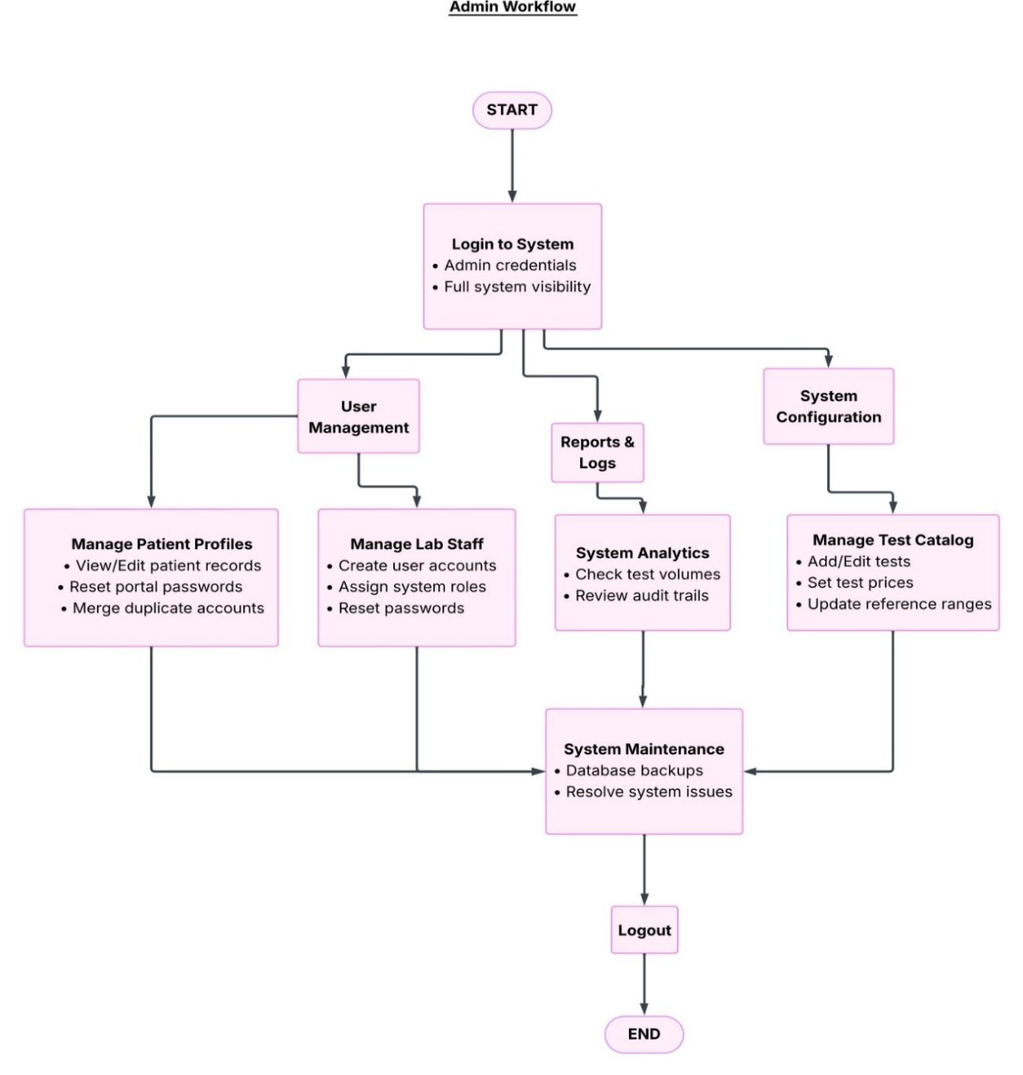
Figure C9: Administrator workflow
Receptionist Workflow. The Receptionist Workflow defines how patients are handled. The receptionist performs duties such as registering patients, scheduling appointments, recording collected samples, issuing invoices, and updating payment information.
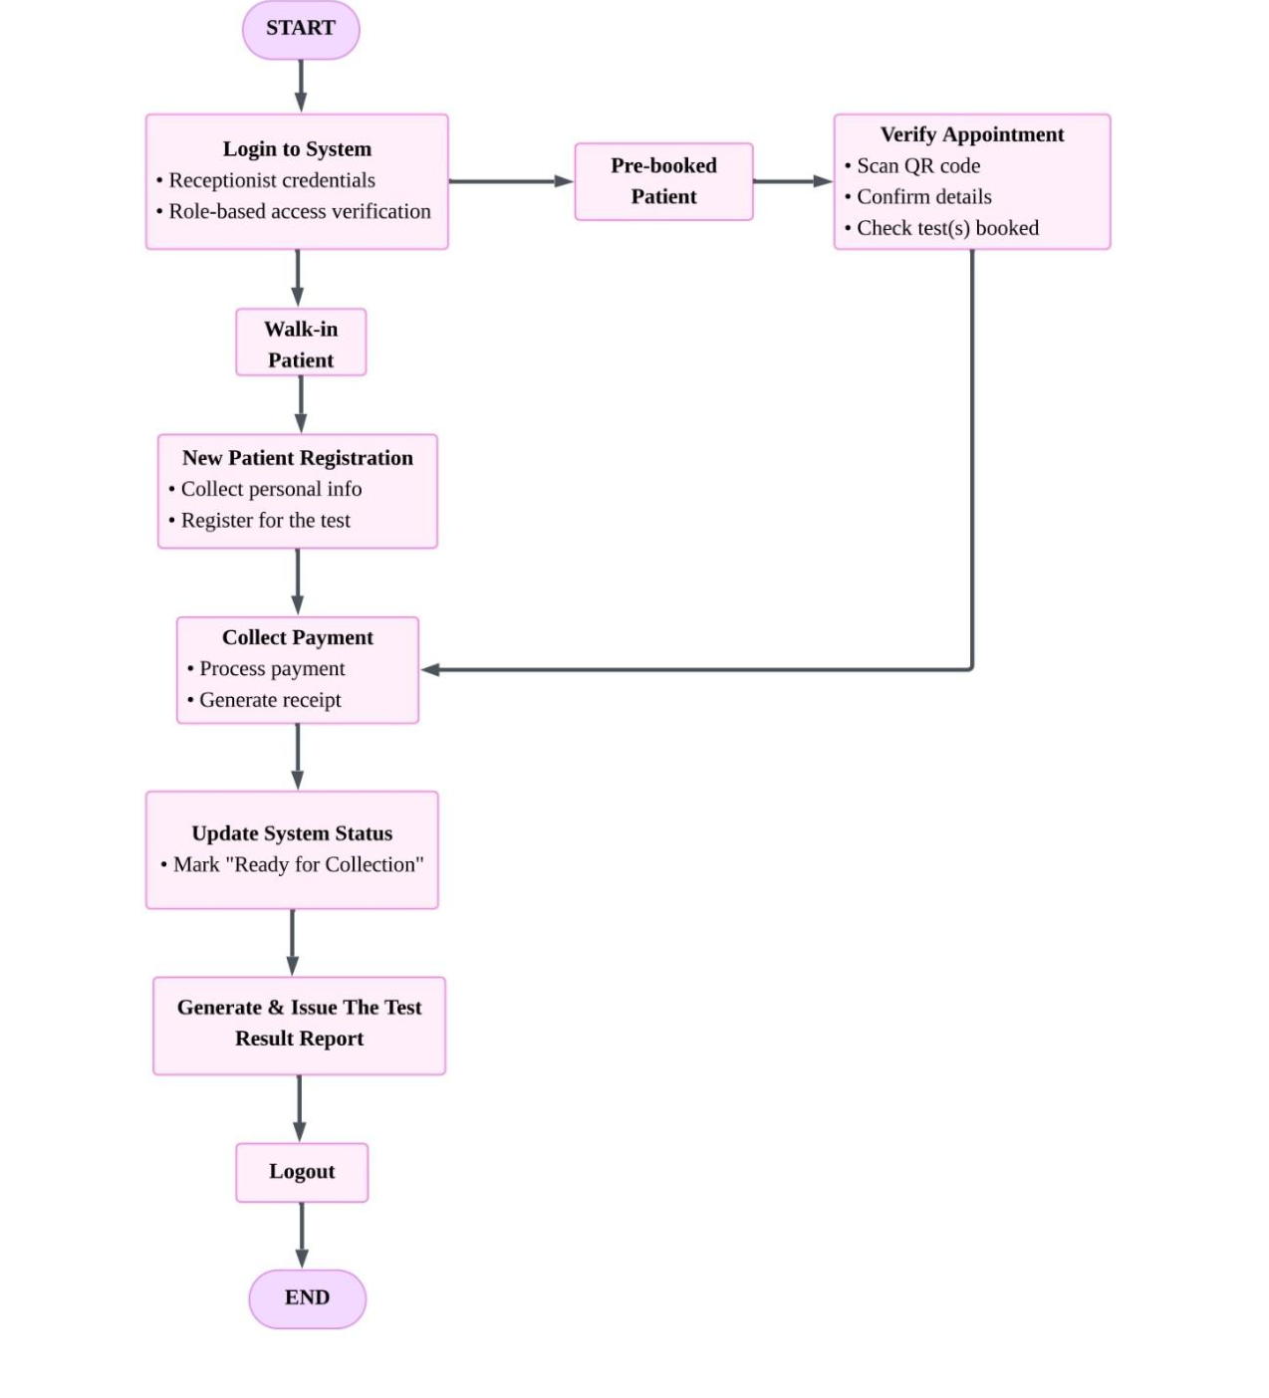
Figure C10: Receptionist workflow
Laboratory Technician Workflow. The Laboratory Technician Workflow begins with receiving collected samples. After performing laboratory tests using semi-automatic equipment, the technician manually enters the test results into the system. Once the results are verified, they are submitted for report generation. This workflow reduces transcription errors and maintains accurate laboratory records.
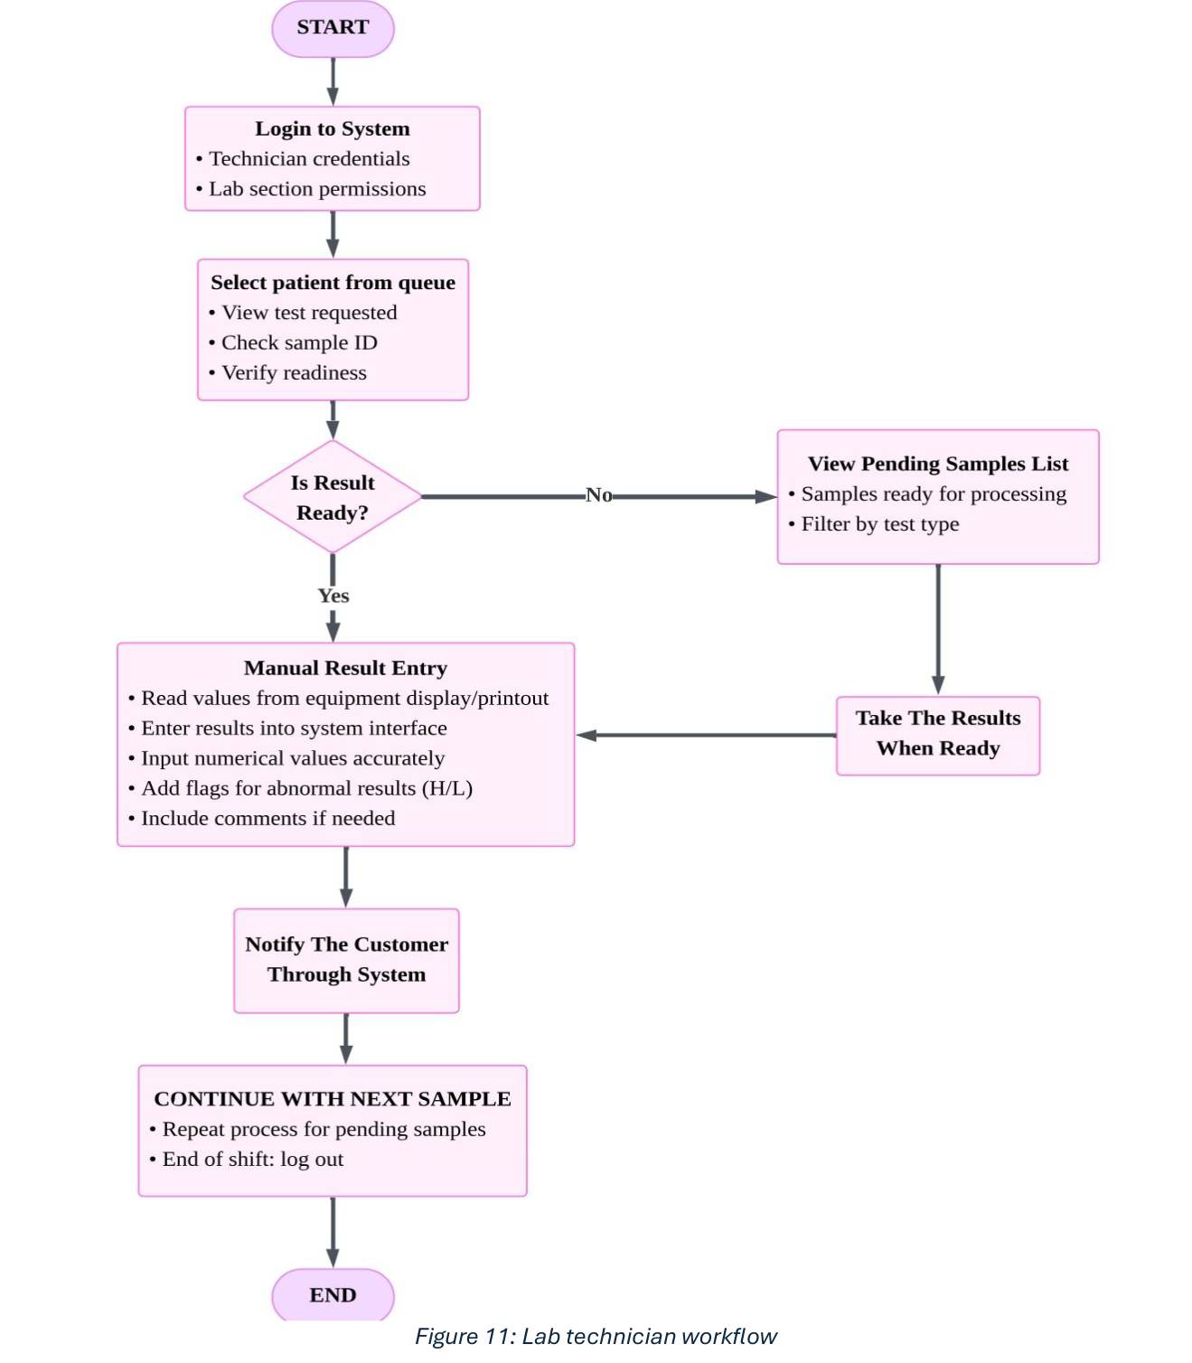
Figure C11: Laboratory technician workflow
Patient Workflow. The Patient Workflow illustrates the services available to patients through the system. Patients can book appointments, view appointment details, receive SMS or email notifications, and access completed laboratory reports through the patient portal. This workflow improves patient convenience by reducing the need for physical visits to obtain laboratory reports.
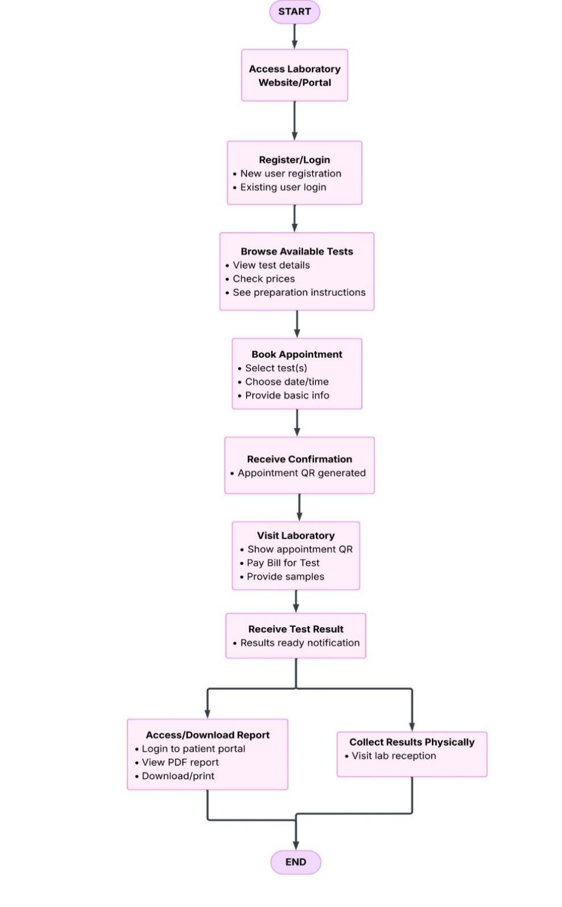
Figure C12: Patient workflow

C2.5 Activity Diagrams
The following activity diagrams present the swim-lane-level logic of the four key processes in the system, showing the responsibilities of each actor alongside the System and Database.

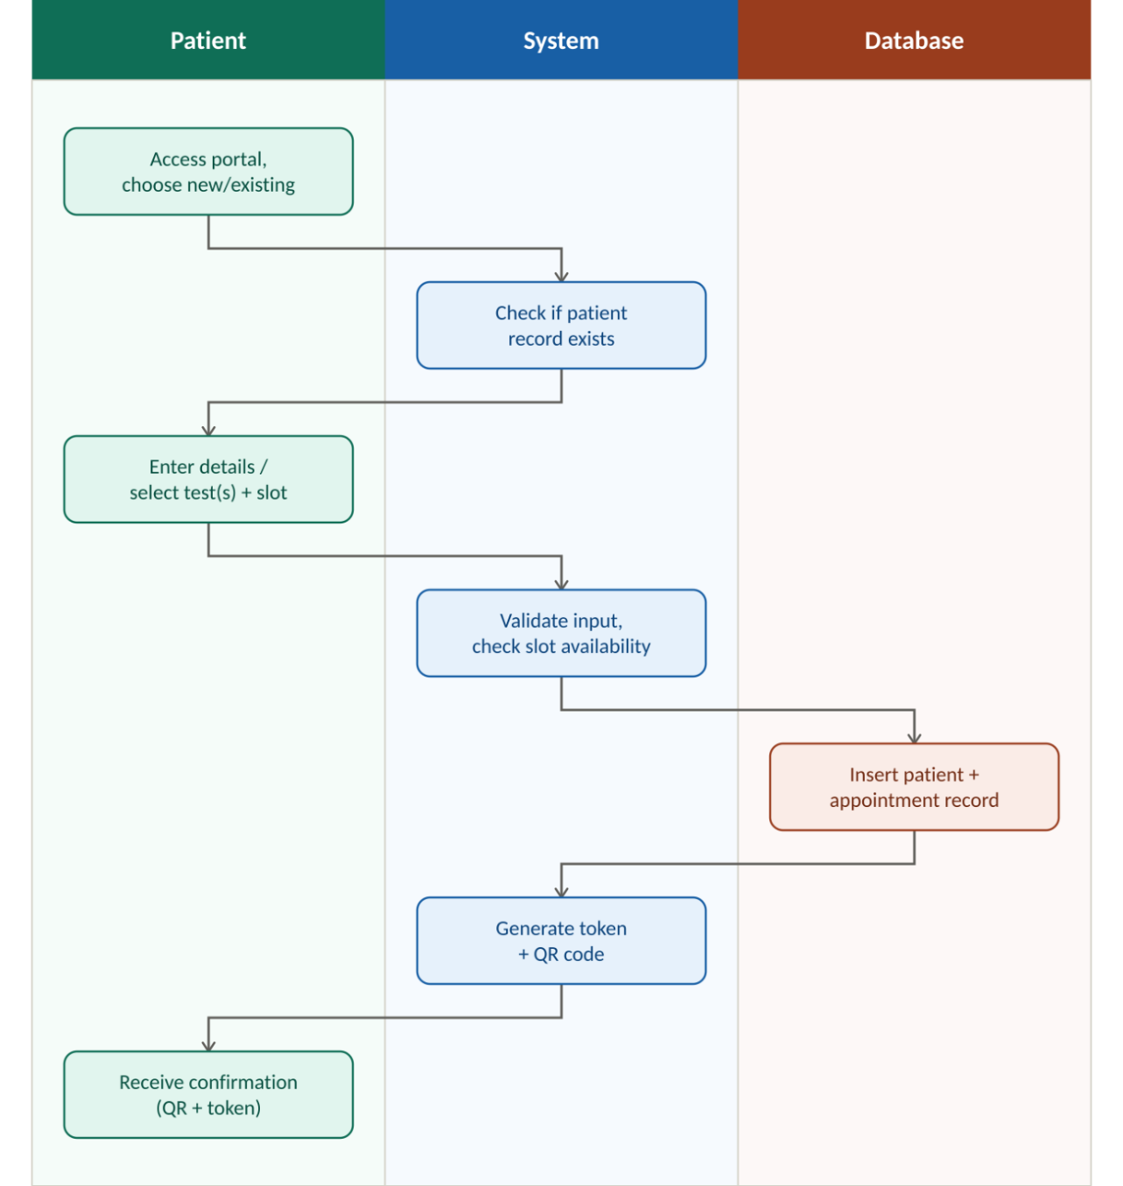
Figure C13: Activity diagram — patient registration & appointment booking
1. Login/Registration — the process begins when the patient accesses the portal and the system checks whether they are a new or existing user.
2. New Patient Flow — if new, the patient enters personal details; the system validates the input (e.g. required fields, valid contact number) before creating the record.
3. Book Appointment — the patient selects the test(s) and a preferred date/time slot. The system checks slot availability before proceeding, rejecting the booking and prompting an alternative slot if unavailable.
4. Confirmation — on success, the system generates a unique appointment token and QR code, stores the appointment record, and returns the confirmation to the patient.
5. End of process — the patient may later use this QR code at reception to verify the appointment.

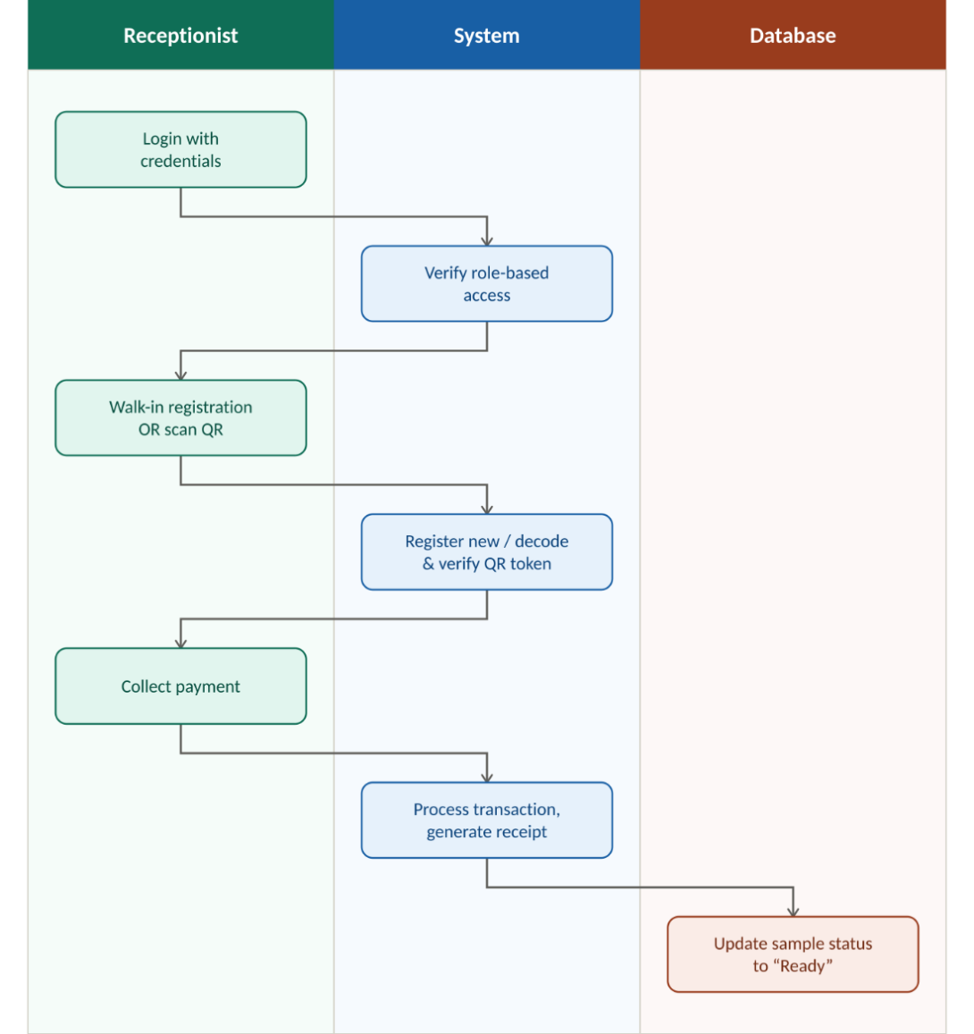
Figure C14: Activity diagram — receptionist verification & billing
1. Login — the receptionist logs in; the system verifies role-based access before granting dashboard access.
2. Decision: walk-in vs pre-booked — the key branch point: walk-in patients are registered fresh, while pre-booked patients are verified via QR code scan.
3. Verify Appointment — for pre-booked patients, the system decodes the QR token and retrieves the matching appointment; an invalid or expired code is rejected with an error message rather than allowing the process to continue.
4. Collect Payment — payment is processed and a receipt generated only after a successful transaction; the sample status is not updated until payment is confirmed, a deliberate safeguard against unpaid samples entering the laboratory queue.
5. Update Status — once payment is confirmed, the system marks the sample “Ready for Collection”, pushing it onto the Laboratory Technician's pending queue.

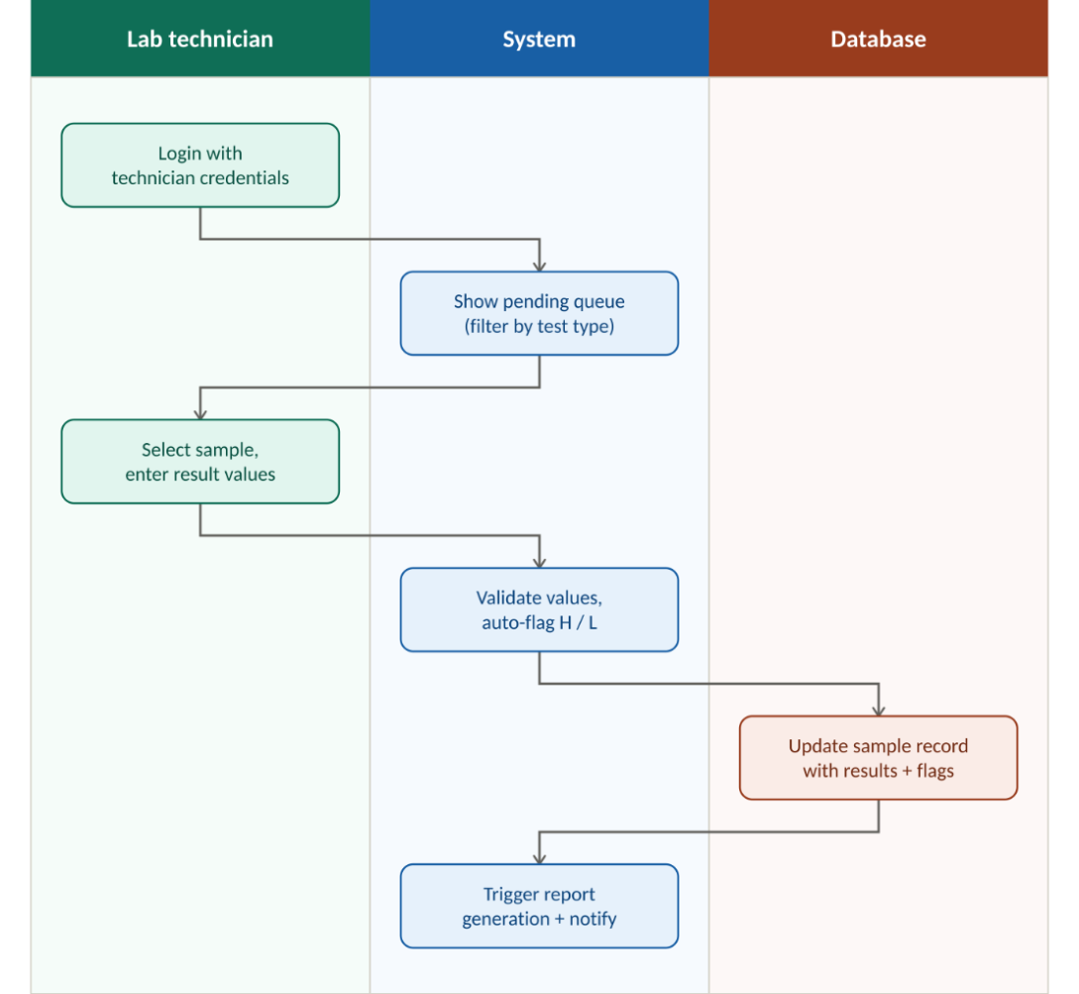
Figure C15: Activity diagram — lab technician result entry
1. Login and Queue View — the technician logs in and views only the samples pending in their laboratory section, optionally filtered by test type.
2. Manual Result Entry — the technician reads values directly from the equipment display/printout and enters them into the system.
3. Automatic Flagging — as each value is entered, the system checks it against the acceptable range for that test and automatically applies an H (high) or L (low) flag where relevant, rather than relying on the technician to remember reference ranges.
4. Save and Trigger Downstream Actions — once results are saved, the sample status changes to “Result Ready”, which automatically triggers report generation and notification rather than requiring a separate manual step.
5. Repeat / End — the technician continues with the next pending sample or logs out at the end of the shift.

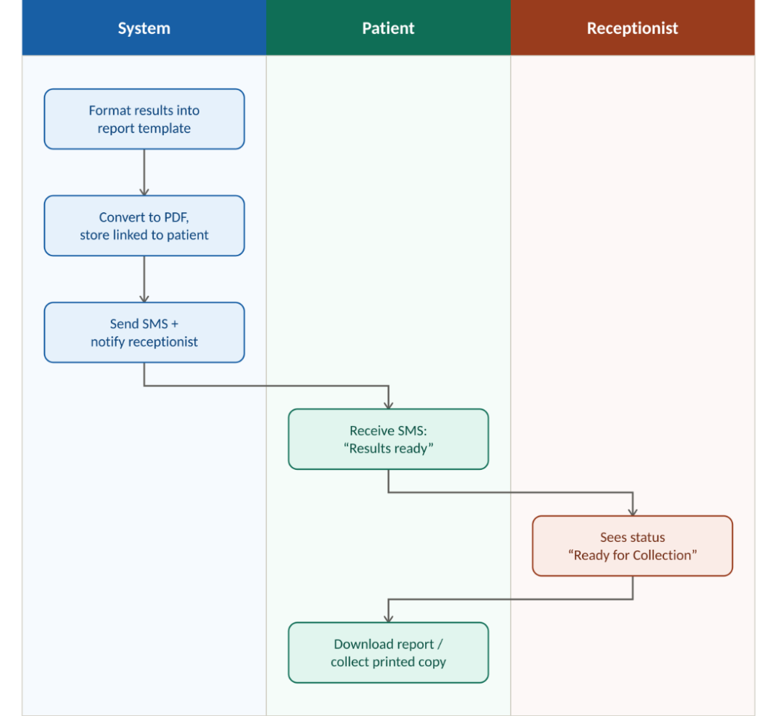
Figure C16: Activity diagram — report generation & notification
1. Report Formatting — once a technician saves results, the system automatically formats them into the standard report template.
2. PDF Conversion and Storage — the report is converted to PDF and stored in the database, linked to the patient's record for later retrieval.
3. Notification — an SMS is sent to the patient informing them the results are ready, and the receptionist's dashboard is simultaneously updated.
4. Retrieval — the patient can either log into the patient portal to view/download the PDF report, or collect a printed copy physically from the receptionist.

C2.6 Interface Design
Interface design defines how users interact with the Laboratory Information System. The interface design prioritises usability, consistency, and accessibility across all user roles, and follows a consistent screen layout across all interfaces to ensure familiarity and ease of use.

Navigation Structure. All screens use a sidebar navigation menu on the left side of the interface. The sidebar displays the system logo at the top, followed by role-specific navigation links organised hierarchically, with the most frequently used options placed at the top. The current active page is highlighted to provide clear visual feedback.
Content Area. The main content area occupies the right portion of the screen and includes a header bar displaying the current page title and breadcrumb navigation. Content is organised using card-based layouts, where related information and controls are grouped into visually distinct cards with subtle borders and background shading.
Colour Scheme. The interface employs a professional medical colour palette: a calming blue (#2563EB) for primary buttons, active navigation states, and important highlights; a light grey (#F8FAFC) background to reduce eye strain during extended use; and dark grey (#1E293B) text for readability. Success states use green, warnings use amber, and errors use red.
Typography. The system uses the Inter font family for all interface elements. Headings use a semi-bold weight at 24px for page titles and 18px for section headings; body text uses a regular weight at 14px; form labels use a medium weight at 12px with uppercase lettering and letter spacing for clarity.
Form Design. All forms follow a consistent layout with labels positioned above input fields. Required fields are marked with an asterisk. Input fields use rounded corners and subtle borders that change colour on focus. Validation messages appear below the relevant field in red text. Primary action buttons are positioned at the bottom of forms, aligned to the right.

Login Screen. The login screen provides a clean, centred interface for user authentication, featuring the system logo, email address and password fields, a primary sign-in button, and links for password recovery and account creation. The interface is deliberately simple and distraction-free.
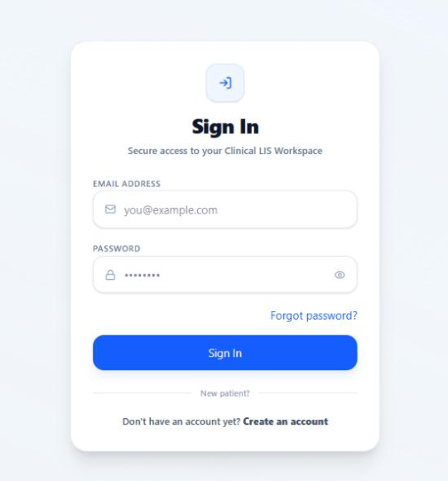
Figure C17: Login screen
Patient Dashboard. The patient dashboard provides a comprehensive overview of the patient's laboratory activities: summary statistics for tests ordered, appointments scheduled, and completed results; a My Appointments section showing upcoming and past appointments with status indicators; a Book Appointment button; and testing guidelines for patient reference.
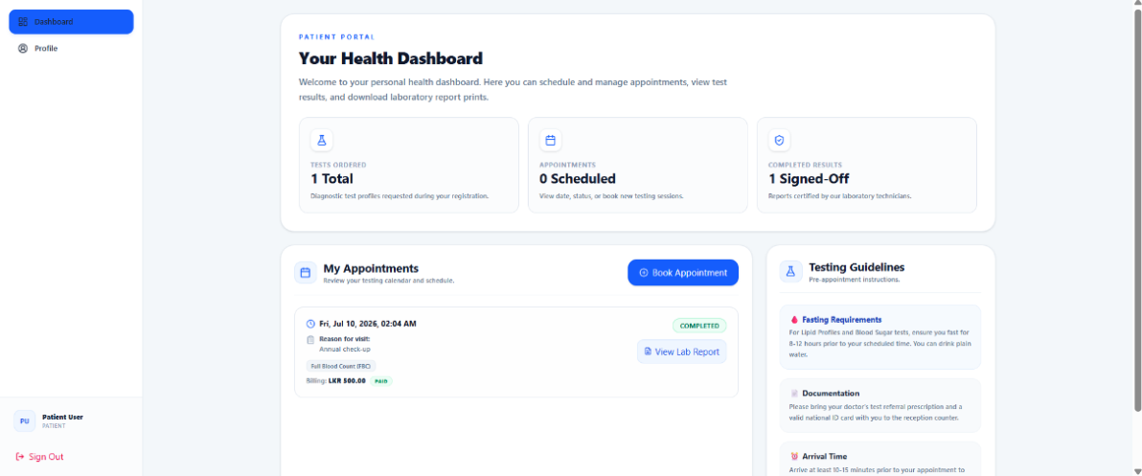
Figure C18: Patient dashboard
Receptionist Dashboard. The receptionist interface is designed for efficient patient intake and billing management. It features a patient worklist and queue showing scheduled appointments with their status, quick action buttons for onboarding patients and booking walk-in appointments, and a payment collection panel displaying billing details and allowing payment processing.
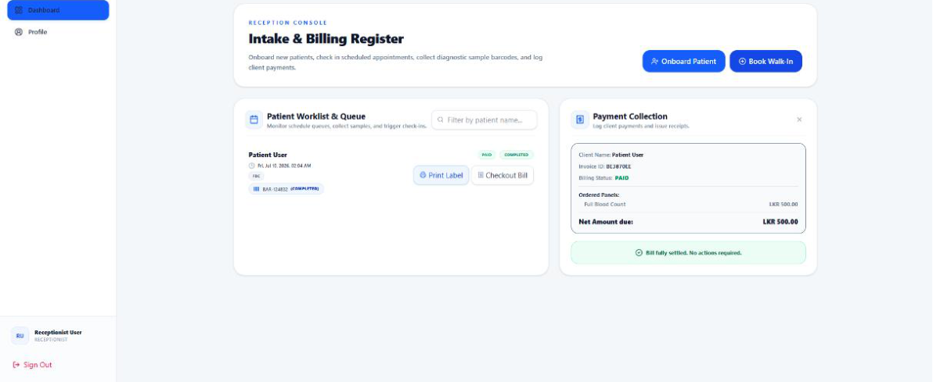
Figure C19: Receptionist dashboard & billing register
Technician Worklist. The technician interface focuses on specimen processing and result entry. It displays a specimen processing queue showing collected samples ready for analysis, with patient information and barcode identifiers. The observation sheet area provides structured input fields for entering test results, optimised for efficient data entry with minimal navigation.
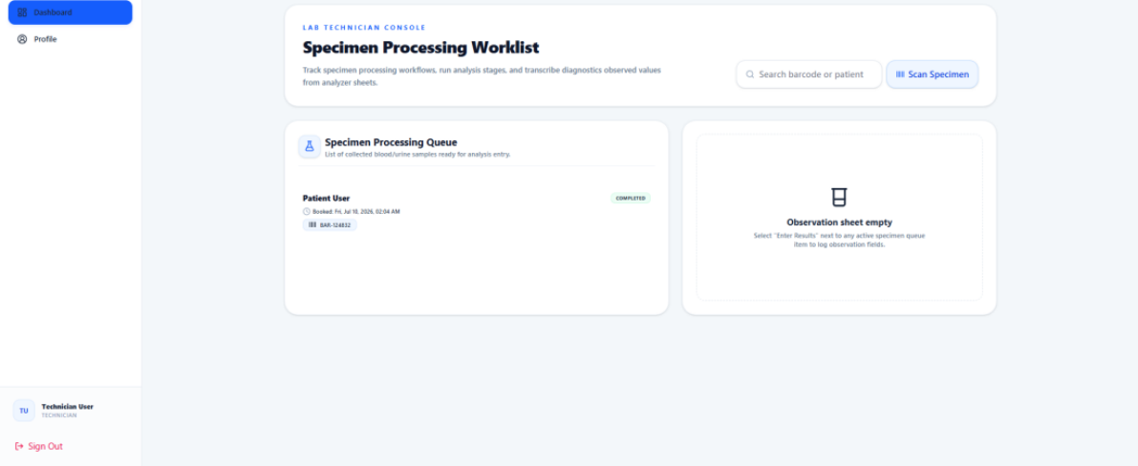
Figure C20: Technician test processing worklist
Administrator Dashboard. The administrator dashboard serves as the system control centre. It displays summary statistics for registered users, active tests, and appointment counts, and the security audit logs section shows recent system activities with timestamps. The interface provides access to user management, test directory management, and profile settings through the sidebar navigation.
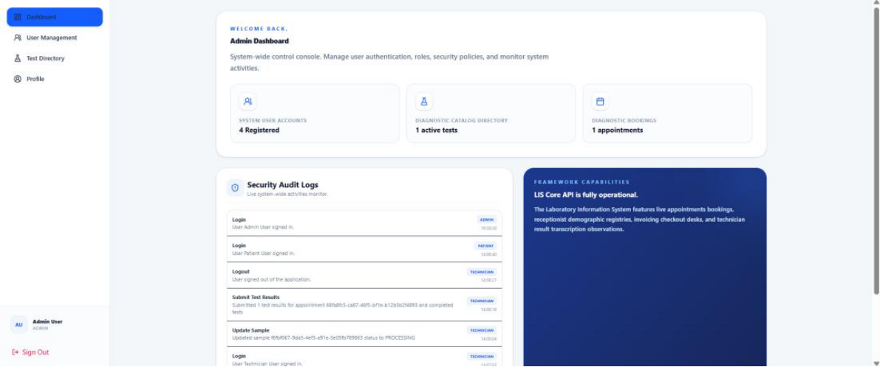
Figure C21: Administrator dashboard
Test Catalogue Management. The test catalogue management process allows administrators to define and maintain the laboratory's test offerings. Each test entry includes a unique test code, descriptive name, medical category (e.g., Haematology), measurement unit, price, reference range values, and a detailed description. Tests can be marked as active or inactive in the catalogue.
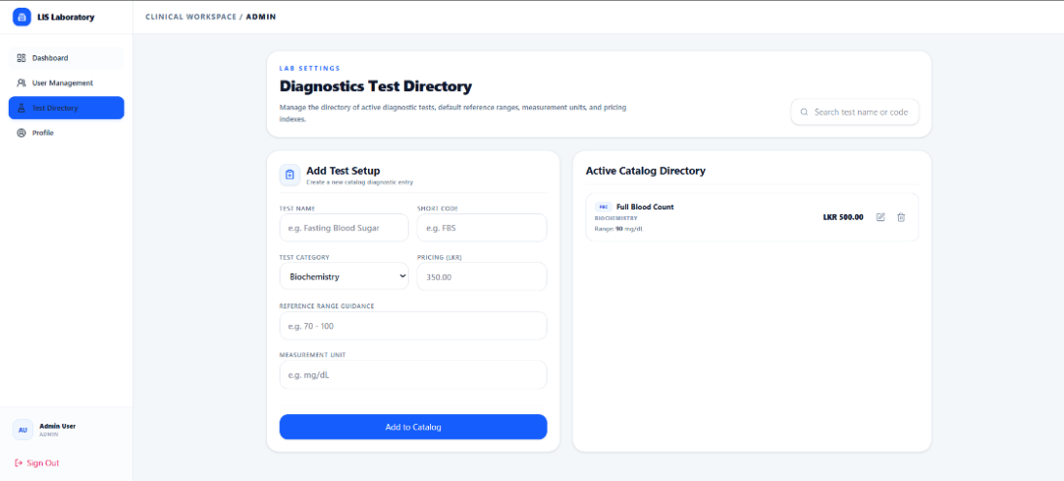
Figure C22: Test catalogue interface
Profile Management. All users can access their profile management interface to update personal information and change their account password. The profile page displays editable fields for contact information and medical details, alongside a secure password change form that requires the current password for verification.
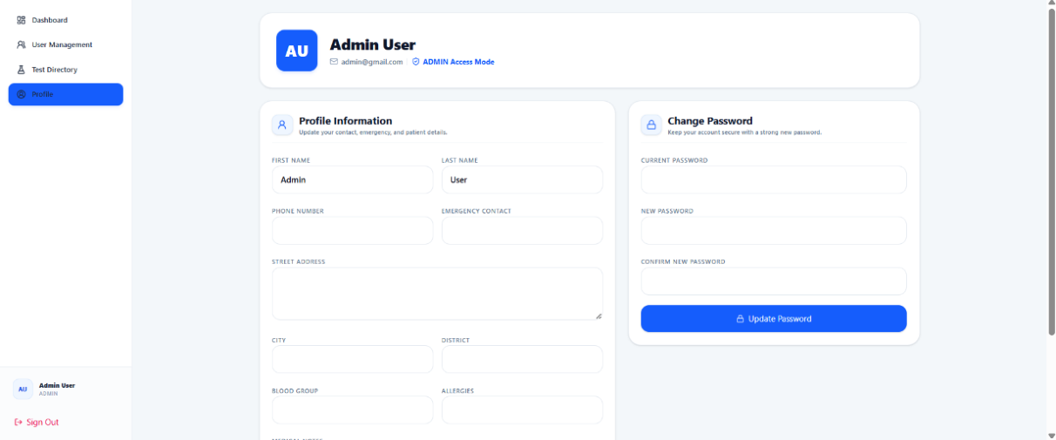
Figure C23: Profile management

i. Consistency — all screens share common layout elements, colour schemes, and interaction patterns, reducing the learning curve for users who interact with multiple parts of the system.
ii. Efficiency — the card-based layout and sidebar navigation minimise the number of clicks required to access common functions; technicians can enter results quickly, and receptionists can process patients efficiently.
iii. Accessibility — the interface uses sufficient colour contrast for readability, clear typography, and intuitive navigation, and form validation provides immediate feedback to prevent errors.
iv. Responsiveness — the layout adapts to different screen sizes using responsive design techniques, ensuring usability across desktop computers, tablets, and mobile devices.
v. Role-Based Adaptation — each user role sees only the navigation items and functions relevant to their responsibilities, reducing complexity and potential for errors.

C3. Hardware and Software Selection
The successful development and implementation of the proposed Laboratory Information System require appropriate hardware and software resources. Selecting suitable development tools enables efficient system design, coding, testing, and maintenance, while appropriate implementation equipment ensures that the completed system operates reliably within the laboratory environment.

C3.1 Development Hardware and Software Equipment

The primary hardware required for developing the system is a laptop or desktop computer with sufficient processing power, memory, and storage capacity to support modern web development tools.
Component | Specification
Processor | Intel Core i5 (10th Generation or above) / AMD Ryzen 5 or above
RAM | Minimum 8 GB (16 GB recommended)
Storage | 512 GB SSD
Display | Full HD (1920 × 1080)
Internet | Broadband internet connection
Table C15: Recommended development workstation specifications
The development process requires running several software applications simultaneously, including Visual Studio Code, Node.js, PostgreSQL, web browsers, and testing tools. A multi-core processor and sufficient RAM improve compilation speed and multitasking performance, while an SSD provides faster project loading, database access, and application execution. A stable internet connection is essential for downloading software packages, collaborating through GitHub, and accessing online documentation.

1. Operating System — Windows 11: provides the development environment for building and testing the system. It supports all required development tools and offers a stable platform for modern web application development, is compatible with Node.js, PostgreSQL, Visual Studio Code and the other software used throughout the project, and its wide hardware compatibility and regular security updates provide a reliable environment for software development.
2. Visual Studio Code: the primary integrated development environment (IDE) for writing, editing, debugging, and managing the source code. It supports JavaScript, React.js, Node.js, HTML, CSS, SQL, and JSON, and provides intelligent code completion, debugging features, Git integration, syntax highlighting, and extension support, improving developer productivity and code quality.
3. React.js: used to develop the presentation layer. It enables the development of reusable user interface components, resulting in a responsive, interactive, and maintainable web application, and improves user experience by updating only the necessary components without reloading the entire page.
4. Tailwind CSS: used for designing the application's user interface. Its utility-based styling simplifies interface development, promotes consistent design, and supports responsive layouts for different screen sizes.
5. Node.js with Express.js: used to implement the backend server and business logic. Node.js efficiently processes multiple user requests using asynchronous programming, while Express.js simplifies API development, routing, authentication, and communication between the frontend and the database.
6. PostgreSQL: the relational database management system for the project, providing secure and reliable storage for patient records, appointments, laboratory test results, billing information, and user accounts, with support for data integrity, scalability, and efficient query processing.
7. Postman: used to test and validate the RESTful APIs developed for the backend, enabling developers to verify API functionality independently of the frontend, helping identify errors early and improving overall software quality.
8. Git and GitHub: Git is used for version control, while GitHub serves as the online repository for project collaboration. Version control allows developers to track source code changes, restore previous versions when necessary, and collaborate effectively within the development team.
9. Figma: used to design the graphical user interface before implementation, allowing the creation of interface prototypes, usability evaluation, and feedback collection before coding begins, reducing design modifications during development.

C3.2 Implementation Hardware and Software Equipment

The Laboratory Information System is accessed through a standard web browser; therefore, administrators, receptionists, and laboratory technicians require a desktop computer or laptop with moderate hardware specifications.
Component | Specification
Processor | Intel Core i3 (10th Generation or above) / AMD Ryzen 3 or above
RAM | Minimum 8 GB
Storage | 256 GB SSD
Display | Full HD monitor
Internet | Broadband internet connection
Table C16: Recommended implementation workstation specifications
1. Desktop Computer or Laptop: the system is browser-based and does not require high-performance hardware. A standard office computer provides sufficient performance for patient registration, appointment management, laboratory result entry, report generation, and billing activities.
2. Laser Printer: used to print laboratory reports, invoices, and administrative documents. Although reports can be accessed electronically, many patients and healthcare providers still require printed copies. Laser printers provide fast, high-quality printing with low operating costs.
3. Barcode Printer: used to print barcode labels for laboratory samples. Barcode labels improve sample identification accuracy, reduce manual errors, and simplify sample tracking throughout the testing process.
4. Barcode Scanner: used to scan sample labels during laboratory operations, enabling quick retrieval of patient and sample information while minimising manual data entry errors and improving operational efficiency.
5. Uninterruptible Power Supply (UPS): supplies temporary backup power during unexpected electricity failures. Power interruptions may result in incomplete transactions or data loss; a UPS allows users to save ongoing work safely and shut down systems properly, improving reliability.
6. Internet Router: a reliable internet connection is required for accessing the web application and transmitting data. The router enables communication between client computers and the application server while supporting online notifications and remote system access.

1. Windows 10/11: the client computers operate using Windows 10 or Windows 11, which provide compatibility with modern web browsers and support all software required to operate the system.
2. Google Chrome or Microsoft Edge: modern web browsers provide access to the system. The application is web-based and is optimised for browsers that support current web technologies, responsive design, and secure HTTPS communication.
3. Node.js Runtime Environment: the backend server is deployed using the Node.js runtime, which executes server-side application logic, processes user requests, and manages communication between the frontend and the PostgreSQL database.
4. PostgreSQL Database Server: stores all system information permanently — patient records, appointments, laboratory test results, reports, billing information, user accounts, and audit logs — while ensuring data consistency, integrity, and security.
5. Email/SMS Notification Service: sends automated messages to patients when laboratory reports become available, improving communication and reducing unnecessary visits to the laboratory.

Part D — Development and Implementation Report

D1. Software Development: Testing
This section presents the testing strategy applied to the Laboratory Information System, the rationale for the test cases designed for each functional module, and a summary of test execution outcomes. The full set of test logs is provided in Appendix E.

D1.1 Justification of Testing Technique
The LIS is a role-based, transactional web application (React.js front end, Node.js/Express.js REST API, PostgreSQL database) serving four actor roles: Administrator, Receptionist, Laboratory Technician, and Patient. Rather than adopting a single testing technique uniformly, the group selected techniques that match the nature of each part of the system, as justified below.
Equivalence Partitioning and Boundary Value Analysis (Input Validation Layer). The backend centralises field-level validation in a reusable rule engine (backend/src/utils/validation.js), which composes validators such as required(), minLength(), email(), passwordStrength(), beforeToday(), oneOf() and matchesField(). Because each validator defines an explicit boundary between valid and invalid input (for example, passwordStrength() requires a minimum of 8 characters containing at least one uppercase letter, one lowercase letter, and one digit), Equivalence Partitioning was used to identify valid and invalid input classes for every form (patient registration, login, appointment booking, test/template creation), and Boundary Value Analysis was used to test values exactly at, just below, and just above each threshold (e.g. 7- vs 8-character passwords, an appointment date exactly at the current server time). This combination was chosen specifically because the validation logic is rule-based and declarative, so its correctness can be verified precisely at the stated thresholds rather than through broad theoretical sampling.
Integration Testing (Multi-Table Transactional Workflows). Several controller functions wrap multiple related database writes inside a single PostgreSQL transaction (BEGIN…COMMIT/ROLLBACK). For example, createAppointment() in appointmentController.js inserts a row into appointments, links selected tests via appointment_tests, computes a total from the tests table, and creates both an invoices row and a samples row in the same transaction; submitResults() in resultController.js upserts test_results rows, then cascades status changes to both appointments and samples, and finally broadcasts the change over Socket.io. A unit test of any single function in isolation would not reveal whether these dependent writes stay consistent with one another. Integration testing was therefore used to verify that a single API call produces the correct combined state across appointments, appointment_tests, invoices, samples and test_results, and that a failure partway through the transaction correctly rolls back all of it.
Role-Based Access Control (RBAC) / Security Testing. Every protected route is wrapped with an authenticate() middleware (JWT verification plus a live lookup against the user_sessions table) and an authorizeRoles(...roles) middleware that checks req.auth.role against an explicit allow-list. Because access control is enforced entirely through this middleware pair rather than scattered in-controller checks, it was tested directly and systematically: for every route, the group verified that (a) a request with no token is rejected with 401, (b) a request with a valid token but a disallowed role is rejected with 403, and (c) a request from an allowed role succeeds. This is a security-relevant technique rather than a generic functional one, applied because RBAC is a core non-functional requirement for a clinical system handling patient data.
Session and Two-Factor Authentication (2FA) Testing. The authentication module implements two non-trivial pieces of session/security logic: a hard limit of three concurrent active sessions per user (with automatic revocation of the oldest session in createUserSession()), and a dual-mode 2FA flow (TOTP via an authenticator app, or a 6-digit email OTP that expires after 10 minutes, in enableTwoFactor()/verifyTwoFactorLogin()). These are time- and count-based conditions that are easy to get subtly wrong (off-by-one session limits, OTP codes that fail to expire), so they were tested with dedicated scenario-based test cases in addition to the general validation testing above, rather than assumed to be covered incidentally by other tests.
Each technique above is anchored to a named file, function, and business rule in the LIS codebase, avoiding a purely theoretical treatment of testing techniques.

D1.2 Choice and Design of Test Cases
Test cases were derived directly from the validation rules and business logic implemented in the system, so that each chosen data value has a specific reason for being included rather than being an arbitrary example. The table below summarises the rationale behind the data values chosen for the highest-risk functions in each of the six modules.
Module | Function Under Test | Technique | Chosen Data Values | Rationale
Auth & User Mgmt | Password strength (passwordStrength()) | BVA + EP | 7 chars (invalid); 8 chars w/ upper+lower+digit (valid boundary); 8 chars missing a digit; empty string | The regex threshold is exactly 8 characters with three character-class requirements; boundary values around 8 and one-missing-class inputs directly probe the regex logic
Auth & User Mgmt | Session limit (createUserSession()) | BVA (count-based) | 2nd login (allowed); 3rd login (allowed, becomes 3rd active); 4th login (must auto-revoke oldest session) | The rule is “revoke the oldest session when active count >= 3”; the boundary sits at the 3rd/4th session, so these counts are the only values that can expose an off-by-one error
Auth & User Mgmt | Email OTP expiry (verifyTwoFactorLogin()) | BVA (time-based) | Code submitted at 9m59s after issue (valid); code submitted at 10m01s after issue (expired) | The OTP is issued with a hard-coded 10-minute validity window (NOW() + INTERVAL '10 minutes'); testing just inside and just outside this window is the only way to confirm the expiry check fires at the right instant
Appointments | Appointment date (createAppointment()) | BVA | Date = now − 1 minute (rejected); date = now + 1 minute (accepted); date = far future (accepted) | The controller rejects new Date(appointment_date) < new Date(); values either side of “now” are the only way to test this comparison at its boundary
Sample & Test Mgmt | Test code uniqueness (createTest()) | EP | Brand-new code (valid class); code identical to an existing test (duplicate class) | createTest() explicitly checks for an existing row with the same test_code and returns 409 Conflict; the two classes map directly to the two branches of that check
Sample & Test Mgmt | Sample status transition (updateSample()) | EP | status = “COLLECTED” (triggers collected_at/collected_by write); status = other valid enum value; status omitted | updateSample() branches its SQL specifically on status === 'COLLECTED'; each partition exercises a different code path, and the omitted case checks the explicit required-field guard
Results & Reporting | Result submission (submitResults()) | EP + Integration | Well-formed results array (valid); results array missing testId; results array missing resultValue; empty array | The function validates the shape of each array element before writing; missing fields and an empty array test the guard clauses, while a valid array tests the full appointment→sample cascade
Invoicing | Payment collection (collectPayment()) | BVA | amount_paid = net_amount exactly (should mark PAID); amount_paid < net_amount (should remain PENDING); amount_paid = 0; amount_paid = −500 | The controller only checks amount_paid === undefined; it does not reject zero or negative values before inserting a payment row, so boundary values at and below zero were chosen specifically to test for this gap
Admin/Security & Audit | Report template update (updateTemplate()) | EP | Update template A by its own id; update template A while a different template B also exists | The UPDATE statement's WHERE clause was inspected during test design and found to reference the wrong parameter placeholder; the second case (multiple templates present) was chosen specifically to reveal whether the wrong row gets updated
Admin/Security & Audit | Role authorization (authorizeRoles()) | EP (security) | No Authorization header; valid token, disallowed role; valid token, allowed role; token for a revoked session | These four classes correspond exactly to the four branches inside authenticate()/authorizeRoles() (missing token, wrong role, success, revoked session), giving full decision coverage of the guard
Table D1: Rationale for test-case data selection per module (extract; full set in Appendix E)
Test data was chosen using this same equivalence-partition/boundary approach for the remaining input fields not shown above (e.g. e-mail format on registration, required fields on appointment creation, oneOf() role/status enumerations), following the identical principle of testing at and around each rule's decision boundary rather than with arbitrary values.

D1.3 Test Logs
Test cases were executed against the running backend (Express API) and, where relevant, verified end-to-end through the React front end. A representative extract of the test log is shown below; the complete log of all executed test cases, including the regression cases for the defects found in TC-23 and TC-27, is provided in Appendix E.
ID | Test Case Description | Expected Result | Actual Result | Result | Conclusion / Action
TC-01 | Register patient with password “Abc1234” (7 chars, meets all classes) | HTTP 400, “must be at least 8 characters” | HTTP 400 with matching field error | Pass | No action
TC-04 | 4th concurrent login for the same user (3 sessions already active) | Oldest session auto-revoked; new session created; 3 active sessions remain | Oldest session revoked; audit log entry “Security Alert” written; 3 active sessions | Pass | No action
TC-07 | Email OTP submitted 11 minutes after issue | HTTP 401, “Verification code has expired or is invalid.” | HTTP 401 with matching message | Pass | No action
TC-10 | Create appointment with appointment_date one minute in the past | HTTP 400, “Appointment date cannot be in the past.” | HTTP 400 with matching message | Pass | No action
TC-15 | Update sample status to “COLLECTED” with no existing sample row | A new sample row is created with status COLLECTED and a barcode | New row inserted correctly | Pass | No action
TC-19 | Submit results with one array element missing resultValue | HTTP 400, “Each result must include testId and resultValue.” | HTTP 400 with matching message | Pass | No action
TC-23 | Collect payment with amount_paid = −500 on a valid invoice | Request rejected as invalid input | HTTP 200 — payment of −500 accepted and summed into total_paid, corrupting the payment_status calculation | Fail | Defect logged: collectPayment() must validate amount_paid > 0 before inserting a payment row. Assigned to Invoicing module owner for a follow-up fix (add a validator(amount_paid) check returning HTTP 400)
TC-27 | Update report template B's name while template A also exists in the table | Only template B's row is updated | Template A's row was updated instead, because the SQL WHERE clause reused the $2 placeholder (already bound to “header”) instead of the id placeholder | Fail | Defect logged: updateTemplate() WHERE clause must bind to the correct parameter index. Reassigned to the correct positional parameter and scheduled for regression re-test (TC-27b, Appendix E)
TC-31 | Access GET /api/admin/audit-logs with a valid PATIENT token | HTTP 403, “You are not allowed to access this resource.” | HTTP 403 with matching message | Pass | No action
TC-34 | Access any protected route with a token whose session jti has been revoked | HTTP 401, “Session has been revoked or expired.” | HTTP 401 with matching message | Pass | No action
Table D2: Test log extract (expected/actual outcome, pass/fail, and follow-up action)
Two genuine defects were found during testing (TC-23 and TC-27), both of which are discussed further in Section D4 (Critical Appraisal) as items for post-submission remediation. All other test cases in the extract passed on first execution.

D2. Implementation: Conversion and Training Plan

D2.1 Justification of Conversion Technique
The LIS is designed for a single small-to-medium diagnostic laboratory rather than a multi-branch organisation, and it directly handles safety-critical data: patient test results, sample chain-of-custody status, and billing. A direct (immediate) cutover was rejected because it would leave no fallback if a defect surfaced in a safety-critical path (for example, the amount_paid validation gap identified in Section D1.3) after paper records had already been discontinued. A pilot conversion (running the new system at one branch while others continue on paper) was also rejected, since the laboratory operates as a single site with one reception desk and one sample-processing bench, so there is no second branch to pilot against.
The group therefore adopted a phased parallel-running conversion: the LIS is introduced module by module (registration/authentication, then appointments and sample intake, then results entry, then billing, then administration/reporting), and for each module the new system runs alongside the existing paper-based process until reconciliation between the two confirms the module is trustworthy, after which the paper process for that module is retired. This technique was chosen specifically because it (a) matches the way the system's own modules are already separated by role and by database table, so each phase corresponds to a coherent, independently verifiable slice of functionality, and (b) protects patient safety by never removing the paper fallback for a clinical workflow (sample tracking, results) until the equivalent digital workflow has been reconciled against it for a full operating cycle.

D2.2 Conversion Schedule and Resource Plan
The conversion is planned over an eight-week period. The schedule below shows each phase against its calendar week; “■” marks the weeks during which that phase is active.
Phase | W1 | W2 | W3 | W4 | W5 | W6 | W7 | W8
0. Environment & account setup | ■
1. Auth & registration parallel run | ■ | ■
2. Appointments & sample intake parallel run |  | ■ | ■
3. Results entry parallel run |  |  | ■ | ■
4. Billing/invoicing parallel run |  |  |  | ■ | ■
5. Admin/reporting cutover |  |  |  |  | ■ | ■
6. Full cutover & paper decommission |  |  |  |  |  | ■ | ■
7. Post-go-live hypercare |  |  |  |  |  |  | ■ | ■
Table D3: Eight-week phased conversion schedule

Who: the group's Admin/Security module owner acts as the implementation lead, provisioning PostgreSQL (database/schema.sql, database/seed.sql) and the four default role accounts (admin@gmail.com, recep@gmail.com, tech@gmail.com, patient@gmail.com) before Week 1. The Auth module owner runs a 1-hour hands-on session for reception and technician staff in Week 1 on login and 2FA setup; the Appointments and Results module owners each run a 1-hour session for their respective staff groups immediately before their phase goes live (Weeks 2 and 3).
What: patient demographic records already held on paper are transcribed into the users/user_profiles tables during Weeks 1–2 by reception staff, working from existing patient files; test catalogue data (from the laboratory's existing price list) is entered into the tests table by the Admin module owner before Week 2 using the admin test-management screens.
Where: the system is deployed on a single on-premises machine on the laboratory's local network (backend on port 5000, PostgreSQL locally, frontend built with Vite and served to reception/technician workstations); patients access the patient portal from the reception desk during the parallel-running phase, moving to home/remote access once results verification has been reconciled in Weeks 3–4.
When: each phase begins only once the previous phase's reconciliation checks have passed for two consecutive operating days, so the calendar above is a planned baseline rather than a fixed deadline.
How: for each phase, staff continue to complete the existing paper form/register in addition to using the LIS; at the end of each day during that phase, the implementation lead reconciles a sample of digital records against the paper equivalents (e.g. comparing sample barcodes and result values). The paper process for a phase is only retired once two consecutive days show zero reconciliation discrepancies.
This narrative also constitutes the training plan: each module is taught to the staff who will operate it immediately before that module's phase begins, using the live system rather than a separate training environment, so that training and parallel-running reinforce each other.

D3. Implementation: User Guide
This user guide covers system requirements and installation, first-time login and security setup, the operating instructions for each of the four roles, a summary of the system's main functions, and general error handling. It is written to be usable both by a technically minded administrator performing the installation and by day-to-day reception, technician and patient users.

D3.1 System Requirements and Installation

- Node.js version 18 or later (backend and frontend both run on Node.js).
- A running PostgreSQL server, reachable from the machine that will host the backend.
- A modern web browser (Chrome, Edge, or Firefox) for all four user roles.
- Network access between the frontend, backend (default port 5000) and the machines from which the frontend (default port 5173) will be accessed.

- Ensure the PostgreSQL server is running and reachable.
- From the project root, run: cd backend then npm run db:setup. This automated utility verifies the database connection, applies the schema in database/schema.sql, and seeds the four default role accounts and sample data from database/seed.sql.
- If the schema needs to be upgraded later without a full reset, run npm run db:upgrade from the backend directory.

- In the backend directory, create a .env file (based on .env.example) and set: PORT, CLIENT_URL, DB_HOST, DB_PORT, DB_NAME, DB_USER, DB_PASSWORD, DATABASE_URL, JWT_SECRET (minimum 32 characters), JWT_EXPIRES_IN, BCRYPT_ROUNDS, and the SMTP_* variables used for e-mail OTP delivery.
- Install dependencies (npm install, first run only) and start the API in development mode with npm run dev. The API listens on the configured PORT (default 5000).

- In a separate terminal, navigate to the frontend directory, run npm install, then npm run dev. The Vite development server serves the application on http://localhost:5173 and proxies /api requests through to the backend.
- For a production build, run npm run build in the frontend directory and serve the generated frontend/dist folder from a web server or reverse proxy.
Default Login Credentials. The seed script creates one account per role for initial access. These must be changed immediately in any real deployment.
Role | Email | Password
Admin | admin@gmail.com | Admin@123
Receptionist | recep@gmail.com | Recep@123
Technician | tech@gmail.com | Tech@123
Patient | patient@gmail.com | Patient@123
Table D4: Default seeded accounts, one per role

D3.2 First-Time Login and Security Setup
- Open the frontend URL and sign in with an assigned e-mail and password.
- If two-factor authentication has been enabled for the account, the system will request a verification code after the password step, either from an authenticator app (TOTP — scan the QR code shown during setup) or by e-mail (a 6-digit code valid for 10 minutes, resendable if it expires).
- Users can enable or disable 2FA from their profile page; enabling 2FA requires entering one valid code before it is switched on, to guard against locking the account out with a mistyped secret.
- Administrators can review and, if necessary, remotely revoke any active session (including a stolen or forgotten one) from the Security page.

D3.3 Operating Instructions by Role

- Register a new account from the registration screen (name, date of birth, gender, e-mail, phone, password); the system rejects an e-mail already in use and enforces the password strength rule described in Section D1.1.
- Book an appointment by choosing a date/time (the system rejects a date/time in the past) and, optionally, selecting one or more tests from the catalogue; selecting tests automatically generates a pending invoice and a pending sample record.
- View upcoming and past appointments, along with their linked test list, sample status, and invoice/payment status, from the patient dashboard.
- Once a technician has submitted results, view the results (value, reference range, unit, and normal/abnormal flag) for a completed appointment.
- Share the printed/QR barcode from a visit with a third party (e.g. an insurer) who can independently verify a report's authenticity via the public barcode-verification screen, without needing to log in.

- View all appointments across all patients, including linked tests, sample status and invoice status, from the reception dashboard.
- Book an appointment on behalf of a walk-in patient (patient, date, reason and tests are all required for staff-created bookings).
- Check a patient in on arrival: this generates a unique barcode, marks the linked sample as COLLECTED, and timestamps the collection.
- Cancel a scheduled appointment (only appointments still in SCHEDULED status can be cancelled).
- Collect payment against an invoice, recording the amount and payment method; the invoice automatically moves to PAID once payments received sum to at least the net amount.

- View the list of samples awaiting processing, including patient name, appointment reason, and current sample status.
- Update a sample's status as it moves through the workflow (e.g. COLLECTED → PROCESSING → COMPLETED); collection details (who and when) are recorded automatically when a sample is marked COLLECTED.
- Enter results for each test linked to an appointment; submitting a complete results set automatically marks the appointment and its sample as COMPLETED and pushes a real-time notification to connected reception and patient screens.

- Manage the test catalogue: create, update, or remove tests (code, name, category, price, reference range, unit); the system prevents two tests from sharing the same test code.
- Manage report templates used to format printed/PDF results (header, footer, logo, notes).
- Manage user accounts, including activating/deactivating accounts.
- Review the live activity feed and the full audit log (who did what and when, across every module).
- View all currently active sessions system-wide (user, IP address, browser, expiry) and forcibly revoke any session, which immediately signs that session out on its next request.

D3.4 Description of Main Functions
Module | Main Functions
Authentication & User Management | Registration, login, logout, JWT session issuance, session-limit enforcement (max 3 concurrent), TOTP and e-mail two-factor authentication, profile and password management, user account administration
Appointments | Patient self-booking, staff-assisted booking, appointment listing (patient and staff views), check-in with barcode generation, cancellation
Sample & Test Management | Sample listing and status tracking, test catalogue management (create/update/delete tests)
Results & Reporting | Result entry and upsert, appointment/sample completion cascade, real-time status broadcast (Socket.io), public barcode-based report verification
Invoicing | Invoice generation on booking, invoice/payment listing, payment collection with automatic PAID/PENDING status calculation
Admin, Security & Audit | Report template management, system-wide audit log, live activity feed, active session monitoring and remote revocation
Table D5: Main functions grouped by module

D3.5 General Error Handling
The API returns a consistent JSON error shape with an HTTP status code and a human-readable message (and, for validation failures, a per-field error map) via a shared error-handling middleware (backend/src/middleware/error.js and utils/httpError.js). The table below explains what each status code means to an end user and what action to take.
HTTP Status | Typical Message | Meaning to the User | Recommended Action
400 Bad Request | “Validation failed” (with field-level detail) or a specific rule message, e.g. “Appointment date cannot be in the past.” | One or more submitted fields did not meet the system's rules | Correct the highlighted field(s) using the message shown next to each field and resubmit
401 Unauthorized | “Invalid credentials or inactive account.”, “Session has been revoked or expired.”, “Invalid or expired authentication token.” | Either the login details were wrong, the account is deactivated, or the current session is no longer valid | Re-enter credentials, or log in again; if the account appears deactivated, contact an administrator
403 Forbidden | “You are not allowed to access this resource.” | The logged-in account's role does not have permission for this action | Confirm the correct role is logged in; otherwise contact an administrator to request access
404 Not Found | “Invoice not found.”, “Sample not found.”, “Appointment not found.”, “No matching clinical record found for this barcode.” | The referenced record does not exist or the identifier/barcode was entered incorrectly | Re-check the identifier or barcode; if the record should exist, contact reception/admin
409 Conflict | “An account with this email already exists.”, “A test with that code already exists.” | The submitted value duplicates something already in the system | Use a different e-mail address or test code, or edit the existing record instead of creating a new one
500 Internal Server Error | Generic failure message (no sensitive detail returned to the client) | An unexpected server-side error occurred | Retry the action; if it persists, report it to the technical/admin team with the time of the error so the server log and audit trail can be checked
Table D6: General error handling reference

D4. Critical Appraisal

D4.1 Group Critical Appraisal
From a macro perspective, the group succeeded in delivering a working, role-segmented LIS covering the full patient journey: registration and authentication, appointment booking, sample collection, result entry, real-time status updates, invoicing/payment, and administrative oversight (audit logging and session security). The clearest evidence of a coherent overall design is that the six functional areas map cleanly onto six independent controller/route pairs sharing one PostgreSQL schema, which allowed the group to divide work along the same boundaries used for this appraisal.

- No automated test framework was configured for the backend (the package.json test script is a placeholder that simply exits with an error), so all testing documented in Section D1 had to be performed manually against a running instance, which was significantly more time-consuming than an automated suite and increased the risk of a manual step being skipped under time pressure.
- Coordinating six members around one shared PostgreSQL schema (database/schema.sql) created integration risk whenever more than one member needed to extend the same table (for example, the sessions table added later via a separate add_sessions_table.js migration script rather than the main schema file); this was managed by treating schema changes as reviewed, sequential migrations rather than direct edits.
- Testing (Section D1.3) surfaced two real defects that had not been caught during individual development: a missing lower-bound check on payment amounts in the Invoicing module, and an incorrect SQL parameter index in the Admin module's template-update query. Both illustrate the value of the cross-module, systematic testing pass described in Section D1, as opposed to relying only on each member's testing of their own code.

- Introduce an automated test suite (e.g. Jest with Supertest against a test database) so that the manual test cases in Section D1 can be converted into a repeatable regression suite, catching defects like TC-23 and TC-27 automatically on every change.
- Add account lockout / rate-limiting after repeated failed login attempts, since the current login flow has no limit on password guesses beyond the general absence of brute-force protection.
- Extend validateBody()-style validation to the Invoicing and Admin modules, which currently perform ad hoc checks (or none, in the case of payment amounts) rather than using the shared validation rule engine already built for Authentication and other modules.
- Activate the SMS/e-mail notification preference fields already present in the patients table schema (notification_preference, sms_enabled, email_enabled) to automatically notify patients when results are ready, rather than requiring patients to check the portal themselves.
- Formalise sample and appointment status transitions as an explicit state machine, to prevent an invalid transition (e.g. marking a sample COMPLETED before it has been COLLECTED) that the current implementation does not explicitly guard against.

D4.2 Individual Critical Appraisal
Each member's appraisal below focuses on the module they were individually responsible for, in line with the module ownership confirmed for this group.
PV Kavinda (D/BSE/25/0014) — Authentication & User Management. Module responsibility: authController.js, middleware/auth.js, utils/jwt.js, utils/twoFactor.js and the users/user_profiles/user_sessions tables. Technical challenges faced: implementing two structurally different 2FA delivery paths (TOTP secret/QR generation via speakeasy vs. a time-boxed e-mail OTP) behind a single enableTwoFactor()/verifyTwoFactorLogin() interface without duplicating the expiry and validation logic; getting the session-limit and auto-revocation logic (createUserSession()) to behave correctly at exactly three active sessions, which required careful ordering of the count-check, revoke, and insert steps inside one function; and ensuring the JWT payload and the live user_sessions row stay consistent, so that revoking a session (logout, or admin-triggered revocation) is reflected immediately by authenticate() on the very next request. Suggested individual enhancement: add rate-limiting/lockout on the login endpoint after repeated failed password attempts for the same account or IP address.
WMDGJ Warnasooriya (D/COE/25/0003) — Appointments. Module responsibility: appointmentController.js and the appointments/appointment_tests tables. Technical challenges faced: keeping the patient-initiated (createAppointment()) and staff-initiated (createAppointmentByStaff()) booking paths consistent, since both must create the same linked invoice and sample rows but differ in required fields and the identity of the booking party; designing the cancelAppointment() authorization so that a patient can only cancel their own appointment while reception/admin can cancel any appointment, using a single function with role-dependent SQL rather than two near-duplicate functions; and making the past-date rejection in createAppointment() precise at the boundary of “now”, so a booking made for the current minute is not incorrectly rejected. Suggested individual enhancement: prevent double-booking by validating that a patient does not already have another SCHEDULED appointment at an overlapping time.
P Rohit (D/BCS/25/0017) — Sample & Test Management. Module responsibility: sampleController.js, testController.js and the samples/tests tables. Technical challenges faced: designing updateSample() so that marking a sample COLLECTED also stamps collected_at/collected_by, while other status changes do not overwrite that history — this required branching the SQL rather than using one generic UPDATE; handling the case where checkInAppointment() (in the Appointments module) is called before a sample row exists yet, so updateSample() and the check-in flow do not conflict when both can create a sample record; and preventing duplicate test codes in the shared test catalogue (createTest()) while still allowing every other field to be edited freely via updateTest(). Suggested individual enhancement: introduce an explicit, enforced status state machine for samples (e.g. PENDING → COLLECTED → PROCESSING → COMPLETED) so an out-of-order transition is rejected rather than silently accepted.
Imesha Rajapaksha (D/BCS/25/0019) — Results & Reporting. Module responsibility: resultController.js, services/socketService.js and the test_results table. Technical challenges faced: using an INSERT … ON CONFLICT DO UPDATE (upsert) in submitResults() so a technician can correct a previously entered result without a separate “edit” endpoint, while still recording who entered/edited it and when; coordinating the three-way status cascade (test_results → appointments.status → samples.status) inside one transaction so results, appointment status, and sample status can never be left out of sync if part of the request fails; and wiring the real-time Socket.io broadcast so reception and patient screens update immediately, while ensuring a broadcast failure does not roll back the already-committed database changes. Suggested individual enhancement: add a review/approval step for a second technician or a pathologist before a submitted result is marked COMPLETED and released to the patient portal, rather than releasing immediately on entry.
AAN Hirundika (7151) — Invoicing. Module responsibility: invoiceController.js and the invoices/payments tables. Technical challenges faced: calculating payment_status by summing all rows in the payments table for an invoice, which needed care to correctly move an invoice from PENDING to PAID exactly when the cumulative total reaches (not exceeds) the net amount; during testing (Section D1.3, TC-23) it was found that collectPayment() does not reject a negative or zero amount_paid before writing a payment row, which is the single most significant defect surfaced across the whole system; and keeping invoice totals in sync with the tests selected at booking time (createAppointment() computes total_amount/net_amount from the tests table), given that test prices can later be edited by the Admin module. Suggested individual enhancement: fix the identified defect by validating amount_paid > 0 (and amount_paid <= outstanding balance) before inserting a payment row, and add this as a permanent regression test case.
Kavindu Kavishka (D/COE/25/0004) — Admin, Security & Audit. Module responsibility: adminController.js, services/auditService.js and the audit_logs/user_sessions/report_templates/tests tables. Technical challenges faced: building a system-wide audit trail (logAudit()) that every other module calls into, which required agreeing on a consistent action-naming and description convention across all six members' code so the audit log reads coherently; during testing (Section D1.3, TC-27) it was found that updateTemplate() binds its WHERE id = clause to the wrong SQL parameter placeholder ($2, already bound to header, instead of the id parameter), which can silently update the wrong report template; and implementing session listing and remote revocation (listSessions()/revokeSession()) so an administrator can see and end a session on another user's device without needing direct database access. Suggested individual enhancement: fix the identified defect by correcting the parameter index in the updateTemplate() query, and add an automated regression test asserting that only the targeted template row changes when multiple templates exist.

Appendices

Appendix A: Interview Summary
A total of three staff members were interviewed to assess operational workflows and identify systemic pain points, together with one patient representative.
Role | Number Interviewed | Key Finding
Laboratory Technician | 1 | Excel templates are inconsistent; manual entry requires 15–20 min per report
Receptionist | 1 | Significant redundancy due to duplicate data entry across multiple systems
Administrator | 1 | Lack of automated backup mechanisms; high-level reporting is difficult
Patient Representative | 1 | No online access for patients; physical visits required to check report status
Table Apx-1: Interview summary

1. Interview Sheet #1 — Laboratory Technician. Q: Walk me through your report generation process. A: I load the sample, wait for the machine printout, and type the values into my personal Excel template. I have to re-type patient details the receptionist already took. It takes about 15–20 minutes total. Q: Have you ever lost data or made entry errors? A: Yes, typing mistakes happen, especially with long biochemistry panels. Once our PC crashed and we lost two weeks of digital records because we don't have a shared backup.
2. Interview Sheet #2 — Receptionist. Q: Describe the patient registration process. A: I write their details in the logbook, then write the exact same details on a sample register slip for the lab. Then, later, I type the exact same details into the billing software. I'm writing the same thing three times.
3. Interview Sheet #3 — Administrator. Q: What is your biggest concern from a management perspective? A: Data loss and lack of auditing. If a computer fails, we lose records. Also, I cannot automatically track patient volumes or see who edited a specific report because there are no user accounts.
4. Interview Sheet #4 — Patient Representative. Q: What frustrates you most about using the laboratory currently? A: I have to come to the laboratory twice — once for the sample and once to collect the report. Sometimes when I come the second time, the report is not ready yet. I also cannot book an appointment online; I have to call during working hours. Q: Would you use an online portal to view your report if available? A: Definitely yes. If I could download my report from my phone, that would save me a lot of time.

Appendix B: Observation Summary

i. 08:07–08:19: patient registration takes 12 minutes due to the receptionist manually handwriting details in both the main logbook and the sample slip.
ii. 08:35–08:57: technician spends 16 minutes manually transcribing results from the analyser printout into an Excel file, re-typing demographics, and fixing cell formatting.
iii. 08:58–09:00: receptionist re-enters the patient into the separate billing software.
iv. 10:15 (peak): queue forms in the waiting area; wait times extend to 45 minutes solely due to the single-technician Excel report generation bottleneck.

v. Average patient registration time: 10.5 minutes.
vi. Average report generation time: 16.5 minutes.
vii. Observed errors: 2 (one digit transposition, one incorrect patient name).
viii. Data redundancy: patient data manually entered 3 separate times per visit.

Appendix C: System Models & Sampling Data

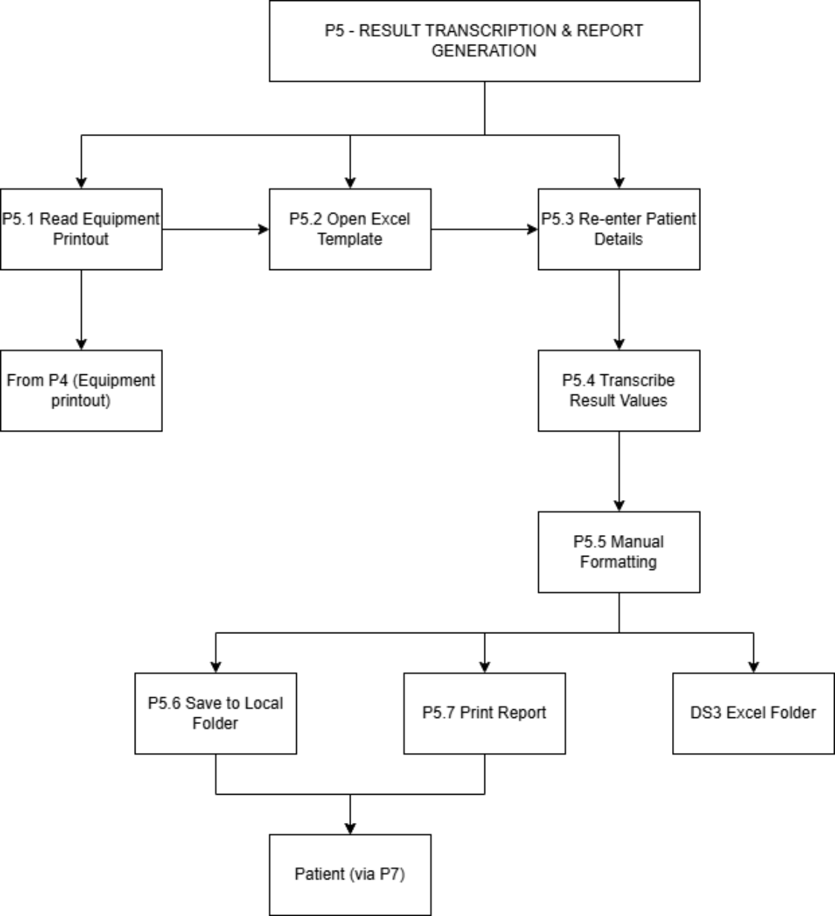
Figure Apx-1: Level 2 DFD of the current system
1. P2 (Patient Registration): highlights the redundant manual data flow of patient demographics from the patient, to the logbook, and onto the paper sample slip without digital retention.
2. P5 (Result Transcription): maps the flow of data from the equipment printout into local, isolated Excel folders (DS-3), highlighting steps (like manual formatting) that an LIS will completely automate.
3. P6 (Billing): demonstrates the isolation of the Standalone Billing DB (DS-4), which receives no automated data from the Registration or Testing modules.

4. Methodology: stratified random sampling of 75 historical records (25 Haematology, 25 Biochemistry, 25 Microbiology).
5. Findings: 8 total errors identified across the 75 records (including transposed digits, missing measurement units, and incorrect reference ranges).
6. Calculated error rate: 10.7% record-level error rate; 6.4% field-level transcription error rate.

Appendix D: Sample Excel Template Analysis
Analysis of the Excel templates currently in use identified five distinct versions circulating among staff. Key discrepancies confirming the need for an LIS:
1. Inconsistent Reference Ranges: templates A and C had different “normal” ranges for the exact same haematology parameters depending on which technician worked that day.
2. Inconsistent Units: some templates used standard SI units, while others used conventional units, creating severe clinical misinterpretation risks.
3. Lack of Authentication: none of the five templates contained a verifiable digital signature or audit-trail capability.

Appendix E: Full Test Logs
The table below records every test case executed for the LIS: test case description (data values, module and function under test), test case result, and test case conclusion (including any action taken).
ID | Module / Function | Data Values Tested | Result | Conclusion / Action
TC-01 | Auth — passwordStrength() | Password = “Abc1234” (7 chars) | Pass | Rejected with correct message; no action
TC-02 | Auth — passwordStrength() | Password = “Abcdefg1” (8 chars, all classes) | Pass | Accepted; no action
TC-03 | Auth — email() | Email = “not-an-email” | Pass | Rejected with correct message; no action
TC-04 | Auth — createUserSession() | 4th login attempt with 3 sessions already active | Pass | Oldest session revoked automatically; no action
TC-05 | Auth — createUserSession() | 2nd login attempt with 1 session already active | Pass | No revocation triggered, as expected; no action
TC-06 | Auth — enableTwoFactor() (TOTP) | Correct TOTP code from authenticator app | Pass | 2FA enabled successfully; no action
TC-07 | Auth — verifyTwoFactorLogin() (Email OTP) | Code submitted 11 minutes after issue | Pass | Correctly rejected as expired; no action
TC-08 | Auth — verifyTwoFactorLogin() (Email OTP) | Code submitted 9 minutes after issue | Pass | Accepted; no action
TC-09 | Auth — authenticate() middleware | Request with revoked session jti | Pass | Rejected 401; no action
TC-10 | Appointments — createAppointment() | appointment_date = now − 1 minute | Pass | Rejected 400; no action
TC-11 | Appointments — createAppointment() | appointment_date = now + 1 minute, with 2 testIds | Pass | Appointment, invoice, and sample rows all created consistently; no action
TC-12 | Appointments — cancelAppointment() | Patient cancels own SCHEDULED appointment | Pass | Cancelled successfully; no action
TC-13 | Appointments — cancelAppointment() | Patient attempts to cancel another patient's appointment | Pass | Correctly returns 404 (no matching row for that patient); no action
TC-14 | Sample Mgmt — createTest() | testCode duplicates an existing test | Pass | Rejected 409; no action
TC-15 | Sample Mgmt — updateSample() | status = “COLLECTED”, no existing sample row | Pass | New sample row created with barcode; no action
TC-16 | Sample Mgmt — updateSample() | status field omitted from request body | Pass | Rejected 400 “Status is required.”; no action
TC-17 | Results — submitResults() | Valid results array, 2 tests, appointment exists | Pass | Results saved; appointment and sample both moved to COMPLETED; no action
TC-18 | Results — submitResults() | appointmentId does not exist | Pass | Rejected 404; no action
TC-19 | Results — submitResults() | Array element missing resultValue | Pass | Rejected 400 with correct message; no action
TC-20 | Results — verifyReport() | Barcode does not match any sample | Pass | Rejected 404 with correct message; no action
TC-21 | Invoicing — collectPayment() | amount_paid = net_amount exactly | Pass | Invoice correctly moves to PAID; no action
TC-22 | Invoicing — collectPayment() | amount_paid < net_amount | Pass | Invoice correctly remains PENDING; no action
TC-23 | Invoicing — collectPayment() | amount_paid = −500 | Fail | Negative amount accepted and summed into total, corrupting payment_status. Defect logged; assigned for fix (validate amount_paid > 0)
TC-23b | Invoicing — collectPayment() (regression, post-fix design) | amount_paid = −500 (after proposed fix) | Not yet retested | Pending code fix and re-test before final submission
TC-24 | Admin — createTest() | price omitted from request body | Pass | Rejected 400; no action
TC-25 | Admin — listSessions() / revokeSession() | Admin revokes another user's active session | Pass | Session revoked; subsequent request with that token rejected 401; no action
TC-26 | Admin — listAuditLogsFull() | Confirm audit entries appear for actions in TC-04, TC-12, TC-17, TC-25 | Pass | All four actions correctly present in the audit log; no action
TC-27 | Admin — updateTemplate() | Update template B's name while template A also exists | Fail | Template A was updated instead of template B (WHERE clause bound to wrong parameter index). Defect logged; assigned for fix
TC-27b | Admin — updateTemplate() (regression, post-fix design) | Repeat of TC-27 after correcting the parameter index | Not yet retested | Pending code fix and re-test before final submission
TC-28 | Security — authorizeRoles() | PATIENT token used against an ADMIN-only route | Pass | Rejected 403; no action
TC-29 | Security — authenticate() | Request with no Authorization header | Pass | Rejected 401; no action
TC-30 | Security — authenticate() | Malformed / tampered JWT | Pass | Rejected 401 “Invalid or expired authentication token.”; no action
Table Apx-2: Full test log

Appendix F: List of Abbreviations
Abbreviation | Meaning
ACID | Atomicity, Consistency, Isolation, Durability
AES | Advanced Encryption Standard
API | Application Programming Interface
CDC | Centers for Disease Control and Prevention
CSS | Cascading Style Sheets
DFD | Data Flow Diagram
ER | Entity-Relationship
FR | Functional Requirement
HTTPS | Hypertext Transfer Protocol Secure
JWT | JSON Web Token
KDU | General Sir John Kotelawala Defence University
LIS | Laboratory Information System
LKR | Sri Lankan Rupee
OTP | One-Time Password
OWASP | Open Web Application Security Project
PDF | Portable Document Format
QA | Quality Assurance
QR | Quick Response (code)
RBAC | Role-Based Access Control
SMS | Short Message Service
TLS | Transport Layer Security
TOTP | Time-based One-Time Password
UAT | User Acceptance Testing
UI/UX | User Interface / User Experience
UPS | Uninterruptible Power Supply
WHO | World Health Organization
Table Apx-3: Abbreviations used in this report

