



User Interface

Colours

#0091ff - Blue

#ff7300 - Orangte

#bebebe - Grey

Colours are taken from the City of Gosnells website and previous application for the City of Gosnells.

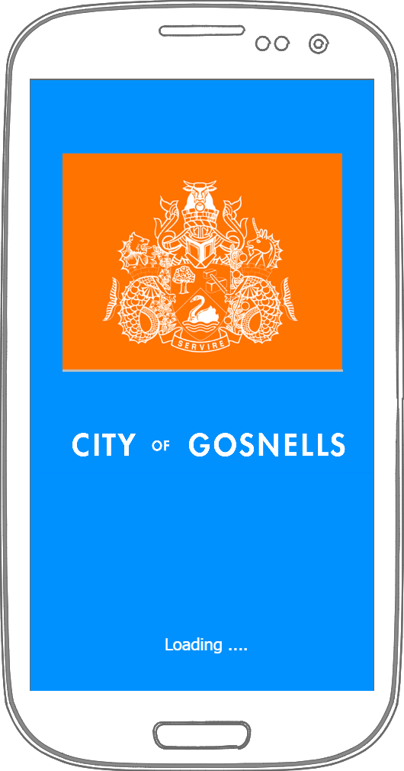

Splash Screen:

The splash screen contains the City of Gosnells logo in the color themes used throughout the app. Loading is displayed at the bottom with three moving dots to let the user the app is connecting to the web service.

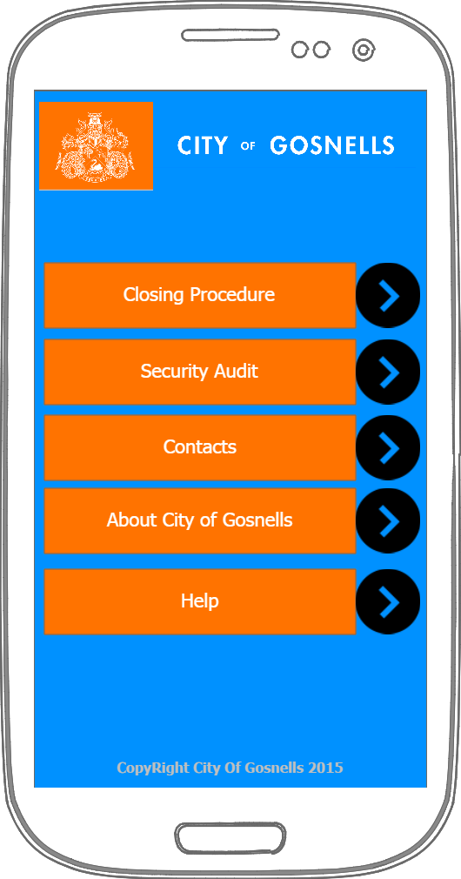

Main Menu

The main menu has buttons leading to all the activities. There is a copyright notice down the bottom.

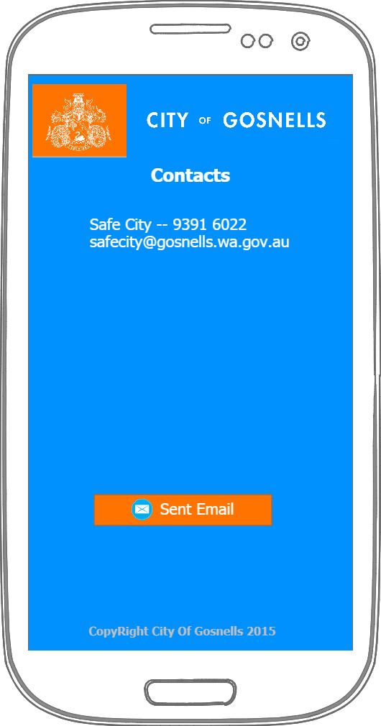

Contacts:

The Contacts Activity has a list of contacts and sites that the user can visit if the

use needs further help. I has one button that will return the user to the main menu. The email address are links and will use the users choice of email app to send.

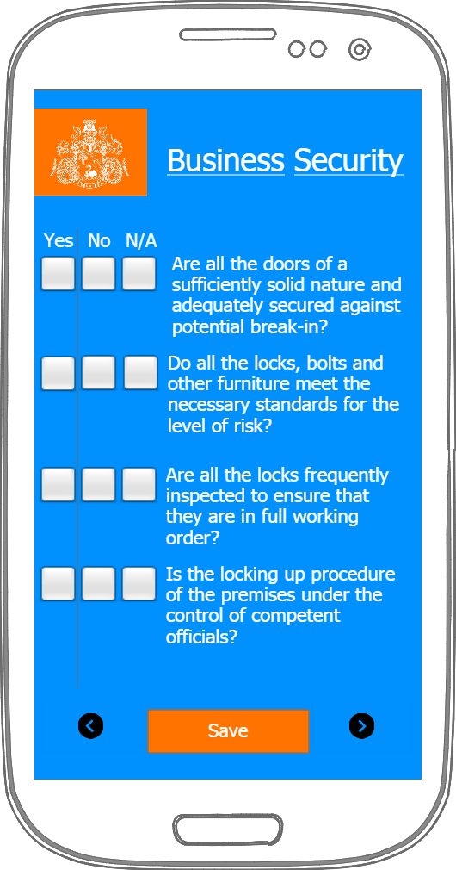

Check Box:

The Checkbox activity contains the main functionality of the application. Data is loaded from the web service. In the example above it contains a scrollview with a list of questions relating to the one topic. The save button saves the user progress and returns to menu. The forward button saves progress and takes the user to the next topic. Return takes the user to the previous topic.

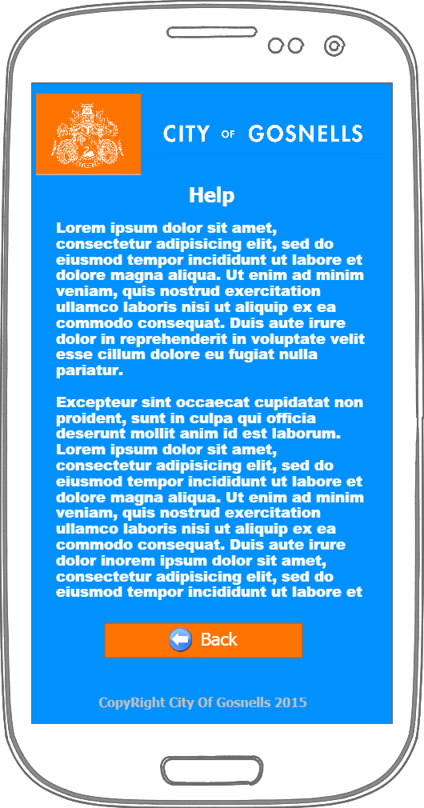

Help Screen

The Help activity contains information on how to user the app. The back button will return the user to main menu.

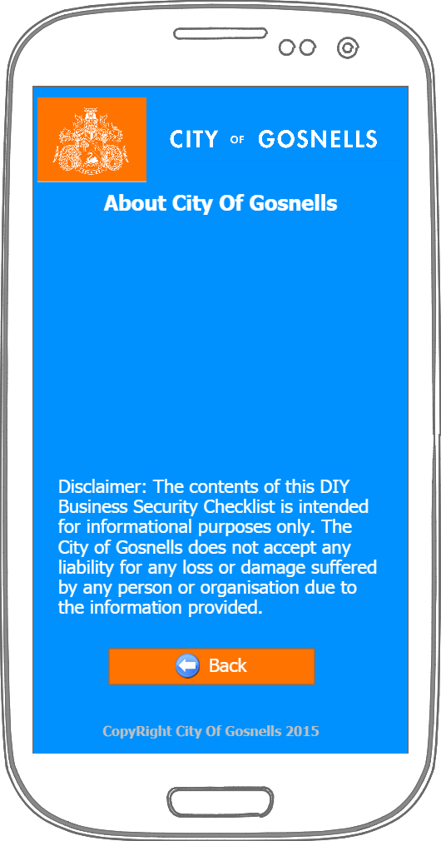

Information:

Contains information for the City of Gosnells and the legal disclaimer. The back button returns the user to the main menu.