**Interpolating North American Ice Sheet Layers to 30-yr Temporal Resolution**

Adam B. Smith | Missouri Botanical Garden | 2020-02

**Dyke (vectorized) glaciers**

Dr. Patrick Bartlein (University of Oregon) vectorized representations of North American ice sheet cover from Dyke & Prest (1987) and Peltier (1994). These representations are provided as shapefiles for 1000-yr increments from 21 to 5 Kybp. To interpolate to 30-yr time slices, we borrowed a method from graphical animation called “tweening” which estimates intermediate states of a graphic based on start and end states. For each 1000-yr time period (e.g., 8 to 7 Kybp), we used the two shapefile representations as the start/end points. To minimize distortion from assuming a 2D space for 3D data, we projected the polygons to an oblique azimuthal equidistant projection with a center point calculated from the centroid of the polygon from 21 Kybp. We then applied the *interpPolysByTween()* function in the *birdsEye* package for R (Smith 2020a). We varied the number of intermediate time steps (100 or 1000) and ease method (cubic or linear), but results extremely similar regardless of settings, so in the end used 1000 intermediate steps and a linear ease. We then selected a subset of steps to represent the polygons for each 30 yr. **Known issues**: The tweening sometimes creates regular “unnatural” shapes (e.g., very long straight lines). On some occasions it makes small ice fragments “migrate” across the landscape to join larger sheets. Also, there is often a sudden change in the state of the layer every 1000 yr due to the start/end points of the interpolation time period changing.

**Peltier (rasterized) glaciers**

Richard Peltier developed a spatially explicit model of ice sheet development using ice-sheet loading and mantle viscosity (Roy & Peltier 2015, 2017, 2017). These layers are provided for every 1000 yr for 21 and 20 Kybp, and for every 500-yr increment thereafter to 0 ybp. To interpolate the layers we applied the *interpolateRasters()* function in the *enmSdm* package for R (Smith 2020b). This function interpolates values cell-by-cell across time using either a linear function or splines anchored at each period’s start/end points (i.e., every 1000 or 500 yr). The interpolations are constructed such that they go through each anchor point exactly (e.g., they exactly recreate the input data, plus intermediate steps). **Known issues**: As with the Dyke layers, there is often a sudden change in ice sheet extent every 500 or 1000 yr due to the stare/end points of the interpolation time period changing. The spline interpolation should smooth over this, but it also estimates large swaths of ice in CONUS when there should be none (i.e., 0 Kybp).

**Citations**

Dyke, A.S. & V.K. Prest. 1987. Late Wisconsinan and Holocene history of the Laurentide ice sheet. Geographie physique et Quaternaire 41:237-263.

Peltier, W.R. 1994. Ice-Age Paleotopography. Science 265:195-201.

Roy, K. & Peltier, W.R. 2015. Glacial isostatic adjustment, relative sea level history and mantle viscosity: reconciling relative sea level model predictions for the U.S. East coast with geological constraints. Geophysical Journal International 201:1156-1181.

Roy, K., & Peltier, W.R. 2017. Space-geodetic and water level gauge constraints on continental uplift and tilting over North America: Regional convergence of the ICE-6G_C (VM5a/VM6) models. Geophysical Journal International 210:1115-1142.

Roy, K., & Peltier, W.R. 2018. Relative sea level in the Western Mediterranean basin: A regional test of the ICE-7G_NA (VM7) model and a constraint on Late Holocene Antarctic deglaciation. Quaternary Science Reviews 183:76-87.

Smith, A.B. 2020. birdsEye, a package for GIS. Version 0.0.0.5. GitHub: <https://github.com/adamlilith/birdsEye>

Smith, A.B. 2020. enmSdm, a package modeling species distributions and niches. Version 0.4.0.3 GitHub: <https://github.com/adamlilith/enmSdm>

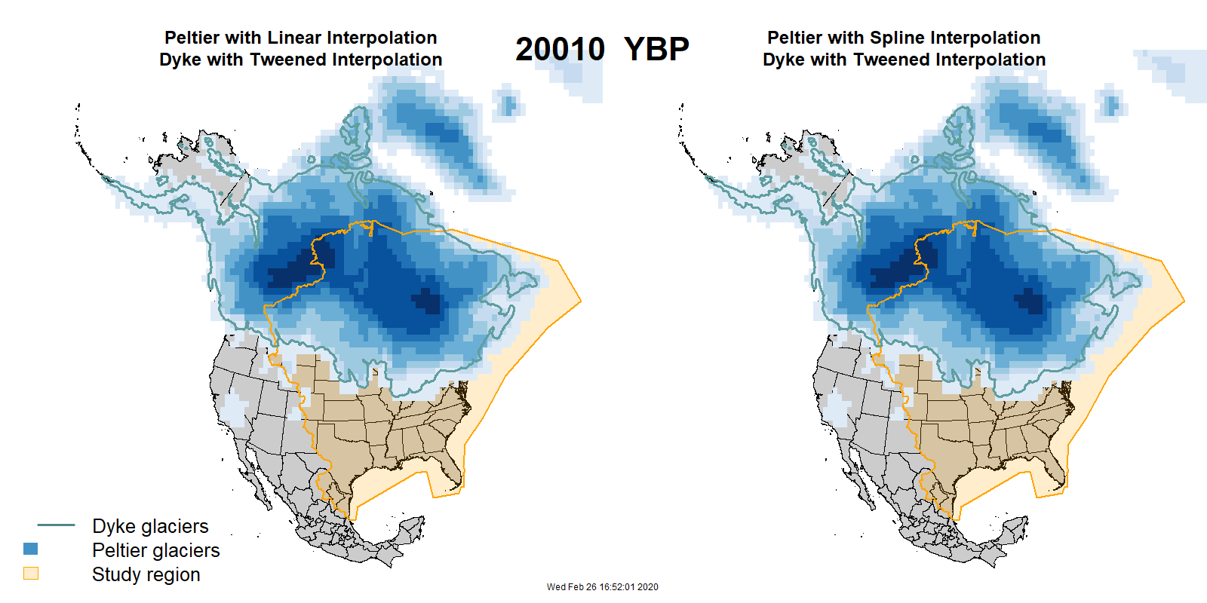

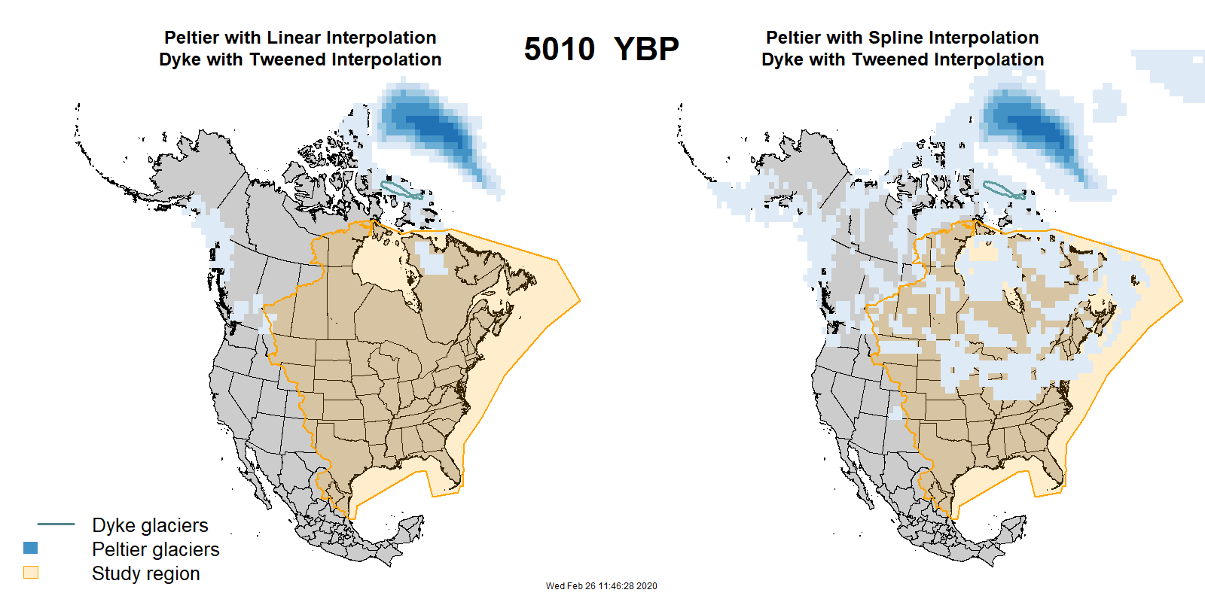

**Animations** are available at: <https://drive.google.com/file/d/1RN5aql9Sww_Ai33e0gCmi3ZxEvQfNzuT/view?usp=sharing>.

Please note this is a large file (30 MB) so may take a while to load in your browser.