Single-Pixel TIMESAT Prediction Stability Test

Purpose
This note documents a single-pixel experiment designed to clarify the difference between the legacy HR-VPP output setting used in VITO's test and a prediction-oriented monthly output setting.
The central question is whether a target year with incomplete observations should be handled by adding a future buffer year, or by keeping the target year as the last output year and disabling last-year trimming.

Terminology

Legacy HR-VPP Buffer Setting
This refers to the old setting:
"p_st_timestep": -1

In the legacy implementation, this single value combines two independent choices:
- Monthly output sampling on days [1, 11, 21]
- Removal of the first and last years from the yfit output
In the explicit configuration syntax this corresponds to:
{
"time_sampling": "monthly",
"monthly_days": [1, 11, 21],
"drop_first_year": true,
"drop_last_year": true
}

With input data from 2020-2025, this setting removes 2020 and 2025 from the yfit output. Therefore, to obtain yfit output for 2025 under the legacy setting, 2026 data must be added so that 2025 is no longer the last year.

Prediction-Oriented Monthly Setting
This setting keeps the same monthly output dates but does not remove the target year:
{
"time_sampling": "monthly",
"monthly_days": [1, 11, 21],
"drop_first_year": false,
"drop_last_year": false
}

This allows a target year such as 2025 to be output even when only early-season 2025 observations are available. This setting is more appropriate for prediction-style or early-season monitoring tests because it does not require future-year observations merely to make the target year visible in the output.

Conceptual Difference
The monthly sampling scheme is the same in both settings. The important difference is the buffer-year trimming:
Setting | Monthly dates | Drops first year | Drops last year | Needs 2026 to output 2025?
Legacy HR-VPP buffer setting | [1, 11, 21] | Yes | Yes | Yes
Prediction-oriented monthly setting | [1, 11, 21] | No | No | No

Thus, the prediction-oriented setting is not changing the output sampling frequency. It only separates monthly sampling from the buffer-year trimming rule.

Local Data Used for the Test
The current local test data cover:
2020-2024

The target year used for the local test is:
2023

The tested pixel is:
row = 500
col = 500

The tests use the range-mode-enabled timesat.tsfprocess build.

Progressive Target-Year Tests
To mimic the VITO-style question using the local complete record, we keep the surrounding time series but progressively remove observations from the target year, 2023:
Scenario | Target-year observations retained
through_2023_02 | January-February 2023
through_2023_04 | January-April 2023
through_2023_06 | January-June 2023
full_year | Full 2023

All scenarios use monthly yfit output on days [1, 11, 21].

Experiment A: 2020-2024 Data
This test uses the full local data span, including 2024 after the target year.
Output files:
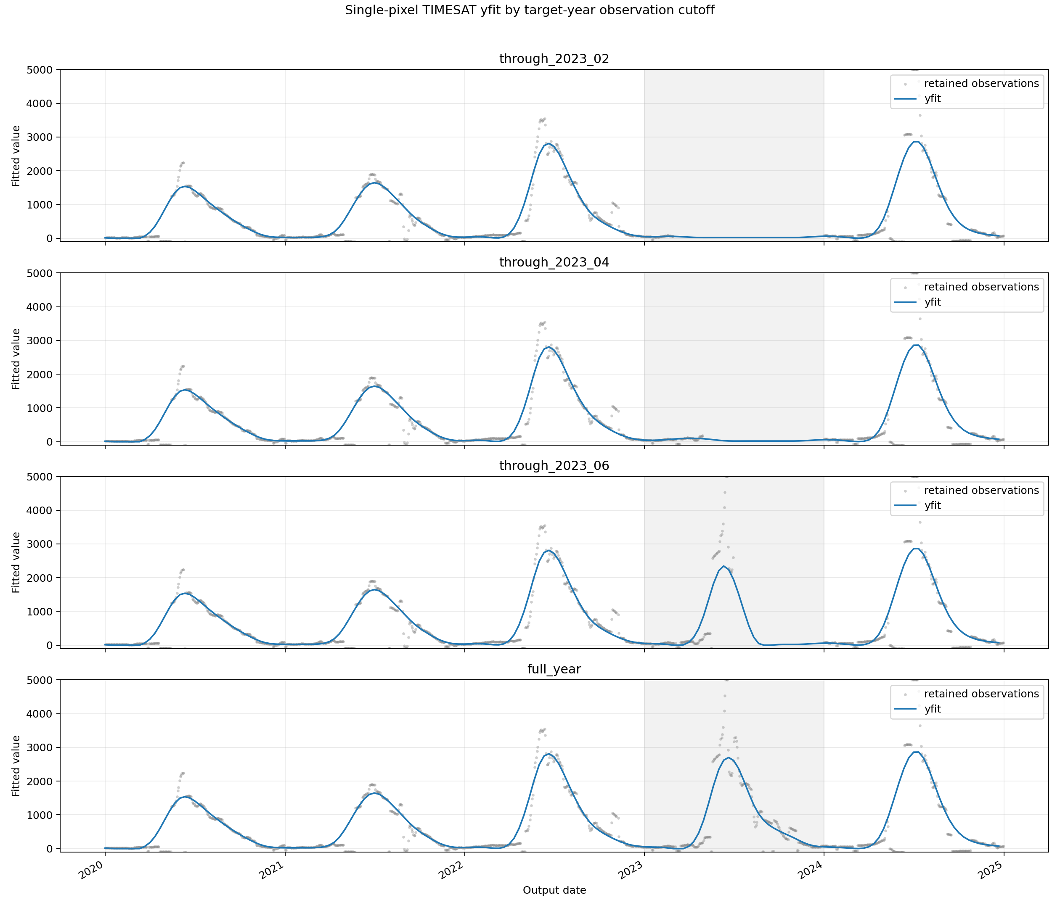
- `progressive_full_timeseries_yfit.png`
- `progressive_full_timeseries_yfit.csv`
- `progressive_manifest.json`
The manifest reports:
Scenario | Raw start | Raw end | Raw count | Output start | Output end | Output count
through_2023_02 | 2020-01-02 | 2024-12-31 | 905 | 2020-01-01 | 2024-12-21 | 180
through_2023_04 | 2020-01-02 | 2024-12-31 | 940 | 2020-01-01 | 2024-12-21 | 180
through_2023_06 | 2020-01-02 | 2024-12-31 | 977 | 2020-01-01 | 2024-12-21 | 180
full_year | 2020-01-02 | 2024-12-31 | 1086 | 2020-01-01 | 2024-12-21 | 180

Differences against the full_year target-year yfit values:
Scenario | N | Bias | MAE | RMSE | Max absolute difference
through_2023_02 | 36 | -750.696 | 763.363 | 1168.274 | 2678.061
through_2023_04 | 36 | -736.161 | 757.769 | 1161.202 | 2676.585
through_2023_06 | 36 | -295.198 | 301.509 | 469.446 | 1061.033

For this pixel, the early-season-only scenarios do not reconstruct the full 2023 seasonal peak. The fitted curve remains much lower than the full-year reference until enough target-year observations are included.

Experiment B: 2020-2023 Data Only
This test removes 2024 and processes only 2020-2023.
Output files:
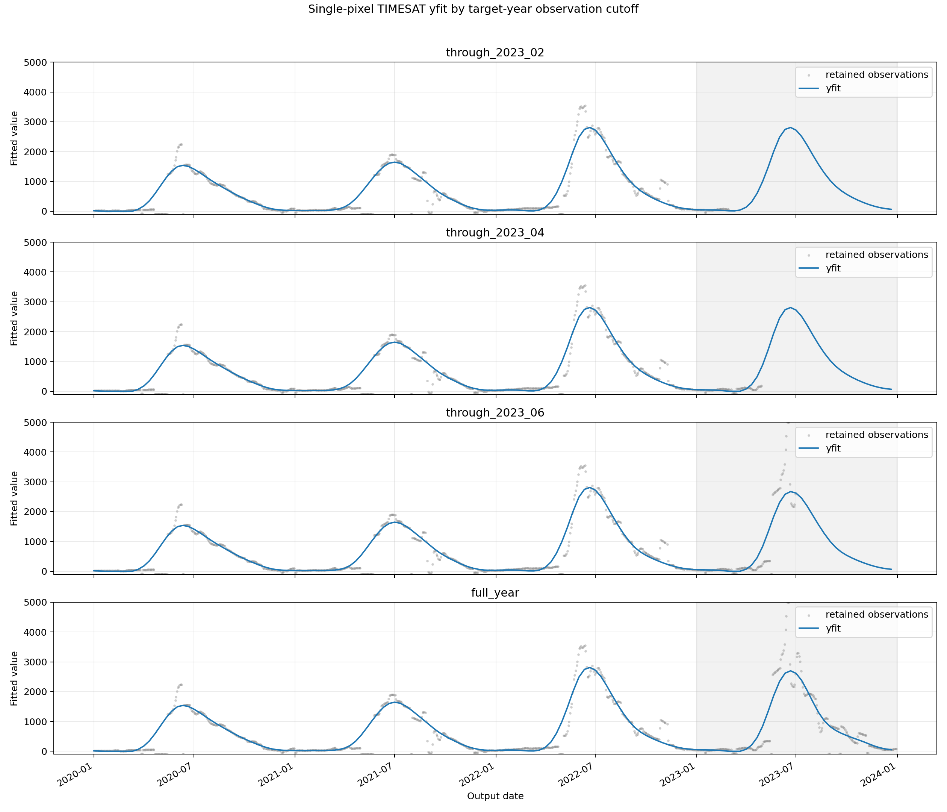
- `progressive_full_timeseries_yfit.png`
- `progressive_full_timeseries_yfit.csv`
- `progressive_manifest.json`
The manifest reports:
Scenario | Raw start | Raw end | Raw count | Output start | Output end | Output count
through_2023_02 | 2020-01-02 | 2023-02-28 | 687 | 2020-01-01 | 2023-12-21 | 144
through_2023_04 | 2020-01-02 | 2023-04-29 | 722 | 2020-01-01 | 2023-12-21 | 144
through_2023_06 | 2020-01-02 | 2023-06-30 | 759 | 2020-01-01 | 2023-12-21 | 144
full_year | 2020-01-02 | 2023-12-30 | 868 | 2020-01-01 | 2023-12-21 | 144

Differences against the full_year target-year yfit values:
Scenario | N | Bias | MAE | RMSE | Max absolute difference
through_2023_02 | 36 | 76.339 | 81.160 | 113.309 | 265.088
through_2023_04 | 36 | 59.228 | 63.931 | 101.480 | 266.306
through_2023_06 | 36 | 28.010 | 43.994 | 83.175 | 256.625

For this pixel, the no-future-year test gives smaller target-year differences than the version that also included 2024. This supports the concern that adding a future year can change the fitted target-year curve, which is undesirable for prediction-oriented evaluation.

Interpretation
The results show that TIMESAT fitting is sensitive to how the target year is treated at the temporal boundary. Under the legacy HR-VPP buffer setting, the target year is only available if an additional future year is supplied. This makes the target-year output retrospective, because future observations can influence the fitted curve.
For a prediction-oriented test, the target year should remain in the output without requiring future-year data. The prediction-oriented monthly setting preserves the same monthly output dates as the legacy setting, while avoiding automatic last-year removal.

Suggested Wording for VITO
The legacy p_st_timestep = -1 setting conflates monthly output sampling with buffer-year trimming. For HR-VPP production this is useful, because the first and last years can be treated as temporal buffers. However, for prediction-oriented experiments the last year is the evaluation year and should not be removed.
Therefore, we use the same monthly output schedule as the legacy setting, [1, 11, 21], but disable first-year and last-year trimming. This allows the target year to be evaluated without adding future-year data. If future-year data are added only to make the target year visible under the legacy setting, the resulting target-year fit is retrospective rather than a strict prediction.

Reproducible Commands
2020-2024 progressive test:
python experiments/single_pixel_prediction_stability/run_single_pixel_stability.py \
--config HRVPP2_config/VPP/settings_hrvpp2_VPP_v7.json \
--row 500 \
--col 500 \
--target-year 2023 \
--future-cutoff 2024-12-31 \
--progressive-target \
--cutoff-months 2 4 6 12 \
--require-range-mode

2020-2023 progressive test:
python experiments/single_pixel_prediction_stability/run_single_pixel_stability.py \
--config HRVPP2_config/VPP/settings_hrvpp2_VPP_v7.json \
--row 500 \
--col 500 \
--target-year 2023 \
--data-end 2023-12-31 \
--progressive-target \
--cutoff-months 2 4 6 12 \
--require-range-mode \
--out-dir experiments/single_pixel_prediction_stability/output_2020_2023

