Beebole Time Reporting
Once you are active in the UA system you will need to report your hours into the Beebole system.
First Time Login Link: https://beebole.com/
Enter your UA email address and select “Forgot?” password it will send you a link to setup your password.
We suggest you enter your hours worked each day into Beebole.
Remember to click on the “Send for Approval” button.

Submitting a Time Sheet in BeeBole
Interns must submit timesheets to the BeeBole payroll system before 10:00 am on Friday at the end of each pay period (every other week). Rosie Johnson will review and approve internship hours for pay.
1. Interns that have not registered and used the BeeBole system before will receive login information via their UArizona email address directly from BeeBole.

2. On the BeeBole Home page, you will see a space to input your daily work hours. Under Timesheet, use the front and back arrows next to "Today" to make sure you are entering time on the correct dates.

3. Enter your time for each day that you worked. Note, you do not have to add digital notes to your hours, this is optional. You do not have to submit vacation or sick leave, this is not applicable for student workers.
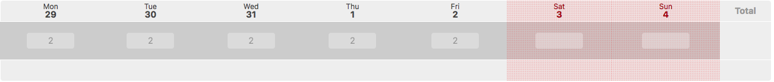

4. Go to "record your time on"...Select Project: All Companies and Projects...then select: Working Time.

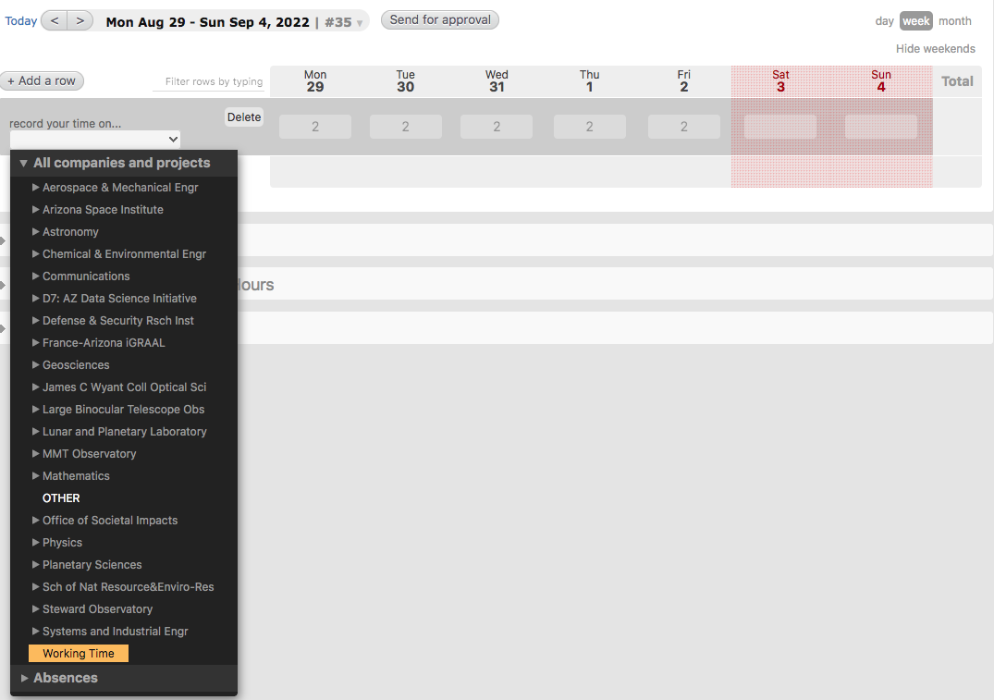

5. And finally, make sure you click "Send for Approval" to submit your hours. Note that you have to do this each week (i.e., you must click Send for Approval for each week that you are entering hours). If you don't click "Send for Approval" for each week of work, your time will not be submitted, and you risk not receiving pay for those hours.


