PHYSICAL HOMELAB
BUILD LOG
Proxmox VE 9.2 installation on Dell OptiPlex 7050
Session date: October 14, 2026
Status: Proxmox installed; network access remains to be configured

SESSION OUTCOME
Proxmox VE 9.2 was installed successfully to the Dell's internal 512 GB NVMe SSD. The server boots to the Proxmox console. The management address was configured as 192.168.0.50/24, but the web interface is not reachable yet because the server has not established a working network connection. No virtual machines were created or migrated during this session.

1. Hardware and starting point
The Dell OptiPlex was newly acquired for the physical homelab. There was no data on the machine that needed to be preserved. Windows 10 Education was present before Proxmox installation.
System | Dell OptiPlex 7050
Processor | Intel Core i5-6500T @ 2.50 GHz
Memory | 16 GB RAM (15.9 GB usable previously reported in Windows)
Internal storage | 512 GB NVMe SSD; installer identified /dev/nvme0n1, 476.94 GiB
Hypervisor | Proxmox Virtual Environment 9.2
Home network | Quantum Fiber; router located in parents’ room, too far for a direct Ethernet run to the user's room

2. Preparation and booting the installer
- Downloaded the Proxmox VE 9.2 ISO installer.
- Installed Rufus on the other computer and used it to write the ISO to a USB drive, creating bootable installation media.
- Inserted the USB into the OptiPlex and selected “UEFI: USB DISK 3.0 PMAP” from the Dell one-time boot menu. The firmware showed UEFI boot mode and Secure Boot ON.
The Proxmox graphical installer loaded successfully.

Screenshot 1 — Proxmox VE installer boot menu.
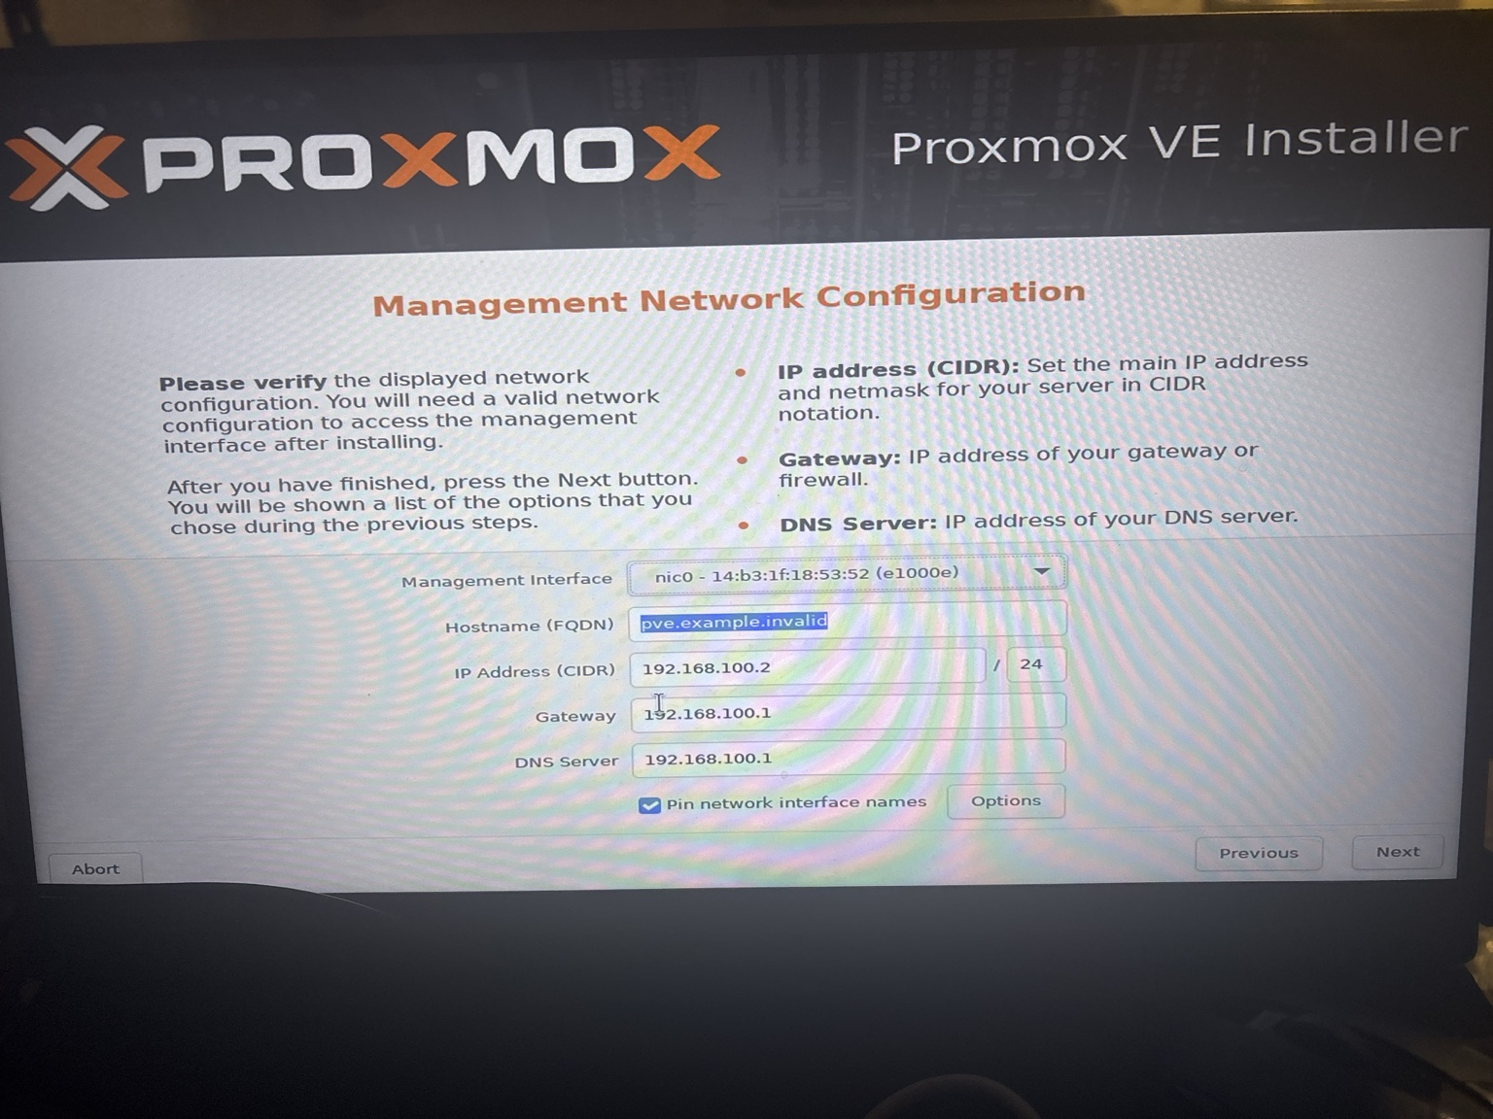
Screenshot 2 — Proxmox installation summary/installer screen.

3. Challenge #1 — Installer could not find a hard disk
Initial error: “No Hard Disk found! The installer could not find a supported hard disk.” The Dell BIOS had SATA Operation set to “RAID On.”
Resolution performed: entered BIOS Setup → System Configuration → SATA Operation, changed the mode from RAID On to AHCI, and accepted the firmware warning that changing SATA mode may prevent an existing OS from booting or require reinstallation. Returning to the installer made the internal NVMe drive available.
The installer then showed the target disk as “/dev/nvme0n1 (476.94 GiB, PC SN810 NVMe WDC 512GB).” This was selected as the installation target. The installer warned that existing partitions and data on the selected disk would be lost; the user had indicated there was nothing to preserve.
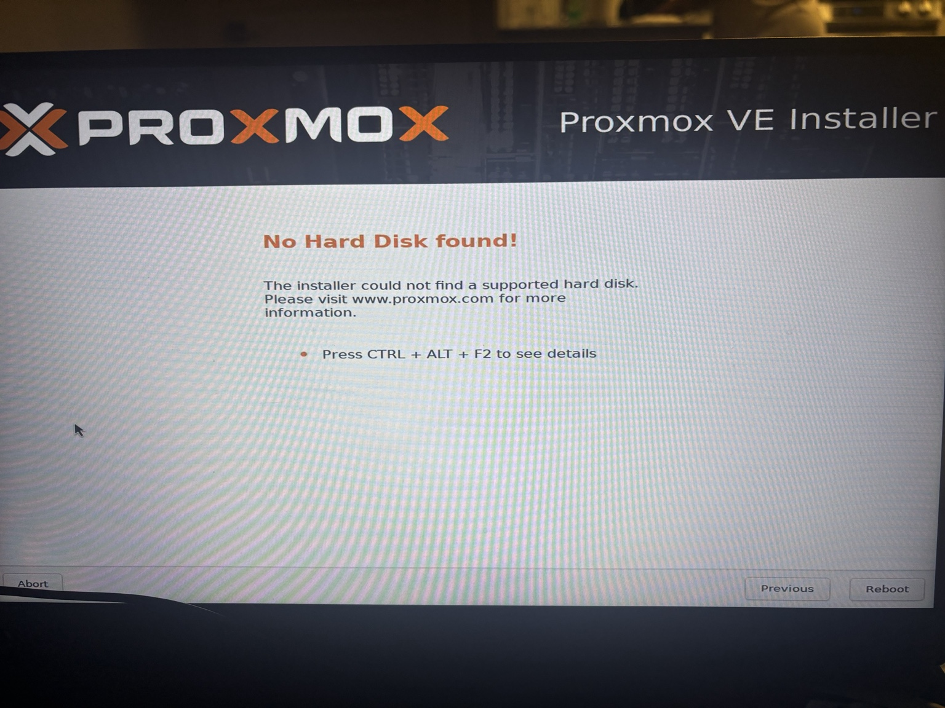
Screenshot 3 — Initial “No Hard Disk found” error.
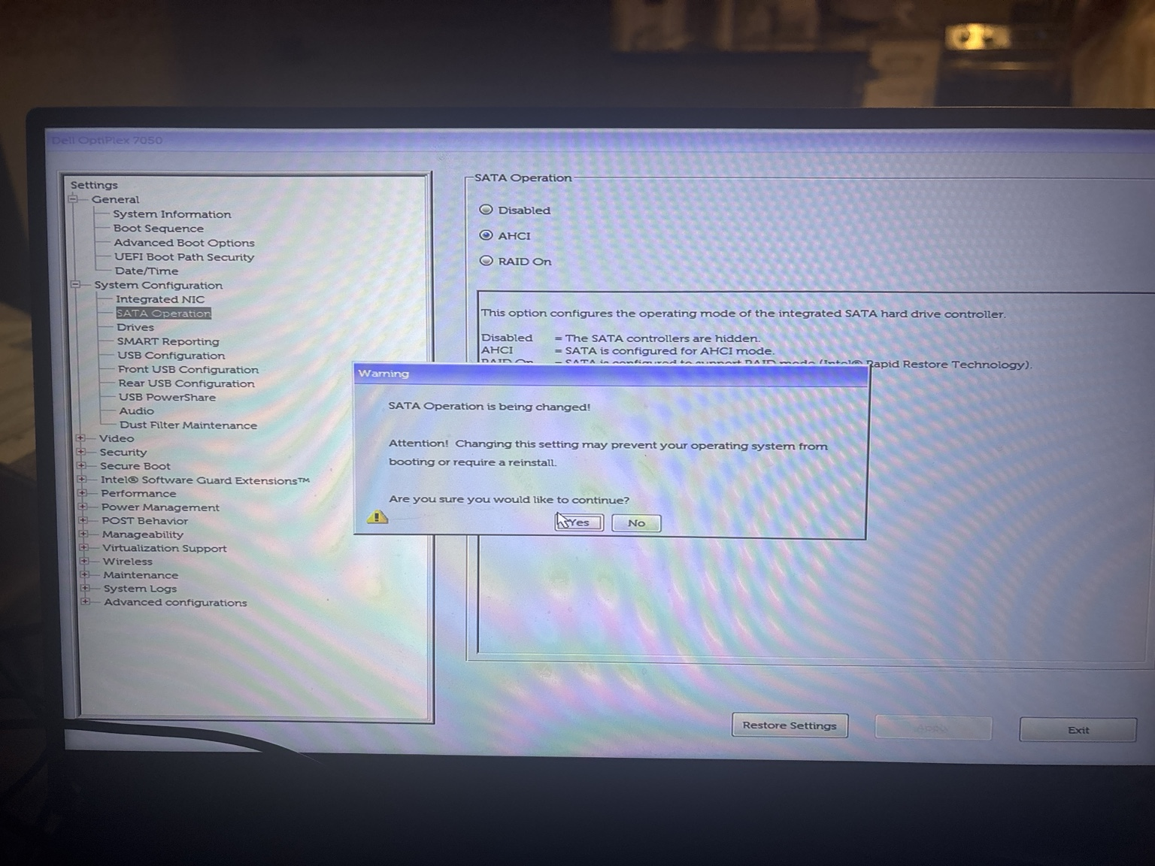
Screenshot 4 — BIOS SATA Operation changed to AHCI and warning accepted.
Lesson learned: On this OptiPlex, the installer did not detect the target drive with the firmware set to RAID On; changing SATA Operation to AHCI allowed the installation to proceed. This is a hardware/firmware-specific observation, not a universal instruction for every computer.

4. Installation choices
- Accepted the Proxmox VE end-user license agreement.
- Selected the internal 512 GB NVMe SSD as the target disk.
- Selected United States as the country, America/Denver as the timezone, and en-us as the keyboard layout.
- Configured the hostname as pve.timlab.local.
- Selected the wireless device shown by the installer as “nic1 … (iwlwifi)” for the management interface.
- Entered management IP 192.168.0.50/24, gateway 192.168.0.1, and DNS server 192.168.0.1.
- Reviewed the summary and clicked Install. The installer began creating logical volumes and continued through installation.
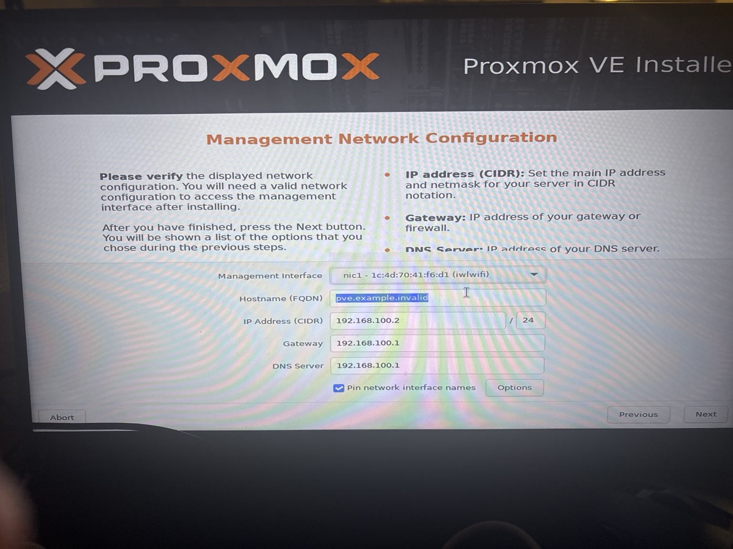
Screenshot 7 — Management network configuration with hostname, IP, gateway, and DNS.
Screenshot 8 — Installer summary before installation.

5. Installation completed
After installation, the Dell rebooted into the Proxmox console. The console displayed the management URL https://192.168.0.50:8006/ and a pve login prompt. The root account was used to log into the local console.
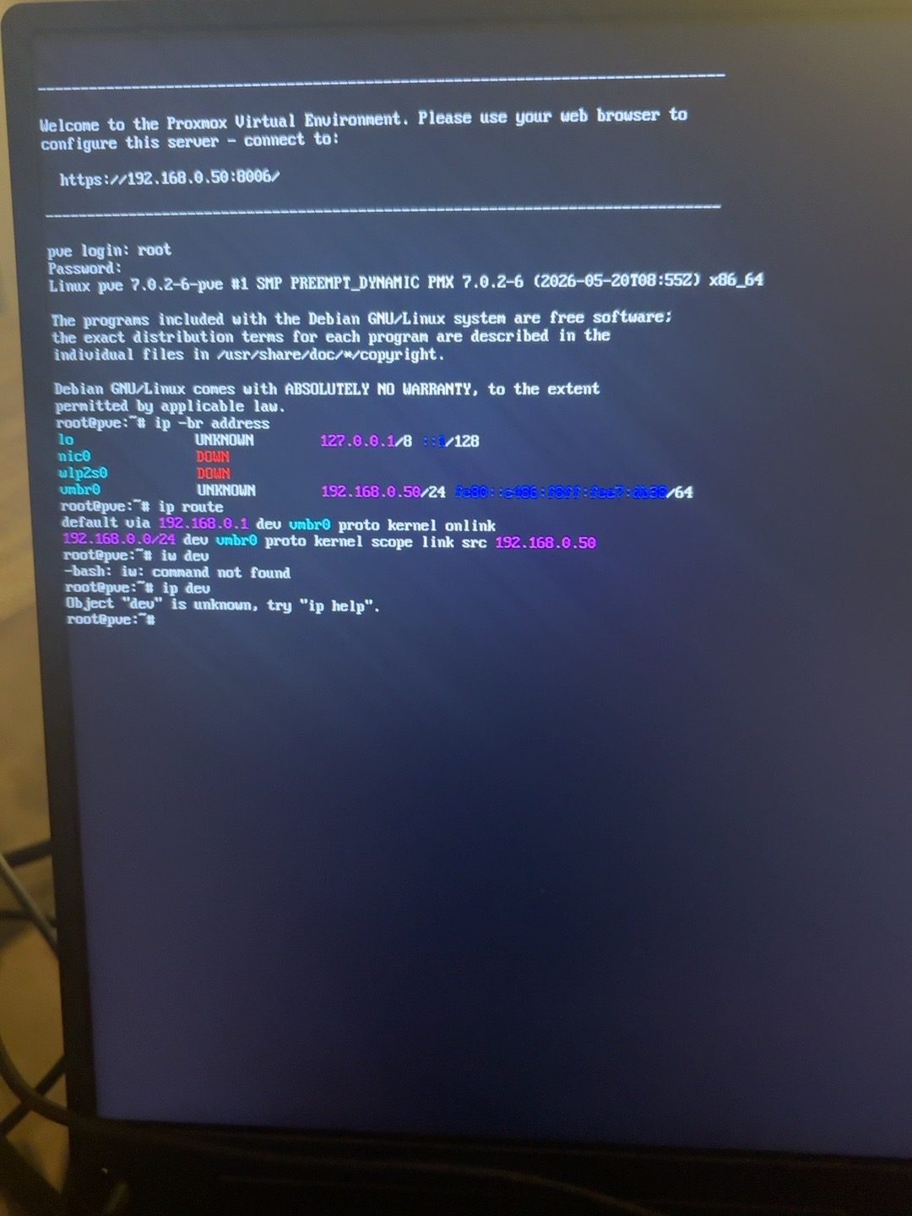
Screenshot 9 — Proxmox console after successful installation.
The installation is complete. The web interface was not yet reachable from the other laptop; this is a separate networking issue, not evidence that the installation failed.

6. Challenge #2 — Browser could not reach the Proxmox web interface
Attempted to open https://192.168.0.50:8006 from the other laptop while it was connected to Quantum Fiber Wi-Fi. Microsoft Edge returned ERR_CONNECTION_TIMED_OUT.
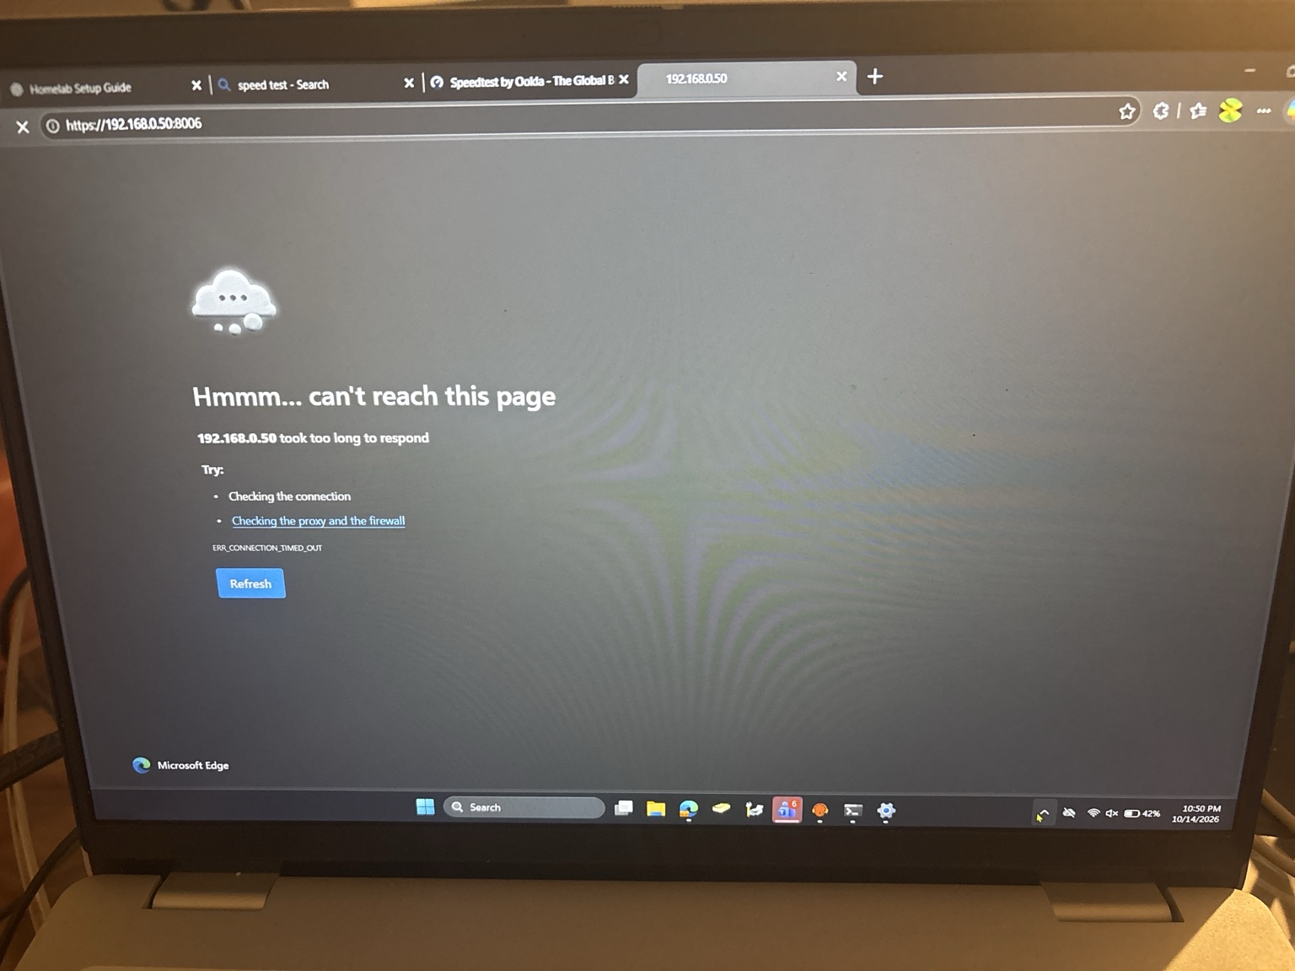
Screenshot 10 — Browser timeout when opening the Proxmox management URL.
The home router is in the user's parents’ room and is too far from the Dell for a practical direct Ethernet connection. A Wi-Fi extender or Wi-Fi-to-Ethernet bridge is planned for a later session. The server was not successfully connected to the home wireless network during this session.

7. Network troubleshooting performed
Logged into the Proxmox local console as root and ran the following diagnostics:
- ip -br address
- ip route
- ip link show
- lspci | grep -i -E 'network|wireless|ethernet'
- lspci -k | grep -A 4 -i network
- lsmod | grep iwlwifi
- ip link set wlp2s0 up
- command -v wpa_supplicant
- command -v iwctl
- ls -l /sys/class/net/wlp2s0
Key observations from the console:
- The Intel Wireless 8265 / 8275 adapter was detected by PCI hardware enumeration.
- The kernel driver in use was iwlwifi, and the iwlwifi module was loaded.
- Network interfaces shown included nic0 (Ethernet), wlp2s0 (Wi-Fi), and vmbr0 (Proxmox bridge).
- At the captured diagnostic stage, nic0 and wlp2s0 were shown DOWN. vmbr0 was UP/LOWER_UP and held 192.168.0.50/24.
- The route table showed a default route via 192.168.0.1 on vmbr0. This was configured but did not prove end-to-end connectivity.
- The commands iw and rfkill returned “command not found.” The command checks for wpa_supplicant and iwctl produced no path/output in the screenshot, so their availability was not established.
- Attempted to bring wlp2s0 up with ip link set wlp2s0 up; a later captured status still showed it DOWN. No successful Wi-Fi association was confirmed.
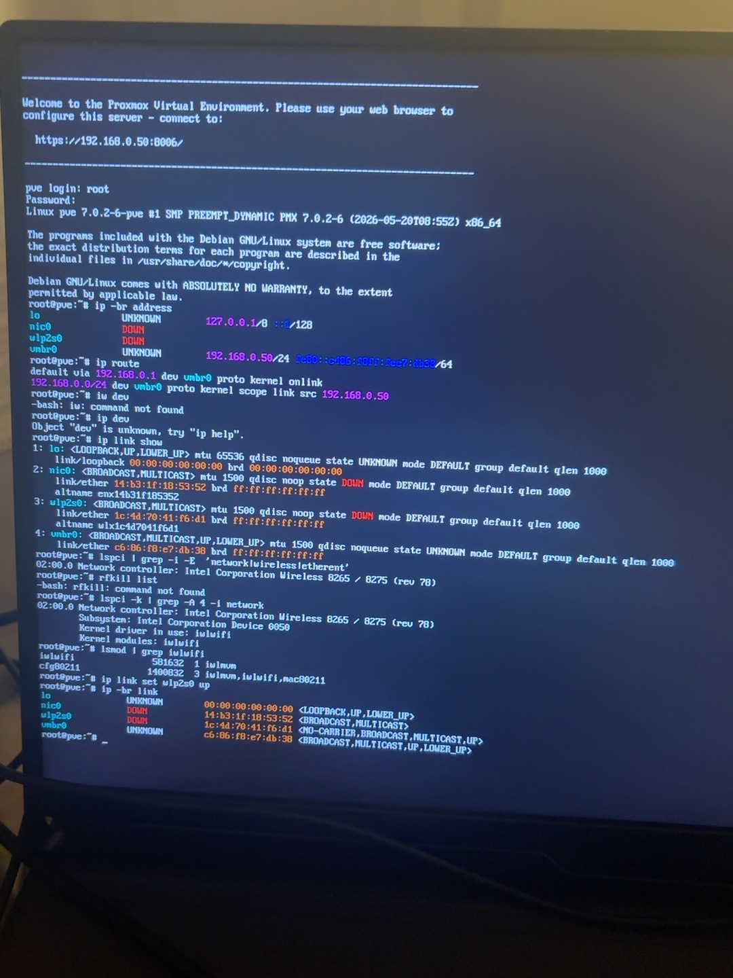
Screenshot 11 — Network diagnostics: driver detected, interface states, and missing iw/rfkill commands.
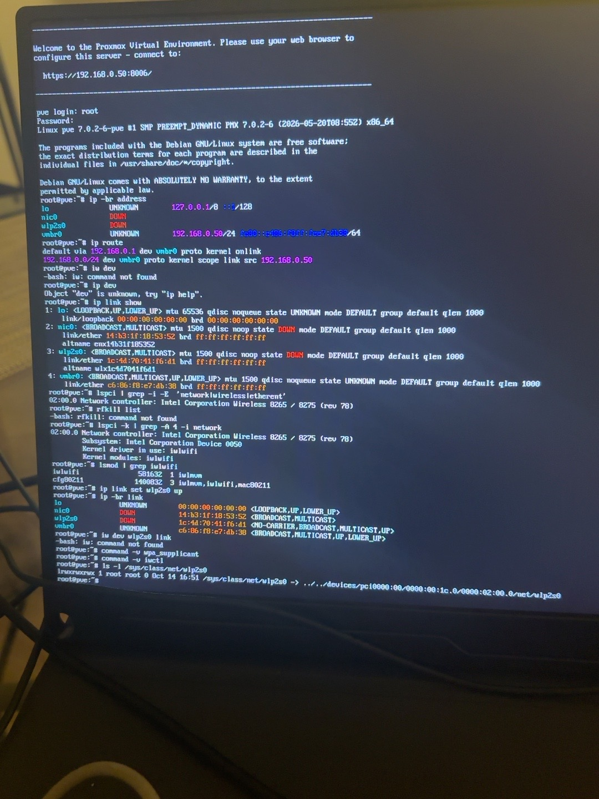
Screenshot 12 — Follow-up checks for wireless tools and sysfs interface presence.

8. Challenge status — resolved vs. still open
Item | Status | Evidence / notes
Create bootable installer USB | Resolved | Rufus used to write Proxmox VE 9.2 ISO.
Boot installer in UEFI mode | Resolved | USB boot entry selected; installer loaded.
Installer cannot see disk | Resolved | BIOS SATA Operation changed from RAID On to AHCI; NVMe target appeared.
Install Proxmox VE | Resolved | Dell boots to Proxmox console and displays management URL.
Reach web GUI from laptop | Open | Browser timed out at 192.168.0.50:8006.
Connect Dell to Quantum Fiber Wi-Fi | Open | Wi-Fi driver is detected, but no association confirmed; network interfaces shown down.
Migrate existing VirtualBox VMs | Not started | No VM creation or migration occurred during this session.

9. Current configuration reference
Proxmox version | Proxmox VE 9.2 (console reported kernel 7.0.2-6-pve)
Hostname entered | pve.timlab.local
Management interface selected in installer | nic1 / Intel Wi-Fi device (iwlwifi)
Configured management IP | 192.168.0.50/24
Configured gateway | 192.168.0.1
Configured DNS | 192.168.0.1
Management URL | https://192.168.0.50:8006/
Current network status | Not reachable from laptop; connectivity not verified

10. Next session checklist
- ☐ Power on the Dell and confirm it reaches the Proxmox console.
- ☐ Use a Wi-Fi extender/bridge that has an Ethernet port, or another suitable wired connection, to connect the Dell to the home LAN.
- ☐ Ensure the network connection actually uses the home subnet 192.168.0.0/24 and verify that 192.168.0.50 is not already assigned to another device before relying on it.
- ☐ Confirm the physical link and routing, then try https://192.168.0.50:8006 from the laptop.
- ☐ Once the web UI is reachable, verify storage and memory; check `pvesm status`, `lsblk`, `free -h`, and `systemctl is-active pveproxy`.
- ☐ Only after network access is stable, prepare to migrate the existing VirtualBox Windows Server 2022 domain controller `DC01` and Ubuntu VM. Keep original VM files unchanged until migrated copies are verified.

11. Lessons learned
- The first obstacle was disk detection, and changing SATA mode from RAID On to AHCI allowed the Proxmox installer to see the NVMe drive.
- The Proxmox install can complete without a working network connection, but remote administration through the web UI requires a functioning management network.
- Proxmox detects the Intel Wi-Fi adapter and its kernel driver, but the wireless tools/connection were not ready in this installation. A Wi-Fi-to-Ethernet bridge is a practical next step because it lets Proxmox use a standard wired interface.
- Do not claim the web interface or Wi-Fi is working until it has been tested successfully from the laptop.

End of session log — next action: establish network connectivity, then access the Proxmox web UI.

